Graphical Abstract
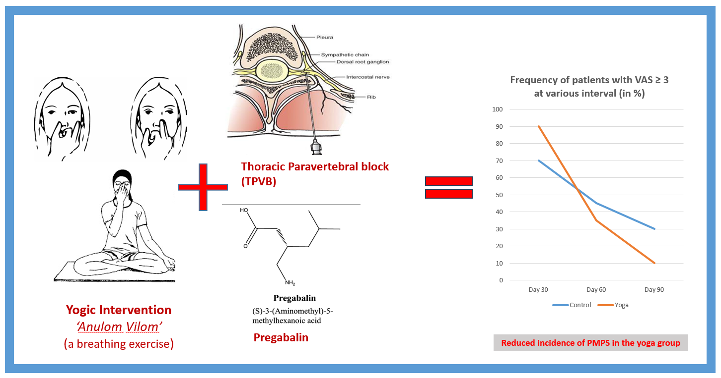

Integrating yoga ‘anulom vilom’ along with multimodal pain management approach using thoracic paravertebral block on pregabalin on post-mastectomy pain syndrome.

