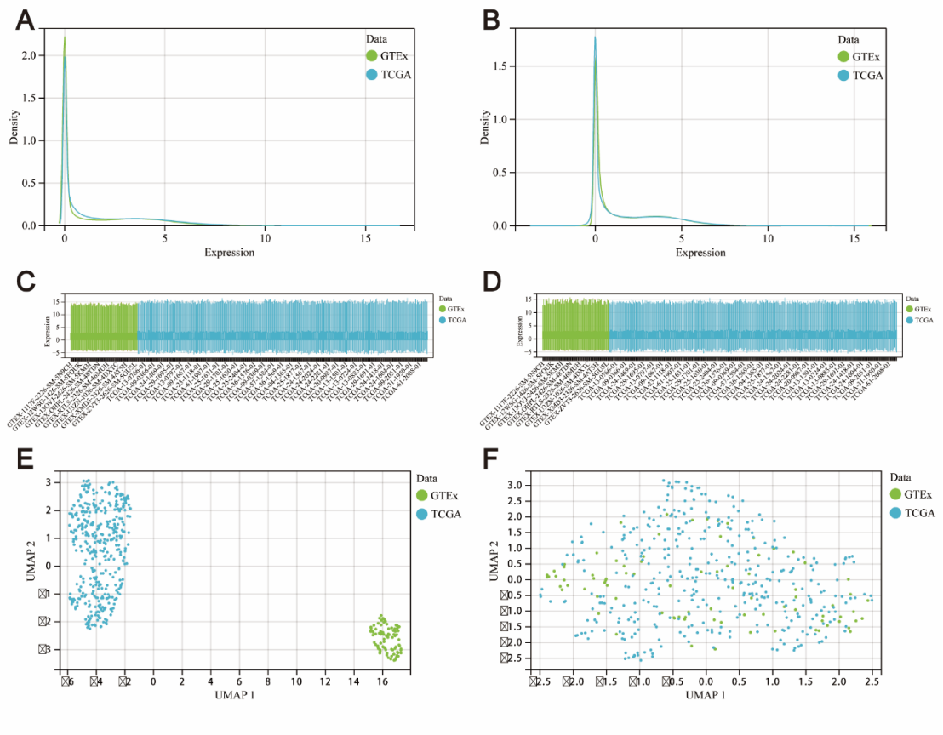
Supplementary Figure 1 presents the data distribution of both pre and post-removal of batch influences, visualized in the ensuing manner: (A, B) Density plots, (C, D) Boxplots, and (E, F) UMAP plots.
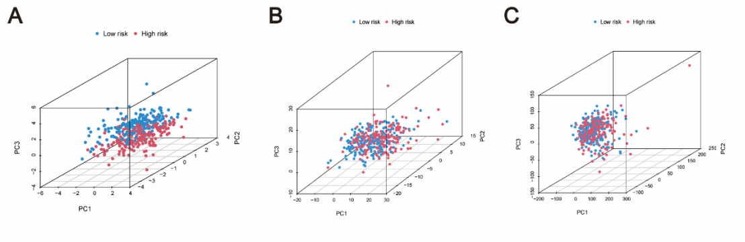
Supplementary Figure 2 displays the PCA executed for the low-risk versus high-risk cohorts, distinguished subsequently: (A) The prognostic model comprising a set of ten lysosomal genes. (B) The set of LRGs. (C) The complete set of all genes.
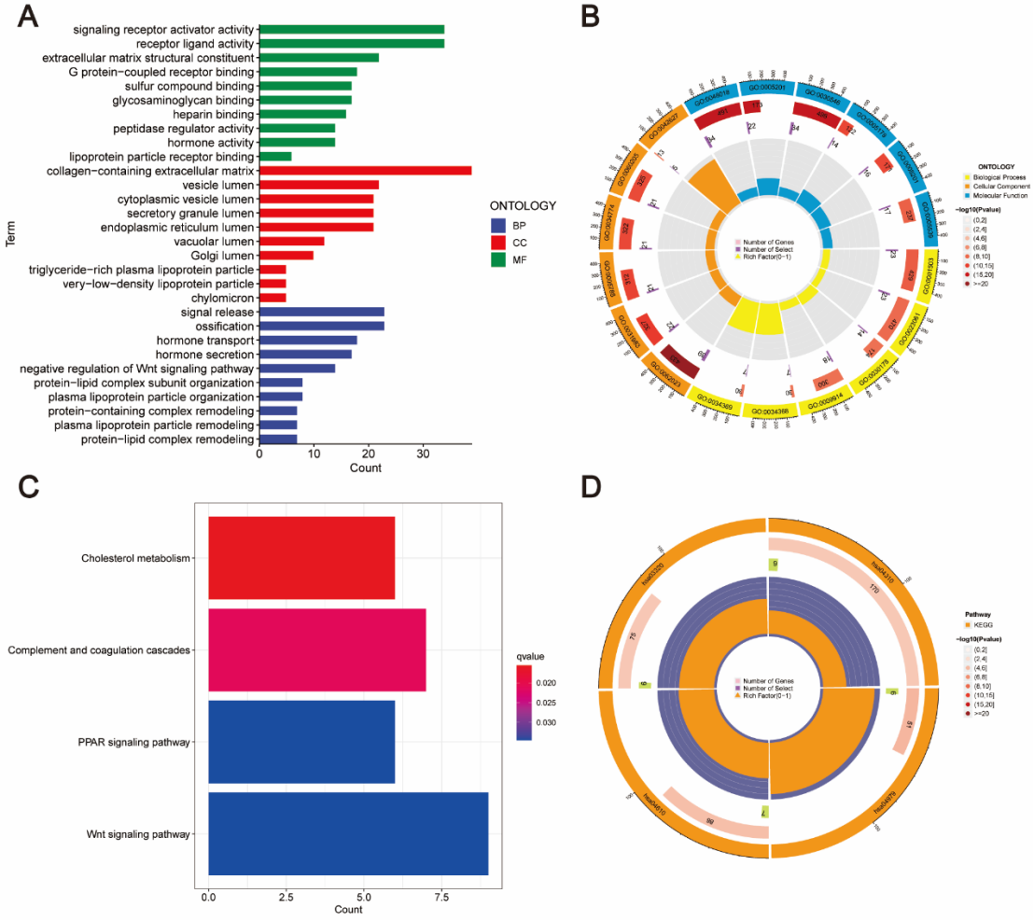
Supplementary Figure 3 illustrates the functional enrichment examination of DEGs distinguishing the high-risk from the low-risk categories, encapsulated thus: (A) A bar graph illustrating the results from the GO enrichment analysis. (B) Circular plot illustrating the GO enrichment analysis outcomes. (C) Bar plot displaying the KEGG pathway enrichment analysis findings. (D) Circular plot illustrating the KEGG pathway enrichment analysis results.

