ONLINE- ONLY SUPPLEMENTARY MATERIAL

Supplementary Table 1. Characteristics of excluded sample 2
Supplementary Table 2. Missingness in key covariates for analytic sample 3
Supplementary Table 3. State-level marginal and co-occurrent prevalence of hypertension, n = 50,023 4
Supplementary Table 4. Individual, and household characteristics associated with chronic disease status, n = 50,023 6
Supplementary Table 5. Association of spouse’s disease status with own disease status adjusting for spouse’s characteristics, n = 50,023 7
Supplementary Table 6. Association of spouse’s blood pressure and body mass index with own biomarkers, n = 50,023 couples 8
Supplementary Table 7. Association of spouse’s disease status with own disease status, n = 54,356 9
Supplementary Note 1. Spousal concordance and joint burden of disease 10
Supplementary Figure 1. Flowchart of analytic sample 12
Supplementary Figure 2. Framework for analysis of spousal concordance 13
Supplementary Figure 3. State-level prevalence of hypertension burden among spousal pairs 14
Supplementary Figure 4. Total and undiagnosed hypertension in married Indian adults by spouse’s hypertension status, n = 50,023 15

Supplementary Table 1. Characteristics of excluded sample

 | Excluded sample (n = 4,333)
 | Husbands | Wives
Individual characteristics
Age in years | 39.2 (38.9, 39.6) | 34.4 (34, 34.7)
Years of schooling | 8.6 (8.4, 8.9) | 7.3 (7, 7.5)
Consumes alcohol (%) | 28.1 (26.1, 30.2) | 1.1 (0.7, 1.4)
Tobacco use (%) | 47.6 (45.2, 49.9) | 4.8 (3.9, 5.6)
Body mass index (kg/m²) | 23.9 (23.6, 24.1) | 23.8 (23.5, 24.0)
Weight status
Underweight (< 18.5kg/m²) | 2.9 (2.3, 3.6) | 8.6 (7.5, 9.7)
Normal (18.5 – 24.9kg/m²) | 21.3 (19.6, 23) | 37.2 (35.3, 39.2)
Overweight (25-29.9kg/m²) | 11.1 (9.9, 12.4) | 18.5 (16.9, 20.1)
Obese (≥ 30 kg/m²) | 2.5 (1.9, 3.1) | 7.1 (6.1, 8.1)
Attained schooling
No education | 14.2 (12.9, 15.6) | 26.4 (24.7, 28.2)
Primary | 13.3 (11.7, 14.9) | 12.6 (11.2, 14.1)
Secondary | 51.4 (49.2, 53.6) | 44.6 (42.3, 46.9)
Higher | 21 (19, 23.1) | 16.3 (14.2, 18.4)
Household characteristics
Number of children | 5.5 (5.4, 5.6) | To be merged
Household members | 2.3 (2.3, 2.4)
Household wealth quintile at national level (%)
Q1 | 14.7 (13.3, 16.1) | To be merged
Q2 | 15.8 (14.3, 17.3)
Q3 | 18.5 (16.8, 20.1)
Q4 | 22.2 (20.4, 24)
Q5 | 28.8 (26.5, 31.2)
Rural (%) | 56.7 (53.7, 59.7)
Chronic disease outcomes
Diabetes (%) | - | -
Self-reported Diabetes (%) | - | -
Treated Diabetes (%) | - | -
Joint prevalence of Diabetes (%)
Hypertension (%) | - | -
Self-reported Hypertension (%) | - | -
Treated Hypertension (%) | - | -
Joint prevalence Hypertension (%)

Supplementary Table 2. Missingness in key covariates for analytic sample

 | Analytic sample (n = 50,023)
 | Husbands | Wives
Individual characteristics
Age in years | 0 (0%) | 0 (0%)
Years of schooling | 0 (0%) | 0 (0%)
Consumes alcohol (%) | 0 (0%) | 0 (0%)
Tobacco use (%) | 0 (0%) | 0 (0%)
Body mass index (kg/m²) | 155 (0.3%) | 86 (0.2%)
Attained schooling | 0 (0%) | 0 (0%)
Household characteristics
Number of children | 0 (0%)
Household members | 0 (0%)
Household wealth quintile at national level (%) | 0%
Rural (%) | 0%
Caste endogamy (%) | 0 (0%)
Chronic disease outcomes
Random Blood Glucose (mg/dL)
Systolic Blood Pressure (mm Hg) | 9 (0%) | 1 (0%)
Diastolic Blood Pressure (mm Hg) | 9 (0%) | 1 (0%)
Diabetes (%)
Self-reported Diabetes (%) | 0 (0%) | 0 (0%)
Co-occurring Diabetes (%)
Hypertension (%)
Self-reported Hypertension (%) | 0 (0%) | 0 (0%)
Co-occurring Hypertension (%)

Supplementary Table 3. State-level marginal and co-occurrent prevalence of hypertension, n = 50,023

 | Husbands | Wives | Co-occurent
Andaman & Nicobar Islands | 38.8  (30.3, 47.3) | 17.6  (11.5, 23.7) | 9.3  (4.3, 14.4)
Andhra Pradesh | 30.3  (26.9, 33.7) | 19.5  (16.4, 22.6) | 8.5  (6.6, 10.5)
Arunachal Pradesh | 41.7  (37.9, 45.5) | 30.2  (26.9, 33.5) | 16.3  (13.5, 19.1)
Assam | 26.5  (24.4, 28.6) | 19  (17.1, 20.8) | 7  (5.9, 8.2)
Bihar | 26.5  (23.7, 29.4) | 21.7  (19.1, 24.3) | 9.6  (7.6, 11.6)
Chandigarh | 38.8  (24.4, 53.2) | 28.2  (14.2, 42.2) | 9.5  (1.4, 17.5)
Chhattisgarh | 33.2  (30.6, 35.8) | 22.3  (20.1, 24.5) | 9.3  (7.5, 11.1)
Dadra & Nagar Haveli And Daman & Diu | 15.7  (8.8, 22.6) | 14.2  (9.2, 19.2) | 1.2  (-0.1, 2.5)
Goa | 32.4  (23.4, 41.5) | 15.9  (9.7, 22.2) | 6.7  (2.3, 11.2)
Gujarat | 20.9  (18.6, 23.2) | 15.7  (13.9, 17.5) | 5.2  (4.1, 6.2)
Haryana | 31.8  (28.7, 34.8) | 27.7  (24.4, 30.9) | 11  (8.8, 13.1)
Himachal Pradesh | 29.8  (25.1, 34.4) | 20.8  (16.9, 24.7) | 9.6  (6.8, 12.5)
Jammu & Kashmir | 24.2  (20.8, 27.6) | 23.1  (19.6, 26.6) | 8.7  (6.5, 11)
Jharkhand | 29  (26.3, 31.6) | 19.8  (16.8, 22.9) | 9  (6.8, 11.2)
Karnataka | 34.6  (31.5, 37.8) | 17.9  (15.9, 19.9) | 7.6  (6, 9.2)
Kerala | 32.6  (28.6, 36.6) | 18.2  (14.7, 21.6) | 7.3  (5.2, 9.4)
Ladakh | 26.5  (15.4, 37.6) | 25.4  (14.2, 36.7) | 12.4  (1.1, 23.6)
Lakshadweep | 30.5  (16.8, 44.2) | 23  (12.5, 33.5) | 9.3  (0.6, 18)
Madhya Pradesh | 27.2  (25.2, 29.2) | 20  (18.3, 21.6) | 7.1  (6.1, 8.1)
Maharashtra | 27.6  (24.9, 30.3) | 19.2  (16.7, 21.7) | 7.1  (5.2, 8.9)
Manipur | 44.7  (38.9, 50.5) | 24.9  (21.2, 28.7) | 13.1  (9.2, 17.1)
Meghalaya | 28.9  (22.3, 35.6) | 21  (15.7, 26.3) | 8.6  (4.8, 12.5)
Mizoram | 27.5  (20.8, 34.3) | 18.4  (13.6, 23.2) | 5.1  (2.5, 7.7)
Nagaland | 35.2  (30, 40.4) | 27.8  (22.7, 33) | 10.9  (7.6, 14.2)
Nct Of Delhi | 46.7  (41.8, 51.6) | 23.8  (20.1, 27.5) | 12.8  (10.2, 15.4)
Odisha | 30.9  (28.3, 33.4) | 23  (20.7, 25.3) | 8.8  (7.2, 10.3)
Puducherry | 32  (21.4, 42.7) | 11.6  (4.9, 18.4) | 3.2  (0.6, 5.9)
Punjab | 49.5  (46, 52.9) | 38  (34.4, 41.7) | 21.5  (18.4, 24.7)
Rajasthan | 23.1  (21, 25.1) | 16.8  (15, 18.5) | 6.7  (5.5, 7.9)
Sikkim | 53.8  (41.9, 65.8) | 38.1  (28.8, 47.3) | 24.2  (15.5, 32.9)
Tamil Nadu | 36.3  (33.5, 39.1) | 20.5  (17.7, 23.4) | 10.2  (8, 12.5)
Telangana | 35.9  (32.9, 39) | 19.3  (17.1, 21.4) | 8.9  (7.3, 10.4)
Tripura | 28.9  (23.7, 34) | 22.5  (18.9, 26.2) | 9  (5.9, 12.1)
Uttar Pradesh | 29.1  (27.5, 30.7) | 24  (22.6, 25.5) | 9.4  (8.4, 10.5)
Uttarakhand | 41.7  (37, 46.3) | 25.9  (21.5, 30.3) | 12.6  (8.6, 16.5)
West Bengal | 22.8  (20.2, 25.3) | 18.4  (16.1, 20.8) | 6  (4.4, 7.6)
Andaman & Nicobar Islands | 38.8  (30.3, 47.3) | 17.6  (11.5, 23.7) | 9.3  (4.3, 14.4)

Survey weighted prevalence estimates and 95% confidence intervals

Supplementary Table 4. Individual, and household characteristics associated with hypertension, n = 50,023

 | Hypertension
Prevalence Ratio (95% CI) | Wives | Husbands
Spouse’s confirmed disease status | 1.37  (1.30, 1.44) | 1.32  (1.26, 1.38)
Own characteristics
Age in years | 1.05  (1.04, 1.05) | 1.03  (1.03, 1.04)
Level of education (ref: No education)
Primary | 1.03  (0.96, 1.11) | 1.05  (0.98, 1.13)
Secondary | 0.98  (0.92, 1.05) | 1.06  (1.00, 1.13)
Higher | 0.86  (0.77, 0.97) | 1.10  (1.01, 1.19)
Consumes alcohol (%) | 1.21  (1.04, 1.40) | 1.22  (1.16, 1.27)
Tobacco use (%) | 1.15  (1.05, 1.26) | 1.00  (0.95, 1.04)
Body mass index (kg/m²) | 1.05  (1.05, 1.06) | 1.04  (1.03, 1.04)
Household characteristics
Number of children (count) | 0.97  (0.95, 0.99) | 1.00  (0.98, 1.01)
Household members (count) | 1.00  (0.99, 1.01) | 0.99  (0.99, 1.00)
Rural residence | 1.05  (0.98, 1.12) | 0.95  (0.90, 1.00)
National Wealth Quintile (ref: Q1)
Q2 | 0.99  (0.92, 1.07) | 1.06  (0.99, 1.13)
Q3 | 1.05  (0.97, 1.14) | 1.15  (1.07, 1.23)
Q4 | 1.06  (0.97, 1.17) | 1.16  (1.08, 1.25)
Q5 | 1.01  (0.91, 1.12) | 1.15  (1.05, 1.25)

Supplementary Table 5. Association of spouse’s hypertension with own hypertension status adjusting for spouse’s characteristics, n = 50,023

 | Hypertension
Prevalence Ratio (95% CI) | Wife | Husband
Spouse’s confirmed disease status | 1.38  (1.31, 1.45) | 1.31  (1.25, 1.37)
Personal characteristics
Age (years) | 1.05  (1.04, 1.05) | 1.03  (1.03, 1.04)
Level of education (ref: None)
Primary | 1.02  (0.95, 1.11) | 1.04  (0.97, 1.12)
Secondary | 1.00  (0.93, 1.07) | 1.07  (1.00, 1.13)
Higher | 0.90  (0.79, 1.03) | 1.13  (1.03, 1.23)
Alcohol use | 1.22  (1.05, 1.41) | 1.21  (1.16, 1.27)
Tobacco use | 1.14  (1.04, 1.25) | 0.99  (0.95, 1.04)
BMI (kg/m²) | 1.05  (1.05, 1.06) | 1.04  (1.03, 1.04)
Household characteristics
Number of children (count)
Household members (count) | 1.00  (0.99, 1.01) | 0.99  (0.99, 1.00)
Rural residence | 1.05  (0.98, 1.12) | 0.95  (0.90, 1.00)
National Wealth Quintile (ref: Q1)
Q2 | 1.00  (0.92, 1.08) | 1.06  (1.00, 1.13)
Q3 | 1.06  (0.98, 1.15) | 1.15  (1.08, 1.23)
Q4 | 1.08  (0.99, 1.19) | 1.17  (1.08, 1.26)
Q5 | 1.05  (0.94, 1.16) | 1.16  (1.06, 1.26)
Spouse’s characteristics
Level of education (ref: None)
Primary | 1.05  (0.97, 1.14) | 1.03  (0.97, 1.10)
Secondary | 1.00  (0.93, 1.08) | 0.99  (0.94, 1.05)
Higher | 0.95  (0.85, 1.07) | 0.94  (0.86, 1.03)
Alcohol use | 0.98  (0.93, 1.04) | 1.02  (0.90, 1.15)
Tobacco use | 1.04  (0.99, 1.10) | 1.07  (0.99, 1.17)
BMI (kg/m²) | 0.99  (0.99, 1.00) | 1.00  (1.00, 1.01)
Age (years) for spouse was not included due to multicollinearity

Supplementary Table 6. Association of spouse’s blood pressure with own blood pressure, n = 50,023 couples

 | Systolic Blood Pressure (mm Hg)
Coefficient (95% CI) | Wives | Husbands
Spouse’s biomarker (per 1 unit) | 0.12  (0.11, 0.13) | 0.13  (0.11, 0.14)
Personal characteristics
Age in years | 0.44  (0.42, 0.47) | 0.20  (0.18, 0.22)
Level of education (ref: No education)
Primary | -0.77  (-1.28, -0.25) | 0.15  (-0.43, 0.72)
Secondary | -1.05  (-1.49, -0.62) | 0.25  (-0.23, 0.74)
Higher | -1.97  (-2.66, -1.29) | -0.04  (-0.68, 0.59)
Consumes alcohol (%) | 1.89  (0.65, 3.13) | 1.74  (1.36, 2.11)
Tobacco use (%) | -0.73  (-1.44, -0.01) | -0.54  (-0.92, -0.16)
Body mass index (kg/m²) | 0.46  (0.42, 0.51) | 0.57  (0.52, 0.62)
Household characteristics
Number of children (count) | -0.64  (-0.78, -0.50) | 0.03  (-0.11, 0.17)
Household members (count) | 0.01  (-0.05, 0.06) | -0.03  (-0.08, 0.02)
Rural residence | 0.46  (-0.03, 0.96) | -0.43  (-0.90, 0.05)
National Wealth Quintile (ref: Q1)
Q2 | -0.56  (-1.05, -0.07) | 0.61  (0.14, 1.08)
Q3 | -0.18  (-0.73, 0.36) | 0.95  (0.42, 1.49)
Q4 | -0.42  (-1.02, 0.17) | 1.24  (0.66, 1.82)
Q5 | -0.22  (-0.97, 0.53) | 1.10  (0.41, 1.80)

Supplementary Table 7. Association of spouse’s hypertension status with own hypertension status, n = 54,356

 | Hypertension
Prevalence Ratio (95% CI) | Wives | Husbands
Spouse’s confirmed disease status | 1.37  (1.30, 1.45) | 1.31  (1.26, 1.37)
Personal characteristics
Age in years | 1.05  (1.04, 1.05) | 1.04  (1.03, 1.04)
Level of education (ref: No education)
Primary | 1.04  (0.97, 1.12) | 1.06  (0.99, 1.13)
Secondary | 0.99  (0.93, 1.06) | 1.09  (1.03, 1.15)
Higher | 0.84  (0.75, 0.94) | 1.12  (1.04, 1.21)
Consumes alcohol (%)
Tobacco use (%) | 1.11  (1.02, 1.21) | 0.98  (0.94, 1.03)
Body mass index (kg/m²) | 1.03  (1.02, 1.03) | 1.01  (1.01, 1.02)
Household characteristics
Number of children (count) | 0.97  (0.95, 0.99) | 1.00  (0.99, 1.02)
Household members (count) | 1.00  (0.99, 1.01) | 0.99  (0.99, 1.00)
Rural residence | 1.04  (0.98, 1.12) | 0.96  (0.91, 1.01)
National Wealth Quintile (ref: Q1)
Q2 | 1.02  (0.95, 1.10) | 1.07  (1.01, 1.14)
Q3 | 1.09  (1.01, 1.18) | 1.17  (1.10, 1.24)
Q4 | 1.13  (1.04, 1.24) | 1.20  (1.12, 1.29)
Q5 | 1.09  (0.99, 1.21) | 1.20  (1.11, 1.30)

Analysis was carried out for all couples of legal age with and without the outcome variable after imputing the outcome variable and not deleting after imputation. All associations (95% confidence intervals) were estimated from survey-weighted Poisson regression (with robust standard errors) of 10 multiply-imputed datasets. Associations were adjusted for state of residence.

Supplementary Note 1. Spousal concordance and joint burden of disease

 | Husband’s Outcome = Yes | Husband’s Outcome = No | Marginal
Wife’s Outcome = Yes | Pr[W=1, H = 1] | Pr[W=1, H = 0] | Pr[W = 1]
Wife’s Outcome = No | Pr[W=0, H = 1] | Pr[W=0, H = 0] | Pr[W = 0]
Marginal | Pr[H = 1] | Pr[H = 0]

Method 1: Used in the current manuscript
From the regression model, we are estimating the magnitude of couple concordance as the prevalence ratio (PR) of disease based on the spouse’s disease status based on a Poisson regression, i.e.
PR = Pr[W=1|H=1] ÷ Pr[W=1|H=0]
= Pr[W = 1,H = 1]/Pr[H = 1] ÷ Pr[W = 1, H = 0]/Pr[H=0]
We estimate the 95% robust confidence intervals for the prevalence ratios. As the marginal prevalence increases across both margins, a greater difference between observed and expected (product of margins) joint prevalence is required to achieve the same magnitude of spousal association of disease. We consider this to be a statistical issue related to differences in marginal prevalence and not related to stronger or weaker spousal concordance since spouses are still more likely than independent pairs to be concordant in disease status.

Method 2
Tests of spousal concordance are under a null hypothesis of Pr[W=1] = Pr[H = 1] or Pr[W=0, H =1] = Pr[W=1, H =0] based on a contingency table such as the one above using McNemar’s Chi-squared test for paired samples. The cell proportions are proportions of husband-wife pairs with the observed joint burden. The test statistic is calculated based on the numbers of discordant pairs in the contingency matrix.
McNemar’s test statistic:
χ²_{(df=1)} = (N_{W=0, H = 1} – N_{W=1, H = 0})² ÷ (N_{W=0, H = 1} + N_{W=1, H = 0})
Method 3
If we were to perform Pearson’s chi-squared test for independence, the test may be a slightly less powerful test for equality of proportions, but these differences may not matter for large sample sizes:
χ²_{(df=1)} = $\sum{\frac{{(N_{W=1, H=1}-N.\operatorname{Pr}\left[W=1\right].Pr⁡[H=1])}^{2}}{N.\operatorname{Pr}\left[W=1\right].Pr⁡[H=1]}}$

Supplementary Figure 1. Flowchart of analytic sample
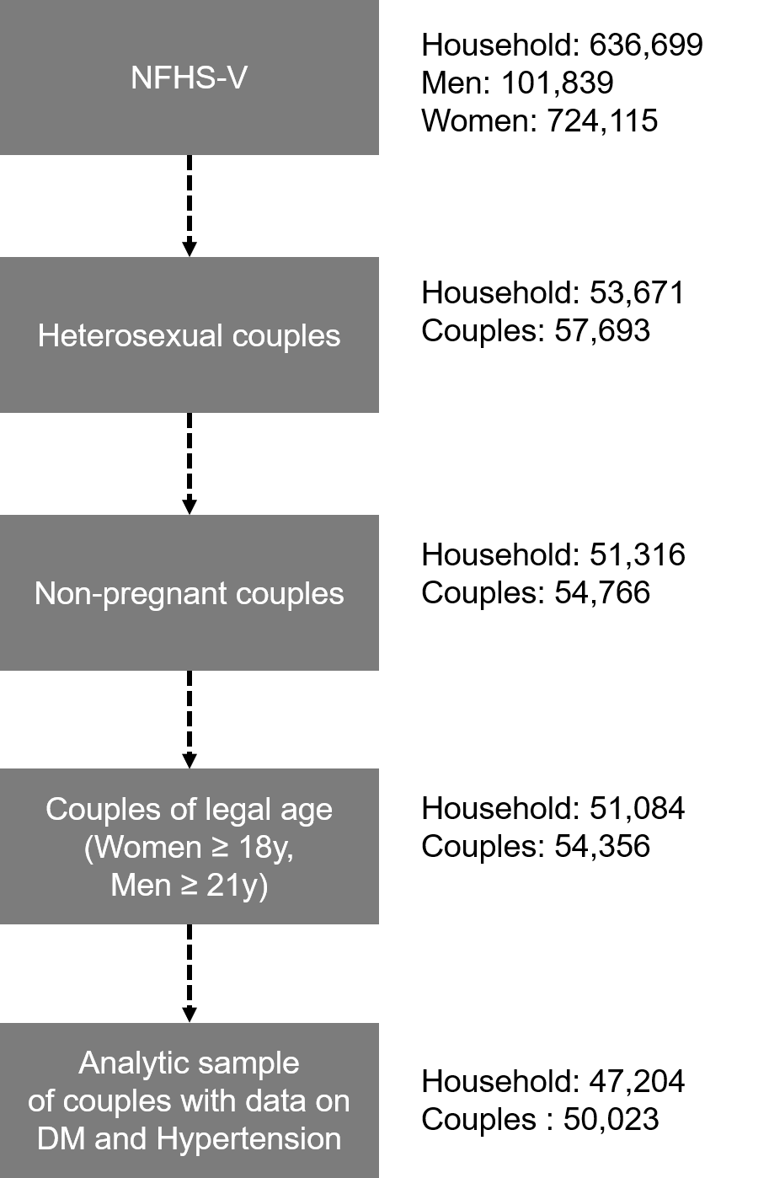

Supplementary Figure 2. Framework for analysis of spousal concordance
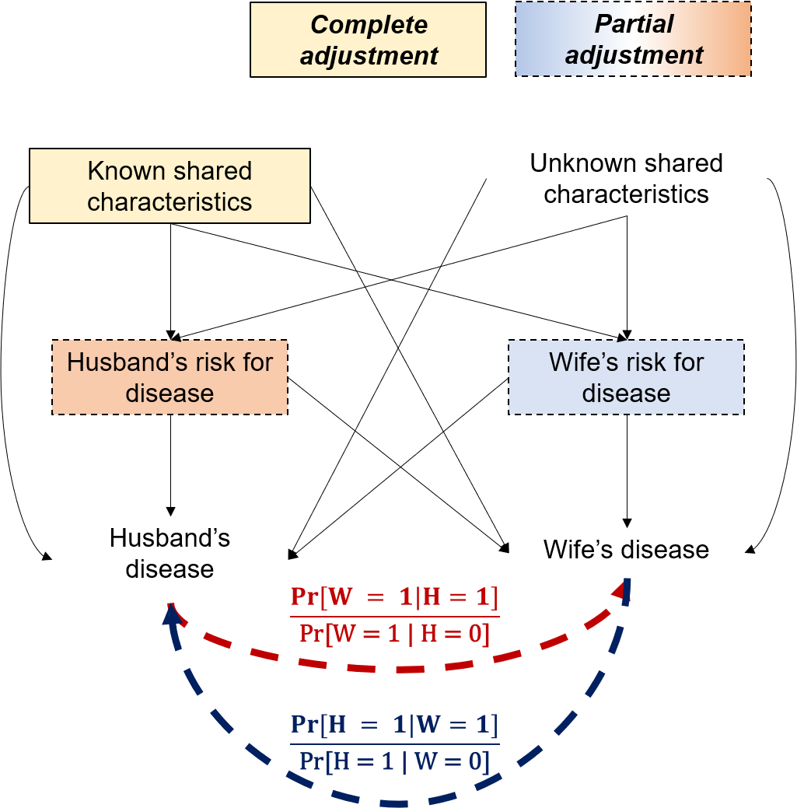

Unknown shared characteristics include shared genetics, shared environment before marriage (e.g. built environment, diet and physical activity) and shared environment after marriage that are confounders for the observed spousal concordance. This is in addition to other pathways such as marital satisfaction and physiological responses from relationship quality that could be from spouse’s disease. The association of husband’s disease status with wife’s disease status is shown in Red, and requires adjustment for wife’s individual characteristics and known shared characteristics. The association of wife’s disease status with husband’s disease status is shown in blue and requires adjustment for husband’s individual characteristics and known shared characteristics.

Supplementary Figure 3. State-level prevalence of hypertension burden among spousal pairs

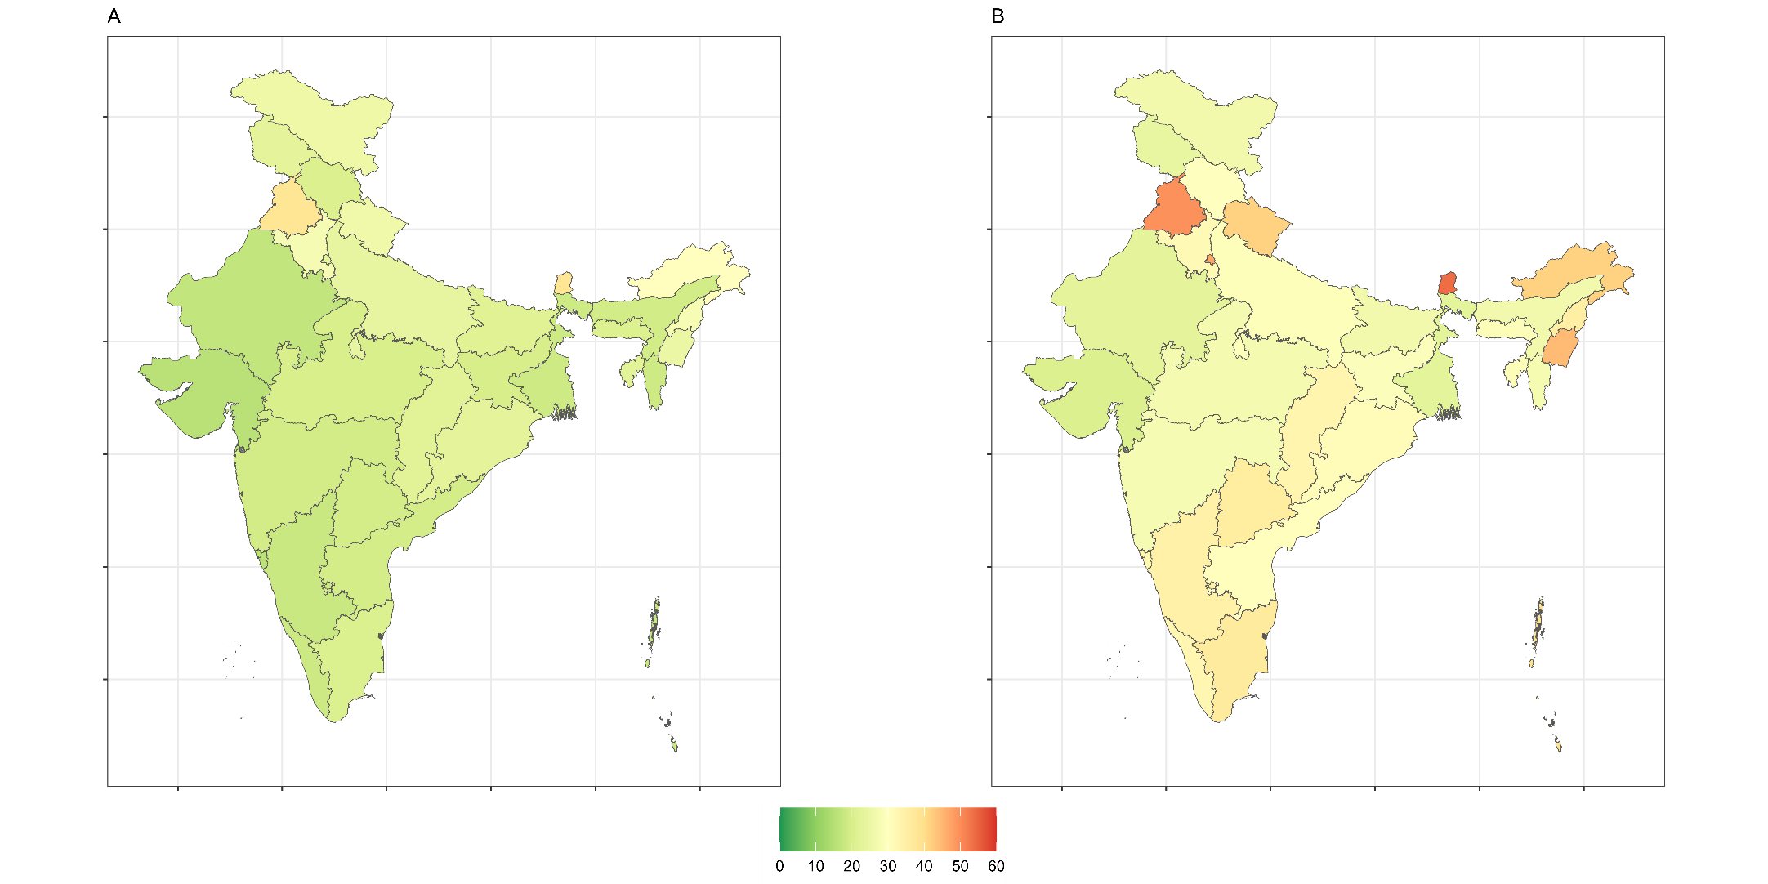

A: Wives hypertension, B: Husband’s hypertension

Supplementary Figure 4. Total and undiagnosed hypertension in married Indian adults by spouse’s hypertension status, n = 50,023
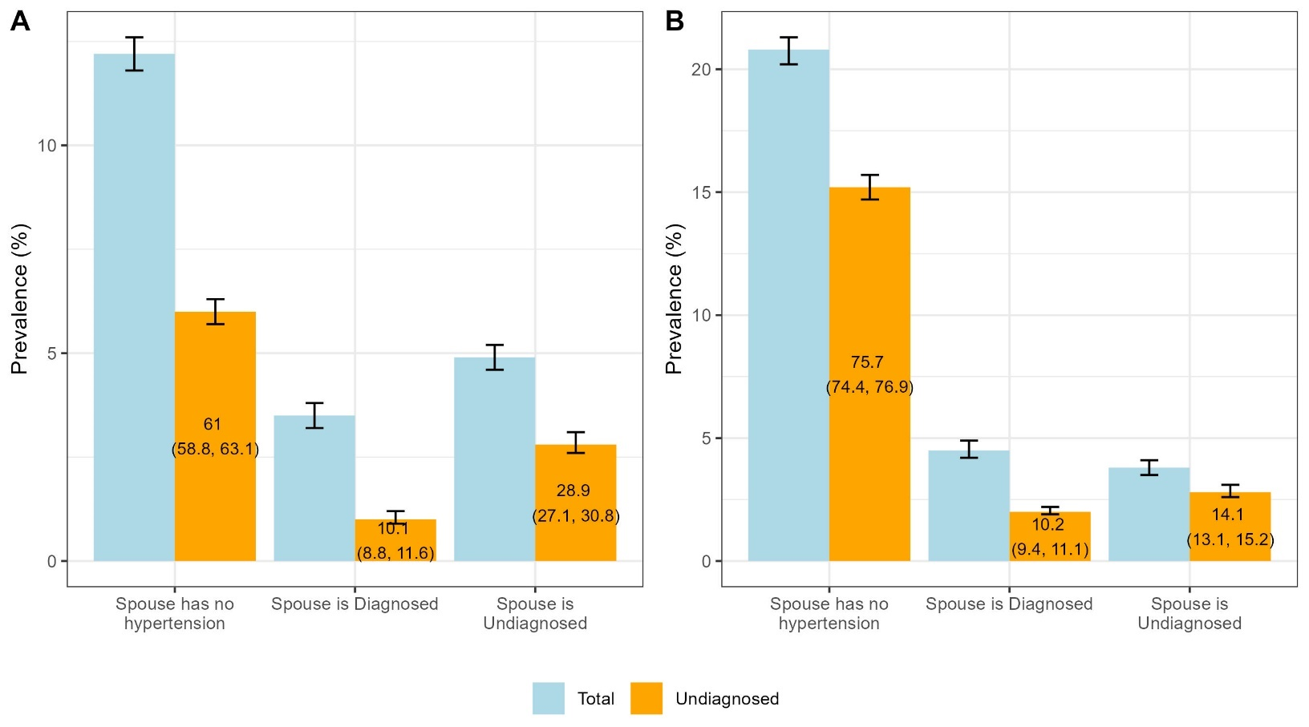
All estimates are proportions and 95% confidence intervals. Estimates in columns of undiagnosed diabetes are proportions attributed to hypertension status of their spouse, (A) among married women by husband’s hypertension diagnosis status and (B) Among married men by wife’s hypertension diagnosis status

