Supplementary Information for:
Divergent renal localization patterns of heterozygote-derived two distinct AA amyloids in a cat

Natsumi Kobayashi, Masahiro Kaneda, Susumu Iwaide, Yoshiyuki Ito, Miki Hisada, Yuka Kato, Niki Sedghi Masoud, Machie Tsuneyasu, Tomoko Akamine, Tomoaki Murakami*

*Correspondence: Tomoaki Murakami.
E-mail: mrkmt@cc.tuat.ac.jp

Table of contents:
Supplementary Methods
Supplementary Figures 1-3
Supplementary Table 1

Supplementary Methods

Cross-validation of the newly produced antibody
In this study, a new antibody was produced by immunizing peptides with the sequence DKYFHARGNYDAAQRGPGG, which corresponds to residues 32-50 of Felis catus mature SAA (UniProt accession: P19707). Although this region of SAA is highly conserved among animal species, residue 45 is known to be diverse. For example, the 45th amino acid residue of SAA in cow (UniProt accession: P35541), quail (UniProt accession: A0A8C2TJQ9), and flamingo (GenBank accession: KFQ80790.1) are glutamine, arginine, and lysine, respectively. Therefore, preliminary experiments were conducted to verify the cross-reactivity of the new antibodies to SAA with 45th residue other than glutamine.
Congo red staining and IHC with commercial anti-SAA antibody (PAA885Hu01, Cloud-Clone Corp.) and newly produced anti-SAA antibody were performed on amyloid deposits in cow (kidney), quail (cecum) and flamingo (kidney). The conditions for immunohistochemistry are the same as described in Materials and Methods in the text.
Amyloid deposits in bovine, quail, and flamingo were all positive for anti-Pan-SAA antibodies (Supplementary Fig. 3). On the other hand, only amyloid deposits of cattle with Q45 are positive for this antibody (Supplementary Fig. 3), indicating that this antibody specifically detects SAA with Q45. Therefore, this study refers to the commercial antibody as the anti-Pan-SAA antibody and the newly produced antibody as the anti-SAA^{Q45} antibody.
Supplementary Figures

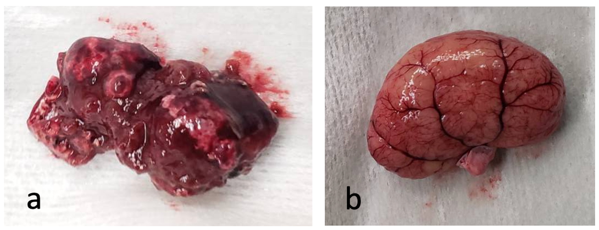

Supplementary Figure 1. Gross images of the liver and kidney at the necropsy. (a) Liver. The surface is irregular due to multifocal hemorrhage and necrosis. (b) Kidney. Fading is observed.

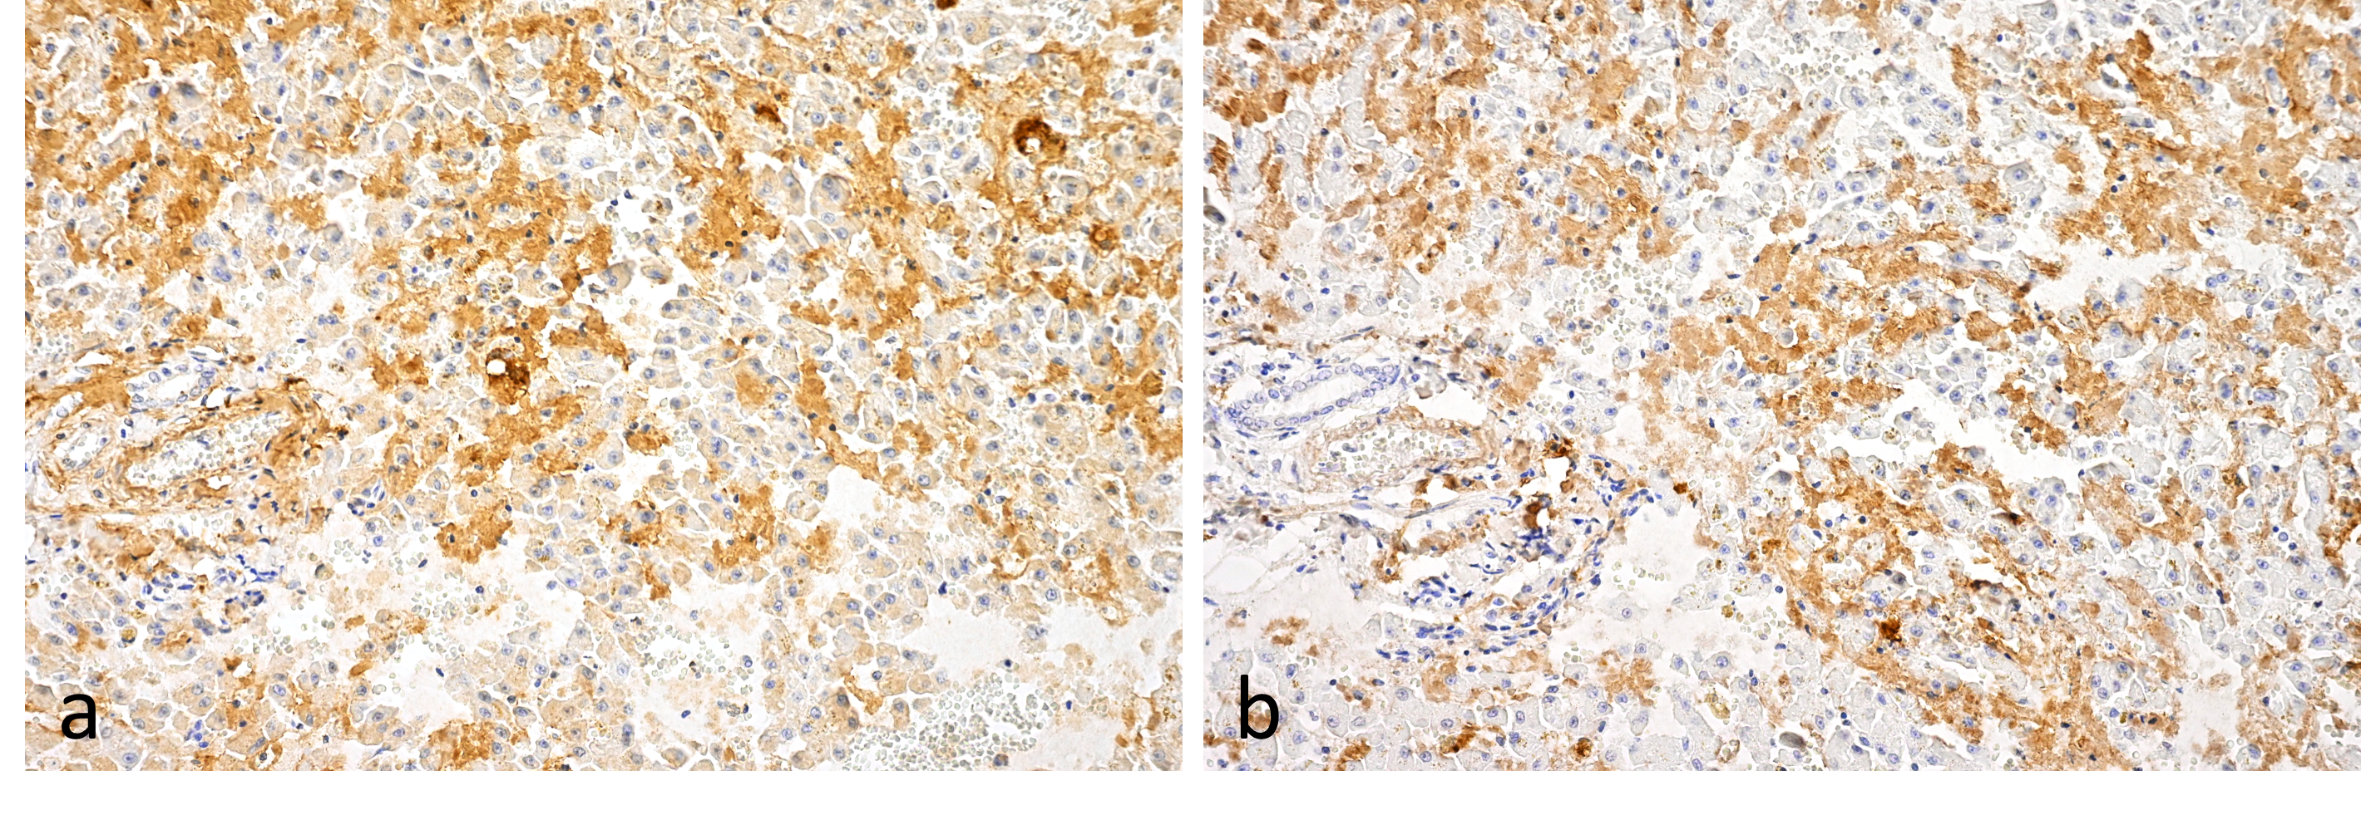

Supplementary Figure 2. Immunohistochemistry of hepatic amyloid deposits. Amyloid deposits were positive for both anti-Pan-SAA (a) and anti-SAA^{Q45} antibodies (b). There is no apparent difference in distribution between the two.

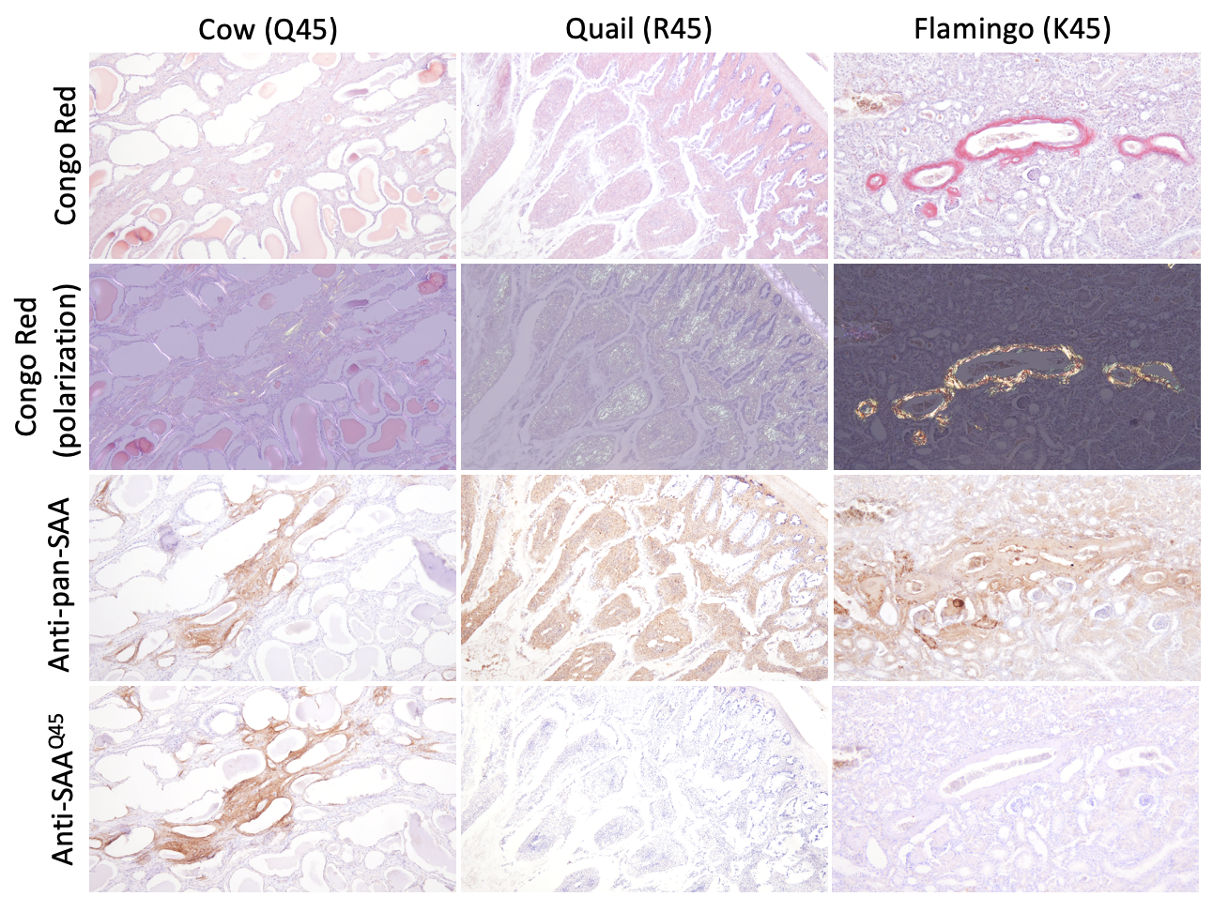

Supplementary Figure 3. Verification of cross-reactivity of newly produced anti-SAA antibodies.
Amyloid deposits are observed in the tubulointerstitium in a cow, in the lamina propria of the duodenum in a quail, and in the vessel wall in a flamingo. Pan-SAA antibodies react to amyloid deposits in all three species. In contrast, the newly produced antibody (anti-SAA^{Q45}) reacted only to bovine amyloid deposits.

Supplementary Table

Supplementary Table 1. Representative proteins detected by mass spectrometry of amyloid deposits in glomeruli, outer medulla, and papilla.
UniProt  accession |  | Glomeruli |  |  |  | Outer medulla |  |  |  | Papilla
UniProt  accession | Protein Description | 1 | 2 | 3 |  | 1 | 2 | 3 |  | 1 | 2 | 3
A0A337SKP2 | Serum amyloid A protein |  |  |  |  | 43 | 44 | 48 |  | 51 | 34 | 37
Q1T770 | Serum amyloid A protein | 24 | 12 | 8 |  | 40 |  |  |  | 51 | 32 | 33
A0A2I2U7Y0 | Albumin | 25 | 26 | 16 |  | 77 | 77 | 82 |  | 31 | 31 | 39
M3WPG6 | Apolipoprotein A1 | 1 | 3 | 4 |  | 16 | 16 | 9 |  | 1 | 3 | 4
A0A2I2UXL4 | Hemoglobin subunit beta-1 | 3 | 2 | 2 |  | 9 |  | 5 |  |  |  | 3
A0A1K0FUL4 | Hemoglobin subunit alpha | 3 |  | 1 |  | 5 | 8 | 5 |  | 3 | 6 | 2
A0A337S2X4 | Histone H2A | 1 | 2 | 3 |  | 3 | 5 | 5 |  | 2 | 1
A0A5F5XGD0 | Haptoglobin |  | 2 | 3 |  | 6 | 3 | 4 |  | 2 | 3 | 2
M3W2F5 | Collagen type I alpha 1 chain |  | 4 | 3 |  | 5 | 3 | 2 |  | 2 | 2 | 3
The proteins detected from over 6 of the 9 samples are listed. The numbers indicate the number of peptides detected by mass spectrometry.

