The impacts of cadmium exposure on epiphytic bacterial communities and water quality in constructed wetlands.
Deqiang Chen ª, Lydia Adarkwa Adjei ª, Abigail Mwin-nea Samwini ª, Felix Gyawu Addo ª, Wambley Adomako Baah ª, Robert Bofah-Buoh ª, Benjamin Manirakiza ^{b}*
ªKey Laboratory of Integrated Regulation and Resource Development on Shallow Lakes, Ministry of Education, College of Environment, Hohai University, Nanjing 210098, China
^{b} University of Rwanda (UR), College of Science and Technology (CST), Department of Biology, P.O. Box 3900, Kigali, Rwanda
Corresponding authors: Benjamin Manirakiza, Email: benjaminmanirakiza500@gmail.com
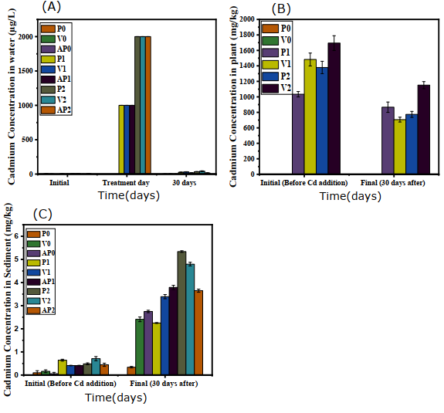
Fig. S1. Cd concentration in water (A), plants (B) and sediments (C).
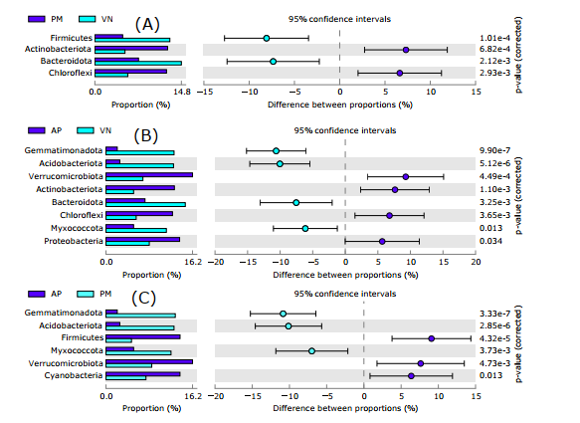
Fig. S2. The plots for the difference statistics among epiphytic bacterial phyla (A-C) based on Fischer’s exact test (p < 0.05).
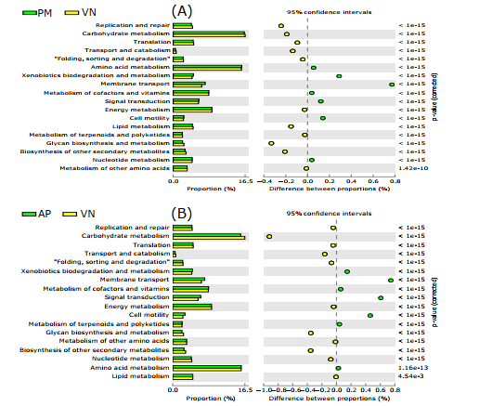
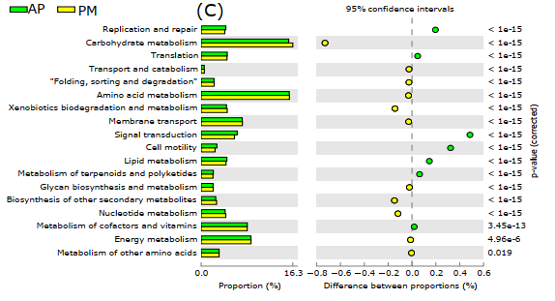

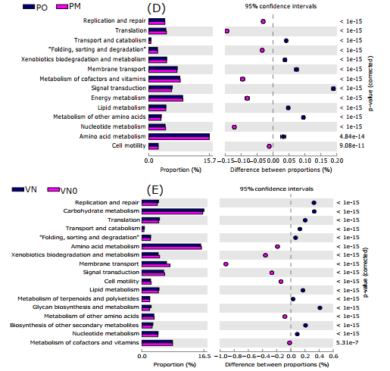
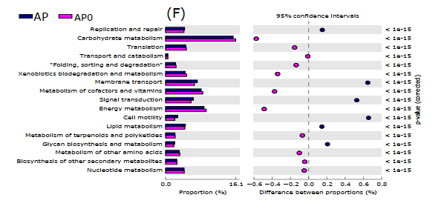
Fig. S3. Fisher’s exact test on the differences among the 18 dominant metabolic pathways (A-F, Level2 level) between control (PO, VN0, and AP0) and treatment (VN0.5, VN1, VN2, PM0.5, PM1, PM2, AP0.5, AP1, and AP2) groups. The result shows that Cd decreased metabolic pathways of bacterial communities in epiphytic biofilms.
Sample\Estimators | Shannon | Simpson | Ace | Chao | Coverage
AP1 | 3.275547 | 0.183849 | 510.6304 | 490.7895 | 0.996464
VN0 | 5.052706 | 0.017097 | 1169.208 | 1145.1 | 0.992221
AP2 | 2.456776 | 0.34003 | 518.6022 | 504.2727 | 0.996093
VN0.2 | 4.133628 | 0.059651 | 760.8518 | 766.7215 | 0.995218
AP0 | 4.012148 | 0.049223 | 693.6137 | 677.1282 | 0.994881
P0.5 | 3.556032 | 0.081283 | 627.7996 | 655.4677 | 0.995353
P1 | 4.945299 | 0.019941 | 1132.952 | 1153.181 | 0.992389
VN1 | 4.37705 | 0.041845 | 1009.667 | 1001.283 | 0.992288
AP0.5 | 4.265094 | 0.044126 | 680.395 | 685.6316 | 0.995656
P2 | 4.808971 | 0.022117 | 1073.912 | 1114.265 | 0.992389
PO | 4.802022 | 0.018992 | 1100.349 | 1103.224 | 0.991547
P2 | 4.187815 | 0.038752 | 804.7383 | 822.1507 | 0.99377
Table S1. Bacterial alpha diversity indices (p > 0.05)

Cadmium in water (µg/L) |  |  |  | Cadmium in plant (mg/kg) |  | Cadmium in sediment (mg/kg)
Sample | Before deterioration | Cadmium concentration after addition | After Deterioration | Before deterioration | After Deterioration | Before deterioration | After Deterioration
P1 | 4.488 | 1000 | 26.56 | 1034.297 | 866.8806 | 0.642501 | 2.25
P2 | 7.7255 | 2000 | 34.891 | 1379.351 | 774.2045 | 0.485469 | 5.34
VN1 | 2.008 | 1000 | 31.553 | 1482.594 | 706.4271 | 0.412061 | 3.39
VN2 | 0.674 | 2000 | 42.526 | 1694.735 | 1151.271 | 0.707825 | 4.795
AP1 | 7.795 | 1000 | 17.332 | 0 | 0 | 0.411249 | 3.79
AP2 | 5.833 | 2000 | 16.34 | 0 | 0 | 0.443566 | 3.65
P0 | 5.42 | 5.02 | 3.005 | 0.56 | 1.756385 | 0.099 | 0.34
VN0 | 2.32 | 1.97 | 3.208 | 0.61 | 1.964642 | 0.163 | 2.41
AP0 | 0.51 | 0.5 | 1.635 | 0 | 0 | 0.058 | 2.75
Table S2. Observed changes before and after leaf deterioration for 0mg/L Cd, 1mg/L Cd, and 2mg/L Cd
Table S3. Cadmium removal and accumulation rates in water, leaves, and sediments
Cadmium in water (µg/L) |  |  |  | Cadmium in plant (mg/kg) |  |  | Cadmium in sediment (mg/kg)
P1 | 1000 | 26.56 | 94.82544 | 1034.297 | 866.8806 | 8.093246 | 0.642501 | 2.25 | -55.5747
P2 | 2000 | 34.891 | 96.57073 | 1379.351 | 774.2045 | 21.93591 | 0.485469 | 5.34 | -83.3329
VN1 | 1000 | 31.553 | 93.88243 | 1482.594 | 706.4271 | 26.17598 | 0.412061 | 3.39 | -78.3243
VN2 | 2000 | 42.526 | 95.83594 | 1694.735 | 1151.271 | 16.03389 | 0.707825 | 4.795 | -74.2741
AP1 | 1000 | 17.332 | 96.59266 | 0 | 0 | 0 | 0.411249 | 3.79 | -80.4225
AP2 | 2000 | 16.34 | 98.37924 | 0 | 0 | 0 | 0.443566 | 3.65 | -78.3286
P0 | 5.02 | 3.005 | 25.10903 | 0.56 | 1.756385 | -106.82 | 0.099 | 0.34 | -54.8975
VN0 | 1.97 | 3.208 | -23.9088 | 0.61 | 1.964642 | -111.036 | 0.163 | 2.41 | -87.33
AP0 | 0.5 | 1.635 | -53.1616 | 0 | 0 | 0 | 0.058 | 2.75 | -95.8689

