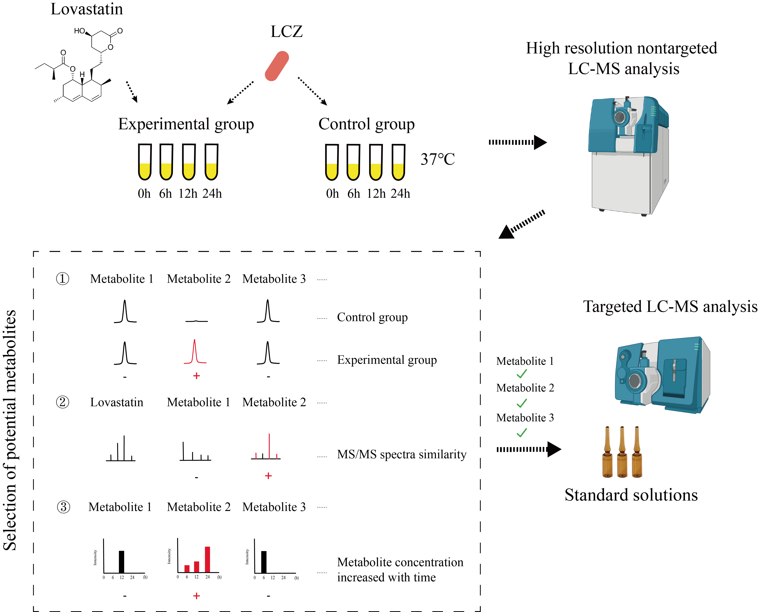

Fig. S1 Flow chart for identifying lovastatin metabolites produced in Lacticaseibacillus paracasei Zhang (LCZ) monoculture. Lovastatin was incubated in the presence or absence of LCZ, and the resultant culture supernatants were comparatively analyzed by non-targeted metabolomics by liquid chromatography-mass spectrometry (LC-MS). Metabolites of interest specific to LCZ cultivation and increased with incubation time were characterized and quantified by targeted metabolomics analysis.

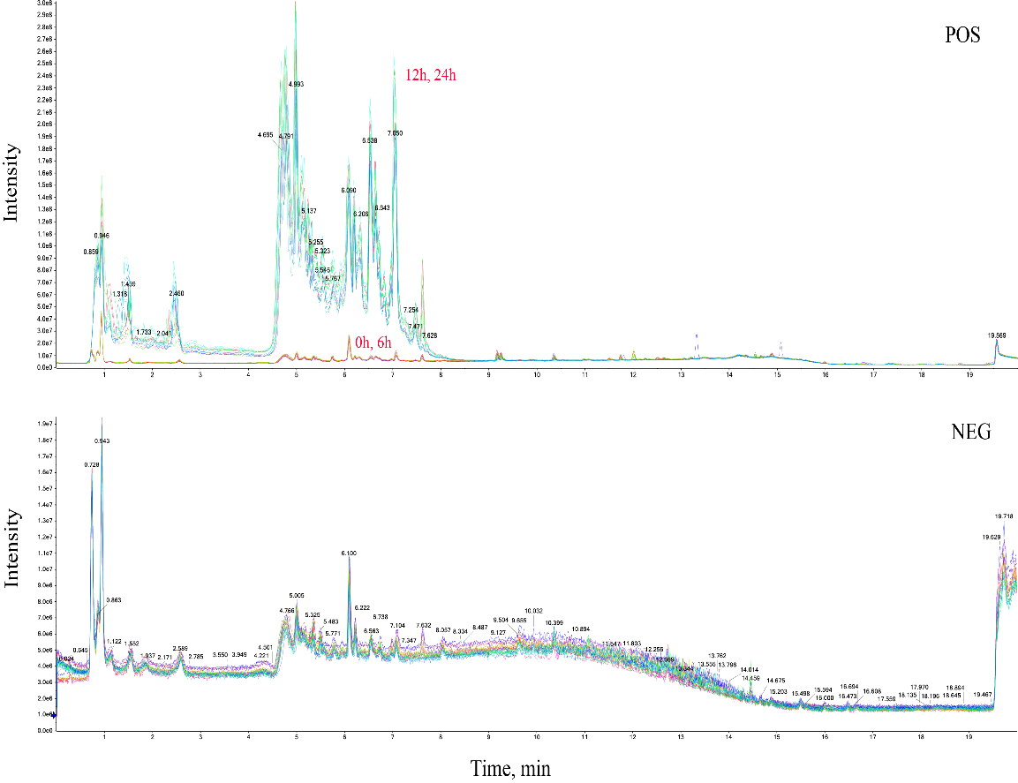

Fig. S2 Overlay total ion chromatograms of all samples run in the positive (upper panel) and negative (lower panel) ion modes.

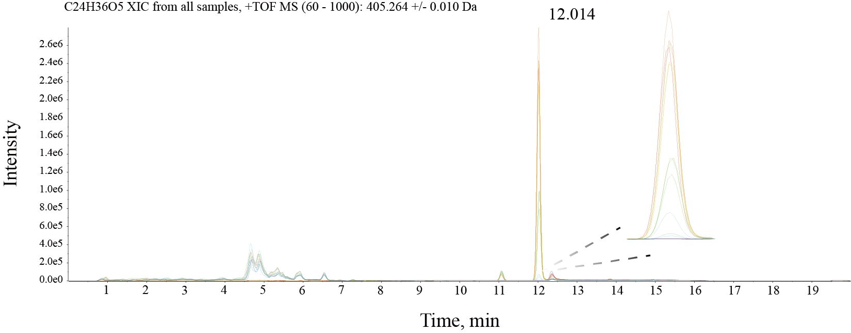

Fig. S3 Overlay of the extracted ion chromatograms (XICs) of all samples. The inset shows the peaks corresponding to lovastatin, which has a theoretical mass-to-charge ratio of 405.264 m/z and a retention time of 12.017 min.
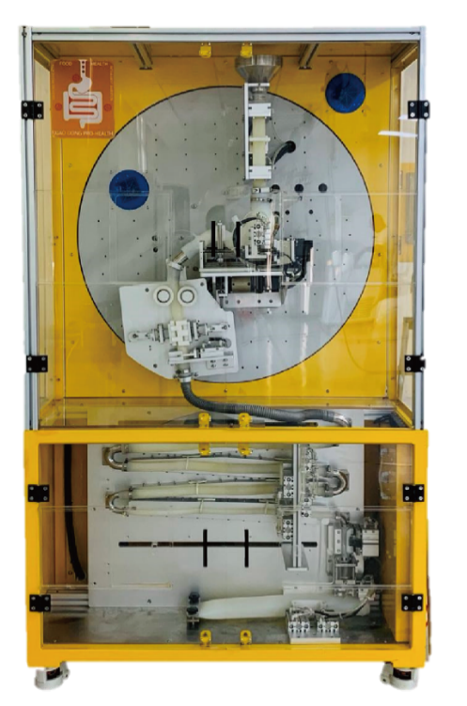

Fig. S4 The image of a near-real dynamic human stomach in vitro (DHS-IV) system.
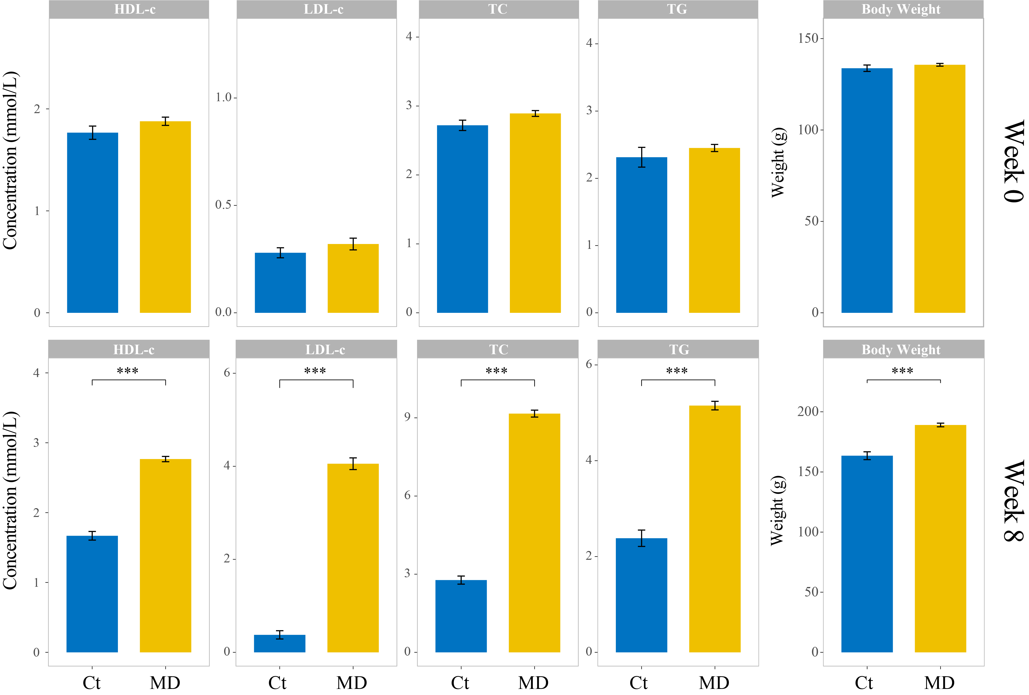

Fig. S5 Changes in body weight and serum lipid levels before and after induction of hyperlipidemia in Syrian golden hamsters. Ct represents the control group receiving a normal diet, while MD represents the model group receiving a high-fat diet. Error bars represent standard deviation. Statistically significant differences between groups were evaluated using the Wilcoxon test (***p < 0.001). HDL-c, high-density lipoprotein cholesterol; LDL-c, low-density lipoprotein cholesterol; TC, total cholesterol; and TG, triglycerides.
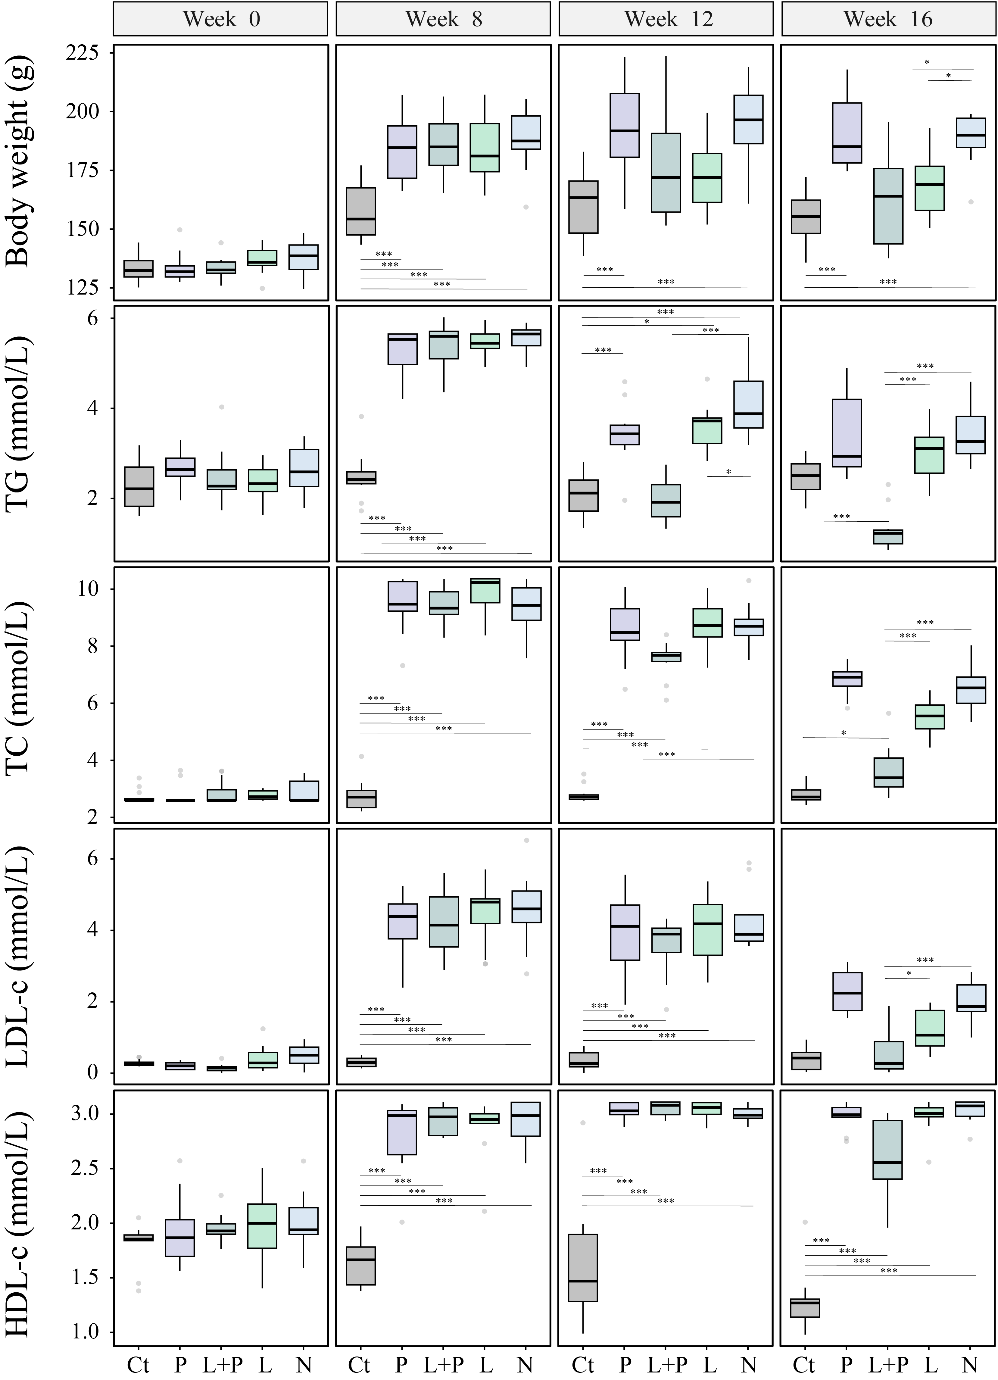

Fig. S6 Changes in body weight and serum lipid levels in different groups of Syrian golden hamsters during the intervention. Ct represents the control group that received standard chow throughout the trial, while P, L+P, L, and N represent the probiotic, low-dose lovastatin plus probiotic, low-dose lovastatin, and no treatment groups, respectively. Statistically significant differences between groups were evaluated using the Wilcoxon test (*p < 0.05; ***p < 0.001). TG, triglycerides; TC, total cholesterol; LDL-c, low-density lipoprotein cholesterol; HDL-c, high-density lipoprotein cholesterol.
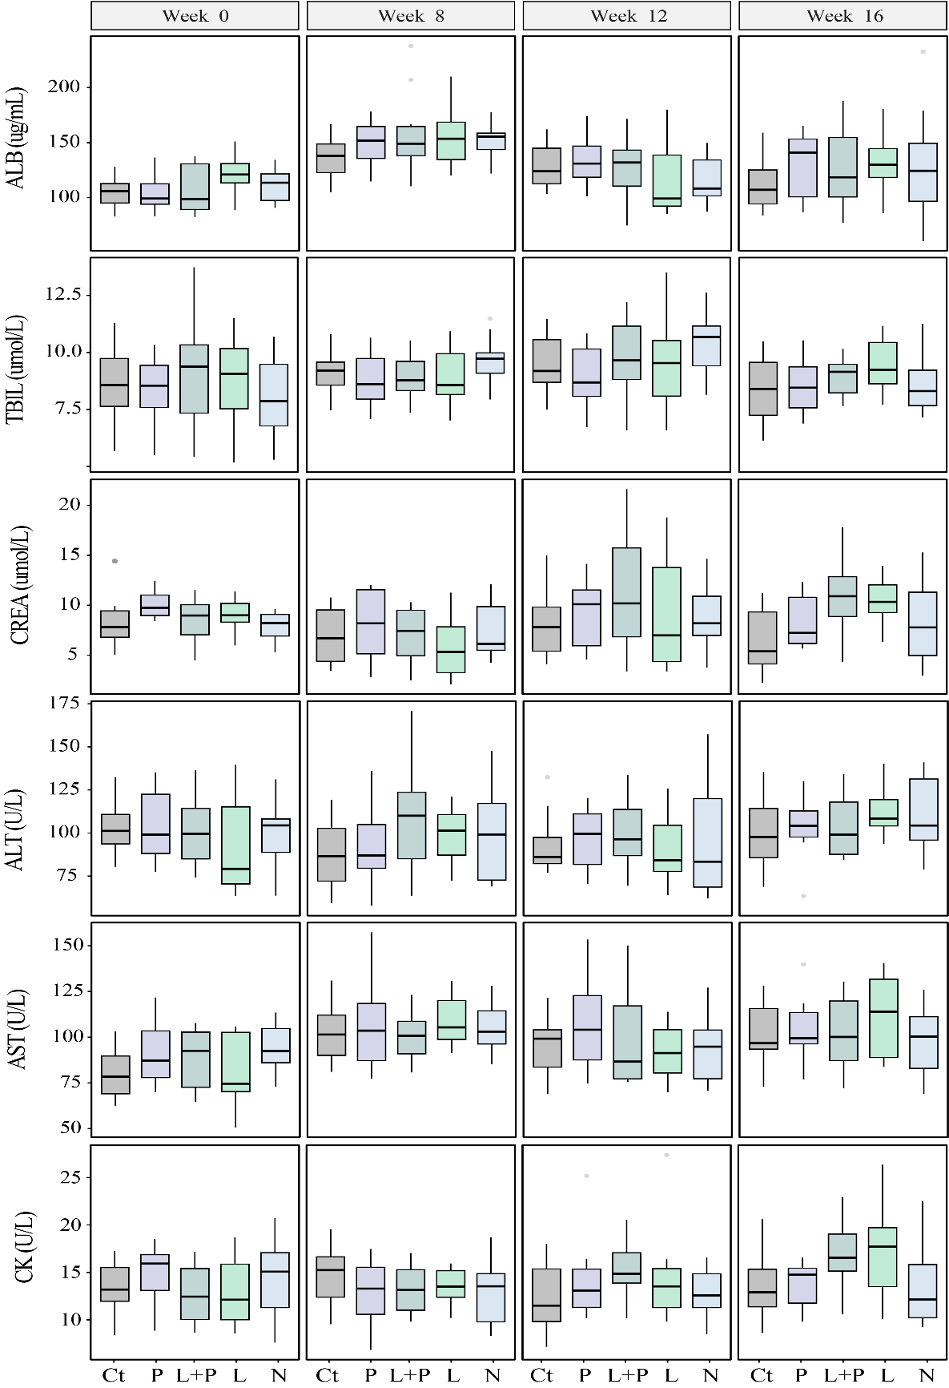

Fig. S7 Changes in serum levels of albumin (ALB), total bilirubin (TBIL), creatinine (CREA), alanine aminotransferase (ALT), aspartate aminotransferase (AST), and creatine kinase (CK) in different groups of Syrian golden hamsters during the intervention. Ct represents the control group that received standard chow throughout the trial, while P, L+P, L, and N represent the probiotic, low-dose lovastatin plus probiotic, low-dose lovastatin, and no treatment groups, respectively. No statistically significant differences were found between groups based on the Wilcoxon test.
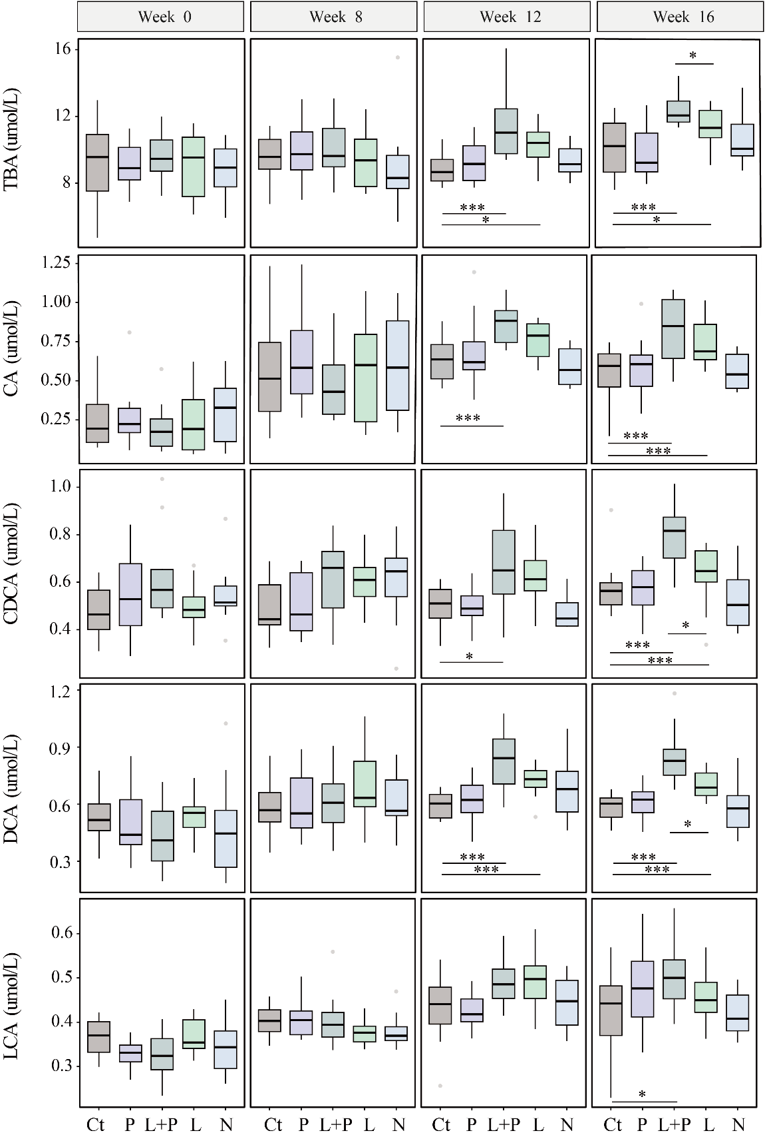

Fig. S8 Changes in serum levels of total bile acids (TBA), cholic acid (CA), chenodeoxycholic acid (CDCA), deoxycholic acid (DCA), and lithocholic acid (LCA) in different groups of Syrian golden hamsters during the intervention. Ct represents the control group that received standard chow throughout the trial, while P, L+P, L, and N represent the probiotic, low-dose lovastatin plus probiotic, low-dose lovastatin, and no treatment groups, respectively. Statistically significant differences between groups were evaluated using the Wilcoxon test (*p < 0.05; ***p < 0.001).
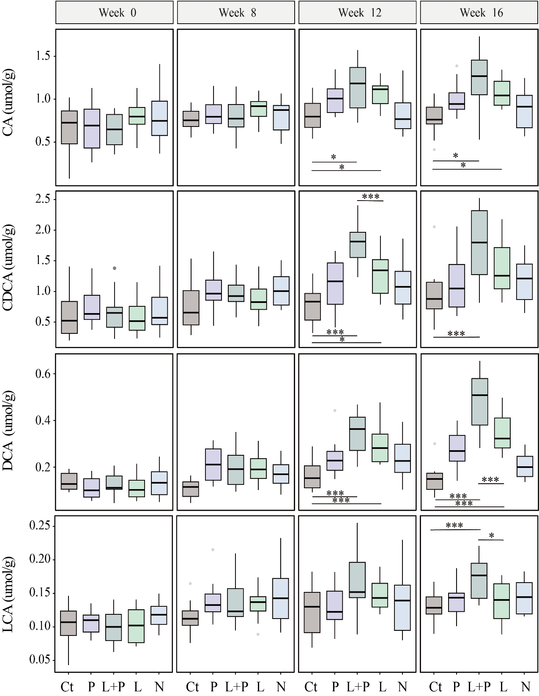

Fig. S9 Changes in fecal levels of cholic acid (CA), chenodeoxycholic acid (CDCA), deoxycholic acid (DCA), and lithocholic acid (LCA) in different groups of Syrian golden hamsters during the intervention. Ct represents the control group that received standard chow throughout the trial, while P, L+P, L, and N represent the probiotic, low-dose lovastatin plus probiotic, low-dose lovastatin, and no treatment groups, respectively. Statistically significant differences between groups were evaluated using the Wilcoxon test (*p < 0.05; ***p < 0.001).

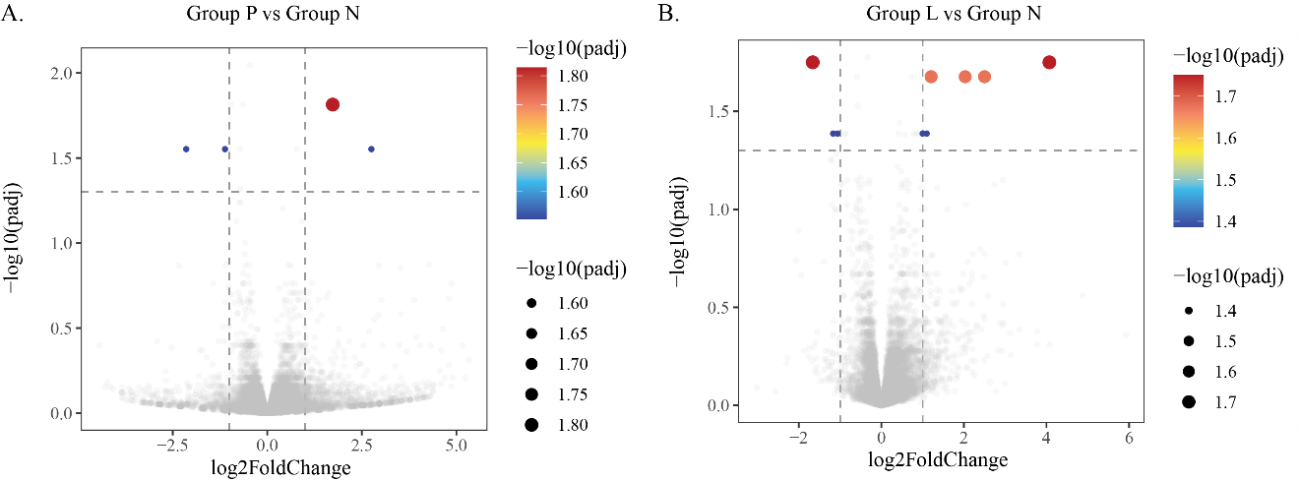

Fig. S10 Volcano plots showing significant differentially expressed genes (DEGs) between (A) the probiotic (P) and no treatment (N) groups; B) the low-dose lovastatin (L) and N groups. The color scales and the dot size represent the level of -log₁₀ (adjusted p-value). Significant DEGs (cut-off level = adjusted p < 0.05, log₂ [fold change] > 1 or < −1) are represented by red or blue dots, while genes showing no significant difference are represented by gray dots.

Fig. S11 Gene set enrichment plots of differentially expressed genes related to different metabolic processes and functions.

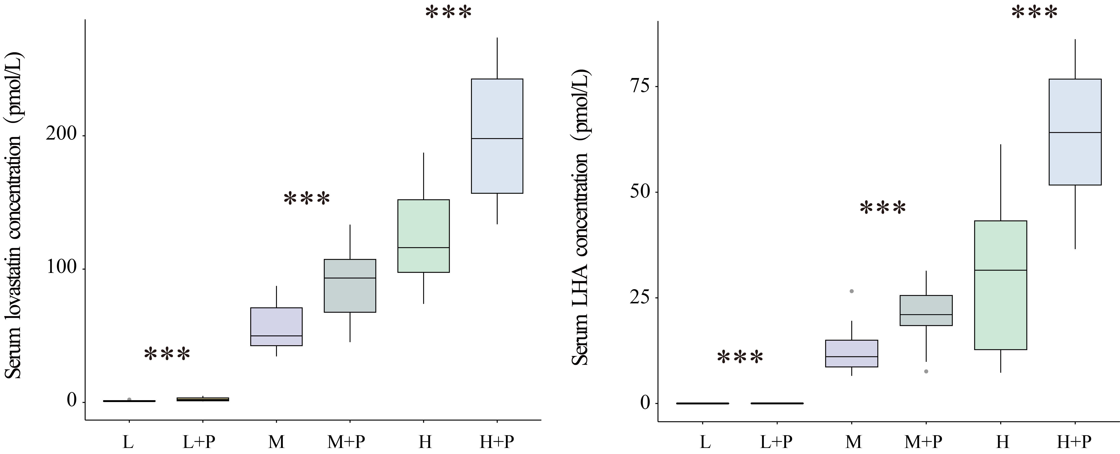

Fig. S12 Effects of co-administration of Lacticaseibacillus paracasei Zhang (LCZ) on serum lovastatin and lovastatin hydroxy acid (LHA) levels in different groups of golden hamsters. L, M, and H represent low, medium, and high doses, respectively. P represents probiotics. Statistically significant differences between groups were evaluated using the Wilcoxon test (*p < 0.05; ***p < 0.001).
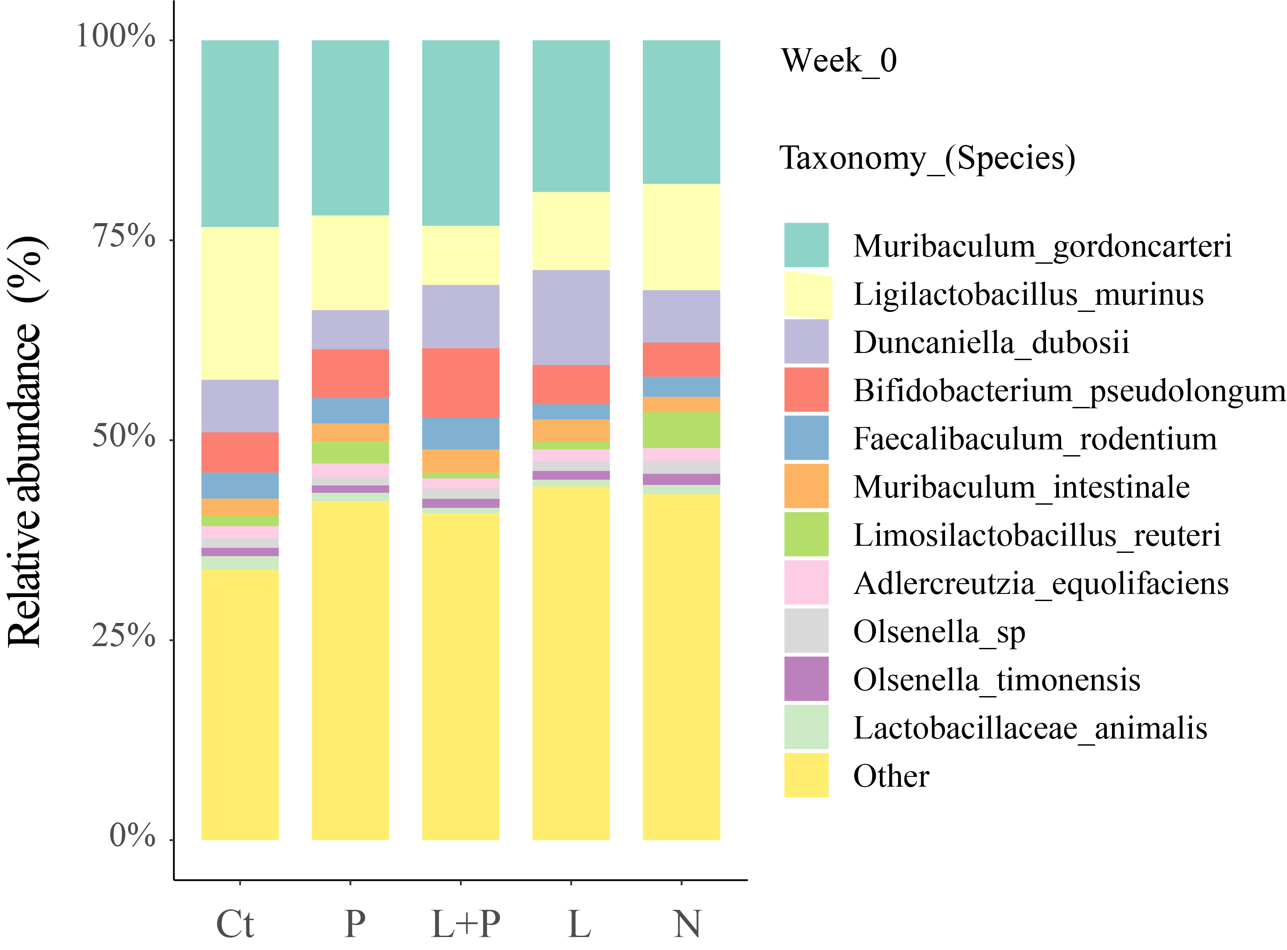

Fig. S13 Species-level fecal microbiota composition of golden hamsters at baseline (week 0). “Other” represents taxa that were below 1% of total sequences. Ct represents the control group that received standard chow throughout the trial, while P, L+P, L, and N represent the probiotic, low-dose lovastatin plus probiotic, low-dose lovastatin, and no treatment groups, respectively.

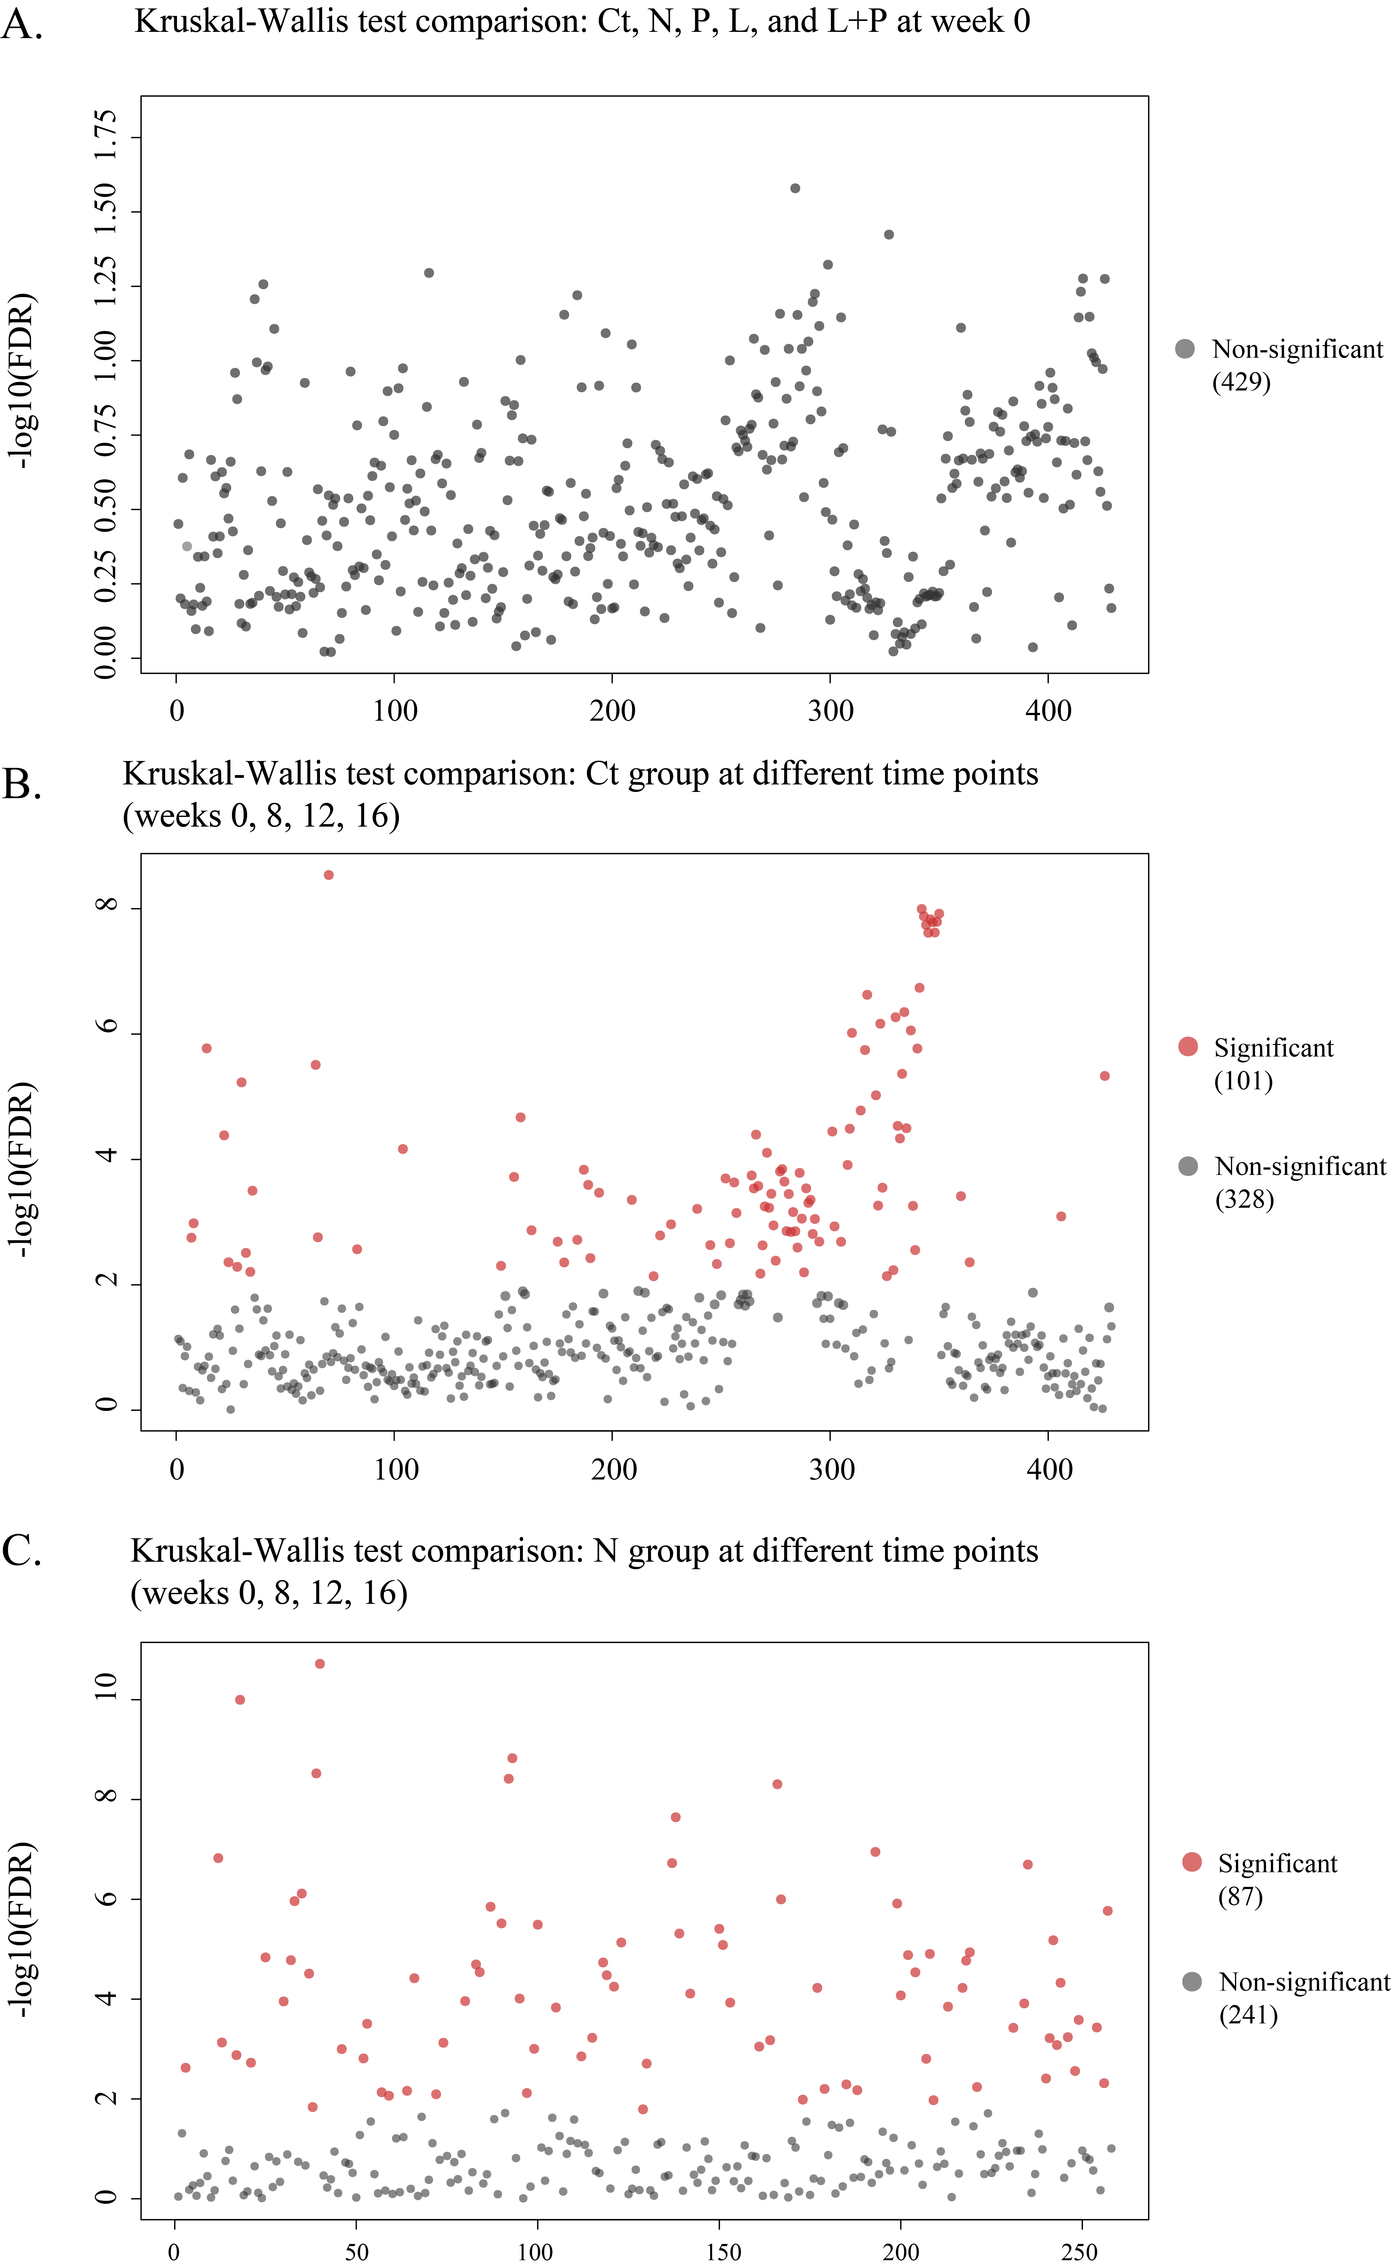

Fig. S14 Exclusion of age- and diet-related natural variation in the fecal microbiota of Syrian golden hamsters. Dot plots show the results of Kruskal-Wallis tests to identify significant differences between or within groups (Ct, control group that received standard chow throughout the trial; N, no treatment group; P, probiotic group; L, low-dose lovastatin group; and L+P, low-dose lovastatin plus probiotic). Each dot represents a bacterial species; red and gray dots represent species showing statistically significant and non-significant changes in the comparison. Comparison was made among (A) Ct, N, P, L, L+P groups at week 0 to confirm no intergroup variation at baseline; (B) different time points (weeks 0, 8, 12, and 16) in the Ct group; (C) different time points (weeks 0, 8, 12, 16) in the N group.

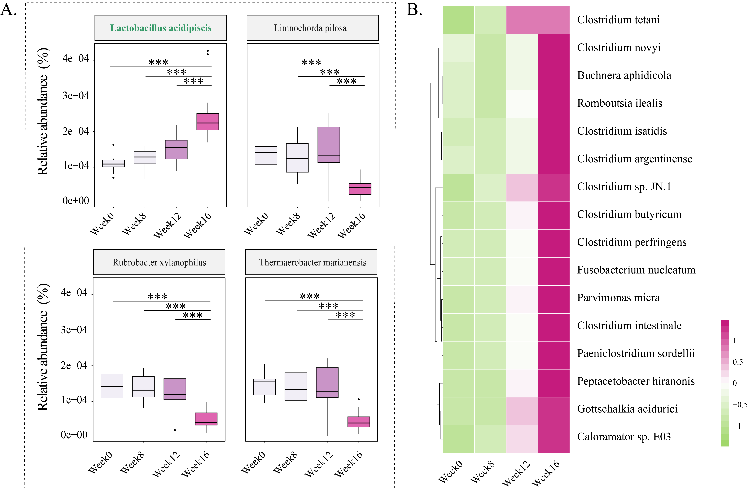

Fig. S15 Variation in the relative abundance of significantly changed fecal bacteria species in A) the probiotic (P) group; and B) the low-dose lovastatin (L) group during the intervention. Statistically significant differences between time points were evaluated by the Wilcoxon test (***p < 0.001). The color scale represents the relative abundance, ranging from high abundance (crimson) to low abundance (light green).

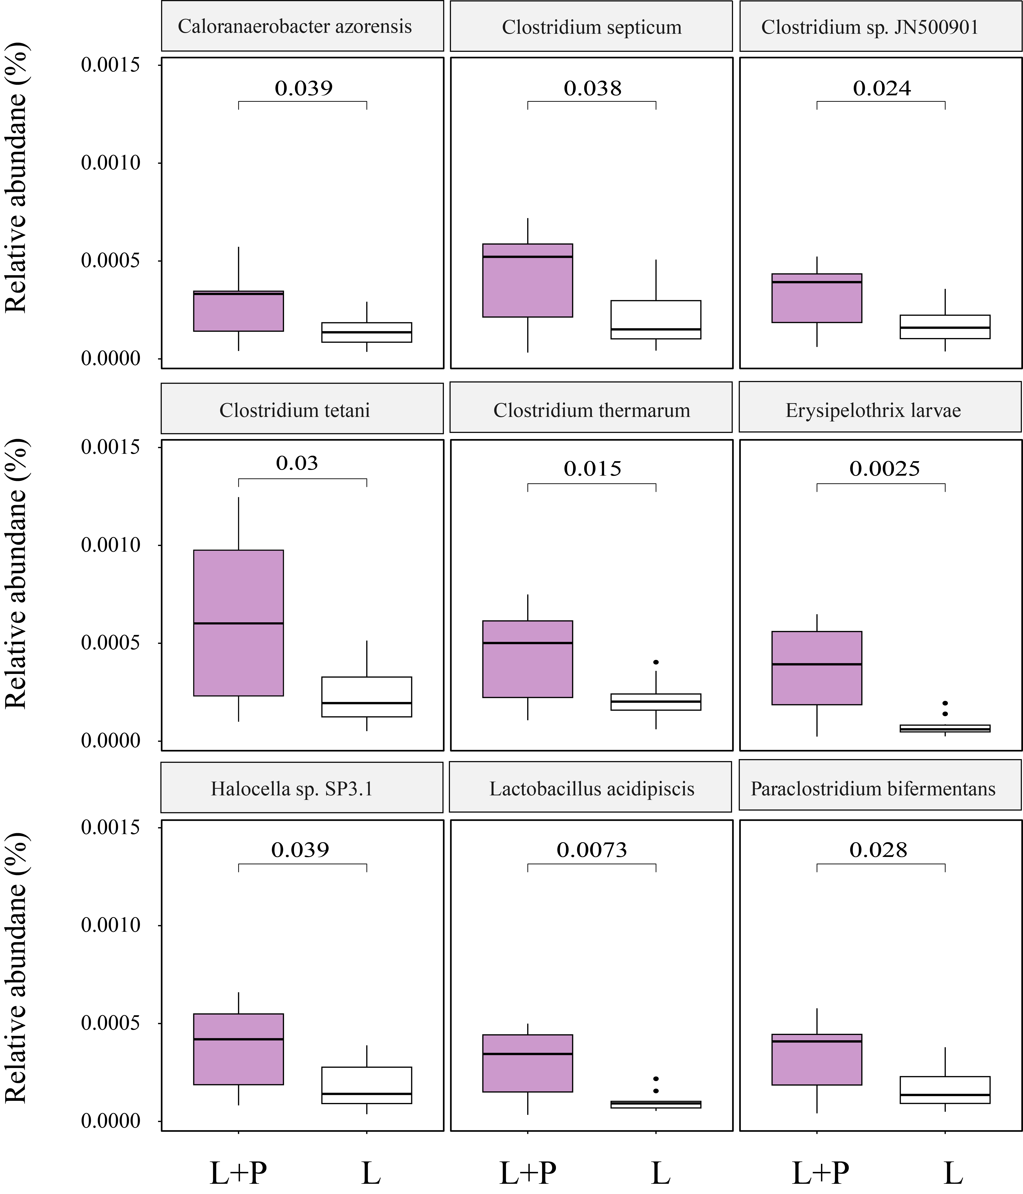

Fig. S16 Comparison of the relative abundance of significantly changed bacterial species between the low-dose lovastatin plus probiotic (L+P) and low-dose lovastatin (L) groups. Statistically significant differences between groups were evaluated by the Wilcoxon test, and the resulting p-values are shown.

Fig. S17 The number of significantly changed metabolites. A) Results of the Kruskal-Wallis test on gut metabolites intensity across all groups at week 0. B) results of the Kruskal-Wallis test on gut metabolites intensity at different time points (week 0, week 8, week 12, week 16) in the control (Ct) group. C) results of the Kruskal-Wallis test on gut metabolites intensity at different time points (week 0, week 8, week 12, week 16) in the model (N) group. Each point represents a metabolite; red dots indicate metabolites with statistically significant changes, while gray dots represent metabolites with non-significant changes.

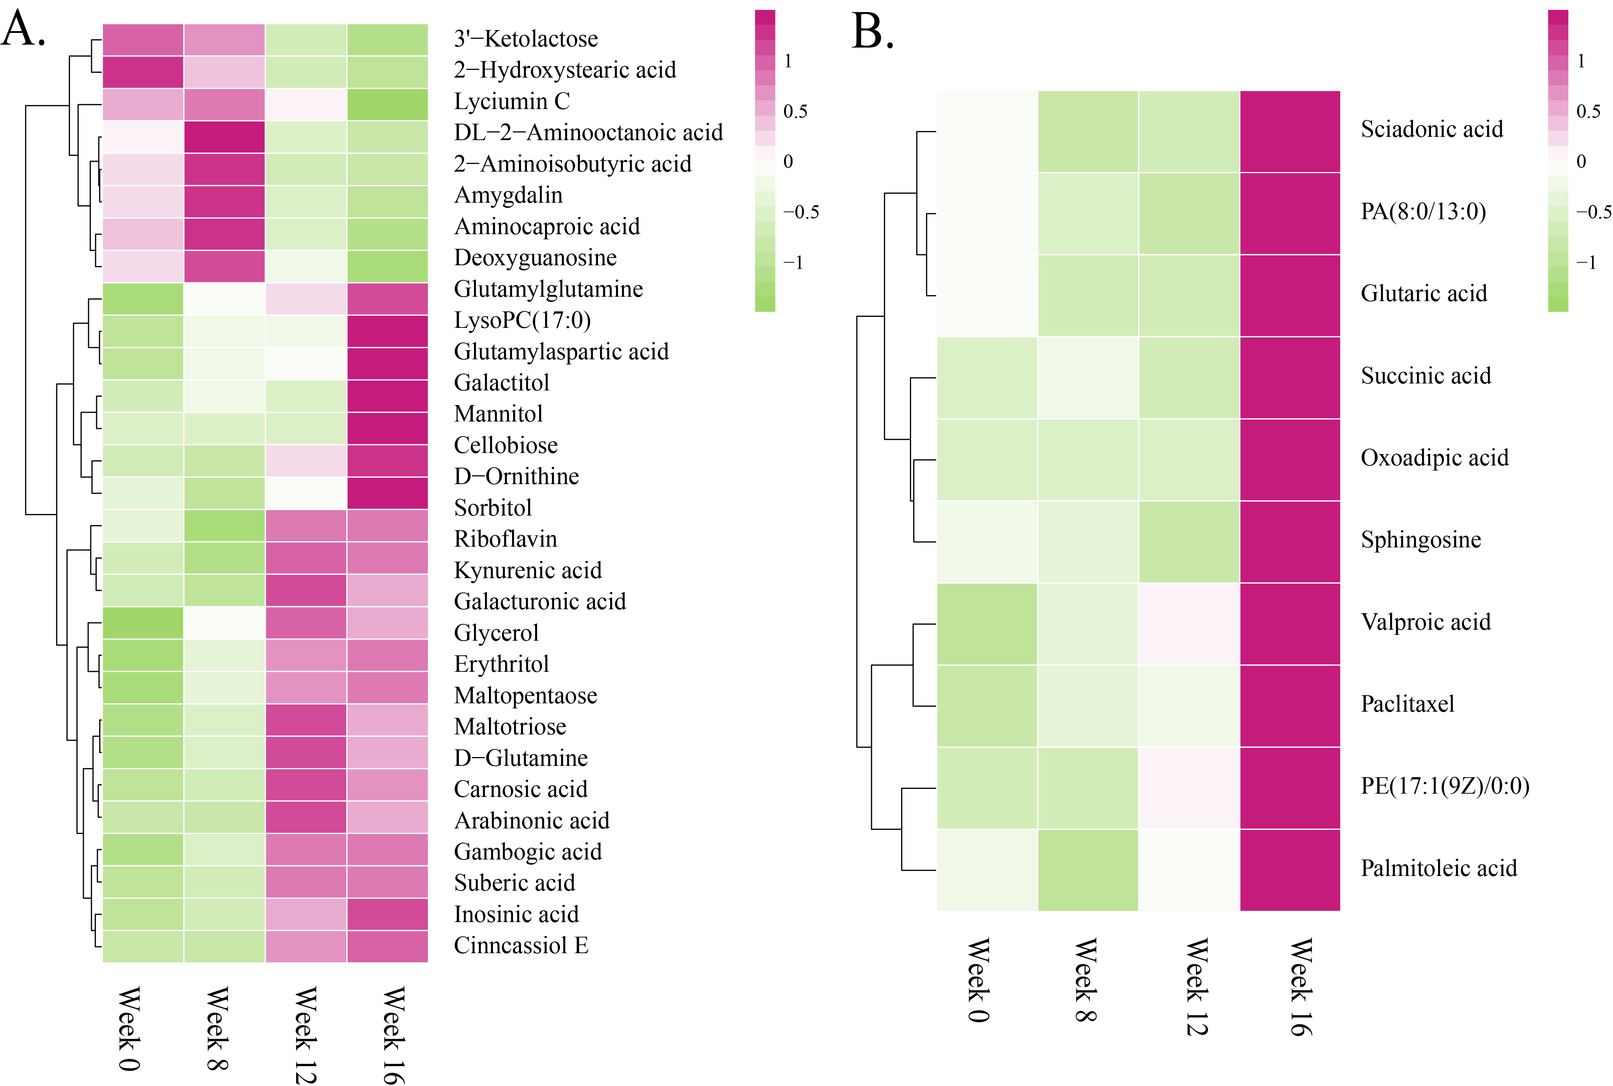

Fig. S18 Heatmaps showing variations in the relative abundance of significantly changed fecal metabolites in A) the low-dose lovastatin (L) group; and B) the probiotic (P) group throughout the intervention. The color scales represent the relative abundance, ranging from high abundance (crimson) to low abundance (light green).

Fig. S19 Comparison of the abundance of significantly different metabolites between the low-dose lovastatin plus probiotic (L+P) and low-dose lovastatin (L) groups. Signal intensity was measured in counts per second (cps). Statistically significant differences between groups were evaluated by the Wilcoxon test, and the resulting p-values are shown.

