Supplementary Information
Species composition but not interspecific facilitation enhances zinc and selenium uptake in multispecies grasslands
Authors: Omotola Obasoro^{1,2}, Jane Shackleton^{2,3}, Cornelia Grace², Jean Kennedy², Ron de Goede¹, *Ellis Hoffland¹
Affiliations: 1. Soil Biology Group, Wageningen University and Research, the Netherlands
2. Global Innovation Centre, Devenish Research Development and Innovation, Ireland
3. School of Agriculture and Food Science, University College Dublin, Ireland

*Corresponding author: Soil Biology Group, Wageningen University and Research, the Netherlands.
E-mail address: ellis.hoffland@wur.nl

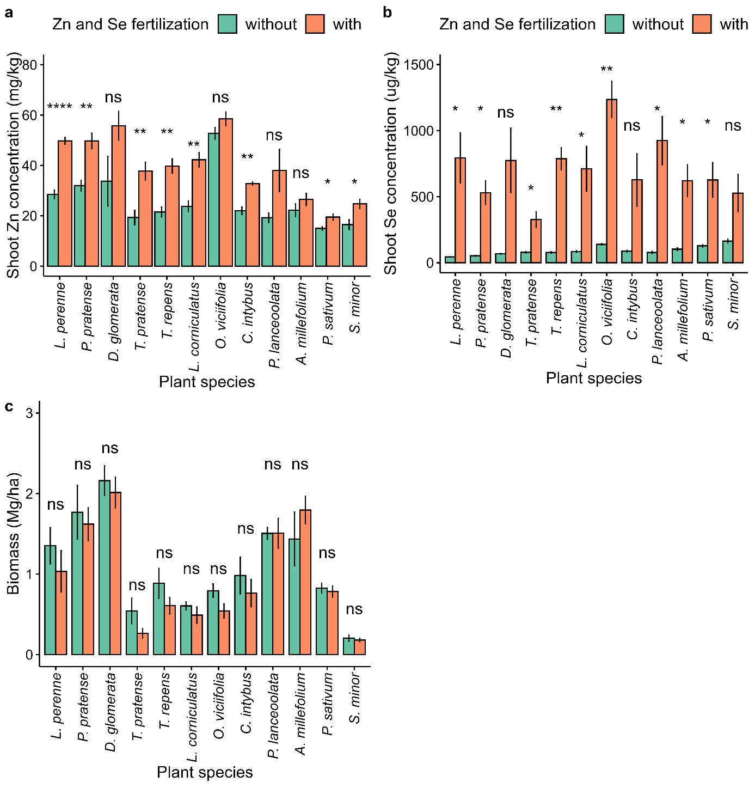
Fig. S1 Effect of Zn and Se fertilization on a) Zn concentration, b) Se concentration and c) aboveground biomass in all the monocultures in the greenhouse experiment. Error bars represent SEM (n = 4). Asterisks indicate the significant difference between plant species with or without Zn and Se fertilizer, P < 0.001 ***, P < 0.01 **, P < 0.05*, ns = not significant.

Table S1 Sowing proportions of each species in the mixtures in the greenhouse experiment.
 | 2-species mixture |  |  |  |  |  |  | 3-species mixture |  |  |  |  | 6-species mixture |  |  |  |  | 12-species
 | 2S1 | 2S2 | 2S3 | 2S4 | 2S5 | 2S6 |  | 3S1 | 3S2 |  |  | 6S1 |  | 6S2 |  |  | All
L. perenne | 0.5 |  | 0.5 |  |  |  |  | 0.4 |  |  |  | 0.20 |  |  |  |  | 0.133
P. pratense |  | 0.5 |  | 0.5 |  |  |  |  | 0.4 |  |  | 0.20 |  |  |  |  | 0.133
D. glomerata |  |  |  |  |  |  |  |  |  |  |  |  |  | 0.40 |  |  | 0.133
T. repens | 0.5 |  |  |  |  | 0.5 |  | 0.3 |  |  |  | 0.15 |  |  |  |  | 0.075
T. pratense |  | 0.5 |  |  | 0.5 |  |  |  | 0.3 |  |  | 0.15 |  |  |  |  | 0.075
L. corniculatus |  |  |  |  |  |  |  |  |  |  |  |  |  | 0.15 |  |  | 0.075
O. viciifolia |  |  |  |  |  |  |  |  |  |  |  |  |  | 0.15 |  |  | 0.075
C. intybus |  |  |  | 0.5 |  | 0.5 |  |  | 0.3 |  |  | 0.15 |  |  |  |  | 0.060
P. lanceolata |  |  | 0.5 |  | 0.5 |  |  | 0.3 |  |  |  | 0.15 |  |  |  |  | 0.060
A. millefolium |  |  |  |  |  |  |  |  |  |  |  |  |  | 0.10 |  |  | 0.060
P. sativum |  |  |  |  |  |  |  |  |  |  |  |  |  | 0.10 |  |  | 0.060
S. minor |  |  |  |  |  |  |  |  |  |  |  |  |  | 0.10 |  |  | 0.060

Table S2 Sowing proportions of each species in the swards in the field experiment.
 | Perennial ryegrass sward | 6-species sward | 12-species sward
L. perenne | 1 | 0.20 | 0.133
P. pratense | 0 | 0.20 | 0.133
D. glomerata | 0 | 0.00 | 0.133
T. repens | 0 | 0.15 | 0.075
T. pratense | 0 | 0.15 | 0.075
L. corniculatus | 0 | 0.00 | 0.075
O. viciifolia | 0 | 0.00 | 0.075
C. intybus | 0 | 0.15 | 0.060
P. lanceolata | 0 | 0.15 | 0.060
A. millefolium | 0 | 0.00 | 0.060
P. sativum | 0 | 0.00 | 0.060
S. minor | 0 | 0.00 | 0.060

