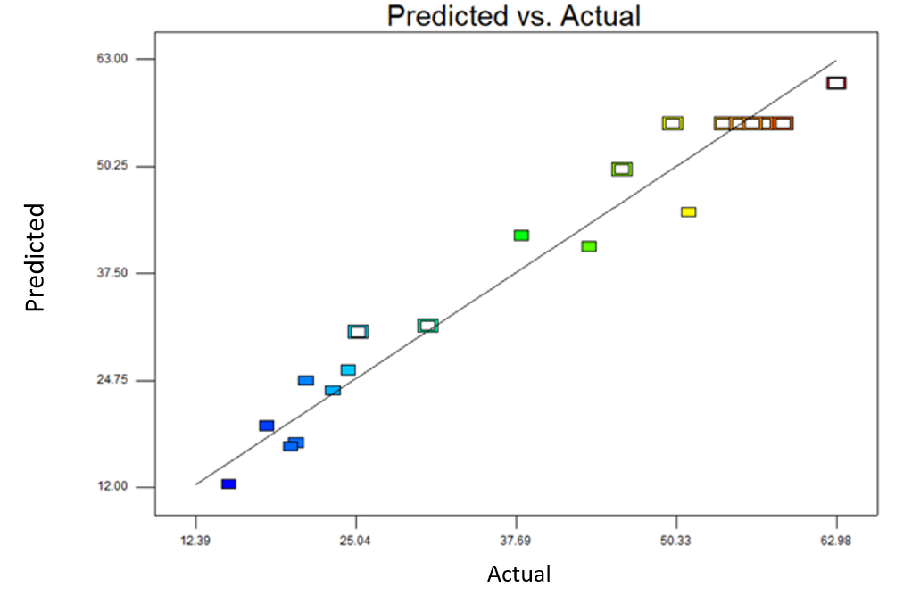
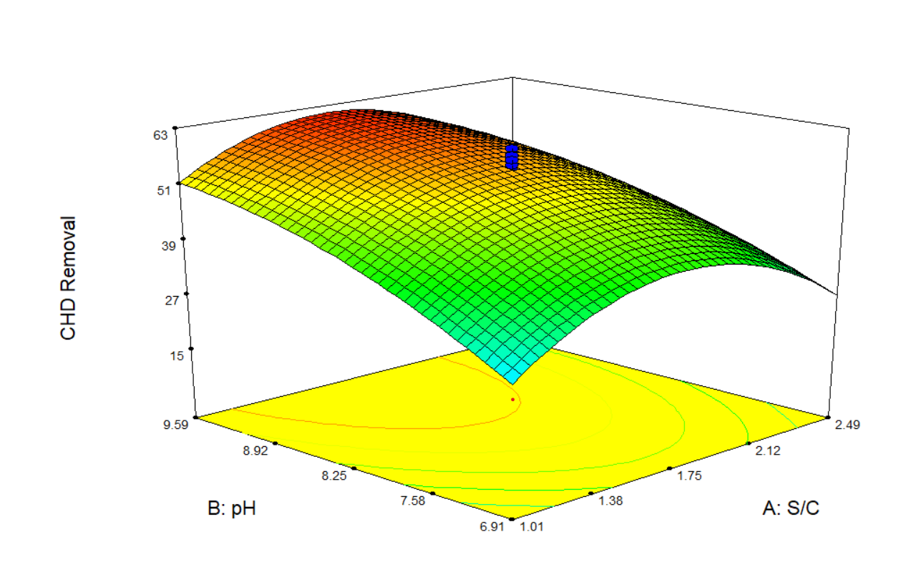
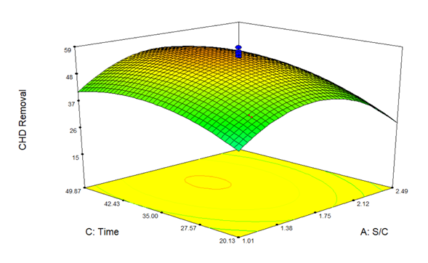
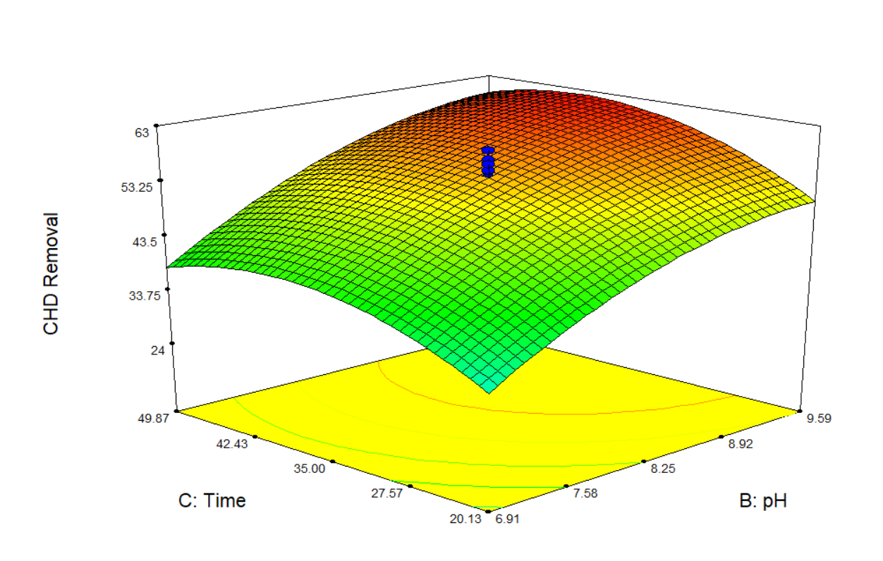
a
b
c
d

Fig S1 (A): Graphical representation of interaction among all the variable and predicted versus actual graph (GO).

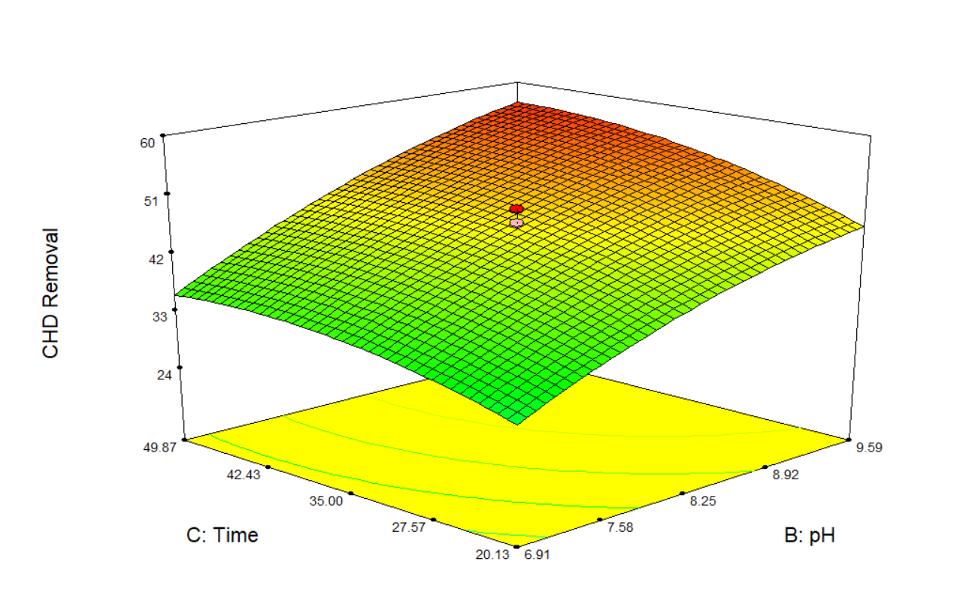
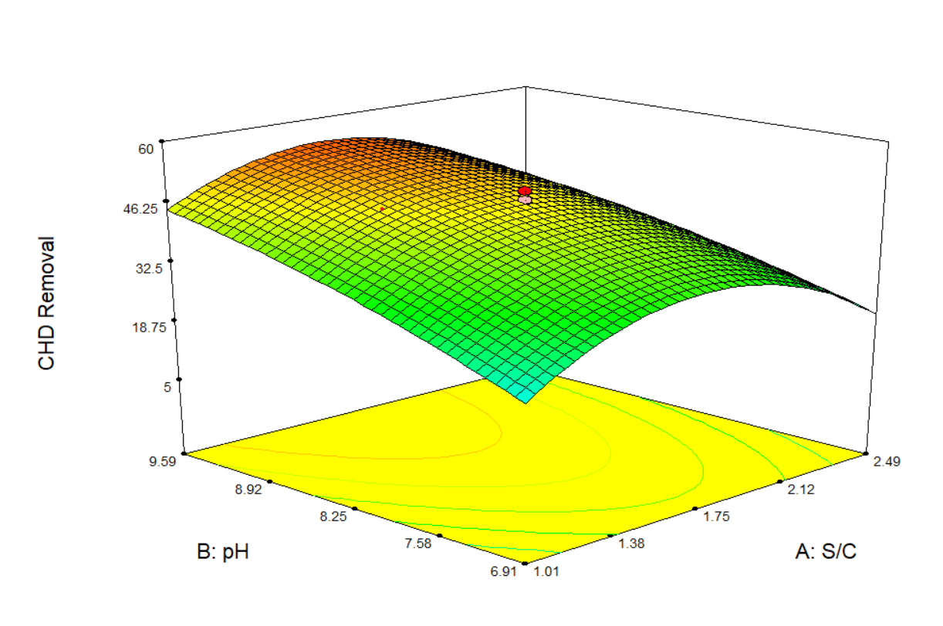
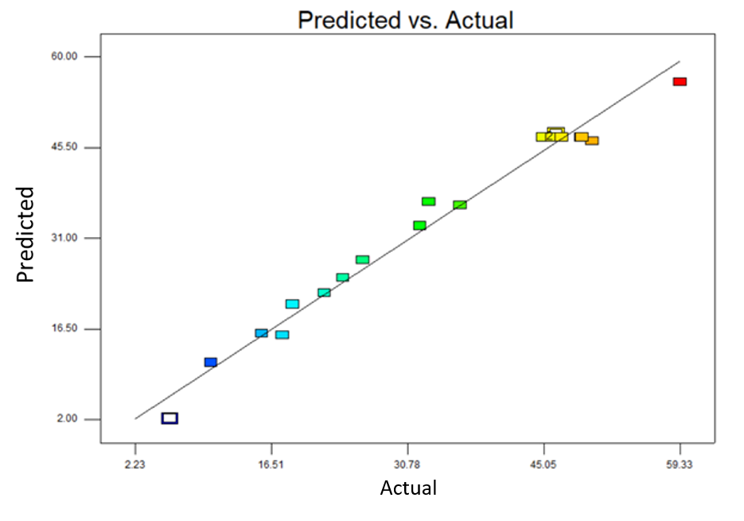
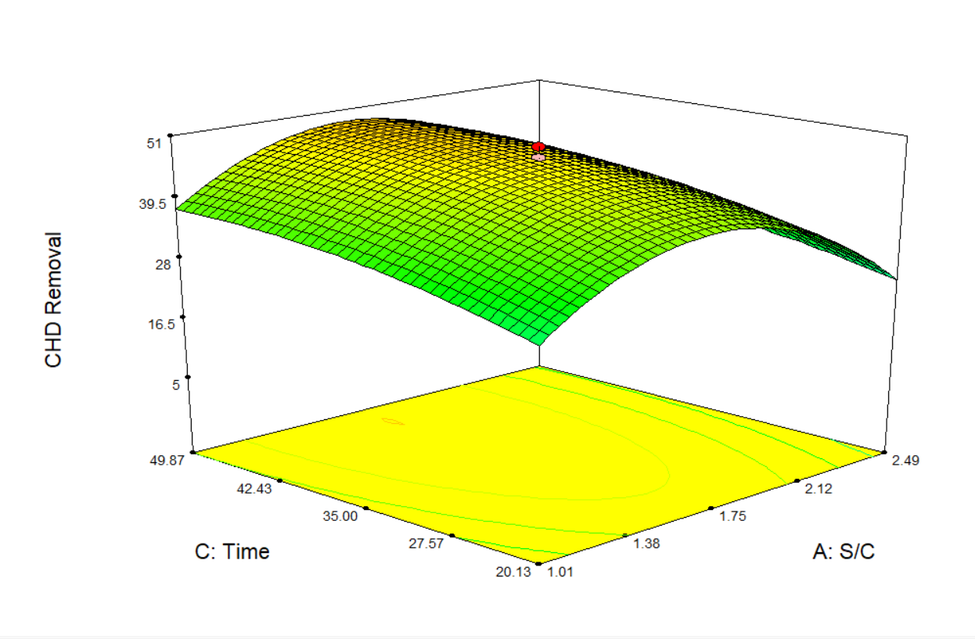
Fig: S1(B): Graphical representation of interaction among all the variable and predicted versus actual graph (BaFe₂O₄/rGO).
a
d
c
b

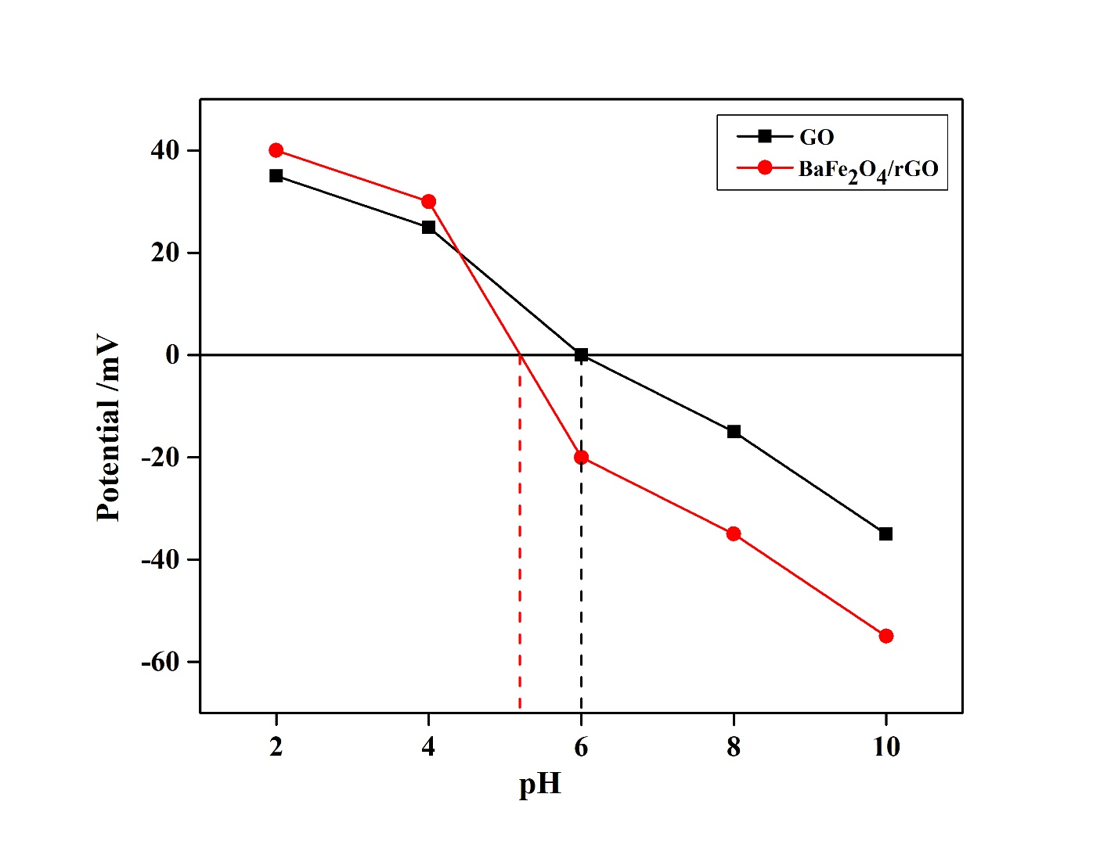Fig S2: Zeta potential of GO and BaFe₂O₄/rGO at different pH.

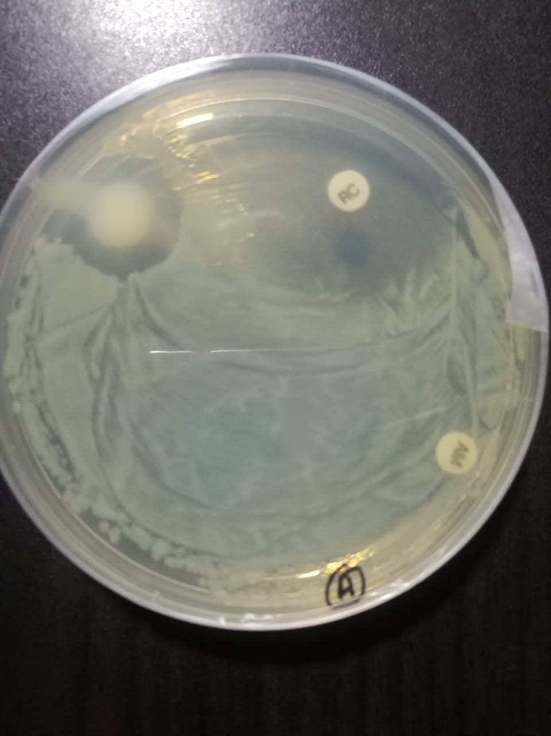
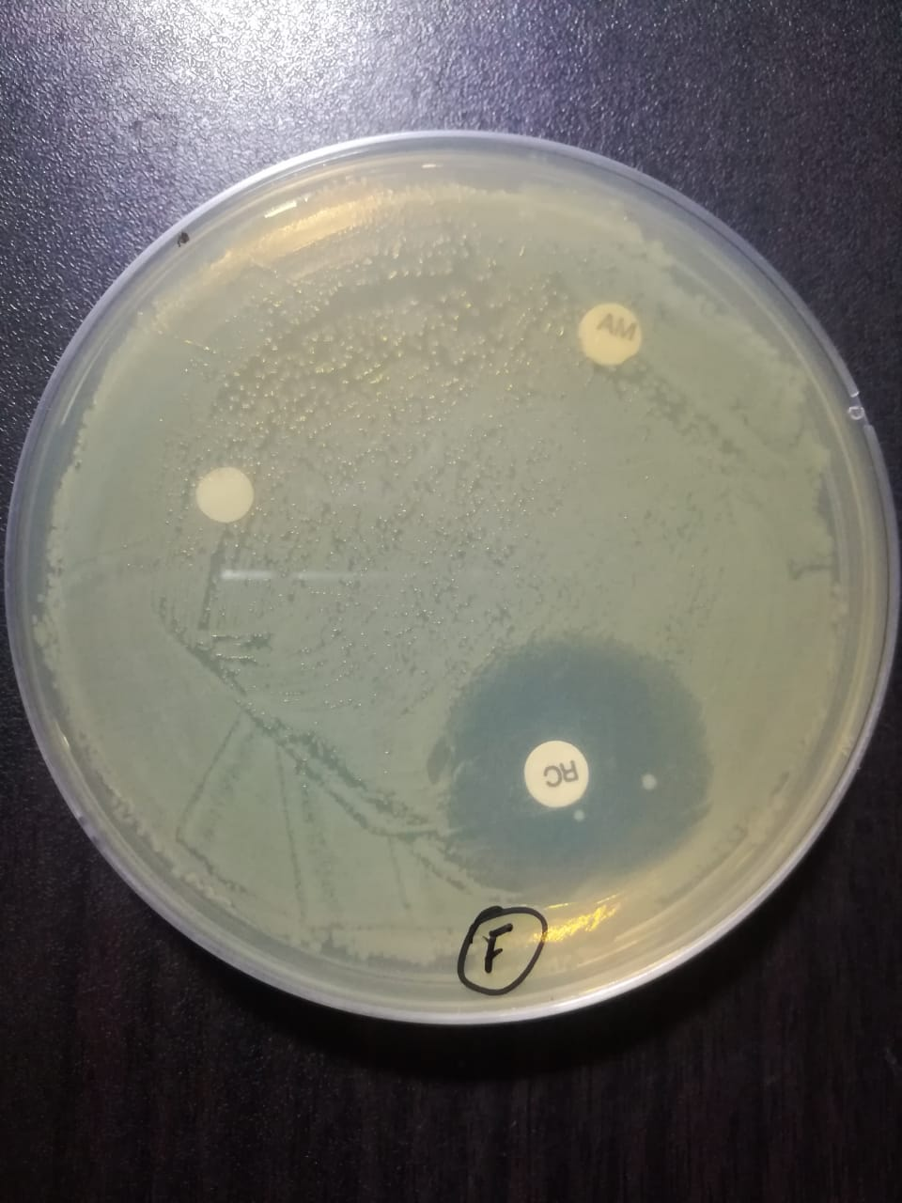
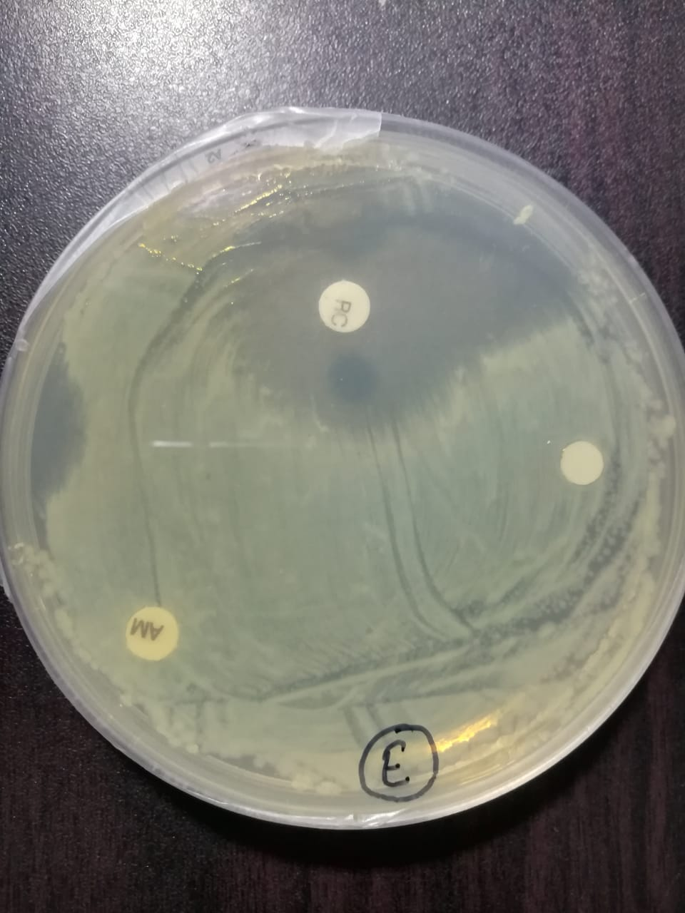
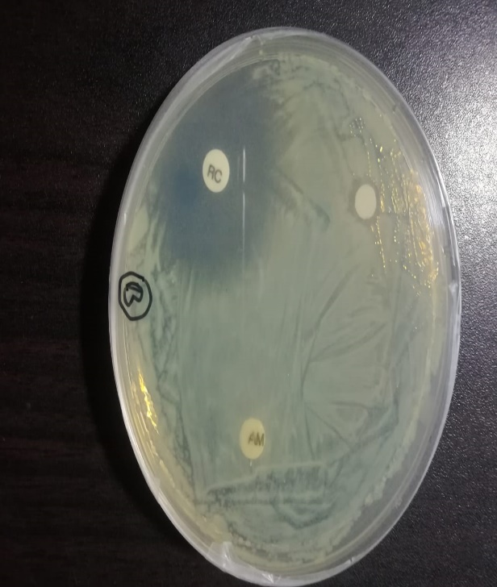
a
d
b
c
b

c

Fig S3: Bacterial susceptibility test on bacterial strains, Standard antibiotic; Pure CHD; Treated CHD by GO and BaFe₂O₄/rGO.

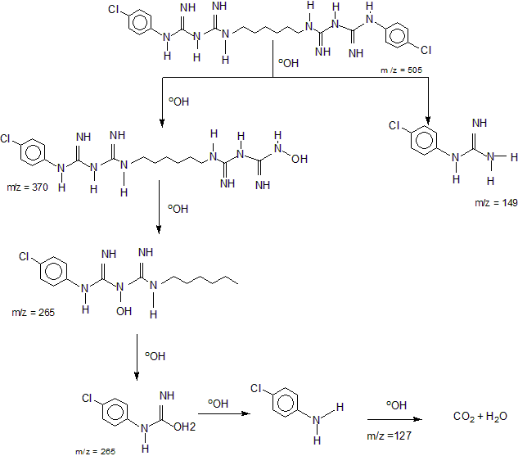
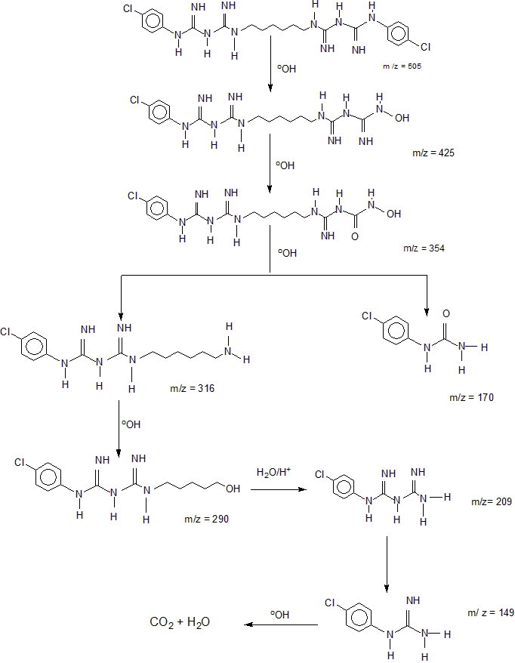
a
b

Fig S4: Possible pathway of CHD degradation by (a) GO and (b) BaFe₂O₄/rGO.

