Table 1: Base line characters at enrolement ( N= 27)
Age (years) | Bacterial Prostatitis(N=19) | Abacterial Prostatitis (N=8)
Age (years) | 52.15±15.71 | 37±12.30
Duration of symptoms ± SD (months) | 8.05±6.39 | 10±7.48
Prostate size ± SD (grams) | 39.94±13.99 | 30±10.73
Post-ejaculation pain ( N , percentage) | 15/19, 78.94% | 7/8 , 87.5%
Penile pain (N, percentage) | 11/19 , 57.89% | 4/8 , 50%
Testicular pain (N, percentage) | 08/19 , 42.10% | 5/8 , 62.5%
Suprapubic pain (N, percentage) | 13/19 , 68.42% | 5/8 , 62.5%
Increased frequency (N, percentage) | 10/19 , 52.63% | 6/8 ,75%
Dysuria | 11/19 , 57.89% | 3/8 , 37.5%
Perineal pain | 06/19 , 31.57% | 1/8 , 12.5%

Organisms | N, (Percentage)
Staphlococcus epidermidis | 08/19, (42.10%)
Escherichia coli | 06/19, (31.57%)
Staphylococcus aureus | 02/19, (10.52%)
Entercoccus | 01/19, (5.26%)
Proteus mirabilis | 01/19, (5.26%)
Streptococcus | 01/19, (5.26%)
Table 2: The glass-test results (N=19)

(Organisms)  Antimicrobials Staphylococcus Staphylococcus  Epidermidis(08) Enterococcus(01) Streptococcus(01) aureus(02) | E-Coli(06) Proteous  mirabilis(01)  mirabilis |  | Over all sensitivity (N=19)
Ampicillin 12.5% 100% 100% 0% | 50% | 50% | 31.57%
Ceftriaxone 0 % 0% 0% 0% | 5.26% | 0% | 5.26%
Cefotaxime 0% 0% 0% 0% | 0% | 0% | 00%
Clindamycin 20% 0% 0% 0% | 5.26% | 0% | 5.26%
Co-trimoxazole 50% 0% 0% 0% | 15.78% | 50% | 36.84%
Ciprofloxacin 0% 100% 0% 0% | 00% | 16.6% | 10.52%
Erythromycin 12.5% 0% 0% 0% | 5.26% | 0% | 15.78%
Fosfomycin 50% 0% 100% 100% | 26.31% | 100% | 73.68%
Gentamycin 20% 0% 0% 0% | 10.52% | 33.33% | 26.31%
Imipenem 12.5% 00% 0 % 50% | 21.05% | 16.6% | 31.57%
Linezolid 50% 100% 100% 50% | 10.52% | 16.6% | 36.84%
Meropenem 12.5% 0% 0% 0% | 21.05% | 33.33% | 21.05%
Nitrofurantoin 50% 0% 100% 100% | 26.31% | 66.66% | 68.42%
Piperacillin/Tazobactum 00% 00% 0% 0.0% | 10.52% | 50% | 15.78%
Teicoplanin 62.5% 100% 100.0% 100.0% | 10.52% | 0% | 63.15%
Vancomycin 50% 100% 100% 100% | 26.31% | 16.6% | 47.36%
Table 3: Antimicrobial sensitivity patterns in positive three glass test

Types of Prostatitis | No of Visits | Visit 1  (at enrolment)  mean±SD; median | Visit 2 (1week)  mean±SD; median | Visit 3 ( 5th week)  mean±SD; median | Visit 4(13th week)  mean±SD; median | Visit 5(20th week)  mean±SD;median | p value
Bacterial  Prostatitis | IPSS Score | 15.3684±10.0178 ; 18.0 | 11.3158±7.7176 ; 13.0 | 7.2632±5.2688 ; 8.0 | 2.5263±1.7754 ; 3.0 | 0.7895±0.7132 ; 1.0 | <0.001
Bacterial  Prostatitis | Qol | 5.1053±0.7374 ; 5.0 | 3.4211±1.1263 ; 3.0 | 2.6842±0.9459 ; 3.0 | 1.6316±1.0651 ;1.0 | 1±0.5773 ; 1.0 | <0.05
Bacterial  Prostatitis | PMRV | 27.4211±15.9733; 27 | 17.2632±10.2352 ; 15 | 11.3684±6.1392 ; 10 | 7.2105±4.7443 ; 7 | 2.2105±2.2504 ; 2 | <0.03
Table 4: IPSS, Qol and PMRV for bacterial and abacterial Prostatitis
Abacterial Prostatitis | IPSS Score | 15.25±7.3824; 16.5 | 11.625±5.8782; 14.0 | 8.25±4.0267 ; 9.5 | 5.5±3.1167;6.5 | 3.625±2.4458; 4.0 | <0.05
Abacterial Prostatitis | Qol | 3.125±1.4577; 3.5 | 2.875±1.3562 ; 3.0 | 2±0.9258;2.0 | 1.5±0.7559;1.0 | 1.25±0.7071 ;1.0 | <0.04
Abacterial Prostatitis | 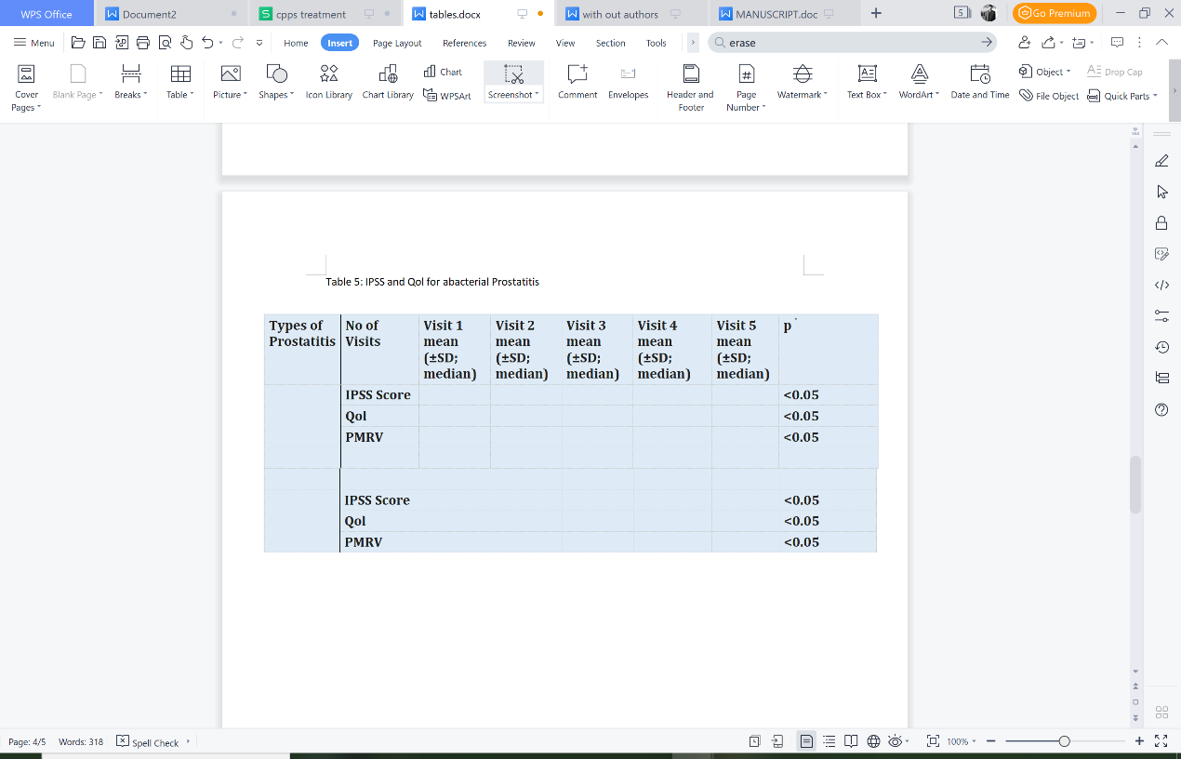  PMRV | 18.75±9.7211;17 | 14±7.0102; 13 | 10.5±5.7569 ; 11.5 | 6.75±3.8821 ;8.0 | 3.5±2.9761 ; 4.0 | <0.05

No of Visits |  | Visit 1  mean  (±SD; median) | Visit 5  mean  (±SD; median) | p value
Bacterial  Prostatitis | Flow max on Uroflowmetry | 10.4211±3.0058 ; 12 | 16.0526±3.17059 ; 16.0 | 0.065
Abacterial  Prostatitis | Flow max on Uroflowmetery | 11.875±1.4577 ; 12.0 | 16.5±2.3299 ; 15.0 | 0.092
Table 5 : Uroflowmertic studies

Table 6 : Bacterial localization in the three-glass test

