Supplementary figures:
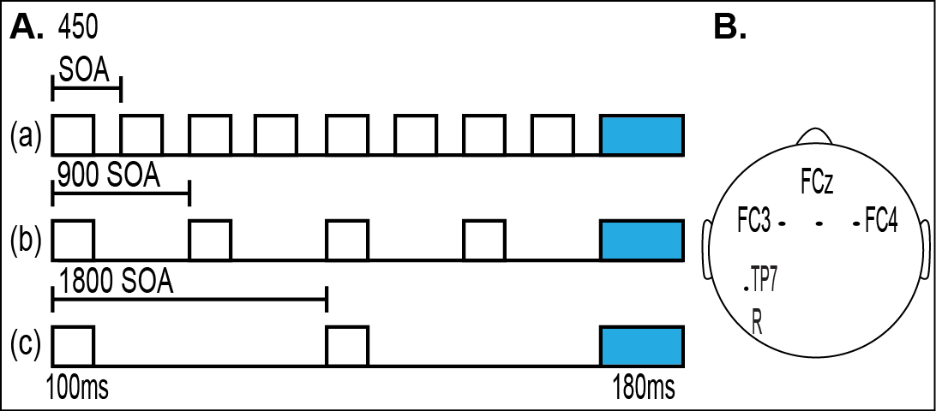
Subject | Age | Mutations | (RSSS) | Seizures | Seizure OS | Ambulatory | Medications | Age of R
1 | 6-10 | R255X | 13 | yes | 48 mos | no | Trazadone, Depakote | N/A
2 | 6-10 | R133C | 8 | yes | 72 mos | yes | Lovastatin, Topomax, Abilify, Lexapro, Depakene, Nexium | 21 mos
3 | 10-14 | R306C | 7 | yes | 168 mos | yes | Lovastatin, Ambien, Trazodone | 50-60 mos
5 | 10-14 | C964C | 5 | no | no | yes | Trazadone | 156 mos
7 | 6-10 | deletion | 9 | no | no | yes | Lovastatin | 11 mos
8 | 10-14 | R255X | 6 | no | no | yes | Lovastatin | 12 mos
9 | 14-18 | R270X | 14 | N/A | N/A | no | none | N/A
13 | 10-14 | deletion | 14 | yes | 30 mos | no | Depakene, Lexapro,Lactulose | N/A
14 | 10-14 | Q170x mutation at nucleotide c508 | 10 | N/A | N/A | yes | N/A | 18 mos
16 | 10-14 | deletion | 12 | no | 72 mos | yes | Risperdol and Necon | 144 mos
17 | 20-24 | R133C | 12 | yes | 108 mos | yes | Depakote, Carintor, Artane, Copaxone | 17 mos
18 | 6-10 | deletion | 11 | N/A | N/A | no | Depakene | N/A
19 | 16-20 | R270X | 13 | no | N/A | no | N/A | N/A
21 | 16-20 | 418ins4 | 15 | yes | N/A | no | Diastat, Depakene, Carnitor | N/A
22 | 16-20 | T158M | 11 | yes | 72 mos | yes | Lexapro, Lamictal | 15-18 mos
23 | 6-10 | Large deletion | 12 | yes | 60 mos | no | Valproic acid | N/A
24 | 6-10 | Deletion exon 3&4 | 9 | yes | 36 mos | no | Keppra, deplane | N/A
25 | 10-14 | T158M | 12 | no | N/A | no | Nanadol, prevacid | 24 mos
4 | 16-20 | T158M | 11 | yes | 120 mos | yes | Copaxone, Topomax, Lovastatin, | 10 mos
6 | 6-10 | R294X | 7 | no | no | yes | Lexapro, Lovastatin, Prilosec | 17 mos
10 | 10-14 | R306C | 9 | no | no | yes | Lexapro | 18 mos
11 | 14-18 | R306C | 10 | no | no | yes | Lexapro, Copaxone, Trazodone, | N/A
12 | 6-10 | deletion | 7 | yes | 24 mos | no | Depakene, Lactulose, Lovastatin, | 30 mos
15 | 10-14 | T158M | 10 | N/A | N/A | no | N/A | N/A
20 | 6-10 | R133C | 10 | yes | 42 mos | yes | Abilify, Lexapro, Desyrel | 24 mos
Figure S1: Oddball paradigm design: A. 3 experimental conditions with varied stimulus presentation intervals (SOA): (a) 450 ms intervals between stimuli, (b) 900 ms between stimuli and (c) 1800 ms between stimuli. B. Shows a map of the electrode site of interest (FC3, FCz, and FC4) and reference electrode R (TP7).

Table S1. Clinical demographics of all enrolled participants with Rett syndrome. The shaded area depicts excluded participants. RSSS = Rett Syndrome Severity Score; Seizure OS = Seizure on set; Age of R = Age of regression in months (mos.); N/A = Not Available.

 | TD (N=24)  Mean Age: 12.3 ± 4.7 |  |  | RTT (N=17)  Mean Age: 12.6 ± 4.8
 | 450 SOA | 900 SOA | 1800 SOA | 450 SOA | 900 SOA | 1800 SOA
Average Accepted  Std. trials ± SD | 412.5 ± 153 | 718.5 ± 96 | 720 ± 81 | 239.1 ± 81 | 507.6 ± 153 | 460.2 ± 96
Accepted Overall | 1851 |  |  | 1207
Grand average AEP values ± SD | 1.18 ± 0.85 | 0.79 ± 1.01 | 0.61 ± 1.17 | 0.64 ± 0.90 | 0.25 ± 0.99 | -0.13 ± 1.07

Table S2. Number of accepted standard trials and grand average AEP values and corresponding standard deviations (±SD) included in the analysis across conditions in typically developing controls and in participants with Rett syndrome.

 |  | TD (N=24) |  |  | RTT (N=17)
 |  | 450 SOA | 900 SOA | 1800 SOA | 450 SOA | 900 SOA | 1800 SOA
SNR | Pre-DSS Mean ±SEM | 21.09 ± 2.77 | 30 ± 3.25 | 26.55 ± 3.4 | -0.81 ± 3.72 | 9.29 ±4.76 | 14.88 ± 2.86
SNR | Mean ± SEM Across Conditions | 26.13 ± 0.64 |  |  | 7.75 ± 0.91
SNR | Post-DSS ± SEM | 30.98 ± 3.25 | 49.75 ± 3.86 | 43.46 ± 3.69 | 23.13 ± 3.56 | 30.29 ± 4.26 | 36.76 ± 5.02
SNR | Mean ± SEM Across Conditions | 41.4 ± 8.45 |  |  | 30.06 ± 7.29
ITV | Pre-DSS Mean ± SEM (µv) | 3.57 ± 0.3 | 3.55 ± 0.3 | 3.54 ± 0.29 | 7.35 ± 0.88 | 7.93 ± 1.03 | 8.01 ± 1.05
ITV | Mean ±SEM (µv) Across Conditions | 3.55 ± 0.29 |  |  | 7.76 ± 0.97
ITV | Post-DSS ± SEM (µv) | 1.68 ± 0.14 | 1.52 ± 0.13 | 1.41 ± 0.12 | 1.59 ± 0.21 | 1.72 ± 0.23 | 1.95 ± 0.21
ITV | Mean ±SEM (µv) Across Conditions | 1.54 ± 0.13 |  |  | 1.75 ± 0.21

Table S3. Mean ± SEM for SNR and ITV, Pre and Post–DSS, for each condition in typically developing (TD) controls and in participants with Rett syndrome (RTT).

