Supporting Information

Novel Synthesis of New Triazine Sulfonamides with Antitumor, Anti-microbial and SARS-CoV-2 Activities

Reham A. Mohamed-Ezzat¹ and Galal H. Elgemeie^{2*}
¹Chemistry of Natural & Microbial Products Department, Pharmaceutical and Drug Industries Research Institute, National Research Center, Cairo, 12622, Egypt
²Department of Chemistry, Faculty of Science, Helwan University, Cairo, 11795, Egypt.

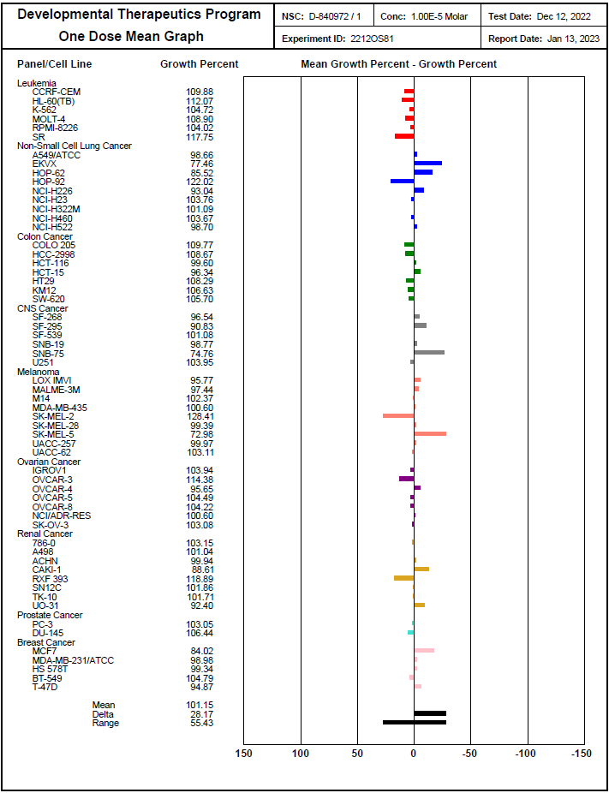
Fig. S1. Anticancer screening data of compound 3a (NSC D-840972) in concentration 10⁻⁵ M.

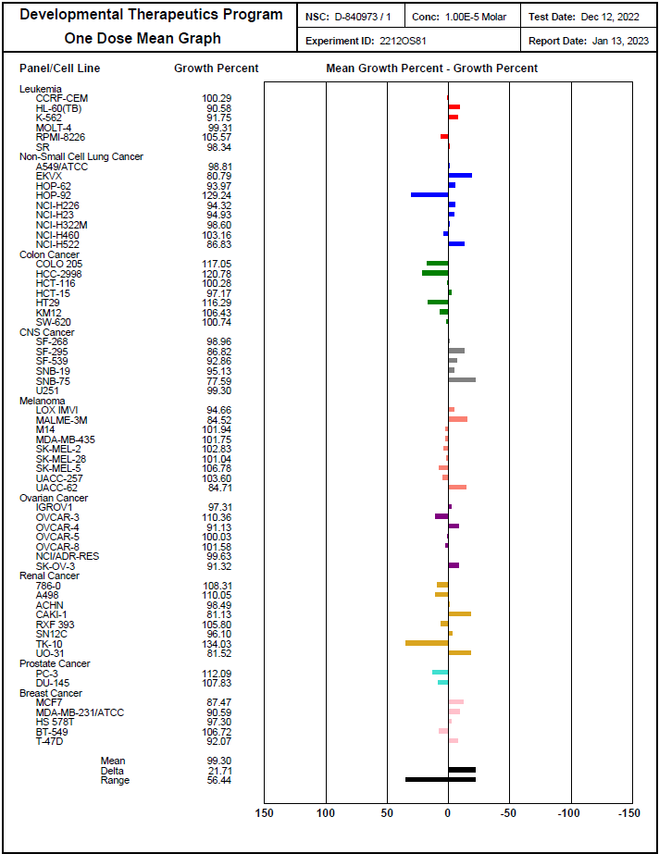
Fig. S2. Anticancer screening data of compound 3b (NSC D-840973) in concentration 10⁻⁵ M.

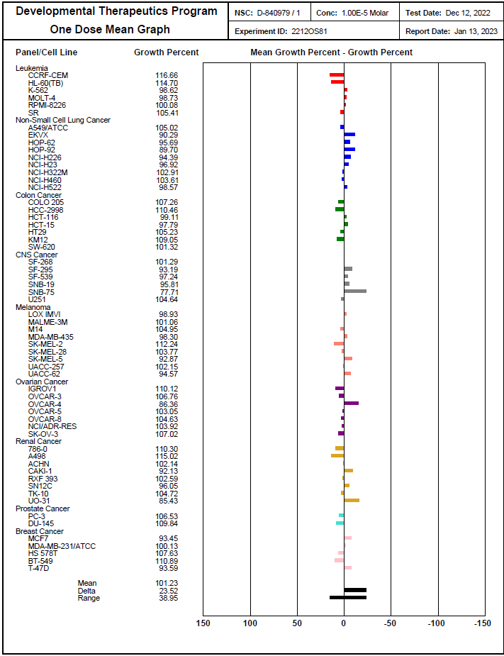
Fig. S3. Anticancer screening data of compound 4a (NSC D-840979) in concentration 10⁻⁵ M.

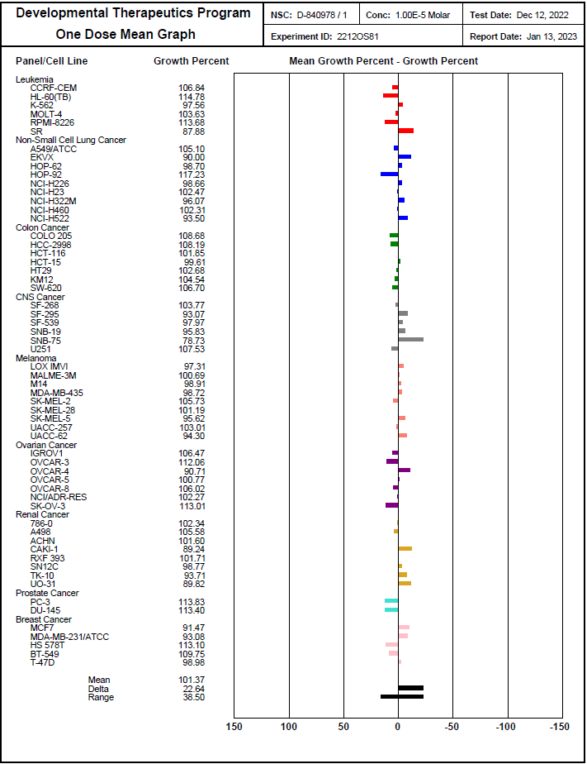
Fig. S4. Anticancer screening data of compound 4b (NSC D-840978) in concentration 10⁻⁵ M.

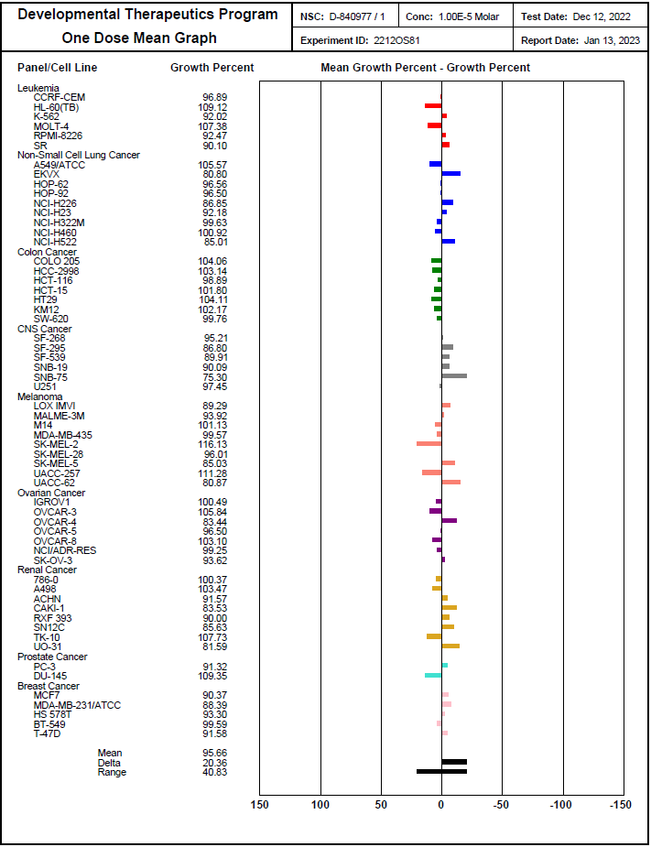

Fig. S5. Anticancer screening data of compound 5a (NSC D-840977) in concentration 10⁻⁵ M.

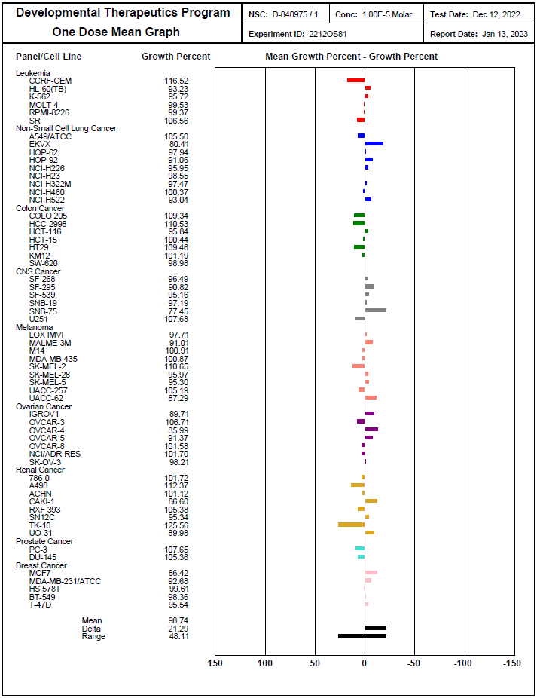
Fig. S6. Anticancer screening data of compound 5b (NSC D-840975) in concentration 10⁻⁵ M.

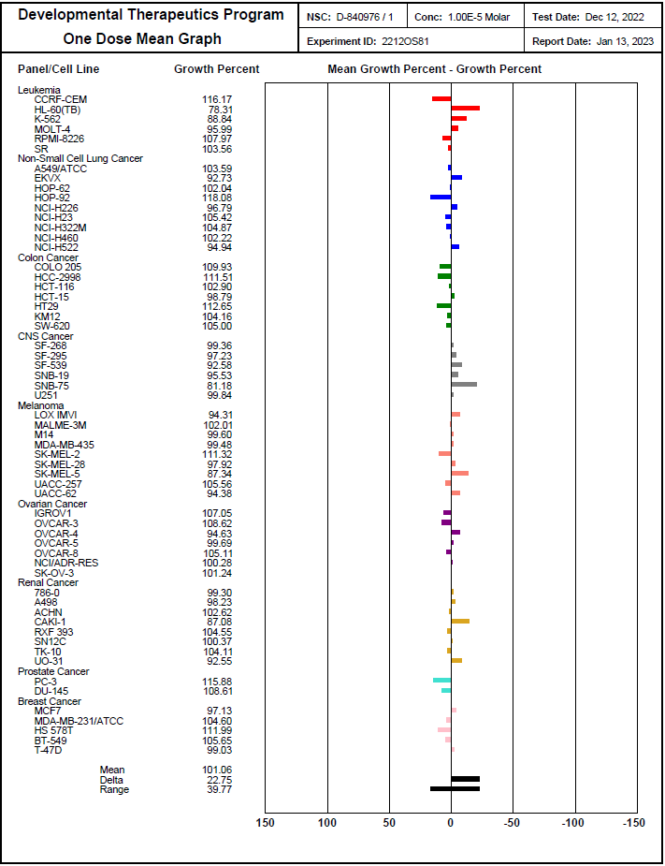
Fig. S7. Anticancer screening data of compound 7b (NSC D-840976) in concentration 10⁻⁵ M.

Compound 3a

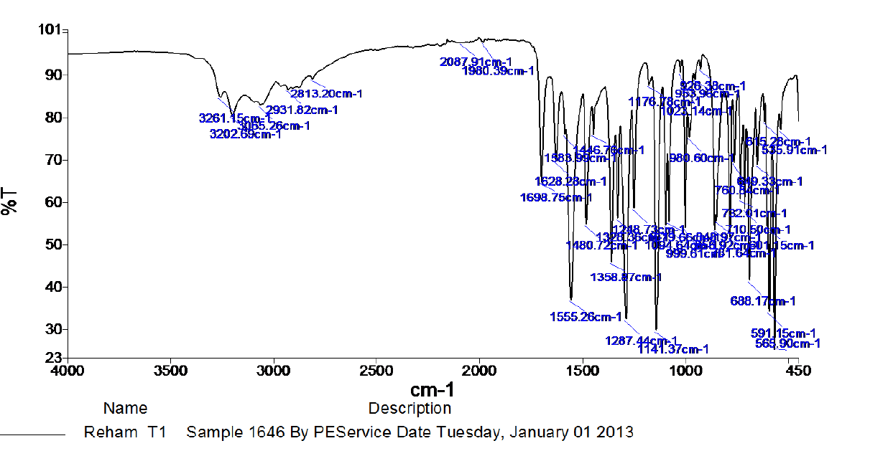

Fig. S8. IR spectrum of compound 3a

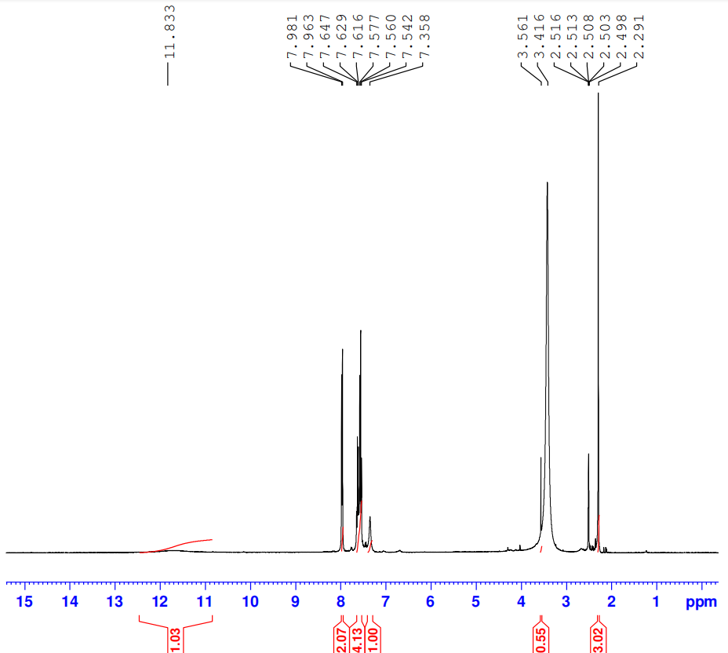Fig. S9. ¹H NMR spectrum of compound 3a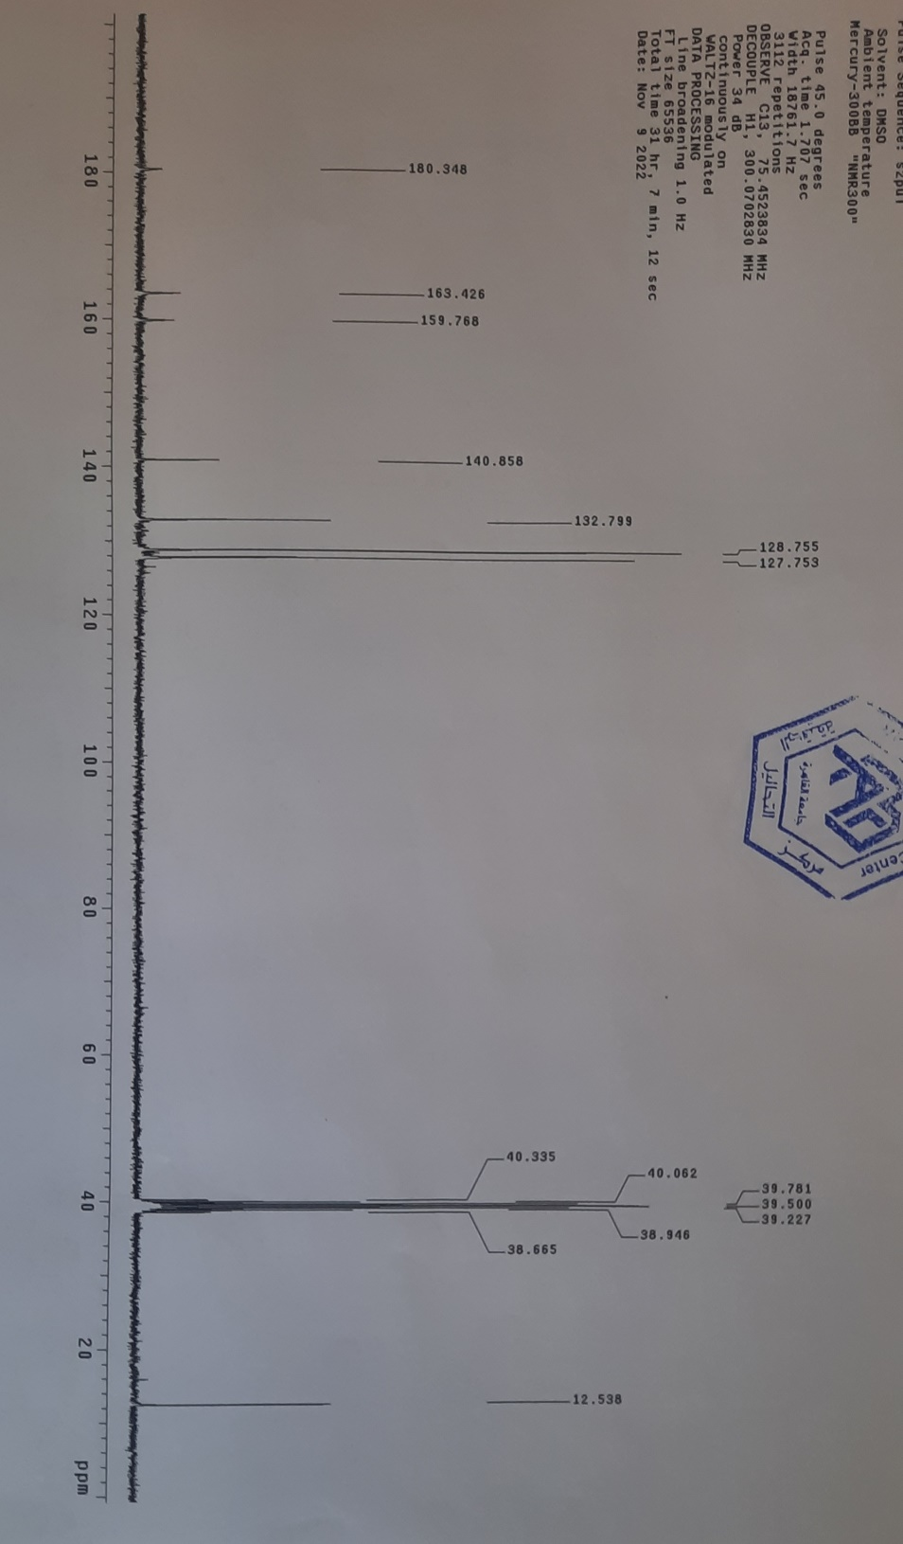
Fig. S10. ¹³C NMR spectrum of compound 3a

Compound 3b

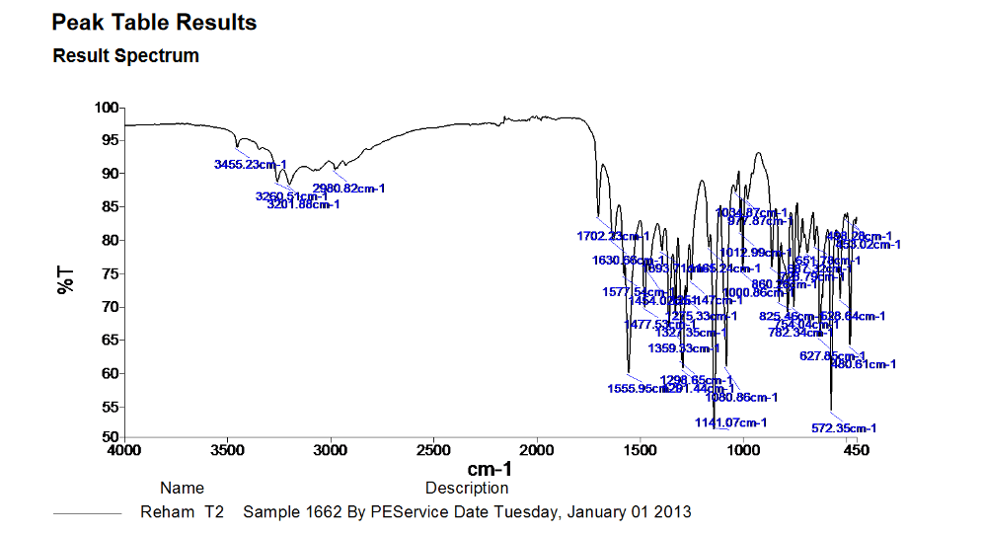

Fig. S11. IR spectrum of compound 3b

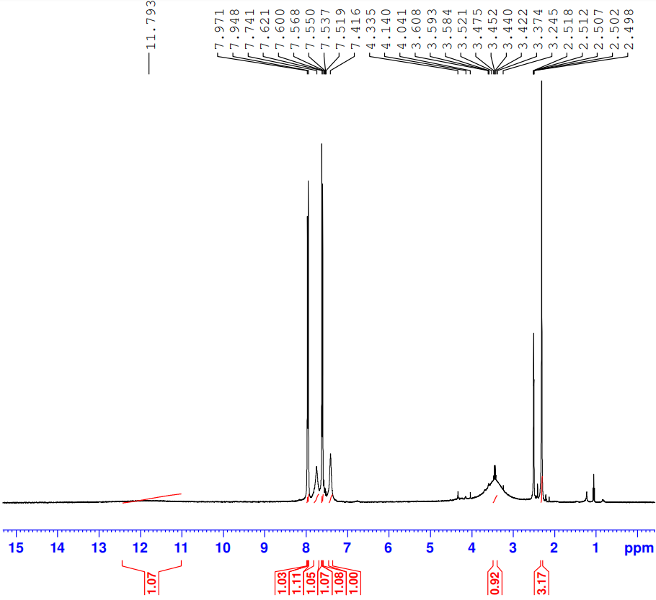

Fig. S12. ¹H NMR spectrum of compound 3b

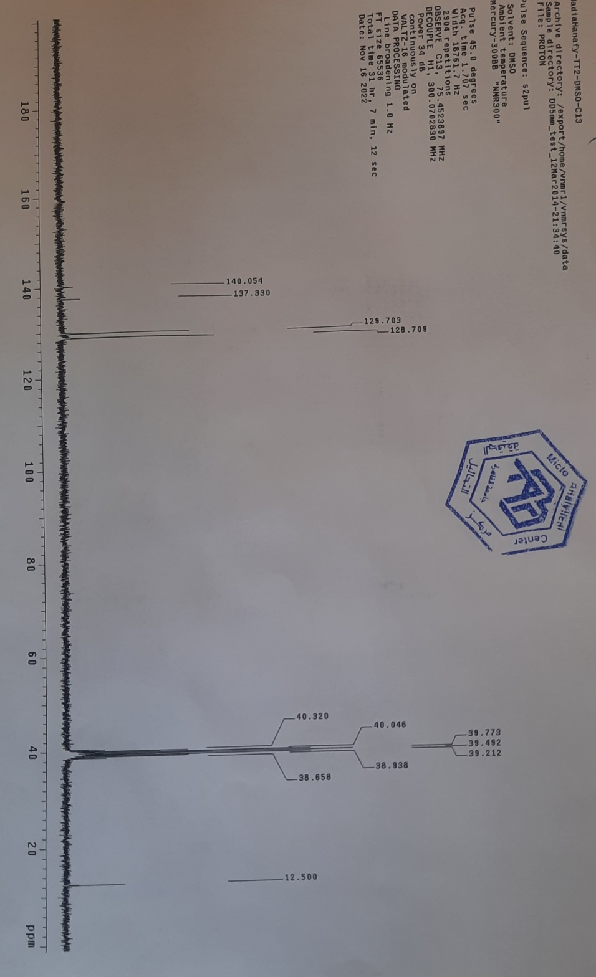

Fig. S13. ¹³C NMR spectrum of compound 3b

Compound 4a
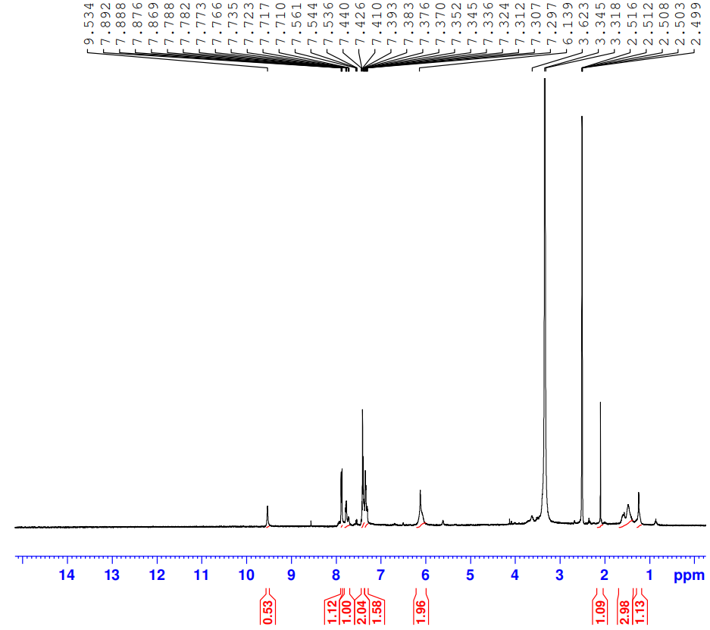
Fig. S14. ¹H NMR spectrum of compound 4a.

Compound 4a

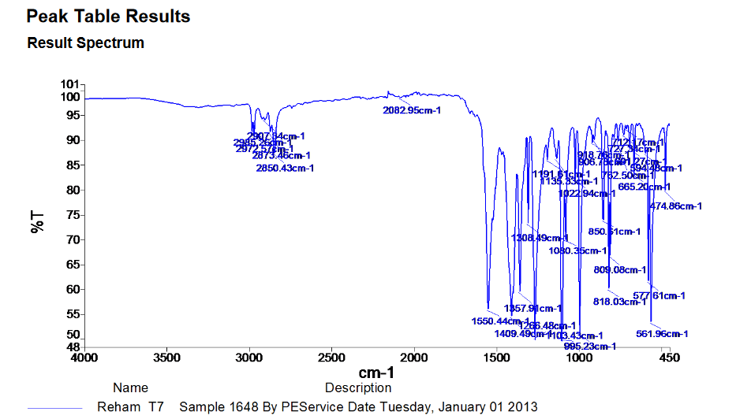

Fig. S15. IR spectrum of compound 4a

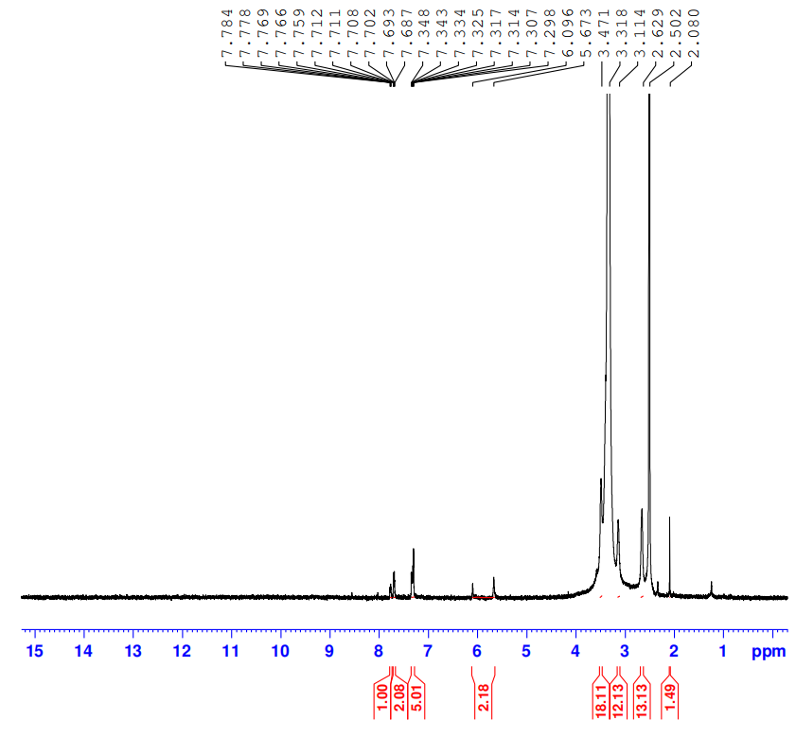

Fig. S16. ¹H NMR spectrum of compound 4a

Compound 5a

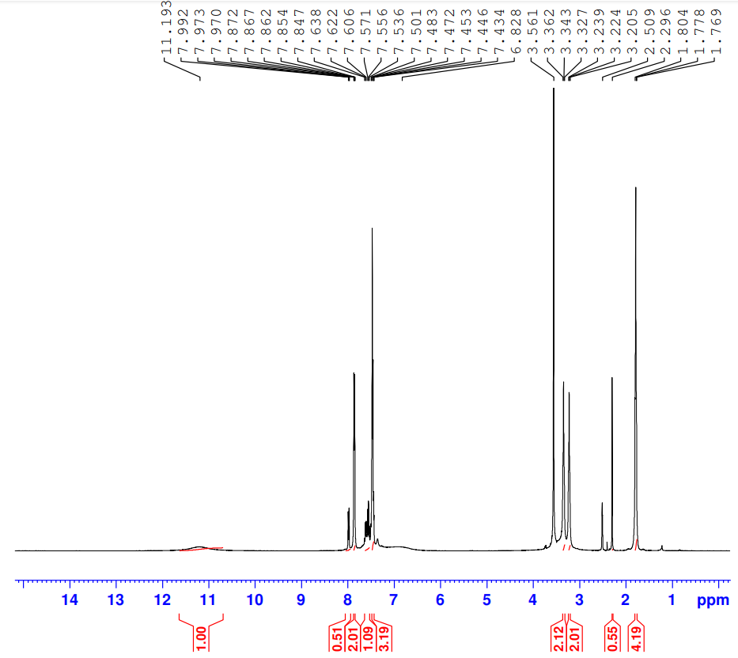
Fig. S17. ¹H NMR spectrum of compound 5a
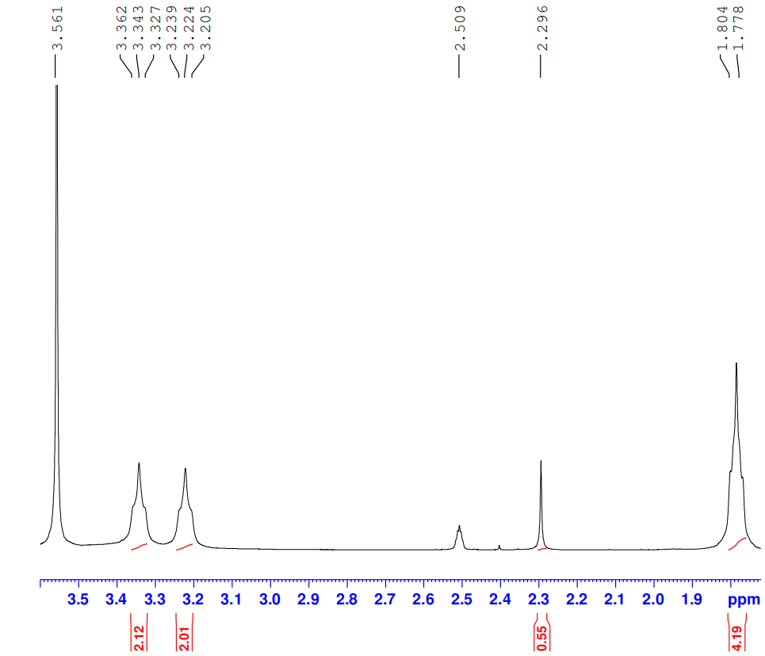

Fig. S18. ¹H NMR spectrum of compound 5a

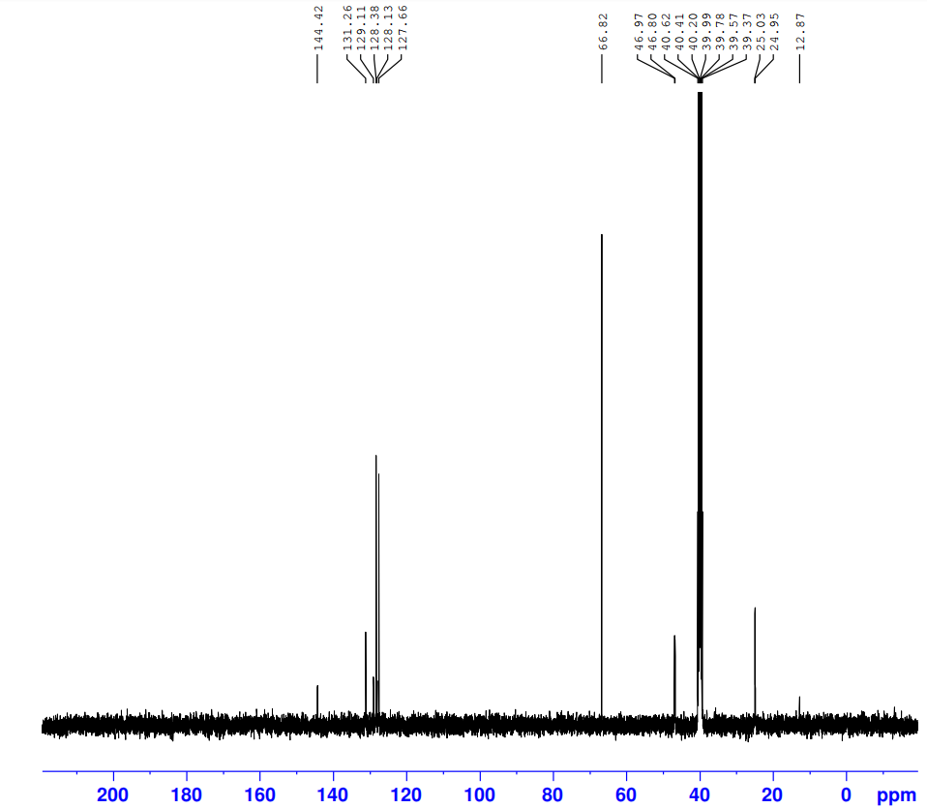

Fig. S19. ¹³C NMR spectrum of compound 5a

Compound 5b
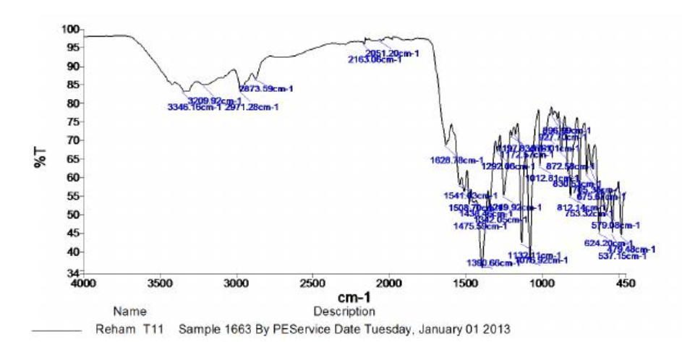

Fig. S20. IR spectrum of compound 5b

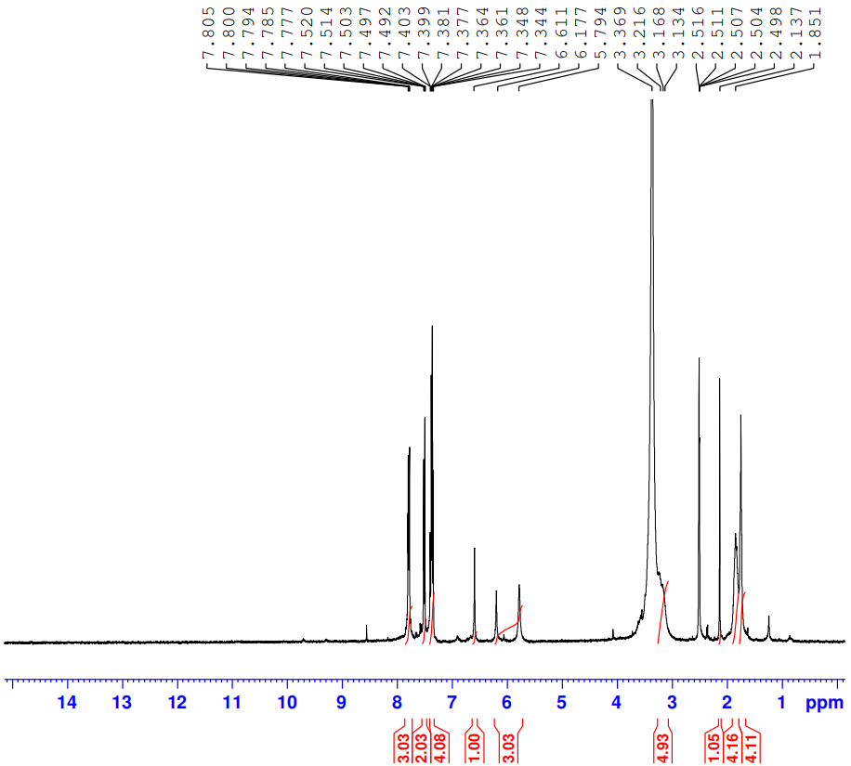

Fig. S21. ¹H NMR spectrum of compound 5b
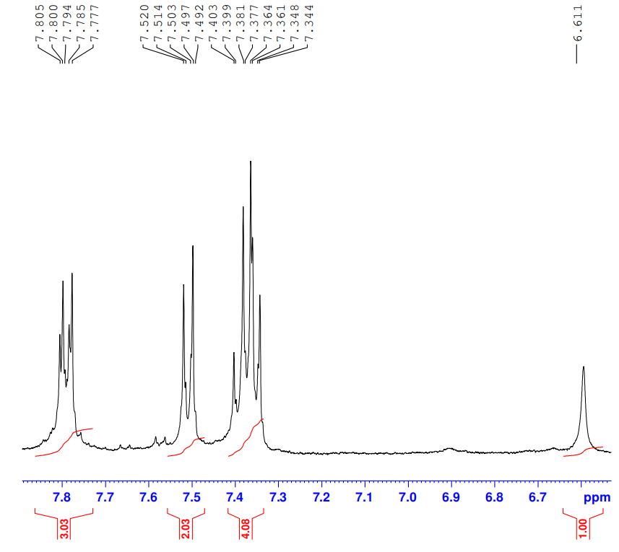

Fig. S22. ¹H NMR spectrum of compound 5b
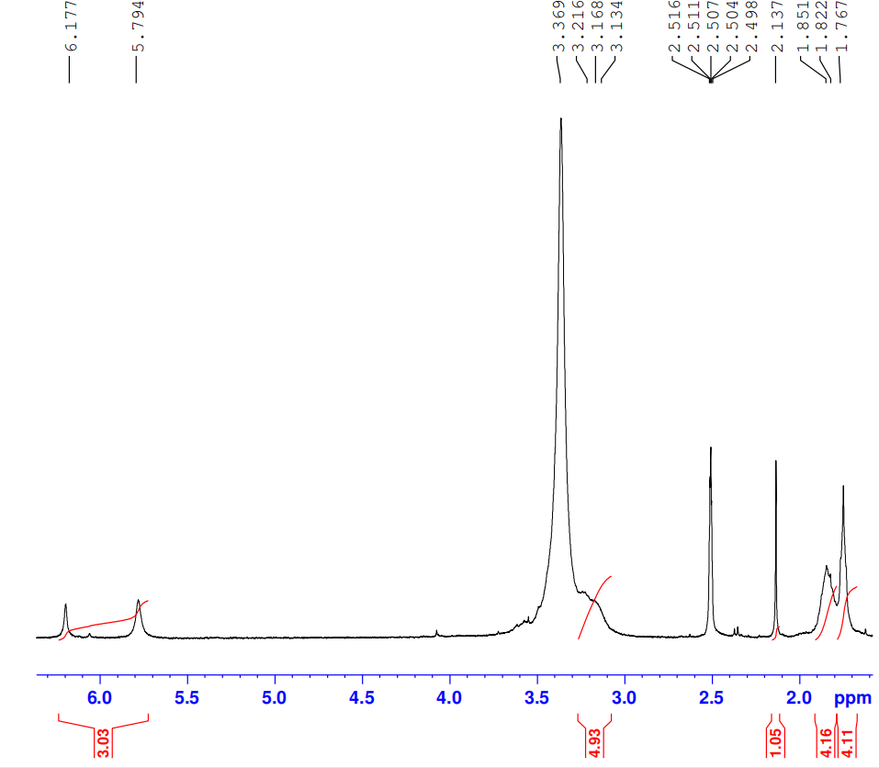
Fig. S23. ¹H NMR spectrum of compound 5b

Compound 7b

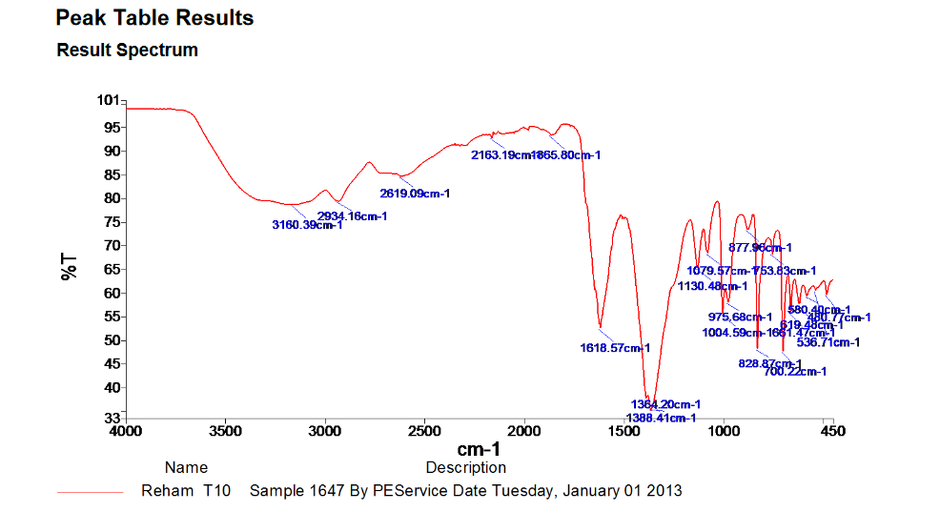

Fig. S24. IR spectrum of compound 7b

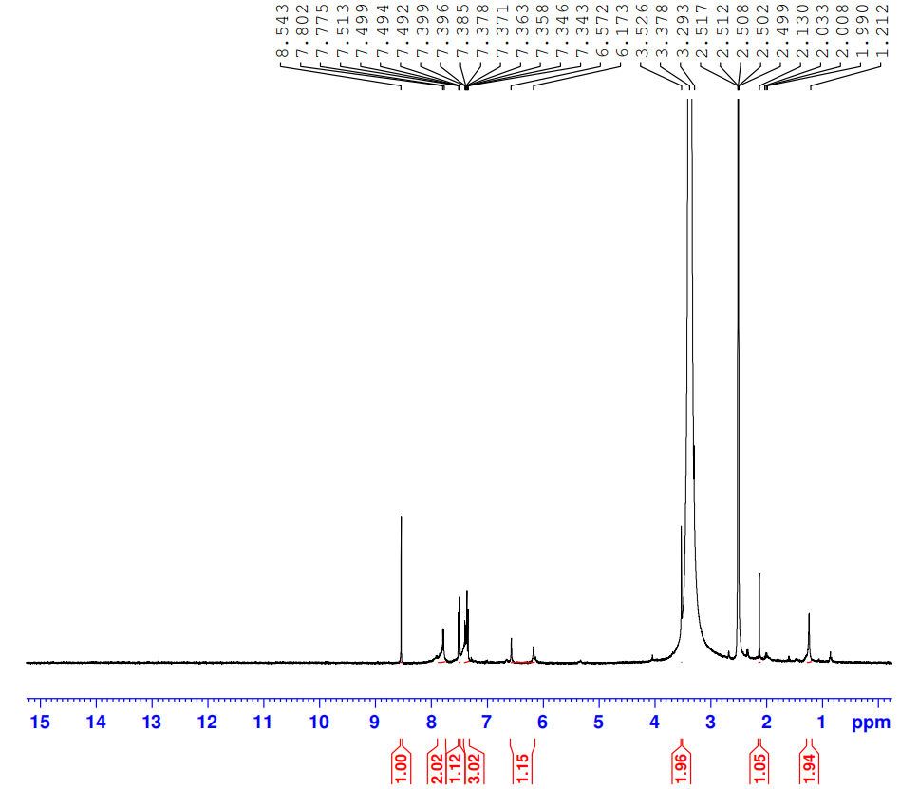
Fig. S25. ¹H NMR spectrum of compound 7b

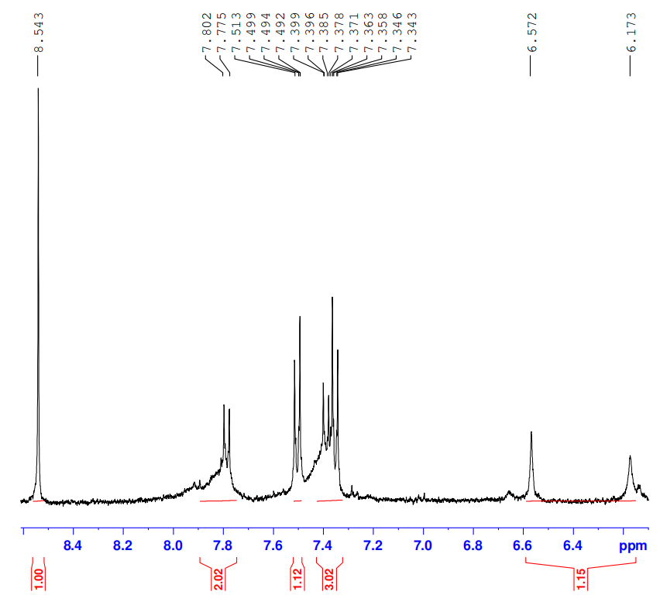

Fig. S26. ¹H NMR spectrum of compound 7b

