Appendix 1. Interview Schedule

Topic 1 – The current approach to the use of skin tests for TB as part of the diagnostic process including specific challenges

For health providers:
- How do you use TB skins tests in your current practice?
- What do you think are the challenges with this/the current approach to using TB skin tests?

For patients/public:
- What is your understanding / experience of how skin tests are currently used as part of the diagnostic process for TB?
- What do you think are the challenges with this/the current approach to using TB skin tests?

Topic 2 – Experiences with using skin-based testing and the NSTs specifically, including details on ease of use and process of using the skin-based tests as part of the diagnostic process

For both:
- Thinking back to your experience with skin tests, what has been your experience with receiving (patients) / using (health providers) TB skin tests?
  - Have you found TB skin tests easy to use? Why or why not?

- What has been your experience with novel skin-based tests (e.g., C-TB, Diaskin test, ESAT6-CFP10)?
  - Did you find the test easy to use? Why or why not?

Topic 3 – Determining challenges and benefits of using the skin-based tests with a focus on the experience of using the NSTs

For both:
- Have you experienced any challenges/barriers in using novel skin tests in comparison to other tests?
- What do you think some of the benefits are/would be of using novel skin-based tests for TB in comparison to older tests?
- How useful have you found/do you anticipate novel skin-based tests for TB to be and why?

Topic 4 – The feasibility of implementing the NSTs

For both:
- Knowing what you know now about the novel skin tests – if you were offered all 3 test options (TST, IGRA and the novel skin tests) which option would you prefer to use? Why?
- What factors influenced your decision-making?
  - Are there some factors that are more important to you than others?
  - Accuracy vs inconvenience vs discomfort vs accessibility vs cost vs timing of results? What would be more important to you?

For health providers:
- How would you feel about using novel skin tests in your current practice/ what might need to change?
  - How easy would it be to implement compared to other TB tests (TST/IGRA)?
  - What challenges might there be?

For patients/public:
- How would you feel about receiving a novel skin test from your health provider?
  - Why do you feel that way?

Topic 5 – The overall acceptability of the NST such as burden (i.e., psychological or physical consequences of the test), attitude, understanding, perceived test efficacy

For both:
- Did you experience/do you anticipate there being any psychological or physical consequences of using the novel skin-based tests?
- Would you be willing to use a novel skin-based test for TB in future? Why or why not?
- How well do you think the novel skin-based tests work compared to the existing skin-based tests and blood tests?

Topic 6 – Potential impacts of NSTs on health equity and policy (health provider only)

For health providers:
- What (if any) impact do you think the use of these novel skin-based tests will have on health equity?
  - Differences in accessibility
  - Differences in engagement / usability
  - Barriers / challenges to access and use
- What do you think is the impact of these novel skin tests on current healthcare policy?

Appendix 2. Coding Framework
Themes
Contextual factors
COVID-19 pandemic
Reduced clinic access
Shortage of blood test bottles or other materials
Healthcare setting
Ability to screen alongside other tests-
Aspects of healthcare system and infrastructure
Public funding of tests
Income of country
Low-cost tests more appropriate for low-resource settings
Scalability for large scale screening programs
Provider-related factors
Communication with patient around the test-
Endorsement by others
Provider endorsement
Usefulness perceptions
Resources
Equipment or sample storage requirement
Hospital or clinic environment
Laboratory requirement
Trained staff requirement
Transport requirement
Test environment
Hospital environment
Usefulness of test affected by the care pathway that follows
Equity factors
Access and transport issues
Amount of staff in low resource setting
Greater accessibility from lower cost
Health environment crowdedness
Long journey to clinic
Patient doesn't need to visit healthcare setting
Return visit to read result
Specialised staff training
Transportation to clinic
Wait time
Affected by infrastructure required
Scalability for large scale screening programmes
Portability
To reach vulnerable groups (e.g., homeless)
Suitability to low-income country setting
Cost
Resourcing
Suitability to subgroups
BCG vaccine
Children
Comorbidities
Health workers
Needle phobic
Skin tone
Patient factors
Demographics
Age
Needle phobic individuals
Skin tones
Familiarity perceptions
Similar experience to other accepted tests
Patient experience
A return visit required to healthcare setting to read the test result
Comfort
Discomfort
Not uncomfortable
Perception that NSTs are more comfortable than IGRA
Sore arm
Health environment crowdedness
Health Literacy
Level of invasiveness
Long journey to clinic
Patient doesn't need to visit healthcare setting
Physical consequences
No physical consequences
Painful
Welt on arm
Psychological consequences
Anxiety
Environment-related
Anxiety from hospital environment
Test-related
NST- Anxiety from seeing welt on arm
No psychological consequences
Stigma
Stress from false positives
Time spent at hospital or clinic
Timeliness of result for patient
Transport
Travel to a healthcare setting required
Unease from 'live' reading in front of patient
Perceptions of provider
Endorsement by others
Provider communication
Provider endorsement
Skin test perceptions
A basic test
A dated technology
An improved version of the TST
Test knowledge
Amount of research evidence
Limited public knowledge
Usefulness perceptions
Test factors
Ability to differentiate between latent and active TB
Accuracy
Downstream benefits of high accuracy
Avoid patients receiving unnecessary treatment
Improve evaluation of TB treatments
Improve rates of diagnosis
Less expensive in the long run
Prevent psychological stress from false positives
Save hospital resources
Downstream challenges of low accuracy
Expense of false positives
Psychological stress from false positives
Sensitivity
Specificity
Concerns about boosting
Human vs. machine
NSTs, IGRAs are more accurate than TSTs (antigen-specific)
Certainty of results
Cost
Ease of administration
Portability
Reliability
Human vs. machine reading of results
Suitability in subgroups
BCG vaccine
Children
Comorbidities
Health workers
Needle phobic
Skin tone
Time to receive result

Appendix 3. In-Depth Acceptability Results
People-related factors
There were 7 subthemes relating to people factors for acceptability of TBI tests (Figure 1). These included consumer experience, consumer demographics, perceptions of skin tests, knowledge, familiarity, and provider-consumer communication, which were discussed by both consumers and providers. Consumers also discussed how useful they perceived the test to be for themselves in terms of diagnosis and management of TBI – whereas this perceived usefulness of the test from a consumer perspective was not discussed by any health provider participants.
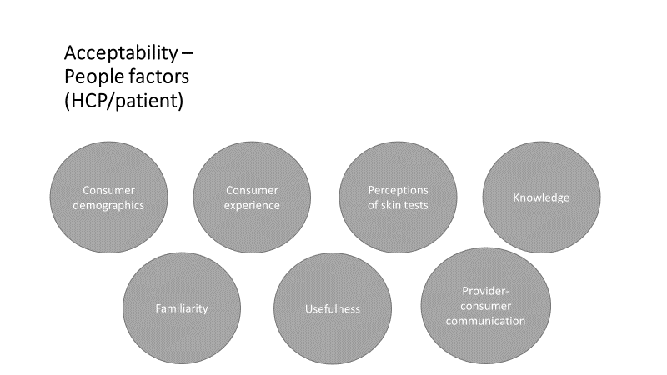
Figure 1. People factors affecting test acceptability.
Consumer Experience
Several aspects of the consumer experience were found to affect the acceptability of TBI tests. All 3 TBI tests were reported to involve some discomfort during the procedure, including a slightly sore arm. Although, one consumer reported not finding blood tests uncomfortable.
“I had one many years ago and I remember it being quite uncomfortable… not invasive, that’s over, that’s too strong a word but yeah quite an uncomfortable test.” (ID001, HIC, Consumer)
In terms of the physical consequences of the tests, both the TBST and TST involve a welt on the arm. In rare cases, there may also be significant reactions from the intradermal injection. Moreover, the skin tests were reported to be painful tests at times due to the intradermal injection. Other participants did not perceive any physical consequences of TBST. No physical consequences were reported for the IGRA.
“…that’s a painful test, you know, in comparison with the IGRA, so that skin test, it’s very, it’s a painful test, it’s intradermal injection, it’s very painful.” (ID020, LMIC, Provider)
Mixed feedback was received regarding the psychological consequences of the tests. Some participants anticipated that there would be no psychological consequences of the TBST, while others anticipated that there may be additional anxiety associated with TBST due to these being a new test. For TBST and TST, anxiety may also be felt around the intradermal injection and the uncertainty of what the welt on the skin means. Some consumers reported feeling uneasy from the ‘live’ reading that took place in front of them, an experience that is avoided with the IGRA.
“We also found perspective from the patient that maybe people at the beginning, they worry that it’s painful and they scared of injection, but once they (indistinct), they like it very much because you can see physically the test result on your arm… at the beginning, many people worry about it, they worry that it would be unsafe, severe adverse reactions, and people would die if you injected PPD. Of course it’s not the case, there’s so many evidence in the world (indistinct) but they still worry, it took us a year to prove that it’s safe… It’s new things, injecting, people might even think that they are like, when you conduct clinical trial is the mice, they may be considered they are mice for the research.” (ID013, HIC, Provider)

“Psychologically, I would say yes, I would say that you’ve got, you can see and I, I mean I would totally go and Google and I would try to be diagnosing what was going on, and I would imagine that I guess you get some people who wouldn’t care, and so I imagine that a fair few people would actually, if they were interested in the outcome of the result, they might actually be concerned about what was going on in their arm and that might cause, psychological distress might be a little bit too strong word but a little bit of unease and uncertainty and apprehension I would say, because you can see what’s going on rather than it being a blood test taken away and it’s gone, it’s in a laboratory, you have no idea what’s going on.” (ID001, HIC, Consumer)
Moreover, in some cultures there is a stigma associated with the welt on the arm that a skin test may produce, and which an IGRA test can help to avoid. This stigma was raised as a serious concern in rural Indian communities:
“So some extent stigma can also be doing it like, so for these other tests they silently go to the lab and they’ll give the sample and come back. Here, this line or this mark is going to be for two days, so have attached, stigma attached to TB, so it could be a thing.” (ID005, LMIC, Provider)
Unique to the TST, the lower accuracy of this test could also prompt unnecessary stress for consumers from false positives:
“I think [the TBST are] more beneficial, it’s less strain on your mental health… [the existing tests are] probably not as reliable, not efficient (indistinct)… are they up to scratch, the results? There might be something wrong there.” (ID006, HIC, Consumer)
Anxiety was also reported as a consequence of the IGRA for consumers who are particularly uncomfortable with needles:
“Some patients may be absolutely, they’re completely terrified of having blood test but a skin test might be something they can cope with or who knows, I don’t know.” (ID012, HIC, Provider)
Some participants also reported that a hospital environment prompted feelings of anxiety. Although this environment is more commonplace for administration of the IGRA, it is possible that TST and TBST administrations may also take place in this environment.
Another aspect of the consumer experience that affected the acceptability of TBI tests was their degree of invasiveness. The IGRA was perceived to be more invasive than the TBST and TST. Moreover, certain cultures may be less comfortable with the degree of invasiveness that a blood sample requires.
“I feel like the need to sort of draw blood is a barrier for IGRA… it’s certainly a barrier when you’ve got to draw blood versus doing it via skin. I mean it’s not, I don’t, it is non-invasive to a certain degree but there is, it’s not like a breath test or peeing on a stick.” (ID017, HIC, Provider)

“Any test which is subcutaneous is fairer than intravenous because the blood test makes you draw out blood isn’t it?... Africans have some myth about people taking their blood.” (ID008, LMIC, Consumer)
Lastly, the complicated process involved with skin tests was perceived to reduce acceptability in consumers with low health literacy.
“First of all the test is a very complex thing, though to the provider it might be easy but from the patient’s perspective it is difficult. Like as of my understanding, patient should not have, should not rub on the injected areas and all those certain precautions need to be taken up. So to what extent patient keeps those things into mind is one end and this might require two visits to the test clinic. So from the patient perspective, I feel like it’s a bit complicated thing but not too much complicated if proper counselling is to be given to them.” (ID005, LMIC, Provider)
Demographics
Concerns were raised about the suitability of the IGRA and TBST for use in people with darker skin tones. One consumer described challenges they had faced with healthcare providers trying to find their veins for blood tests due to their darker skin tone, which reduces the acceptability of the IGRA in this population. However, concerns were also raised about whether accurate readings could be guaranteed for the TBST for persons with darker skin tones.
“Sometimes they can’t find my vein so it’s difficult to do blood tests… I know in most cases it’s easier to get a white person’s vein than a black person. So to me, I’ll go for the skin one and somebody else, so it’s not one size fit all.” (ID007, HIC, Consumer)
“Have they looked into the reading of the results with different skin types, different skin colours and can they guarantee that that’s accurate across all skin types, would be my other thought?” (ID001, HIC, Consumer)
All three tests were described as challenging for individuals with a needle phobia, with either a blood draw or an intradermal injection involved:
“Some patients also do not like injections. There are a number of patients who does not like injectables, so the moment you are inserting the needle, they feel very psychologically uneasy, so it brought a lot of problems.”
Researcher: “Is that even with the skin test, that they worry about the needle?”
Participant: “Yes.” (ID008, LMIC, Consumer)
Similar concerns were raised about placing intradermal injections in children, an experience that can be particularly challenging as it is more involved than a blood draw. Moreover, children were reported to struggle with the itchiness of the TST:
“I suppose with children particularly, it can be quite challenging cos obviously it’s a needle and it’s not a particularly quick injection either, so you can’t just sort of plunge it in and out.” (ID012, HIC, Provider)

“Well first of all it is kind of difficult to apply to the children because they move and also they tend to scratch the place that we put the TST.” (ID009, LMIC, Provider)
Perceptions of Skin Tests
Some participants viewed the TBST as an improved version of the TST. This perception tended to be driven by knowledge that the TBST were a more accurate test. Conversely, other participants described skin tests as a basic and dated technology, and questioned the utility of introducing another skin test. Some participants expressed a desire for new kinds of technologies for TB testing.
“I think that it’s good to have this kind of new test but as a researcher, I would like to see a more advanced one because we know that the barrier with the TST is the injection, that people are afraid. So if there is another way like there’s now a technique that you have a tab or something you put on your skin instead of injection, something like that, then it would look less painful.” (ID013, HIC, Provider)

“If one is going to persist in using skin tests, it certainly has potential great advantages over the tuberculin skin test. My argument is we should be getting away from skin tests and doing something that makes much more sense… This whole conversation is surreal to me, why people are doing this with a 100 year old technology… If it’s better than the TB skin test then the issue is replacing that test with this test, that’s, I totally understand that and that’s a perfectly reasonable thing. We are trying to get away from skin testing period.” (ID014, HIC, Provider)
Knowledge
Most participants expressed having limited knowledge about the TBST. One participant reported that being able to see the evidence around the TBST would help to improve her understanding and perceptions.
“There is a need for a lot of public awareness.” (ID011, LMIC, Consumer)
“I would be willing to use it if I see evidence that it was better than what I was using before but I wouldn’t know until it’s tried out.” (ID007, HIC, Consumer)
Familiarity
The familiarity of skin tests for TB testing was reported to improve the acceptability of TBST. Some participants discussed how they were already used to administering or receiving skin tests, thus using a new skin test would not be a challenge for consumers or providers. Other participants talked about how they were more familiar with the IGRA and thus would prefer to continue using that over the TBST.
“For us like, well we are so used to have TST around as a standard of care so having a new TST, it’s not that really big challenge or change in the actual procedure.” (ID009, LMIC, Provider)

“Everybody is very much used to a skin test, initially PPD, so now Diaskintest, no problems at all.” (ID015, LMIC, Provider)
Provider-Consumer Communication
Both patients and providers felt that the acceptability of TBST could be improved through careful communication with consumers around test use. This could include describing the benefits of TBST over alternatives, and providing counseling to address any consumer concerns around the test (e.g., about the meaning of the skin mark).
“For me, it’s about perception. If from the initial stages, we market this product in a positive way, I think the perception by the outside, the general population will be good, but if for example, people begin to market in a negative way to say this skin test is also giving a problem in terms of once you are tested it leaves you maybe with a scar, it leaves you with this problem… then you will see that the public perception of the tests will be in the negative… I think we need to do a lot of, engage more community-based interventions in terms of promoting the new skin tests so that the public understanding of the new method is accepted.” (ID003, LMIC, Consumer)

“So this test to some extent would be an easy test to convince a patient if proper counseling is given to them because it is just an injection we are giving… if you counsel them properly, I don’t see any psychological and physical, I don’t see anything except the bulge which will be coming because of the test impact or the test reaction.” (ID005, LMIC, Provider)

“Certainly the introduction of novel skin tests required a lot of community education work. People needed to be explained about the usage of these tests and once they would be convinced, then this would abolish any potential psychological problem.” (ID016, LMIC, Provider)
Moreover, endorsement of the TBST by healthcare providers and organizations (e.g., the WHO) was expected to improve acceptability.
“I would like to think that if it was something that was being genuinely considered by World Health Organization and healthcare across the world as a suitable test, I would like to that that it’s a good one, it’s worth carrying on with.” (ID001, HIC, Consumer)
Usefulness
A couple of consumers questioned how useful the TBST would be. Interestingly, this did not come up as a finding from any healthcare provider participant. One consumer reported needing evidence that the TBST are better than the TST and IGRA to think that they are useful. Another consumer felt that how useful the TBI tests are in practice depends on the care pathway that follows a positive result.
“If it’s not broken, why are we trying to fix it? What’s the evidence that’s saying what we were doing before doesn’t, it’s not adequate and why are we doing this? I need to see proof of this.” (ID007, HIC, Consumer)

“I would say it was pretty useless because someone, like I got a bit of paper that I was given that said yes, you had exposure to tuberculosis, but there was no follow up from it.” (ID001, HIC, Consumer)
Test Factors
Five subthemes described test factors that contributed to the perceived acceptability of TBI tests. These subthemes were discussed by both consumers and healthcare provider participants, and included test accuracy, reliability, time to receive the result, suitability in specific subgroups, and the ability to differentiate between latent and active TB. There were no subthemes that were discussed only by consumers or providers. These subthemes are described in greater detail below (Figure 2).
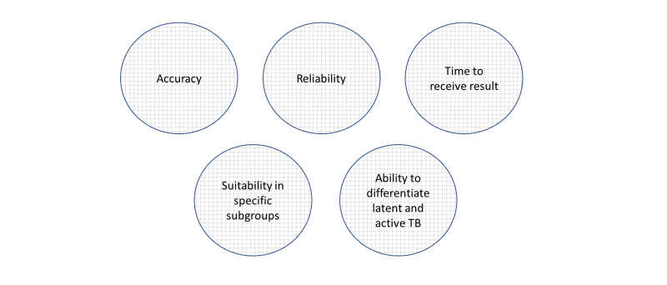
Figure 2. Test-related factors affecting acceptability.
Accuracy
A major factor affecting test acceptability was perceived accuracy. TBST and the IGRA were perceived to have greater accuracy than the TST. This was driven by perceptions of greater specificity and sensitivity, and resulted in greater perceived certainty in the results produced by these tests. However, some concerns were raised that similar to the TST, a “boosting” effect may be found with the TBST whereby serial testing involving intradermal injections may increase false-positive results. Moreover, the TBST and TST are more susceptible to human error while reading the results compared to the IGRA.
“I guess I don’t have a lot of experience with the novel skin tests but I guess my
understanding is that it is really, they’re sort of equivalent to the IGRA in terms of based on the same kind of antigens so you’re essentially getting the equivalent performance in terms of losing the cross-reactivity that you see with the TST with BCG and other non-tuberculosis mycobacterium but in a skin prick form as opposed to blood test… If I was choosing between a TST and a novel skin test, then I would choose the novel skin test due to the improved specificity really.” (ID019, HIC, Provider)

“The measurement involves a ballpoint pen with free flowing ink and you sort of make the mark on the person’s arm until you start to feel a little bit of resistance and then you stop and then you do that on the other side and you stop, and then you measure the distance between those two stops and that’s probably the most accurate way to interpret the induration. But as you can imagine, I mean thank about doing that and think about the issue, how hard that would be and the sort of saying well if it’s 9mms they’re infected, and if it’s 11mms, they’re not infected. Really? Seriously? Do you really believe that?” (ID014, HIC, Provider)
Many participants discussed the downstream benefits of the TBST’s greater accuracy in comparison to the TST. These included preventing psychological stress from false positives, improving rates of diagnosis, improving the evaluation of TB treatments, avoiding consumers receiving unnecessary treatments, saving hospital resources, and reducing expenses in the long term. Participants also discussed the downstream challenges of a test with lower accuracy, such as the TST. These included psychological stress for consumers from false-positives and the expense of false-positives.
Reliability
The TST was perceived to be less reliable than the IGRA, and in some cases, the TBST. Most often, lower reliability perceptions were driven by the degree of human error that could take place for the TST comparative to the IGRA, which was perceived to produce a more objective result. Perceptions that TBST produces less false positives than the TST contributed to feeling as though the TBST were a more reliable test.
“The reading is not like a laboratory reading saying you’ve got this amount of whatever, I don’t quite know how it works with the blood tests, but it’s based on someone actually looking at it and visually grading it, which I would imagine is open to a little bit of personal interpretation and possibly not necessarily getting the accurate range across the like, yeah, if someone different looks at it they might grade it slightly differently.” (ID001, HIC, Consumer)
Time to Receive Result
Some consumers reported being more willing to use the TBST due to the perception that their results would be received more efficiently than the IGRA, which could take one to several weeks to receive a result.
Suitability in Specific Subgroups
Different TBI tests were viewed as more or less suited to particular subgroups. The TBST were believed to be more suited to people with prior BCG vaccination and children than the TST, although they are less suited to children with allergies. One country in which the Diaskintest is in use reported implementing alternative procedures to screen children with severe allergies who receive a positive TBST result, which involved a confirmatory IGRA test.
The IGRA test was discussed as being more suited to use in persons with HIV and BCG vaccination compared to the TST, and more suitable for use in children with allergies compared to the TBST. The TST was judged as more suitable for use in young children than the IGRA due to small veins creating complications with conducting blood draws. Moreover, the TST was discussed as being more suitable for use in groups with prior drug misuse issues whose veins have been damaged, compared to the IGRA:
“We are currently running a program in people that use drugs, so we are using TST to help us in order to diagnose latent TB so we can provide them or offering them the preventive therapy… for people that use heroin or injectable drugs because they don’t have good veins to draw blood and skin tests is better or is easier to use in those scenarios.” (ID009, LMIC, Provider)
Ability to Differentiate Latent and Active TB
A perceived disadvantage of all 3 TBI tests was that none could differentiate between latent and active TB. Several participants discussed the technical challenges and thus low likelihood of developing a test to achieve that aim:
“No the challenges were that it was not really possible to differentiate by the results of the PPD test who is really infected and who really needs preventive treatment… currently all researchers in the field all over the world are looking for some biomarker that could help differentiate latent TB infection from the active TB infection right, yes, but it is very difficult to develop such a biomarker, such a test, because TB infection is very evasive, it can be latent and then it can be active.” (ID015, HIC, Provider)
Contextual Factors
Three subthemes covered contextual factors contributing to TBI test acceptability (Figure 3). Both consumers and healthcare providers discussed how provider perceptions of the test and the infrastructure for test follow-up impact on acceptability. However, only consumer participants discussed how the test environment affects test acceptability – no provider participants mentioned this in their discussion.
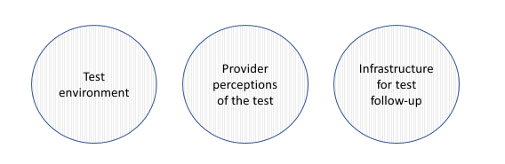
Figure 3. Contextual factors affecting test acceptability.
Provider Perceptions of the Test
Provider communication with consumers around the TBST was anticipated to affect their acceptability (as discussed in an earlier work package: Acceptability > Provider-consumer communication), as this affected the consumer perceptions of the test. Moreover, endorsement and acceptance by healthcare workers and organizations (e.g., the WHO) was expected to increase the acceptability of the TBST. Providers also discussed how useful they thought the TBST would be for their clinical practice compared to the existing tests and in the context of implementation and acceptability challenges. Several providers felt that the TBST would be useful for providing an alternative option for TB screening in situations where the TST or IGRA were not appropriate. Other providers felt that the TBST would only be useful in situations where it is replacing the TST, because of the resources required. Some providers felt very negatively about TB skin tests due to their limitations in accuracy and reliability, and believed that they would only be helpful in very specific situations (e.g., evaluating the effectiveness of new TB treatments in resource-limited settings).
Infrastructure for Test Follow-Up
The infrastructure available to support test follow-up and the care pathway in place (i.e., the processes in place in the health system to support ongoing communication, follow-up and engagement with the consumer) affected acceptability of the TBI tests and consumer perception of whether the test was worthwhile to take. Participants reported issues such as receiving a positive TST result in a large-scale screening program but not receiving any clinical follow-up, or government policies such as deporting individuals with a positive TBI test result.
“If you are being tested and shows positive, then you have to have the TBI treated before you go and those who travel out of the country and they are subjected to the skin test and it turns positive, then we get them deported, so those are some of the challenges… treatment for TBI is not readily available.” (ID010, LMIC, Provider)
Test Environment
The test environment was not raised as an influencing factor for test acceptability by any health providers. Some consumers felt that hospital environments were anxiety-provoking, as discussed in an earlier section (see Acceptability > Consumer experience). This issue could be applicable to all 3 TBI tests, although a hospital appointment is most often involved when receiving the IGRA compared to the skin tests.

Appendix 4. In-depth Feasibility Results

People Factors
Only one subtheme described a people factor that impacted feasibility, which was consumer experience. This subtheme was discussed by both healthcare providers and consumers (Figure 1). Whilst provider communication and infrastructure for test follow-up are also potential factors that may be considered as relevant for feasibility considerations, participants only discussed provider-consumer communication as part of acceptability to influence beliefs and uptake of the test. Similarly, whether there was infrastructure in place for follow-up for a positive test result was discussed as part of acceptability, as it influenced consumer perceptions of whether the test was worthwhile getting, rather than in the context of feasibility.
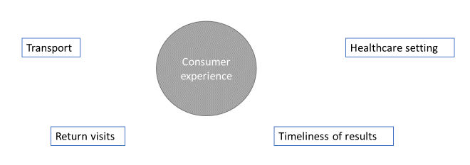
Figure 1. People factors affecting feasibility.

Consumer Experience
Aspects of the consumer experience that impacted the feasibility of TBI tests included a return visit to read the test results, transport requirements, the timeliness of the results, and the healthcare setting.
A common feasibility concern around the TST and TBST was the need for consumers to return to have their test results read 48-72 hours after test administration as part of a second clinic appointment. Often consumers were lost to follow-up, and issues around access to transportation exacerbated the issue, as some participants reported:
“I mean we know a very large percentage of TB skin tests are never read.” (ID014, HIC, Provider)

“So we have another issue like when we apply TST we do make an appointment and then we ask them for another appointment at 72 hours in order to know the result but now not always everybody shows up to the second appointment… can be related to transportation or money resources, so maybe they don’t have enough resources to move around the city or to go to another meeting… it tends to happen, and when it is we know we can’t reapply the TST immediately which we will wait at least well ideally six months but at least three to six months.” (ID009, LMIC, Provider)
A clear advantage for the IGRA in terms of feasibility was the requirement for only one clinic visit to administer the test. This was found to have benefits for healthcare providers in terms of then only needing to allocate resources to follow up positive TBI individuals:
“Well honestly I prefer the IGRA. I think it is a better test in so many ways because one single visit.” (ID009, LMIC, Provider)

“The good thing about the T-SPOT or the IGRA is that they, once they’ve had the blood test done that’s it and actually if they’re not sort of then we can put effort knowing that it’s positive or negative. If it’s positive then obviously we will be following up and putting more effort into trying to find somebody whereas often with a Mantoux, if they don’t come back within the timeframe then it has to be repeated.” (ID012, LMIC, Provider)
Transportation was also a part of the consumer experience for receiving the IGRA, with consumers needing to visit a clinic or hospital to receive the test. This may be more of a feasibility concern in middle/low-income countries compared to high-income countries. This experience is described by a consumer below:
“I mean I guess if you’re looking slightly wider you have to, like I had to drive to the hospital, I had to park, I had to pay for parking, I had to go down into the appointment, into the occupational (indistinct) work, like screening area.” (ID001, HIC, Consumer)
Another consumer experience factor affecting feasibility was the timeliness of receiving the test result. This was perceived to be better with skin tests than with the IGRA, according to one consumer who preferred receiving a more immediate result a couple of days after administration:
“Well it’s low cost, the results coming back quicker, you might have to go to the visit but you’re not waiting months, waiting weeks or the three weeks, that’s quite lengthy to get your results. Waiting two, three days which is good news.” (ID006, HIC, Consumer)
Lastly, the often-busy healthcare environments in which IGRA are typically administered may impair feasibility. Consumers reported needing to spend a lot of time waiting in a crowded or under-staffed hospital clinic to receive the IGRA, which may not be feasible for some consumers. In some cases, consumers speculated that the TBST could be a more efficient process than the IGRA:
“If you’re going to the clinic and there’s no one that can take your blood that day because there’s no one there so you go to the other part of the hospital and then you take a ticket and you wait an hour or whatever and I think that could have been done, that sort of thing in a couple of minutes. So I think it’s not just the cost, I think it’s probably more time, my guess would be it’s more time efficient as well.” (ID002, HIC, Consumer)

Test Factors
Four subthemes described test factors that impacted TBI test feasibility (Figure 2). These were cost, time to receive the result, portability of the test, and ease of administration. All four subthemes were discussed by both consumers and healthcare providers.
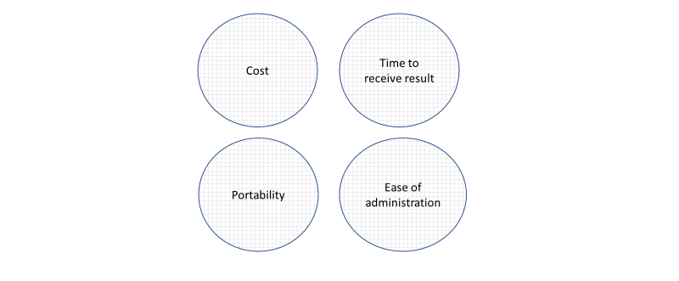
Figure 2. Test-related factors affecting feasibility.

Cost
The TBST and TST were discussed as being of lower cost than the IGRA, thus improving their feasibility in this respect. Some healthcare providers talked about how they would be able to save costs in their current practice with TBST, while others acknowledged that the low cost may increase the willingness of governments to fund the TBST. A couple of providers discussed how the low cost affected their usage intentions towards the TBST. Quotes from providers discussing these aspects are presented below:
“I think in my current practice, since we are now dealing with TB patients as well, it will be an added advantage. I’m saving in costs because we are looking forward to do testing of TB like in children whereby I know it’s very difficult for them to submit a sputum and we intend to at least maybe use this tool…” (ID004, LMIC, Provider)

“It depends also, we have to be very clear here that the country’s, the service provider, which is the Government in most cases, might want to go for a cheaper option. So here, also the costs come into play, that which one will be cheaper to roll out to a bigger population and therefore it depends on the cost, cost become, so the blood test might be easier, might be a perfect one, but the Government might say oh the cost is a little bit higher so I go for the cheaper commodity.” (ID008, LMIC, Consumer)

“The novel skin tests have a very good promising perspective, rollout very easy because it have a low cost and higher specificity in comparison with the IGRA… Generally I guess people believe that the IGRA could have been widely used if we do not think about the cost… We plan to use the novel skin test in future just because the cost, in terms of cost, and also they have a good specificity.” (ID020, LMIC, Provider)

Time to Receive the Result
Although the quick time to receive the result for skin tests relative to the IGRA improved acceptability in some cases, in other cases, the 72 hour wait time for skin tests was described as a disadvantage in terms of feasibility. This is especially the case when consumers need to travel a long distance to reach a clinic, or a remote clinic is visiting rural communities:
“I mean, it’s considerably better than not doing it without a doubt but I would say that might have limitations in, I’ve been in teams where I’ve done clinics and you’re not there for 72 hours, so in remote healthcare or people travel considerable distances to receive treatment and testing, they’re probably not gonna hang around 72 hours to have the results read.” (ID001, HIC, Consumer)

Portability
Portability was discussed as an advantage of the TBST and TST over the IGRA. The portability of skin tests made them more feasible for use in remote communities or mobile health clinics comparative to the IGRA:
“Yeah, I think this is better because if you choose one community you know that needs to be work on it, I think it’s going to be better to a small community that we need to diagnose or if you have a case then pulmonary TB around so we can go and do novel test, yeah, that will be the small community.” (ID018, LMIC, Provider)
Moreover, the portability of skin tests was discussed as an advantage for improving test accessibility to people who are unable to or do not want to visit a healthcare setting:
“If you were going into say a homeless shelter or somewhere, to take the blood is quite a drawn out thing, pardon the pun, and then it’s go to go to the lab and it’s got to be processed in a certain time. I mean obviously these tests you have to come back and look at people but you could go to a setting and do that, going to the people rather than people coming to the setting and sometimes I think that’s gonna be invaluable… because that’s a barrier to a lot of people, it’s a barrier and they don’t want to go to a healthcare setting.” (ID002, HIC, Consumer)

Ease of Administration
In terms of the ease of administration, the TST was discussed as being relatively easy to use with appropriately trained staff available. Some providers discussed the technique of the TST as being tricky at first, but ease of use came with practice and appropriate training:
“I mean, they’re fairly easy to use. I mean they’re a bit fiddly but they’re not, once you get used to it it’s just getting the technique… But it’s yeah, it’s not difficult, once you get the hang of it.” (ID012, HIC, Provider)

“We found that we have to retrain our staff at least every six months of the year… with the result sometimes it’s incorrect so every, for example in the community they accepting every time they go to a village, I have to spend the first two or three times intensively to check every (indistinct) to make sure that the member have inserted correctly, this is more challenge… I think from my personal point of view, it’s pretty easy to use cos I know how to do it and I do it myself and I train other people… the technique is easy, in our team I mean we use the TST for 10,000 in total and there’s only one incident occupation who the needle stick.” (ID013, HIC, Provider)
The TBST were judged as being easy to use due to requiring a similar administration technique to the TST, although a trained staff requirement would also apply:
“The novel skin test, the Diaskintest, is performed exactly with the same technique, the same logistic as the PPD test and then it will be assessed after 72 hours of placement of test. So this, well identity of implementation technique makes it very user friendly because there is no need of retraining the staff and all the staff have already been trained.” (ID016, LMIC, Provider)

“So you know actually in China so in the past actually especially two years before, we normally use the PPD, always use the traditional one. So two years ago, actually the EC, that’s the novel skin test, that gets the license, so we gradually introduced the EC in our field… you know actually for this novel skin test it’s very similar for the process and procedure, it’s very similar.” (ID020, LMIC, Provider)

“I think in terms of the actual administration of the test and the reading of the test, I think, because I think it is very similar to the Mantoux so I don’t think they’re a particular, well certainly from my point of view, I can’t speak for my staff but from my point of view I don’t feel any sort of particular concerns about that… I don’t think it would be too difficult because we already so, I mean we don’t do masses of Mantoux’s but we do do them. So we already have clinics set up, so our clinics sort of how they run.” (ID012, HIC, Provider)
The IGRA was viewed as less easy to administer in comparison to the skin tests due to the complexity involved, although this was not heavily discussed:
“Ideally if we had an alternative which was a, you know, fingerprick blood test or something that you could do that was much more straightforward that didn’t require the same complexity that the IGRA do…” (ID019, HIC, Provider)

Contextual Factors
Three subthemes covered contextual factors that impacted test feasibility (Figure 3). These were all discussed by both consumers and healthcare providers, and included resource requirements, the COVID-19 pandemic, and the health system setting.
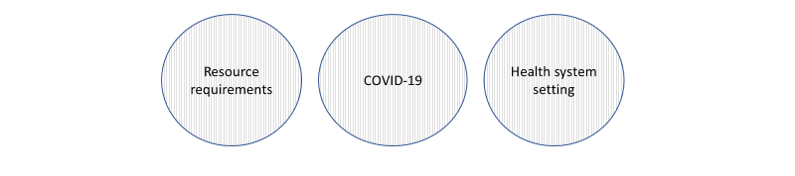
Figure 3. Contextual factors affecting test feasibility.

Resource Requirements
The TBST, TST, and IGRA all require access to specific test equipment and trained staff – as such, the availability of a trained workforce was considered key for test feasibility. However, the IGRA also requires access to a laboratory for test analysis and a hospital or clinic for the blood draw. As a result, there is also a mandatory transport requirement for the IGRA on the part of the consumer to the hospital or clinic. Patient transport may be a requirement of the TBST and TST in some settings, however not necessarily due to their portability. Overall, the IGRA requires more resources to administer than TBST and the TST, which may reduce its feasibility in more resource-limited settings.
“I feel like the good thing about it is you don’t need much lab infrastructure, I feel like the need to sort of draw blood is a barrier for IGRA… I think that yeah, the lab aspect, yeah the fact that [the TBST] can be administered in pretty much any kind of setting is good, even though, I don’t know about the stability of like what’s the names, sometimes they go out of date.” (ID017, HIC, Provider)

COVID-19
Reduced clinic appointments and a shortage of blood test bottles and other test materials reduced the feasibility of all three TBI tests during the COVID-19 pandemic.
“I think right now if you were offered a blood test and you were given an appointment, like I think you treat that as a privilege because not all healthcare appointments are easily accessible at all at the moment.” (ID001, HIC, Consumer)

“I think they’re mainly using the blood test although I don’t know what’s happened since COVID cos I think it’s all sort of grinding to a halt.” (ID002, HIC, Consumer)

Health System Setting
Considerations relating to health system infrastructure was a key aspect of feasibility. The TBST and TST are lower-cost test options that were viewed to be more appropriate for low-resource settings. Moreover, their low cost and portability were discussed as making them more scalable for use in large scale screening programs than the IGRA. However, an advantage of the IGRA was the ability to screen for TBI alongside other tests when used as part of a routine blood draw. Participants also discussed how aspects of the healthcare system would affect the ease of implementing TBST (e.g., government approvals and willingness to fund the tests).
“At the time I had the blood taken, I had loads, they look loads of different vials cos they were testing for immunity for all sorts of healthcare related conditions… it was just another one of the blood tubes that they happened to take that day, so it didn’t bother me at all.” (ID001, HIC, Consumer)

“Honestly, I love IGRA. I think they should be the standard of care but they are expensive, so trying to be honest and trying to be realistic in countries where money matters, I think this new test can give us a chance to improve the program.” (ID009, LMIC, Provider)

