Picture1. Stomatal density in leaves of diploid, triploid and tetraploid of FI synthetic banana hybrids
Diploid | Triploid | Tetraploid
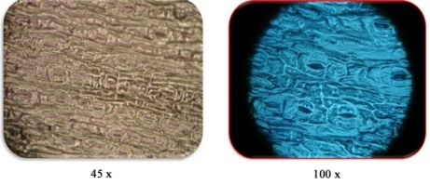 | 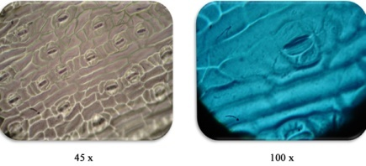 | 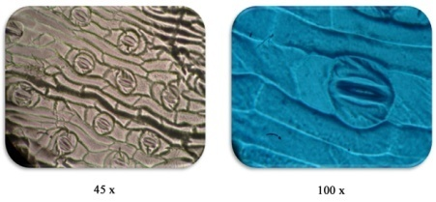
Picture 2. phonological characters of pollen of diploid, triploid and tetraploid of FI synthetic banana hybrids
Diploid | Triploid | Tetraploid
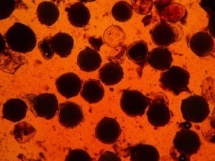 | 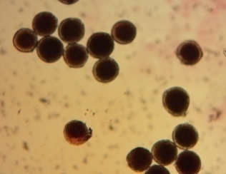 | 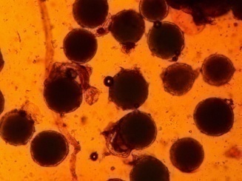

Picture 3. Comparison of plant morphology of ploid, triploid and tetraploid banana hybrids.
Diploid  (H-11-49- AA) | Triploid  (H-11-25 - AAA) | Tetraploid  (H-11-78-AABB)
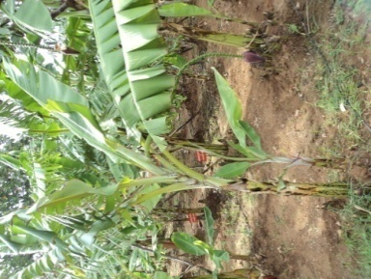 | 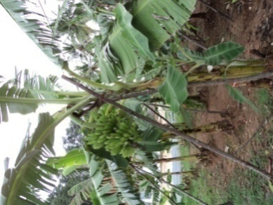 | 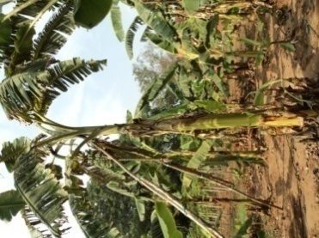
(A). Whole plant view
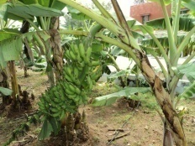 | 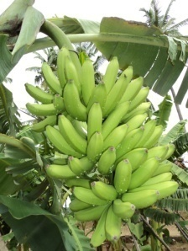 | 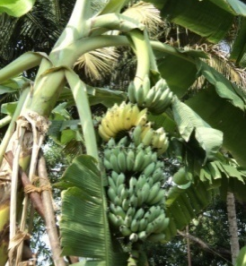
(B). Bunch size
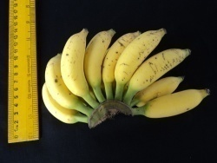 | 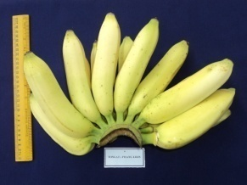 | 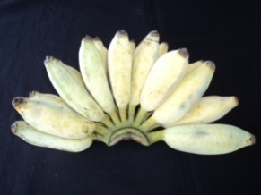
(C). Finger size

