
Nasir Ahmad Jalali, received his B.S Degree from Kabul Education University and his Master degree (MS) from Kabul University cooperated by Tallinn University, Estonia in 2016. Currently he is pursuing his PhD degree from the School of Computer and Communication Engineering at University of Science and Technology Beijing (USTB), China from 2020. Mr. Jalali has been an associate professor at Ghazni University, Ghazni, Afghanistan since 2012. His research interest includes network security, information security, federated learning, machine learning, big data, chatbots security and IoT privacy-preserving. Mr. Jalali has published four academic papers and he is the author of two books entitled MPLS-VPN Impacts on VoIP-QoS and Framework Development for Higher Education Information Security in Afghanistan respectively.
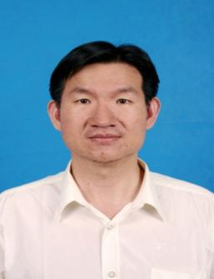
Chen Hongsong received his Ph.d Degree of Computer Science in Harbin Institute of Technology in 2006. He is a professor in University of Science and Technology Beijing (USTB), China from 2008. He was a visiting scholar in Department of Computer Science of Purdue University from 2013-2014. He is a high-level member of China Computer Federation. He is an IEEE member now. His research interests include Artificial Intelligence and information security, wireless network and pervasive computing, trust computing. He got the excellent young academic paper award in USTB in 2009.He has published more than 60 academic papers and 5 books.

