Supplementary Information for “Persisting influence of continental inheritance on early oceanic spreading”

Adrien Moulin¹, Sigurjón Jónsson¹
¹King Abdullah University of Science and Technology (KAUST), Thuwal, Saudi Arabia

Supplementary Figures:

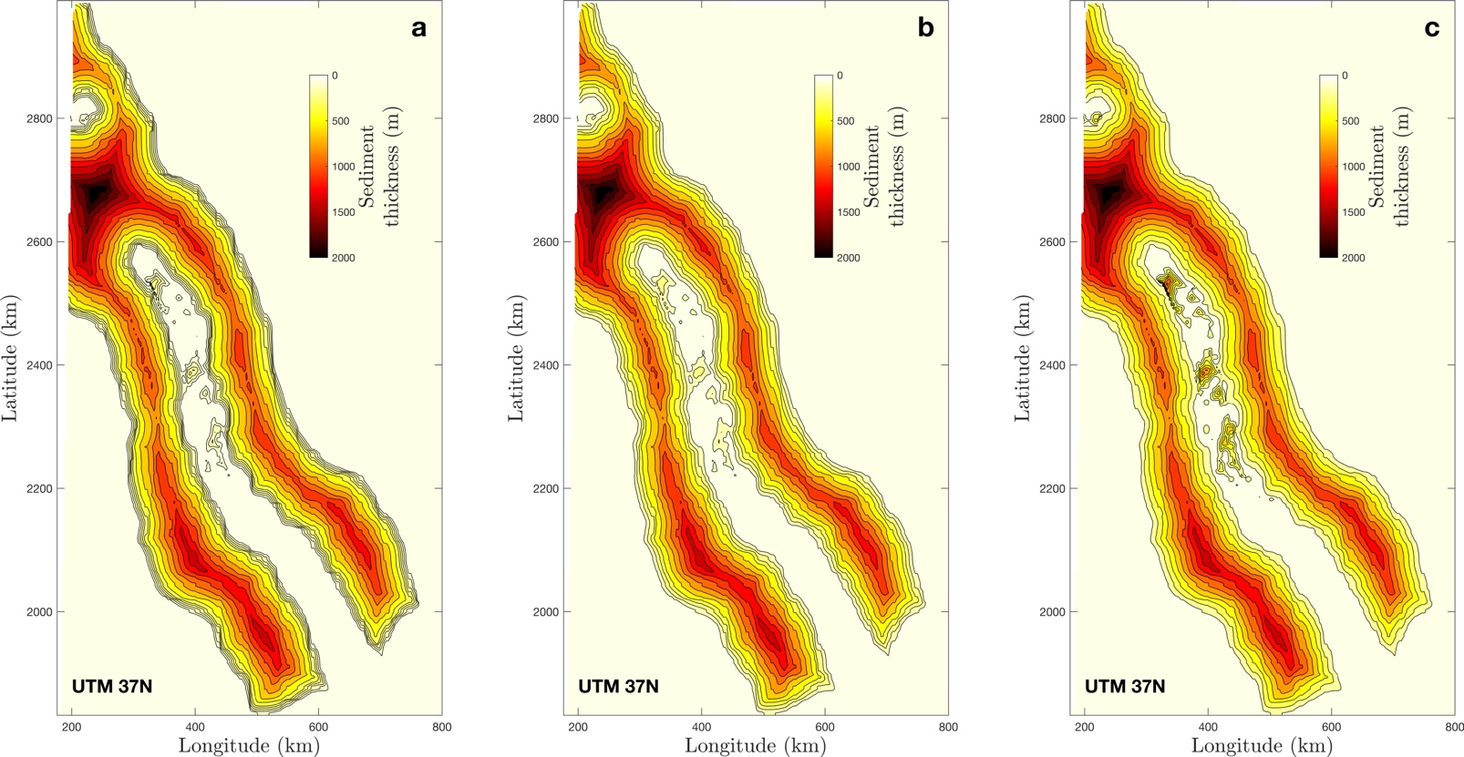

Figure S1: Sediment thickness grids used to compute the Mantle Bouguer anomaly. The sediment away from the central trough has a lens shape in cross-section with thickness increasing from 0km (at the edges of the axial trough and coastal plain) to 2km midway. The three grids differ by the thickness of the salt flows within the axial trough: at most 250m (a), at most 500m (b), or at most 1000m (c). Contour lines have a spacing of 150m, except between 0 and 250m where it is 50m in (a), and 100m in (b). The Bouguer anomaly difference between these 3 models is depicted as a transparent red envelope in Fig. 3a of the main text. Note that the excess axial sediment thickness around Latitude 2700 km is unconstrained and artificially generates the large negative Mantle Bouguer Anomaly seen around 1400-1500 km in Fig. 3a of the main text.

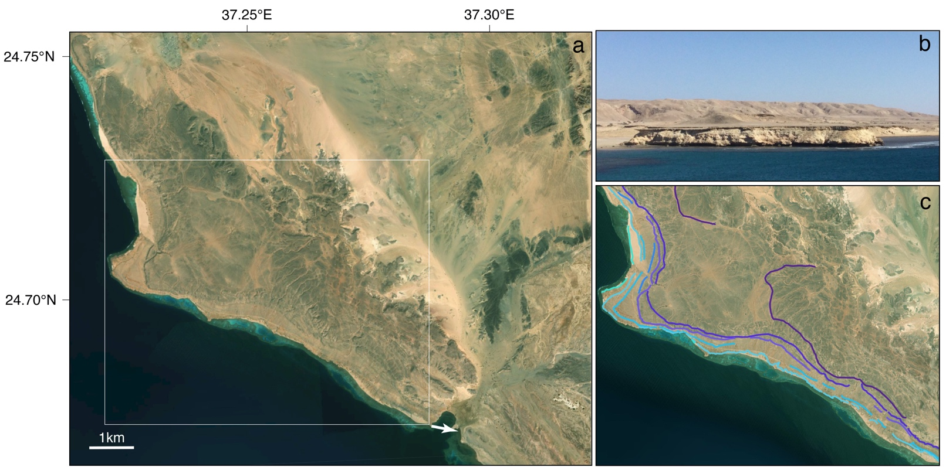

Figure S2: (a) GoogleEarth image of the Arabian coast between Yanbu and UmmLujj (corresponding to the coastal area encompassed by the circle denoting the Lunayyir volcanic field in Fig. 1b of the main text) showing several levels of marine coral terraces presently standing up to 90m above sea level. The arrow depicts the view angle of the field picture in (b). The white box shows the area of (c). (b) Field picture of the marine coral terraces as seen from the location shown in (a). (c) Preliminary mapping of 7 terrace levels based on field observations and the analysis of satellite images.

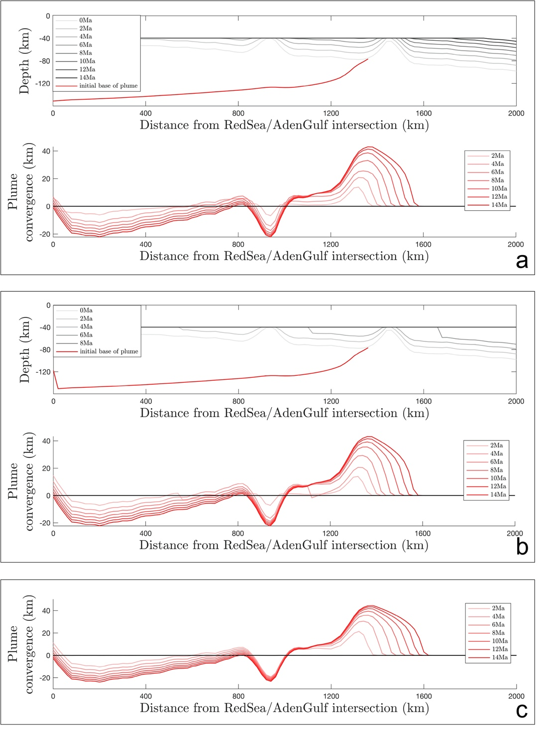

Figure S3: Along-axis transects of a 2D plume-spreading model evolution based on the same code as in Figure 5 of the main text. In all the 3 explored cases, the model starts with the lithosphere and plume thickness obtained at time=26Ma from the model presented in Figure 5a of the main text (time denotes time after the onset of spreading). The upper plots in (a) and (b) show the evolution of the lithospheric thickness every 2Ma (gray tones). In (a) oceanic spreading is imposed to occur at t=0 at the location which has the most thinned lithosphere (~40km in our model), and initiate elsewhere as soon as the lithosphere reaches the same value. The same condition is imposed in (b) except that spreading is also forced independently by a wave that propagates from left to right at a rate of 280km/Ma. In (c) oceanic spreading is synchronous and occurs at t=0 (the lithospheric thickness always remains at ~40km). The lower plots in (a), (b), and (c) depict the convergence of plume material relative to initial time, and show a deficit of plume convergence where the pre-rift lithosphere was thinner (i.e., at an horizontal distance of ~950km). This deficit persists longer when moving from case (c) (~1Ma) to case (b) (5-6Ma) and from case (b) to case (a) (almost 10Ma).

