Appendix A
Certificate of approval received from Jabatan Pendidikan Negeri Terengganu (File No. P.T.06030-35(76) in Appendix A.
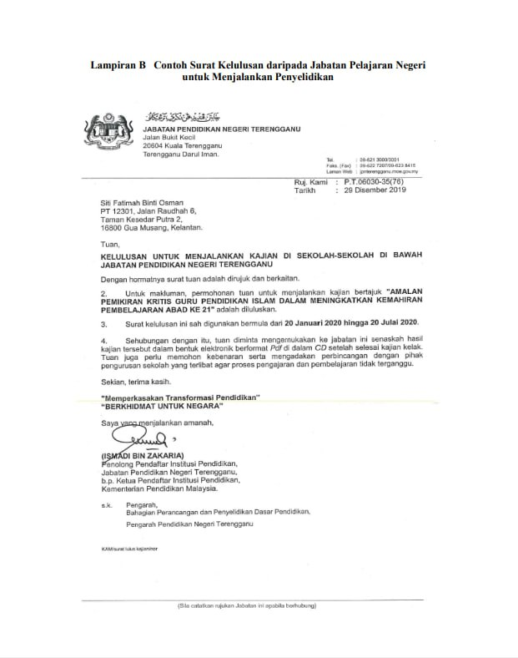

Appendix B

|

Consent form for Publication
I Mohd Shamsury Abdul Rahman give my consent for information about myself/my child or ward/my relative (circle as appropriate) to be published in
[Name of journal] Discover Sustainability
[Manuscript number] a897e222-1be6-42b1-ab42-6dccb04fec93
[Corresponding author] Siti Fatihah Osman
NB: In cases where the patient has died or is incapable of giving consent, consent may be given by the next of kin. If the patient is under the age of 16, consent should be given by a parent or guardian.

I understand that the text and any pictures or videos published in the article
- will be used only in educational publications intended for professionals
Or
- if the publication or product is published on an open access basis, I understand that it will be freely available on the internet and may be seen by the general public.

The pictures, videos and text may also appear on other websites or in print, may be translated into other languages or used for commercial purposes.

I understand that the information will be published without my/my child or ward’s/my relative’s (circle as appropriate) name attached, but that full anonymity cannot be guaranteed.

I have been offered the opportunity to read the manuscript.

I acknowledge that it is not possible to ensure complete anonymity, and someone may be able to recognize me. However, by signing this consent form I do not in any way give up, waive or remove my rights to privacy. I may revoke my consent at any time before publication, but once the information has been committed to publication (“gone to press”), revocation of the consent is no longer possible.
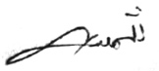
Name Mohd Shamsury Abdul Rahman Date 16.05.2020 Signed
Author name Muhammad Talhah Ajmain @ Jima’ain Date 16.05.2020 Signed 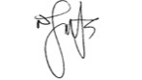

Please keep this consent form in the patient’s case files. The manuscript reporting this patient’s details should state that ‘Written informed consent for publication of their clinical details and/or clinical images was obtained from the patient/parent/guardian/ relative of the patient. A copy of the consent form is available for review by the Editor of this journal.

|

Consent form for Publication

I Rapiah Jusoh give my consent for information about myself/my child or ward/my relative (circle as appropriate) to be published in
[Name of journal] Discover Sustainability
[Manuscript number] a897e222-1be6-42b1-ab42-6dccb04fec93
[Corresponding author] Siti Fatihah Osman
NB: In cases where the patient has died or is incapable of giving consent, consent may be given by the next of kin. If the patient is under the age of 16, consent should be given by a parent or guardian.

I understand that the text and any pictures or videos published in the article
- will be used only in educational publications intended for professionals
Or
- if the publication or product is published on an open access basis, I understand that it will be freely available on the internet and may be seen by the general public.

The pictures, videos and text may also appear on other websites or in print, may be translated into other languages or used for commercial purposes.

I understand that the information will be published without my/my child or ward’s/my relative’s (circle as appropriate) name attached, but that full anonymity cannot be guaranteed.

I have been offered the opportunity to read the manuscript.

I acknowledge that it is not possible to ensure complete anonymity, and someone may be able to recognize me. However, by signing this consent form I do not in any way give up, waive or remove my rights to privacy. I may revoke my consent at any time before publication, but once the information has been committed to publication (“gone to press”), revocation of the consent is no longer possible.
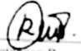
Name Rapiah Jusoh Date 28.01.2020 Signed
Author name Muhammad Talhah Ajmain @ Jima’ain Date 28.01.2020 Signed

Please keep this consent form in the patient’s case files. The manuscript reporting this patient’s details should state that ‘Written informed consent for publication of their clinical details and/or clinical images was obtained from the patient/parent/guardian/ relative of the patient. A copy of the consent form is available for review by the Editor of this journal.
|

Consent form for Publication

I Rumaizah Abdullah give my consent for information about myself/my child or ward/my relative (circle as appropriate) to be published in
[Name of journal] Discover Sustainability
[Manuscript number] a897e222-1be6-42b1-ab42-6dccb04fec93
[Corresponding author] Siti Fatihah Osman
NB: In cases where the patient has died or is incapable of giving consent, consent may be given by the next of kin. If the patient is under the age of 16, consent should be given by a parent or guardian.

I understand that the text and any pictures or videos published in the article
- will be used only in educational publications intended for professionals
Or
- if the publication or product is published on an open access basis, I understand that it will be freely available on the internet and may be seen by the general public.

The pictures, videos and text may also appear on other websites or in print, may be translated into other languages or used for commercial purposes.

I understand that the information will be published without my/my child or ward’s/my relative’s (circle as appropriate) name attached, but that full anonymity cannot be guaranteed.

I have been offered the opportunity to read the manuscript.

I acknowledge that it is not possible to ensure complete anonymity, and someone may be able to recognize me. However, by signing this consent form I do not in any way give up, waive or remove my rights to privacy. I may revoke my consent at any time before publication, but once the information has been committed to publication (“gone to press”), revocation of the consent is no longer possible.
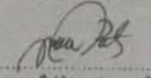
Name Rumaizah Abdullah Date 13.04.2020 Signed
Author name Muhammad Talhah Ajmain @ Jima’ain Date 13.04.2020 Signed

Please keep this consent form in the patient’s case files. The manuscript reporting this patient’s details should state that ‘Written informed consent for publication of their clinical details and/or clinical images was obtained from the patient/parent/guardian/ relative of the patient. A copy of the consent form is available for review by the Editor of this journal.
|

Consent form for Publication
I Nur Diyana Rahim give my consent for information about myself/my child or ward/my relative (circle as appropriate) to be published in
[Name of journal] Discover Sustainability
[Manuscript number] a897e222-1be6-42b1-ab42-6dccb04fec93
[Corresponding author] Siti Fatihah Osman
NB: In cases where the patient has died or is incapable of giving consent, consent may be given by the next of kin. If the patient is under the age of 16, consent should be given by a parent or guardian.

I understand that the text and any pictures or videos published in the article
- will be used only in educational publications intended for professionals
Or
- if the publication or product is published on an open access basis, I understand that it will be freely available on the internet and may be seen by the general public.

The pictures, videos and text may also appear on other websites or in print, may be translated into other languages or used for commercial purposes.

I understand that the information will be published without my/my child or ward’s/my relative’s (circle as appropriate) name attached, but that full anonymity cannot be guaranteed.

I have been offered the opportunity to read the manuscript.

I acknowledge that it is not possible to ensure complete anonymity, and someone may be able to recognize me. However, by signing this consent form I do not in any way give up, waive or remove my rights to privacy. I may revoke my consent at any time before publication, but once the information has been committed to publication (“gone to press”), revocation of the consent is no longer possible.

Name Nur Diyana Rahim Date 18.06.2020 Signed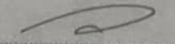
Author name Muhammad Talhah Ajmain @ Jima’ain Date 18.06.2020 Signed

Please keep this consent form in the patient’s case files. The manuscript reporting this patient’s details should state that ‘Written informed consent for publication of their clinical details and/or clinical images was obtained from the patient/parent/guardian/ relative of the patient. A copy of the consent form is available for review by the Editor of this journal.

|

Consent form for Publication
I Anisah Mat Soh give my consent for information about myself/my child or ward/my relative (circle as appropriate) to be published in
[Name of journal] Discover Sustainability
[Manuscript number] a897e222-1be6-42b1-ab42-6dccb04fec93
[Corresponding author] Siti Fatihah Osman
NB: In cases where the patient has died or is incapable of giving consent, consent may be given by the next of kin. If the patient is under the age of 16, consent should be given by a parent or guardian.

I understand that the text and any pictures or videos published in the article
- will be used only in educational publications intended for professionals
Or
- if the publication or product is published on an open access basis, I understand that it will be freely available on the internet and may be seen by the general public.

The pictures, videos and text may also appear on other websites or in print, may be translated into other languages or used for commercial purposes.

I understand that the information will be published without my/my child or ward’s/my relative’s (circle as appropriate) name attached, but that full anonymity cannot be guaranteed.

I have been offered the opportunity to read the manuscript.

I acknowledge that it is not possible to ensure complete anonymity, and someone may be able to recognize me. However, by signing this consent form I do not in any way give up, waive or remove my rights to privacy. I may revoke my consent at any time before publication, but once the information has been committed to publication (“gone to press”), revocation of the consent is no longer possible.

Name Anisah Mat Soh Date 18.08.2020 Signed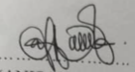
Author name Muhammad Talhah Ajmain @ Jima’ain Date 18.08.2020 Signed

Please keep this consent form in the patient’s case files. The manuscript reporting this patient’s details should state that ‘Written informed consent for publication of their clinical details and/or clinical images was obtained from the patient/parent/guardian/ relative of the patient. A copy of the consent form is available for review by the Editor of this journal.

|

Consent form for Publication

I Ahmad Tarmizi Che Harun give my consent for information about myself/my child or ward/my relative (circle as appropriate) to be published in
[Name of journal] Discover Sustainability
[Manuscript number] a897e222-1be6-42b1-ab42-6dccb04fec93
[Corresponding author] Siti Fatihah Osman
NB: In cases where the patient has died or is incapable of giving consent, consent may be given by the next of kin. If the patient is under the age of 16, consent should be given by a parent or guardian.

I understand that the text and any pictures or videos published in the article
- will be used only in educational publications intended for professionals
Or
- if the publication or product is published on an open access basis, I understand that it will be freely available on the internet and may be seen by the general public.

The pictures, videos and text may also appear on other websites or in print, may be translated into other languages or used for commercial purposes.

I understand that the information will be published without my/my child or ward’s/my relative’s (circle as appropriate) name attached, but that full anonymity cannot be guaranteed.

I have been offered the opportunity to read the manuscript.

I acknowledge that it is not possible to ensure complete anonymity, and someone may be able to recognize me. However, by signing this consent form I do not in any way give up, waive or remove my rights to privacy. I may revoke my consent at any time before publication, but once the information has been committed to publication (“gone to press”), revocation of the consent is no longer possible.
Name Ahmad Tarmizi Che Harun Date 16.07.2020 Signed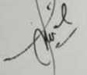
Author name Muhammad Talhah Ajmain @ Jima’ain Date 16.07.2020 Signed

Please keep this consent form in the patient’s case files. The manuscript reporting this patient’s details should state that ‘Written informed consent for publication of their clinical details and/or clinical images was obtained from the patient/parent/guardian/ relative of the patient. A copy of the consent form is available for review by the Editor of this journal.

