Table 3. Right Upper Quadrant (RUQ) port setup. 95th and 5th percentile.
5
5
Right Upper Quadrant (RUQ) port setup
Port number | Port size | Instrument | 95th percentile | 5th percentile
Port 1 | 11 mm | Endoscope | To Xyphoid:  5 cm patient right  18 cm inferior | To Xyphoid:  2 cm patient right  16 cm inferior
Port 2 | 8 mm | Left Hand | To Endoscope:  12 cm patient right  0 cm superior | To Endoscope:  8 cm patient right  0 cm superior
Port 3 | 8 mm | Right Hand | To Endoscope:  10 cm patient left  5 cm superior | To Endoscope:  6 cm patient left  5 cm superior
Port 4 | 8 mm | Reserve | To Right Hand:  10 cm patient left  0 cm superior | To Right Hand:  8 cm patient left  0 cm superior
Port 5 | 12 mm | Assistant | To Endoscope:  6 cm patient right  5 cm inferior | To Endoscope:  4 cm patient right  4 cm inferior
95th percentile  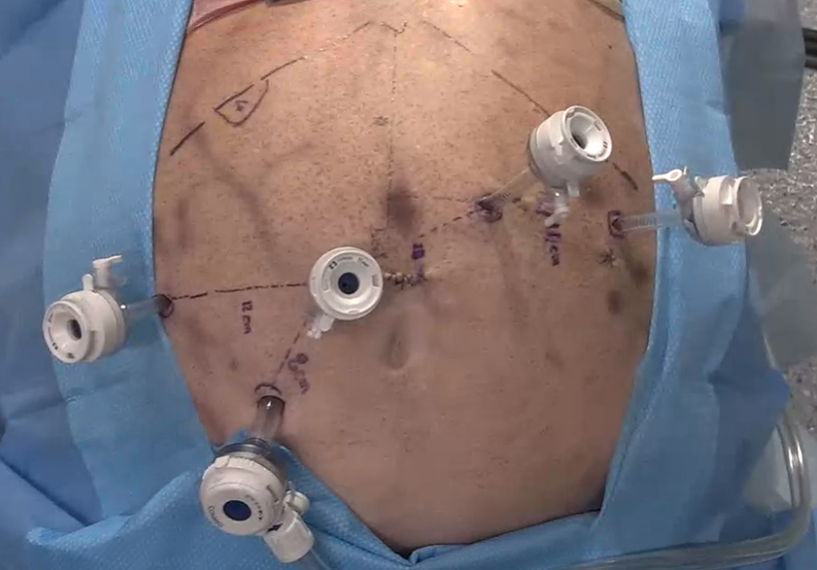  4  3  2  1  Patient head |  |  | 5th percentile  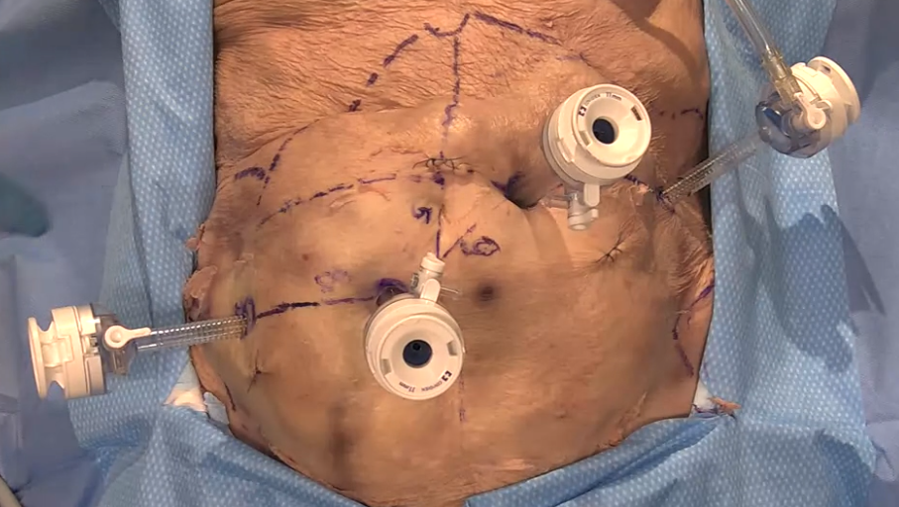  4  3  2  Patient head  1

Table 4. Left Upper Quadrant (LUQ) port setup. 95th and 5th percentile.
Left Upper Quadrant (LUQ) port setup
Port number | Port size | Instrument | 95th percentile | 5th percentile
Port 1 | 11 mm | Endoscope | To Xyphoid:  5 cm patient left  18 cm inferior | To Xyphoid:  2 cm patient left  13 cm inferior
Port 2 | 8 mm | Left Hand | To Endoscope:  9 cm patient right  5 cm superior | To Endoscope:  6 cm patient right  5 cm superior
Port 3 | 8 mm | Right Hand | To Endoscope:  12 cm patient left  0 cm superior | To Endoscope:  8 cm patient left  0 cm superior
Port 4 | 8 mm | Reserve | To Left Hand:  10 cm patient right  0 cm superior | To Left Hand:  8 cm patient right  0 cm superior
Port 5 | 12 mm | Assistant | To Endoscope:  6 cm patient left  6 cm inferior | To Endoscope:  4 cm patient left  4 cm inferior
95th percentile  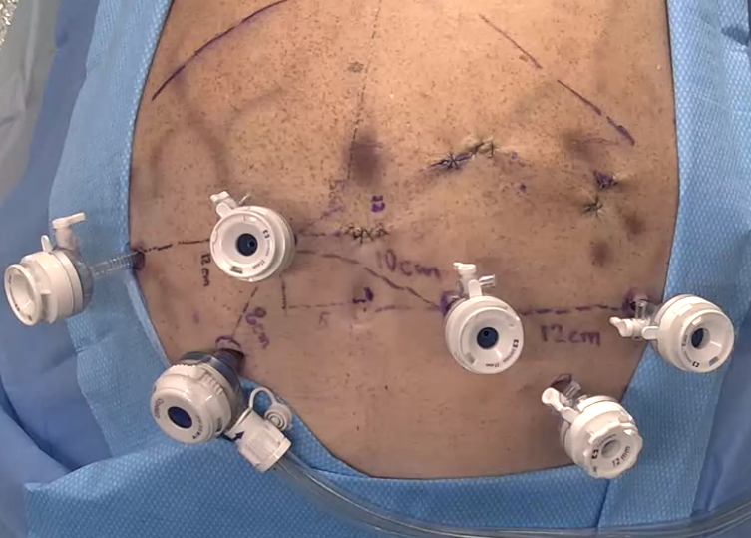  3  4  5  2  1  Patient head |  |  | 5th percentile  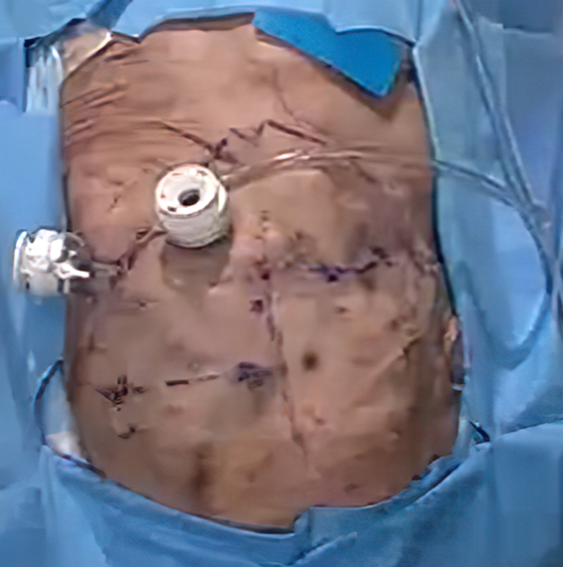  4  2  3  1  5  Patient head

Table 5. Same port placement with different instrument assignment for RUQ and LUQ.
RUQ port setup | LUQ surgeries with RUQ port setup
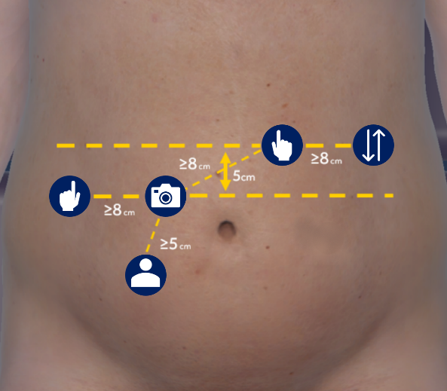 | 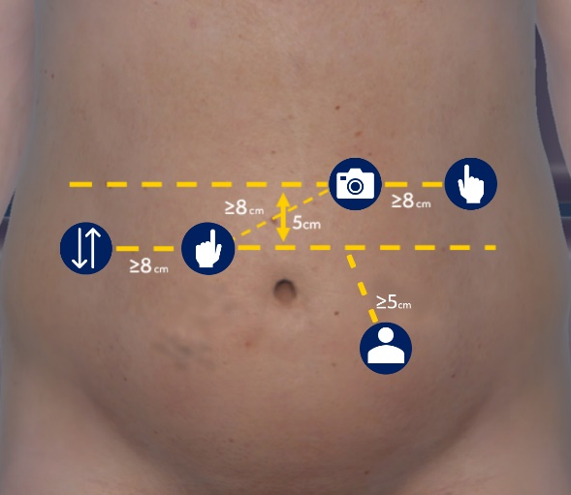

Table 6. Recommended guidelines by Medtronic. a: Alternative port placement for LUQ procedures.
RUQ Surgery  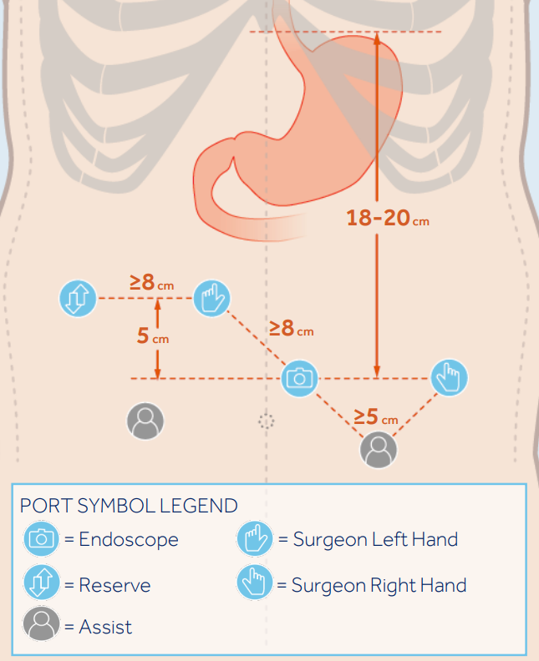 | LUQ Surgery
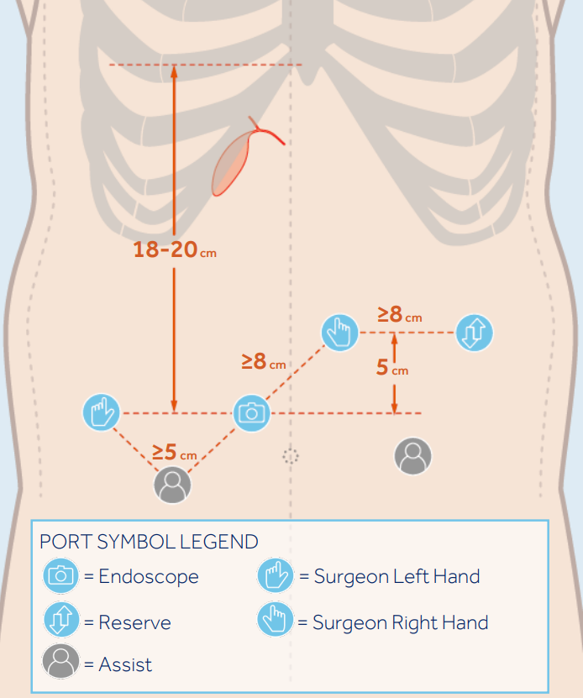 | 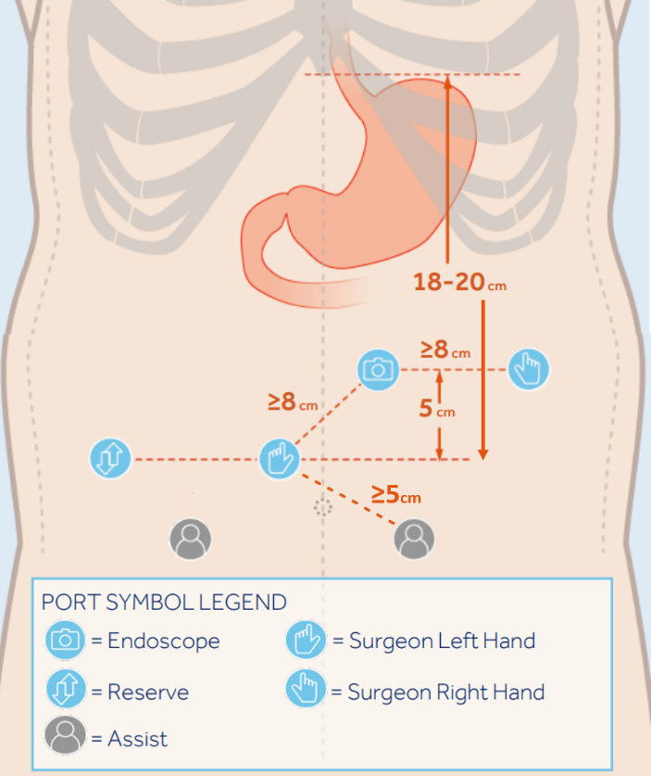  a
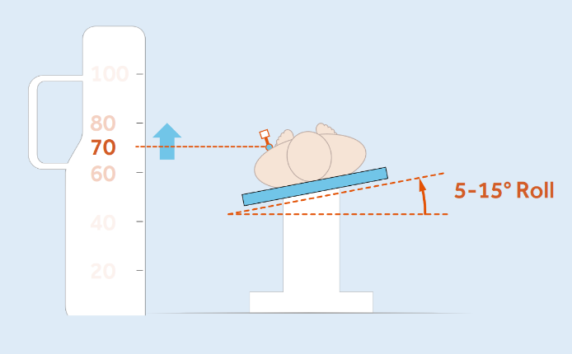 | 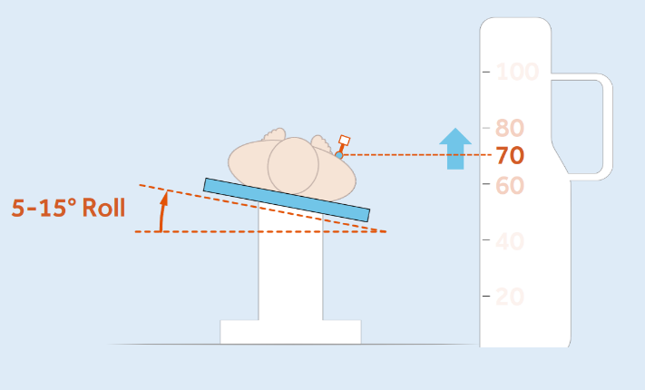
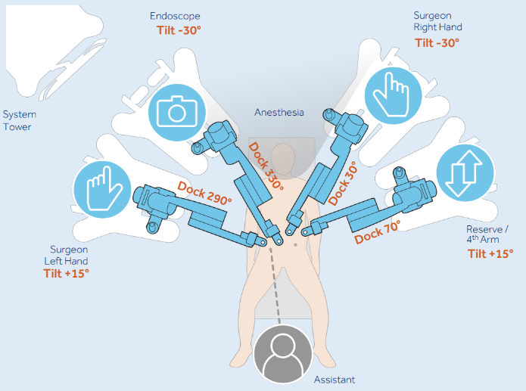 | 