Supplementary Information: Ecology and biogeochemistry of the microbial underworld in two sister soda lakes
Alexandre J. Paquette^{1*}, Srijak Bhatnagar⁴, Agasteswar Vadlamani¹, Timber Gillis², Varada Khot¹, Breda Novotnik¹, Hector De la Hoz Siegler³, Marc Strous¹, and Jayne E. Rattray²
¹ Department of Earth, Energy, and Environment, University of Calgary, 2500 University Drive, Calgary, Alberta T2N1N4, Canada
² Department of Biological Sciences, University of Calgary, 2500 University Drive, Calgary, Alberta T2N1N4, Canada
³ Department of Chemical and Petroleum Engineering, University of Calgary, 2500 University Drive, Calgary, Alberta T2N1N4, Canada
⁴ Faculty of Science and Technology, Athabasca University, 1 University Dr, Athabasca, AB T9S 3A3, Canada
*Corresponding author email: alexandre.paquette@ucalgary.ca

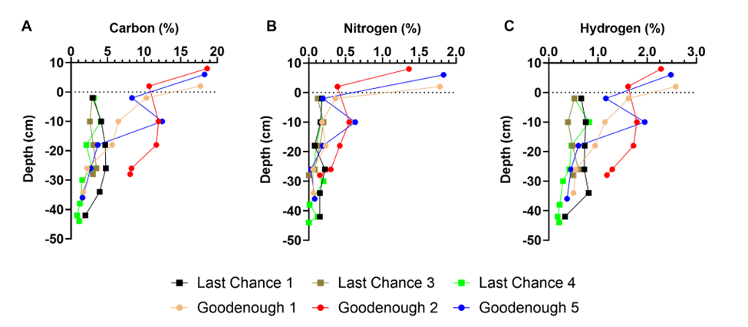
Figure S1: Carbon (A), Nitrogen (B), and Hydrogen (C) content (%) of the sediment material for Last Chance and Goodenough Lake. Sediment material was freeze dried and the CHN content was analyzed using a UNICUBE elemental analyzer (Elementar, Langenselbold, Germany).
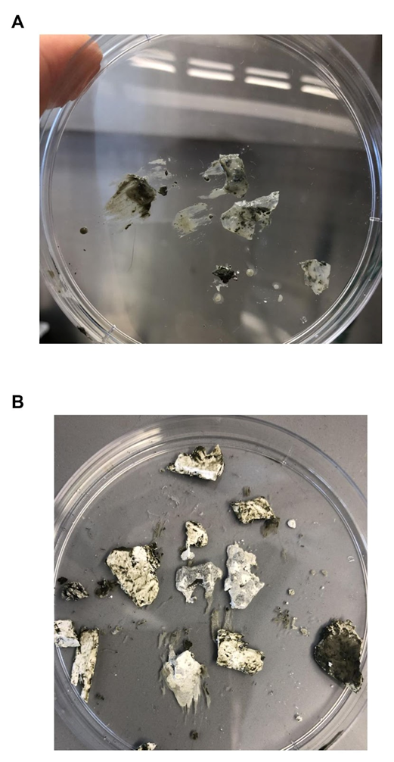
Figure S2: Crystal structures found throughout all cores from Last Chance Lake. The crystals were transparent (A) when initially extracted from the cores, but after a few minutes they began to dry out and turn white (B). These crystals ranged in size from 0.5 – 1.5 cm wide and 1.0 – 3.0 cm in length.
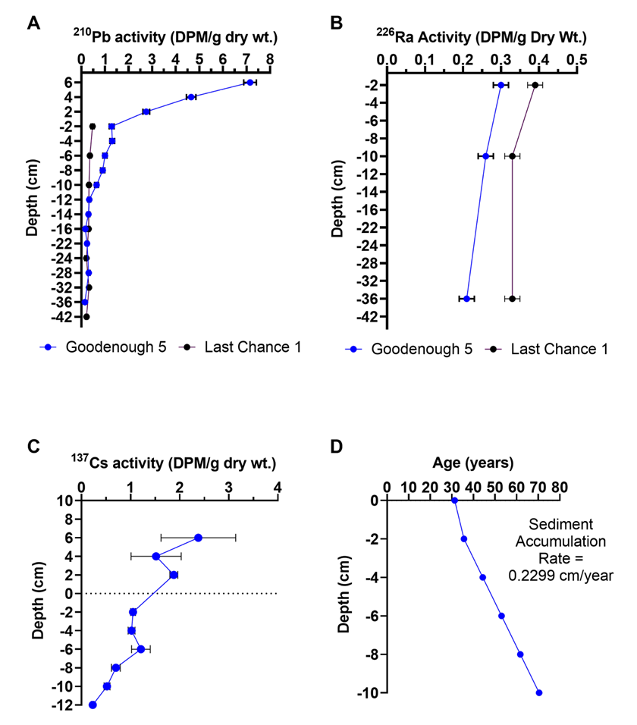
Figure S3: Core dating of Goodenough Lake Core 5 and Last Chance Lake Core 1. The deepest cores from each lake were sent to the Flett Research group (Winnipeg, Manitoba, Canada) for radioisotope dating. ²¹⁰Pb (A) and ¹³⁷Cs (C) activity were measured to determine the rate of sediment accumulation. ²²⁶Ra (B) activity was measured to positively determine the Pb-210 background level throughout the core length. (D) Age profile and sediment accumulation rate for Goodenough Core 5.

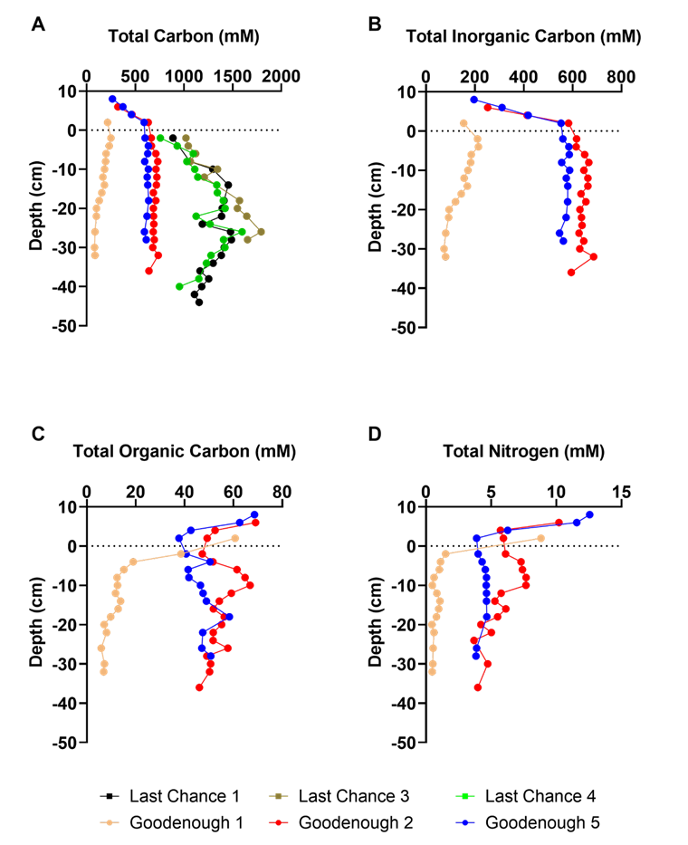
Figure S4: Down-core profiles of total carbon (A), total inorganic carbon (B), total organic carbon (C), and total nitrogen (D) in the porewater. Total carbon (TC), total organic carbon (TOC), and total nitrogen (TN) in the pore water were measured using a Shimadzu Total Organic Carbon TOC-V Analyzer equipped with an ASI-V autosampler (Shimadzu, Columbia, MD, USA). Porewater samples from Last Chance Lake could only be measured for TC as the high salt content of the samples prevented the analysis of TOC, TIC, and TN.

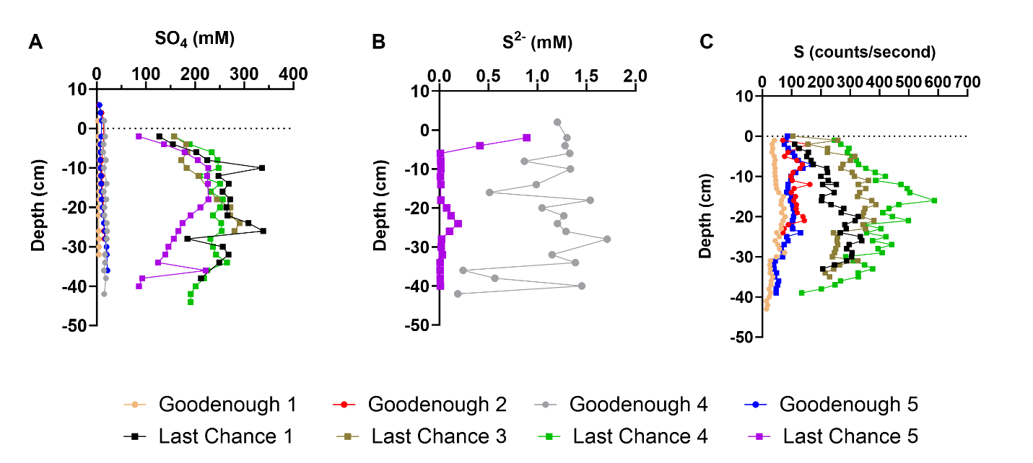
Figure S5: Downcore profiles of SO₄, S²⁻, and Sulfur. (A) Sulfate was measured in the porewater using an ion chromatography system. (B) Porewater sulfide concentration was analyzed with the methylene blue method only for Last Chance Core 5 and Goodenough Core 4. (C) X-Ray Fluorescence was used to determine the content of elemental sulfur in the sediment.
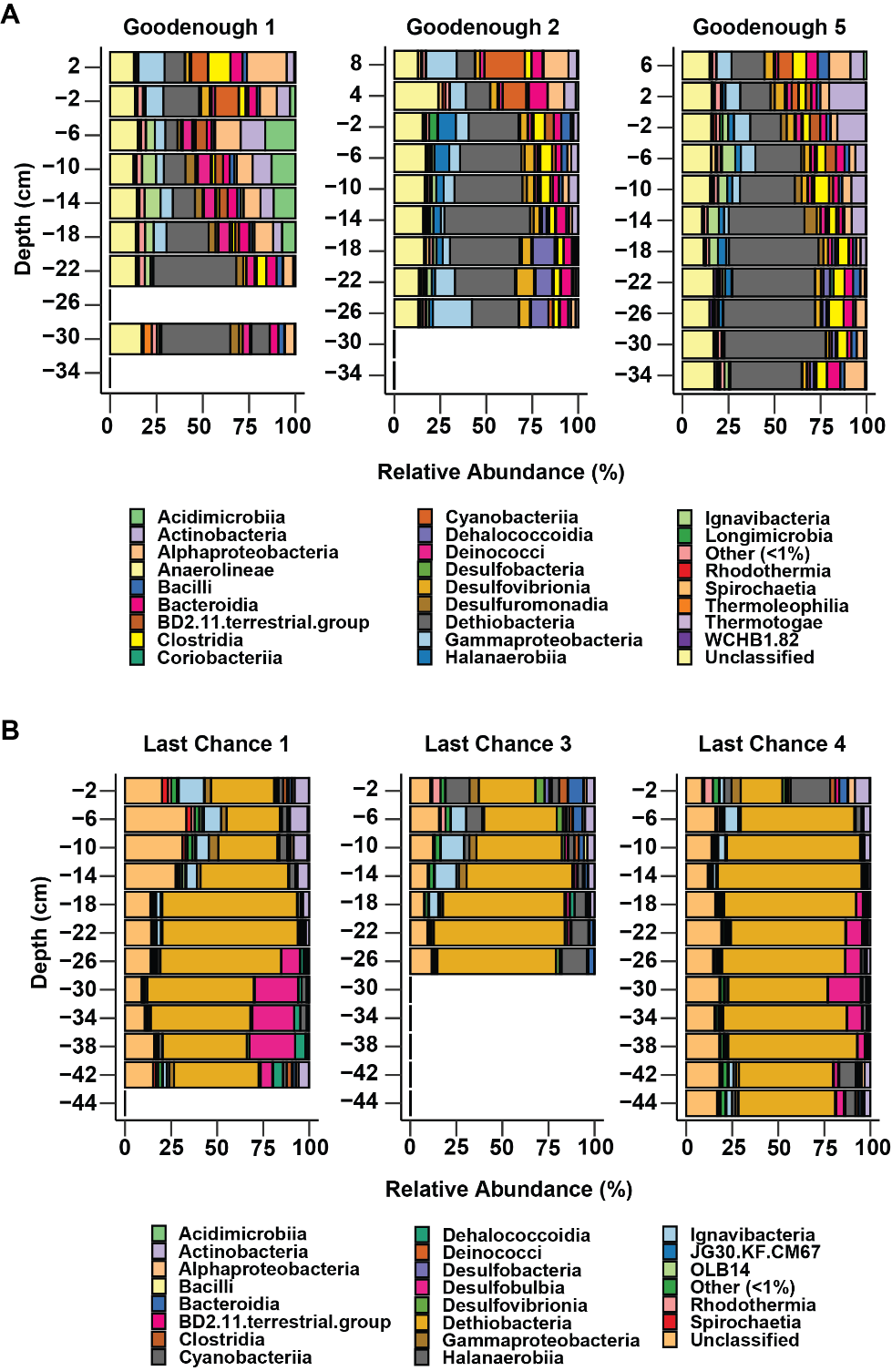
Figure S6: Prokaryotic community composition of sediment cores from Goodenough (A) and Last Chance (B) Lake based on 16S rRNA amplicon sequencing. Relative abundance and taxonomic assignments are shown for those populations that made up more than 1% of the community. Populations that made up less than 1% of the community were combined into a group called other.

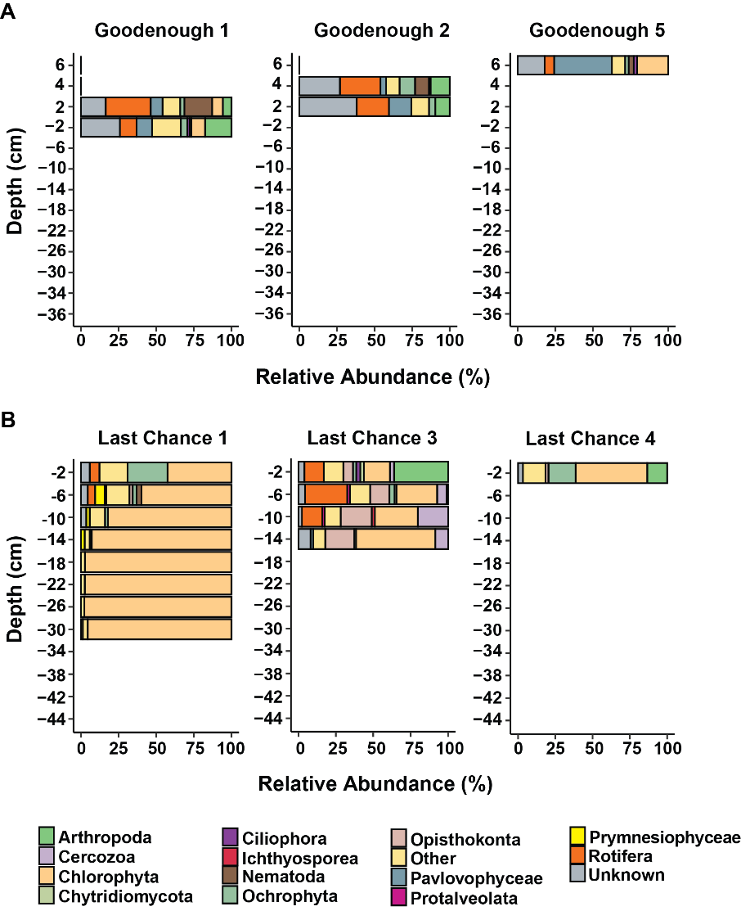
Figure S7: Eukaryotic community in the sediment of Last Chance and Goodenough Lake. Relative abundance of the eukaryotic community in the sediment of Goodenough (A) and Last Chance (B). Data was obtained from 18S rRNA gene amplicon sequencing and classified at the phylum level.

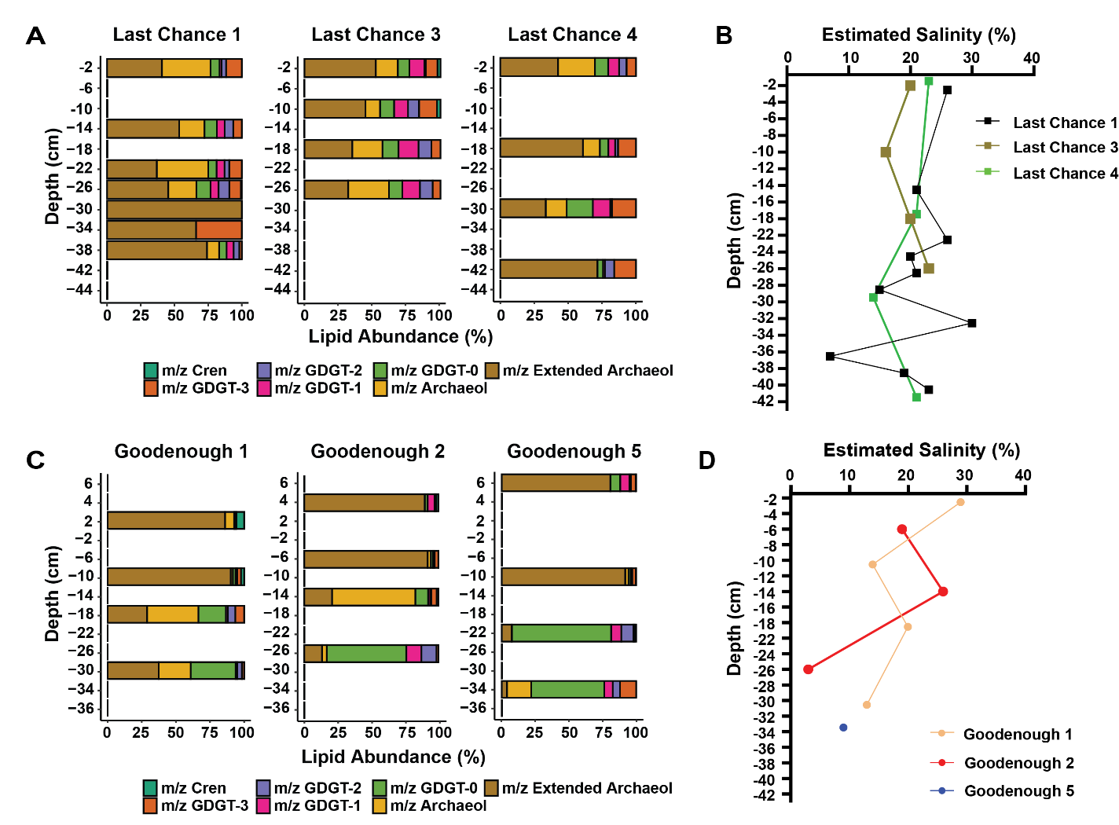
Figure S8: Archaeal lipid abundance and estimated salinity (ACE index) for Last Chance Lake and Goodenough Lake. Archaeal lipid abundance, specifically looking at the isoprenoid glycerol dialkyl glycerol tetraethers (GDGTs) and branched GDGTs in Last Chance Lake (A) and Goodenough Lake (B) was analyzed using HPLC-MS. Salinity was calculated using the ACE index (ratio of archaeol and GDGT-0) for Last Chance Lake (A) and Goodenough Lake (B).
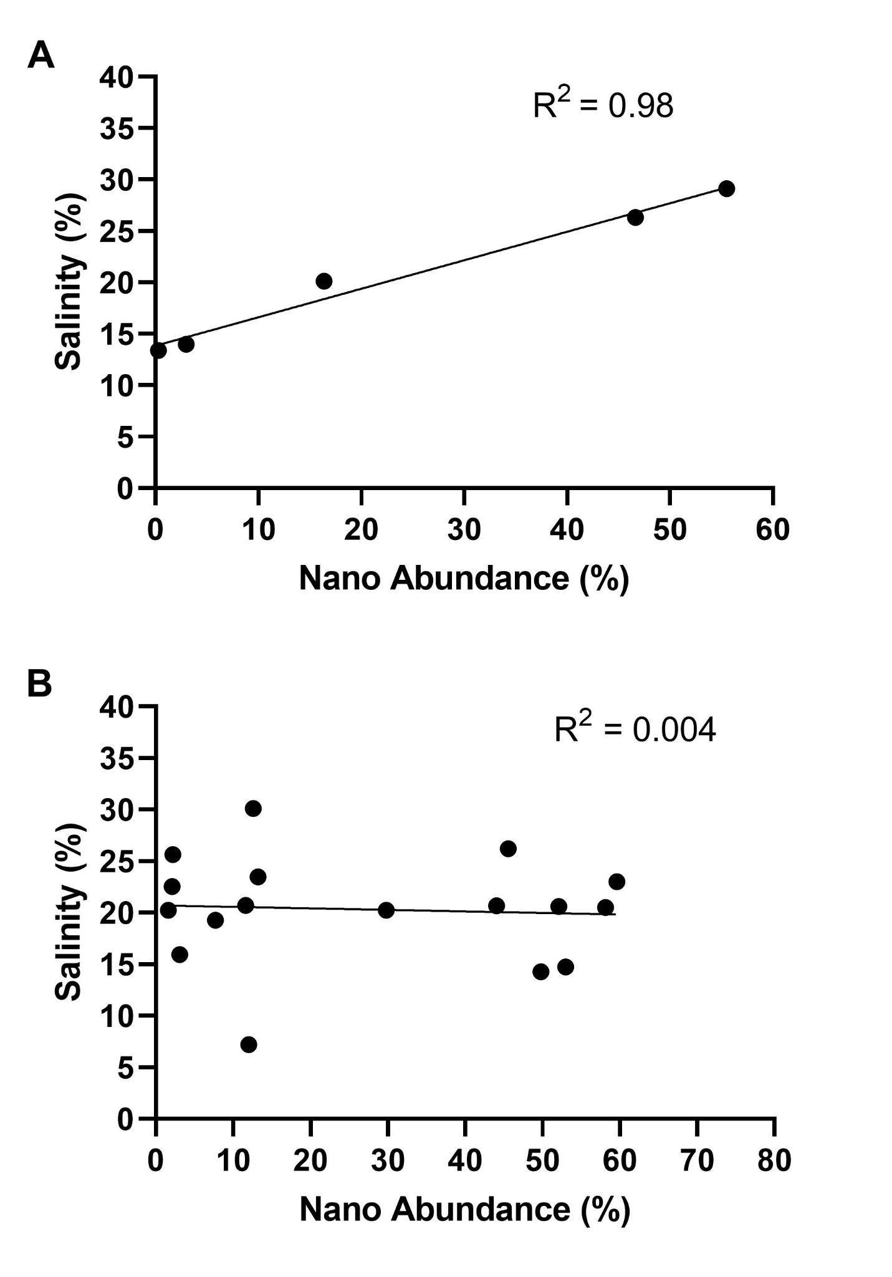
Figure S9: Correlation between the relative abundance of Nanoarchaea (Nano) OTUs and estimated salinity based on the ratio of archaeol and GDGT-0 in Goodenough Lake (A) and Last Chance Lake (B).

Figure S10: Schematic diagram of the sulfur cycle in Last Chance Lake. Diagram is based on the combination of geochemistry and metagenomic analysis of Last Chance Core 1. Genes for each reaction of the sulfur cycle are represented in blue and chemical products of those reactions are in black. The white and pink text represents those genes that were identified in the Dethiobacteria and Desulfobacteriota genomes.

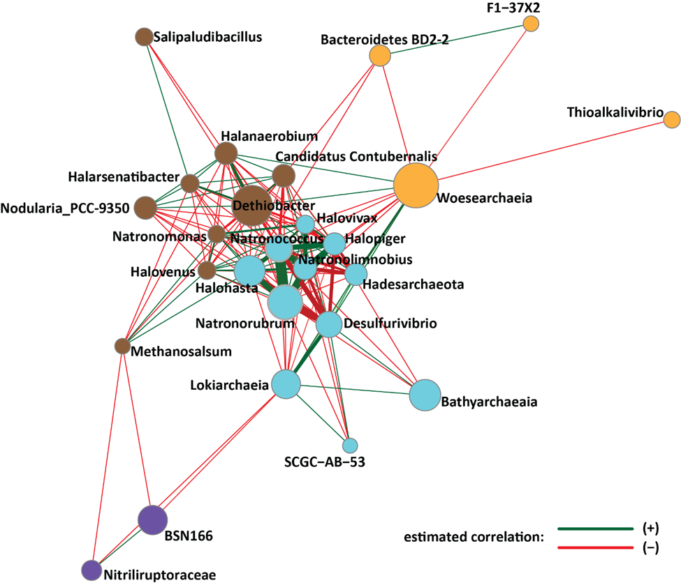
Figure S11: Pearson correlations and unsigned transformation network of the 16S rRNA amplicon data for the bacterial and archaeal community of Last Chance Lake at the genus level. The different node colours represent the clusters and the Pearson correlations between OTUs are represented by the colour of the edges. A green colour represents a positive correlation and red colour is a negative correlation. The thickness of the edge corresponds to how correlated the two OTUs are. The thicker the edge, the higher the correlation. This plot was created using phyloseq, genefilter, and NetCoMi packages in R-Studio.

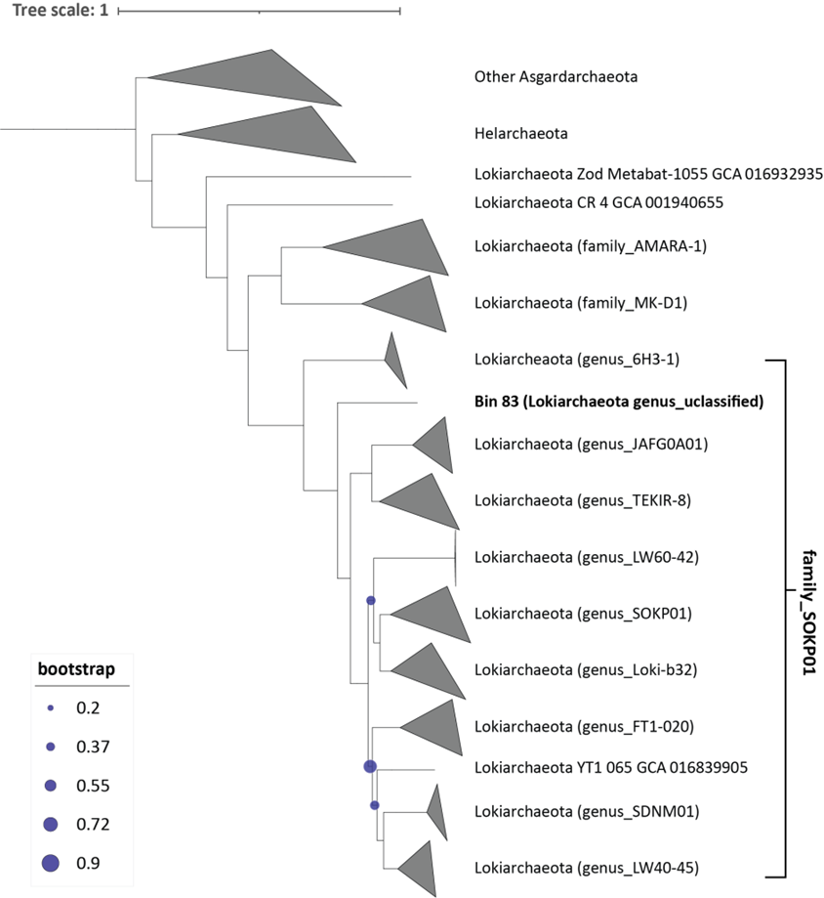
Figure S12: Bootstrapped maximum likelihood phylogenetic tree of 458 Asgardarchaeota metagenome assembled genomes (MAGs) based on a concatenated alignment of 100 conserved single copy genes (50,128 positions) (Parks et al., 2017). For illustration purposes 127 MAGs are displayed above. Nodes with bootstrap values of less than 90% are highlighted with a blue dot. Bin 83 indicates the Lokiarchaeota MAG from Last Chance Core 1, now classified under the family SOKP01.
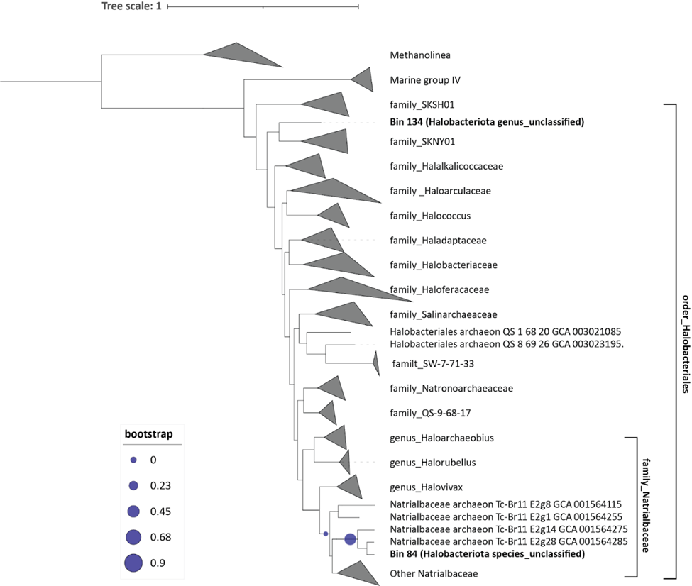
Figure S13: Bootstrapped maximum likelihood phylogenetic tree of 534 Halobacteriales metagenome assembled genomes (MAGs) based on a concatenated alignment of 134 conserved single copy genes (67,742 positions) (Parks et al., 2017). Nodes with bootstrap values of less than 90% are highlighted with a blue dot. Bin 84 and 134 indicate the Halobacteria MAGs from Last Chance Core 1.
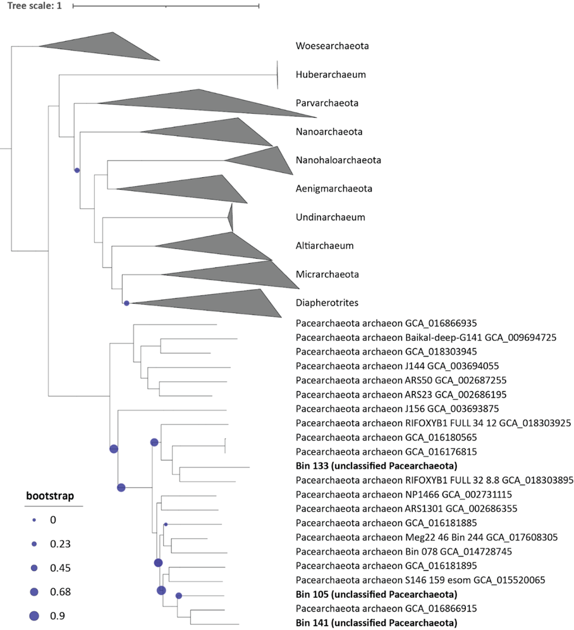
Figure S14: Bootstrapped maximum likelihood phylogenetic tree of 338 DPANN metagenome assembled genomes (MAGs) based on a concatenated alignment of ** conserved single copy genes (** positions) (Parks et al., 2017). Nodes with bootstrap values of less than 90% are highlighted with a blue dot. Bins 133, 105 and 141 indicate Pacearchaeota MAGs from Last Chance Core 1

