Appendix
Table A1: Definition of the variables
Variables | Definition
Individual characteristics
Child Poverty | If the household was income-poor in 1987-88 using the national threshold level
Gender | Male if Gender=1, 0 otherwise
Age | Age in years
Married (Categorical variable) | Marital status is unmarried if Married=1; married if Married=2 (base category); widow/widower if Married=3; divorced if Married=4; and separated if Married=5
Education (Categorical variable) | No education if Education=0 (base category); primary education if Education =5 (5 years of education); secondary education if Education=6-10 (6 to 10 years of education); higher secondary if Education=11-12; Graduation if Education=13-16; and post-graduation if Education=17 and above
Age at first marriage | The first marriage age in years
Occupation (Categorical variable) | Occupation is wage labor if Occupation=1(base category); salaried labor if Occupation=2; self-employed if Occupation=3; Trader if Occupation=4; production related work if Occupation=5; farming if Occupation=6; and unemployed if Occupation=7
Religion (Categorical variable) | Religion is Islam if Religion=1 (base category); Hindu if Religion=2; Buddhist if Religion=3; and Christian if Religion=4
Household characteristics
Health status | The health of the household members aged between 26-40 years is ‘almost always sick’ if Health status=1; ‘sometimes sick’ if Health status=2; and ‘hardly ever sick’ if Health status=3
Household size | Number of household members
Earning members | Number of earning members
Dependency ratio | Dividing the number of dependents (those not in the labor force) by the number of working-age individuals in the household
Monthly Household Income (BDT) | Monthly household income in Bangladesh Taka (BDT)
Total land holding (Decimal) | Household total land holding in decimal
Tube well (%) | Household proportion of having tube wells in percentage
Electricity (%) | Household proportion of having electricity connection in percentage
NGO participation (%) | Proportion of household membership status in non-government organizations (NGO) in percentage
Source: Based on the authors’ estimation method
Figure A1: (a), the first graph, age distribution of females and males for sample individuals, (b), the last graph, age distribution at first marriage for females and males
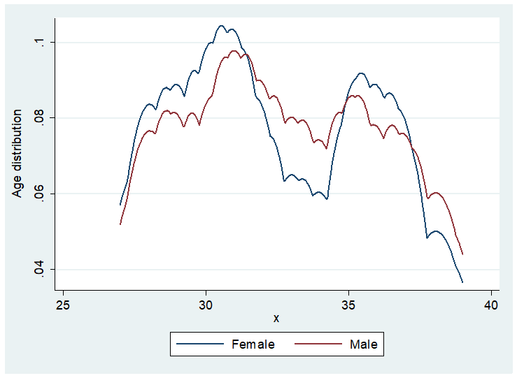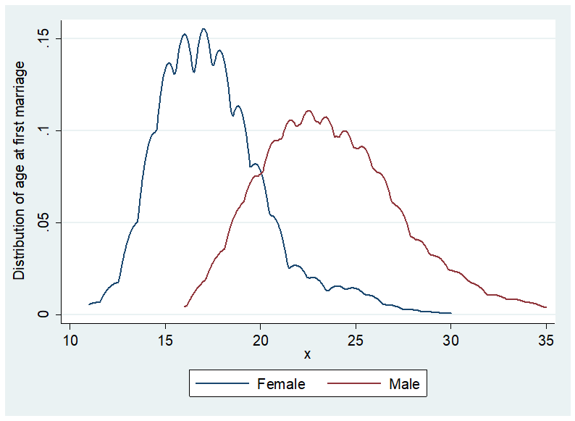
Source: Authors’ illustration using MHPD data.
Figure A2: Health status in adulthood according to (a), the first graph, marital status, (b) education, (c) number of earnings members, (d) monthly household income, (e) access to tube wells, and (f) access to electricity,
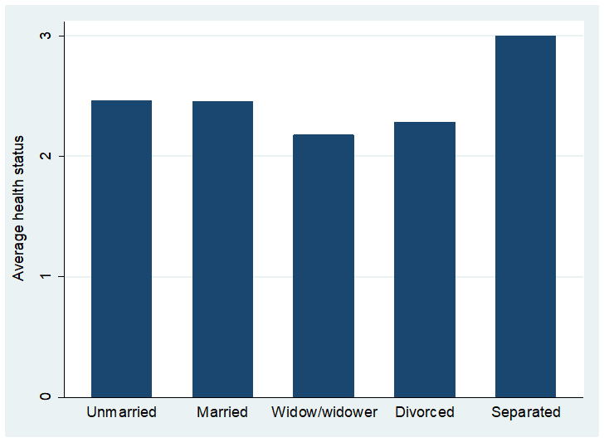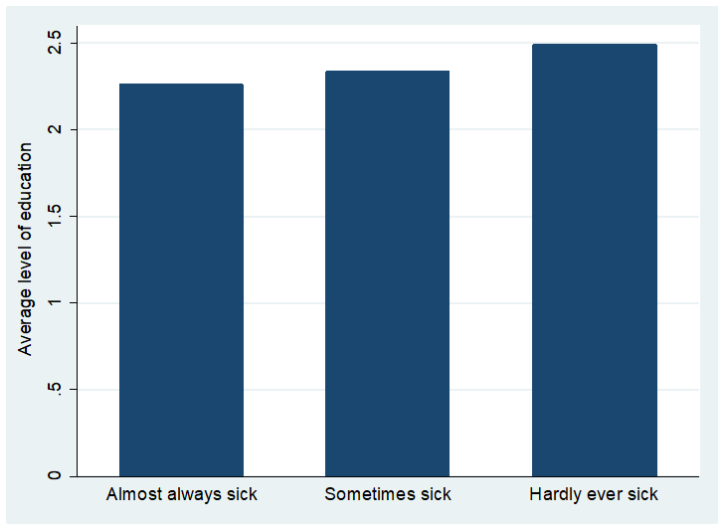
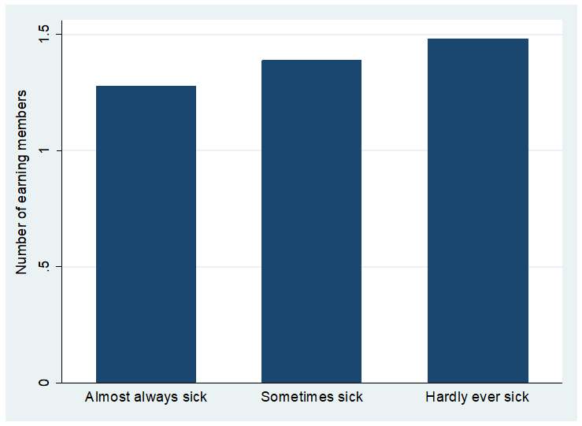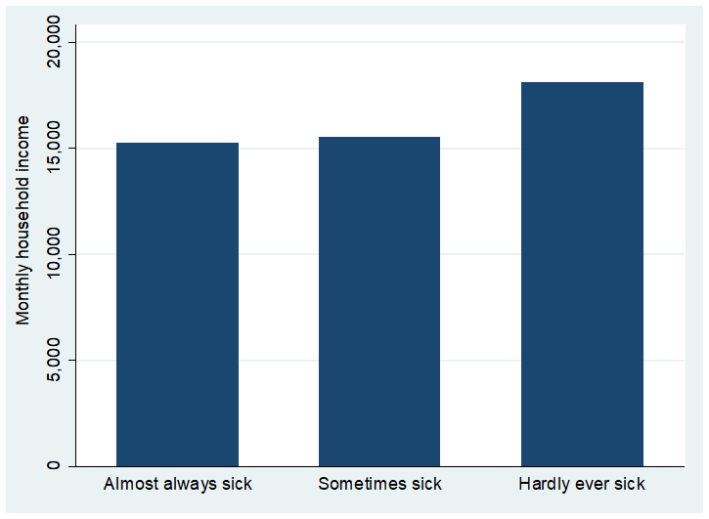
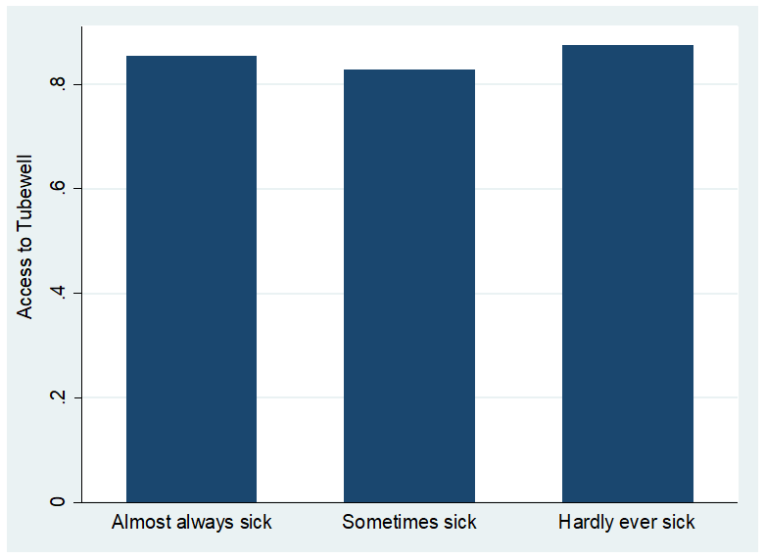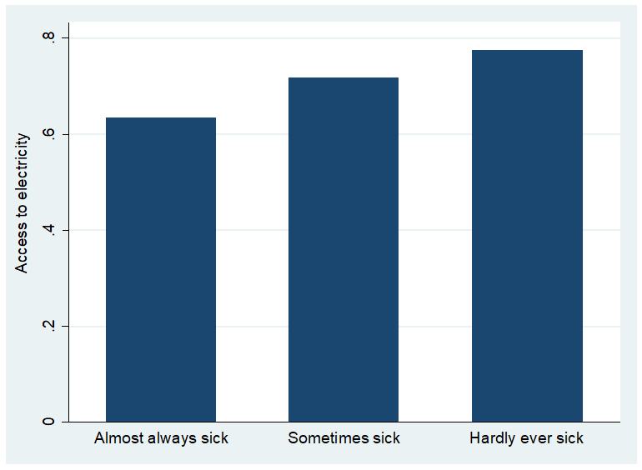
Source: Authors’ illustration using MHPD data.

