Identification of the differential transport pathways of saturated and unsaturated fatty acid esters in hepatocytes
Fengwu Chen1,2,#, Aizhen Yang1#, Yue Lu1#, Yuxin Zhang1,3, Jianan Bu1, Runlin Guo1, Yue Han4, Depei Wu4,*, Yi Wu1,4,*

Supplementary Materials:
- Supplementary Figures (1-5)
- Supplementary Tables (1-4)

Figure S1
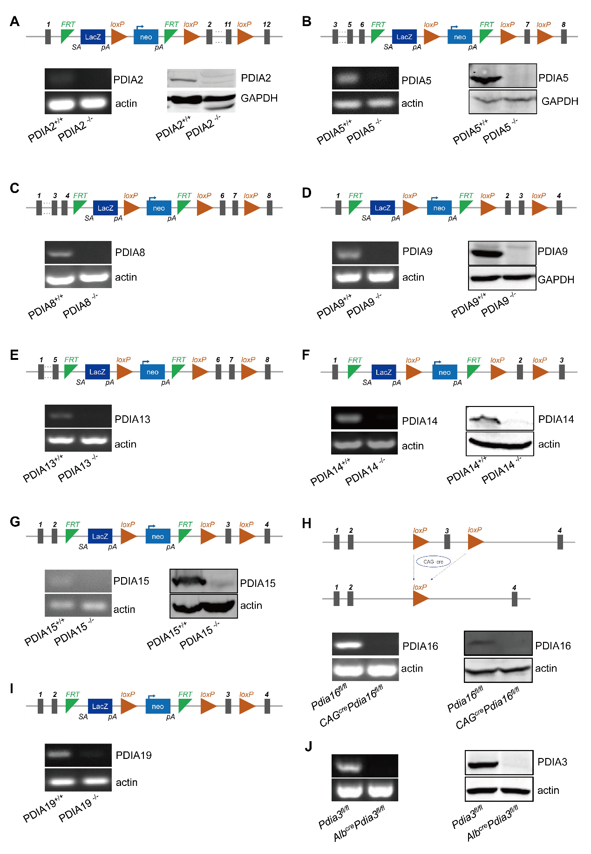
Figure S1. Generation and characterization of 10 strains of PDIs-knockout mice. Strategies for the construction of Pdia2^{-/-} (A), Pdia5^{-/-} (B), Pdia8^{-/-} (C), Pdia9^{-/-} (D), Pdia13^{-/-} (E), Pdia14^{-/-} (F), Pdia15^{-/-} (G), CAG-cre/Pdia16^{fl/fl} (H), and Pdia19^{-/-} (I) mice. Total RNA extracted from livers of PDIs-knockout and control mice was converted to cDNA by reverse transcription (RT), and the cDNA was analyzed by semiquantitative reverse transcription-polymerase chain reaction (RT-PCR) with indicated primers (Table S3) on a 7500 Real-time PCR system. Actin was used as an internal control. Expressions of PDIA5 (B), PDIA9 (D), PDIA14 (F), PDAI15 (G), PDIA16 (H), and PDIA3(J) protein in livers were deternmined by Western blotting. Representative image of three independent experiments is shown.

Figure S2
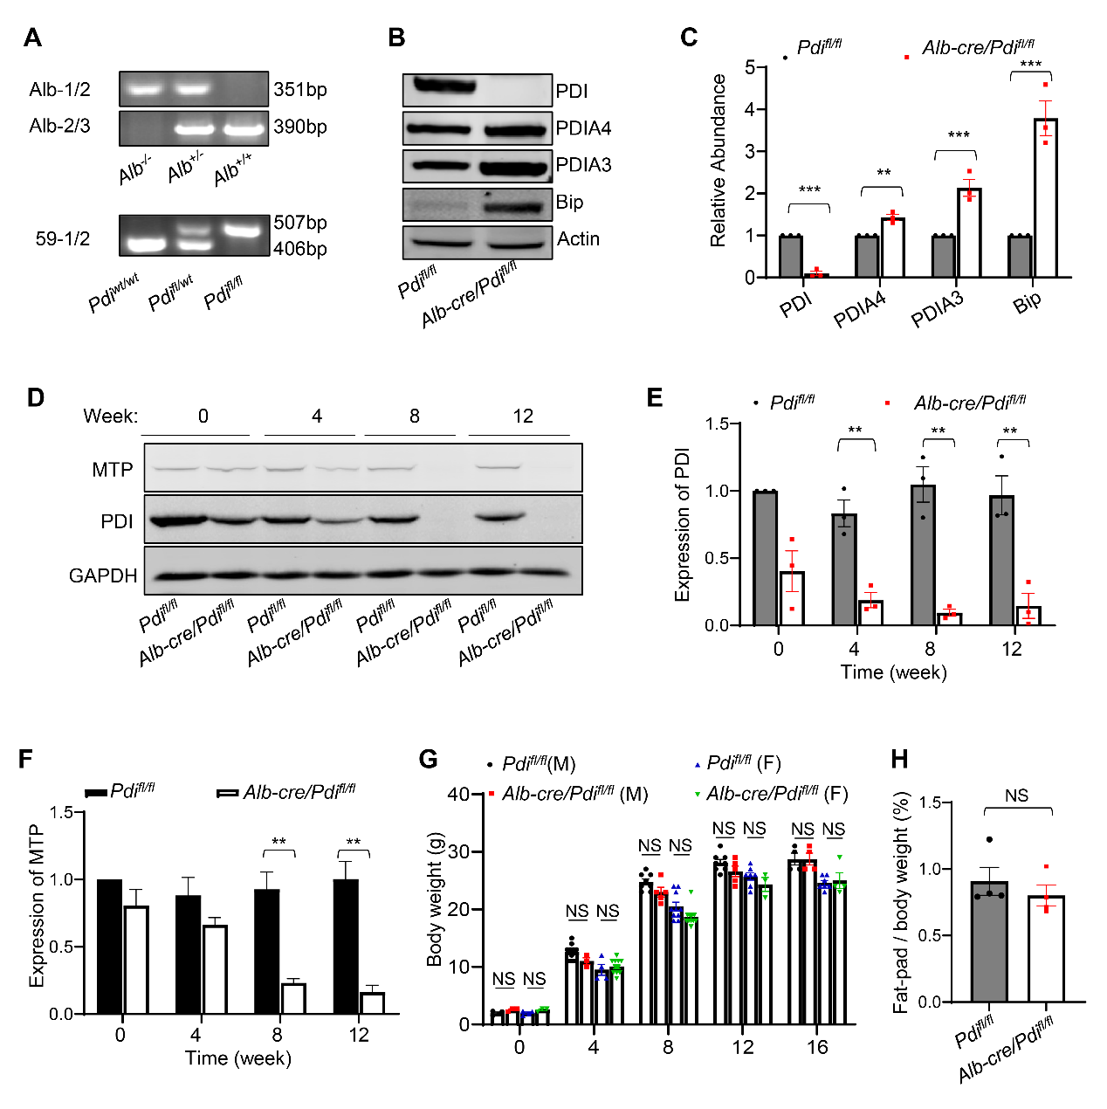

Figure S2. Characterization of hepatocyte-specific PDI-deleted mice. (A) Genotyping of Alb-cre/Pdi^{fl/fl} mice was analyzed by polymerase chain reaction (PCR) of tail genomic DNA with primers for the Pdi^{fl/fl} alleles (507 bp) and Alb-cre alleles (351 bp). (B-C) Expression of PDI protein was eliminated in the liver of Alb-cre/Pdi^{fl/fl} mice. (B) Lysates of livers isolated from Pdi^{fl/fl} and Alb-cre/Pdi^{fl/fl} mice were resolved by SDS-PAGE, transferred onto a PVDF membrane and immunoblotted with indicated antibodies. (C) Relative abundance of PDI, ERp57, ERp72, and Bip in each sample was quantitated by the band intensity determined with ImageJ software. n = 3 for WT, n = 3 for KO. Data are presented as mean ± SEM, **P < 0.01 and ****P < 0.0001 (two-tailed Student’s t test). (D-F) Expressions of PDI and MTP proteins gradually decreased over time in the livers of Alb-cre/Pdi^{fl/fl} mice. (D) Livers isolated from Pdi^{fl/fl} and Alb-cre/Pdi^{fl/fl} mice at different weeks were lysed and analyzed with SDS-PAGE and Western blotting with anti-PDI and anti-MTP antibodies, and GAPDH was used as a loading control. Relative abundance of PDI (E) and MTP (F) in each sample was quantitated by the band intensity determined with ImageJ software. n = 3 for WT, n = 3 for KO. Data are presented as mean ± SEM, **P < 0.01 (two-tailed Student’s t test). (G) Average body weight of Alb-cre/Pdi^{fl/fl} and Pdi^{fl/fl} mice at different weeks. Statistical analysis of male and female mice was performed separately. The number of each mouse was determined by counting a dot. Data are presented as mean ± SEM, NS, not significant. (H) The ratio of fat-pad weight to body weight of Alb-cre/Pdi^{fl/fl} mice (n = 4) and Pdi^{fl/fl} mice (n = 4). Data are presented as mean ± SEM, NS, not significant.

Figure S3
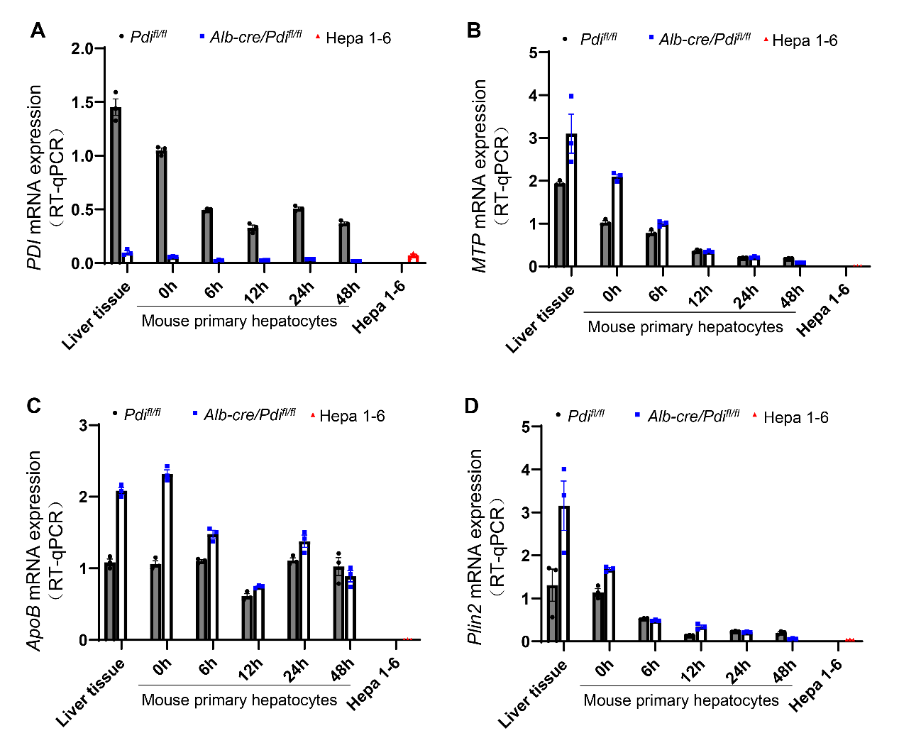

Figure S3. Gene expression profiles quickly change in cultured primary mouse hepatocytes. Total RNA was extracted from the livers of Pdi^{fl/fl} and Alb-cre/Pdi^{fl/fl} mice, primary mouse hepatocytes were cultured for the indicated times (hours), and Hepa 1-6 cells were converted to cDNA by reverse transcription (RT). The cDNA was analyzed by quantitative reverse transcription PCR (RT-qPCR) with the indicated primers for Pdi, ApoB, Mttp, and Plin2 genes on a 7500 Real-time PCR system.

Figure S4
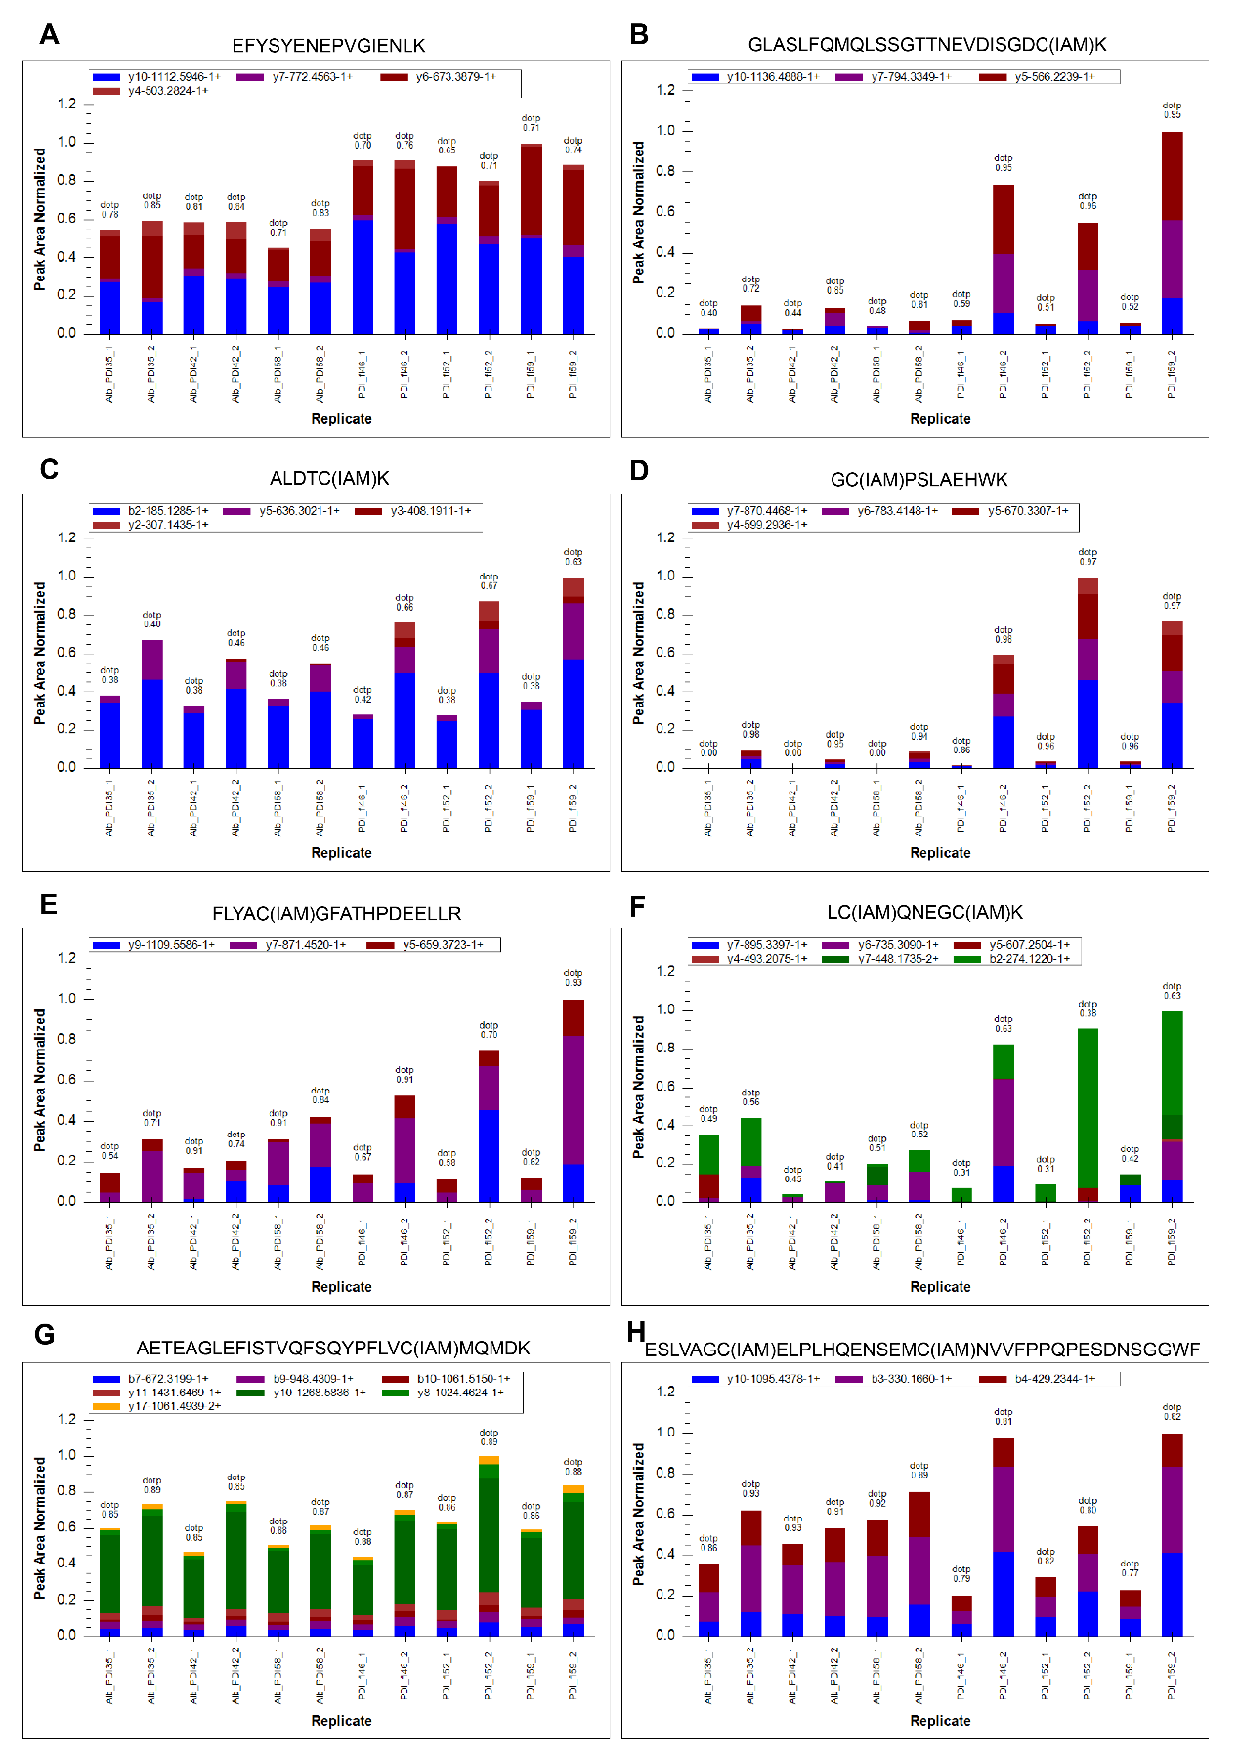

Figure S4: Peak area distribution of the qualified fragment ions of targeted peptides. Liver lysates of Pdi^{fl/fl} and Alb-cre/Pdi^{fl/fl} mice were alkylated with IAM and analyzed using PRM-MS, and 8 peptides of MTP were systematically detected by spectral matching using a previously prepared reference library. The traces of the qualified b- and y-type fragment ions of each peptide were extracted, and the peak areas were determined. The abundance of endogenous peptides was determined by summing the peak areas of fragment ions of the corresponding peptide.

Figure S5
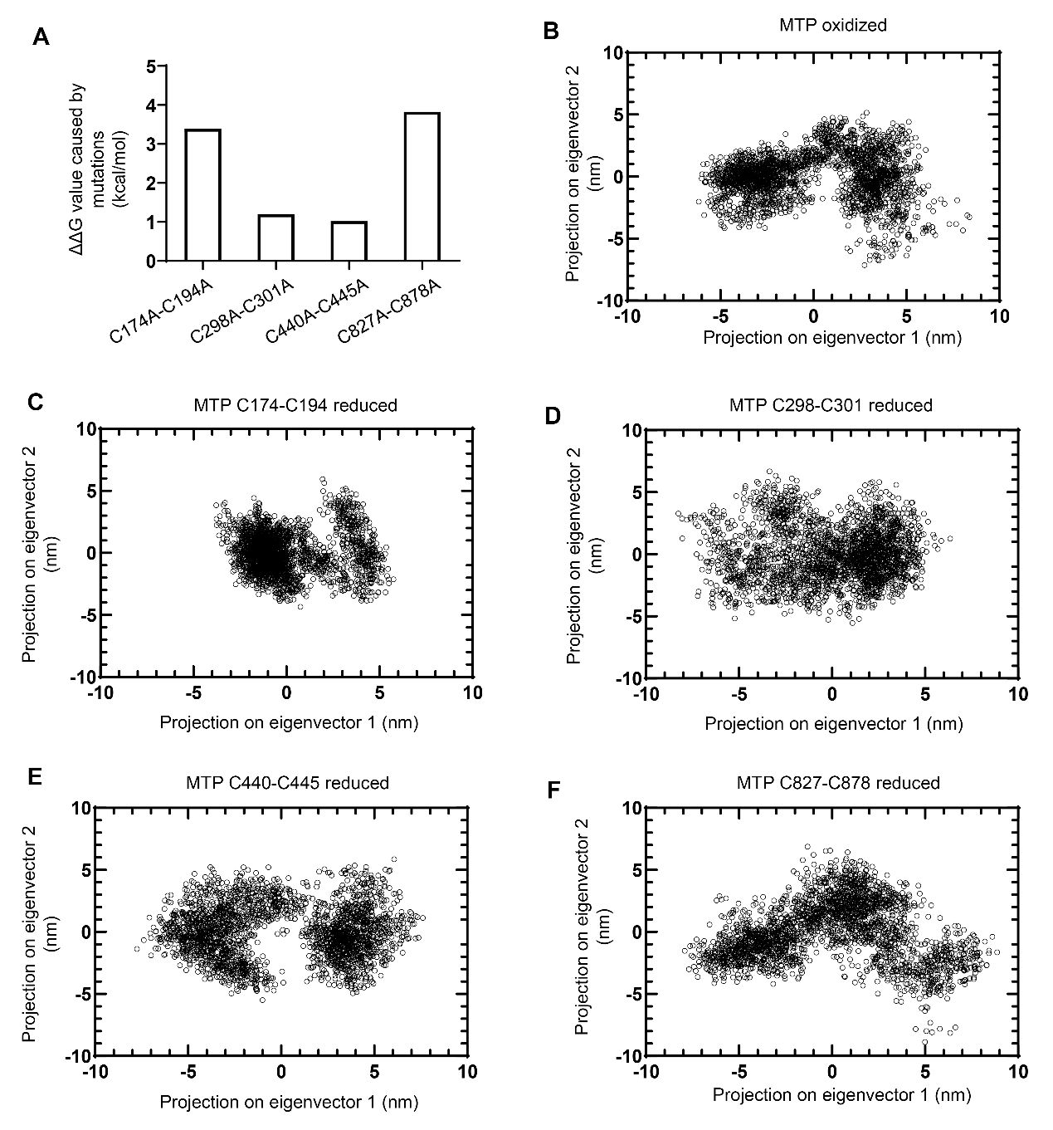
Figure S5. Every disulfide bond of MTP is needed for its structural stability and expression. (A) The changes in the Gibbs free energy (ΔΔG) values for MTP mutants with FoldX 3.0. (B-F) Conformational distribution of MTP proteins with an intact (oxidized) (B) or missing (reduced) Cys174-Cys194 (C), Cys298-Cys301 (D), Cys440-Cys445 (E), and Cys827-Cys878 (F) disulfide bonds, projected along two major conformational eigenvectors obtained from molecular dynamics simulations which started from the MTP-PDI complex conformation (PDB code 6I7S), supporting the notion that the redox state of each disulfide bond has significant structural implications.

Table S1. Plasma biochemical parameters of hepatocyte PDI-deleted mice and control mice. Plasma was isolated from 12-hour-fasted Alb-cre/Pdi^{fl/fl} (n=6) and Pdi^{fl/fl} (n=6) mice, and subsequently analyzed via a fully automatic biochemical analyzer. Two-tailed Student’s t-tests were used to calculate p-values, and the data are shown as mean ± SEM.
Parameters | Pdi^{fl/fl} | Alb-cre/Pdi^{fl/fl} | P value
Alanine Aminotransferase (ALT), IU/L | 31.17±2.74 | 36.00±3.84 | 0.3294
Aspartate Aminotransferase (AST), IU/L | 61.00±11.36 | 55.00±7.84 | 0.6731
Total Protein (TP), g/L | 39.53±2.16 | 40.27±2.41 | 0.8251
Albumin (ALB), g/L | 25.43±1.66 | 26.75±1.51 | 0.5702
Total Bilirubin (TBIL), μmol/L | 0.72±0.12 | 0.68±0.14 | 0.8585
Glucose (GLU), mmol/L | 8.26±1.09 | 2.96±0.51 | 0.0013
Blood Urea Nitrogen (BUN), mmol/L | 11.70±1.32 | 13.28±1.20 | 0.3941
Lactate Dehydrogenase (LDH), IU/L | 206.20±40.49 | 192.70±33.09 | 0.8015
Cholesterol (CHOL), mmol/L | 2.23±0.25 | 0.61±0.13 | 0.0002
Triglyceride (TG), mmol/L | 0.30±0.03 | 0.06±0.02 | <0.0001
High-density Lipoprotein (HDL), mmol/L | 1.63±0.16 | 0.50±0.10 | 0.0002
Low Density Cholesterol (LDL), mmol/L | 0.32±0.07 | 0.07±0.01 | 0.0057

Table S2. Spectral library of alkylated synthesized peptides. Eight peptides of MTP were synthesized and alkylated with iodoacetamide, and subsequently analyzed using DDA mode of mass spectrometry. The raw files were searched by using a quantitative proteomics software package (MaxQuant 1.6.15.0), and the processed data were imported into Skyline 20.1 software to build a spectral library as follows.
Cysteine | Alkylated synthetic peptides | Mass [m/z] | CS [z] | Start [min] | End [min] | NCE
None (Control) | EFYSYENEPVGIENLK | 965.957088 | 2 | 18.181 | 24.181 | 27
C174 | GLASLFQMQLSSGTTNEVDISGDC[IAM]K | 886.751037 | 3 | 19.844 | 25.844 | 27
C194 | ALDTC[IAM]K | 354.173264 | 2 | 3.4986 | 9.4986 | 27
C301 | GC[IAM]PSLAEHWK | 395.522085 | 3 | 8.596 | 14.596 | 27
C397 | FLYAC[IAM]GFATHPDEELLR | 680.327892 | 3 | 24.941 | 30.941 | 27
C440-C445 | LC[IAM]QNEGC[IAM]K | 504.715501 | 2 | 2.3451 | 8.3451 | 27
C827 | AETEAGLEFISTVQFSQYPFLVC[IAM]MQMDK | 1090.511629 | 3 | 23.289 | 29.289 | 27
C866, C878 | ESLVAGC[IAM]ELPLHQENSEMC[IAM]N  VVFPPQPESDNSGGWF | 1354.264394 | 3 | 19.4 | 25.4 | 27

Table S3: Sequences of primers used for genotyping and quantitative PCR
Genes | Forward | Reverse
Genotyping
Alb-cre 1/2 | TTGGCCCCTTACCATAACTG | TGCAAACATCACATGCACAC
Alb-cre 2/3 | TTGGCCCCTTACCATAACTG | GAAGCAGAAGCTTAGGAAGATGG
PDI flox 1/2 | TCTGGAAAAGGAAGTCCAACCGAGA | AAGTCTCCTCAAGGAAGCCAGGGAC
Quantitative PCR
PDI | CTCGACAAAGATGGGGTTGT | GCAAGAACAGCAGGATGTGA
PDIA2 | AGAATGGAAACCGCACAAAC | GACACCTTCCTCATCCTCCA
PDIA3 | TGGTGTGGCCACTGTAAGAA | TTTAATTCACGGCCACCTTC
PDIA5 | GGGAAGAACAGCAGACAAGC | TCTTACAGTGTGGGCACCAA
PDIA8 | TCTGCCTCTTTCGACTGGTT | TGCGCATGCTCTCTTCATAC
PDIA9 | CCTGAAGATCATGGGGAAGA | TGGTCACAGCTCCTCCTTCT
PDIA13 | GTGTATTGATGGTGCTTTCTCT | GTGCTCCTATTCTCCCTTTC
PDIA14 | GGCTGATTGTTCTCCTTAGG | TCTCAGAGCCTTCCGATG
PDIA15 | AAAGGAATTCCCAGGCTTGT | CCGTTGTGTTCTCCCACTTT
PDIA16 | TCTTGGTGTGGAGCCTGCAAAG | CATCAGGGCTGAAGTCTTCATCC
PDIA19 | GCTGGGGTCTTGGATTTTT | CGGCTCTCACTTTTCCTTTG
ApoB | TTGGCAAACTGCATAGCATCC | TCAAATTGGGACTCTCCTTTAGC
ApoE | GACCCAGCAAATACGCCTG | CATGTCTTCCACTATTGGCTCG
ApoC1 | TCCTGTCCTGATTGTGGTCGT | CCAAAGTGTTCCCAAACTCCTT
ApoC3 | TACAGGGCTACATGGAACAAGC | CAGGGATCTGAAGTGATTGTCC
CideB | AACCCCAGTGACTTACTCAGG | AGACACGGAAAGGTCGCTG
ADRP | GAGATGGCAGAGAACGGTGT | AGCCCCTTACAGGCATAGGT
MTP | ATACAAGCTCACGTACTCCACT | TCTCTGTTGACCCGCATTTTC
ACC1 | GTTCTGTTGGACAACGCCTTCAC | GGAGTCACAGAAGCAGCCCATT
FASN | CACAGTGCTCAAAGGACATGCC | CACCAGGTGTAGTGCCTTCCTC
DGAT1 | GGTTCCGTGTTTGCTCTGGCAT | CCACTGACCTTCTTCCCTGTAG
DGAT2 | CTGTGCTCTACTTCACCTGGCT | CTGGATGGGAAAGTAGTCTCGG
SCD1 | GCAAGCTCTACACCTGCCTCTT | CGTGCCTTGTAAGTTCTGTGGC
Actin | CATTGCTGACAGGATGCAGAAGG | TGCTGGAAGGTGGACAGTGAGG
FLAG tag
MTTP-FLAG F | TACAAGGATGACGACGATAAGTGAATCTAGAGCGGCCGCC
MTTP-FLAG R | ATCGTCGTCATCCTTGTAATCAAAACCATCCGCTGGAAGTACTA
Site mutation
MTTP-C174A | GTAGATATCTCTGGAAATGCTAAAGTGACCTACCAG
MTTP-C194A | TAAGGCCTTGGATTCAGCCAAAATAGCGAGGTCT
MTTP-C440A | CACTTGTCAGAAAGTTGGCTCAGAATGAAGGCTGC
MTTP-C445A | GCTCAGAATGAAGGCGCCAAACTCAAAGCAGTAG
MTTP-C298A | GTCTTCCAGAGCCACGCTAAAGGATGTCCTTCTC
MTTP-C301A | AGCCACGCTAAAGGAGCTCCTTCTCTCTCGGA
MTTP-C827A | AGTACCCATTCTTAGTTGCCATGCAGATGGACAAG
MTTP-C878A | AGAGAACTCAGAGATGGCCAAAGTGGTGTTTGCC
MTTP-C397A | GAGGTTTCTCTATGCCGCTGGATTTGCTTCTCATC
MTTP-C866A | AAGCGTATTAGCAGGAGCTGAATTCCCGCTCCA

Table S4: Key resources
REAGENT or RESOURCE | SOURCE | IDENTIFIER
Antibodies
Rabbit anti-PDI antibody | Abclonal | Cat#A19239
Rabbit anti-PDIA3 antibody | This paper | ¹
Rabbit anti-PDIA5 antibody | Proteintech | Cat#15545-1-AP, RRID:AB_2160995
Rabbit anti-PDIA9 antibody | Abcam | Cat#ab11420 , RRID:AB_298025
Rabbit anti-PDIA14 antibody | Abcam | Cat#ab174276
Rabbit anti-PDIA15 antibody | Proteintech | Cat#19834-1-AP, RRID:AB_10644285
Rabbit anti-PDIA16 antibody | Abcam | Cat#ab134938
Mouse anti-Bip antibody | BD | Cat#610979, RRID:AB_398292
Rabbit anti-APOB antibody | Sigma-Aldrich | Cat#AB742, RRID:AB_11213353
Mouse anti-ApoE antibody | Santa Cruz | Cat#sc-393302
Rabbit anti-apoC3 antibody | Abcam | Cat#ab55984, RRID:AB_879561
Rabbit anti-CideB antibody | Multi Science | Cat#ab32233
Rabbit anti-ADRP antibody | Proteintech | Cat#15294-1-AP, RRID:AB_2878122
Mouse anti-MTP antibody | BD Biosciences | Cat#612022, RRID:AB_399417
Mouse anti-FLAG M2 antibody | Sigma | Cat#F1804-200UG, RRID:AB_262044
Rabbit anti-ACC antibody | Cell Signaling Technology | Cat#3662, RRID:AB_2219400
Rabbit anti-FASN antibody | Abcam | Cat#ab22759, RRID:AB_732316
Rabbit anti-SCD1 antibody | Cell Signaling Technology | Cat#2794, RRID:AB_2183099
Rabbit anti-Actin antibody | Abclonal | Cat#AC026, RRID:AB_2768234
Rabbit anti-GAPDH antibody | Cell Signaling Technology | Cat#14C10, RRID:AB_10693448
Chemicals
Tyloxapol | Sigma-Aldrich | Cat#T8761
MG132 | Sigma-Aldrich | Cat#M8699
3-Methyladenine | Sigma-Aldrich | Cat#M9281
Trifluoroacetic acid | Sigma-Aldrich | Cat#76-05-1
Acetonitrile | Fisher Chemical | Cat#75-05-8
Formic acid | Fluka | Cat#64-18-6
Iodoacetamide (IAM) | Sigma | Cat#144-48-9
N-ethylmaleimide (NEM) | Thermo scientific | Cat#23030
TCEP | Thermo scientific | Cat#20490
Urea | Sigma | Cat#57-13-6
HEPES | Sigma-Aldrich | Cat#7365-45-9
EGTA | Sigma-Aldrich | Cat#13368-13-3
KBr | Sigma-Aldrich | Cat#746444
Critical Commercial Assays
BCA Protein Assay Kit | Beyotime | Cat#P0011
Triglyceride Assay Kit | EnzyChrom | Cat#ETGA-200
Cholesterol Assay KIT | EnzyChrom | Cat#ECCH-100
Free Fatty Acid Quantitation KIT | Sigma-Aldrich | Cat#MAK044
MTP Activity Assay Kit | Sigma-Aldrich | Cat#MAK110
Others
OptiPrepTM | Alere Technologies AS | Cat#as1114542
Protease Inhibitor Cocktail | Roche | Cat#04693132001
Trypsin | Promega | Cat#V5111
Streptavidin Agarose Resins | Thermo Fisher | Cat#20347
Protein G beads | Genscript | Cat#L00209
H&E staining kit | Servicebio | Cat#G1005
Oil Red O staining solution | Servicebio | Cat#G1016
Fixative for TEM | Servicebio | Cat#G1102
EMbed-812 Kit for EM Embedding | SPI | Cat#90529-77-4
OCT Compound | Sakura | Cat#4583
BODIPY 493/503 | Thermo Fisher | Cat#D3922
DAPI | Servicebio | Cat#G1012
Collagen I, Rat Tail | Corning | Cat#354236
Collagenase Type IV | Gibco | Cat#17104-019
Hank’s Balanced Salt Solution | Gibco | Cat#14170146
DMEM, low glucose, pyruvate | Gibco | Cat#11885084
DMEM/F-12 | Gibco | Cat#11320033
Fetal bovine serum (FBS) | Gibco | Cat#10099-141
Penicillin/streptomycin | Beyotime | Cat#c0222
1st Strand cDNA Synthesis Kit | Vazyme | Cat#R312-02
SYBR qPCR Master Mix | Vazyme | Cat#Q711-02
Ultra-One Step Cloning Kit | Vazyme | Cat#C115-01
Fast Mutagenesis Kit V2 | Vazyme | Cat#C214-01
GelRed | Biotium | Cat#41003
Lipofectamine 3000 | Thermo Fisher | Cat#L3000008
Plasmid
hMTTP expression plasmid | Sino Biological | Cat#HG17688-UT

1. Wang, L. et al. Platelet-derived ERp57 mediates platelet incorporation into a growing thrombus by regulation of the alphaIIbbeta3 integrin. Blood 122, 3642-3650 (2013).

