Table S1: Primers used for gene expression study:
Gene | Primer sequence
lepa | forward: TCAGGGAACACATTGACGGG
lepa | reverse: ATTCCCGCTGACAAACCCAT
lepr | forward: GGAGCTCGAGTTCAGGATGC
lepr | reverse: CTCTTACGTGTCCTACTCCGC
gnrh3 | forward: GTGGAAAGGAAGGTTGCTGG
gnrh3 | reverse: TTGCCTCCATTTCACCAACG
lhb | forward: GAGACCATTAACCTGCCCGA
lhb | reverse: TGTCCGAGGTCTAGTATGCG
fshb | forward: TCACTGTGGAGAGCGAAGAA
fshb | reverse: AGACTGAATCAACCCCTGCA
nrg1 | forward: CCGTCAACAGCCTTGGAAAA
nrg1 | reverse: TCCTTCTCGCTCTCATTGCA
esr1 | forward: CAGTAAATCAGGAGCGTCGC
esr1 | reverse: CCAGCAACAGGTCATACAGC
cyp19a | forward: GAGGCTGTGGTGGATCTTCT
cyp19a | reverse: ACAACAGGACCCAGACCAAA
hsd3b | forward: AACACACCGCCCTCTAGTC
hsd3b | reverse: TTCACTGCTGGGTTTTGCC
gapdh | forward: AAGAAAGTGGAGATCGTGGC
gapdh | reverse: TTGGCAGGTTTCTCAAGACG

Tissue homogenate preparation: Brain and Ovary tissues was homogenized in ice-cold PBS (pH 7.4) and then centrifuged at 12,000g for 30 min. Supernatant was collected and used for further estimations.
Estimation of Melatonin: Melatonin level in brain was estimated as per protocol given by Amin et al., 2000. To a test-tube, 0.5 ml of 50 mM ninhydrin (in methanol), 0.2 ml of brain tissue homogenate and 0.8 mL of 96% H2SO4 was added. When the reaction mixture came at room temperature, the volume was made up to 2 ml with methanol. The absorbance was measured at 397 nm (Shimadzu UV-1900 UV–VIS Spectrophotometer) against a reagent blank prepared in the same manner.
Estimation of Catalase activity: Catalase activity was measured in ovarian tissue, according to Sinha, 1972. Briefly; 1 ml of PBS (pH 7.0) was mixed with 0.4 ml of H₂O₂ (0.2 M) and then 0.1 ml of tissue homogenate was added into it. After incubating the mixture for 1 minute, 1 ml of acidic potassium dichromate (K₂Cr₂O₇) solution was added. The mixture was then boiled for 10 minutes in a water bath at 100 ºC. The absorbance of the solution was measured at 610 nm in a spectrophotometer (Shimadzu UV-1900 UV–VIS Spectrophotometer). The activity of catalase was determined by calculating the amount of H₂O₂ (µM) depleted per minute per milligram of tissue.
Acidic potassium dichromate solution; this reagent is prepared by mixing a 5% solution of K₂Cr₂O₇ with glacial acetic acid (1:3, by volume).
Estimation of Lipid Peroxidase (LPO) activity: LPO was measured in ovarian tissue, by the estimation of malonaldehyde (MDA) level; according to Ohkawa et al., 1979. In 1.3 ml of Thiobarbituric acid reagent, 0.2 ml of tissue homogenate was added and incubated for 60 minutes at 95 ºC. The reaction mixture was then brought to room temperature and centrifuged at 500g for10 min at 4°C. The supernatant containing MDATBA by-product was read at 532 nm using spectrophotometer (Shimadzu UV-1900 UV–VIS Spectrophotometer).
Thiobarbituric acid reagent; 0.2 ml of 8% SDS, 0.5 ml of 20% acetic acid, 0.5 ml of 0.8% thiobarbituric acid (TBA) and 0.1 ml of 0.8% butylated hydroxy toluene (BHT).

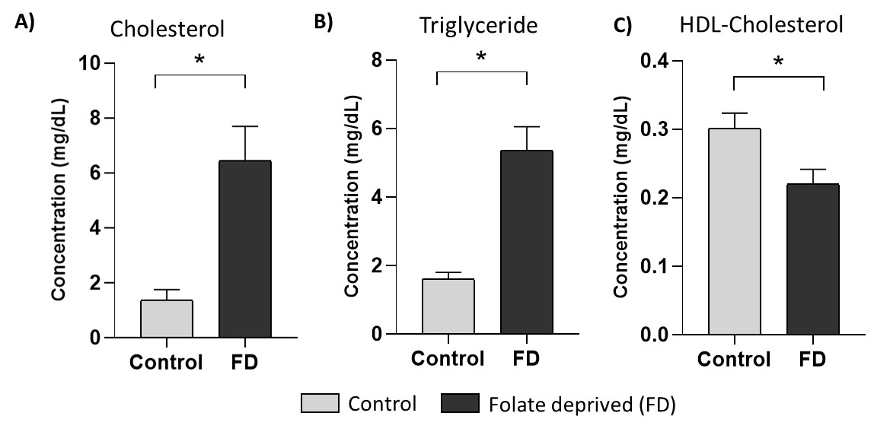
Fig S1: Folate deprivation induces dyslipidaemia. Estimation of (A) Cholesterol (B)Triglyceride and (C) HDL-Cholesterol in the liver tissue of zebrafish. All estimations were done by the commercially available kits (Reckon diagnostics). All values are expressed as Mean ± SEM; n=3. *, p ≤ 0.05; FD, folate deprived.

