Supplementary File
Mid-infrared light reduces the nicotine content and detoxifies bidis for safer smoking.
Umakanthan^{1*}, Madhu Mathi²
^{1*}Veterinary Surgeon, Gokulam Annadhan Temple Complex, Plot no.: 1684, Meenavilakku-Meenakshipuram Road, Anaikaraipatty Post, Bodinayakanur Taluk, Theni Dt, Tamil Nadu, India - 625582
²Veterinary claims expert, Allianz Services Private Limited, Technopark, Trivandrum, Kerala – 695581, India.
*Corresponding author: Ph. 09345572218; Email: rkbuma@gmail.com

Supplementary Data
D1: Raw data files of Tobacco instrumentations
https://drive.google.com/drive/folders/19vL8eQWnCGjLSD8Zl0CWoOBJRrGYlKKv?usp=drive_link
Supplementary Videos
V1: Method of MIRGA spraying:
https://drive.google.com/file/d/1mmWpJ3CKTRuu9jsrEm7cz4g8SvOOpbkA/view?usp=drive_link
V2: Tobacco trial video link: https://drive.google.com/file/d/1kenC9dU8YCMoECwi_rqElnjjvAJt-ZYA/view?usp=drive_link (‘Genno-treated bidis’ in this video refers to the ‘MIR-treated bidis’)

Table 1: GCMS analysis of tobacco samples
RT (min) | Name of compound | % Area present in each sample |  |  | Remarks
 |  | Control | 2 sprayed | 10 sprayed
4.233 | Pyridine, 3-(1-methyl-2-pyrrolidinyl)-, (S), NICOTINE | 2.99 | 0.0 | 0.0 | Nicotine disappeared in 2 sprayed samples
5.217 | Pyridine, 3-(1-methyl-2-pyrrolidinyl)-, (S), NICOTINE | 3.1 | 0.0 | 4.16 | Nicotine disappeared in 2 sprayed samples but increased in 10 sprayed samples
13.547 | Oleic acid | 0.68 | 0.92 | 2.94
13.777 | Hexadeconic acid | 0.21 | 0.0 | 0.0
14.35 | cis-Vaccenic acid | 2.57 | 0.0 | 0.0
14.351 | Oxalocyc;ododecan | 0.0 | 0.0 | 3.21
14.738 | Z-8-Methyl-9-tetradecenoic acid | 0.0 | 0.0 | 6.47
14.748 | Cyclopentadecanone | 8.21 | 0.0 | 8.11
14.833 | 6-Octadecenoic acid | 6.43 | 0.0 | 4.8
14.833 | Octadecanoic acid | 0.0 | 0.0 | 4.8
15.825 | 7-Pentadecyne | 2.98 | 0.0 | 0.0
15.835 | 9,17-Octadecadienal | 9.7 | 0.0 | 0.0
16.213 | Cyclopentadecanone | 21.1 | 0.0 | 0.0 | Most abundant peak in Control
16.213 | 9-Octadecenal | 0.0 | 0.0 | 18.47 | Most abundant peak in 10 sprayed sample
16.29 | 13-Octadecenal | 0.0 | 0.0 | 13.97
16.298 | cis-9-Hexadecenal | 9.5 | 0.0 | 0.0
16.308 | Vitamin B | 7.7 | 0.0 | 0.0
16.355 | Vitamin E | 11.21 | 0.0 | 0.0
16.402 | 13-Octadecenal | 7.73 | 0.0 | 0.0
16.478 | 5-Acetamido-4,7-dioxo | 6.97 | 0.0 | 0.0
16.487 | 13-Octadecenal | 6.21 | 0.0 | 9.54
16.79 | Benzene | 0.0 | 0.0 | 3.05
17.31 | Benzenepropanenitrile | 0.0 | 13.63 | 0.0 | Most abundant peak in 2 sprayed sample
17.641 | Chalcone | 7.21 | 0.0 | 0.0
17.641 | Benzene | 0.0 | 2.51 | 0.0
17.641 | 2-(2-Methyl)-1H-indol-3-ylmethane | 0.0 | 0.0 | 7.21
17.792 | Naphthalene-4a | 6.63 | 0.0 | 0.0
17.792 | Benzene | 0.0 | 1.08 | 0.0
17.792 | Butane | 0.0 | 0.0 | 5.38
17.953 | 1-Methyl-3-phenylindole | 0.0 | 3.01 | 0.0
17.953 | 13-octadecenal | 7.84 | 8.22 | 0.0
18.39 | Butane | 0.0 | 6.03 | 5.38
19.293 | 1,2-Benzisothiazol | 0.0 | 3.55 | 0.0
19.447 | 1H-Purin-2-amine | 0.0 | 9.29 | 0.0
20.85 | Benz-1,4-oxazepine | 0.0 | 0.0 | 6.31
20.865 | gamma-Sitosterol | 0.0 | 16.43 | 0.0 | Most abundant peak in 2 sprayed sample

Supplementary Text
T1:
MIRGA (under-patent no.: 401387) is a 20-mL capacity polypropylene plastic atomizer containing an inorganic (molar mass 118.44 g/mole) water-based solution. The sprayer unit has dimensions 86 × 55 × 11 mm, an orifice diameter of 0.375 mm, ejection volume 0.062 + 0.005 mL, and ejection time 0.2 s. The average pressure is 3900 Pa, and the cone liquid back pressure is 2000 N/m². During spraying, approximately 1-μg weight of water is lost as mist and the non-volatile material in the sprayed liquid has a concentration of 153 mg/mL. Depending on the pressure applied to the plunger, every spraying is designed to generate 2–6 µm as estimated by an FTIR (retro-reflector) interferometer instrument (Detector type D* [cm HZ1/2 - 1] MCT [2-TE cooled]) at Lightwind, Petaluma, CA, USA.
Raw data files for estimation of 2-6 µm mid-IR generated from MIRGA while spraying: https://drive.google.com/drive/folders/1r0xlVNIkbzvJNHgBlGv5DpeOvyQoH2OD?usp=drive_link
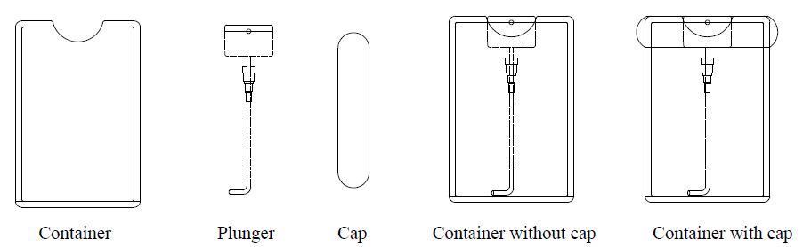
Fig.1: Parts of the MIRGA sprayer

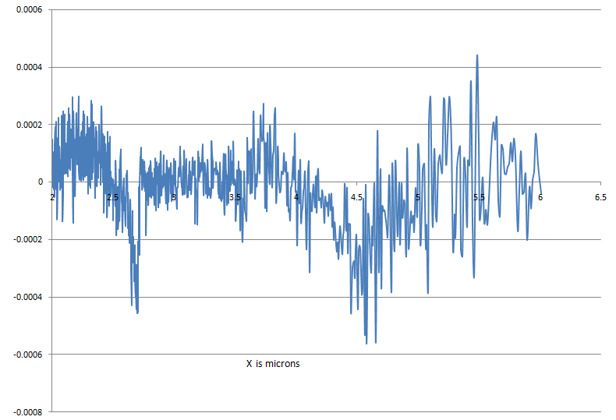
Fig.2: Estimation of 2-6 µm mid-infrared while spraying MIRGA atomizer

T2: Detailed discussion
Discussion
Invention background
The four observable states of matter (solid, liquid, gas, plasma) are composed of intermolecular and intramolecular bonds. The inherent characteristics of neutrons, protons and electrons are unique, however, difference in their numbers is what constitutes different atoms and how these atoms bind together develop into different molecules with unique characters. In the electromagnetic wave (EMW) spectrum mid-IR region is vital and interesting for many applications since that region coincides with the internal vibration of most molecules (CORDIS, European commission). Almost all thermal radiation on the earth surface lies in the mid-IR region, 66% of the sun’s energy we receive is infrared (Aboud et al., 2019) and is absorbed and radiated by all particles on the earth. Naturally, at molecular level, interaction of mid-IR wavelength energy elicits rotational and vibrational modes (from about 4500-500 cm⁻¹ roughly 2.2 to 20 microns) through a change in dipole movement leading to chemical bond alteration (Girard, 2014).
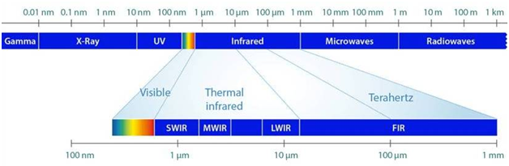
Fig.3: Electromagnetic Spectrum
During our research we observed: (A) In all objects, even though atoms always remain as atoms their chemical bond parameters are continuously prone to alteration by cosmic and physical energies (eg: EMW, heat, pressure, humidity) causing the bonds compression/stretching/bending (Alvarez et al., 2012; Smith, 1999; Shankar, 2017; Mohan, 2004), breaking (McMakin, 2011; Moss, 2011) and new bond formation (Raven, 2012). These alterations ultimately lead to the change in the physicochemical characters of the objects. (B) The dynamic, constant, mutual influences of EMW among earth, celestials and living bodies are continuously causing alterations in the inherent physiochemical characters of earthly objects, like enhancement due to optimum dose of energy or decrease/ destruction due to more dose of energy (detailed below). Thus based on these concepts, the MIRGA was developed to alter bond parameters thereby potentiate any usables’ natural characters.
MIRGA definition
We define MIRGA as ‘a harmless, economical atomizer containing an imbalanced ratio of ions suspended in water, which influence the natural potency of target substances by generating mid-IR while spraying’.
Technique of mid-IR generation from MIRGA
We designed MIRGA as to accommodate an imbalanced ratio of ions suspended in water in their fundamental state and can move as free particles. The solution has very little background frequency of detectable disintegration which is less than that of cosmic events whereas even humans have more radioactivity (around 10 microns) (Ashcroft, 2000; Sanders, 2014). We designed MIRGA to generate energy based on various below given processes like, (A) spraying leads to ionization (electron getting separated from atom) and the pathway for electron re-absorption are also many, due to these two oscillatory processes energy generated. (B) while spraying, water-based ionic solution gets excited/charged, which in turn leads to oscillation among the imbalanced ions (Verheest, 2000) in their excited state, resulting in the emission of photons (Keping et al., 2004; Fauchais et al., 2014). (C) Though low electromagnetic field exists between charged particles of the MIRGA’s ionic solution, during spraying the induced oscillation between these charged particles produces energy (Wendish et al., 2009; Singh, 2009; Prasad, 2017; Pople, 1999). (D) Also, in the natural rainfall process, more energy is required to break water bonds for creating smaller water droplets from the clouds (Barry et al., 1998). Therefore, these droplets should have more stored energy and then travels down at a velocity from a specific distance thus gaining also a kinetic energy. When the rain hits the earth’s surface, it forms a very thin film of mid-IR (nearly 6 micron), hence there is a net heat gain (Barry et al., 1998; Eniday, 2019). We simulated this rainfall’s energy gaining process also in MIRGA i.e., when imbalanced ions in liquid media are atomized, the ejected smaller droplets should have higher internal energy as well as an acquired kinetic energy and the energy emitted by breaking the surface tension. From trial and experience, we calibrated an ejection pressure to obtain a desired fine mist, and minimized the evaporation rate by altering the pH and density of the solution. Also considering other facts like, the accelerated ions in the sprayed ionic clouds collide among them and generate energy (Krishnakumar, 2019), we incorporated those phenomena in our atomizer and designed in such a way to emit energy in the 2-6 µm mid-IR range.
The inorganic compounds used in the generation of MIR are a perspective for biomedical applications (Tishkevich et al., 2019; Dukenbayev et al., 2019). It is also a new synthesis method for preparation of functional material (2-6 µm mid-IR) (Kozlovskiy et al., 2021; El-Shater et al., 2022). It is well known that the combination of different compounds, which have excellent electronic properties, leads to new composite materials, which have earned great technological interest in recent years (Kozlovskiy et al., 2021; Almessiere et al., 2022).
Action of MIRGA emitted 2-6 µm mid IR on the target substances
While spraying MIRGA, most of the mid-IR energy scatters through the air and gets absorbed by receptors (edibles or usables) molecules. Virtually all organic compounds absorb mid-IR radiation which causes a change in molecule’s vibrational state to move from the lower ground state to excited higher energy state (Girard, 2014). This leads to changes in chemical bonds (Shankar, 2017; Mohan, 2004) and these bond parameter changes led to consequent changes in target’s physical and chemical characters, configuration, compound transformation depending on the dose of energy applied (Yi, 2012; Esmaeili, 2015; Atkins et al., 2011; Datta et al., 2014). Nanostructured water layers can be triggered upon application of mid-IR radiation, since water molecules absorb in this region. (Sommer et al., 2008; Sommer et al., 2011)
Depending on number of MIRGA spraying (energy given), a receptor’s chemical bond configurations and subsequent physical and chemical characters can be altered to our desire.
As displayed in the results, 2-6 µm MIR generated from the MIRGA equipment caused chemical and molecular level changes in the tobacco components. This action of the MIR is called as photodegradation which means alterations of materials by light. In this process, chemical components of the tobacco have absorbed the MIR generated by MIRGA spraying, and the absorbed MIR photons have broken the chemical bonds of nicotine molecule; thereby the nicotine molecules are degraded and transformed into another molecule/ compound, as reported in GCMS analysis.
Toxicological study on MIRGA
Even though, MIRGA generates the safe 2-6 µm mid-IR energy, and moreover spraying is done 0.25–0.50 meter externally right away to packaged consumables, we also wanted to study the MIRGA’s toxicity effect by cytotoxicity assay. In-vitro Vero, A549 and Human dermal fibroblast cells study proved that MIRGA sprayed mist was non-toxic in any way (Fig. 4).
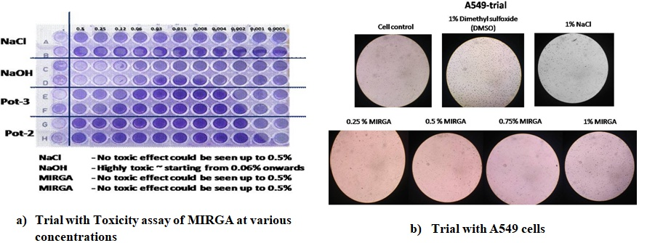
Figure 4: MIRGA’s toxicological studies
Field studies also showed that, MIRGA spray is eco-friendly, non-toxic, non-irritant to soft tissues such as cornea, safe to infants even if sprayed directly, needs no skill but easy to handle (like perfume body spray), and highly economical (USD 0.30 per MIRGA unit which emits 300 sprayings).
Safety of MIRGA sprayed usables
In our nearly two-decades of research, we observed MIRGA induced bond altered target substances had not shown any adverse reaction upon consumption/use. As a comparison, to assure the safety of the bond altered targets’ millennium long consumption by human/ living kinds; we submit that in nature, (A) Stereochemical configuration has great influence on taste (Williamson et al., 2011) e.g. variety of mango, grapes, rice, etc., (B) Cooking and digestive enzymes break chemical bonds thereby soften our edibles. And, as an example; raw rice on water-boiling to boiled rice; rice on raw heat to puffed rice; rice on boiling and drying to flat rice; rice on pressure to rice flour (Scanlon et al., 2011; Kowtaluk, 2006), each by-product has its unique aroma, taste, texture and shelf life but with same molecular formula C₆H₁₀O₅), (C) In food industry, sensory attributes and shelf-life are enhanced by altering the food’s chemical bonds using various irradiation processes like, radappertization, radicidation, raduriaztion (Sivasankar, 2014), (D) On heating, ice to water to steam manifestations are due to changes in the hydrogen bonding, where steam has negligible hydrogen bonding (Trevor, 1999) but chemical composition (H₂O) remains the same (Raymond, 2010).
MIRGA’s primeval and future scope
The water based MIRGA could be the first novel pioneer potentiating technology. This type of atomizer technology also seems to be present with the extra-terrestrials for their therapeutic use during visitations (Blue planet project).
In various usables, a range from 30% to 173% potentiation has been achieved by us. Even considering the least 30% in some usables have resulted in 30% economic, resource, and ecological savings as well as health benefits. But there is a knowledge gap between potentiation from 30% to at least 100% for all usables, which can be filled-up by refining MIRGA’s ionic solution, concentrations, atomizer pressures, other parameters and even formulating a better solution.
Using MIRGA, we conducted experiments which resulted in resource savings with edible oils, vegetables, fruits, food, coffee, tea, alcohol, tobacco, cocoa, edible salts, sugar, herbal, cement, spices, chemicals, pharmaceuticals, dairy products, liquid and gaseous fuels, and vaccine. Human and veterinary disease therapy and were included in these studies, and the results are promising. The laboratory analysis of these substances revealed the altered chemical bonds, configuration and chemical compound transformation. In foodstuffs, detoxification of agrochemical residues resulted as well as enhancement of sensory attributes and shelflife. These results are being separately submitted for publication. The individual results are about to be published.
A variety of mid-IR emitters are now available e.g. silicon photonic devices (CMOS Emerging Technologies, 2012), cascade lasers (quantum and interband) (Jung et al., 2017), non-cascade based lasers, chalcogenide fibre-based photonic devices (Sincore et al., 2018) and suspended-core tellurium-based chalcogenide fibre photonic devices (Bo et al., 2018). These emitters are not as cost-effective as MIRGA, and useful only in astronomy, military, medicine, industry as well in the laboratory. They are much too complex in daily domestic applications for the average user.
Because of MIRGA’s wide range of applications, we believe that MIRGA will definitely resonate in many scientific researches such as biophotonics, therapeutics, health, ecology and many other fields. Our further research on MIRGA and its other manifestations which we developed namely MIRGA salt, MIRGA vapor and MIRGA plasma in human endeavors is dynamically now ongoing.
References
- CORDIS, European commission. New advances in mid-infrared laser technology, Compact, high-energy, and wavelength-diverse coherent mid-infrared source. Available at: https://cordis.europa.eu/project/rcn/99977/brief/en (last accessed on 27.01.2019)
- Aboud S, Altemimi A, Al-Hilphy A, Lee Y C, Cacciola F, 2019. molecules A Comprehensive Review on Infrared Heating Applications in Food Processing. Molecules. 24. 2-21. 10.3390/molecules24224125.
- Girard J E, 2014. Principles of Environmental Chemistry, 3rd edition, Jones & Bartlett Learning, USA, p99
- Alvarez A, Prieto M, 2012. Fourier Transform Infrared spectroscopy in Food Microbiology, Springer Science & Business Media, p3.
- Smith B C, 1999 Infrared Spectral Interpretation: A Systematic Approach, CRC Press, LLC, 7
- Shankar D R, 2017. Remote Sensing of Soils. Germany: Springer-Verlag GmbH, p268
- Mohan J, 2004. Organic Spectroscopy: Principles and Applications, 2nd edition, Alpha science international Ltd., Harrow, UK, 19. Available at: https://books.google.co.in/books?id=fA08Uy5DR0QC&printsec=frontcover&dq=Jag+Mohan.+Organic+Spectroscopy:+Principles+and+Applications&hl=en&sa=X&ved=0ahUKEwjHpcHUi9fgAhXXFIgKHXvRCpIQ6AEIKjAA#v=onepage&q=Jag%20Mohan.%20Organic%20Spectroscopy%3A%20Principles%20and%20Applications&f=false
- McMakin C, 2011. Frequency specific Microcurrent in pain management E-book, Elsevier, China, p 30.
- Moss D, 2011. Biomedical Applications of Synchrotron Infrared Microspectroscopy: A Practical Approach, Royal Society of Chemistry, UK, p 58.
- Raven P H, Berg L R, Hassenzahl D M, 2012. Environment, John Wiley & Sons, Inc., USA, p45. Available at: https://books.google.co.in/books?id=QVpO2R51JBIC&pg=RA1-PA45&dq=electromagnetic+waves+make+form+new+bonds&hl=en&sa=X&ved=0ahUKEwiTnO2amMbjAhUJ3o8KHSfkAJEQ6AEIMjAB#v=onepage&q=electromagnetic%20waves%20make%20form%20new%20bonds&f=false
- Ashcroft F, 2000. Life at the Extremes: The Science of Survival, University of California Press, California, p122
- Sanders R H, 2014. Revealing the Heart of the Galaxy, Cambridge University Press, USA, p70
- Verheest F. Waves in Dusty Space Plasmas, Kluwer Academic Publishers, Netherlands, 89, (2000)
- Keping S, Yu G, 2004. Recent developments in Applied Electrostatics (ICAES2004): Proceedings of the Fifth International Conference on Applied Electrostatics, Elsevier Ltd., UK, p87.
- Fauchais P , Heberlein J V R, Boulos J I, 2014. Thermal Spray Fundamentals From Powder to Part. Springer Science & Business Media, New York, 84
- Wendish M, Brenguier J L, 2019. Airborne Measurements for environmental Research: Methods and Instruments, Wiley-VCH. Available at: https://books.google.co.uk/books?id=tHdwhn-c5mgC&pg=PT419&dq=A+regularly+oscillating+charge+produces+a+harmonic+electromagnetic+waves+Manfred&hl=en&sa=X&ved=0ahUKEwjBqdv75tvgAhWpSxUIHbQ_D0gQ6AEIKjAA#v=onepage&q=A%20regularly%20oscillating%20charge%20produces%20a%20harmonic%20electromagnetic%20waves%20Manfred&f=false (last accessed on 27.02.2019)
- Singh K C, 2009. Basic Physics, PHL Learning Private Limited, New Delhi, p413
- Prasad M, 2017. Soul, God and Buddha in Language of Science, Notion Press, Chennai
- Pople S, 1999. Complete Physics, Oxford University Press, Oxford, p166
- Barry R, Chorley R, 1998. Atmosphere, Weather and Climate, 7th edition, Routledge, London, p51
- Eniday: https://www.eniday.com/en/sparks_en/harnessing-the-energy-of-rain/ (last accessed on 06.02.2019)
- Krishnakumar T (2019). Application Of Microwave Heating In Food Industry. 10.13140/RG.2.2.27035.72488.

Tishkevich D I, Korolkov I V, Kozlovskiy A L, Anisovich M, Vinnik D A, Ermekova A E, Vorobjova A I, Shumskaya E E, Zubar T I, Trukhanov S V, Zdorovets M V, Trukhanov A V, 2019. Immobilization of boron-rich compound on Fe₃O₄ nanoparticles: Stability and cytotoxicity, J. Alloys Compd. 797, 573-581. https://doi.org/10.1016/j.jallcom.2019.05.075.

Dukenbayev K, Korolkov I V, Tishkevich D I, Kozlovskiy A L, Trukhanov S V, Gorin Y G, Shumskaya E , Kaniukov E Y, Vinnik D A, Zdorovets M V, Anisovich M, Trukhanov A V, Tosi D, Molardi C, 2019. Fe₃O₄ nanoparticles for complex targeted delivery and boron neutron capture therapy, Nanomaterials, 494. https://doi.org/10.3390/nano9040494.

Kozlovskiy A L, Alina A, Zdorovets M V, 2021. Study of the effect of ion irradiation on increasing the photocatalytic activity of WO₃ microparticles, J. Mater. Sci.: Mater. Electron. 32, 3863-3877. https://doi.org/10.1007/s10854-020-05130-8

El-Shater R E, Shimy H E, Saafan S A, Darwish M A, Zhou D, Trukhanov A V, Trukhanov S V, Fakhry F, 2022. Synthesis, characterization, and magnetic properties of Mn nanoferrites, J. Alloys Compd. 928, 166954. https://doi.org/10.1016/j.jallcom.2022.166954

Kozlovskiy A L, Zdorovets M V, 2021. Effect of doping of Ce^{4+/3+} on optical, strength and shielding properties of (0.5-x)TeO₂-0.25MoO-0.25Bi₂O₃-xCeO₂ glasses, Mater. Chem. Phys. 263, 124444. https://doi.org/10.1016/j.matchemphys.2021.124444
- Almessiere M A, Algarou N A, Slimani Y, Sadaqat A, Baykal A, Manikandan A, Trukhanov S V, Trukhanov A V, Ercan I, 2022. Investigation of exchange coupling and microwave properties of hard/soft (SrNi_{0.02}Zr_{0.01}Fe_{11.96}O₁₉)/(CoFe₂O₄)_{x} nanocomposites, Mat. Today Nano, 100186. https://doi.org/10.1016/j.mtnano.2022.100186
- Yi G, 2012. Semiconductor Nanostructures for Optoelectronic Devices: Processing, Characterization and Applications. Berlin, Heidelberg: Springer-Verlag, p198
- Esmaeili K, 2015. Viremedy, Homeopathic Remedies, and Energy Healing Remedies as Information – including Remedies; A Synopsis [Revision Aug 2015; E-pub.: Aug.2015] (First Pub: 2013). Google books, p43
- Atkins P, Paula J, 2011. Physical Chemistry for the Life Sciences, Oxford university press, Oxford, p365
- Datta S N, O’Trindle C, Illas F, 2014. Theoretical and Computational Aspects of Magnetic Organic Molecules. Imperial College Press, London, p224
- Sommer A, Caron A, Fecht H J, 2008. Tuning Nanoscopic Water Layers on Hydrophobic and Hydrophilic Surfaces with Laser Light. Langmuir : the ACS journal of surfaces and colloids. 24. 635-6. 10.1021/la7032737.
- Sommer A, Zhu D, Mester A, Försterling H D, 2011. Pulsed Laser Light Forces Cancer Cells to Absorb Anticancer Drugs - The Role of Water in Nanomedicine. Artificial cells, blood substitutes, and immobilization biotechnology. 39. 169-73. 10.3109/10731199.2010.516262.
- Williamson K L, Masters K M, 2011. Macroscale and Microscale Organic Experiments, 6th edition, Brooks/ Cole C engage learning, CA, p720
- Scanlan N, 2011. Complementary Medicine for Veterinary Technicians and Nurses, Wiley-Blackwell publishing, USA.
- Kowtaluk H, 2006. Food for today 9E, 9th edition. Tata McGraw-Hill Publishing Company Limited, NewDelhi, p456.
- Sivasankar B. Food Processing and preservation, PHI Learning Private Limited, Delhi, 246, (2014)
- Trevor Day, 1999. Ecosystems: Oceans. Routledge Taylor & Francis Group, London and New York, p44
- Raymond K W, 2010. General Organic and Biological Chemistry, 3rd edition, John Wiley & Sons, Inc., USA, p176
- Blue planet project: Alien Technical research–25, Westchester Camp, Office of the Central Research #3.CODE: ARAMISIII–ADR3-24SM, p80-81
- CMOS Emerging Technologies. CMOSET 2012: Abstracts, p49. Available at: https://books.google.co.in/books?id=3XVYC-yBgksC&pg=PA49&dq=mid+infra#v=onepage&q&f=false
- Jung D, Bank S, Lee M L, Wasserman D, 2017. Next-generation mid-infrared sources. Journal of Optics, 19(12), 123001. doi:10.1088/2040-8986/aa939b.
- Sincore A, Cook J, Tan F, El Halawany A, Riggins A, McDaniel S, Cook G, Martyshkin D V, Fedorov V V, Mirov S B, Shah L, Abouraddy A F, Richardson M C, Schepler K L, 2018. High power single-mode delivery of mid-infrared sources through chalcogenide fiber. Optics Express, 26(6), 7313. doi:10.1364/oe.26.007313
- Bo W, Zheming Z, Xunsi W, Youmei T, Nan M, Peng C, Zugang X, Zijun L, Peiqing Z, Xiang S, Qiuhua N, Shixun D, Rongping W, 2018. Mid-infrared supercontinuum generation in a suspended-core tellurium-based chalcogenide fiber. Optical Materials Express, 8(5), 1341. doi:10.1364/ome.8.001341.

Video V2: Tobacco trial video link: https://drive.google.com/file/d/1kenC9dU8YCMoECwi_rqElnjjvAJt-ZYA/view (‘Genno-treated bidis’ in this video refers to the ‘MIR-treated bidis’)
Explanation of the video:
With the results inferred from experiment I, the M-0 and M-2 bidis respectively evaluated as Neither like nor dislike and Like very much. M-2 bidis illustrated to have reduced nicotine content than in M-0, the bidis were smoked by a volunteer smoker. The smoke from M-0 and M-2 bidis were blown into jars each separately contained air, water, honey bees, flowers, birds, ornamental fishes and on sacrificed goat lungs. Also swabs collected from the smoker’s buccal cavity. Appropriate controls maintained. The results were compared and presented. (Video V2)
    - Test 1: Into air
The control beedi was smoked and the inhaled smoke was blown into a first clean glass jar and closed tightly. Next the S-2 beedi was smoked and the inhaled smoke was blown into a second clean glass jar and closed tightly. After a few minutes the two jars were observed. The researchers and spectators witnessed the appearance of first jar to be polluted, but the second jar appeared to be clear and pollution-free. No scientific pollution analysis was done.
    - Test 2: Into water
The inhaled smoke from the control beedi was blown into a first jar containing water and closed tightly. Next, inhaled smoke from S-2 sprayed beedi was blown into a second jar containing water and closed tightly. After a few minutes the researchers and spectators found the water in the first jar to be polluted but water in the second jar appeared to be clear and unpolluted. No scientific pollution analysis done.
    - Test 3: On insects and flowers
The honey bees are reliable and good bio-indicators of pollution and toxicity (Zhelyazkova; Celli). The honey bees and rose flowers were kept in the first glass jar with its mouth sealed with cloth containing a small opening to blow in the tobacco smoke. The inhaled smoke from the control beedi was blown into the jar. Next, some other honey bees and rose flowers were kept in a second glass jar with its mouth was sealed with cloth having a small opening to blow-in smoke. The inhaled smoke from the S-2 beedi was blown into the second jar. The bees in the first jar were seems to show dysponea signs and some were unconscious and aroma of the rose flower found to be reduced. The bees in second jar were present unaffected, active, normal and also the aroma of the rose flower remained same.
    - Test 4: On birds
Birds are reliable indicator and used to characterize ecosystem to monitor environmental changes and to assess the results of restoration measures (Roche). Two healthy birds were caged one in each cage. The smoke from the control beedi was blown into the first cage. The bird in that cage immediately showed dysponea signs and altered behavior. Next, the S-2 beedi smoke was blown into the second cage. The bird in the 2nd cage showed no breathing difficulty and the behavior remained normal.
    - Test 5: On aquatics
Fishes have been widely documented as useful indicators and a good monitoring tool of environmental water quality because of their differential sensitivity to pollution (Naigaga; Chovanec). Ornamental fishes are sensitive to polluted/ contaminated water. Ornamental fishes were kept in two separate jars filled with water. The smoke from the control beedi was blown into the first jar. Immediately the swimming speed of the fish appeared to have been reduced, seen tired and has difficulty in breathing. Next, smoke from an S-2 beedi was blown into a second jar containing fish. The activities and behavior were observed to be unaffected and the swimming speed of the fish remained unchanged.
    - Test 6: On goat’s lung
Two goat lungs slaughtered a few minutes ago were purchased (from Government licensed slaughter house) and trialed. The smoke from control beedi was pumped into the first lung. The moisture content of the first lung was found to have reduced and appeared discolored. Next the smoke from an S-2 beedi was pumped into a second lung. The second lung appeared to be unaffected and its features remained unchanged.
    - Test 7: From the smoker’s buccal cavity
First, after smoking a control beedi an oral swab was taken. Later, after smoking an S-2 beedi an oral swab was taken from the same smoker. Both were stained and compared. The cell pathology was noticed in control. In S-2, cells were normal and without pathology.
These tests were presented in the supplementary file as Video S1, in which the ‘MIR-treated bidis’ were called formerly as ‘Genno-treated bidis’.

