SUPPLEMENTARY MATERIAL
Table S1: Short-list of 11 high potential study species that was compiled based on local industry experience with key notes, comments and observations from NCC Environmental Services and literature.
Plant species | Comments and observations
Prionium serratum | Great potential, classified as ecosystem engineer, slow growing
Berula erecta | Potentially invasive, medical properties
Cyperus prolifer | Great once established
Phragmites australis | Very common, great for nutrient uptake, invasive
Typha capensis | Efficient nutrient and heavy metal removers
Cyperus textilis | Remove heavy metals, nitrogen and phosphorus from wastewater; hardy plants
Juncus kraussii | Good nutrient remover
Cyperus papyrus | Works well, grows tall and may topple floating wetland
Juncus lomatophyllus | Spreads well
Isolepis prolifera | Very easy to grow, establish and propagate; tolerant of very polluted water
Gunnera perpensa | Forms an interesting relationship with blue-green algae, medicinal properties

Table S2: An evaluation of 11 potential wetland species using six criteria, scored from 1-5, 1 being lowest, 5 being highest. The top scoring three species are indicated in bold.
 |  | Plant criteria |  |  |  |  |  | Total score
 |  | 1 | 2 | 3 | 4 | 5 | 6 | (30)
Plant species | Cyperus textilis | 5 | 5 | 5 | 5 | 4 | 5 | 29
Plant species | Juncus lomatophyllus | 5 | 5 | 4 | 4 | 5 | 5 | 28
Plant species | Prionium serratum | 5 | 5 | 3 | 4 | 5 | 5 | 27
Plant species | Cyperus prolifer | 5 | 5 | 4 | 4 | 4 | 4 | 26
Plant species | Gunnera perpensa | 5 | 4 | 4 | 5 | 4 | 4 | 26
Plant species | Isolepis prolifera | 5 | 4 | 4 | 5 | 3 | 5 | 26
Plant species | Berula erecta | 4 | 5 | 4 | 5 | 3 | 5 | 26
Plant species | Juncus kraussii | 5 | 5 | 4 | 4 | 3 | 4 | 25
Plant species | Cyperus papyrus | 5 | 4 | 4 | 4 | 3 | 2 | 22
Plant species | Phragmites australis | 3 | 5 | 5 | 5 | 3 | 1 | 22
Plant species | Typha capensis | 3 | 5 | 5 | 5 | 3 | 1 | 22

Table S3: Climatic and greenhouse conditions recorded between 27 January 2017 and 27 February 2017 (31 days). The weather data were collected at the Sonbessie weather station at Stellenbosch University, South Africa and the greenhouse data were collected using a data logger (Model: TinyTag Plus 2: TGP -4500; Gemini Data Loggers).
 | Climatic conditions
Ambient | Mean temperature | 21.7°C
Ambient | Mean minimum temperature | 12.7°C
Ambient | Mean maximum temperature | 35.1°C
Ambient | Mean relative humidity | 63.8%
Ambient | Total rainfall | 3.3mm
Ambient | Number of days without rainfall | 29
Greenhouse | Mean temperature | 22.4°C
Greenhouse | Mean minimum temperature | 12.1°C
Greenhouse | Mean maximum temperature | 39.3°C
Greenhouse | Mean relative humidity | 76.3%
Greenhouse | Hours of sunshine | 372
Greenhouse | Number of days with a maximum temperature of 25°C or higher | 23

The concentrations found in the studies (Table S4) were analysed and averaged according to various scales/regions (Table S5). When considering the average for the ‘Western Cape, South Africa’, the majority of the studies were from the Western Cape but included studies from other parts of South Africa. The adjusted means were obtained by rounding up the mean value from South African studies. These values were used to guide the concentrations used in the mesocosm experiment.
Table S4: Local and international nutrient concentrations of water bodies under various conditions. Where ranges or various sites in the same water body were described in scientific papers, the mean was used for this table. All concentrations were transformed into their ionic forms.
Concentration (mg/L) |  |  | Ecosystem type | Climate | Location | Notes | Reference
PO₄³⁻ | NH₄⁺ | NO₃⁻
- | 0.70 | 5.22 | Lake | Subtropical | China | Anthropogenic nutrient enrichment causing cyanobacterial blooms; pH between 8 and 9, seasonal NH₄-N and NO₃-N fluctuations | Wu et al. (2014b)
8.31 | 52.95 | - | Former bog | Temperate | Germany | Paludiculture (cultivation of marshland) with Sphagnum moss in a previously agriculture intensive system; surface water; pH between 4 and 6 | Temmink et al. (2017)
23.00 | - | 180.00 | Salt marsh | Mediterranean | Spain | Acidic conditions (pH between 6.2 and 7.8); mining; highly eutrophic conditions due to intensive agricultural practices upstream | González-Alcaraz et al. (2011)
- | 3.57 | - | Lake | Temperate | China | Raw, eutrophic water quality: 1.75-3.79 mg/L for NH₄-N, but water quality standards for raw water in China are 2 mg/L for NH₄-N | Wu et al. (2016)
- | 2.81 | 1.42 | Lake | Subtropical | China | Hydroponic type system to treat eutrophic wastewater using an aquatic plant; pH of 8.13 | Hu et al. (2008)
0.08 | 0.67 | 3.45 | Lake | Subtropical | China | N and P removal by aquatic plant with low-energy ion implantation; eutrophic lake water utilised | Li et al. (2009)
- | 2.78 | - | Lake | Subtropical | China | Vegetated floating bed enhanced with bivalve species and biofilm carrier | Li et al. (2010)
- | 3.86 | 18.15 | River | Subtropical | China | Floating island used in eutrophic river for water purification | Zhao et al. (2012)
- | 17.26 | - | River | Subtropical | Taiwan | Wastewater treatment of anthropogenic nutrient input e.g. sewage; comparing removal and economics between conventional facilities versus constructed wetlands | Teng et al. (2012)
- | 3.44 | 11.62 | River | Subtropical | China | N removal by Canna-grown floating wetlands with immobilised denitrying bacteria; pH between 6.5 and 7 | Sun, Liu & Jin (2009)
0.40 | - | - | Lake | Temperate | Japan | Relationship between algae and diatoms species dominance and P fluctuations due to water dilution in eutrophied lake; pH of 7 | Amano et al. (2010)
- | - | 1.60 | Lake | Mediterranean | Italy | Reservoir accumulating nutrients from anthropogenic sources (i.e. agriculture and sewage) | Padedda et al. (2015)
0.46 | - | 0.83 | Constructed wetland | Mediterranean | Western Cape, South Africa | Constructed wetland used to purify agricultural run-off (including pesticides) in Lourens River basin; nitrates and orthophophates are only written in words - assumed in NO₃⁻ and PO₄³⁻ notation; pH between 6.7 and 7.2 | Schulz & Peall (2001)
0.28 | - | 0.51 | River | Mediterranean | Western Cape, South Africa | Urban stormwater run-off in Cape Town; pH of 8.34 | Ward & Winter (2016)
0.55 | - | - | River | Temperate | Gauteng, South Africa | Hypertrophic water from the Vaal River purified for potable water usage; Midvaal; pH of 8.76 | van Rensburg, Barnard & Krüger (2016)
- | - | 2.78 | River | Temperate | Eastern Cape, South Africa | Swartkops River; polluted due to urban sewage and industrial effluent; pH of 8.2. Unpolluted rivers nearby: Kromme River (NO₃-N: 0.064 mg/L; PO₄-P: 0.121 mg/L) and Sundays River (NO₃-N: 0.629 mg/L; PO₄-P: 0.233 mg/L). | Emmerson (1989)
0.25 | - | - | River | Mediterranean | Western Cape, South Africa | Berg River; mean (of min and max) over a period between the 1970s to 2005 | De Villiers & Thiart (2007)
0.18 | - | - | River | Mediterranean | Western Cape, South Africa | Gouritz River; mean (of min and max) over a period between the 1970s to 2005 | De Villiers & Thiart (2007)
0.05 | - | - | River | Mediterranean | Western Cape, South Africa | Breede River; mean (of min and max) over a period between the 1970s to 2005 | De Villiers & Thiart (2007)
0.38 | - | 2.88 | River | Subtropical | Eastern Cape, South Africa | Keiskamma River; receiving domestic and agricultural run-off; pH between 6.6 and 7.4 | Morrison et al. (2001)
- | 0.14 | - | River | Subtropical | KwaZulu Natal, South Africa | Mooi River; receiving mostly agricultural run-off; pH of 7.33 | De La Rey et al. (2004)
1.10 | 1.90 | 2.20 | Reservoir | Subtropical | Zimbabwe | High nutrient loads mostly due to sewerage works; pH of 8.91 | Rommens et al. (2003)
- | 0.16 | - | Wetland | Mediterranean | Western Cape, South Africa | Four wetlands on the Cape Agulhas Plain experiencing eutrophic water quality conditions due to agricultural activities | Gordon, Adams & Garcia-Rodriguez (2011)
5.67 | - | - | River | Mediterranean | Western Cape, South Africa | Mix of agricultural run-off and sewage in Bottelary River, Cape Town; pH between 6.15 and 8.43 | Feng (2005)
0.06 | 0.08 | ≤5.00 | Aquifer borehole water | Mediterranean | Western Cape, South Africa | Extracted water from multiple boreholes from the Cape Flats aquifer. These concentrations are regarded as low concentrations. "Other parameters often indicating agricultural pollution are, however, low in concentration: NO₃ (≤5 mg/L except 13.1 mg/L in borehole number 21), NH₄-N (0.004-0.009 mg/L) and PO₄ (0.006-0.043 mg/L)." | Xu & Usher (2006)

Table S5: Mean eutrophic concentrations for international and local studies. Values are averaged from those displayed in Table S4. The adjusted means are the values for eutrophic conditions used in the mesocosm experiment.
 | Mean concentration (mg/L)
 | PO₄³⁻ | NH₄⁺ | NO₃⁻
All studies | 1.51 | 2.01 | 2.32
All studies, excluding South Africa | 2.93 | 2.55 | 2.92
Western Cape, South Africa | 0.31 | 0.15 | 1.84
Adjusted mean for this study | 0.30 | 0.20 | 2.00

Table S6: Summary of the physico-chemical variables (±standard deviation) that were recorded each week over the one-month floating wetland mesocosm experiment. Abbreviations: Temp: water temperature, DO: dissolved oxygen, Cond: conductivity, TDS: total dissolved solids and SAL: salinity. Letters denote significant differences within each parameter at p<0.05 using a one-way ANOVA.
Treatment | Temp  (°C) | DO  (%) | Cond  (uS.cm⁻¹) | TDS  (ppm) | SAL  (ppt) | pH
Control | 25.2 ± 1.30ª | 0.1 ± 0.03ª | 139.6 ± 4.54ª | 90.3 ± 2.84ª | 0.1 ± 0.00ª | 7.5 ± 0.22ª
Cyperus textilis | 25.2 ± 1.06ª | 0.1 ± 0.02ª | 140.7 ± 8.51ª | 91.1 ± 5.67ª | 0.1 ± 0.01ª | 7.6 ± 0.21ª
Juncus lomatophyllus | 24.3 ± 0.96ª | 0.1 ± 0.03ª | 110.8 ± 4.19ª | 73.0 ± 3.29ª | 0.1 ± 0.00ª | 7.1 ± 0.16^{b}
Prionium serratum | 25.0 ± 1.72ª | 0.1 ± 0.03ª | 119.3 ± 7.07ª | 77.7 ± 5.27ª | 0.1 ± 0.00ª | 7.2 ± 0.20^{ab}

Table S7: Nutrient removal from the various planted floating wetlands in the mesocosm experiment.
Treatment | Replicate | Nutrient | Total removal (mg) | Removal efficiency (%) | Removal rate (mg/m2/day)
Control | 1 | NH4-N | 38.17 | 91.60 | 3.65
Control | 2 | NH4-N | 35.46 | 84.91 | 3.39
Control | 3 | NH4-N | 38.86 | 93.28 | 3.71
Control | 4 | NH4-N | 36.06 | 86.56 | 3.45
Control | 5 | NH4-N | 39.51 | 94.95 | 3.78
Control | 6 | NH4-N | 40.25 | 96.64 | 3.85
Control | 1 | NO3-N | 363.08 | 96.11 | 34.70
Control | 2 | NO3-N | 363.06 | 96.11 | 34.70
Control | 3 | NO3-N | 375.54 | 99.44 | 35.89
Control | 4 | NO3-N | 364.28 | 96.48 | 34.82
Control | 5 | NO3-N | 347.29 | 92.02 | 33.19
Control | 6 | NO3-N | 369.30 | 97.78 | 35.30
Control | 1 | PO4-P | 109.07 | 97.15 | 10.42
Control | 2 | PO4-P | 107.44 | 95.73 | 10.27
Control | 3 | PO4-P | 105.62 | 94.10 | 10.09
Control | 4 | PO4-P | 111.29 | 99.19 | 10.64
Control | 5 | PO4-P | 108.37 | 96.54 | 10.36
Control | 6 | PO4-P | 108.34 | 96.54 | 10.35
Cyperus textilis | 1 | NH4-N | 36.89 | 88.28 | 3.53
Cyperus textilis | 2 | NH4-N | 38.96 | 93.30 | 3.72
Cyperus textilis | 3 | NH4-N | 39.75 | 94.98 | 3.80
Cyperus textilis | 4 | NH4-N | 38.95 | 93.29 | 3.72
Cyperus textilis | 5 | NH4-N | 39.71 | 94.98 | 3.80
Cyperus textilis | 6 | NH4-N | 40.22 | 96.64 | 3.84
Cyperus textilis | 1 | NO3-N | 363.18 | 95.93 | 34.71
Cyperus textilis | 2 | NO3-N | 376.76 | 99.63 | 36.01
Cyperus textilis | 3 | NO3-N | 376.29 | 99.45 | 35.97
Cyperus textilis | 4 | NO3-N | 375.55 | 99.26 | 35.89
Cyperus textilis | 5 | NO3-N | 356.73 | 94.27 | 34.10
Cyperus textilis | 6 | NO3-N | 354.97 | 94.06 | 33.93
Cyperus textilis | 1 | PO4-P | 109.06 | 97.15 | 10.42
Cyperus textilis | 2 | PO4-P | 112.23 | 100.00 | 10.73
Cyperus textilis | 3 | PO4-P | 112.28 | 100.00 | 10.73
Cyperus textilis | 4 | PO4-P | 112.22 | 100.00 | 10.73
Cyperus textilis | 5 | PO4-P | 112.25 | 100.00 | 10.73
Cyperus textilis | 6 | PO4-P | 112.21 | 100.00 | 10.73
Juncus lomatophyllus | 1 | NH4-N | 36.21 | 86.60 | 3.46
Juncus lomatophyllus | 2 | NH4-N | 40.43 | 96.65 | 3.86
Juncus lomatophyllus | 3 | NH4-N | 40.33 | 96.65 | 3.85
Juncus lomatophyllus | 4 | NH4-N | 40.40 | 96.65 | 3.86
Juncus lomatophyllus | 5 | NH4-N | 40.86 | 98.32 | 3.91
Juncus lomatophyllus | 6 | NH4-N | 39.51 | 94.95 | 3.78
Juncus lomatophyllus | 1 | NO3-N | 368.30 | 97.41 | 35.20
Juncus lomatophyllus | 2 | NO3-N | 358.93 | 94.82 | 34.31
Juncus lomatophyllus | 3 | NO3-N | 374.45 | 99.07 | 35.79
Juncus lomatophyllus | 4 | NO3-N | 359.54 | 95.01 | 34.36
Juncus lomatophyllus | 5 | NO3-N | 375.68 | 99.63 | 35.91
Juncus lomatophyllus | 6 | NO3-N | 372.52 | 98.70 | 35.61
Juncus lomatophyllus | 1 | PO4-P | 110.01 | 97.97 | 10.51
Juncus lomatophyllus | 2 | PO4-P | 112.25 | 100.00 | 10.73
Juncus lomatophyllus | 3 | PO4-P | 112.25 | 100.00 | 10.73
Juncus lomatophyllus | 4 | PO4-P | 112.26 | 100.00 | 10.73
Juncus lomatophyllus | 5 | PO4-P | 112.21 | 100.00 | 10.73
Juncus lomatophyllus | 6 | PO4-P | 109.23 | 97.35 | 10.44
Prionium serratum | 1 | NH4-N | 37.84 | 90.01 | 3.62
Prionium serratum | 2 | NH4-N | 39.13 | 93.32 | 3.74
Prionium serratum | 3 | NH4-N | 37.23 | 88.37 | 3.56
Prionium serratum | 4 | NH4-N | 40.76 | 96.68 | 3.90
Prionium serratum | 5 | NH4-N | 39.05 | 93.31 | 3.73
Prionium serratum | 6 | NH4-N | 39.05 | 93.31 | 3.73
Prionium serratum | 1 | NO3-N | 352.19 | 92.81 | 33.66
Prionium serratum | 2 | NO3-N | 366.60 | 96.68 | 35.04
Prionium serratum | 3 | NO3-N | 373.44 | 98.34 | 35.69
Prionium serratum | 4 | NO3-N | 372.41 | 97.97 | 35.60
Prionium serratum | 5 | NO3-N | 370.92 | 97.97 | 35.45
Prionium serratum | 6 | NO3-N | 375.65 | 99.26 | 35.90
Prionium serratum | 1 | PO4-P | 112.30 | 100.00 | 10.73
Prionium serratum | 2 | PO4-P | 109.30 | 97.36 | 10.45
Prionium serratum | 3 | PO4-P | 112.30 | 100.00 | 10.73
Prionium serratum | 4 | PO4-P | 112.31 | 100.00 | 10.73
Prionium serratum | 5 | PO4-P | 112.25 | 100.00 | 10.73
Prionium serratum | 6 | PO4-P | 109.76 | 97.76 | 10.49

The use of composite sampling, for the in-situ experiment, was essential due to budget constraints. The results of the previously conducted mesocosm experiment were thus used to run an ANOVA power analyses to determine whether the intended sample size was sufficient to detect significant differences, if present. The results of the ANOVA power analysis can be seen in Table S8 and Table S9 below.

Table S8: Power to detect significant differences in nutrient uptake among the three species (p=0.05).
 | Total Nitrogen | Total Phosphorous
Shoot | 0.9607533 | 0.7110479
Root | 0.6338653 | 0.1765282

Table S9: Power to detect significant differences in nutrient partitioning between roots and shoots (p=0.05).
Total Nitrogen | Total Phosphorous
0.9998169 | 0.9888621

Table S10: Summary of the physico-chemical variables (±standard deviation) that were recorded each week over the three-month floating wetland in-situ experiment. Abbreviations: Temp: water temperature, DO: dissolved oxygen, Cond: conductivity, TDS: total dissolved solids and SAL: salinity. Letters denote significant differences within each parameter at p<0.05 using a one-way ANOVA.
 | Temp  (°C) | DO  (%) | TDS  (mg/l) | pH
Concrete Retention Pond | 16.6 ± 2.26ª | 0.3 ± 0.08ª | 227.1 ± 96.37ª | 7.2 ± 0.28ª

Total plant nutrient uptake ranged from 55-853 mg/m² of nitrogen per day and 12-129 mg/m² of phosphorus per day across all three species (Table S11). This translates to a total annual uptake of 2-312 g/m² and 4- 47 g/m² of nitrogen and phosphorus respectively (Table S11). Cyperus textilis had a significantly higher shoot and total nitrogen and phosphorus uptake (mg/plant/day) compared to Prionium serratum and Juncus lomatophyllus while root nitrogen and phosphorus uptake did not differ among species (Fig S 1).

Table S11: Estimated daily (mg.m⁻².d⁻¹) and annual (g.m⁻².y⁻¹) nitrogen and phosphorus uptake measured from 12 March 2021 to 12 June 2021 at the Water Hub, South Africa.
 | C. textilis |  |  |  | J. lomatophyllus |  |  |  | P. serratum
 | Nitrogen |  | Phosphorus |  | Nitrogen |  | Phosphorus |  | Nitrogen |  | Phosphorus
 | Daily | Annual | Daily | Annual | Daily | Annual | Daily | Annual | Daily | Annual | Daily | Annual
Shoots | 809 | 295 | 124 | 45 | 42 | 15 | 10 | 4 | 285 | 104 | 25 | 9
Roots | 45 | 17 | 5 | 2 | 13 | 5 | 2 | 1 | 28 | 10 | 1 | 0.3
Total | 853 | 312 | 129 | 47 | 55 | 2 | 12 | 4 | 313 | 114 | 26 | 9

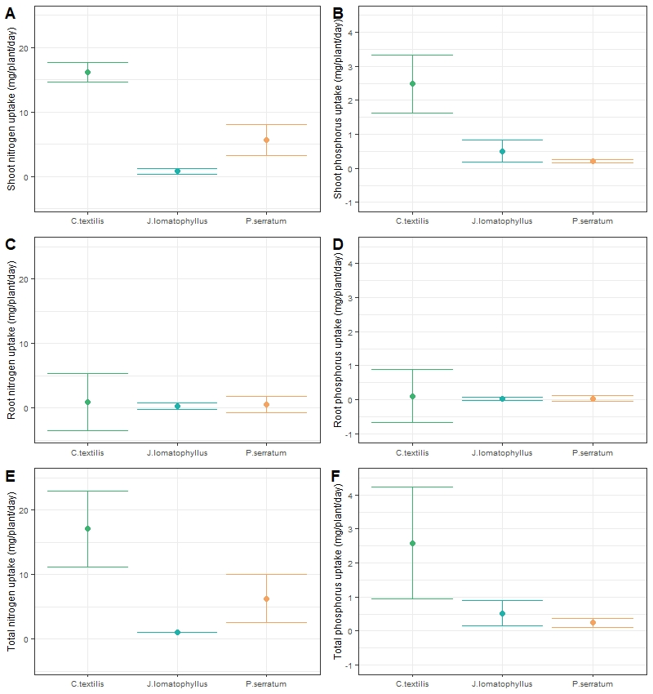
a
b
a
a
a
a
b
c
c
a
b
b
a
a
a
a
b
b
Fig S 1 Estimated mean shoot nitrogen (A), shoot phosphorus (B), root nitrogen (C), root phosphorus (D), total nitrogen (E), and total phosphorus (F) uptake in mg of nutrient per plant per day measured from 12 March 2021 to 12 June 2021, at the Water Hub, Western Cape, South Africa. The error bars represent the minimum and maximum uptake rates while letters indicate significant differences between species (p<0.05).

There was a general increase the nitrogen content (g) over the experiment period for all three species (Fig S 2), however, there was a general decline in daily shoot and root nutrient accumulation (g/day) over the experiment (Fig S 3). Cyperus textilis had significantly higher shoot nitrogen content (g/day) than both P. serratum and J. lomatophyllus, and P. serratum had significantly higher shoot nitrogen content than J. lomatophyllus (Fig S 2). There was an interaction between sampling day and species for root nitrogen content. In general, C. textilis and P. serratum both performed better than J. lomatophyllus in terms of root nitrogen content (Fig S 3). Cyperus textilis had significantly higher total nitrogen content than both P. serratum and J. lomatophyllus, and P. serratum had significantly higher total nitrogen content than J. lomatophyllus (Fig S 3).
There was a general increase in the phosphorus content (g) over the experiment period for all three species (Fig S 2), however, there was a general decline in daily shoot and root phosphorus accumulation (g/day) over the experiment (Fig S 3). Cyperus textilis had significantly higher shoot and total phosphorus content (g/day) than both J. lomatophyllus and P. serratum (Fig S 3). Cyperus textilis had significantly higher root phosphorus content on sampling day 56 than both J. lomatophyllus and P. serratum (Fig S 3).
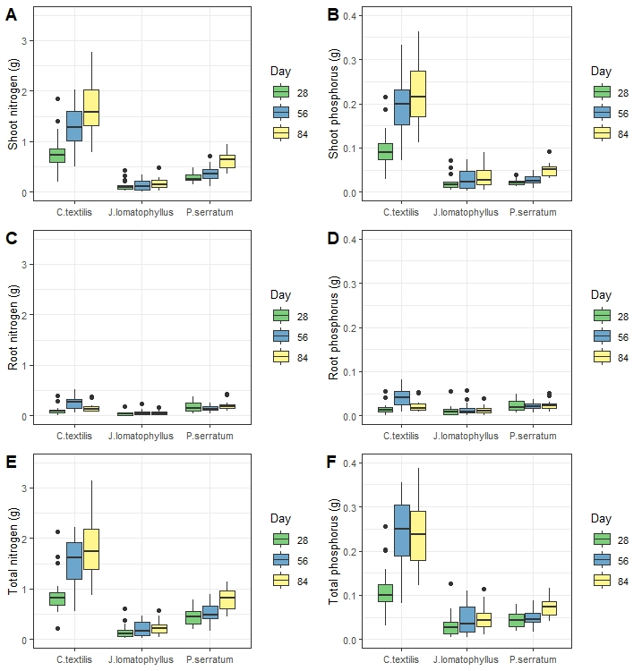
Fig S 2 Box-and-whisker plots of shoot nitrogen (A), shoot phosphorus (B), root nitrogen (C), root phosphorus (D), total nitrogen (E), and total phosphorus (F) content (g) measured from 12 March 2021 to 12 June 2021 the Water Hub, Western Cape, South Africa. Outliers are indicated by black dots.

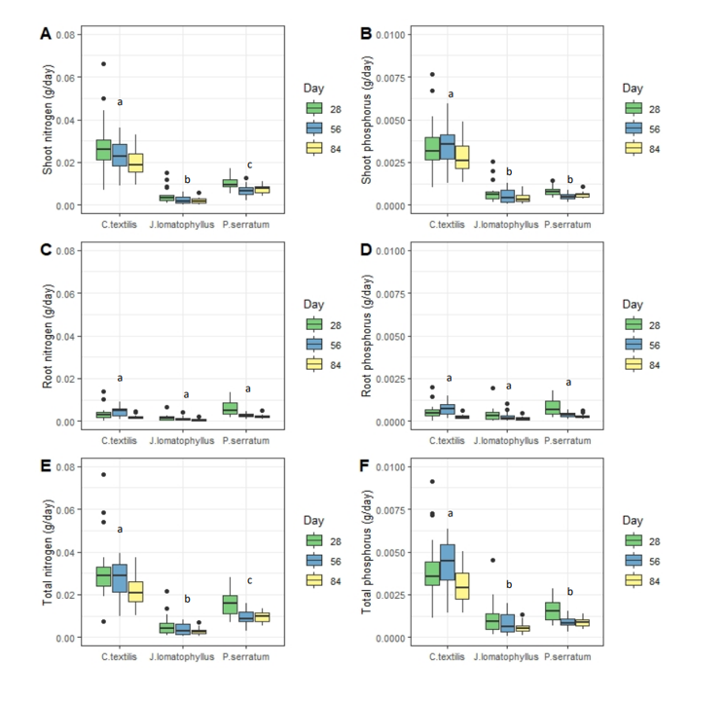
Fig S 3 Box-and-whisker plots of shoot nitrogen (A), shoot phosphorus (B), root nitrogen (C), root phosphorus (D), total nitrogen (E), and total phosphorus (F) content standardised by time (g/day) measured from 12 March 2021 to 12 June 2021 the Water Hub, Western Cape, South Africa. Outliers are indicated by black dots while letters indicate significant differences between species (p<0.05). The interaction between species and sampling day was significant for root nitrogen (C) and root phosphorus (D) content thus, separate models were run for each day, and symbols indicating significant differences are not indicated on the graph.

Juncus lomatophyllus had a significantly higher shoot and root nitrogen and phosphorus concentration (g/kg) than both C. textilis and P. serratum (Fig S 4). Cyperus textilis had significantly higher shoot and total phosphorus concentration than P. serratum (Fig S 4).
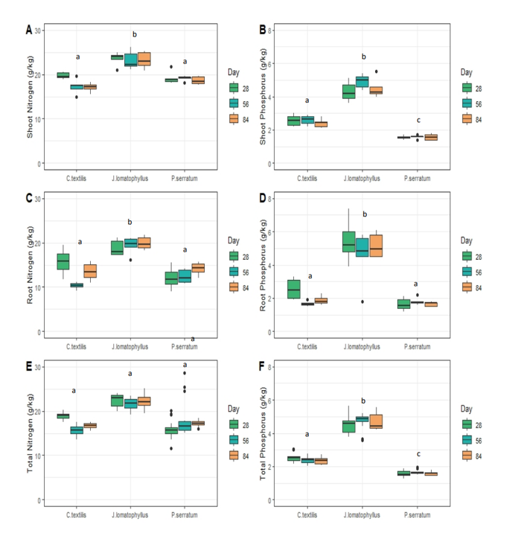
Fig S 4 Box-and-whisker plots of shoot nitrogen (A), shoot phosphorus (B), root nitrogen (C), root phosphorus (D), total nitrogen (E), and total phosphorus (F) standardised by plant weight (g of nutrient per kg of plant material) measured from 12 March 2021 to 12 June 2021 the Water Hub, Western Cape, South Africa. Outliers are indicated by black dots while letters indicate significant differences (p<0.05). The interaction between species and sampling day was significant for total nitrogen content (E) thus, separate models were run for each day, and symbols indicating significant differences are not indicated on the graph.

Table S12: Summary of the total nitrogen and total phosphorus plant uptake data (separate for root, shoot and total) for the in-situ experiment.
Species | Location | Replicate | Total Nitrogen Uptake (mg) | Total Phosphorus Uptake (mg)
Cyperus textilis | Root | 1 | 83.89 | 10.84
Cyperus textilis | Root | 2 | 75.16 | 10.69
Cyperus textilis | Root | 3 | -25.48 | -3.64
Cyperus textilis | Root | 4 | 33.77 | 4.58
Cyperus textilis | Root | 5 | -4.74 | -1.54
Cyperus textilis | Root | 6 | -9.75 | -3.60
Juncus lomatophyllus | Root | 1 | 4.57 | 0.70
Juncus lomatophyllus | Root | 2 | 10.16 | 0.58
Juncus lomatophyllus | Root | 3 | 55.79 | 11.99
Juncus lomatophyllus | Root | 4 | 1.78 | 1.63
Juncus lomatophyllus | Root | 5 | 9.93 | 2.51
Juncus lomatophyllus | Root | 6 | -37.26 | -11.01
Prionium serratum | Root | 1 | -8.88 | -1.74
Prionium serratum | Root | 2 | 33.21 | 1.91
Prionium serratum | Root | 3 | -12.64 | -3.75
Prionium serratum | Root | 4 | -14.74 | -2.75
Prionium serratum | Root | 5 | 56.71 | 5.52
Prionium serratum | Root | 6 | 41.05 | 3.73
Cyperus textilis | Shoot | 1 | 666.56 | 94.27
Cyperus textilis | Shoot | 2 | 657.95 | 87.05
Cyperus textilis | Shoot | 3 | 349.61 | 55.12
Cyperus textilis | Shoot | 4 | 591.86 | 115.51
Cyperus textilis | Shoot | 5 | 183.99 | 25.38
Cyperus textilis | Shoot | 6 | 264.87 | 39.09
Juncus lomatophyllus | Shoot | 1 | 46.22 | 7.65
Juncus lomatophyllus | Shoot | 2 | 29.66 | 6.69
Juncus lomatophyllus | Shoot | 3 | 110.49 | 19.73
Juncus lomatophyllus | Shoot | 4 | -13.99 | -1.13
Juncus lomatophyllus | Shoot | 5 | 9.66 | 1.95
Juncus lomatophyllus | Shoot | 6 | -41.42 | -0.90
Prionium serratum | Shoot | 1 | 190.68 | 14.03
Prionium serratum | Shoot | 2 | 108.72 | 10.42
Prionium serratum | Shoot | 3 | 137.09 | 11.68
Prionium serratum | Shoot | 4 | 167.15 | 13.01
Prionium serratum | Shoot | 5 | 159.98 | 13.62
Prionium serratum | Shoot | 6 | 193.65 | 21.44
Cyperus textilis | Total | 1 | 750.46 | 105.11
Cyperus textilis | Total | 2 | 733.11 | 97.74
Cyperus textilis | Total | 3 | 324.13 | 51.48
Cyperus textilis | Total | 4 | 625.63 | 120.09
Cyperus textilis | Total | 5 | 179.25 | 23.83
Cyperus textilis | Total | 6 | 255.13 | 35.49
Juncus lomatophyllus | Total | 1 | 50.80 | 8.35
Juncus lomatophyllus | Total | 2 | 39.82 | 7.27
Juncus lomatophyllus | Total | 3 | 166.28 | 31.72
Juncus lomatophyllus | Total | 4 | -12.21 | 0.50
Juncus lomatophyllus | Total | 5 | 19.59 | 4.46
Juncus lomatophyllus | Total | 6 | -78.68 | -11.90
Prionium serratum | Total | 1 | 181.80 | 12.29
Prionium serratum | Total | 2 | 141.93 | 12.33
Prionium serratum | Total | 3 | 124.45 | 7.93
Prionium serratum | Total | 4 | 152.41 | 10.26
Prionium serratum | Total | 5 | 216.68 | 19.14
Prionium serratum | Total | 6 | 234.70 | 25.17

Table S13: Concentrations of Total Nitrogen and Total Phosphorus in roots and shoots within the different treatments from both experiments.
Experiment | Species | Location | Replicate | TN concentration (mg/kg) | TP concentration (mg/kg)
In-situ | Cyperus textilis | Roots | 1 | 15900 | 2300
In-situ | Cyperus textilis | Roots | 2 | 11000 | 1600
In-situ | Cyperus textilis | Roots | 3 | 12600 | 1800
In-situ | Cyperus textilis | Roots | 4 | 12200 | 1800
In-situ | Cyperus textilis | Roots | 5 | 15100 | 2000
In-situ | Cyperus textilis | Roots | 6 | 14100 | 1700
In-situ | Cyperus textilis | Shoots | 1 | 17500 | 2500
In-situ | Cyperus textilis | Shoots | 2 | 18300 | 2400
In-situ | Cyperus textilis | Shoots | 3 | 16800 | 2200
In-situ | Cyperus textilis | Shoots | 4 | 16800 | 2800
In-situ | Cyperus textilis | Shoots | 5 | 15600 | 2100
In-situ | Cyperus textilis | Shoots | 6 | 17600 | 2500
In-situ | Juncus lomatophyllus | Roots | 1 | 18800 | 4500
In-situ | Juncus lomatophyllus | Roots | 2 | 21700 | 5100
In-situ | Juncus lomatophyllus | Roots | 3 | 19400 | 4500
In-situ | Juncus lomatophyllus | Roots | 4 | 21200 | 6100
In-situ | Juncus lomatophyllus | Roots | 5 | 18300 | 4800
In-situ | Juncus lomatophyllus | Roots | 6 | 20000 | 5800
In-situ | Juncus lomatophyllus | Shoots | 1 | 25000 | 4200
In-situ | Juncus lomatophyllus | Shoots | 2 | 22000 | 4300
In-situ | Juncus lomatophyllus | Shoots | 3 | 22400 | 4200
In-situ | Juncus lomatophyllus | Shoots | 4 | 23400 | 4600
In-situ | Juncus lomatophyllus | Shoots | 5 | 20800 | 4000
In-situ | Juncus lomatophyllus | Shoots | 6 | 25300 | 5500
In-situ | Prionium serratum | Roots | 1 | 12000 | 1500
In-situ | Prionium serratum | Roots | 2 | 13400 | 1500
In-situ | Prionium serratum | Roots | 3 | 15700 | 1700
In-situ | Prionium serratum | Roots | 4 | 13900 | 1700
In-situ | Prionium serratum | Roots | 5 | 14700 | 1700
In-situ | Prionium serratum | Roots | 6 | 15200 | 1800
In-situ | Prionium serratum | Shoots | 1 | 18000 | 1400
In-situ | Prionium serratum | Shoots | 2 | 19600 | 1700
In-situ | Prionium serratum | Shoots | 3 | 17700 | 1500
In-situ | Prionium serratum | Shoots | 4 | 18300 | 1400
In-situ | Prionium serratum | Shoots | 5 | 19500 | 1600
In-situ | Prionium serratum | Shoots | 6 | 18400 | 1800
Mesocosm | Cyperus textilis | Roots | 1 | 7092.6 | 578
Mesocosm | Cyperus textilis | Roots | 2 | 6847.8 | 630
Mesocosm | Cyperus textilis | Roots | 3 | 6742.8 | 569
Mesocosm | Cyperus textilis | Roots | 4 | 7519.6 | 627
Mesocosm | Cyperus textilis | Roots | 5 | 7914.9 | 463
Mesocosm | Cyperus textilis | Roots | 6 | 6846.1 | 417
Mesocosm | Cyperus textilis | Roots | 7 | 7150.5 | 459
Mesocosm | Cyperus textilis | Roots | 8 | 7315.4 | 493
Mesocosm | Cyperus textilis | Roots | 9 | 7165.4 | 440
Mesocosm | Cyperus textilis | Roots | 10 | 7990.2 | 470
Mesocosm | Cyperus textilis | Roots | 11 | 8335.1 | 420
Mesocosm | Cyperus textilis | Roots | 12 | 6960.5 | 696
Mesocosm | Cyperus textilis | Shoots | 1 | 7650 | 966
Mesocosm | Cyperus textilis | Shoots | 2 | 7951.3 | 1260
Mesocosm | Cyperus textilis | Shoots | 3 | 7094.2 | 1189
Mesocosm | Cyperus textilis | Shoots | 4 | 8268.2 | 1545
Mesocosm | Cyperus textilis | Shoots | 5 | 9456 | 1490
Mesocosm | Cyperus textilis | Shoots | 6 | 7138.2 | 1600
Mesocosm | Cyperus textilis | Shoots | 7 | 7776.8 | 1151
Mesocosm | Cyperus textilis | Shoots | 8 | 8050.1 | 1995
Mesocosm | Cyperus textilis | Shoots | 9 | 8038.3 | 969
Mesocosm | Cyperus textilis | Shoots | 10 | 7803.9 | 1469
Mesocosm | Cyperus textilis | Shoots | 11 | 9231.3 | 1358
Mesocosm | Cyperus textilis | Shoots | 12 | 8119.1 | 1867
Mesocosm | Juncus lomatophyllus | Roots | 1 | 6438.5 | 884
Mesocosm | Juncus lomatophyllus | Roots | 2 | 11173 | 926
Mesocosm | Juncus lomatophyllus | Roots | 3 | 9704 | 743
Mesocosm | Juncus lomatophyllus | Roots | 4 | 6677.8 | 758
Mesocosm | Juncus lomatophyllus | Roots | 5 | 7696.6 | 837
Mesocosm | Juncus lomatophyllus | Roots | 6 | 7772.4 | 748
Mesocosm | Juncus lomatophyllus | Roots | 7 | 8073.8 | 798
Mesocosm | Juncus lomatophyllus | Roots | 8 | 7427.7 | 827
Mesocosm | Juncus lomatophyllus | Roots | 9 | 7243.9 | 978
Mesocosm | Juncus lomatophyllus | Roots | 10 | 6894.9 | 692
Mesocosm | Juncus lomatophyllus | Roots | 11 | 8140.1 | 785
Mesocosm | Juncus lomatophyllus | Roots | 12 | 7215.3 | 757
Mesocosm | Juncus lomatophyllus | Shoots | 1 | 6107.7 | 1817
Mesocosm | Juncus lomatophyllus | Shoots | 2 | 7097.7 | 1948
Mesocosm | Juncus lomatophyllus | Shoots | 3 | 7150.4 | 1460
Mesocosm | Juncus lomatophyllus | Shoots | 4 | 9494.7 | 1640
Mesocosm | Juncus lomatophyllus | Shoots | 5 | 11275 | 1701
Mesocosm | Juncus lomatophyllus | Shoots | 6 | 10255 | 1677
Mesocosm | Juncus lomatophyllus | Shoots | 7 | 8347.7 | 1557
Mesocosm | Juncus lomatophyllus | Shoots | 8 | 11181 | 2198
Mesocosm | Juncus lomatophyllus | Shoots | 9 | 7827.7 | 1675
Mesocosm | Juncus lomatophyllus | Shoots | 10 | 10022 | 1689
Mesocosm | Juncus lomatophyllus | Shoots | 11 | 10353 | 1927
Mesocosm | Juncus lomatophyllus | Shoots | 12 | 10789 | 1718
Mesocosm | Prionium serratum | Roots | 1 | 2183.6 | 235
Mesocosm | Prionium serratum | Roots | 2 | 2937.7 | 296
Mesocosm | Prionium serratum | Roots | 3 | 2398.2 | 230
Mesocosm | Prionium serratum | Roots | 4 | 3265.9 | 263
Mesocosm | Prionium serratum | Roots | 5 | 2512.8 | 382
Mesocosm | Prionium serratum | Roots | 6 | 3128.1 | 254
Mesocosm | Prionium serratum | Roots | 7 | 1838.5 | 235
Mesocosm | Prionium serratum | Roots | 8 | 3906 | 273
Mesocosm | Prionium serratum | Roots | 9 | 4865.9 | 219
Mesocosm | Prionium serratum | Roots | 10 | 3022.3 | 289
Mesocosm | Prionium serratum | Roots | 11 | 3887.4 | 296
Mesocosm | Prionium serratum | Roots | 12 | 5381.5 | 279
Mesocosm | Prionium serratum | Shoots | 1 | 4885.6 | 255
Mesocosm | Prionium serratum | Shoots | 2 | 5361.9 | 359
Mesocosm | Prionium serratum | Shoots | 3 | 3164.8 | 238
Mesocosm | Prionium serratum | Shoots | 4 | 3473.8 | 287
Mesocosm | Prionium serratum | Shoots | 5 | 2421.8 | 432
Mesocosm | Prionium serratum | Shoots | 6 | 3757.3 | 284
Mesocosm | Prionium serratum | Shoots | 7 | 2324.8 | 212
Mesocosm | Prionium serratum | Shoots | 8 | 2593.7 | 348
Mesocosm | Prionium serratum | Shoots | 9 | 2284.7 | 159
Mesocosm | Prionium serratum | Shoots | 10 | 3211.5 | 438
Mesocosm | Prionium serratum | Shoots | 11 | 3954.4 | 267
Mesocosm | Prionium serratum | Shoots | 12 | 4070.7 | 325

Table S14: Summary of TN and TP content in both roots and shoots in order to calculate the TN and TP shoot:root ratio for both experiments.
Plant species | TN content in all ROOT tissue (mg) | TP content in all ROOT tissue (mg) | TN content in all SHOOT tissue (mg) | TP content in all SHOOT tissue (mg) | TN shoot:root ratio | TP shoot:root ratio
MESOCOSM EXPERIMENT
Prionium serratum | 31.45 | 3.38 | 79.30 | 4.14 | 2.52 | 1.22
Prionium serratum | 33.78 | 3.40 | 117.30 | 7.85 | 3.47 | 2.31
Prionium serratum | 37.89 | 3.63 | 69.50 | 5.23 | 1.83 | 1.44
Prionium serratum | 56.75 | 4.57 | 108.78 | 8.99 | 1.92 | 1.97
Prionium serratum | 78.64 | 11.96 | 94.48 | 16.85 | 1.20 | 1.41
Prionium serratum | 62.02 | 5.04 | 122.28 | 9.24 | 1.97 | 1.84
Prionium serratum | 16.76 | 2.14 | 53.81 | 4.91 | 3.21 | 2.29
Prionium serratum | 34.85 | 2.44 | 31.55 | 4.23 | 0.91 | 1.74
Prionium serratum | 85.38 | 3.84 | 75.59 | 5.26 | 0.89 | 1.37
Prionium serratum | 20.47 | 1.96 | 18.19 | 2.48 | 0.89 | 1.27
Prionium serratum | 44.47 | 3.39 | 48.81 | 3.30 | 1.10 | 0.97
Prionium serratum | 52.51 | 2.72 | 47.24 | 3.77 | 0.90 | 1.39
Juncus lomatophyllus | 56.28 | 7.73 | 66.65 | 19.83 | 1.18 | 2.57
Juncus lomatophyllus | 49.38 | 4.09 | 50.54 | 13.87 | 1.02 | 3.39
Juncus lomatophyllus | 86.81 | 6.65 | 67.96 | 13.88 | 0.78 | 2.09
Juncus lomatophyllus | 72.30 | 8.21 | 145.29 | 25.10 | 2.01 | 3.06
Juncus lomatophyllus | 38.25 | 4.16 | 128.05 | 19.32 | 3.35 | 4.64
Juncus lomatophyllus | 71.34 | 6.87 | 119.16 | 19.49 | 1.67 | 2.84
Juncus lomatophyllus | 30.69 | 3.03 | 60.75 | 11.33 | 1.98 | 3.74
Juncus lomatophyllus | 35.30 | 3.93 | 96.54 | 18.98 | 2.74 | 4.83
Juncus lomatophyllus | 33.79 | 4.56 | 118.44 | 25.34 | 3.51 | 5.56
Juncus lomatophyllus | 40.38 | 4.05 | 89.21 | 15.03 | 2.21 | 3.71
Juncus lomatophyllus | 46.82 | 4.52 | 54.45 | 10.13 | 1.16 | 2.24
Juncus lomatophyllus | 33.36 | 3.50 | 94.81 | 15.10 | 2.84 | 4.31
Cyperus textilis | 53.37 | 4.35 | 60.84 | 7.68 | 1.14 | 1.77
Cyperus textilis | 93.23 | 8.58 | 128.90 | 20.43 | 1.38 | 2.38
Cyperus textilis | 39.97 | 3.37 | 43.03 | 7.21 | 1.08 | 2.14
Cyperus textilis | 15.82 | 1.32 | 14.57 | 2.72 | 0.92 | 2.06
Cyperus textilis | 14.90 | 0.87 | 18.43 | 2.90 | 1.24 | 3.33
Cyperus textilis | 11.49 | 0.70 | 21.03 | 4.71 | 1.83 | 6.73
Cyperus textilis | 7.72 | 0.50 | 17.79 | 2.63 | 2.31 | 5.32
Cyperus textilis | 8.16 | 0.55 | 8.40 | 2.08 | 1.03 | 3.79
Cyperus textilis | 10.72 | 0.66 | 22.80 | 2.75 | 2.13 | 4.18
Cyperus textilis | 15.24 | 0.90 | 19.99 | 3.76 | 1.31 | 4.20
Cyperus textilis | 21.35 | 1.08 | 20.52 | 3.02 | 0.96 | 2.81
Cyperus textilis | 17.25 | 1.72 | 22.80 | 5.24 | 1.32 | 3.04
IN-SITU EXPERIMENT
Cyperus textilis | 111.46 | 16.12 | 1461.95 | 208.85 | 13.12 | 12.95
Cyperus textilis | 361.41 | 52.28 | 2350.25 | 335.75 | 6.50 | 6.42
Cyperus textilis | 191.75 | 27.74 | 1821.23 | 260.18 | 9.50 | 9.38
Cyperus textilis | 201.19 | 29.26 | 2636.48 | 345.77 | 13.10 | 11.82
Cyperus textilis | 155.98 | 22.69 | 1670.42 | 219.07 | 10.71 | 9.66
Cyperus textilis | 200.64 | 29.18 | 1631.26 | 213.94 | 8.13 | 7.33
Cyperus textilis | 154.10 | 22.01 | 2090.59 | 273.77 | 13.57 | 12.44
Cyperus textilis | 370.44 | 52.92 | 2773.01 | 363.13 | 7.49 | 6.86
Cyperus textilis | 71.69 | 10.24 | 1084.94 | 142.08 | 15.13 | 13.87
Cyperus textilis | 181.66 | 26.80 | 1779.96 | 296.66 | 9.80 | 11.07
Cyperus textilis | 115.17 | 16.99 | 1450.01 | 241.67 | 12.59 | 14.22
Cyperus textilis | 101.63 | 14.99 | 2452.30 | 408.72 | 24.13 | 27.26
Cyperus textilis | 117.63 | 15.58 | 1504.15 | 202.48 | 12.79 | 13.00
Cyperus textilis | 70.82 | 9.38 | 1267.81 | 170.67 | 17.90 | 18.19
Cyperus textilis | 102.53 | 13.58 | 1191.06 | 160.34 | 11.62 | 11.81
Cyperus textilis | 91.51 | 11.03 | 1109.33 | 157.58 | 12.12 | 14.28
Cyperus textilis | 128.03 | 15.44 | 1521.87 | 216.18 | 11.89 | 14.00
Cyperus textilis | 80.93 | 9.76 | 788.13 | 111.95 | 9.74 | 11.47
Juncus lomatophyllus | 58.09 | 13.91 | 146.75 | 24.65 | 2.53 | 1.77
Juncus lomatophyllus | 26.88 | 6.43 | 189.50 | 31.84 | 7.05 | 4.95
Juncus lomatophyllus | 45.50 | 10.89 | 145.00 | 24.36 | 3.19 | 2.24
Juncus lomatophyllus | 93.09 | 21.88 | 156.86 | 30.66 | 1.68 | 1.40
Juncus lomatophyllus | 80.07 | 18.82 | 224.18 | 43.82 | 2.80 | 2.33
Juncus lomatophyllus | 39.71 | 9.33 | 253.22 | 49.49 | 6.38 | 5.30
Juncus lomatophyllus | 106.12 | 24.62 | 128.13 | 24.02 | 1.21 | 0.98
Juncus lomatophyllus | 172.08 | 39.92 | 295.23 | 55.36 | 1.72 | 1.39
Juncus lomatophyllus | 105.54 | 24.48 | 476.22 | 89.29 | 4.51 | 3.65
Juncus lomatophyllus | 29.89 | 8.60 | 68.80 | 13.52 | 2.30 | 1.57
Juncus lomatophyllus | 42.19 | 12.14 | 87.05 | 17.11 | 2.06 | 1.41
Juncus lomatophyllus | 46.22 | 13.30 | 33.93 | 6.67 | 0.73 | 0.50
Juncus lomatophyllus | 26.17 | 6.86 | 24.13 | 4.64 | 0.92 | 0.68
Juncus lomatophyllus | 35.69 | 9.36 | 106.08 | 20.40 | 2.97 | 2.18
Juncus lomatophyllus | 19.03 | 4.99 | 56.99 | 10.96 | 2.99 | 2.20
Juncus lomatophyllus | 5.80 | 1.68 | 243.13 | 52.86 | 41.92 | 31.42
Juncus lomatophyllus | 22.60 | 6.55 | 291.46 | 63.36 | 12.90 | 9.67
Juncus lomatophyllus | 40.60 | 11.77 | 216.57 | 47.08 | 5.33 | 4.00
Prionium serratum | 244.44 | 30.56 | 724.86 | 56.38 | 2.97 | 1.85
Prionium serratum | 188.64 | 23.58 | 728.82 | 56.69 | 3.86 | 2.40
Prionium serratum | 211.80 | 26.48 | 634.14 | 49.32 | 2.99 | 1.86
Prionium serratum | 407.36 | 45.60 | 676.03 | 58.64 | 1.66 | 1.29
Prionium serratum | 114.03 | 12.77 | 744.60 | 64.58 | 6.53 | 5.06
Prionium serratum | 185.72 | 20.79 | 370.24 | 32.11 | 1.99 | 1.54
Prionium serratum | 159.04 | 17.22 | 651.89 | 55.25 | 4.10 | 3.21
Prionium serratum | 86.98 | 9.42 | 370.28 | 31.38 | 4.26 | 3.33
Prionium serratum | 104.41 | 11.31 | 490.64 | 41.58 | 4.70 | 3.68
Prionium serratum | 111.62 | 13.65 | 478.55 | 36.61 | 4.29 | 2.68
Prionium serratum | 178.20 | 21.79 | 731.63 | 55.97 | 4.11 | 2.57
Prionium serratum | 135.94 | 16.63 | 594.02 | 45.44 | 4.37 | 2.73
Prionium serratum | 201.83 | 23.34 | 593.00 | 48.66 | 2.94 | 2.08
Prionium serratum | 206.54 | 23.89 | 451.04 | 37.01 | 2.18 | 1.55
Prionium serratum | 246.52 | 28.51 | 721.11 | 59.17 | 2.93 | 2.08
Prionium serratum | 429.86 | 50.90 | 652.28 | 63.81 | 1.52 | 1.25
Prionium serratum | 210.82 | 24.97 | 937.11 | 91.67 | 4.44 | 3.67
Prionium serratum | 152.91 | 18.11 | 367.08 | 35.91 | 2.40 | 1.98

Cyperus textilis had significantly higher shoot dry mass than both P. serratum and J. lomatophyllus (Table S15). In general, Prionium serratum and J. lomatophyllus did not differ in terms of shoot dry mass. Both C. textilis and P. serratum had significantly greater root and total dry mass than J. lomatophyllus, but C. textilis and P. serratum did not differ from each other (Table S15). Cyperus textilis and P. serratum also had significantly greater leaf dry matter content than J. lomatophyllus (Table S15). Cyperus textilis had significantly greater root dry matter content (RDMC) than both P. serratum and J. lomatophyllus and P. serratum had significantly greater RDMC than J. lomatophyllus (Table S15).

Table S15: Summary of mean plant functional traits and indices measured from 12 March to 8 June 2021 in the water tanks holding the floating wetlands, at the Water Hub, Western Cape, South Africa (±standard deviation). LDMC: Leaf dry matter content; RDMC: Root dry matter content. Letters indicate significant differences between species (p<0.05). Where the interaction between species and sampling day occurred, multiple letters, separated by a dash are indicated which represent the three sampling days (Day 28, 56 and 84).
 | Cyperus textilis | Juncus lomatophyllus | Prionium serratum
Shoot dry mass (g) | 71.7±35.82^{a-a-a} | 6.4±4.91^{b-b-b} | 21.8±10.24^{b-b-c}
Root dry mass (g) | 14.6±11.49ª | 2.7±2.37^{b} | 13.7±7.65ª
Total dry mass (g) | 86.2±42.36ª | 9.0±6.55^{b} | 35.5±14.61ª
LDMC (mg/g) | 171.6±47.05ª | 70.7±25.31^{b} | 159.7±30.67ª
RDMC (mg/g) | 205.6±84.61ª | 70.8±31.30^{b} | 171.1±49.44^{c}

Table S16: Summary of the mean plant traits, growth and indices (±standard deviation) of the one-month mesocosm floating wetland experiment (27 January 2017 to 27 February 2017). SRL: specific root length; SLA: specific leaf area; RDMC: root dry matter content; LDMC: leaf dry matter content. Letters denote significant differences at p<0.05.
Traits/indices | Cyperus textilis | Juncus lomatophyllus | Prionium serratum
Plant growth (g) | 5.1 ± 7.37ª | 6.1 ± 4.70ª | -1.6 ± 27.21ª
Root growth (g) | 2.2 ± 3.39ª | 2.2 ± 2.34ª | -0.1 ± 11.12ª
Shoot growth (g) | 2.9 ± 4.01ª | 3.8 ± 2.48ª | -1.5 ± 16.62ª
Plant growth (mm) | 66.7 ± 80.75ª | 6.4 ± 60.20ª | 146.0 ± 186.49ª
Root growth (mm) | 3.4 ± 52.84ª | 13.5 ± 63.13ª | 77.0 ± 65.77ª
Shoot growth (mm) | 63.3 ± 65.37ª | -7.1 ± 22.28ª | 69.0 ± 189.84ª
Plant dry weight (g) | 5.3 ± 3.80ª | 13.3 ± 2.79ª | 37.0 ± 11.21ª
Root dry weight (g) | 2.5 ± 1.88ª | 5.3 ± 1.08ª | 14.5 ± 4.10ª
Shoot dry weight (g) | 2.8 ± 1.94ª | 8.1 ± 1.97ª | 22.5 ± 7.15ª
Plant height (mm) | 580.8 ± 64.39ª | 817.7 ± 30.70ª | 758.6 ± 81.92ª
Root length (mm) | 310.4 ± 34.24ª | 653.0 ± 29.73ª | 439.7 ± 47.21ª
Shoot length (mm) | 270.4 ± 32.13ª | 164.7 ± 14.92ª | 318.9 ± 84.05ª
Root area (mm²) | 782.3 ± 75.59ª | 743.7 ± 35.97ª | 1621.3 ± 278.86^{b}
Leaf area (mm²) | 75.6 ± 14.15ª | 556.4 ± 60.17ª | 2909.9 ± 522.9ª
SRL (mm.g⁻¹) | 3304.1 ± 580.49^{b} | 10074.8 ± 1059.11ª | 779.9 ± 53.93^{c}
SLA (mm².g⁻¹) | 8006.9 ±2362.25^{b} | 11555.7 ± 1539.29ª | 3519.3 ± 349.26^{c}
RDMC (mg.g⁻¹) | 167.6 ± 4.60^{b} | 111.9 ± 10.74^{c} | 203.4 ± 11.90ª
LDMC (mg.g⁻¹) | 280.9 ± 23.37ª | 118.7 ± 17.06^{c} | 215.2 ± 8.85^{b}

In the in-situ experiment, Cyperus textilis was found to have absorbed the most nitrogen and phosphorus out of the three species due to its fast and tall growth. This species absorbed a mean of 17 mg of nitrogen and 2.6 mg of phosphorus per plant daily.
Prionium serratum and Juncus lomatophyllus absorbed a mean of 6.3 mg and 1.1 mg of nitrogen per plant daily respectively, as well as 0.5 mg and 0.2 mg of phosphorus per plant daily respectively.
To understand in real terms what the impact of these uptake rates could mean for a farmer interested in using this nature-based solution on their farm dams, a quick calculation was done using the results of C. textilis as an example.
If a farm dam had 10 floating wetlands, with 10 Cyperus textilis plants on each wetland (i.e., a total of 100 plants), the potential uptake could be as much as 0.6 kg of nitrogen and 0.1 kg of phosphorus per year (Table S14). On a small farm dam with a volume of ± 30m³ these wetlands would greatly improve water quality.

Table S17: Calculations of annual nutrient uptake capacity of 100 Cyperus textilis plants.
Nutrient | Daily uptake per plant (mg) | Annual uptake per plant (mg) | Annual uptake per 100 plants (mg) | Annual uptake per 100 plants (kg)
Nitrogen | 17 | 6205 | 623042 | 0.6230
Phosphorus | 2.6 | 942 | 94236 | 0.0942

