SUPPLEMENTAL MATERIALS

Contents

Tables
Table S1 Analysis on the differences of blood lipid profile levels between with or without kidney stone events
Table S2 Univariate and multivariate analysis of the association between hyperlipidemia and recurrent kidney stone events stratified by covariates
Table S3 Univariate and multivariate analysis of the association between hyperlipidemia and kidney stone events stratified by covariates in unweighted dataset
Table S4 Univariate and multivariate analysis of the association between hyperlipidemia and recurrent kidney stone events stratified by covariates in unweighted dataset
Table S5 Unadjusted and multiple model analyses of the association between statins use and hyperlipidemia
Table S6 Unadjusted and multiple model analyses of the association between statins use and hyperlipidemia in kidney stone formers
Table S7 Unadjusted and multiple model analyses of the association between statins use and hyperlipidemia in recurrent kidney stone formers

Figures
Figure S1 Flow chart showing the number of NHANES participants included in the current analyses
Figure S2 Analysis on the differences of blood lipid profile levels between with or without kidney stones
Figure S3 Analysis on the differences of blood lipid profile levels between with or without recurrent kidney stones

Table S1 Analysis on the differences of blood lipid profile levels between with or without kidney stone events
Triglyceride（mg/dL）
Ethnic | Gender | N | Kidney stone | N | No kidney stone | p-value
White | Male | 254 | 137.5(125.7-149.3) | 1599 | 128(124.2-131.8) | 0.13
White | Female | 166 | 126.6(116.8-136.3) | 1542 | 114.9(110.5-119.3) | 0.034
Black | Male | 42 | 106.8*(83.5-130) | 684 | 104.8**(99.9-109.7) | 0.87
Black | Female | 38 | 102.5(76-129) | 650 | 87.6**(81.8-93.4) | 0.25
Mexican American | Male | 49 | 152.7(133.8-171.6) | 544 | 139.5*(132.6-146.4) | 0.12
Mexican American | Female | 34 | 115.9(98.2-133.5) | 426 | 116.5(109.3-123.7) | 0.95
Other | Male | 63 | 151.1(125.2-177) | 632 | 132.4(123.2-141.6) | 0.14
Other | Female | 43 | 144.1(120.3-167.8) | 539 | 113.1(102.7-123.5) | 0.022
Total cholesterol（mg/dL）
Ethnic | Gender | N | Kidney stone | N | No kidney stone | p-value
White | Male | 254 | 185(179.4-190.7) | 1599 | 189.3(186.9-191.6) | 0.15
White | Female | 166 | 199.1(192.8-205.4) | 1542 | 199.5(196.9-202) | 0.92
Black | Male | 42 | 191.4(177.4-205.4) | 684 | 187.9(183.4-192.3) | 0.65
Black | Female | 38 | 202.2(189.5-215) | 650 | 189.5**(184.6-194.3) | 0.043
Mexican American | Male | 49 | 193.5(180.7-206.4) | 544 | 196.5*(191.8-201.3) | 0.66
Mexican American | Female | 34 | 194.9(177.5-212.4) | 426 | 191.9*(187.1-196.6) | 0.7
Other | Male | 63 | 194.5(183.2-205.8) | 632 | 189.3(185.2-193.4) | 0.37
Other | Female | 43 | 191(172.3-209.6) | 539 | 191.8*(187.1-196.5) | 0.92
High-density lipoprotein cholesterol（mg/dL）
Ethnic | Gender | N | Kidney stone | N | No kidney stone | p-value
White | Male | 254 | 46.3(44.3-48.4) | 1599 | 49.1(48.3-50) | 0.012
White | Female | 166 | 57.6(54.7-60.5) | 1542 | 60.2(59-61.3) | 0.09
Black | Male | 42 | 51.1(45.6-56.6) | 684 | 53.2**(51.9-54.6) | 0.43
Black | Female | 38 | 60.9(53.7-68.1) | 650 | 60.2(58.3-62.1) | 0.85
Mexican American | Male | 49 | 48.9(43.3-54.4) | 544 | 46.7*(45.2-48.2) | 0.45
Mexican American | Female | 34 | 54(48.7-59.2) | 426 | 56.1(54.3-57.8) | 0.43
Other | Male | 63 | 47.6(43.5-51.7) | 632 | 47.5*(46.2-48.8) | 0.94
Other | Female | 43 | 48.5**(44.4-52.6) | 539 | 58.2**(56.3-60.1) | <0.001
Low-density lipoprotein cholesterol（mg/dL）
Ethnic | Gender | N | Kidney stone | N | No kidney stone | p-value
White | Male | 254 | 111.2(106.3-116.1) | 1599 | 114.5(112.7-116.3) | 0.18
White | Female | 166 | 116.2(111-121.5) | 1542 | 116.3(114.4-118.3) | 0.98
Black | Male | 42 | 119(105.9-132.1) | 684 | 113.7(109.8-117.6) | 0.45
Black | Female | 38 | 120.8(111.1-130.5) | 650 | 111.7*(107.6-115.8) | 0.052
Mexican American | Male | 49 | 114.1(105-123.2) | 544 | 121.9**(117.8-126.1) | 0.08
Mexican American | Female | 34 | 117.8(103.9-131.7) | 426 | 112.5(108.5-116.6) | 0.38
Other | Male | 63 | 116.7(106.6-126.8) | 632 | 115.3(111.9-118.7) | 0.79
Other | Female | 43 | 113.5(97.1-130) | 539 | 111*(106.9-115) | 0.71
Triglyceride（mg/dL）
Ethnic | Gender | N | Recurrent kidney stone | N | Non recurrent kidney stone | p-value
White | Male | 90 | 141.8(124.8-158.7) | 164 | 135.1(119.7-150.4) | 0.56
White | Female | 49 | 138.3(116.5-160.1) | 117 | 121.7(109-134.3) | 0.25
Black | Male | 9 | 109.7(49.2-170.1) | 33 | 106*(78.2-133.8) | 0.9152
Black | Female | 6 | 93(37.7-148.3) | 32 | 104.1(74.1-134.1) | 0.7382
Mexican American | Male | 16 | 169.1(139.5-198.8) | 33 | 143.2(118.1-168.4) | 0.21
Mexican American | Female | 7 | 101.4(66.5-136.3) | 27 | 119.6(94.8-144.3) | 0.37282
Other | Male | 21 | 164.8(131-198.7) | 42 | 143.9(108.9-178.9) | 0.39
Other | Female | 15 | 160(126.3-193.7) | 28 | 131.4(97.9-165) | 0.17473
Total cholesterol（mg/dL）
Ethnic | Gender | N | Recurrent kidney stone | N | Non recurrent kidney stone | p-value
White | Male | 90 | 186.2(178-194.5) | 164 | 184.3(176.8-191.8) | 0.74
White | Female | 49 | 198.6(190.3-206.8) | 117 | 199.3(191.2-207.4) | 0.9
Black | Male | 9 | 217.8*(195.3-240.3) | 33 | 184.1(169.6-198.6) | 0.07248
Black | Female | 6 | 181.7(150.2-213.3) | 32 | 205.5(191.5-219.5) | 0.24
Mexican American | Male | 16 | 212.8*(188.3-237.3) | 33 | 182.5(171.5-193.5) | 0.064
Mexican American | Female | 7 | 182.8(147.5-218.1) | 27 | 198.1(177.1-219) | 0.49
Other | Male | 21 | 202.9(185.3-220.5) | 42 | 190.1(174.5-205.7) | 0.25
Other | Female | 15 | 203.1(179.7-226.5) | 28 | 181.3(161.9-200.7) | 0.21
High-density lipoprotein cholesterol（mg/dL）
Ethnic | Gender | N | Recurrent kidney stone | N | Non recurrent kidney stone | p-value
White | Male | 90 | 45.3(42.1-48.4) | 164 | 46.9(44.7-49.1) | 0.34
White | Female | 49 | 53.3(48.7-57.9) | 117 | 59.4(55.8-62.9) | 0.053
Black | Male | 9 | 52.9(42.5-63.2) | 33 | 50.6(44.3-57) | 0.73053
Black | Female | 6 | 64.8*(56.1-73.4) | 32 | 60.2(52-68.5) | 0.44406
Mexican American | Male | 16 | 54.4(42.3-66.4) | 33 | 45.7(41.9-49.5) | 0.21
Mexican American | Female | 7 | 50.8(33.8-67.8) | 27 | 54.8(48.9-60.7) | 0.66
Other | Male | 21 | 45.8(40.9-50.7) | 42 | 48.5(43.5-53.6) | 0.43
Other | Female | 15 | 45(37.1-52.9) | 28 | 51.3*(46-56.6) | 0.17
Low-density lipoprotein cholesterol（mg/dL）
Ethnic | Gender | N | Recurrent kidney stone | N | Non recurrent kidney stone | p-value
White | Male | 90 | 112.6(106-119.2) | 164 | 110.4(108.6-112.2) | 0.65
White | Female | 49 | 117.6(110.3-125) | 117 | 115.6(108.8-122.5) | 0.71
Black | Male | 9 | 143.1*(124.4-161.9) | 33 | 112.4(97.9-126.9) | 0.06893
Black | Female | 6 | 98.2(77.4-119) | 32 | 124.5(113.6-135.3) | 0.093
Mexican American | Male | 16 | 124.5(108.3-140.7) | 33 | 108.1(98.5-117.7) | 0.12
Mexican American | Female | 7 | 111.9(87.6-136.1) | 27 | 119.4(101.7-137) | 0.64
Other | Male | 21 | 124.1(104.5-143.7) | 42 | 112.8(100.1-125.5) | 0.33
Other | Female | 15 | 126.1(105.2-146.9) | 28 | 103.7(88.5-118.8) | 0.14
** P<0.001 vs with stone history or recurrent kidney stone; * P<0.05.
## P<0.001 vs white male or female; # P<0.05.

Table S2 Univariate and multivariate analysis of the association between hyperlipidemia and recurrent kidney stone events stratified by covariates
Subgroup | Model | OR (95% CI) | P
Gender
Male | Unadjusted | 0.97 (0.57 to 1.66) | 0.90
Male | Adjusted | 1.00 (0.53 to 1.88) | 1.00
Female | Unadjusted | 1.58 (0.66 to 3.80) | 0.30
Female | Adjusted | 1.23 (0.46 to 3.29) | 0.67
Age
<45 yr | Unadjusted | 1.71 (0.85 to 3.43) | 0.13
<45 yr | Adjusted | 2.08 (0.66 to 6.57) | 0.19
45-65 yr | Unadjusted | 1.07 (0.52 to 2.21) | 0.85
45-65 yr | Adjusted | 0.90 (0.44 to 1.83) | 0.76
>65 yr | Unadjusted | 0.70 (0.31 to 1.54) | 0.36
>65 yr | Adjusted | 0.75 (0.38 to 1.50) | 0.39
Race or ethnic
White | Unadjusted | 0.97 (0.54 to 1.74) | 0.91
White | Adjusted | 0.92 (0.49 to 1.73) | 0.79
Black | Unadjusted | 1.03 (0.26 to 4.12) | 0.96
Black | Adjusted | 2.97 (- to -) | -
Mexican American | Unadjusted | 2.32 (0.59 to 9.07) | 0.20
Mexican American | Adjusted | 2.34 (- to -) | -
Others | Unadjusted | 2.80 (0.58 to 13.46) | 0.18
Others | Adjusted | 3.31 (- to -) | -
Education Level
Less than high school | Unadjusted | 0.59 (0.19 to 1.82) | 0.35
Less than high school | Adjusted | 0.56 (0.17 to 1.84) | 0.28
High school or equivalent | Unadjusted | 1.07 (0.46 to 2.45) | 0.88
High school or equivalent | Adjusted | 2.03 (0.44 to 9.36) | 0.30
College or above | Unadjusted | 1.40 (0.64 to 3.06) | 0.39
College or above | Adjusted | 1.10 (0.52 to 2.32) | 0.80
Annual family income
$0-19,999 | Unadjusted | 1.88 (0.72 to 4.93) | 0.19
$0-19,999 | Adjusted | 2.24 (0.72 to 6.98) | 0.15
$20,000-34,999 | Unadjusted | 1.10 (0.45 to 2.70) | 0.83
$20,000-34,999 | Adjusted | 1.36 (0.39 to 4.70) | 0.56
$35,000-74,999 | Unadjusted | 0.55 (0.25 to 1.22) | 0.14
$35,000-74,999 | Adjusted | 0.50 (0.18 to 1.39) | 0.17
$75,000 and Over | Unadjusted | 2.10 (0.79 to 5.58) | 0.13
$75,000 and Over | Adjusted | 1.57 (0.24 to 10.16) | 0.54
BMI
<25 | Unadjusted | 1.06 (0.36 to 3.12) | 0.91
<25 | Adjusted | 1.53 (0.29 to 8.14) | 0.54
25-29.9 | Unadjusted | 1.06 (0.52 to 2.14) | 0.87
25-29.9 | Adjusted | 1.05 (0.54 to 2.05) | 0.89
≥30 | Unadjusted | 1.05 (0.52 to 2.10) | 0.89
≥30 | Adjusted | 1.00 (0.48 to 2.07) | 1.00
Hypertension
Yes | Unadjusted | 1.58 (0.88 to 2.84) | 0.12
Yes | Adjusted | 1.38 (0.66 to 2.87) | 0.38
No | Unadjusted | 0.93 (0.45 to 1.94) | 0.85
No | Adjusted | 1.00 (0.48 to 2.09) | 1.00
Diabetes
Yes | Unadjusted | 1.52 (0.74 to 3.12) | 0.25
Yes | Adjusted | 1.23 (0.39 to 3.87) | 0.70
No | Unadjusted | 1.02 (0.57 to 1.84) | 0.94
No | Adjusted | 1.04 (0.58 to 1.87) | 0.90
Smoke
Former | Unadjusted | 0.98 (0.47 to 2.02) | 0.95
Former | Adjusted | 0.88 (0.38 to 2.06) | 0.76
Some days | Unadjusted | 37.93 (- to -) | -
Some days | Adjusted | 0.00 (- to -) | -
Everyday | Unadjusted | 0.80 (0.19 to 3.43) | 0.75
Everyday | Adjusted | 0.79 (0.09 to 7.16) | 0.68
Never | Unadjusted | 1.18 (0.50 to 2.77) | 0.71
Never | Adjusted | 1.13 (0.46 to 2.78) | 0.78
Alcohol
Never | Unadjusted | 0.98 (0.43 to 2.21) | 0.95
Never | Adjusted | 0.85 (0.29 to 2.49) | 0.76
Level 1 | Unadjusted | 1.04 (0.48 to 2.28) | 0.92
Level 1 | Adjusted | 0.92 (0.41 to 2.08) | 0.84
Level 2 | Unadjusted | 0.52 (0.00 to 61.40) | 0.62
Level 2 | Adjusted | 0.00 (- to -) | -
Level 3 | Unadjusted | 4.33 (0.45 to 41.21) | 0.17
Level 3 | Adjusted | 88.90 (- to -) | -
Abbreviations: BMI, body mass index; OR, odds ratio; CI, confidence interval.
Adjusted for age, gender, race, education level, annual family income, BMI, waist, hypertension, diabetes, smoking status, alcohol use

Table S3 Univariate and multivariate analysis of the association between hyperlipidemia and kidney stone events stratified by covariates in unweighted dataset
Subgroup | Model | OR (95% CI) | P
Gender
Male | Unadjusted | 1.19 (0.96 to 1.48) | 0.11
Male | Adjusted | 1.10 (0.88 to 1.38) | 0.41
Female | Unadjusted | 1.71 (1.30 to 2.28) | <0.001
Female | Adjusted | 1.38 (1.03 to 1.86) | 0.03
Age
<45 yr | Unadjusted | 1.99 (1.44 to 2.79) | <0.001
<45 yr | Adjusted | 1.67 (1.18 to 2.39) | <0.001
45-65 yr | Unadjusted | 0.92 (0.70 to 1.22) | 0.57
45-65 yr | Adjusted | 0.85 (0.64 to 1.14) | 0.27
>65 yr | Unadjusted | 1.04 (0.98 to 1.75) | 0.07
>65 yr | Adjusted | 1.36 (1.01 to 1.84) | 0.04
Race or ethnic
White | Unadjusted | 1.34 (1.08 to 1.67) | 0.01
White | Adjusted | 1.18 (0.02 to 0.18) | 0.15
Black | Unadjusted | 1.34 (0.85 to 2.17) | 0.22
Black | Adjusted | 1.34 (0.83 to 2.20) | 0.24
Mexican American | Unadjusted | 0.95 (0.60 to 1.54) | 0.83
Mexican American | Adjusted | 0.83 (0.51 to 1.40) | 0.48
Others | Unadjusted | 1.67 (1.08 to 2.65) | 0.03
Others | Adjusted | 1.41 (0.89 to 2.29) | 0.16
Education Level
Less than high school | Unadjusted | 1.11 (0.79 to 1.58) | 0.55
Less than high school | Adjusted | 1.01 (0.71 to 1.47) | 0.94
High school or equivalent | Unadjusted | 1.17 (0.83 to 1.67) | 0.38
High school or equivalent | Adjusted | 1.09 (0.76 to 1.58) | 0.65
College or above | Unadjusted | 1.55 (1.23 to 1.96) | <0.001
College or above | Adjusted | 1.29 (1.01 to 1.66) | 0.04
Annual family income
$0-19,999 | Unadjusted | 1.43 (1.02 to 2.04) | 0.04
$0-19,999 | Adjusted | 1.16 (0.81 to 1.68) | 0.42
$20,000-34,999 | Unadjusted | 1.74 (1.22 to 2.54) | 0.003
$20,000-34,999 | Adjusted | 1.53 (1.05 to 2.27) | 0.03
$35,000-74,999 | Unadjusted | 1.13 (0.84 to 1.53) | 0.44
$35,000-74,999 | Adjusted | 1.02 (0.74 to 1.41) | 0.90
$75,000 and Over | Unadjusted | 1.20 (0.85 to 1.73) | 0.30
$75,000 and Over | Adjusted | 1.18 (0.81 to 1.72) | 0.39
BMI
<25 | Unadjusted | 1.31 (0.92 to 1.86) | 0.13
<25 | Adjusted | 1.06 (0.73 to 1.54) | 0.76
25-29.9 | Unadjusted | 1.28 (0.97 to 1.71) | 0.09
25-29.9 | Adjusted | 1.26 (0.93 to 1.70) | 0.14
≥30 | Unadjusted | 1.14 (0.87 to 1.50) | 0.34
≥30 | Adjusted | 1.13 (0.86 to 1.50) | 0.39
Hypertension
Yes | Unadjusted | 1.41 (1.10 to 1.82) | 0.008
Yes | Adjusted | 1.40 (1.08 to 1.83) | 0.01
No | Unadjusted | 1.24 (0.99 to 1.56) | 0.07
No | Adjusted | 0.97 (0.76 to 1.24) | 0.80
Diabetes
Yes | Unadjusted | 1.41 (0.97 to 2.06) | 0.08
Yes | Adjusted | 1.45 (0.98 to 2.17) | 0.07
No | Unadjusted | 1.31 (1.08 to 1.59) | 0.01
No | Adjusted | 1.12 (0.92 to 1.37) | 0.25
Smoke
Former | Unadjusted | 1.02 (0.76 to 1.37) | 0.90
Former | Adjusted | 1.02 (0.75 to 1.39) | 0.91
Some days | Unadjusted | 0.80 (0.29 to 2.42) | 0.68
Some days | Adjusted | 0.76 (0.24 to 2.53) | 0.64
Everyday | Unadjusted | 1.63 (1.07 to 2.54) | 0.03
Everyday | Adjusted | 1.27 (0.81 to 2.03) | 0.31
Never | Unadjusted | 1.59 (1.24 to 2.03) | <0.001
Never | Adjusted | 1.29 (1.00 to 1.68) | 0.05
Alcohol
Never | Unadjusted | 1.33 (0.95 to 1.89) | 0.10
Never | Adjusted | 1.31 (0.92 to 1.89) | 0.14
Level 1 | Unadjusted | 1.38 (1.11 to 1.73) | 0.004
Level 1 | Adjusted | 1.16 (0.92 to 1.46) | 0.21
Level 2 | Unadjusted | 1.19 (0.61 to 2.40) | 0.62
Level 2 | Adjusted | 0.92 (0.45 to 1.94) | 0.82
Level 3 | Unadjusted | 1.00 (0.58 to 1.73) | 0.98
Level 3 | Adjusted | 1.12 (0.63 to 2.04) | 0.71
Abbreviations: BMI, body mass index; OR, odds ratio; CI, confidence interval.
Adjusted for age, gender, race, education level, annual family income, BMI, waist, hypertension, diabetes, smoking status, alcohol use

Table S4 Univariate and multivariate analysis of the association between hyperlipidemia and recurrent kidney stone events stratified by covariates in unweighted dataset
Subgroup | Model | OR (95% CI) | P
Gender
Male | Unadjusted | 1.53 (0.99 to 2.40) | 0.058
Male | Adjusted | 1.53 (0.96 to 2.47) | 0.076
Female | Unadjusted | 1.49 (0.80 to 2.91) | 0.23
Female | Adjusted | 1.31 (0.65 to 2.73) | 0.4596
Age
<45 yr | Unadjusted | 2.50 (1.21 to 5.51) | 0.01676
<45 yr | Adjusted | 3.84 (1.53 to 10.70) | <0.001
45-65 yr | Unadjusted | 1.24 (0.71 to 2.22) | <0.001
45-65 yr | Adjusted | 1.26 (0.68 to 2.39) | 0.471
>65 yr | Unadjusted | 1.13 (0.62 to 2.09) | 0.7
>65 yr | Adjusted | 1.22 (0.60 to 2.49) | 0.588
Race or ethnic
White | Unadjusted | 1.17 (0.75 to 1.83) | 0.5
White | Adjusted | 1.10 (0.69 to 1.78) | 0.695
Black | Unadjusted | 1.17 (0.37 to 4.13) | 0.7945
Black | Adjusted | 4.67 (0.79 to 40.40) | 0.114
Mexican American | Unadjusted | 1.64 (0.58 to 5.10) | 0.364
Mexican American | Adjusted | 2.40 (0.57 to 11.82) | 0.248
Others | Unadjusted | 4.17 (1.44 to 15.23) | 0.01494
Others | Adjusted | 7.59 (1.97 to 40.11) | 0.0073
Education Level
Less than high school | Unadjusted | 1.12 (0.56 to 2.35) | 0.7495
Less than high school | Adjusted | 1.08 (0.48 to 2.47) | 0.853
High school or equivalent | Unadjusted | 1.51 (0.74 to 3.20) | 0.265
High school or equivalent | Adjusted | 2.19 (0.86 to 5.94) | 0.1092
College or above | Unadjusted | 1.62 (0.98 to 2.75) | 0.063
College or above | Adjusted | 1.42 (0.83 to 2.48) | 0.212
Annual family income
$0-19,999 | Unadjusted | 1.60 (0.77 to 3.49) | 0.2202
$0-19,999 | Adjusted | 1.79 (0.78 to 4.32) | 0.181
$20,000-34,999 | Unadjusted | 1.73 (0.82 to 3.90) | 0.1644
$20,000-34,999 | Adjusted | 2.17 (0.88 to 5.76) | 0.103
$35,000-74,999 | Unadjusted | 0.99 (0.53 to 1.87) | 0.96653
$35,000-74,999 | Adjusted | 0.84 (0.40 to 1.76) | 0.639
$75,000 and Over | Unadjusted | 1.77 (0.81 to 4.07) | 0.16049
$75,000 and Over | Adjusted | 1.29 (0.46 to 3.64) | 0.62777
BMI
<25 | Unadjusted | 1.54 (0.71 to 3.45) | 0.28
<25 | Adjusted | 2.52 (1.00 to 6.81) | 0.056
25-29.9 | Unadjusted | 1.58 (0.87 to 2.97) | 0.14
25-29.9 | Adjusted | 1.54 (0.79 to 3.09) | 0.21
≥30 | Unadjusted | 1.24 (0.72 to 2.19) | 0.44984
≥30 | Adjusted | 1.34 (0.74 to 2.48) | 0.35
Hypertension
Yes | Unadjusted | 2.13 (1.21 to 3.94) | 0.012
Yes | Adjusted | 1.88 (1.01 to 3.63) | 0.053
No | Unadjusted | 1.17 (0.73 to 1.88) | 0.52141
No | Adjusted | 1.11 (0.67 to 1.84) | 0.694
Diabetes
Yes | Unadjusted | 1.56 (0.73 to 3.54) | 0.2665
Yes | Adjusted | 1.48 (0.56 to 4.10) | 0.439
No | Unadjusted | 1.43 (0.95 to 2.16) | 0.088
No | Adjusted | 1.46 (0.95 to 2.26) | 0.088
Smoke
Former | Unadjusted | 1.51 (0.83 to 2.81) | 0.19
Former | Adjusted | 1.28 (0.64 to 2.60) | 0.485
Some days | Unadjusted | 5.00 (0.53 to 115.59) | 0.2
Some days | Adjusted | - (- to -) | -
Everyday | Unadjusted | 1.16 (0.49 to 2.95) | 0.739
Everyday | Adjusted | 1.45 (0.48 to 4.72) | 0.52
Never | Unadjusted | 1.43 (0.85 to 2.49) | 0.19
Never | Adjusted | 1.41 (0.81 to 2.50) | 0.23
Alcohol
Never | Unadjusted | 0.91 (0.46 to 1.83) | 0.784
Never | Adjusted | 0.96 (0.44 to 2.13) | 0.909
Level 1 | Unadjusted | 1.74 (1.09 to 2.85) | 0.023
Level 1 | Adjusted | 1.53 (0.92 to 2.57) | 0.10366
Level 2 | Unadjusted | 0.55 (0.14 to 2.20) | 0.39
Level 2 | Adjusted | 0.33 (0.00 to 15.80) | 0.568
Level 3 | Unadjusted | 4.67 (1.11 to 32.13) | 0.0595
Level 3 | Adjusted | 33.10 (1.96 to 2620.00) | 0.047
Abbreviations: BMI, body mass index; OR, odds ratio; CI, confidence interval.
Adjusted for age, gender, race, education level, annual family income, BMI, waist, hypertension, diabetes, smoking status, alcohol use

Table S5 Unadjusted and multiple model analyses of the association between statins use and hyperlipidemia
 | Unadjusted |  | Adjusted
 | OR (95% CI) | p-value | OR (95% CI) | p-value
Statins used | 0.66（0.56-0.78） | <0.001 | 0.39（0.32-0.48） | <0.001
Abbreviations: OR, odds ratio; CI, confidence interval.
Adjusted for age, gender, race, education level, annual family income, BMI, waist, hypertension, diabetes, smoking status, alcohol use

Table S6 Unadjusted and multiple model analyses of the association between statins use and hyperlipidemia in kidney stone formers
 | Unadjusted |  | Adjusted
Hyperlipidemia | OR (95% CI) | p-value | OR (95% CI) | p-value
High TG | 1.63(1.04-2.56) | 0.034 | 1.24(0.71-2.17) | 0.4433
High TC | 1.98(1.20-3.29) | 0.0084 | 1.54(0.87-2.71) | 0.13156
Low HDL-C | 2.04(1.44-2.89) | <0.001 | 1.44(0.95-2.19) | 0.0859
High LDL-C | 2.25(1.23-4.11) | 0.0089 | 1.82(0.95-3.49) | 0.071
Abbreviations: OR, odds ratio; CI, confidence interval.
Adjusted for age, gender, race, education level, annual family income, BMI, waist, hypertension, diabetes, smoking status, alcohol use
High TG: TG ≥ 150 mg/dl
High TC: TC ≥ 200 mg/dl
Low HDL-C: HDL-C < 40 mg/dl for males and 50 mg/dl for females
High LDL-C: LDL-C ≥130 mg/dl

Table S7 Unadjusted and multiple model analyses of the association between statins use and hyperlipidemia in recurrent kidney stone formers
 | Unadjusted |  | Adjusted
Hyperlipidemia | OR (95% CI) | p-value | OR (95% CI) | p-value
High TG | 0.77(0.32-1.82) | 0.537 | 0.57(0.20-1.63) | 0.27
High TC | 1.38(0.58-3.26) | 0.45351 | 1.95(0.80-4.71) | 0.1332
Low HDL-C | 0.68(0.34-1.38) | 0.28 | 0.61(0.22-1.65) | 0.306
High LDL-C | 0.98(0.39-2.44) | 0.9588 | 1.51(0.60-3.82) | 0.345
Abbreviations: OR, odds ratio; CI, confidence interval.
Adjusted for age, gender, race, education level, annual family income, BMI, waist, hypertension, diabetes, smoking status, alcohol use
High TG: TG ≥ 150 mg/dl
High TC: TC ≥ 200 mg/dl
Low HDL-C: HDL-C < 40 mg/dl for males and 50 mg/dl for females
High LDL-C: LDL-C ≥130 mg/dl

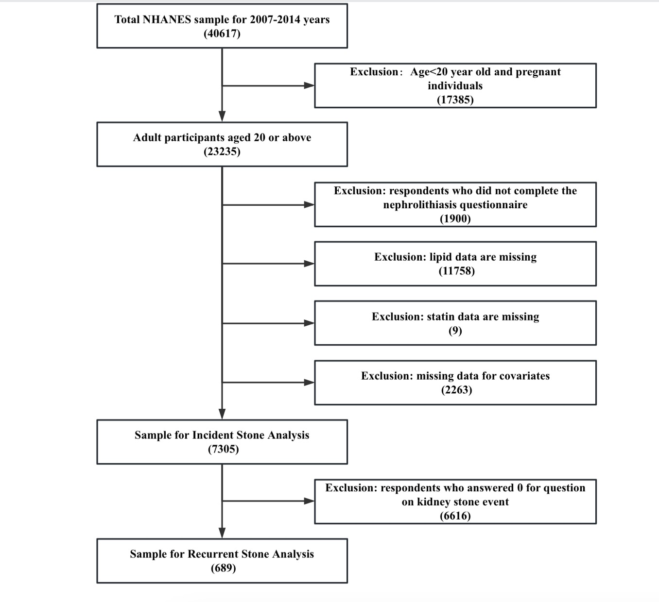
Figure S1 Flow chart showing the number of NHANES participants included in the current analyses

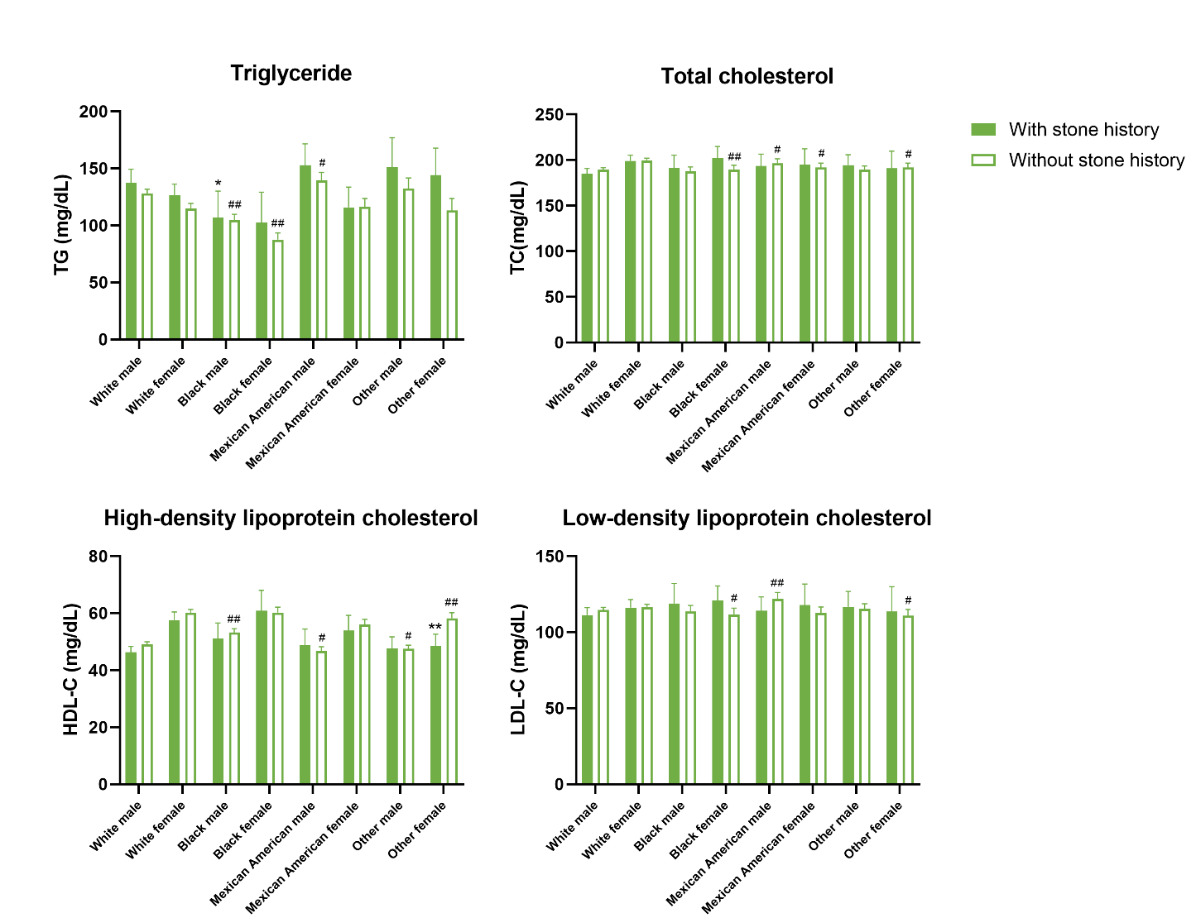
Figure S2 Analysis on the differences of blood lipid profile levels between with or without kidney stones
** P<0.001 vs with stone history or recurrent kidney stone; * P<0.05.
## P<0.001 vs white male or female; # P<0.05.

Figure S3. Analysis on the differences of blood lipid profile levels between with or without recurrent kidney stones
** P<0.001 vs with stone history or recurrent kidney stone; * P<0.05.
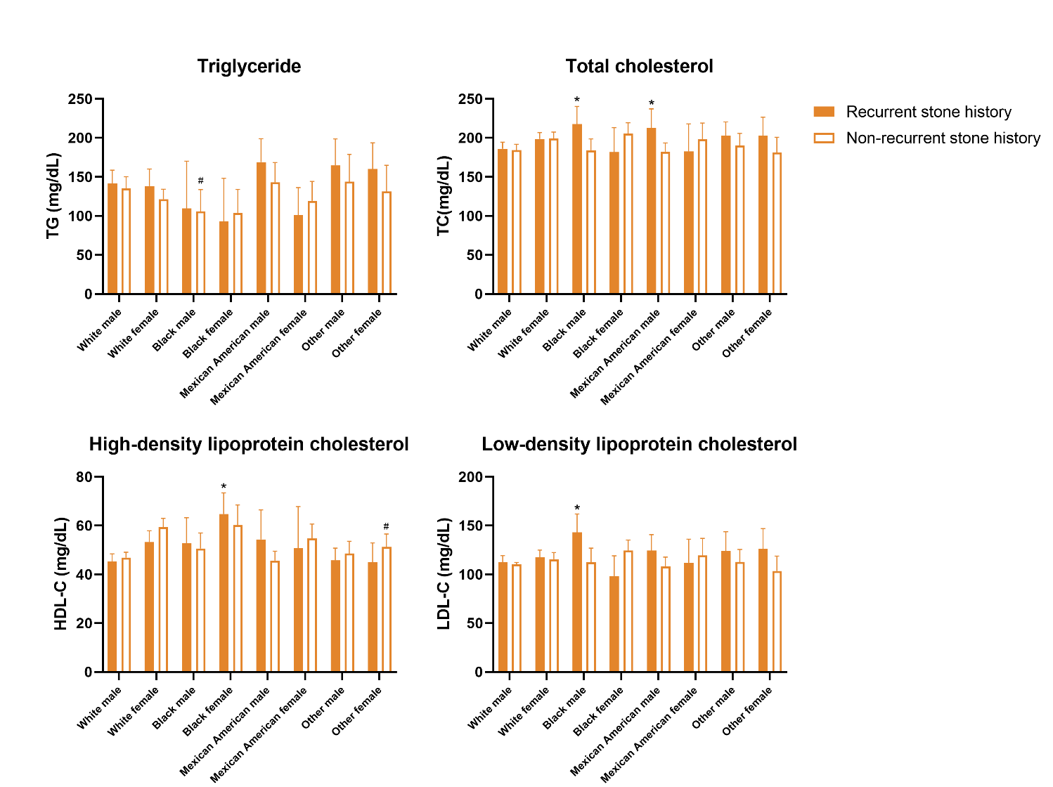
## P<0.001 vs white male or female; # P<0.05.

