New 1,3,4-Triaza-3H-indene Derivatives in Theoretical, Experimental and biological Studies.
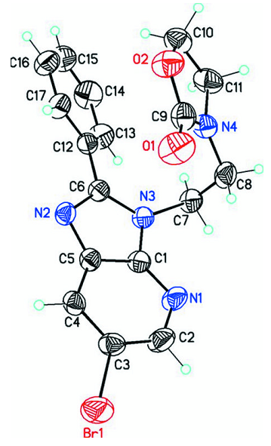
Figure S.1: XRD for 3a^{[34]} which was plotted using ORTEP, represented by ellipsoids (50% prob-ability level)
Table S.1: Crystallographic data of compound 3a
C₁₇H₁₅BrN₄O₂ | F(000) = 784
Mr = 387.24 | Dx = 1.613 Mg m−³
Monoclinic, P2₁/n | Mo Kα radiation, λ = 0.71073 Å
Hall symbol: -P 2yn | Cell parameters from 3008 reflections
a = 11.3553 (6) Å | θ = 3.5–32.3°
b = 11.5915 (5) Å | µ = 2.60 mm−¹
c = 12.2542 (8) Å | T = 170 K
β = 98.685 (6)° | Block, colourless
V = 1594.46 (15) Å³ | 0.22 × 0.20 × 0.18 mm
Z = 4
Oxford Diffraction XcaliburE Gemini  diffractometer | 3791 independent reflections
Radiation source: Enhance (Mo) X-ray Source | 2839 reflections with I > 2σ(I)
graphite | Rint = 0.028
Detector resolution: 16.1500 pixels mm-¹ | θmax = 27.9°, θmin = 3.5°
ω scans | h = −9→14
Absorption correction: multi-scan  (CrysAlis PRO; Oxford Diffraction, 2009) | k = −15→6
Tmin = 0.599, Tmax = 0.652 | l = −15→16
Refinement on F2 | Secondary atom site location: difference Fourier map
Least-squares matrix: full | Hydrogen site location: inferred from neighbouring sites
R[F2> 2σ(F2)] = 0.037 | H-atom parameters constrained
wR(F2) = 0.091 | w = 1/[σ²(Fo²) + (0.0373P)²+ 0.4211P]  where P = (Fo² + 2F_{c}²)/3
S = 1.03 | (Δ/σ)max = 0.001
3791 reflections | Δρmax = 0.50 e Å−³
218 parameters | Δρmin = −0.35 e Å−³

Table S.2: In vitro antibacterial activity of imidazo[4,5-b]pyridine derivatives (2a-3a):
Concentration mg /mL | (2a) |  | (3a)
Concentration mg /mL | B.cereus | B.cereus | E.coli | E.coli
5 | - | - | + | -
2.5 | - | - | + | -
1.25 | - | - | + | +
0.625 | - | - | + | +
0.32 | + | + | + | +
0.15 | + | + | + | +
0.07 | + | + | + | +
0.03 | + | + | + | +
0.01 | + | + | + | +
0.005 | + | + | + | +
0.0025 | + | + | + | +

2.1. Chemistry

¹H NMR (300MHz) and ¹³C NMR (75MHz) spectra were recorded on Bruker Advance DPX 300 instrument using DMSO-d₆ as solvent. The coupling constants (J) were expressed in Hertz (Hz). Multiplicities are reported as follows: singlet (s), doublet (d), doublet of doublets (dd), triplet (t), multiplet (m), and quaternary carbon (Cq). Melting points (mp) were recorded on Kofler bench and were not corrected. Flash chromatography was conducted using flash silica gel 60 (Merck 230-400 mesch). TLC (thin-layer chromatography) was used to monitor the reaction progress. The diffraction data for single crystal of 3a were collected with an Oxford Diffraction XcaliburE diffractometer using Mo Kα radiation. The intensity data were collected and processed using CrysAlisPro software.
    - General alkylation procedure of 6-Bromo-2-phenyl-1,3,4-triazaindan (2a-3b).

K₂CO₃ (0.186 g), (t-BAB) tetra-n-butylammoniumbromide (0.058 g), and 2-(2-bromoethyl)isoindoline-1,3-dione (0.25 g) were added to a solution of 6-Bromo-2-phenyl-1,3,4-triazaindan (0.25 g, 0.9 mmol) in DMF (20 ml). In 6 hours, the reaction was brought to room temperature. Following the filtering out of salts, DMF was evaporated at a low pressure, and the resulting residue was then dissolved in dichloromethane(supplementary materials). The remaining salts were removed by washing the organic phase three times with distilled water, and traces of water in the organic phase were eliminated using desiccant Na₂SO₄. After filtration, the dichloromethane was evaporated (not to dryness), and the obtained product was separated by chromatography on a column of silica gel (eluent: ethyl acetate/hexane (1/1) for compound 2a-b and ethyl acetate/ethanol (4/1) for (3a,b).

X-Ray Crystallography Analysis

The compound 3a was obtained as single crystals by slow evaporation from ethanol solution of the
pure compound at room temperature. Data were collected on Oxford Diffraction XcaliburE Gemini

diffractometer, equipped with graphite monochromatic Cu and Mo Kα radiation at 293 (2) K. Cell refinement and data reduction were carried out by Bruker SAINT. SHELXT [28,29] was used to solve structure. The final refinement was carried out by full-matrix least-squares techniques with anisotropic thermal data for non-hydrogen atoms on 𝐹. CCDC 825409contain the supplementary crystallographic data for these compounds can be obtained free of charge from the Cambridge Crystallographic Data Centre via www.ccdc.cam.ac.uk/data_request/cif.

Hirschfeld Fingerprint Analysis

The 2D and 3D Hirschfeld were obtained using Crystal-Explorer. The crystallographic data was introduced in TONTO as implemented in Crystal Explorer to elucidate. Hirshfeld surface analysis was used to understand the main intermolecular interactions role in a qualitative approach. “dnorm; normalized contact distance” surface is a symmetric function of distances to the surface from the nuclei inside and outside the Hirshfeld surface (di and de), relative to their respective van der Waals radii (vdW), which allows the identification of the regions which are of importance in the crystal packing of compounds. The interaction energy was calculated (B3LYP/6-31G(d,p)) to understand how non-covalent interactions contribute in holding dimers packing.

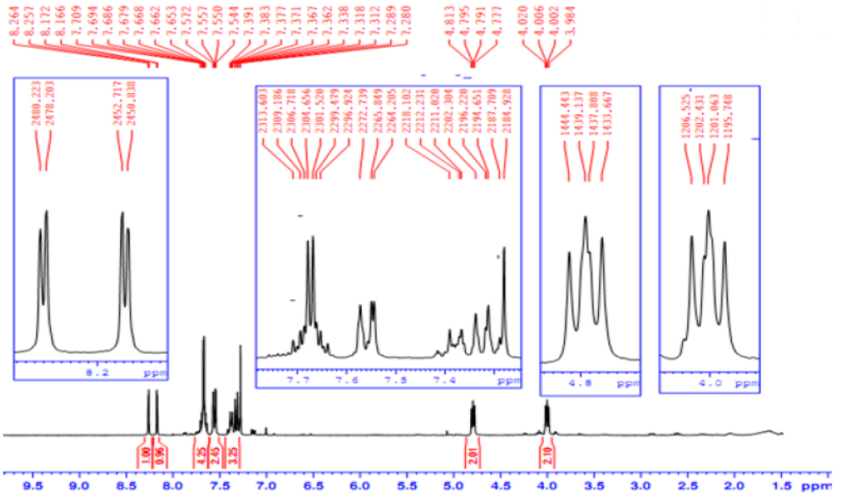
Figure S.2: ¹H NMR spectrum of 2a
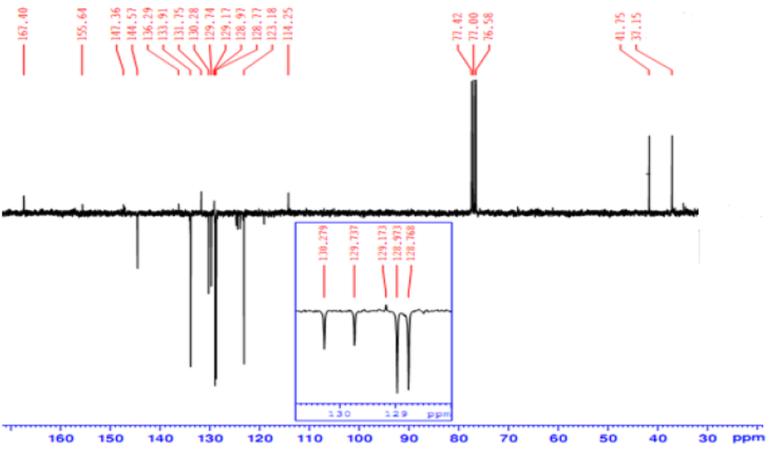
Figure S.3: ¹³CNMR spectrum of 2a

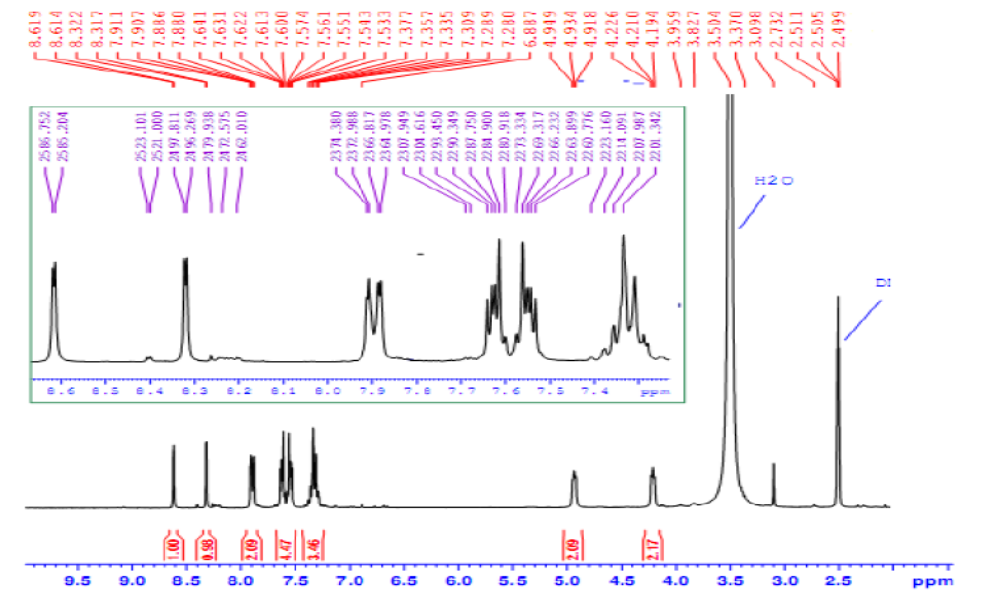
Figure S.4: ¹H NMR spectrum of 2b
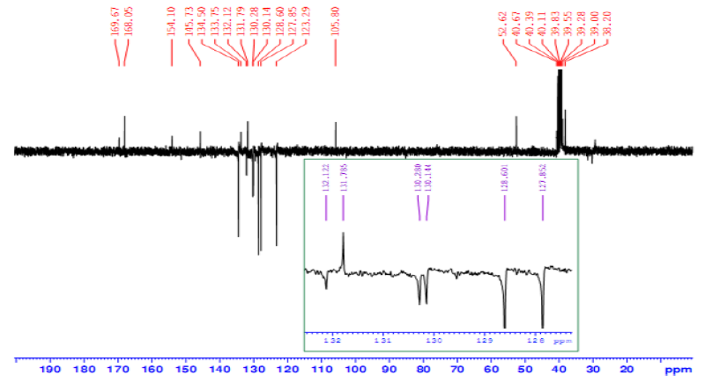
Figure S.5: ¹³CNMR spectrum of 2b

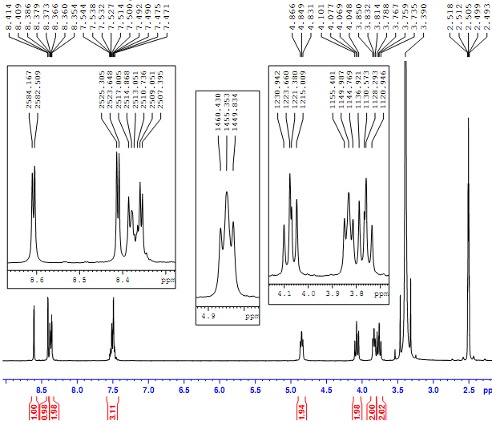
Figure S.6: ¹H NMR spectrum of 3b

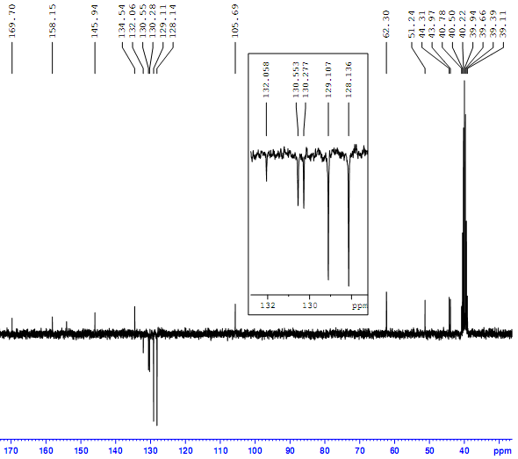
Figure S.7: ¹³CNMR spectrum of 3b

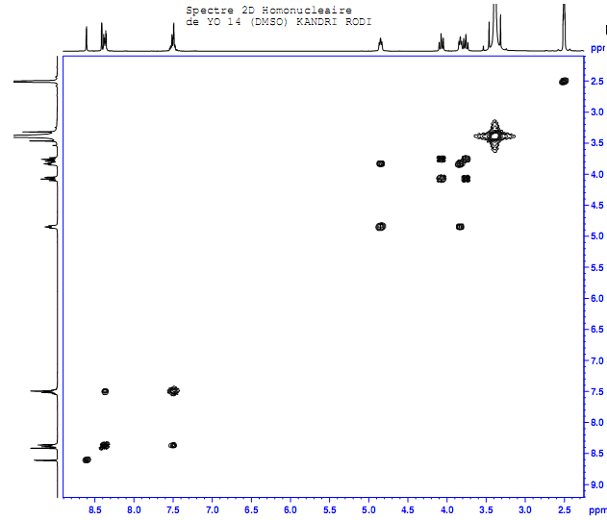
Figure S.8: 1H-1H COSY spectra of 3b

