Supplementary Data and Figure
Sample clinical traits and data quality of the samples
PCA Analysis using gene expression reveals the contribution of the sex of the participants in sample variation at global levels
Dimensionality reduction was performed on the top 500 most variable genes and circRNAs identified in the samples from the PPMI cohort using Principal Component Analysis (PCA) to detect variation contributed by major clinical factors associated with the participants like Sex, Age, Race, Family History, Site of blinded sample collection, and Hoehn Yahr Stage at global levels. Sample clustering based on the most variable circRNAs revealed that the clinical factors tested did not contribute to the sample variation (Supplementary Figure 1a-f). However, in the case of sample clustering by most variable genes, sex of the participants was a major driver for sample variation at a global level (Supplementary Figure 2a-f). Similar sample clustering patterns were observed from the PC Analysis of the top 500 most variable genes and circRNAs. For the PDBP cohort, the impact of the clinical factors (Age, Sex, Race, Family History, and HY Stage) on sample variation was assessed (Supplementary Figure 3a-j). Based on these observations, we accounted for the participants' sex in the gene expression analysis.

Outliers sample detection and concordance of the reported sex of the participants in the study
We also performed Rosner’s Outliers Test on the first principal component (PC1) calculated using the highly expressed circRNA counts in samples at the PPMI and PDBP cohorts and identified two samples to be outliers in the PDBP cohort (Supplementary Figure 4a-b). We also analyzed the concordance between the reported sex of the participants by analyzing the expression of X-linked gene (XIST) and Y-linked (RPS4Y1) genes (Supplementary Figure 4c-d).

circRNAs profiles in whole blood samples from the participants in the study
Using CIRIquant, we identified thousands of circRNAs in samples from Parkinson’s and control participants in PPMI and PDBP cohorts. Out of the 47 circRNAs identified to be unique to samples from Parkinson’s participants in the PPMI cohort, 10 were also detected to be unique to the Parkinson’s samples in the PDBP cohort. Of the control samples, out of the 660 circRNAs identified to be unique to control participants, 81 were also detected exclusively in the samples from controls in the PDBP cohort (Supplementary Figure 5a). In both PPMI and PDBP cohorts, we detected a greater number of reads from the respective linear reads than from the different isoforms of circRNAs generated from the same region (Supplementary Figure 5b). The only exception to this trend was ENSG00000248242|AC004053.1, which generated a circRNA isoform (hsa_circ_0142053) that has more reads compared to its linear counterpart that was detected in the whole blood samples from the participants in the study from both cohorts. We next explored the number of circRNA isoforms generated per genes detected in the PD and control samples from participants in the PPMI and PDBP cohorts. In samples from both cohorts, DENND4A, PICALM, UBAP2, SOX6, and HERC1 were among the top genes generating the largest numbers of different circRNAs isoforms, whereas KIAA0182, CDYL, TMEM56-RWD33, and ZNF609 were among the top genes which generated circRNAs with the greatest number of averages read counts (Supplementary Figure 5c-f). Although most of the identified circRNAs in PPMI and PDBP datasets were under the 3000-nucleotide length, several annotated circRNAs over 3000nt long were also identified (Supplementary Figure 5g).

Differentially expressed circRNAs throughout different time points in the study within disease conditions.
Post-hoc analysis to determine logFC cutoff for the DE analysis
Power calculations were performed post-hoc to determine the effect size cut-off for the differentially expressed circRNAs and genes in the PPMI and the replication (PDBP) datasets using G-Power software. Based on the PD samples in the PPMI and PDBP datasets, analyzing the power using mean differences in matched pairs (using T-test or Whitney Signed Rank test) demonstrates 80% power to detect effect sizes of 0.2 and 0.25, respectively (Supplementary Figure 6a-d).

Visualizing the differentially expressed circRNAs identified in samples from PD participants at different time points throughout the course of the study
In PD samples from the PPMI cohort, most of the circRNAs found to be differentially expressed at Year 2 and Year 3 compared to Baseline were detected in most of the samples collected at three different time points (Supplementary 7a-b). Comparing the average expression of the different circRNAs supported the DE expression analysis results, indicating that more circRNAs were upregulated at Year 3 than Year 2 when compared to baseline expression levels (Supplementary 7c-d).

circRNAs are not differentially expressed in the control participants at the same time points in the study as in early Parkinson’s participants.
Paired differential expression analysis in samples from control participants in the PPMI study (n = 86) at Year 2 and Year 3 compared to Baseline showed no circRNAs to be differentially expressed (Supplementary Figure 7 e-f). We also observed the same in the paired differential expression analysis of samples from control participants in the PDBP cohort (n = 66); no circRNAs were differentially expressed (Supplementary Figure 7g).

The host genes of some of the dysregulated circRNAs are not significantly dysregulated in samples from Parkinson’s Participants at Year 2.
The paired analysis on the samples from PD participants in the PPMI dataset also identified 6,682 genes to be significantly up-regulated (FDR < 0.05 and logFC > 0.2) whereas 3,679 genes were found to be downregulated (FDR < 0.05 and logFC < -0.2) at Year 2 compared to Baseline (Supplementary Table 7, Supplementary Figure 8a). Analyzing the gene expression in the samples PDBP cohort, we identified 467 up-regulated genes (FDR < 0.05 and logFC < 0.25) and 395 down-regulated genes (FDR < 0.05 and logFC < -0.25) at Year 2 compared to Baseline (Supplementary Table 7, Supplementary Figure 7b). At Year 3, 203 genes were found to be upregulated (FDR < 0.05 and logFC < -0.2) and 43 to be downregulated (FDR < 0.05 and logFC < -0.2) (Supplementary Table 7, Supplementary Figure 7c).
Interestingly, some of the significantly dysregulated circRNAs in samples from PD participants at Year 2 did not demonstrate significant dysregulation at its host gene expression levels in either cohort (Supplementary Figure 8a-b). The host gene of circSPECC1, which was significantly upregulated in samples from PD participants at Year 2, was not found to be significantly dysregulated (Figure 8d-e). A similar trend was observed for the host gene. Correlational Analysis demonstrated a significant positive correlation between the dysregulated circRNAs' expression and their respective host genes (Supplementary Figure 9). The expression of circRNAs: circZNF124, circVRK1, circEMB, circNEAT1, and circAGTPBP1 were found to have a moderate positive correlation to the expression of their host genes, whereas the expression of circRNAs: circPICALM, circHIPK3, circSLC8A1, circMAN1A2, circSPECC1, circARHGAP5, and circZNF91 was found to have a weak correlation to their host genes.

Analyzing co-expressed genes in PD samples at different time points in the PPMI cohort to identify genes associated with PD progression
The PD samples in the PPMI cohort were clustered based on the gene expression of the samples in the PPMI cohort. The cutoff height threshold was set to 80, and the detected outlier samples were removed from the downstream analysis (Supplementary Figure 10a). We also plotted the heatmap with the traits used to evaluate the module-trait relationships post-network construction using WGCNA (Supplementary Figure 10b). Using TOM dissimilarity, genes were clustered into 21 modules post-network construction by WGCNA (Supplementary 10c).

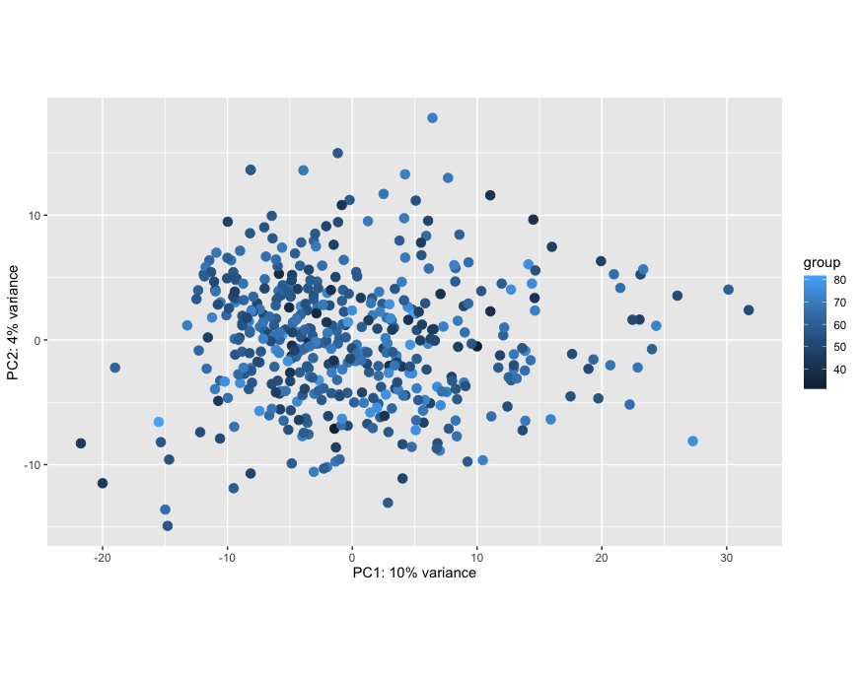
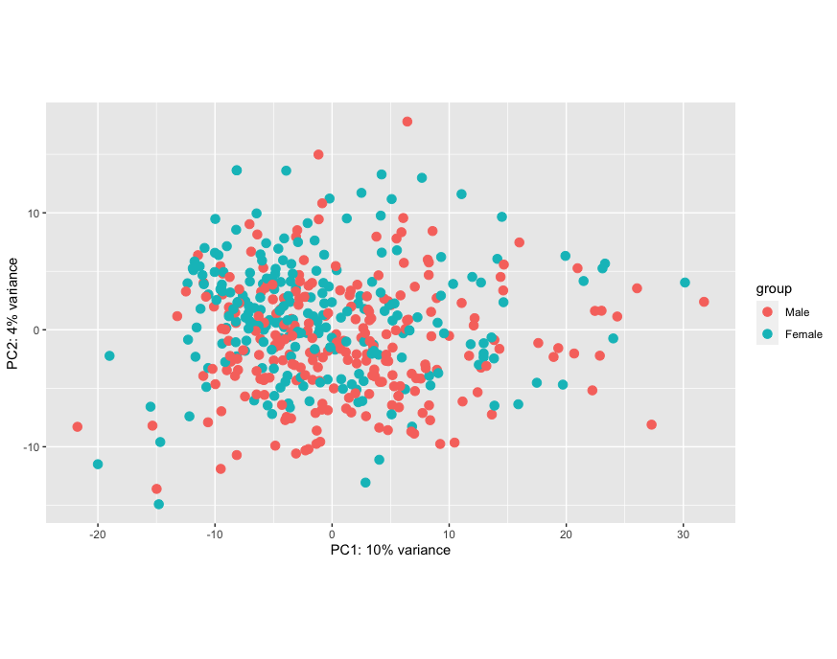
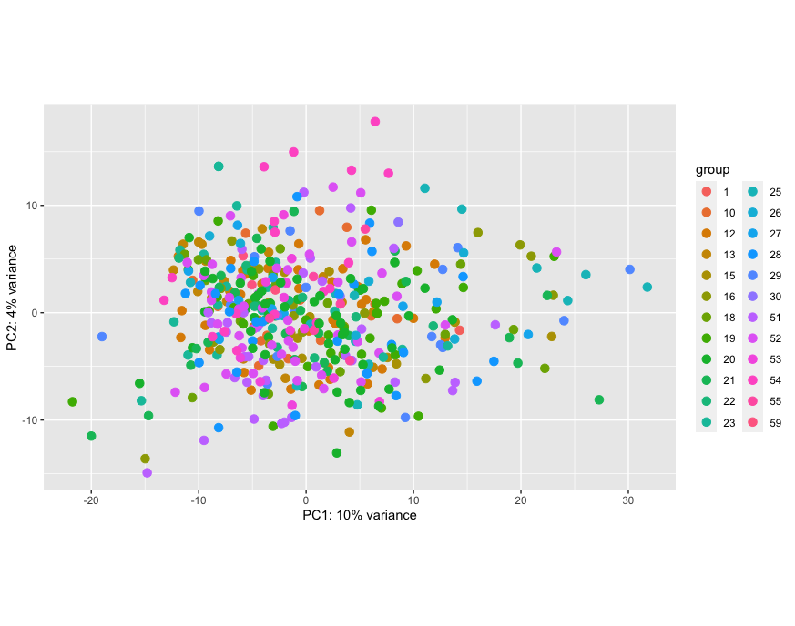
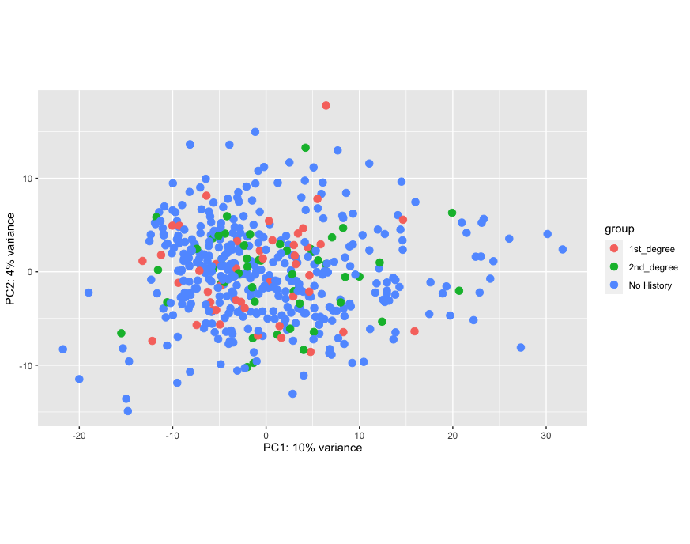
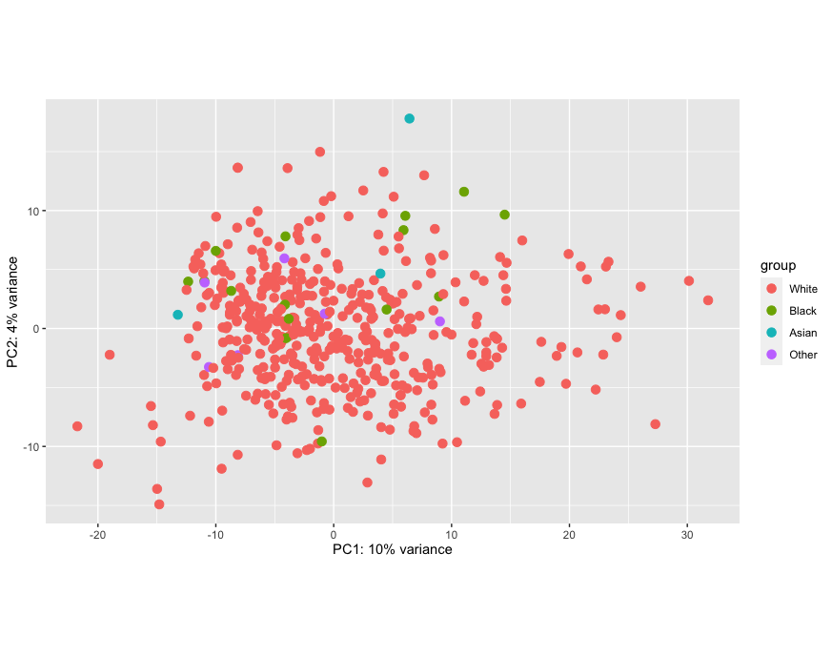
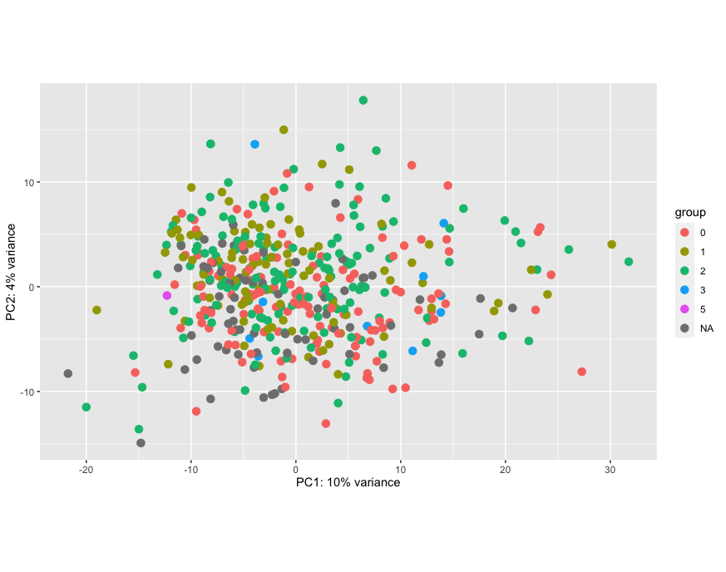
Supplementary Figure 1: Sample variation contributed by clinical factors – Sample clustering based on top 500 most variable circRNAs using PCA depicting the variation among samples (n= 468) from PPMI Cohort contributed by clinical factors at global levels: a) Age, b) Sex, c) Site of sample collection, d) Family History, e) Race, and f) HY Stage.
Age
Sex
Site
Family History
a
b
c
d
e
f
Race
HY Stage

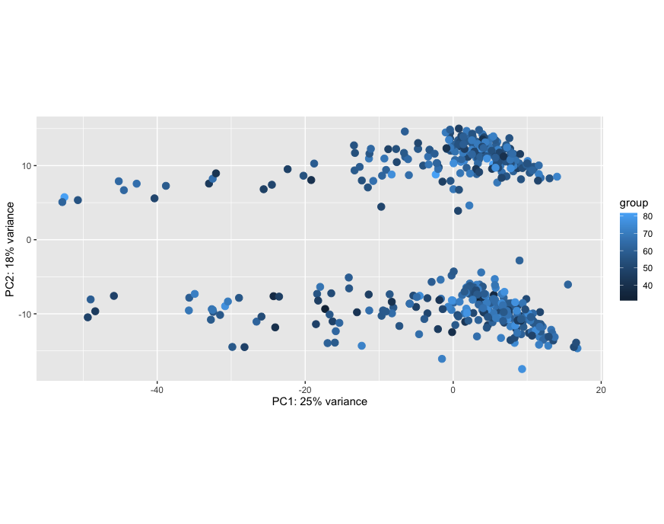
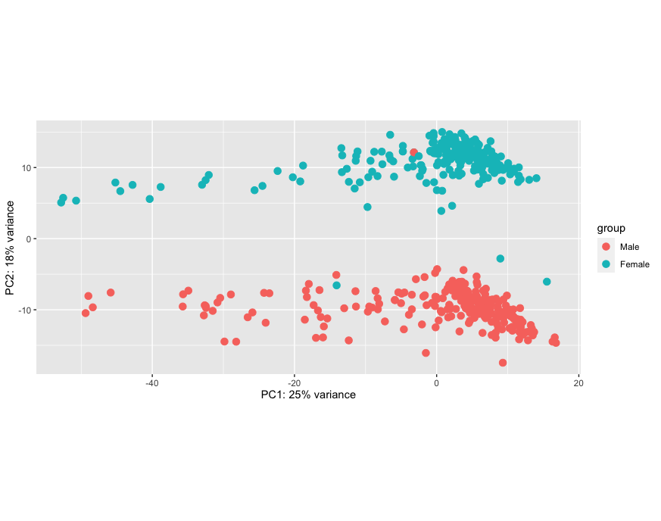
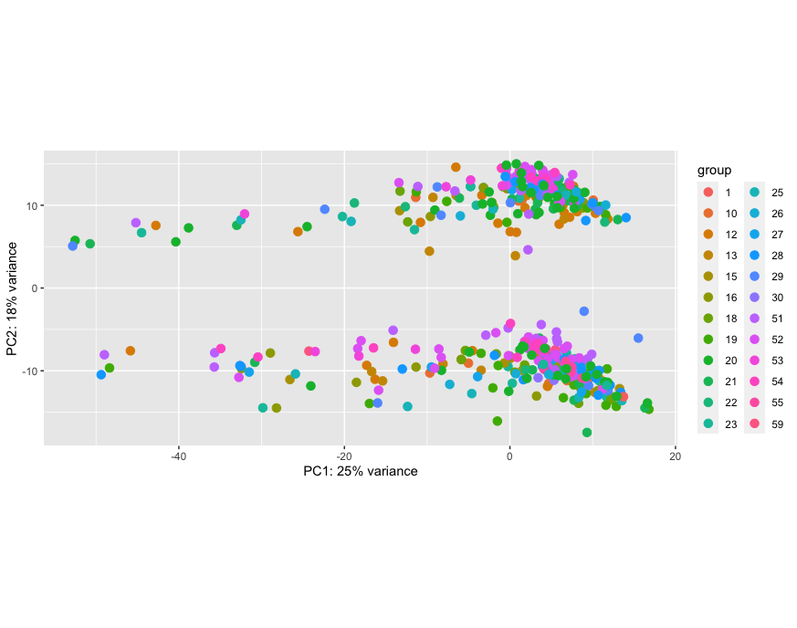
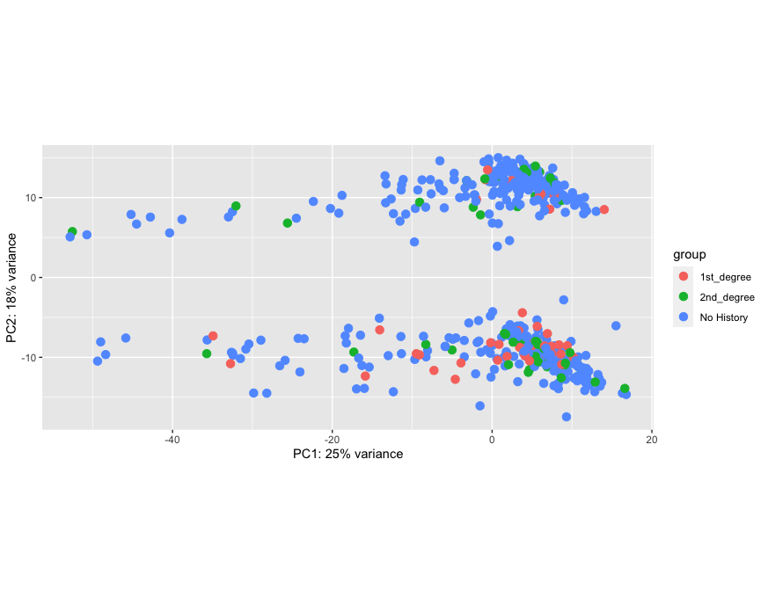
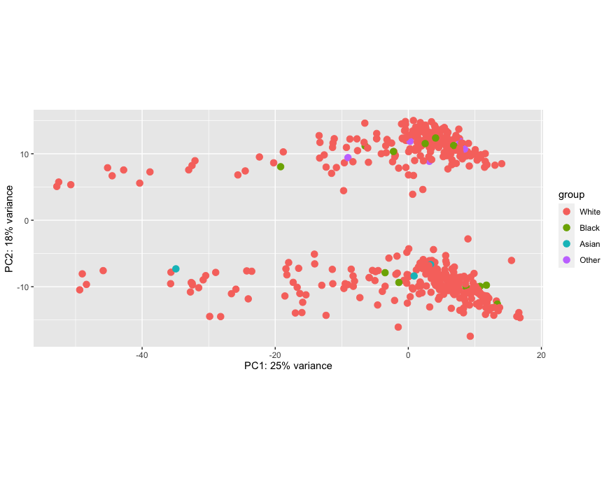
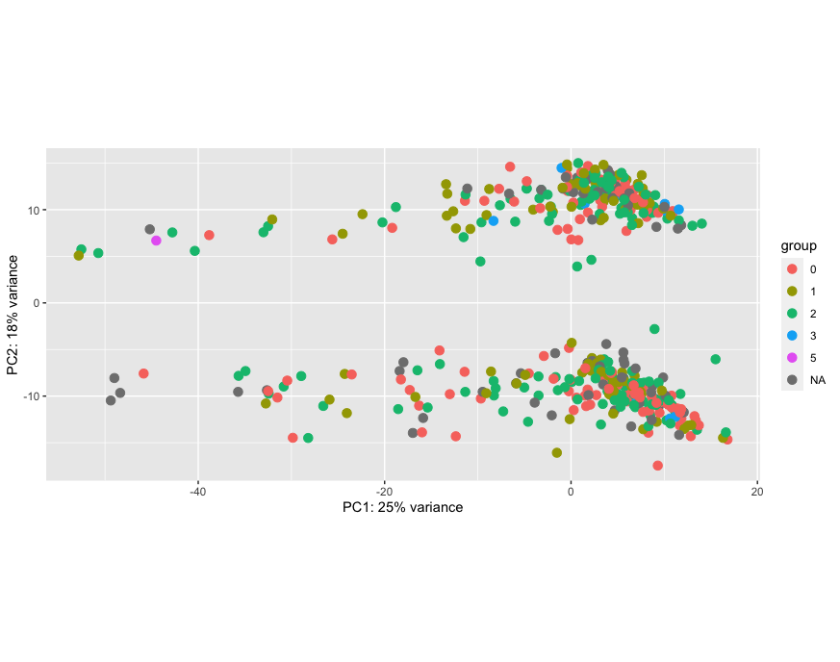
Sex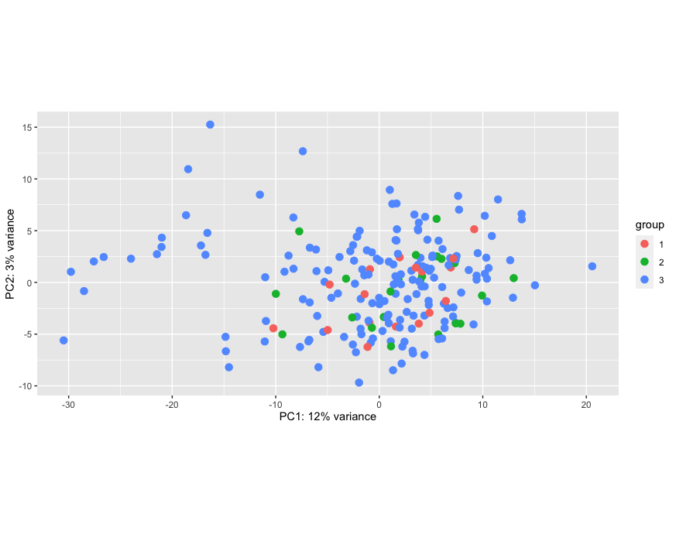ex
Site
Family History
Race
HY Stage
a
b
c
e
f
d
Age

Supplementary Figure 2: Sample variation contributed by clinical factors – Sample clustering based top 500 most variable genes using PCA depicting the variation among samples (n = 468) from PPMI Cohort contributed by clinical factors at global levels: a) Age, b) Sex, c) Site of sample collection, d) Family History, e) Race, and f) HY Stage.

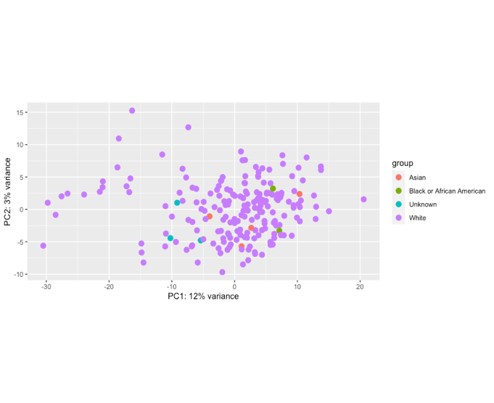
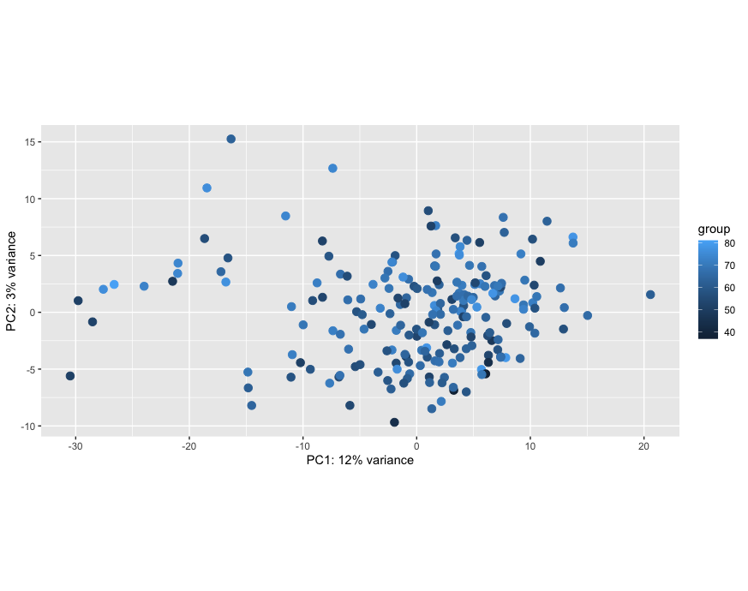
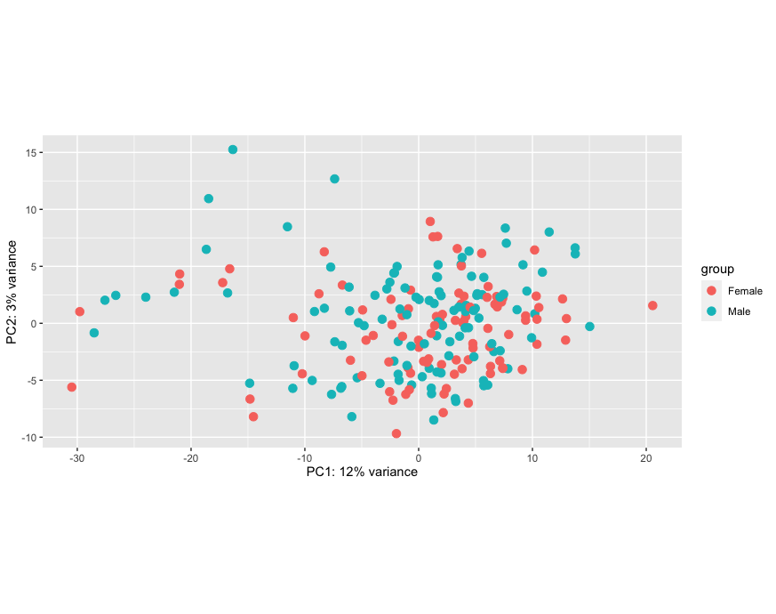
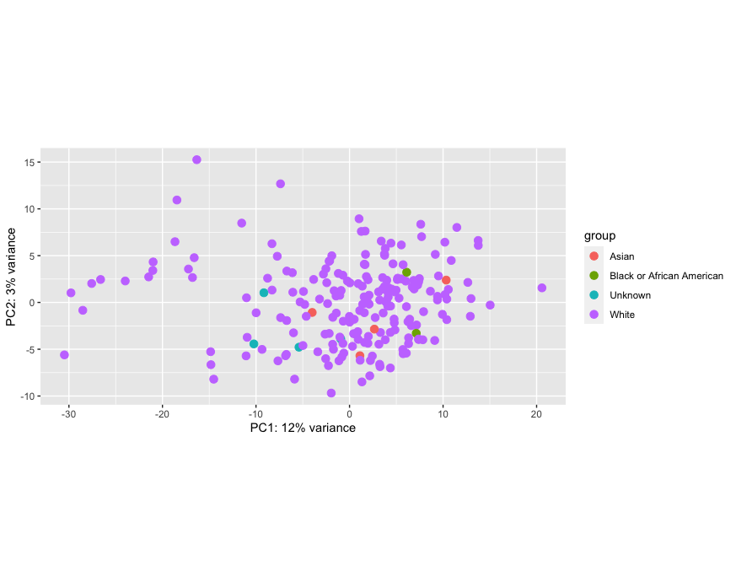
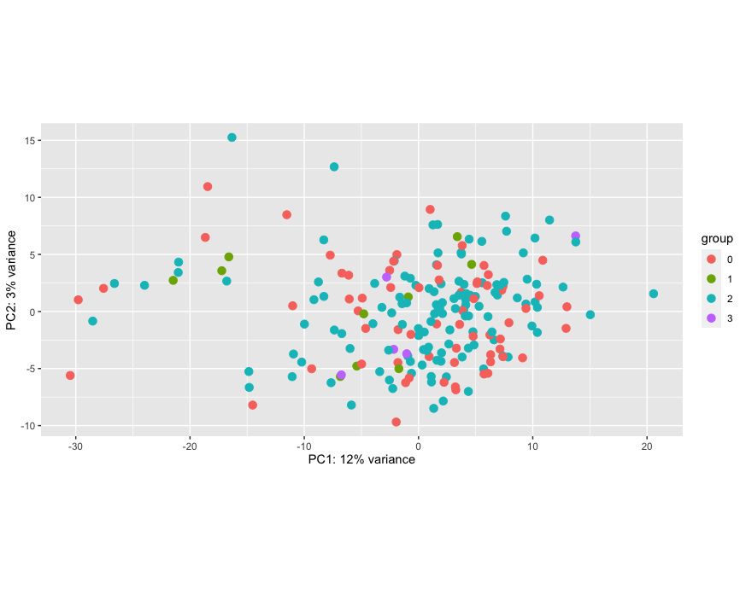
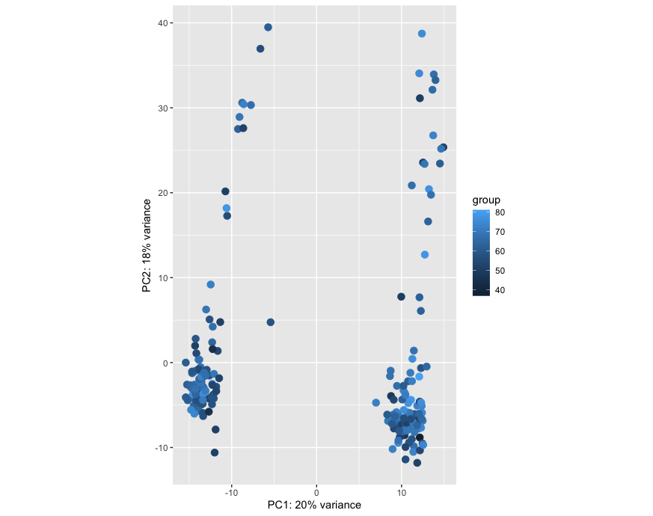
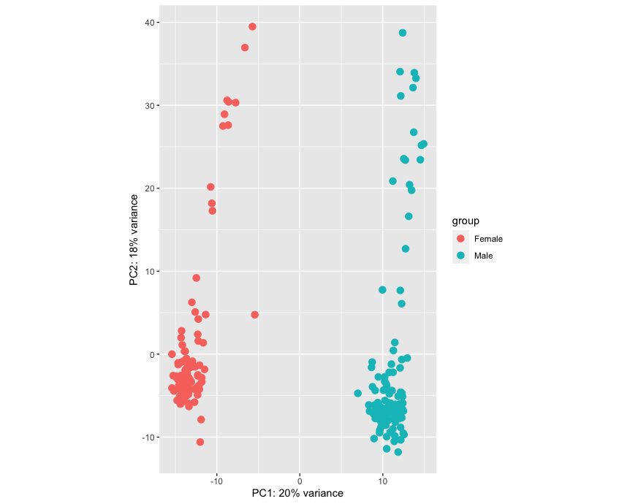
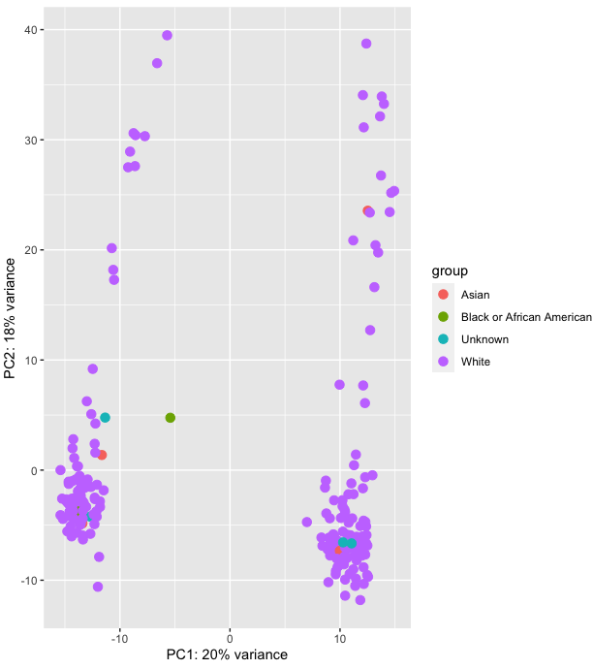
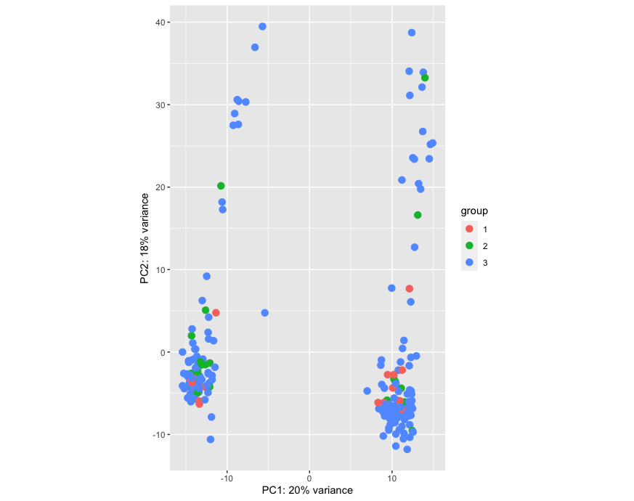
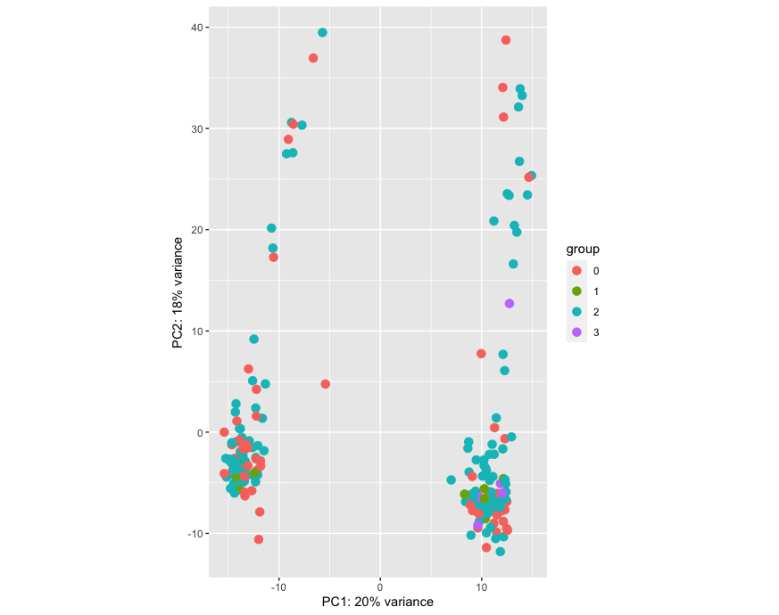
Sexex
Ageex
Race
Family History
HY Stage
a
b
c
e
f
d
g
h
i
j
Ageex
Sexex
Raceex
Family History
HY Stage

Supplementary Figure 3: Sample variation contributed by clinical factors – Sample clustering based top 500 most variable circRNAs using PCA depicting the variation among samples (n = 210) from PPMI Cohort contributed by clinical factors at global levels: a) Age, b) Sex, c) Site of sample collection, d) Family History, e) Race, f) HY Stage and genes using f) Age, g) Sex, h) Race, i) Family History, and j) HY Stage.

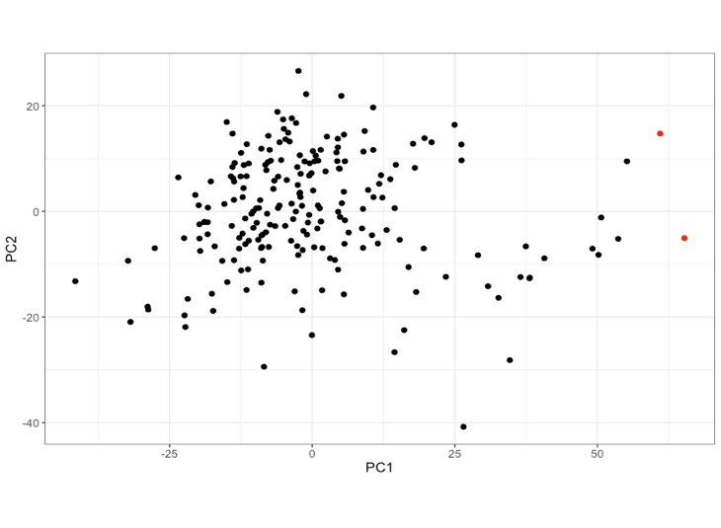
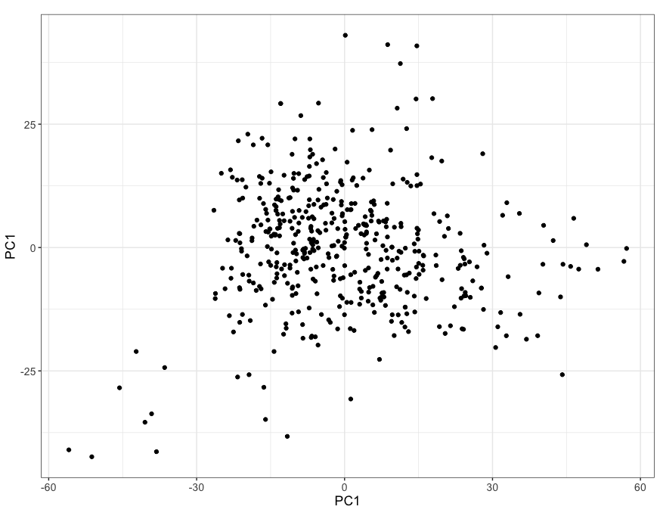
a
b
Supplementary Figure 4: Outliers and concordance on clinical data – PCA plots depicting the outlier samples detected by the Rosner’s Test (Red) in a) PPMI (n = 468) and b) PDBP cohorts (n = 210). Scatterplots depicting the reported sex of the participants in the clinical data of the c) PPMI and d) PDBP cohorts and the expression levels of X-linked (XIST) and Y-linked genes (RPS4Y1).

c
d

a
b
c
d
Supplementary Figure 5: Post-hoc power analysis for differential expression - XY plots depicting the power calculations using: a) t-tests for differences of means (matched pairs) and b) Wilcoxon Signed Rank Test showing power to detect effect sizes based on the total number of PD samples in the PPMI dataset used in our analysis. c) t-tests for differences of means (matched pairs) and b) Wilcoxon Signed Rank Test showing power to detect effect sizes based on the total number of PD samples in the PDBP dataset used in our analysis.

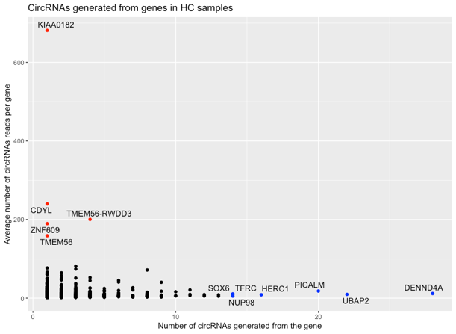
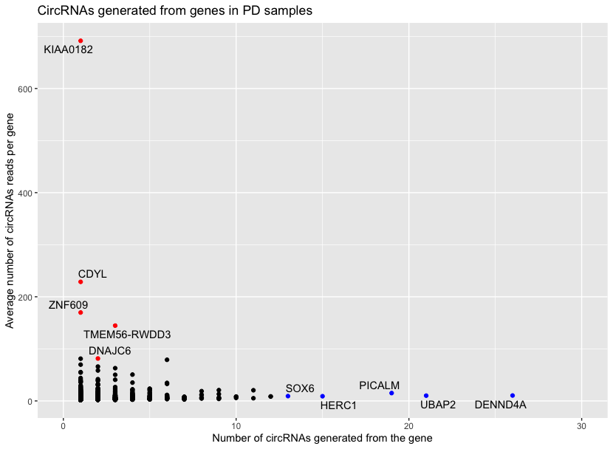
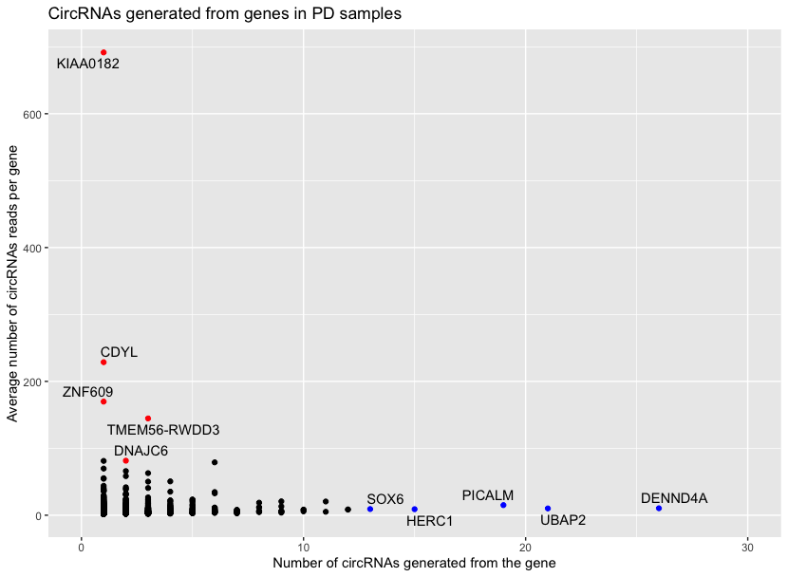
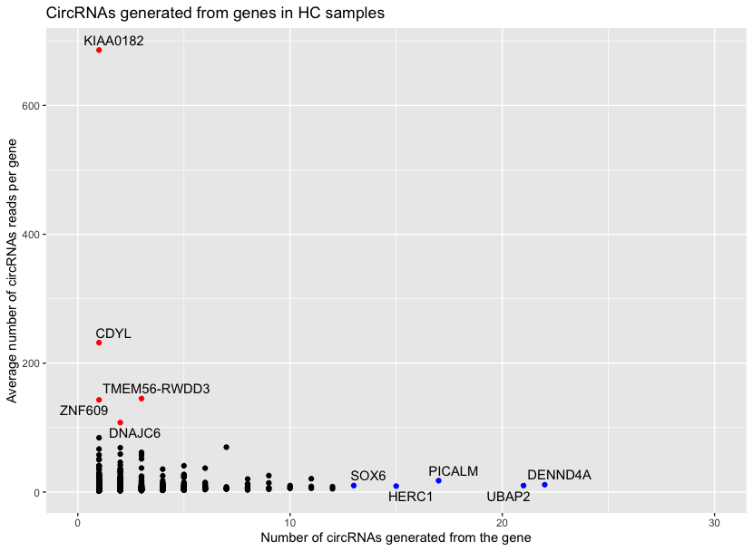
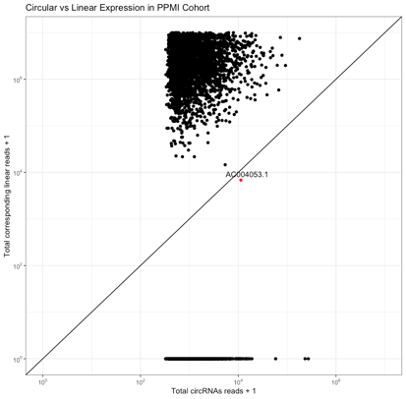
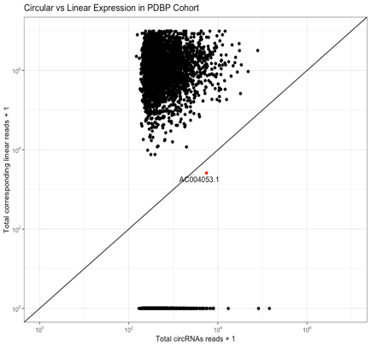
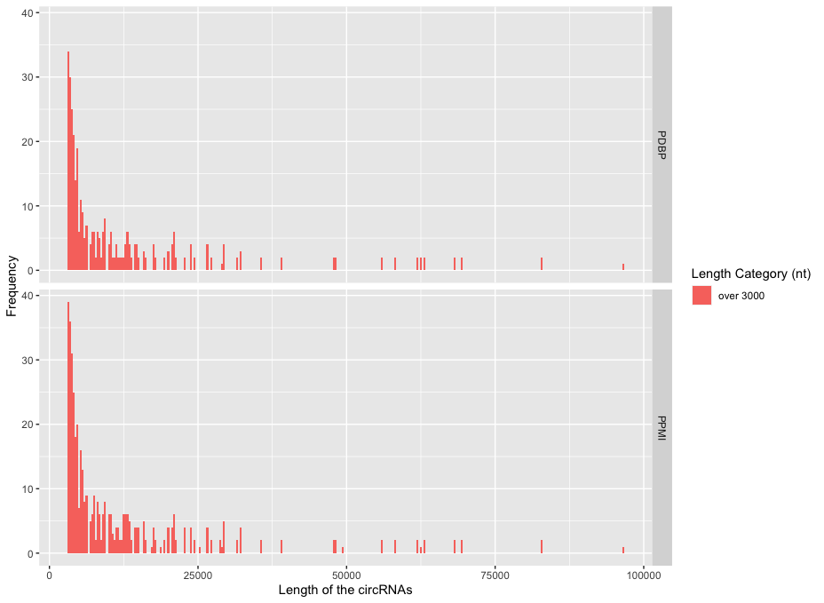
f
e
Supplementary Figure 6: Unique circRNAs identified associated with disease conditions in the study population: Venn Diagram showing circRNAs exclusively identified in the samples from a) Parkinson’s Participants (n=291) and the b) Control participants (n=142) in the PPMI and cohorts. Comparison of circRNAs reads compared to their respective linear reads in the samples from the a) PPMI (n=420) and b) PDBP cohort (n=208). circRNAs with number of isoforms reads more than the reads of their linear counterparts are indicated in red color. CircRNAs generated from the non-coding regions without reads on their linear RNAs are plotted at the bottom of the plots. Total number of circRNAs isoforms and reads generated from various genes detected in the samples from c) Parkinson’s participants and d) Control participants in the PPMI cohort. Total number of circRNAs isoforms and reads generated from various genes detected in the samples from e) Parkinson’s participants and f) Control participants in the PDBP cohort. Genes with highest number of circRNAs reads detected in the samples are labeled red and genes generating the greatest number of different circRNAs isoforms are labeled blue. g) Length Distribution of circRNAs with length over 3000 nucleotide long. Bins was set to 300 for the histogram visualization.
a
b
c
d

g

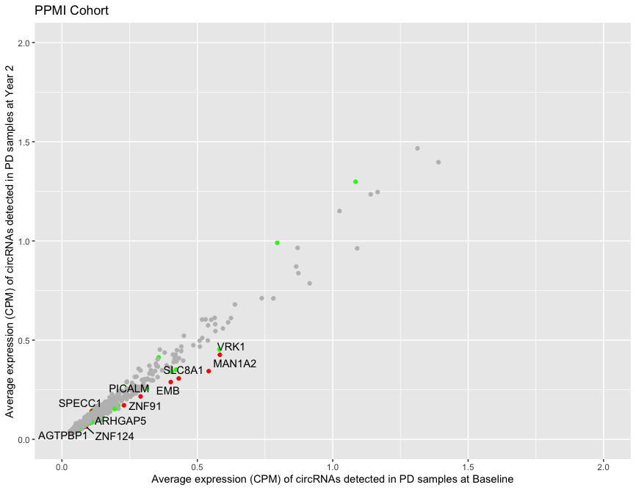
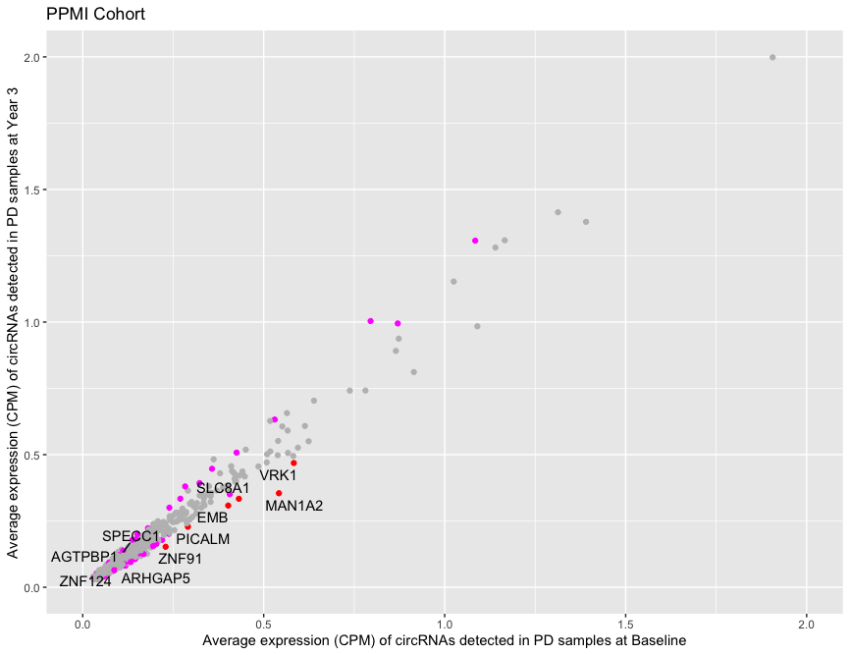
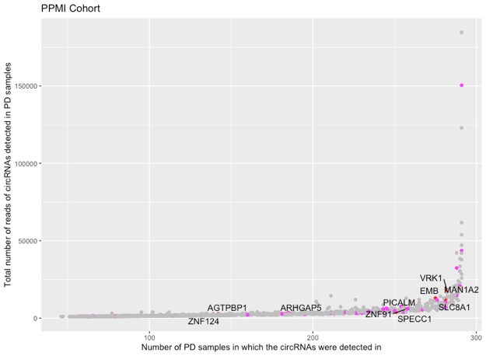
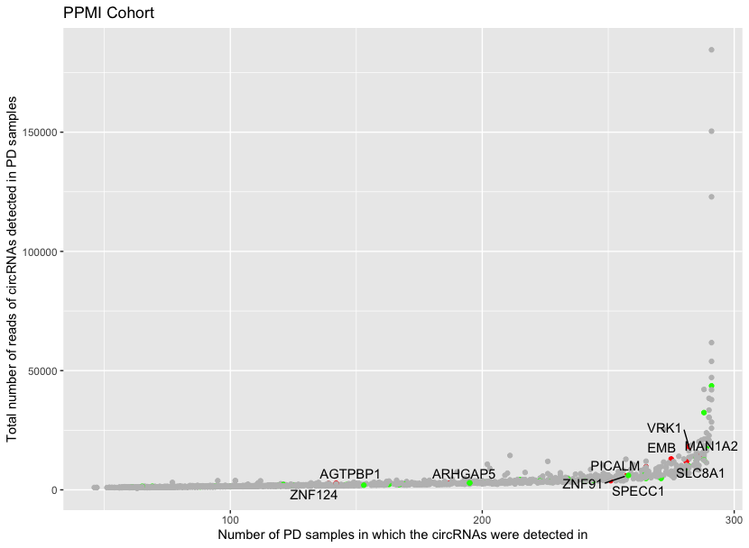
Figure 7: Differentially expressed circRNAs in samples from control participants – Total number of circRNAs reads detected in PD samples from a) PPMI (n = 291) and b) PDBP (n = 142) cohorts. Average expression of circRNAs in PD samples collected at c) Year 2 and d) Year 3 compared to Baseline. Mean abundance plots depicting the differentially expressed circRNAs in samples collected from Parkinson’s participants at Year 2 compared to the Baseline in the e) PPMI cohort: circRNAs with false discovery rate (FDR) < 0.05 and logFC < -0.2 are considered downregulated (black), the circRNAs with FDR < 0.05 and logFC > 0.2 are upregulated (red) and circRNAs with FDR > 0.05 and |logFC|< 0.2 are not significant (black). f) in PDBP cohort: circRNAs with false discovery rate (FDR) < 0.05 and logFC < -0.25 are considered downregulated (black), the circRNAs with FDR < 0.05 and logFC > 0.25 are upregulated (red) and circRNAs with FDR > 0.05 and |logFC|< 0.2 are not significant (black). g) Differentially expressed circRNAs in samples collected from Parkinson’s participants at Year 3 compared to Baseline in the PPMI cohort.

a
b
c
d
e
f
g

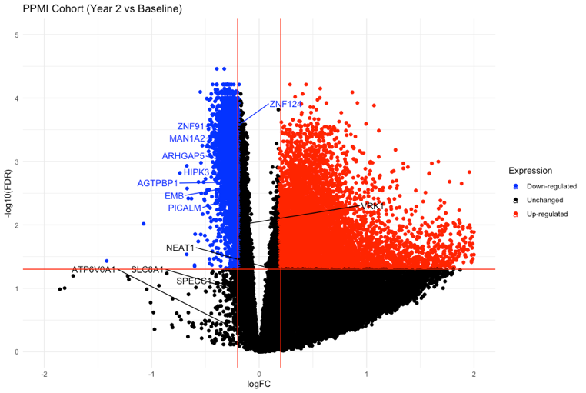
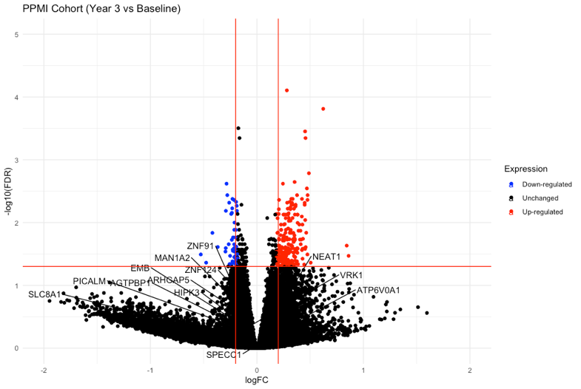
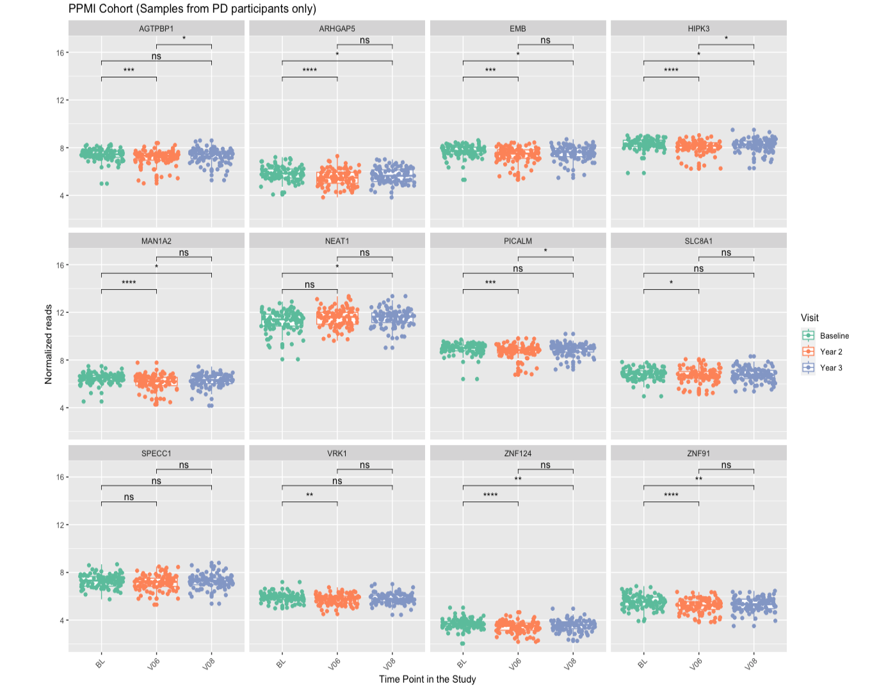
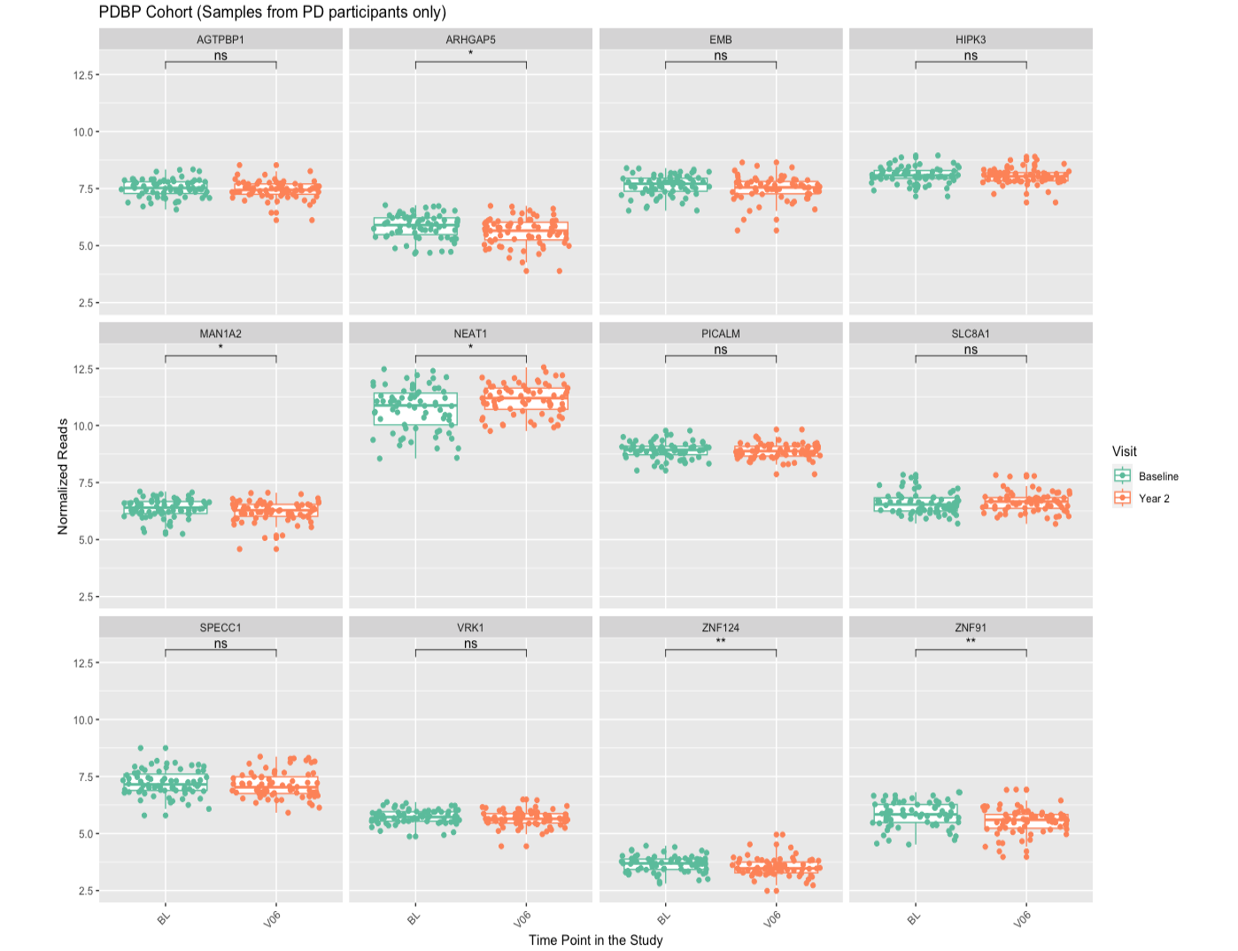
Supplementary Figure 8: Differentially expressed genes in PD participants - Volcano plots depicting the differentially expressed genes in samples collected from Parkinson’s participants at Year 2 compared to the Baseline in the a) PPMI cohort: Genes with false discovery rate (FDR) < 0.05 and log Fold Change (logFC) < -0.2 are considered downregulated (blue), the genes with FDR < 0.05 and logFC > 0.2 are upregulated (red) and genes with FDR > 0.05 or |logFC|< 0.2 are not significant (black). b) PDBP cohort: Genes with false discovery rate (FDR) < 0.05 and logFC < -0.25 are considered downregulated (blue), the genes with FDR < 0.05 and logFC > 0.25 are upregulated (red) and circRNAs with FDR > 0.05 or |logFC|< 0.25 are not significant (black). c) e) Volcano plots depicting the differentially expressed circRNAs in samples collected from Parkinson’s participants at Year 3 compared to Baseline in samples from PD participants in the PPMI cohort. d) Boxplots depicting gene expression of the host genes of the 12 common circRNAs identified by EdgeR to be dysregulated in samples from PD participants at Year 2 in the PPMI cohort. e) Boxplots depicting gene expression of the host genes of the 12 common circRNAs identified by EdgeR to be dysregulated in samples from PD participants at Year 2 in the PDBP cohort. logCPM represents the logarithm of Count Per Million (CPM) normalized read counts of raw gene counts. Paired Wilcoxon Test used to compare the means and test significance.
a
b
c
d
e
Total variable: 43,290
Total variable: 34,168
Total variable: 43,290

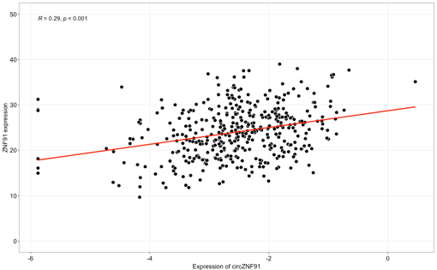
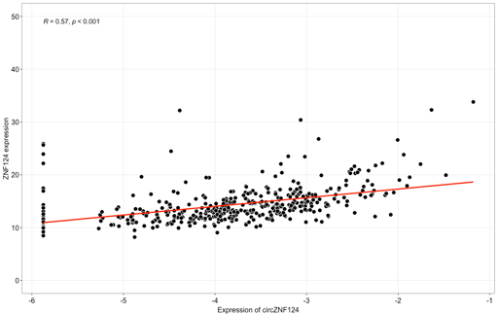
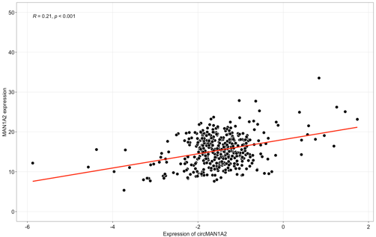
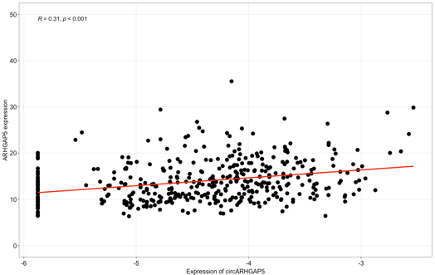
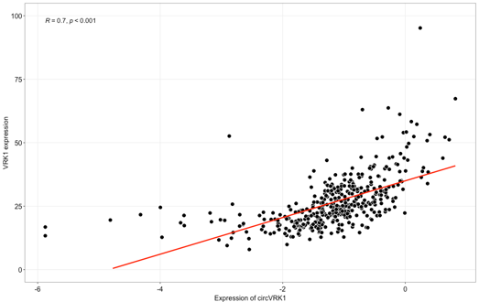
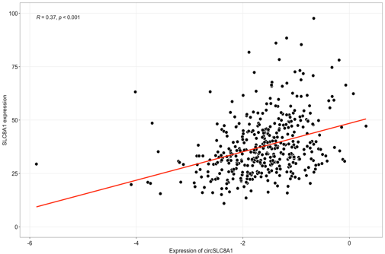
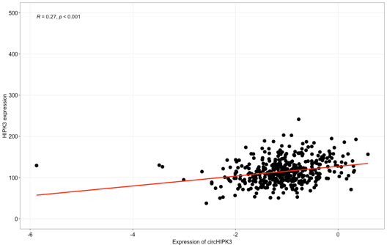
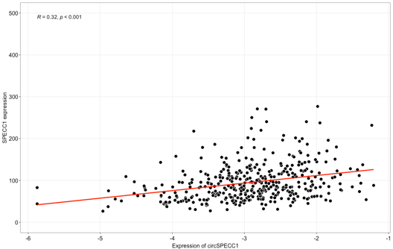
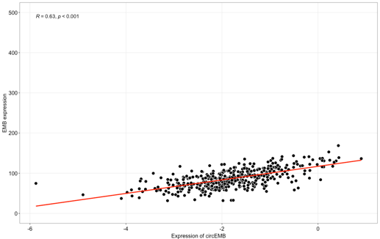
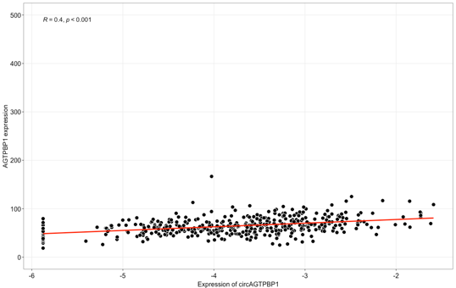
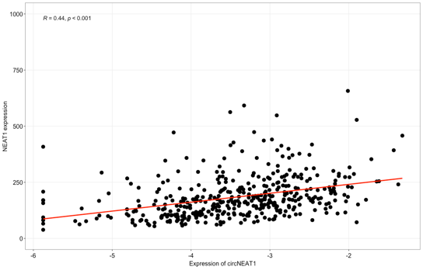
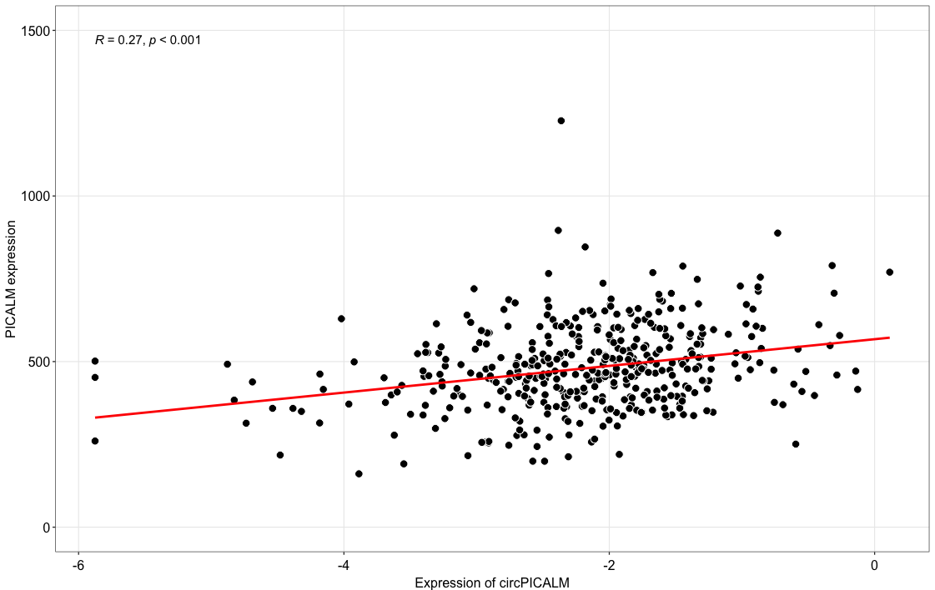

Figure 9: Dysregulated circRNAs are positively correlated with their host genes – Scatter plots depicting the relationship of the 12 circRNAs identified to be dysregulated in the samples from PD participants at Year 2 in both PPMI as well as PDBP studies to the gene expression of their respective host genes. Spearman’s Rank correlation was performed for correlational analysis. Logarithm of counts per million (logCPM) values represents the circRNA expression whereas FPKM normalized gene counts represents the expression of the host genes.

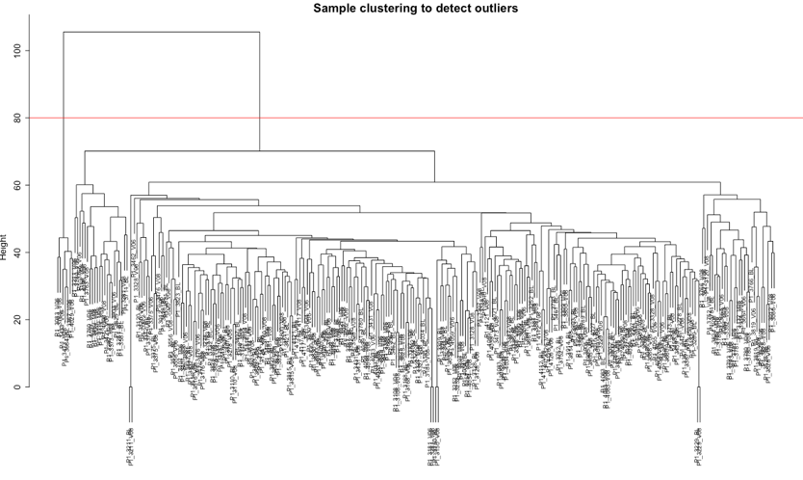
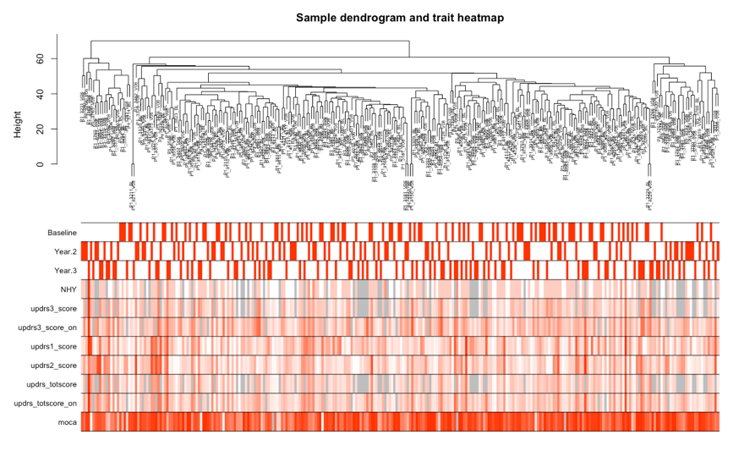
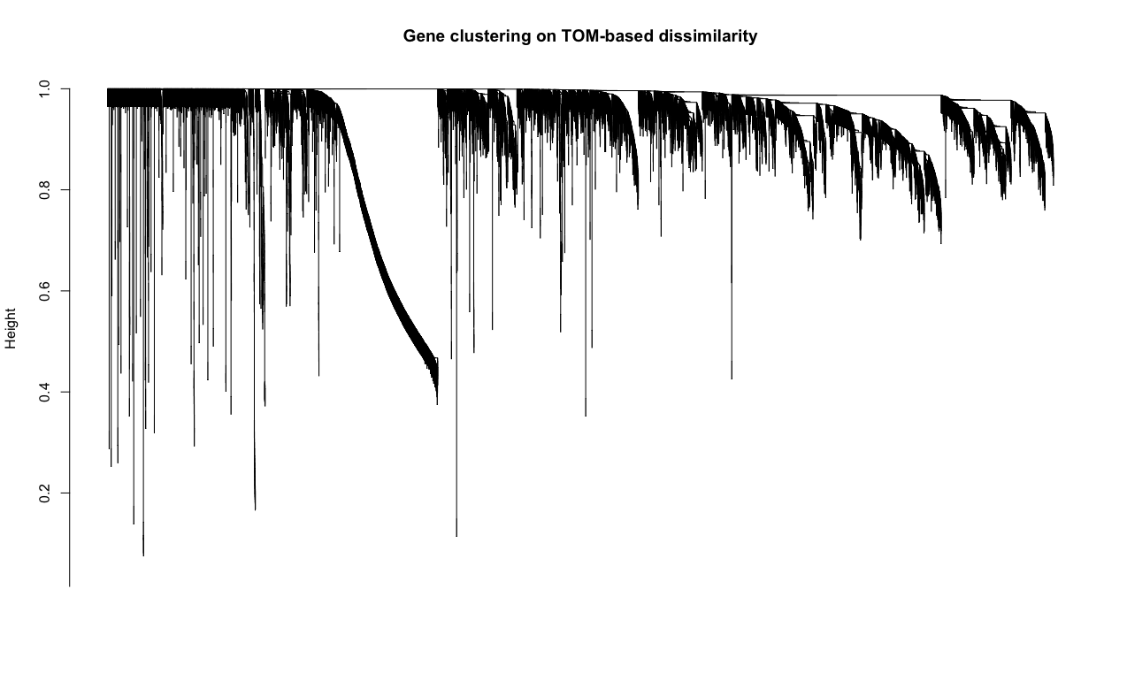
Figure 10: Co-expressed genes in samples from PD participants in the PPMI cohort – a) Dendrogram depicting hierarchal clustering of samples based on gene expression and setting a cutoff at 0.8 height to detect and remove outliers, b) Dendrogram depicting the clustering of the selected samples and heatmap for the traits that is used for evaluating the module trait relationships. c) Clustering of the genes post WGCNA network construction.
a
b
c

