Supplemental Information
Supplementary Figure 1 (a) Peripheral blood from mice was collected to determine leukocyte, red blood cell, and platelet counts. (b) The mouse tissues were sectioned and stained by HE to observe the pathological changes.
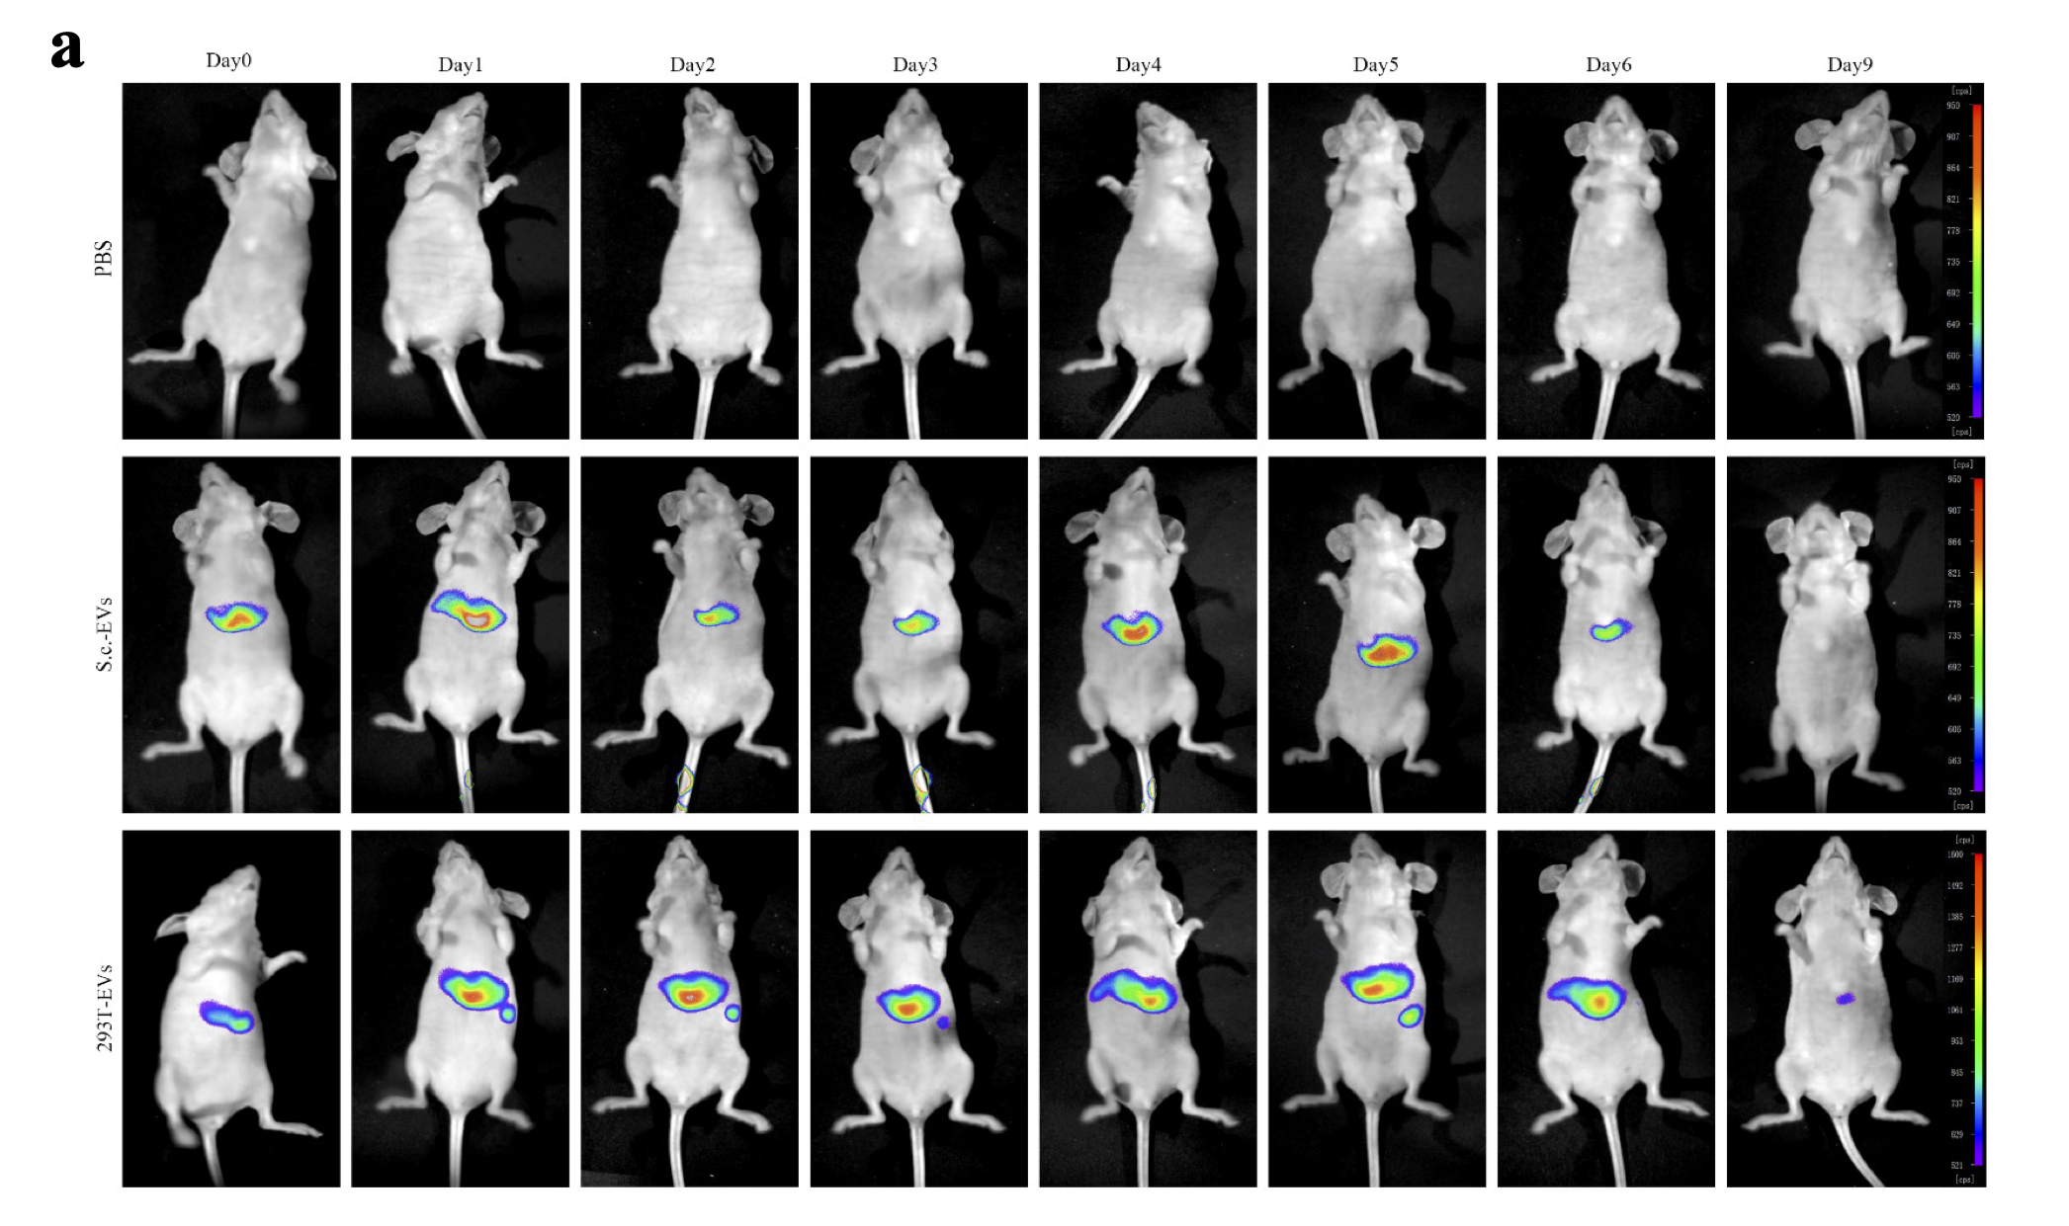
Supplementary Figure 2 (a) After treating mice with DiR-labeled S.c-EVs (20 mg/kg) by tail vein injection, fluorescence images were acquired by small animal imaging system at 0-9 days.
Supplementary Figure 3 (a) Efficiency of EVs encapsulating curcumin. (b) Cell survival rate in different treatment groups.

