Triiodothyronine Supplementation for Children Undergoing Cardiopulmonary Bypass: A Meta-Analysis
Monique R Radman, MD, MAS¹, April E Slee, PhD², Eva M Marwali, MD, PhD³, Michael A Portman, MD⁴
¹Division of Cardiac Critical Care, Department of Pediatrics, Seattle Children’s Hospital, University of Washington, Seattle, Washington
²New Arch Consulting, Issaquah, Washington
³Division of Pediatric Cardiac Intensive Care, National Cardiovascular Center Harapan Kita, Jakarta, Indonesia
⁴Division of Cardiology, Department of Pediatrics, Seattle Children’s Hospital, University of Washington, Seattle, Washington
Thyroid Hormone in Pediatric Cardiac Surgery
Address for Correspondence: Monique R Radman, MD, MAS, Division of Cardiac Critical Care, Seattle Children’s Hospital, 4800 Sand Point Way NE, RC.2.820, Seattle, WA 98105. E-mail: monique.radman@seattlechildrens.org

Supplementary Information Figure Legends

Fig. S1 Cochrane’s risk of bias assessment for each of the 5 included randomized controlled trials. All included trials had an overall low risk of bias.
Fig. S2 Forest plot demonstrating effect of triiodothyronine (T3) versus placebo on mortality. The association between T3 and mortality is shown in the overall population and by age, country and RACHS-1 (Consensus-based method for risk adjustment for surgery for congenital heart disease) categories with censoring at 30 days. There was no significant association between T3 supplementation and 30-day mortality in the overall study group or by age group, country of origin or risk category.

Supplemental Figures
Fig. S1

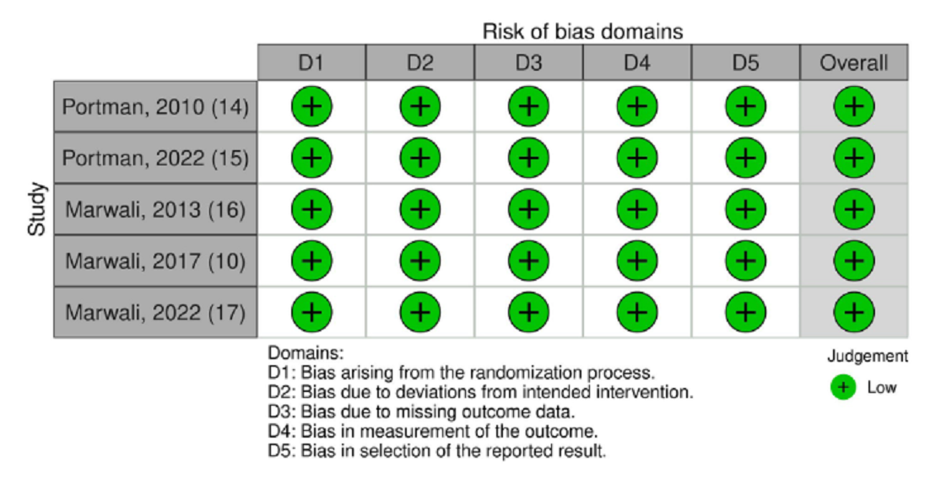

Fig. S2
