Supplemental Table 1. The exclusion criteria for our patient population, following the contraindications of conventional brain MRI.
- Patient weight exceeding 440lbs (200kg).
- Metal implants, such as pacemakers, defibrillators, implanted insulin pumps, deep brain stimulators, vagus nerve stimulators, cochlear implants, or programmable shunts.
- MRI-incompatible surgical hardware, such as staples, screws, or ferromagnetic implants (e.g., aneurysm clips, surgical clips, prostheses, cochlear implant).
- Artiﬁcial hearts or heart valves with steel parts, metal fragments, shrapnel, tattoos near the eye, permanent make-up, steel implants, or other irremovable ferromagnetic objects.

Supplemental Table 2. Description of adverse events during ULF-pMRI scan.
 | Adverse event description
1 | ECMO flow decreased from 6.0 to 0.9. Vital signs also decreased (MAP, HR, SpO₂). The attending physician attempted to pause MRI acquisition, but the scan continued, and the patient recovered spontaneously. ECMO flow and vital signs returned to normal. The clinical team stated the patient had a similar episode in the morning.
2 | When the patient was moved, ECMO flow and MAPs decreased. It resolved after the intervention. These events continued intermittently and resolved spontaneously. The attending physician did a bedside echocardiogram which showed a small IVC. 250ml IVF was administered. Events resolved. It was determined that she was too flexed at the hip.
3 | Approximately 6 minutes after the ULF-pMRI was started during the acquisition of the DWI images, the intraarterial balloon pump (IABP) stopped functioning, and the scan was paused. It was subsequently determined the magnetic field generated by ULF-pMRI affected the patient's ECG leads causing significant artifacts on telemetry. Given that the IABP was set to ECG trigger, cycling stopped as telemetry returned a heart rate of zero. Triggering on the IABP was then switched to internal at a set rate of 75 beats per minute. The PI and physicians caring for the patient conferenced at the bedside and deemed it safe to continue the scan. The scan was resumed without any other issues.
ULF-pMRI: ultra-low-field (0.064T) portable MRI, MAP: mean arterial pressure, HR: heart rate, IVC: inferior vena cava, IVF: intravenous fluid, ECG: electrocardiogram.
Supplemental Table 3. Artifacts on ULF-pMRI imaging.
 | Artifact description
1 | Significant artifact on diffusion images, especially at the skull base. The resolution and contrast were suboptimal, and it was unclear what if any abnormality represents infarct vs. artifact since it encompassed different vascular territories.
2 | Artifact anteriorly obscuring anterior inferior brain
3 | Artifact in the right side of the head which obscured the underlying brain more towards the top of the head
4 | Artifact with loss of signal in the right lower area of the brain
5 | Susceptibility artifact around the right orbit
6 | Artifact in the right side of the brain and cerebellum in the B900 images
7 | Artifact in areas of the right cerebral hemisphere on DWI
8 | The artifact was present due to an open RF cage.
ULF-pMRI: ultra-low-field (0.064T) portable MRI, DWI: diffuse weighted imaging.
Supplemental Table 4. Neurological diagnosis of ABI patients based on ULF-pMRI and CT readings.
 | Age | Gender | Race | BMI | Neurological Diagnosis | CT Read | ULF-pMRI Read
1 | 58 | Female | White | 35.46 | Ischemic Stroke (on MRI) and IPH (on CT scan) | Multiple supratentorial brain parenchymal hemorrhage. | Possible right frontal lobe acute infarct diffusion image. Right parietal encephalomalacia from old infarct.
2 | 72 | Male | White | 44.8 | Ischemic stroke (on MRI) | Increased effacement of the cerebral sulci bilaterally. | T2 signal abnormality in occipital lobes and left temporal land parietal lobe with diffusion restriction.
3 | 52 | Female | White | 43.7 | Ischemic stroke (on MRI) | No acute or subacute intracranial abnormalities. | Possible acute to subacute right frontal lobe infarct.
4 | 58 | Female | White | 27.86 | Ischemic stroke (on MRI and CT) | Small infarct in the left cerebellar hemisphere. | Acute to subacute left lateral cerebellar infarct
5 | 54 | Female | Asian | 18.12 | SAH (on MRI and CT) | Small volume subarachnoid hemorrhage in the right superior frontal sulcus. | T2 FLAIR images show abnormal signals in the right superior frontal sulcus.
6 | 65 | Male | Black | 34.86 | Both HIBI and Brain death  (on MRI and CT) | Loss of gray-white matter distinction in the cerebral and cerebellum, without effacement of the peripheral subarachnoid space. This is suggestive of early hypoxic-ischemic insult. | Suspicious areas of cortical restricted diffusion in bilateral cerebral hemispheres.
7 | 31 | Female | Hispanic | 20.89 | Both HIBI and Brain death (on MRI and CT) | Complete loss of gray-white differentiation and effacement of the ventricles and basal cisterns compatible with extensive global ischemic brain injury, cerebral edema, and transtentorial herniation. | Bilateral cerebral cortex and deep gray matter DWI hyperintensity (which for the most part has corresponding ADC isointensity), with accentuated gray-white matter differentiation on T2/FLAIR images, correlate with the finding discussed on recent CT head exam, concerning hypoxic-ischemic injury. Diffuse cerebral edema and effacement of basal cisterns were demonstrated.
8 | 61 | Male | White | 36.51 | Ischemic stroke (on MRI and CT) | Hypodensities with local mass effect in bilateral occipital lobes and left parietal lobe are suggestive of developing posterior circulation ischemic infarcts. | Evolving recent bilateral PCA territory infarcts and a small lacunar infarct in the left periventricular frontal lobe (lenticulostriate perforator territory).
9 | 31 | Female | Black | 34.69 | Ischemic stroke (on MRI) | No acute intracranial abnormality. | Multiple acute embolic versus watershed infarcts in the bilateral superior frontal lobes, parietal lobes, parieto-occipital junctions, and anterior aspect of the right caudate nucleus.
ABI: acute brain injury, ULF-pMRI: ultra-low-field (0.064T) portable MRI, BMI: body mass index, IPH: intraparenchymal hemorrhage, SAH: subarachnoid hemorrhage, HIBI: hypoxic-ischemic brain injury, DWI: diffuse weighted imaging, ADC: Apparent diffusion coefficient, FLAIR: Fluid attenuated inversion recovery, PCA: posterior cerebral artery.

Supplemental Figure 1. Hemodynamic monitoring during intra-aortic balloon pump (IABP) adverse event (AE). ECG (leads II and V1), respiratory rate (RR), and arterial line waveforms (Art 1 and Art 2) are shown before initiation of ultra-low-field portable MR (ULF-pMR) (A). During the DWI sequence, artifact was noted in the ECG leads causing the IABP to stop functioning (B). Red arrows indicate when IABP triggering was switched from ECG to internal with subsequent restoration of arterial pressure waveforms.

Supplemental Figure 2. Axial non-contrast and MR images of the brain at the level of the centrum semiovale (upper images) and at the level of the basal ganglia (lower images).
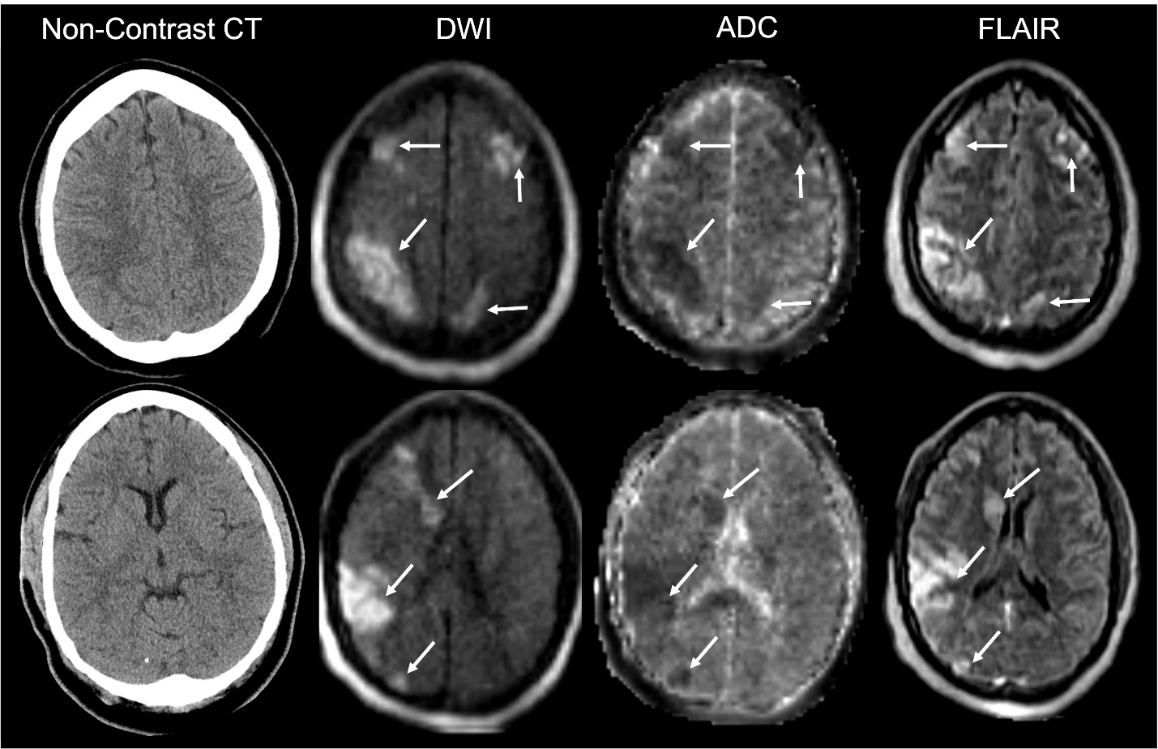
On CT scan images there was no evidence of acute infarcts. However, on subsequent ultra-low-field portable MRI there was evidence of multiple acute watershed versus embolic infarcts in bilateral cerebral hemispheres and head of right caudate nucleus (arrows), which show restriction on DWI, with corresponding low signal attenuation on ADC and hyperintense signal on FLAIR.

