Supplemental Figures

Using Alternative Definitions of Controls to Increase Statistical Power in GWAS

Behavior Genetics

Sarah E. Benstock¹, Katherine Weaver¹, John Hettema¹, Brad Verhulst^{1*}

¹Department of Psychiatry and Behavioral Sciences, Texas A&M University School of Medicine, College Station, TX

*Corresponding Author
verhulst@tamu.edu

Supplemental Figs

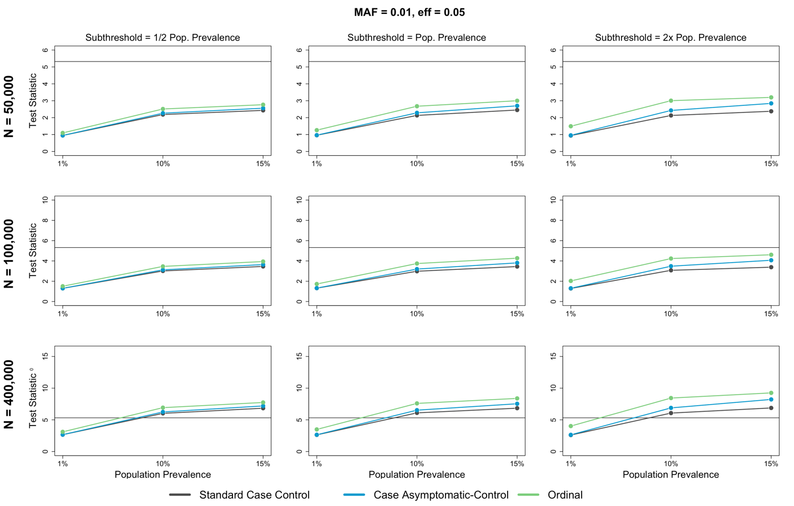
Fig 1 Scatterplots of the simulation results at an effect size of 0.05 and a minor allele frequency of 0.01, where the average test statistic represents statistical power to detect associations, and the black line across all plots represents genome-wide significance

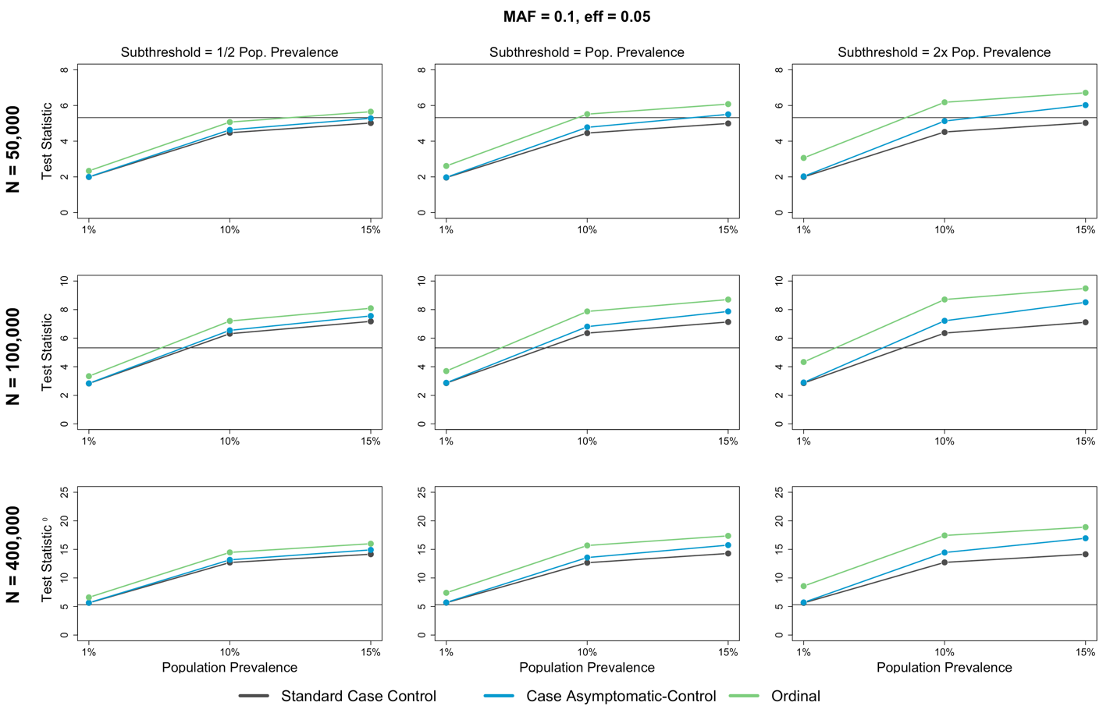
Fig 2 Scatterplots of the simulation results at an effect size of 0.05 and a minor allele frequency of 0.1, where the average test statistic represents statistical power to detect associations, and the black line across all plots represents genome-wide significance

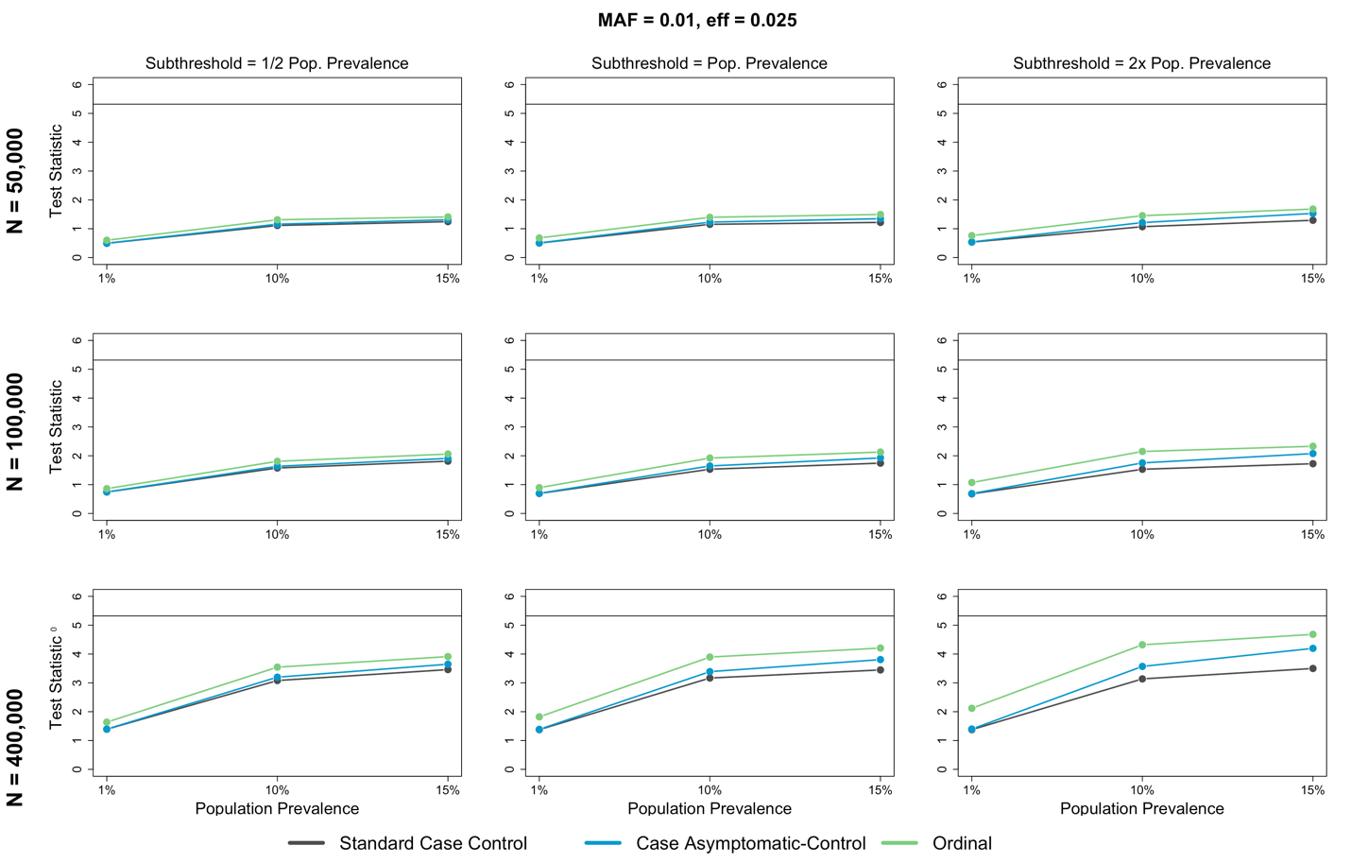
Fig 3 Scatterplots of the simulation results at an effect size of 0.025 and a minor allele frequency of 0.01, where the average test statistic represents statistical power to detect associations, and the black line across all plots represents genome-wide significance

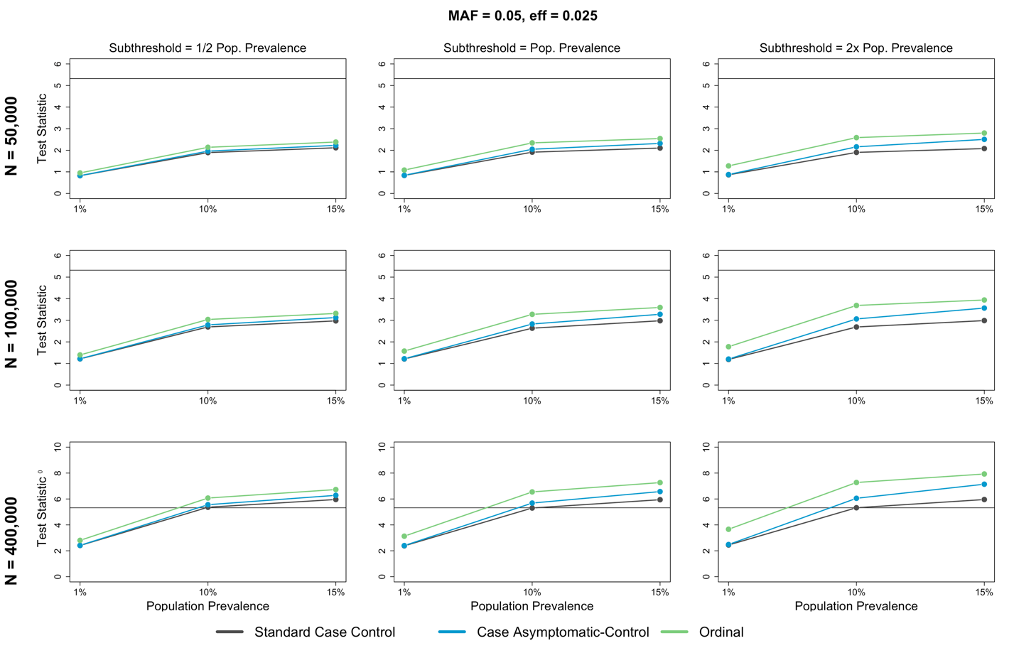
Fig 4 Scatterplots of the simulation results at an effect size of 0.025 and a minor allele frequency of 0.05, where the average test statistic represents statistical power to detect associations, and the black line across all plots represents genome-wide significance

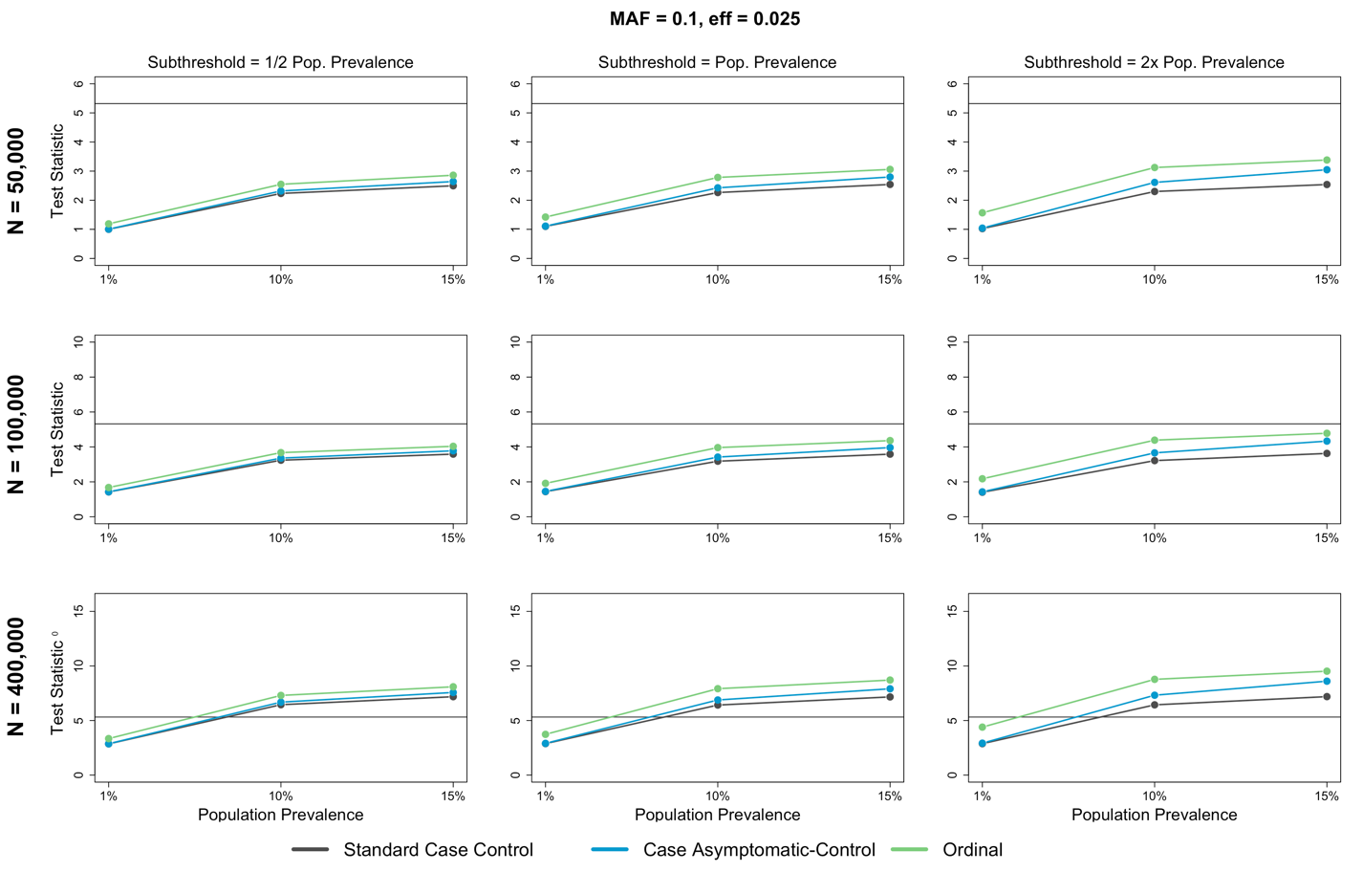
Fig 5 Scatterplots of the simulation results at an effect size of 0.025 and a minor allele frequency of 0.1, where the average test statistic represents statistical power to detect associations, and the black line across all plots represents genome-wide significance

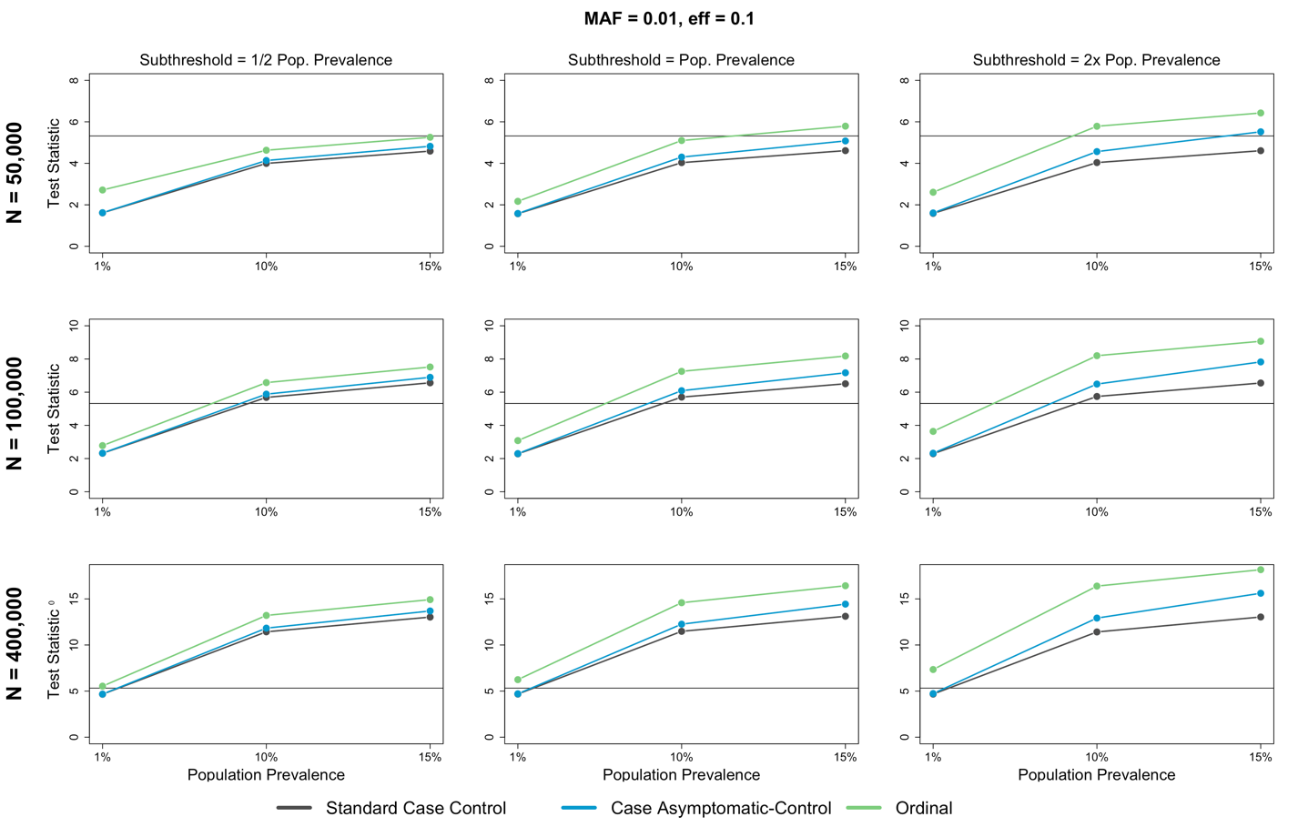
Fig 6 Scatterplots of the simulation results at an effect size of 0.1 and a minor allele frequency of 0.01, where the average test statistic represents statistical power to detect associations, and the black line across all plots represents genome-wide significance

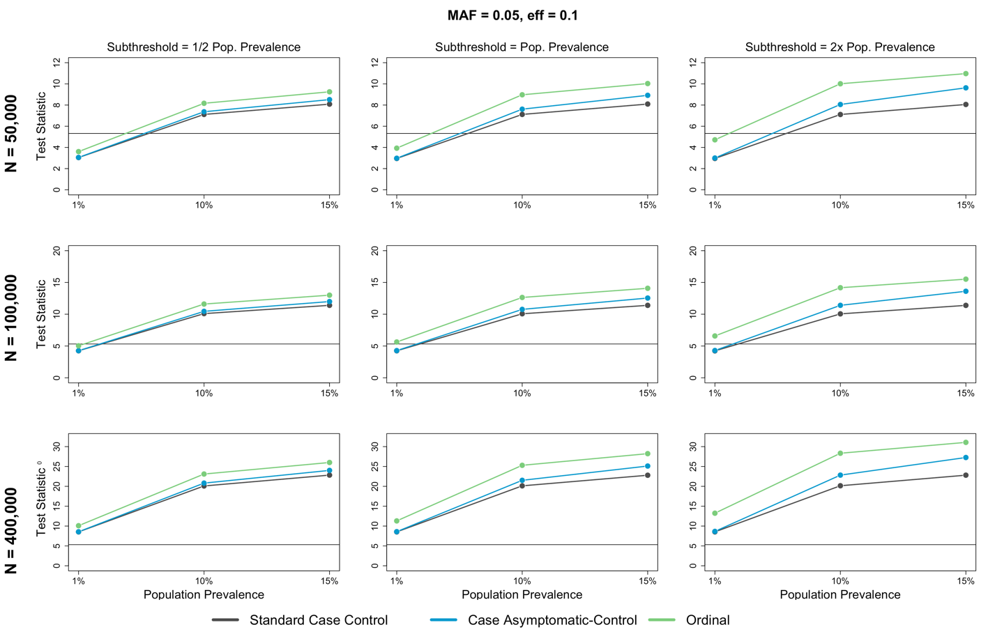
Fig 7 Scatterplots of the simulation results at an effect size of 0.1 and a minor allele frequency of 0.05, where the average test statistic represents statistical power to detect associations, and the black line across all plots represents genome-wide significance

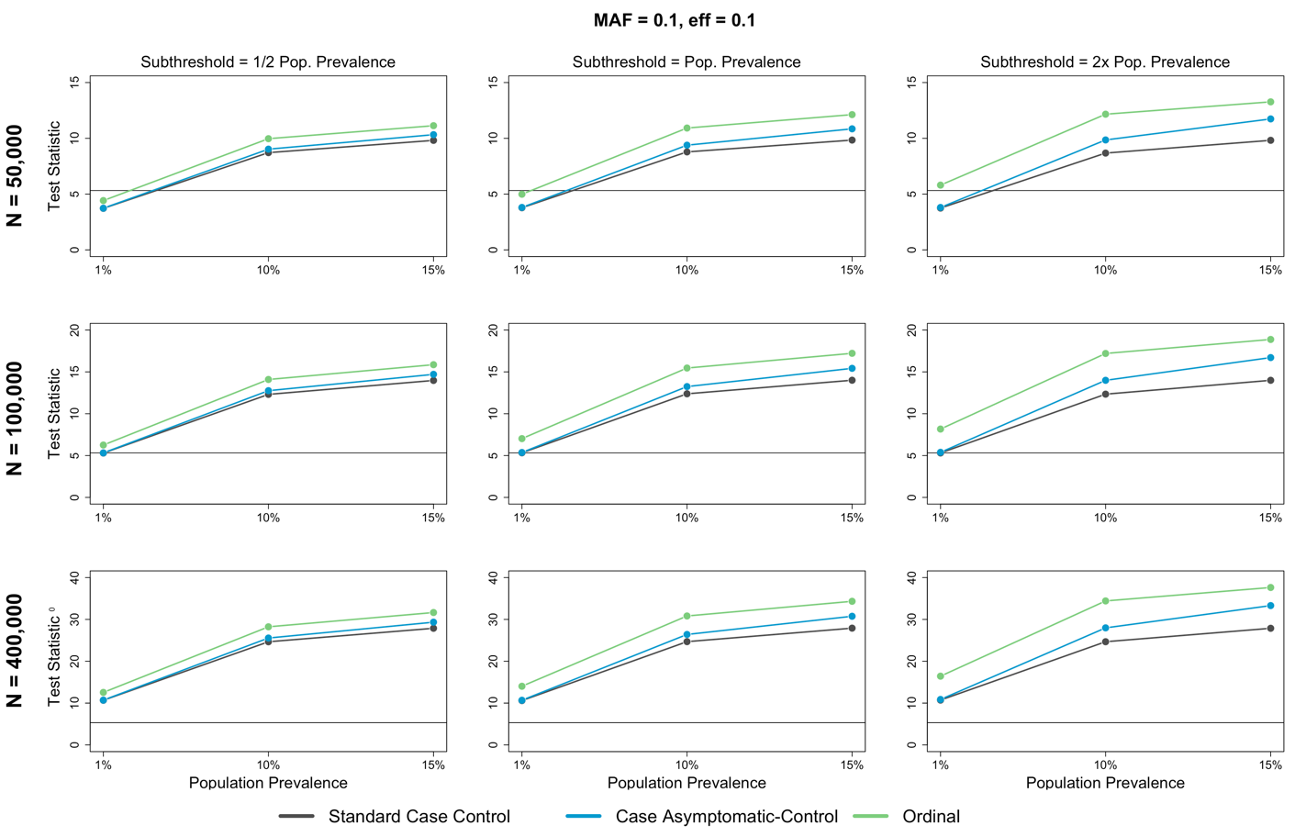
Fig 8 Scatterplots of the simulation results at an effect size of 0.1 and a minor allele frequency of 0.1, where the average test statistic represents statistical power to detect associations, and the black line across all plots represents genome-wide significance

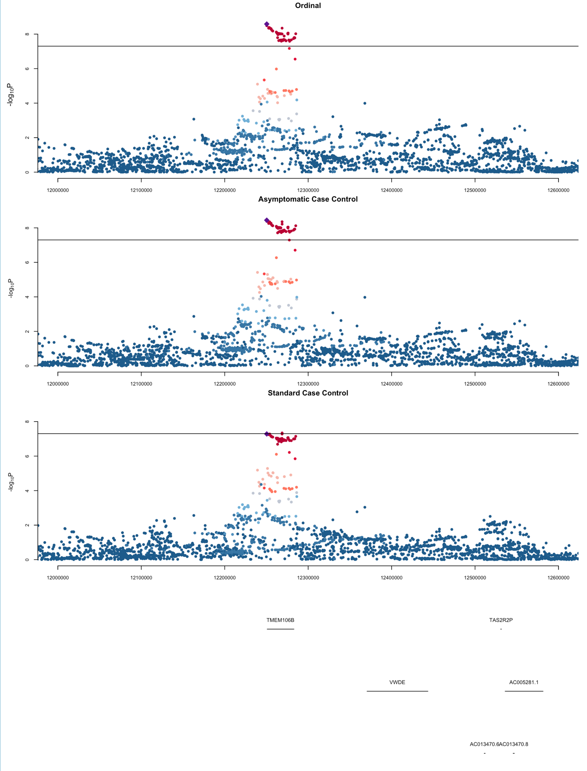

Fig 9 Regional plots of the genome-wide significant locus on Chromosome 7 for the Ordinal, Asymptomatic Case-Control, and Standard Case-Control Models from the demonstration using MDD. The lead SNP from the ordinal and Asymptomatic Case-control models is denoted by the purple diamond. Protein coding genes in the region are displayed at the bottom of the plots

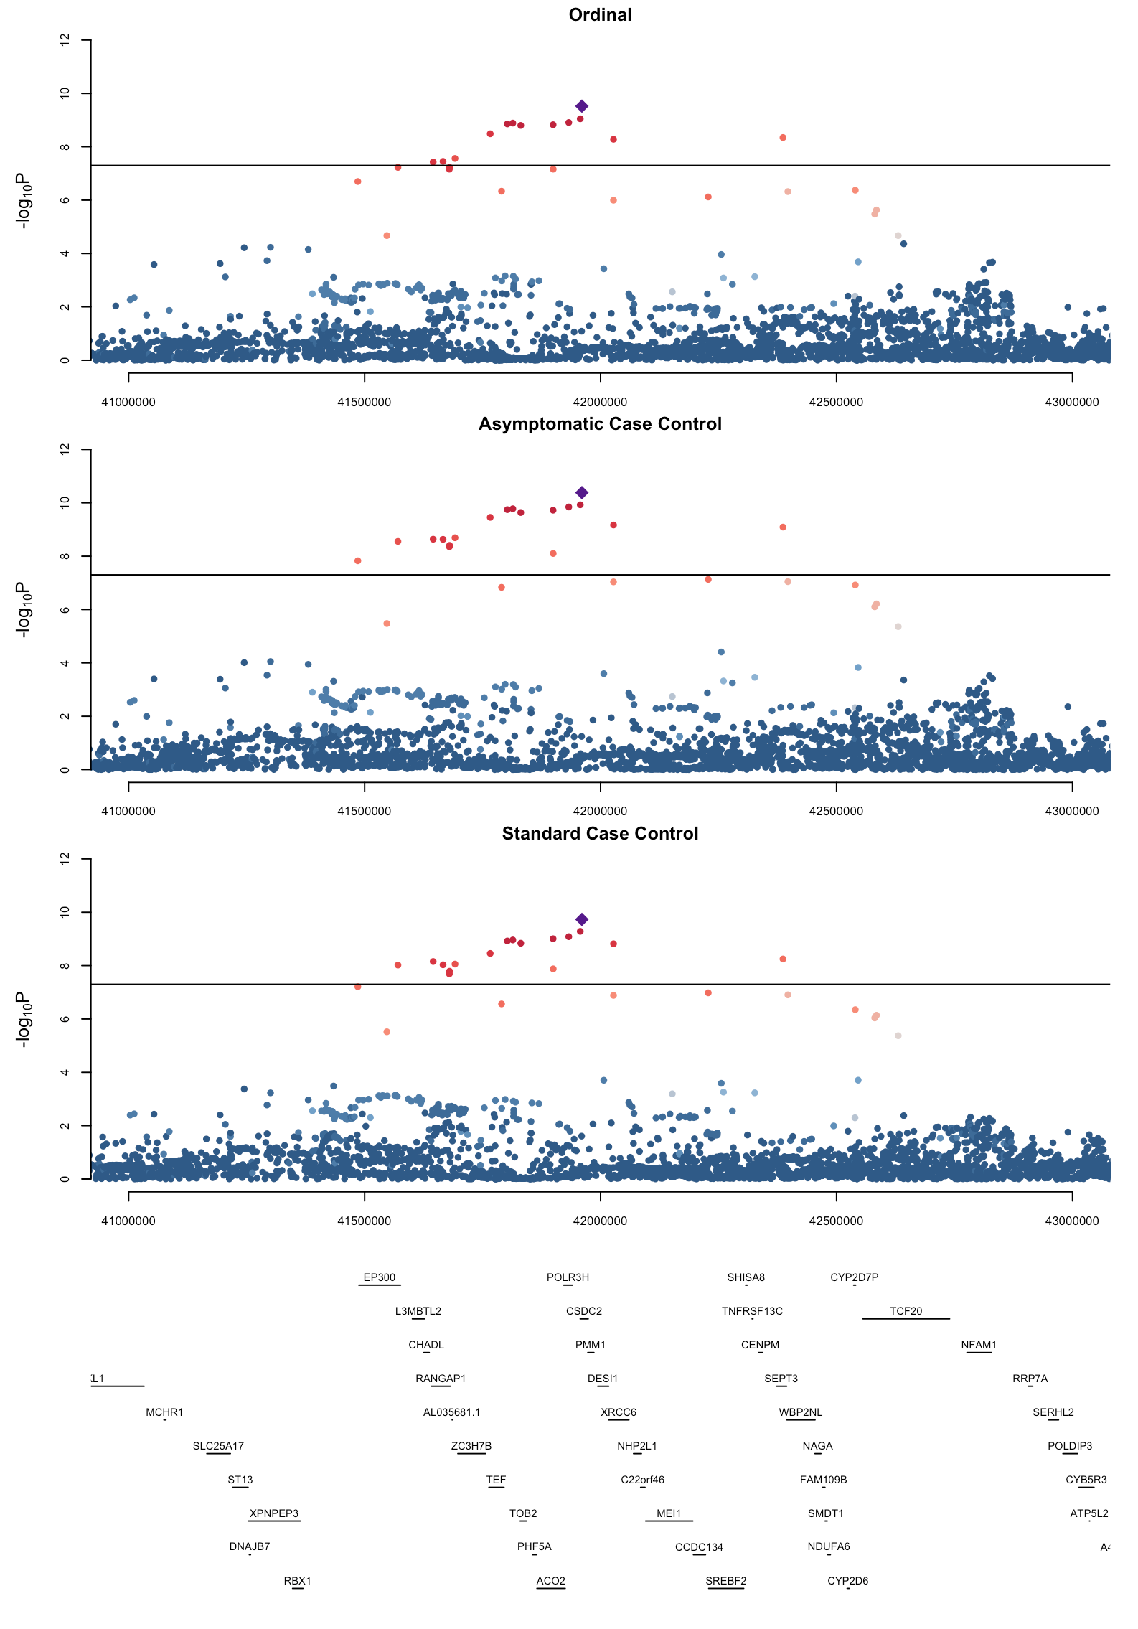

Fig 10 Regional plots of the genome-wide significant locus on Chromosome 22 for the Ordinal, Asymptomatic Case-Control, and Standard Case-Control Models from the demonstration using MDD. The lead SNP from the ordinal and Asymptomatic Case-control models is denoted by the purple diamond. Protein coding genes in the region are displayed at the bottom of the plots

