Table 2. Information on central compounds.
Number | Compound name | Structure type | Structure | Degree
J185 | Luteolin | Flavonoids | 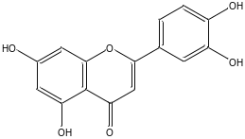 | 15
J179 | Quercetin | Flavonoids | 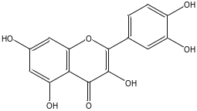 | 14
J51 | 5-Hydroxy-4',7-dimethoxy-flavone | Flavonoids | 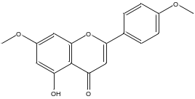 | 13
J186 | Apigenin | Flavonoids | 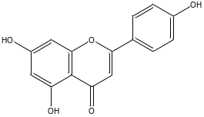 | 12
J47 | Scoparol | Flavonoids | 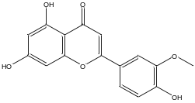 | 12
J50 | 5-Hydroxy-3',4',7-trimethoxyflavone | Flavonoids | 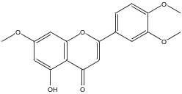 | 11
J180 | Kaempferol | Flavonoids | 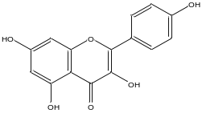 | 11
J40 | 3-methoxy-5,7,3',4'-tetrahydroxy-flavone | Flavonoids | 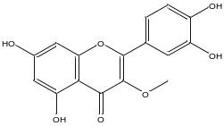 | 11
S144 | Luteolin | Flavonoids |  | 15
S141 | Quercetin | Flavonoids |  | 14
S142 | Kaempferol | Flavonoids | 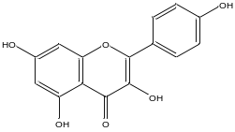 | 11
S66 | 9,12-Octadecadienoic acid | Organic acid | 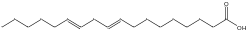 | 11
S61 | Ferulic acid | Organic acid | 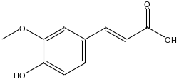 | 10
S29 | Tricin | Flavonoids | 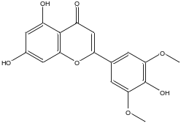 | 10
S62 | 3-Phenylacrylic acid | Organic acid | 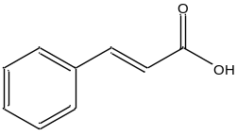 | 10

