Supporting Information Of “Effects of Unoxidized Biochars, Oxidized Biochars, Zinc and Compost on Cadmium Uptake in Spinach”
Table 1 - Chemical characteristics of poultry manure compost.
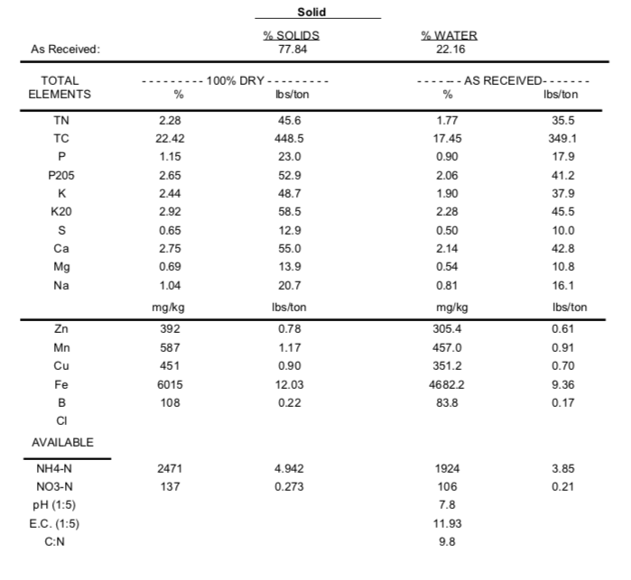
Table 2 - Sewage Sludge chemical elements.
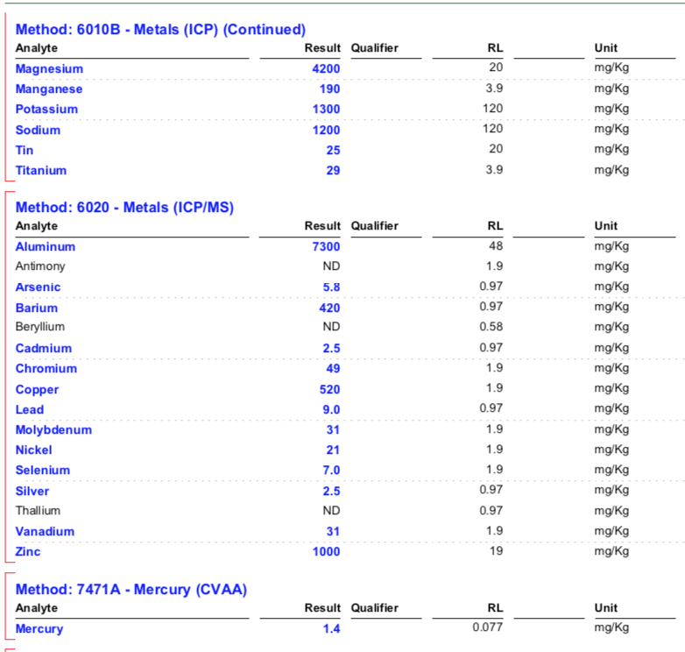

Table 3 – Results of the three life-cycles for the unoxidized biochars (mean values of 4 replicates ± standard deviation).
Time | Treatments | Soil |  |  |  | Plant
Time | Treatments | pH | EC | Cd | Zn | Yield | Cd | Zn
Time | Treatments |  | mS/cm | mg/kg |  | (g dry wt.) | mg/kg
Before planting | Soil | 6.55 ± 0.10 | 2.53 ± 0.40 | 0.64 ± 0.05 | 3.25 ± 0.33 | - | - | -
Before planting | Zinc | 6.64 ± 0.23 | 2.34 ± 0.27 | 0.70 ± 0.04 | 8.85 ± 3.41 | - | - | -
Before planting | Compost | 6.77 ± 0.07 | 2.53 ± 0.34 | 0.57 ± 0.05 | 4.62 ± 4.90 | - | - | -
Before planting | ASB 500 – 1 1% | 6.69 ± 0.10 | 2.69 ± 0.47 | 0.67 ± 0.06 | 3.59 ± 2.42 | - | - | -
Before planting | ASB 500 – 1 5% | 7.01 ± 0.11 | 2.45 ± 0.05 | 0.64 ± 0.05 | 3.11 ± 0.36 | - | - | -
Before planting | CSB 600 - m2 1% | 6.85 ± 0.07 | 2.54 ± 0.40 | 0.64 ± 0.06 | 3.14 ± 0.23 | - | - | -
Before planting | CSB 600 - m2 5% | 6.57 ± 0.08 | 2.96 ± 0.54 | 0.61 ± 0.06 | 3.39 ± 0.10 | - | - | -
Before planting | CSB 600 - m3 1% | 6.62 ± 0.11 | 2.86 ± 0.25 | 0.69 ± 0.03 | 3.34 ± 0.20 | - | - | -
Before planting | CSB 600 - m3 5% | 6.70 ± 0.10 | 2.74 ± 0.21 | 0.51 ± 0.12 | 2.95 ± 0.49 | - | - | -
Before planting | WSB 900 1% | 6.71 ± 0.03 | 2.76 ± 0.43 | 0.68 ± 0.04 | 3.71 ± 0.09 | - | - | -
Before planting | WSB 900 5% | 7.22 ± 0.10 | 2.61 ± 0.09 | 0.58 ± 0.08 | 3.21 ± 0.41 | - | - | -
Before planting | SSB 700 1% | 6.84 ± 0.06 | 2.95 ± 0.35 | 0.74 ± 0.07 | 4.49 ± 0.50 | - | - | -
Before planting | SSB 700 5% | 7.30 ± 0.12 | 3.39 ± 0.21 | 0.65 ± 0.05 | 8.97 ± 1.13 | - | - | -
After 1st harvest | Soil | 5.82 ± 0.34 | 3.24 ± 0.88 | 0.53 ± 0.18 | 1.87 ± 0.70 | 0.11 ± 0.09 | 21.73 ± 2.07 | 137.60 ± 111.58
After 1st harvest | Zinc | 6.16 ± 0.44 | 2.71 ± 0.95 | 0.47 ± 0.29 | 5.55 ± 3.90 | 0.10 ± 0.06 | 10.18 ± 5.91 | 397.98 ± 434.41
After 1st harvest | Compost | 6.30 ± 0.41 | 3.03 ± 0.31 | 0.23 ± 0.17 | 1.47 ± 1.35 | 0.16 ± 0.13 | 8.74 ± 10.30 | 196.71 ± 209.76
After 1st harvest | ASB 500 – 1 1% | 6.01 ± 0.24 | 3.59 ± 1.48 | 0.64 ± 0.25 | 3.43 ± 3.56 | 0.09 ± 0.18 | 23.71 ± 6.80 | 163.30 ± 36.35
After 1st harvest | ASB 500 – 1 5% | 6.36 ± 0.31 | 3.04 ± 0.21 | 0.50 ± 0.15 | 5.54 ± 2.08 | 0.09 ± 0.02 | 10.71 ± 5.61 | 53.52 ± 116.28
After 1st harvest | CSB 600 - m2 1% | 6.38 ± 0.49 | 2.86 ± 0.90 | 0.68 ± 0.08 | 3.52 ± 3.64 | 0.08 ± 0.33 | 14.23 ± 4.08 | 60.32 ± 41.45
After 1st harvest | CSB 600 - m2 5% | 6.29 ± 0.10 | 3.09 ± 0.80 | 0.67 ± 0.03 | 3.72 ± 0.31 | 0.05 ± 0.03 | 24.27 ± 11.51 | 98.16 ± 36.29
After 1st harvest | CSB 600 - m3 1% | 5.73 ± 0.43 | 3.47 ± 0.64 | 0.79 ± 0.09 | 4.09 ± 2.76 | 0.09 ± 0.05 | 21.02 ± 4.28 | 87.95 ± 57.58
After 1st harvest | CSB 600 - m3 5% | 6.36 ± 0.22 | 3.02 ± 0.26 | 0.70 ± 0.05 | 3.36 ± 0.39 | 0.10 ± 0.07 | 14.86 ± 8.41 | 93.93 ± 60.07
After 1st harvest | WSB 900 1% | 6.16 ± 0.15 | 2.96 ± 1.02 | 0.70 ± 0.04 | 6.26 ± 5.60 | 0.27 ± 0.18 | 16.28 ± 5.21 | 65.74 ± 23.57
After 1st harvest | WSB 900 5% | 6.88 ± 0.51 | 3.24 ± 0.46 | 0.55 ± 0.10 | 3.13 ± 1.11 | 0.09 ± 0.52 | 10.02 ± 4.39 | 51.76 ± 18.59
After 1st harvest | SSB 700 1% | 6.24 ± 0.31 | 3.01 ± 0.68 | 0.75 ± 0.06 | 4.88 ± 12.16 | 0.04 ± 0.20 | 18.62 ± 9.91 | 86.64 ± 16.39
After 1st harvest | SSB 700 5% | 6.33 ± 0.17 | 4.31 ± 0.26 | 0.62 ± 0.06 | 11.24 ± 4.17 | 0.00 ± NA | 8.12 ± 1.09 | 61.29 ± 23.75
After 2nd Harvest | Soil | 5.47 ± 0.29 | 3.77 ± 1.00 | 0.76 ± 0.09 | 3.26 ± 0.47 | 0.02 ± 0.02 | 49.52 ± 4.97 | 159.18 ± 24.57
After 2nd Harvest | Zinc | 5.61 ± 0.26 | 2.98 ± 0.44 | 0.79 ± 0.06 | 7.88 ± 0.58 | 0.04 ± 0.02 | 41.42 ± 11.81 | 318.43 ± 96.82
After 2nd Harvest | Compost | 5.70 ± 0.32 | 3.88 ± 1.74 | 0.72 ± 0.04 | 5.09 ± 0.56 | 0.10 ± 0.04 | 24.55 ± 5.59 | 160.79 ± 31.78
After 2nd Harvest | ASB 500 – 1 1% | 5.55 ± 0.07 | 3.89 ± 0.62 | 0.74 ± 0.09 | 3.32 ± 056 | 0.03 ± 0.01 | 63.42 ± 14.67 | 223.83 ± 27.45
After 2nd Harvest | ASB 500 – 1 5% | 5.77 ± 0.11 | 3.78 ± 1.21 | 0.65 ± 0.03 | 3.06 ± 0.16 | 0.04 ± 0.03 | 36.89 ± 4.70 | 141.56 ± 22.17
After 2nd Harvest | CSB 600 - m2 1% | 5.68 ± 0.19 | 3.55 ± 0.60 | 0.72 ± 0.06 | 3.25 ± 1.90 | 0.08 ± 0.03 | 37.46 ± 21.52 | 143.87 ± 50.04
After 2nd Harvest | CSB 600 - m2 5% | 5.52 ± 0.16 | 3.59 ± 0.73 | 0.73 ± 0.06 | 3.80 ± 0.28 | 0.03 ± 0.03 | 52.93 ± 7.56 | 174.27 ± 23.45
After 2nd Harvest | CSB 600 - m3 1% | 5.27 ± 0.01 | 3.30 ± 1.01 | 0.80 ± 0.05 | 3.32 ± 0.17 | 0.03 ± 0.01 | 51.74 ± 14.83 | 226.41 ± 49.52
After 2nd Harvest | CSB 600 - m3 5% | 5.50 ± 0.14 | 3.60 ± 1.26 | 0.71 ± 0.03 | 3.01 ± 0.25 | 0.04 ± 0.01 | 48.34 ± 17.85 | 185.77 ± 69.78
After 2nd Harvest | WSB 900 1% | 5.43 ± 0.12 | 4.17 ± 0.62 | 0.75 ± 0.04 | 3.58 ± 0.43 | 0.04 ± 0.06 | 46.04 ± 20.87 | 175.44 ± 70.14
After 2nd Harvest | WSB 900 5% | 6.26 ± 0.21 | 4.68 ± 0.36 | 0.52 ± 0.07 | 3.11 ± 0.44 | 0.06 ± 0.02 | 27.03 ± 5.76 | 114.11 ± 24.67
After 2nd Harvest | SSB 700 1% | 5.48 ± 0.09 | 3.75 ± 0.68 | 0.73 ± 0.06 | 4.28 ± 0.79 | 0.25 ± 0.33 | 44.57 ± 9.71 | 186.19 ± 33.03
After 2nd Harvest | SSB 700 5% | 5.72 ± 0.15 | 4.84 ± 0.31 | 0.65 ± 0.03 | 10.29 ± 1.09 | 0.06 ± 0.04 | 23.65 ± 8.79 | 163.20 ± 67.46
After 3rd Harvest | Soil | 5.24 ± 0.33 | 4.57 ± 0.96 | 0.75 ± 0.06 | 2.83 ± 0.39 | 0.12 ± 0.06 | 39.69 ± 25.69 | 153.75 ± 79.29
After 3rd Harvest | Zinc | 5.21 ± 0.31 | 5.67 ± 1.44 | 0.68 ± 0.14 | 6.64 ± 0.68 | 0.14 ± 0.06 | 32.74 ± 22.06 | 187.18 ± 188.32
After 3rd Harvest | Compost | 5.35 ± 0.15 | 5.16 ± 1.37 | 0.66 ± 0.04 | 5.44 ± 1.90 | 0.14 ± 0.12 | 35.22 ± 6.16 | 233.97 ± 49.98
After 3rd Harvest | ASB 500 – 1 1% | 5.00 ± 0.16 | 4.91 ± 1.30 | 0.61 ± 0.09 | 2.53 ± 0.27 | 0.10 ± 0.02 | 43.15 ± 16.70 | 181.76 ± 70.31
After 3rd Harvest | ASB 500 – 1 5% | 5.31 ± 0.10 | 4.22 ± 0.24 | 0.58 ± 0.05 | 2.65 ± 0.62 | 0.14 ± 0.05 | 48.42 ± 13.61 | 176.67 ± 53.01
After 3rd Harvest | CSB 600 - m2 1% | 5.10 ± 0.09 | 4.21 ± 0.53 | 0.55 ± 0.09 | 2.83 ± 0.90 | 0.15 ± 0.11 | 39.37 ± 12.71 | 129.06 ± 40.20
After 3rd Harvest | CSB 600 - m2 5% | 4.95 ± 0.05 | 4.57 ± 0.79 | 0.59 ± 0.09 | 2.57 ± 0.55 | 0.16 ± NA | 64.08 ± NA | 196.62 ± NA
After 3rd Harvest | CSB 600 - m3 1% | 4.84 ± 0.13 | 4.87 ± 1.13 | 0.62 ± 0.11 | 3.15 ± 0.60 | 0.13 ± 0.10 | 46.19 ± 15.19 | 158.29 ± 53.03
After 3rd Harvest | CSB 600 - m3 5% | 4.86 ± 0.04 | 4.78 ± 0.49 | 0.60 ± 0.12 | 2.27 ± 0.67 | 0.11 ± 0.10 | 38.77 ± 10.21 | 146.92 ± 42.83
After 3rd Harvest | WSB 900 1% | 4.91 ± 0.03 | 4.00 ± 0.71 | 0.71 ± 0.08 | 3.61 ± 0.93 | 0.13 ± 0.09 | 26.83 ± 14.34 | 116.84 ± 58.74
After 3rd Harvest | WSB 900 5% | 5.57 ± 0.16 | 4.73 ± 0.50 | 0.46 ± 0.07 | 2.10 ± 0.73 | 0.13 ± 0.10 | 20.67 ± 19.55 | 149.24 ± 73.81
After 3rd Harvest | SSB 700 1% | 5.00 ± 0.30 | 4.69 ± 0.70 | 0.65 ± 0.08 | 2.93 ± 0.11 | 0.09 ± 0.08 | 39.95 ± 6.95 | 219.98 ± 43.14
After 3rd Harvest | SSB 700 5% | 5.21 ± 0.07 | 5.11 ± 0.77 | 0.61 ± 0.31 | 10.91 ± 3.47 | 0.13 ± 0.03 | 33.30 ± 5.34 | 221.42 ± 33.41
NA = not applicable
Table 4 – Results of the three life-cycles for the oxidized biochars (mean values of 4 replicates ± standard deviation).
Time | Treatments | Soil |  |  |  | Plant
Time | Treatments | pH | EC | Cd | Zn | Yield | Cd | Zn
Time | Treatments |  | mS/cm | mg/kg |  | (g dry wt.) | mg/kg
Before planting | Soil | 7.77 ± NA | 1.18 ± NA | 0.49 ± NA | 1.69 ± NA | - | - | -
Before planting | Zinc | 7.15 ± NA | 1.45 ± NA | 0.55 ± NA | 10.55 ± NA | - | - | -
Before planting | Compost | 7.45 ± NA | 1.74 ± NA | 0.53 ± NA | 4.41 ± NA | - | - | -
Before planting | ASB 500 – 1 H₂O₂ 1% | 7.64 ± NA | 1.44 ± NA | 0.50 ± NA | 2.45 ± NA | - | - | -
Before planting | ASB 500 – 1 H₂O₂ 5% | 7.66 ± NA | 1.25 ± NA | 0.42 ± NA | 1.57 ± NA | - | - | -
Before planting | CSB 600 - m2 H₂O₂ 1% | 7.64 ± NA | 1.21 ± NA | 0.46 ± NA | 1.63 ± NA | - | - | -
Before planting | CSB 600 - m2 H₂O₂ 5% | 7.34 ± NA | 1.14 ± NA | 0.53 ± NA | 1.75 ± NA | - | - | -
Before planting | CSB 600 - m3 H₂O₂ 1% | 7.73 ± NA | 1.13 ± NA | 0.49 ± NA | 1.57 ± NA | - | - | -
Before planting | CSB 600 - m3 H₂O₂ 5% | 7.11 ± NA | 1.60 ± NA | 0.56 ± NA | 2.33 ± NA | - | - | -
Before planting | WSB 900 H₂O₂ 1% | 7.51 ± NA | 1.88 ± NA | 0.58 ± NA | 2.74 ± NA | - | - | -
Before planting | WSB 900 H₂O₂ 5% | 8.05 ± NA | 1.12 ± NA | 0.36 ± NA | 1.51 ± NA | - | - | -
Before planting | SSB 700 H₂O₂ 1% | 7.32 ± NA | 2.38 ± NA | 0.56 ± NA | 3.21 ± NA | - | - | -
Before planting | SSB 700 H₂O₂ 5% | 7.51 ± NA | 2.80 ± NA | 0.39 ± NA | 6.73 ± NA | - | - | -
After 1st harvest | Soil | 7.23 ± 0.10 | 1.76 ± 0.09 | 0.53 ± 0.05 | 2.10 ± 0.39 | 0.48 ± 0.12 | 18.60 ± 5.26 | 58.49 ± 12.52
After 1st harvest | Zinc | 7.04 ± 0.13 | 1.80 ± 0.27 | 0.49 ± 0.17 | 3.48 ± 2.88 | 0.69 ± 0.46 | 13.07 ± 3.07 | 66.01 ± 9.67
After 1st harvest | Compost | 6.85 ± 0.14 | 2.31 ± 0.14 | 0.63 ± 0.05 | 6.55 ± 1.62 | 0.21 ± 0.06 | 14.71 ± 2.29 | 74.82 ± 22.60
After 1st harvest | ASB 500 – 1 H₂O₂ 1% | 7.04 ± 0.11 | 1.98 ± 0.11 | 0.55 ± 0.04 | 2.38 ± 0.63 | 0.31 ± 0.06 | 16.23 ± 3.77 | 61.71 ± 5.22
After 1st harvest | ASB 500 – 1 H₂O₂ 5% | 6.97 ± 0.04 | 1.96 ± 0.17 | 0.45 ± 0.10 | 1.46 ± 0.46 | 0.32 ± 0.04 | 14.66 ± 1.46 | 50.60 ± 2.94
After 1st harvest | CSB 600 - m2 H₂O₂ 1% | 7.30 ± 0.03 | 1.29 ± 0.16 | 0.62 ± 0.08 | 2.24 ± 1.17 | 0.34 ± 0.04 | 17.81 ± 1.00 | 65.42 ± 13.13
After 1st harvest | CSB 600 - m2 H₂O₂ 5% | 6.64 ± 0.19 | 1.44 ± 0.15 | 0.60 ± 0.05 | 2.48 ± 0.60 | 0.31 ± 0.02 | 18.77 ± 4.18 | 87.22 ± 11.57
After 1st harvest | CSB 600 - m3 H₂O₂ 1% | 6.95 ± 0.13 | 1.67 ± 0.22 | 0.55 ± 0.05 | 1.99 ± 0.07 | 0.42 ± 0.07 | 13.65 ± 1.32 | 56.15 ± 4.51
After 1st harvest | CSB 600 - m3 H₂O₂ 5% | 6.48 ± 0.16 | 2.05 ± 0.28 | 0.72 ± 0.07 | 2.92 ± 0.33 | 0.29 ± 0.09 | 20.76 ± 3.02 | 92.71 ± 21.05
After 1st harvest | WSB 900 H₂O₂ 1% | 7.06 ± 0.08 | 2.31 ± 0.22 | 0.55 ± 0.07 | 2.45 ± 0.43 | 0.40 ± 0.17 | 20.18 ± 3.78 | 74.02 ± 22.57
After 1st harvest | WSB 900 H₂O₂ 5% | 7.56 ± 0.03 | 1.67 ± 0.12 | 0.49 ± 0.02 | 2.28 ± 0.37 | 0.46 ± 0.09 | 12.99 ± 0.89 | 39.29 ± 1.40
After 1st harvest | SSB 700 H₂O₂ 1% | 6.83 ± 0.04 | 2.76 ± 0.14 | 0.63 ± 0.05 | 3.42 ± 0.61 | 0.32 ± 0.06 | 17.13 ± 2.55 | 78.58 ± 12.90
After 1st harvest | SSB 700 H₂O₂ 5% | 7.16 ± 0.06 | 3.03 ± 0.05 | 0.52 ± 0.10 | 7.03 ± 1.62 | 0.47 ± 0.07 | 10.23 ± 2.05 | 105.62 ± 9.67
After 2nd Harvest | Soil | 6.46 ± 0.06 | 2.84 ± 0.31 | 0.58 ± 0.03 | 2.49 ± 0.44 | 0.85 ± 0.30 | 22.14 ± 4.71 | 77.38 ± 8.36
After 2nd Harvest | Zinc | 6.13 ± 0.12 | 3.06 ± 0.31 | 0.62 ± 0.02 | 5.58 ± 1.23 | 1.01 ± 0.25 | 23.51 ± 5.06 | 138.64 ± 15.74
After 2nd Harvest | Compost | 6.14 ± 0.10 | 3.29 ± 0.57 | 0.61 ± 0.03 | 4.45 ± 1.68 | 0.45 ± 0.11 | 18.31 ± 3.38 | 131.62 ± 24.76
After 2nd Harvest | ASB 500 – 1 H₂O₂ 1% | 6.40 ± 0.09 | 2.93 ± 0.11 | 0.63 ± 0.03 | 2.90 ± 1.60 | 0.64 ± 0.11 | 20.47 ± 5.01 | 102.39 ± 14.60
After 2nd Harvest | ASB 500 – 1 H₂O₂ 5% | 6.30 ± 0.13 | 2.78 ± 0.30 | 0.60 ± 0.02 | 2.57 ± 0.17 | 0.64 ± 0.04 | 22.24 ± 3.94 | 116.96 ± 13.46
After 2nd Harvest | CSB 600 - m2 H₂O₂ 1% | 6.67 ± 0.04 | 2.48 ± 0.09 | 0.59 ± 0.02 | 2.60 ± 0.02 | 0.53 ± 0.22 | 18.92 ± 4.26 | 110.76 ± 14.22
After 2nd Harvest | CSB 600 - m2 H₂O₂ 5% | 5.98 ± 0.10 | 2.36 ± 0.14 | 0.63 ± 0.00 | 2.89 ± 0.08 | 0.74 ± 0.13 | 22.95 ± 1.12 | 123.82 ± 4.14
After 2nd Harvest | CSB 600 - m3 H₂O₂ 1% | 6.22 ± 0.07 | 3.05 ± 0.26 | 0.60 ± 0.06 | 2.65 ± 0.18 | 0.65 ± 0.14 | 19.92 ± 1.68 | 86.78 ± 7.74
After 2nd Harvest | CSB 600 - m3 H₂O₂ 5% | 5.63 ± 0.04 | 3.01 ± 0.09 | 0.67 ± 0.04 | 3.42 ± 0.29 | 0.39 ± 0.20 | 34.37 ± 12.48 | 156.91 ± 28.15
After 2nd Harvest | WSB 900 H₂O₂ 1% | 6.38 ± 0.16 | 3.08 ± 0.33 | 0.59 ± NA | 2.93 ± NA | 0.77 ± 0.16 | 23.96 ± 5.76 | 123.09 ± 27.17
After 2nd Harvest | WSB 900 H₂O₂ 5% | 7.01 ± 0.02 | 2.45 ± 0.10 | 0 ± NA | 0 ± NA | 0.79 ± 0.15 | 22.03 ± 3.16 | 89.62 ± 27.11
After 2nd Harvest | SSB 700 H₂O₂ 1% | 6.01 ± 0.14 | 3.38 ± 0.36 | 0 ± NA | 0 ± NA | 0.61 ± 0.15 | 28.38 ± 4.90 | 153.49 ± 30.19
After 2nd Harvest | SSB 700 H₂O₂ 5% | 6.43 ± 0.05 | 3.70 ± 0.10 | 0 ± NA | 0 ± NA | 0.77 ± 0.24 | 15.85 ± 1.69 | 199.73 ± 21.08
After 3rd Harvest | Soil | 6.00 ± 0.04 | 4.02 ± 0.48 | 1.76 ± 0.04 | 2.13 ± 0.25 | 0.15 ± 0.11 | 15.49 ± 8.01 | 87.59 ± 12.34
After 3rd Harvest | Zinc | 5.70 ± 0.14 | 3.96 ± 0.35 | 1.82 ± 0.02 | 3.57 ± 0.30 | 0.22 ± 0.17 | 28.43 ± 20.07 | 175.54 ± 118.00
After 3rd Harvest | Compost | 5.85 ± 0.03 | 4.58 ± 0.41 | 1.86 ± 0.03 | 4.83 ± 0.72 | 0.08 ± 0.14 | 5.18 ± 4.02 | 76.94 ± 30.60
After 3rd Harvest | ASB 500 – 1 H₂O₂ 1% | 5.81 ± 0.09 | 3.79 ± 0.45 | 1.82 ± 0.02 | 2.05 ± 0.08 | 0.15 ± 0.37 | 17.43 ± 11.94 | 84.51 ± 39.45
After 3rd Harvest | ASB 500 – 1 H₂O₂ 5% | 5.79 ± 0.05 | 3.93 ± 0.13 | 1.78 ± 0.03 | 1.98 ± 0.07 | 0.16 ± 0.09 | 20.19 ± 12.46 | 120.96 ± 40.27
After 3rd Harvest | CSB 600 - m2 H₂O₂ 1% | 6.04 ± 0.19 | 3.40 ± 0.10 | 1.81 ± 0.04 | 2.03 ± 0.05 | 0.21 ± 0.11 | 26.06 ± 3.86 | 125.83 ± 21.15
After 3rd Harvest | CSB 600 - m2 H₂O₂ 5% | 5.47 ± 0.04 | 3.70 ± 0.16 | 1.79 ± 0.01 | 2.12 ± 0.10 | 0.22 ± 0.06 | 18.53 ± 11.38 | 98.46 ± 57.51
After 3rd Harvest | CSB 600 - m3 H₂O₂ 1% | 5.70 ± 0.05 | 3.54 ± 0.30 | 1.80 ± 0.02 | 2.24 ± 0.72 | 0.10 ± 0.05 | 12.58 ± 9.32 | 78.41 ± 23.36
After 3rd Harvest | CSB 600 - m3 H₂O₂ 5% | 5.31 ± 0.29 | 4.33 ± 0.49 | 1.85 ± 0.04 | 2.71 ± 0.29 | 0.29 ± 0.25 | 21.66 ± 12.83 | 88.88 ± 44.55
After 3rd Harvest | WSB 900 H₂O₂ 1% | 5.82 ± 0.11 | 4.54 ± 0.25 | 1.78 ± 0.05 | 2.41 ± 0.32 | 0.15 ± 0.20 | 11.05 ± 5.41 | 56.76 ± 21.50
After 3rd Harvest | WSB 900 H₂O₂ 5% | 6.69 ± 0.10 | 3.38 ± 0.15 | 1.66 ± 0.02 | 2.32 ± 0.18 | 0.43 ± 0.23 | 12.36 ± 4.82 | 57.28 ± 21.84
After 3rd Harvest | SSB 700 H₂O₂ 1% | 5.52 ± 0.12 | 4.81 ± 0.62 | 1.86 ± 0.05 | 3.64 ± 0.27 | 0.12 ± 0.18 | 16.15 ± 6.67 | 83.45 ± 26.03
After 3rd Harvest | SSB 700 H₂O₂ 5% | 5.93 ± 0,06 | 4.75 ± 0.14 | 1.76 ± 0.05 | 8.05 ± 0.74 | 0.28 ± 0.15 | 7.22 ± 4.63 | 95.77 ± 68.10
NA = not applicable

