Supplementary figures and tables for Tuominen et al., Molecular, physiological and functional features underlying cortical thinning related to antipsychotic medication use

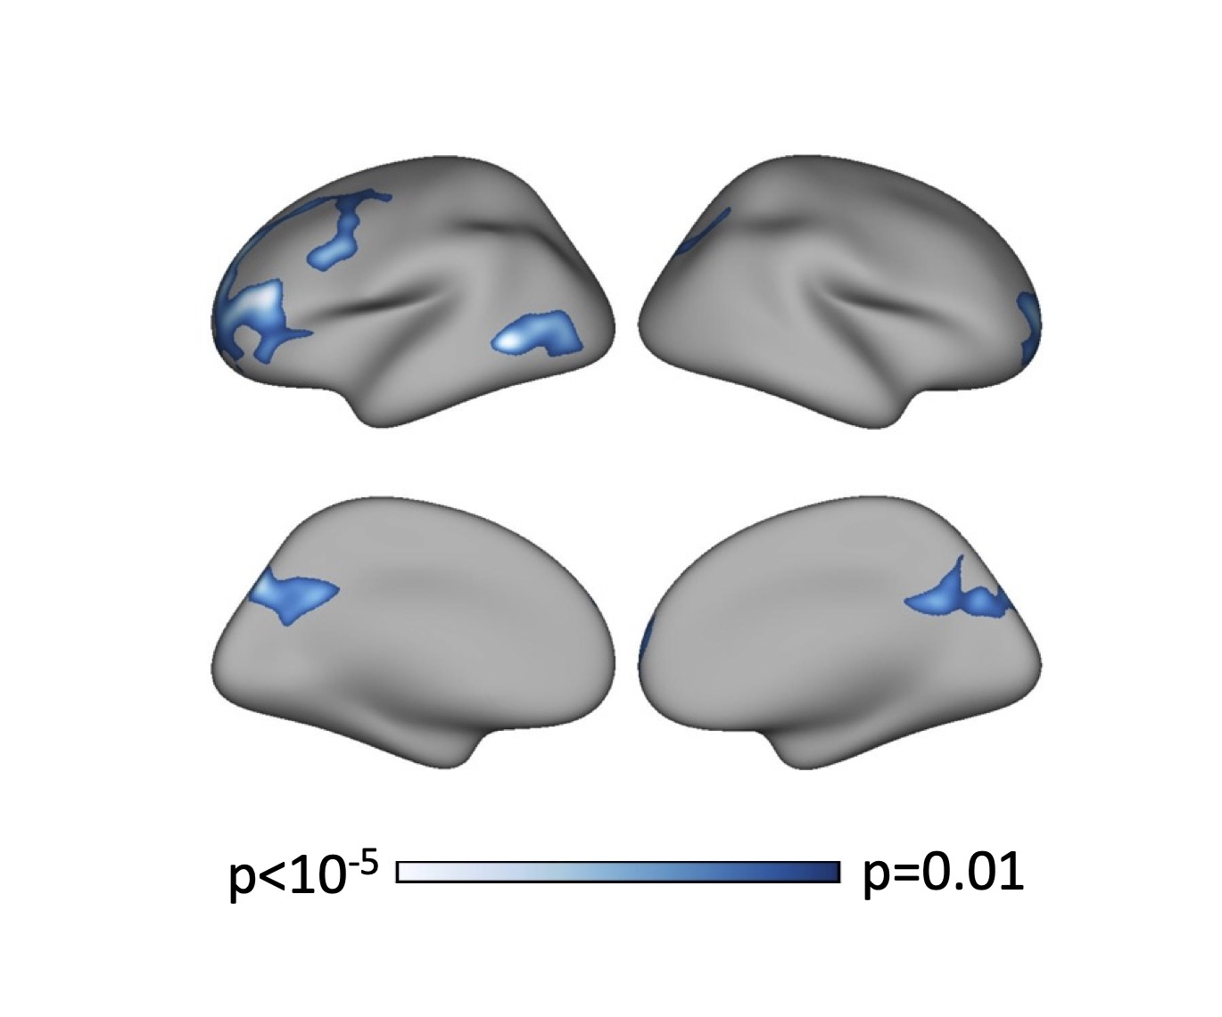
Supplementary Figure 1 Association between lifetime antipsychotic exposure and cortical thickness thresholded at p=0.01. Model includes age, sex, and diagnostic group as nuisance variables. Colorbar indicates p-value. Results are permutation corrected for multiple comparisons.

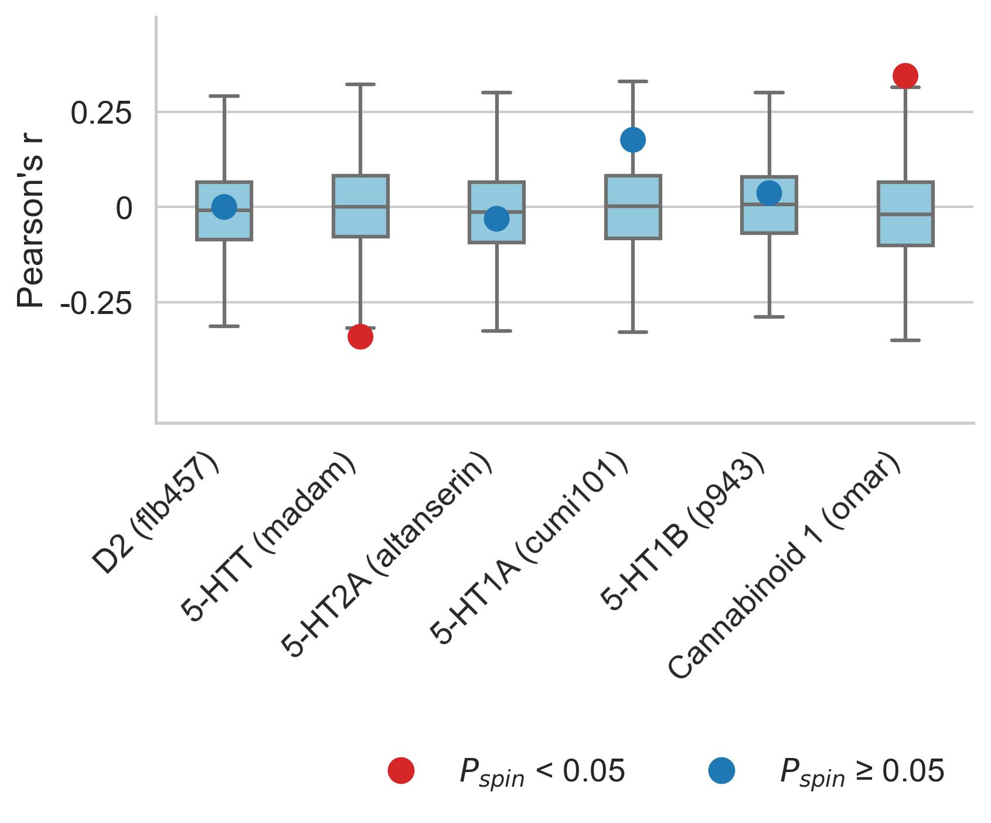
Supplementary Figure 2 Antipsychotic sensitivity and brain organization with additional measures. Six features of brain organization were measured with more than one tracer. For the sake of completeness, these measures were also correlated with AP effects on cortical thickness in the Turku sample. In line with the analysis using the primary measures for these features, no statistically significant associations were found.

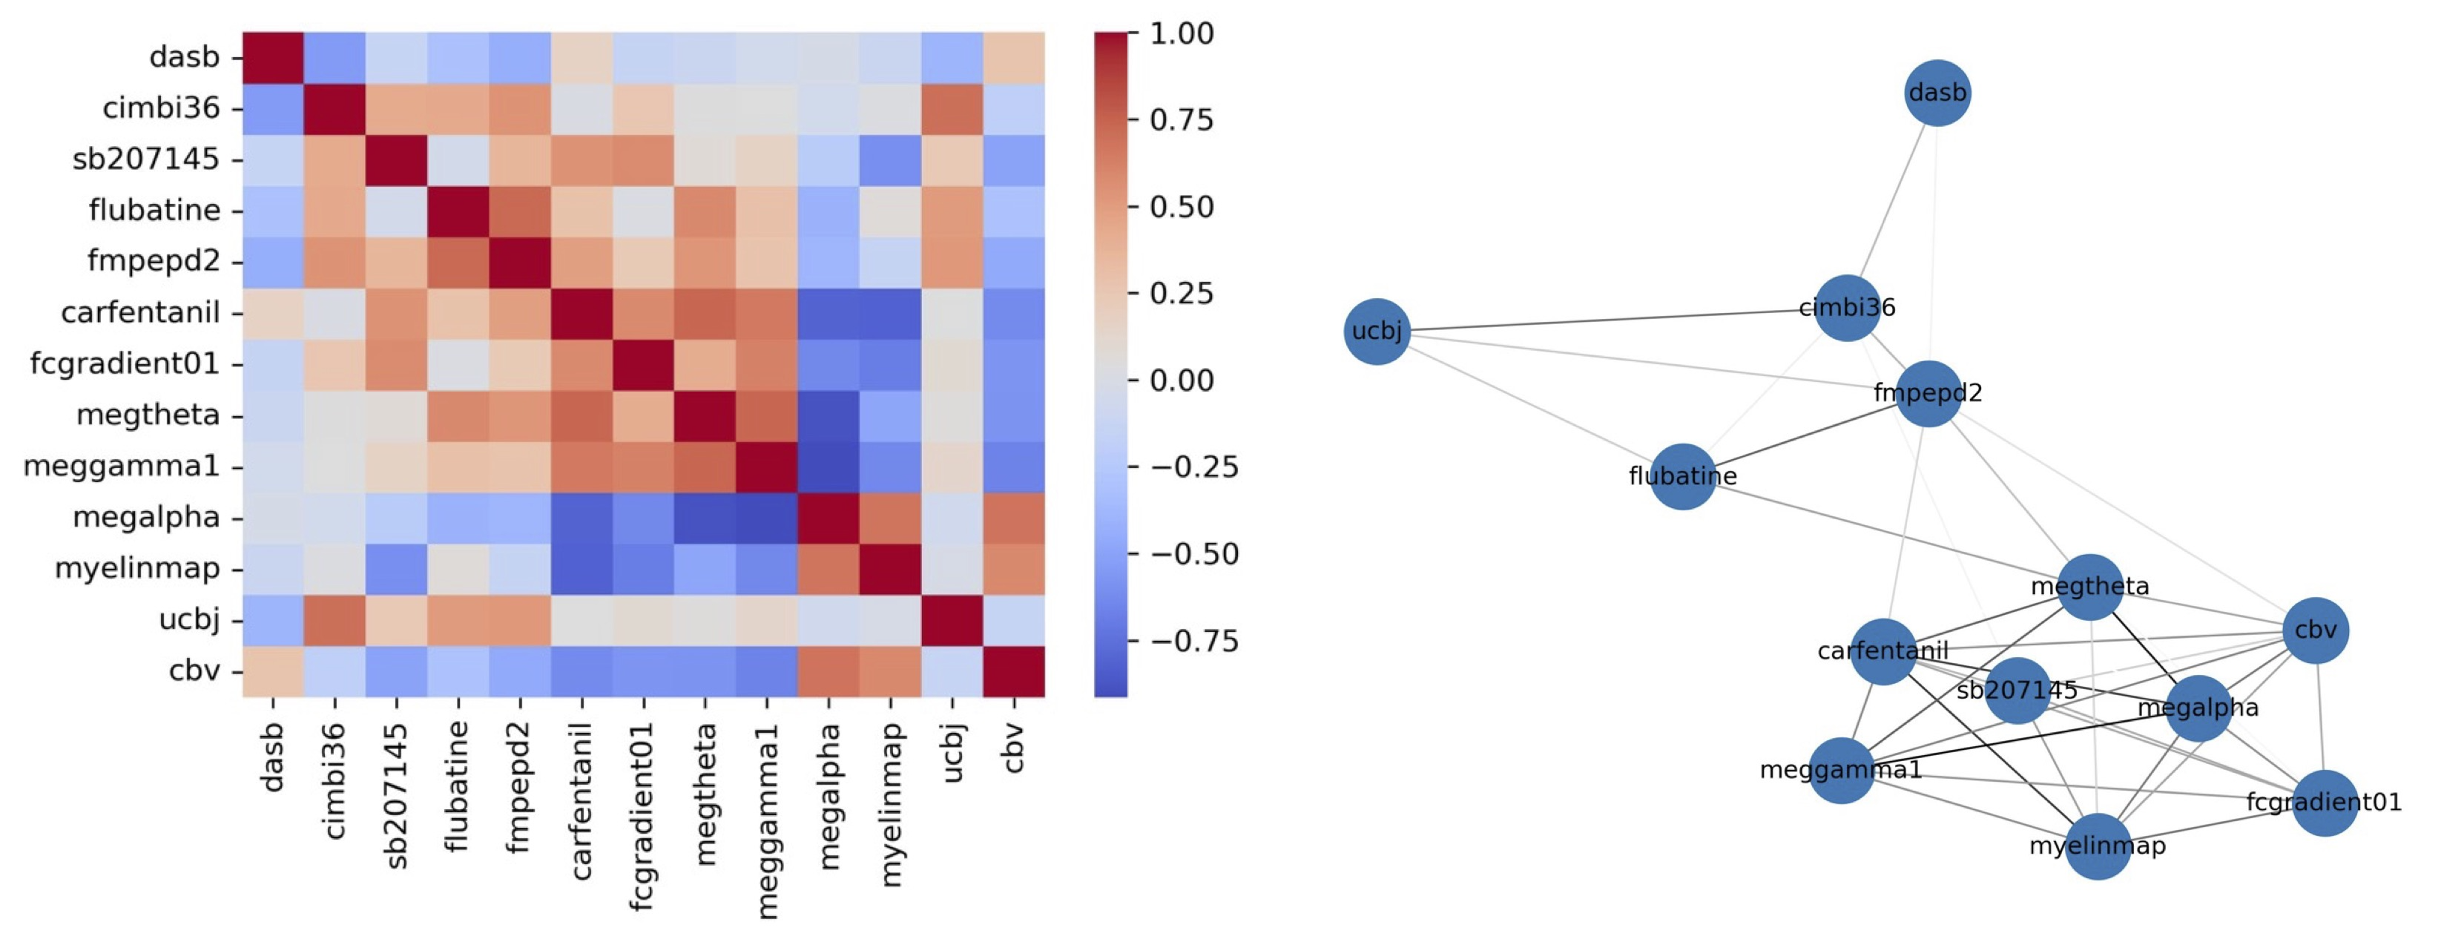
Supplementary Figure 3 Correlations between features of the brain that are associated with antipsychotic related cortical thinning. Left panel show correlation matrix, colorbar indicates Pearson correlation coefficient r. Right panel shows a spring-embedded representation of the correlations. Topographies of serotonin transporter, synaptic density, 5-HT2A, CB1, and α4β2* receptors appear clustered, another cluster is formed by functional measures, cortical myelin, cerebral blood flow, μ- opioid and 5-HT4 receptors.

Supplementary table 1 Sensitivity analyses. The table shows the estimate, standard error, t-value and p-value of antipsychotic exposure on average cortical thickness when including one of the covariates at a time in the model.

Covariate | Estimate | Std. Error | t-value | p-value
Total symptoms score | -1.2E-06 | 2.5E-07 | -4.77 | 0.0000053
Positive symptoms score | -1.2E-06 | 2.6E-07 | -4.60 | 0.0000106
Negative symptoms score | -1.2E-06 | 2.5E-07 | -4.86 | 0.0000036
BMI | -1.1E-06 | 2.5E-07 | -4.30 | 0.0000347
Hospital days | -1.0E-06 | 3.1E-07 | -3.31 | 0.0012269
Times admitted | -1.1E-06 | 2.8E-07 | -3.72 | 0.0003040
GAF | -1.2E-06 | 2.8E-07 | -4.12 | 0.0000688
SOFAS | -1.2E-06 | 2.8E-07 | -4.19 | 0.0000532

Supplementary table 2 shows correlations between antipsychotic related cortical thinning and normative features of the brain in the discovery sample (same data as in figure 2)
tracer / measure | class | target | rho | pspin | fdr_corrected_p_value
sch23390 | dopamine | D1 | -0.13611309816019400 | 0.2522747725227480 | 0.3128207179282070
fallypride | dopamine | D2 | -0.15145839192235800 | 0.1648835116488350 | 0.21297453587974500
dasb | serotonin | 5-HTT | -0.4041914204738630 | 0.0017998200179982 | 0.007970631508277740
way100635 | serotonin | 5-HT1A | -0.2230886044601000 | 0.06729327067293270 | 0.1097942837295220
az10419369 | serotonin | 5-HT1B | 0.19896995442264000 | 0.1095890410958900 | 0.1477069684335910
cimbi36 | serotonin | 5-HT2A | 0.377865933841217 | 0.0011998800119988000 | 0.007439256074392560
sb207145 | serotonin | 5-HT4 | 0.27514812603014100 | 0.018998100189981000 | 0.0368088191180882
gsk215083 | serotonin | 5-HT6 | 0.06486864703669620 | 0.593040695930407 | 0.6339400542704350
feobv | acetylcholine | vAChT | -0.321011588836917 | 0.006299370062993700 | 0.017752770177527700
flubatine | acetylcholine | alpha4 beta2* | 0.3662865373866890 | 0.004899510048995100 | 0.015498450154984500
lsn3172176 | acetylcholine | M1 | 0.18914965240899800 | 0.0948905109489051 | 0.1394860513948610
abp688 | various | mGluR5 | 0.11861066017734100 | 0.32836716328367200 | 0.3915146946843780
fmpepd2 | various | Cannabinoid 1 | 0.45584978842246300 | 0.000999900009999 | 0.007439256074392560
gsk189254 | various | Histamine 3 | 0.07465882818090720 | 0.5506449355064490 | 0.6096426071678550
carfentanil | opioid | mu-opiod | 0.308922119988958 | 0.014698530146985300 | 0.030376962303769600
ly2795050 | opioid | kappa-opioid | 0.20964293008754100 | 0.098990100989901 | 0.1394860513948610
fcgradient01 | functional | Functional Gradient | 0.4736608549761900 | 9.99900009999E-05 | 0.0030996900309969000
megalpha | functional | Alpha Power | -0.39369935598264800 | 0.0016998300169983000 | 0.007970631508277740
megbeta | functional | Beta Power | 0.21379662504879700 | 0.0842915708429157 | 0.13065193480651900
megdelta | functional | Delta Power | 0.28439367925684500 | 0.014298570142985700 | 0.030376962303769600
meggamma1 | functional | Low Gamma Power | 0.4230748599315880 | 0.0005999400059994000 | 0.007439256074392560
meggamma2 | functional | High Gamma Power | 0.25983323129290300 | 0.0212978702129787 | 0.0388372927413141
megtheta | functional | Theta Power | 0.3769190538769740 | 0.004999500049995000 | 0.015498450154984500
megtimescale | functional | Intrinsic Timescale | 0.3007630887583380 | 0.008599140085991400 | 0.022214445222144500
ucbj | structural | Synaptic Vesicles | 0.30075589867662100 | 0.009499050094990500 | 0.02265158099574660
cortical thickness | structural | Cortical Thickness | 0.09457914724924790 | 0.42295770422957700 | 0.48561810485618100
myelin | structural | T1/T2 | -0.34840135738894000 | 0.0038996100389961000 | 0.01511098890110990
cbf | metabolic | CBF | 0.009795333069901100 | 0.9342065793420660 | 0.9342065793420660
cbv | metabolic | CBV | -0.37187655201844700 | 0.0011998800119988000 | 0.007439256074392560
cmr02 | metabolic | CMRO2 | -0.014991231074433000 | 0.9032096790320970 | 0.9333166683331670
cmrglc | metabolic | CMRGlu | 0.26999789426642900 | 0.022897710228977100 | 0.039434945394349500

Supplementary table 3 shows correlations between antipsychotic related cortical thinning and alternative tracers (same data as in supplementary figure 3)
tracer | class | target | rho | pspin
flb457 | dopamine | D2 | -5.79697230025378E-05 | 0.9996000399960000
madam | serotonin | 5-HTT | -0.34088637208110100 | 0.0040995900409959
cumi101 | serotonin | 5-HT1A | -0.031009435680068000 | 0.7922207779222080
p943 | serotonin | 5-HT1B | 0.17632035708924800 | 0.138986101389861
altanserin | serotonin | 5-HT2A | 0.036385225482637400 | 0.7381261873812620
omar | various | Cannabinoid 1 | 0.34450355205267800 | 0.005099490050994900

Supplementary table 4 shows correlations between antipsychotic related cortical thinning and normative features of the brain in the replication sample (same data as in figure 4)
tracer / measure | class | target | rho | pspin | fdr_corrected_p_value
dasb | serotonin | 5-HTT | -0.42730137785045700 | 0.00039996000399960000 | 0.0035996400359964000
cimbi36 | serotonin | 5-HT2A | 0.44723884247094900 | 0.00029997000299970000 | 0.0035996400359964000
sb207145 | serotonin | 5-HT4 | 0.4685705038863450 | 0.0010998900109989000 | 0.004949505049495050
flubatine | acetylcholine | alpha4 beta2* | 0.361200659937138 | 0.0028997100289971 | 0.007456397217421110
feobv | acetylcholine | vAChT | -0.18615621847142200 | 0.12138786121387900 | 0.13892360763923600
fmpepd2 | various | Cannabinoid 1 | 0.5468469740436400 | 0.0005999400059994000 | 0.0035996400359964000
carfentanil | various | $\mu$-opiod | 0.38768215355838800 | 0.0025997400259974 | 0.007456397217421110
fcgradient01 | functional | Functional Gradient | 0.3648219948521910 | 0.006199380061993800 | 0.012398760123987600
megtimescale | functional | Intrinsic Timescale | 0.17808098151252700 | 0.16498350164983500 | 0.16498350164983500
megtheta | functional | Theta Power | 0.3962061791475740 | 0.0016998300169983000 | 0.006119388061193880
meggamma2 | functional | High Gamma Power | 0.19868373094673000 | 0.12348765123487700 | 0.13892360763923600
meggamma1 | functional | Low Gamma Power | 0.2956246730624560 | 0.0188981101889811 | 0.028347165283471700
megdelta | functional | Delta Power | 0.22859793901970000 | 0.0822917708229177 | 0.10580370534375100
megalpha | functional | Alpha Power | -0.35220229889986500 | 0.0053994600539946000 | 0.012148785121487900
myelin | structural | T1/T2 | -0.2702431372254100 | 0.033996600339966 | 0.047072215855337500
ucbj | structural | Synaptic Vesicles | 0.3068443681943620 | 0.0091990800919908 | 0.015053040150530400
cbv | metabolic | CBV | -0.3566093662360660 | 0.007799220077992200 | 0.014038596140386000
cmruglu | metabolic | CMRGlu | 0.15876486313861500 | 0.1643835616438360 | 0.16498350164983500

 | FEP | CHR
Second generation antipsychotics
risperidone (n) | 50 | 12
quetiapine (n) | 35 | 13
olanzapine (n) | 31 | 7
aripiprazole (n) | 12 | 3
paliperidone (n) | 5 | 0
asenapine (n) | 4 | 0
ziprasidone (n) | 1 | 0
sulpride (n) | 1 | 0
First generation antipsychotics
perphenazine (n) | 6 | 2
haloperidol (n) | 3 | 2
flupentixol (n) | 2 | 0
levomepromazine (n) | 2 | 0
Supplementary table 5 shows all the antipsychotic medications that were used in the Turku sample and a number of patients that were ever exposed to these antipsychotics.

Supplementary table 6 shows measures of normative
structural and functional features of the cortex used in this study.
For more details please see: https://docs.google.com/spreadsheets/d/1oZecOsvtQEh5pQkIf8cB6CyhPKVrQuko/edit#gid=1162991686
 | Author/Dataset | Year | Tracer / Measure | Target | Reference
0 | Jaworska | 2020 | fallypride | D2 | Jaworska et al., 2020, Neuropsychopharm
1 | Kaller | 2017 | sch23390 | D1 | Kaller et al., 2017, Eur J Nucl Med Mol Imaging
2 | Radnakrishnan | 2018 | gsk215083 | 5-HT6 | Radhakrishnan et al., 2018, J Nucl Med
3 | Beliveau | 2017 | cimbi36 | 5-HT2A | Beliveau et al., 2017, J Neurosci
4 | Savli | 2012 | way100635 | 5-HT1A | Savli et al., 2012, Neuroimage
5 | Beliveau | 2017 | az10419369 | 5-HT1B | Beliveau et al., 2017, J Neurosci
6 | Beliveau | 2017 | sb207145 | 5-HT4 | Beliveau et al., 2017, J Neurosci
7 | Fazio | 2016 | madam | 5-HTT | Fazio et al., 2016, Neuroimage
8 | Tuominen | NA | feobv | vAChT | NA
9 | Hillmer | 2016 | flubatine | alpha4 beta2* | Hillmer et al., 2016, Neuroimage
10 | Naganawa | 2020 | lsn3172176 | M1 | Naganawa et al., 2020, J Nucl Med
11 | Margulies | 2016 | fcgradient01 | Functional Gradient | Margulies et al., 2016, PNAS
13 | Hcps | 2022 | megalpha | Alpha Power | Shafiei et al., 2022, Plos Biology
14 | Hcps | 2022 | megdelta | Delta Power | Shafiei et al., 2022, Plos Biology
15 | Hcps | 2022 | megbeta | Beta Power | Shafiei et al., 2022, Plos Biology
16 | Hcps | 2022 | meggamma1 | Low Gamma Power | Shafiei et al., 2022, Plos Biology
17 | Hcps | 2022 | meggamma2 | High Gamma Power | Shafiei et al., 2022, Plos Biology
18 | Hcps | 2022 | megtheta | Theta Power | Shafiei et al., 2022, Plos Biology
19 | Hcps | 2022 | megtimescale | Intrinsic Timescale | Shafiei et al., 2022, Plos Biology
20 | Finnema | 2016 | ucbj | Synaptic Vesicles | Finnema et al., 2018, J Cereb Blood Flow Metab
21 | Hcps | 2016 | thickness | Cortical Thickness | Glasser et al., 2016, Nature
22 | Hcps | 2016 | myelin | T1/T2 | Glasser et al., 2016, Nature
23 | Dukart | 2018 | flumazenil | GABA_{A} | Dukart et al., 2018, Sci Rep
24 | Dubois | 2015 | abp688 | mGluR5 | Dubois et al., 2016, Eur J Nucl Med Mol Imaging
25 | Laurikainen | 2018 | fmpepd2 | Cannabinoid 1 | Laurikainen et al., 2019, Neuroimage
26 | Vijay | 2018 | ly2795050 | kappa-opioid | Vijay et al., 2018, Neuropsychopharmacology
27 | Kantonen | 2020 | carfentanil | mu-opiod | Kantonen et al., 2020, Neuroimage
28 | Gallezot | 2017 | gsk189254 | Histamine 3 | Gallezot et al., 2010, J Cereb Blood Flow Metab
29 | Raichle | NA | cbf | CBF | Vaishnavi et al., 2010, PNAS
30 | Raichle | NA | cbv | CBV | Vaishnavi et al., 2010, PNAS
31 | Raichle | NA | cmr02 | CMRO₂ | Vaishnavi et al., 2010, PNAS
32 | Raichle | NA | cmruglu | CMRGlu | Vaishnavi et al., 2010, PNAS

