Supplementary Information

Supplementary Tables
Table S1. Formulation, proximate and fatty acid compositions of standard marine diets (M_{S} and M_{I}) and low fishmeal/fish oil vegetable-based diets (V_{S} and V_{C}) used in respective feeding phases.
ALA, α-linolenic acid; ARA, arachidonic acid; LA, linoleic acid; LC-PUFA, long-chain polyunsaturated fatty acid; MUFA, monounsaturated fatty acid; OA, Oleic acid; PPC, pea protein concentrate; SFA, saturated fatty acid; SPC, soya protein concentrate.
  - * Feed Services Bremen, Bremen, Germany.
  - † Aker BioMarine, Lysaker, Norway.
  - ‡ Caramuru, Itumbiara, Brazil.
  - § Cargill, Minnesota, US.
  - || Agrident, Amsterdam, Netherlands.
  - ** ED&F Man, London, UK.
  - ¶ Nova Nutriway GmbH, Hamburg, Germany
  - †† DSM, Heerlen, Netherlands.
  - ‡‡ Evonik, Essen, Germany.
Table S2. Statistical analysis of Shannon-Weiner index of intestine, water and feed comparisons, n denotes to the sample number. p.adj: adjusted p-value. Significant difference (MWW-tested and BH-corrected) is represented by * (p<0.05) ** (p<0.01) *** (p<0.001) **** (p<0.001). We used the same legend color in figures for different phases.
Comparison |  | 1 | 2 | n1 | n2 | statistic | p.adj
intestine | Within phase | M | V | 18 | 17 | 203 | ns
intestine | Within phase | M | V | 18 | 18 | 240 | *
intestine | Within phase | M | V | 17 | 17 | 170 | ns
intestine | M fish | M | M | 18 | 18 | 302 | ***
intestine | M fish | M | M | 18 | 17 | 284 | ***
intestine | M fish | M | M | 18 | 17 | 121.5 | ns
intestine | V fish | V | V | 17 | 18 | 285 | ***
intestine | V fish | V | V | 17 | 17 | 232 | **
intestine | V fish | V | V | 18 | 17 | 103.5 | ns
feed |  | M | V | 3 | 3 | 9 | ns
water | within phase | M | V | 3 | 3 | 4 | ns
water | within phase | M | V | 3 | 3 | 2 | ns
water | within phase | M | V | 2 | 4 | 7 | ns
water | M water | M | M | 3 | 3 | 0 | ns
water | M water | M | M | 3 | 2 | 4 | ns
water | M water | M | M | 3 | 2 | 6 | ns
water | V water | V | V | 3 | 3 | 0 | ns
water | V water | V | V | 3 | 4 | 12 | ns
water | V water | V | V | 3 | 4 | 12 | ns
Sample type |  | intestine | feed | 105 | 6 | 28 | ***
 |  | intestine | water | 105 | 18 | 5 | ****
 |  | feed | water | 6 | 18 | 6 | ***

Table S3. Taxonomic composition relative abundances in each of the sample type, phase, and fish group. See taxonomic.composition_devStages in https://github.com/marwa38/NP_devStages_ampliseq to download.
l
Table S4. Top 15 genera (or lowest identified taxonomic rank i.e., family) that showed statistically significant difference (MWW-tested and BH-corrected) between fish groups relative abundances (RA, %). We used the same legend color in figures for different phases. Stars represent corrected statistical significance strength (* p<0.05, ** p<0.01, *** p<0.001, **** p<0.0001).
taxa | RA.1 | 1 | 2 | RA.2 | p.adj | taxa | RA.1 | 1 | 2 | RA.2 | p.adj
Ruminococcaceae* | 91.6 | V | V | 42.4 | **** | Lactobacillus | 18.3 | M | M | 5.025 | **
Ruminococcaceae* | 79.2 | M | M | 22.8 | **** | Lactobacillus | 18.3 | M | M | 6.759 | **
OTHERS** | 22.2 | M | M | 5.55 | ** | Lactobacillus | 15.1 | V | V | 1.036 | ***
OTHERS** | 22.2 | M | M | 4.67 | *** | Lactobacillus | 15.1 | V | V | 5.397 | **
OTHERS** | 14 | V | V | 3.5 | *** | Pediococcus | 3.39 | M | M | 0.302 | ***
Pseudomonas | 18.2 | M | M | 4.92 | ** | Pediococcus | 3.39 | M | M | 0.14 | ***
Pseudomonas | 13.9 | V | V | 1.47 | **** | Pediococcus | 2.33 | V | V | 0.114 | ****
Yersinia | 1.85 | M | M | 0.2 | ** | Pediococcus | 2.33 | V | V | 0.001 | ****
Yersinia | 1.08 | V | V | 0.1 | * | Photobacterium | 2.77 | M | M | 0.015 | ***
Staphylococcus | 1.23 | V | V | 0.1 | ** | Photobacterium | 2.77 | M | M | 0 | ***
Staphylococcus | 1.23 | V | V | 0.3 | * | Photobacterium | 1.22 | V | V | 0.048 | ***
Cutibacterium | 1.53 | V | V | 0.11 | **** | Photobacterium | 1.22 | V | V | 1E-04 | ***
Cutibacterium | 1.53 | V | V | 0.16 | *** | Leuconostoc | 2.7 | M | M | 0.52 | **
Cutibacterium | 0.92 | M | M | 0.09 | * | Leuconostoc | 2.7 | M | M | 0.47 | **
Escherichia-Shigella | 0.92 | V | V | 0.24 | ** | Leuconostoc | 2.02 | V | V | 0.099 | ****
Escherichia-Shigella | 0.61 | M | M | 0.18 | ** | Leuconostoc | 2.02 | V | V | 0.261 | ***
 |  |  |  |  |  | Bifidobacteriaceae* | 2.68 | M | M | 0.062 | ****
 |  |  |  |  |  | Bifidobacteriaceae* | 2.68 | M | M | 0.02 | ****
Stimulus |  |  |  |  |  | Bifidobacteriaceae* | 2.02 | V | V | 0.036 | ****
 |  |  |  |  |  | Bifidobacteriaceae* | 2.02 | V | V | 0 | ****
Intermediate |  |  |  |  |  | Lactococcus | 2.4 | M | M | 0.171 | ***
 |  |  |  |  |  | Lactococcus | 2.4 | M | M | 0.238 | ***
Challenge |  |  |  |  |  | Lactococcus | 1.78 | V | V | 0.027 | ****
 |  |  |  |  |  | Lactococcus | 1.78 | V | V | 0.132 | ****
* Taxonomically unclassified genera were assigned to family rank.
** OTHERS refers to all other taxa (other than top 15).

Supplementary Figures
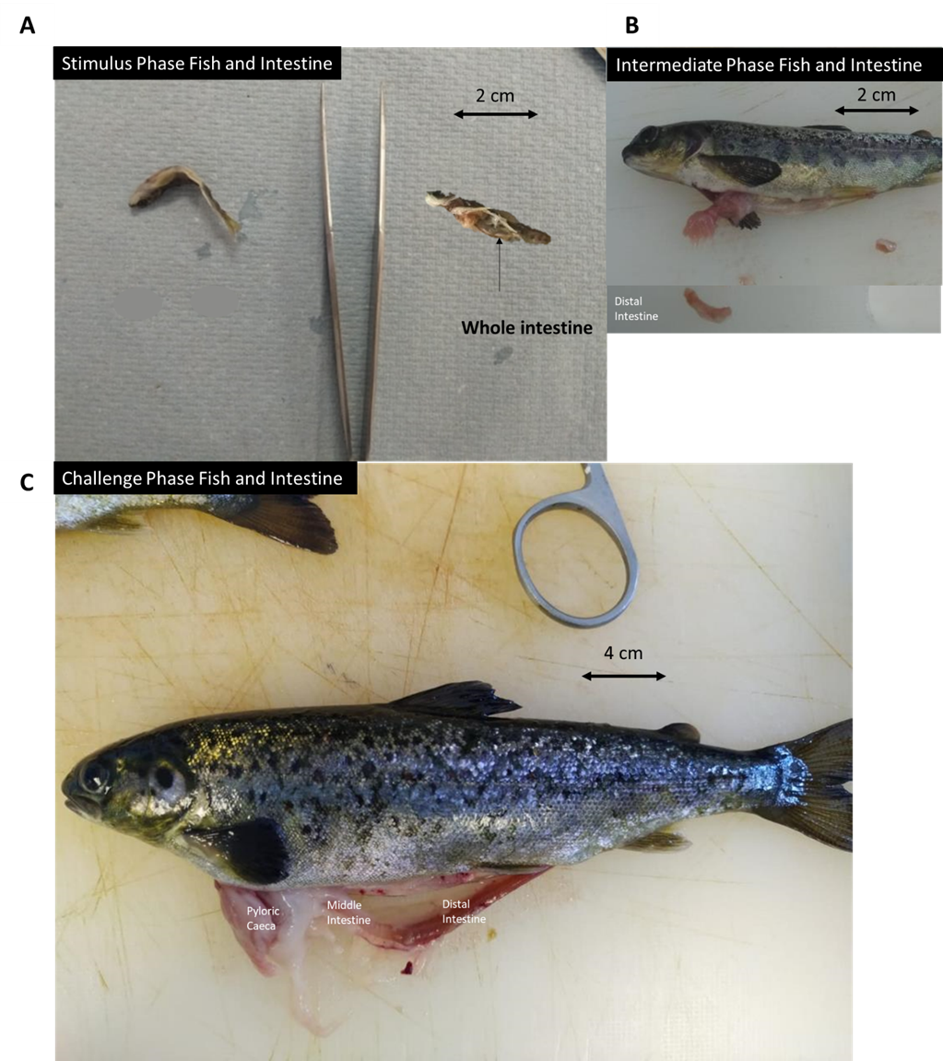
Fig. S1. Atlantic salmon fish and intestine at three sampling points at the end of each phase (stimulus, intermediate and challenge); (A) two (B) 14 and (C) 20 weeks post-first feeding. Whole and distal intestines were sampled from the stimulus and challenge phases respectively.

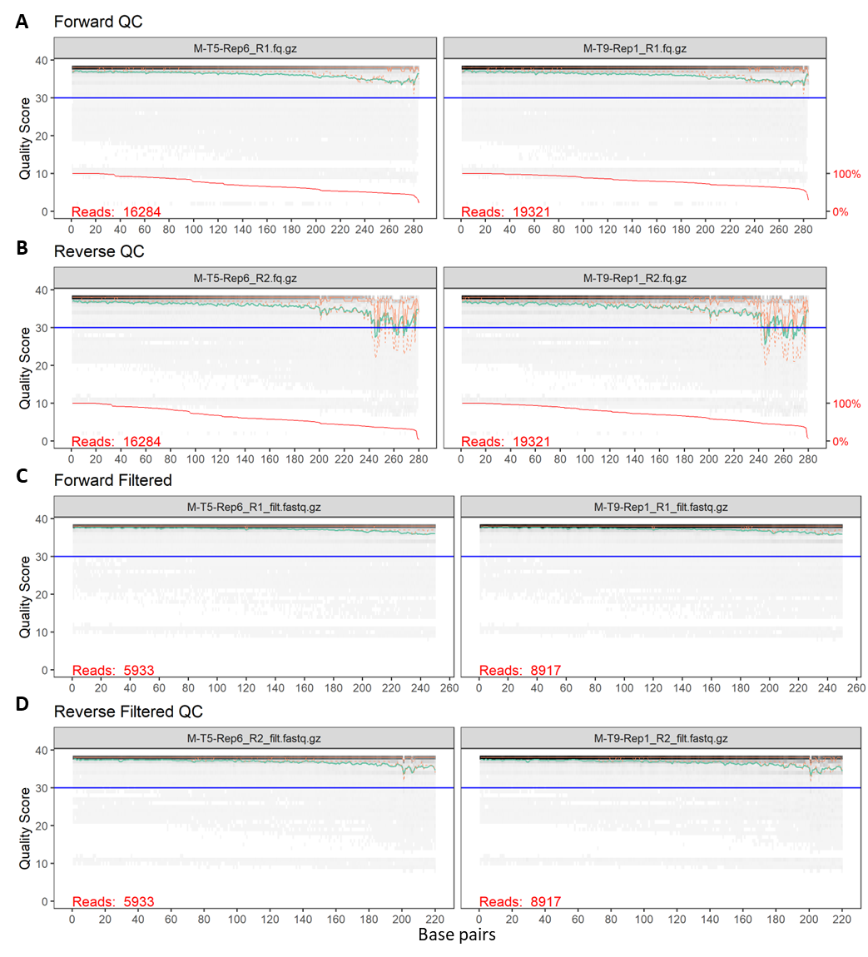
Fig. S2. Quality control for forward (F) and reverse (R) reads per sample (two samples used as example) using the DADA2 package before (A and B) and after filtration (C and D). The green line shows the mean quality score at each position, and the orange lines show the quartiles of the quality score distribution. The blue y-intercept line shows a quality score (Q) above 30, the higher the score the better the base call. Filtration at Q>30 showed up to 250 base pairs (bps) for F reads and 220 bps for R reads thus filtered in. All other samples were checked and the same filtration criteria (Q>30, 250 bps F, and 220 bps R) were applied. M – marine-based diet fed group (for two weeks at Stim); T – tank number; Rep – replicate number; R1 the sequencer label for a forward read while R2 label for a reverse read. Sequence data output from the sequencer is saved as FASTQ files which are compressed and created with the extension *.fq.gz or *.fastq.gz.

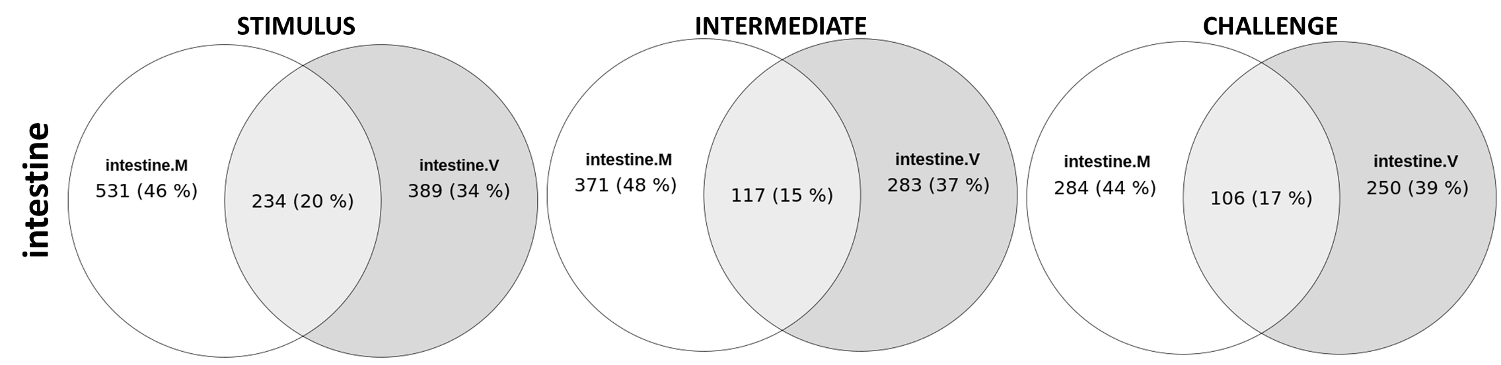
Fig. S3. Venn diagram showing unique and shared microbiota ASVs between M and V fish intestine at different phases (stimulus, intermediate, and challenge).

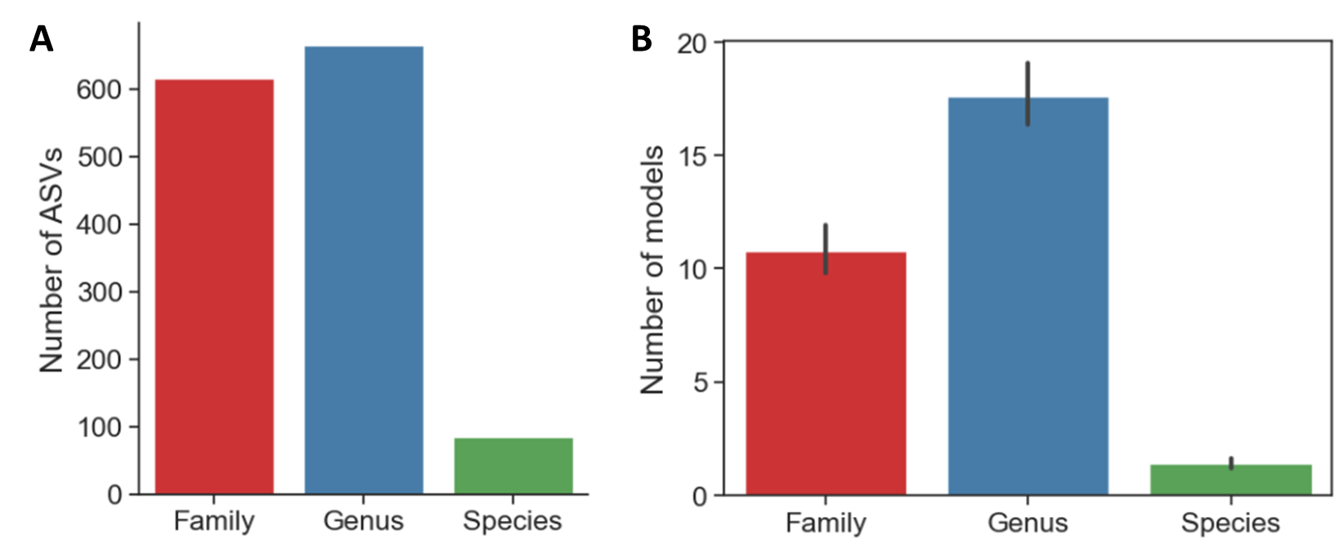
Fig. S4. Number of ASVs mapped to genome-scale metabolic models. (A) Number of samples matched to models at different taxonomic levels and (B) the number of models mapped to each sample by taxonomic level.

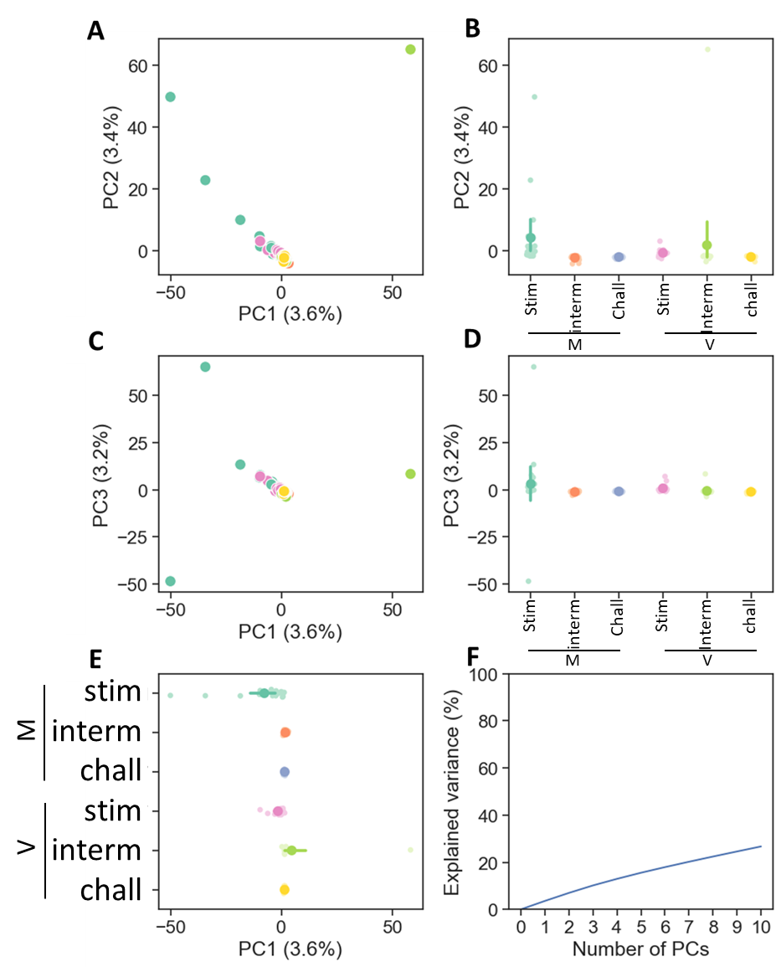
Fig. S5. Principal component (PC) analysis on standardized amplicon sequence variants (ASVs). Score plots for; (A) PC1 and PC2; (B) PC2; (C) PC1 and PC3; (D) PC3 and (E) mean scores with 95% confidence intervals for PC1 and (F) percentage of variance explained by PCs. stim:stimulus, interm: intermediate, chall: challenge.

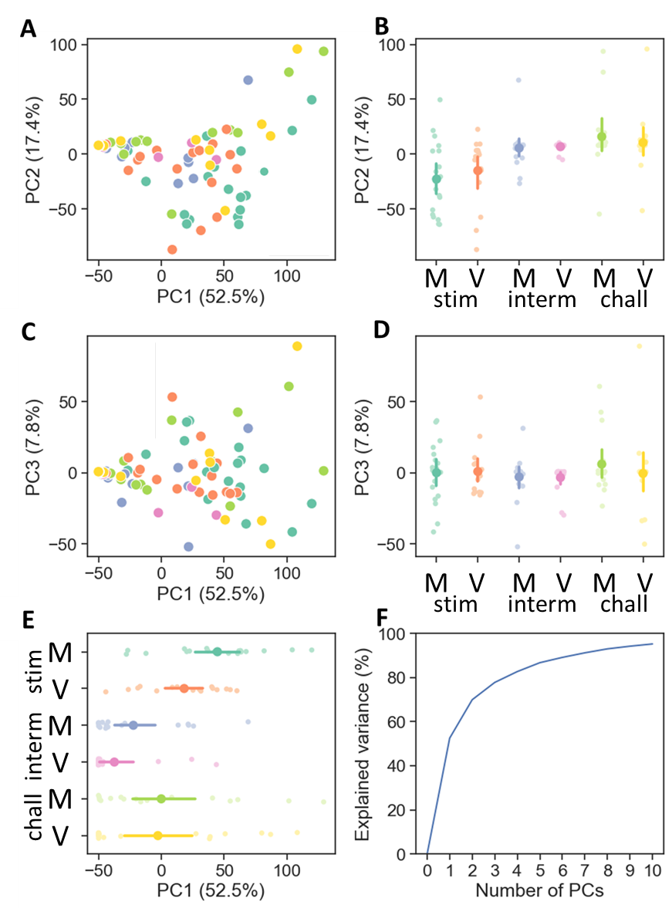
Fig. S6. Principal component analysis (PCA) on metabolic reaction abundances (z-scores). Score plots for (A) PC1 and PC2; (B) PC2; (C) PC1 and PC3; (D) PC3 and (E) mean scores with 95% confidence intervals for PC1 and (F) percentage of variance explained by PCs. stim:stimulus, interm: intermediate, chall: challenge.

