Supplementary Material: Structural equation modeling to prove the structural and measurement models of the Emotional Availability Scales according Figure 1, boxes A-H with model fit and parameter estimation with SAS PROC CALIS (SAS 9.4)

Path coefficients and fit indices from a structural equation for the model in box A in Figure 1 based on scale scores of the Emotional Availability Scales the with an adult and child factor.

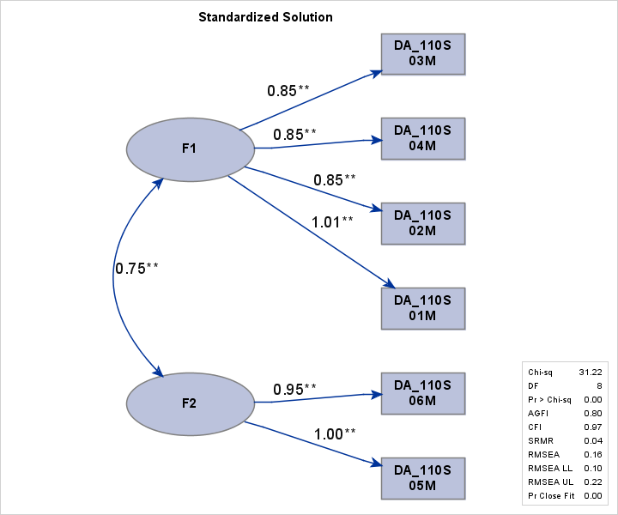
Involvement
Hostility
Responsiveness
Intrusiveness
Structuring
Sensitivity
Child
Adult

Path estimates and model fit indices for six confirmatory factor analysis for the six EAS scales. According to Figure1: Box B. Adult sensitivity; Box C. Adult structuring; Box D. Adult intrusiveness; Box E. Adult hostility; Box F. Child responsiveness; and Box G. Child involvement.
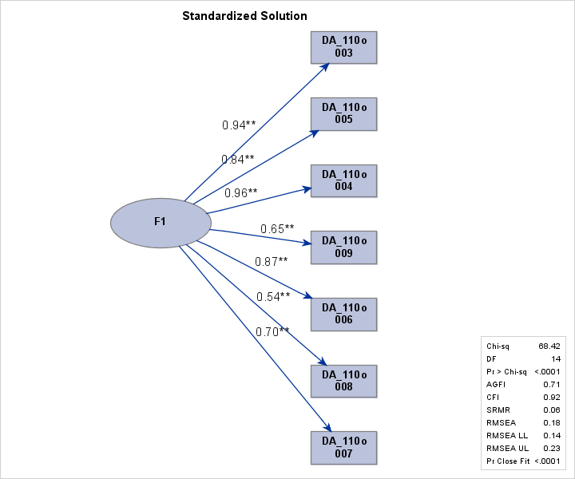  i7  i1  i2  i3  i4  i5  i6  Adult Sensitivity | 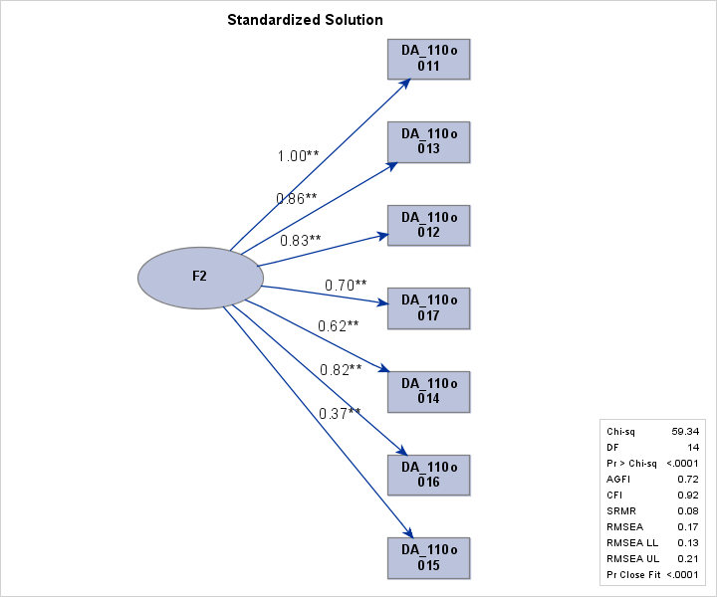  i7  i1  i2  i3  i4  i5  i6  Adult Structuring
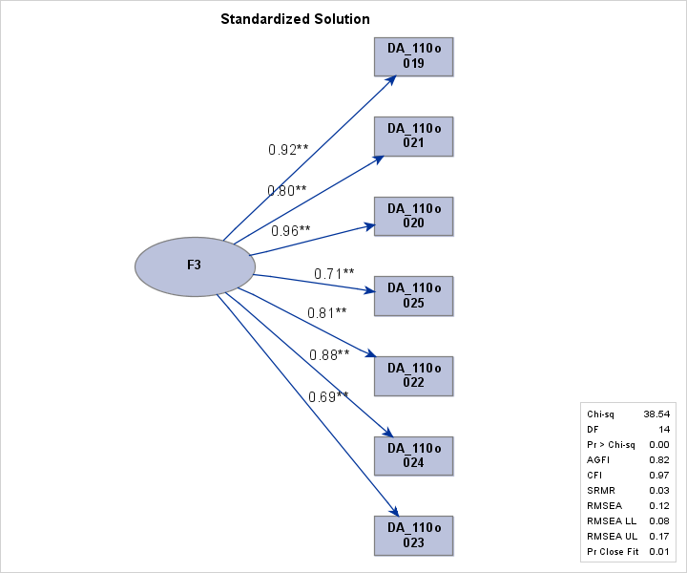  i7  i1  i2  i3  i4  i5  i6  Adult Intrusiveness | 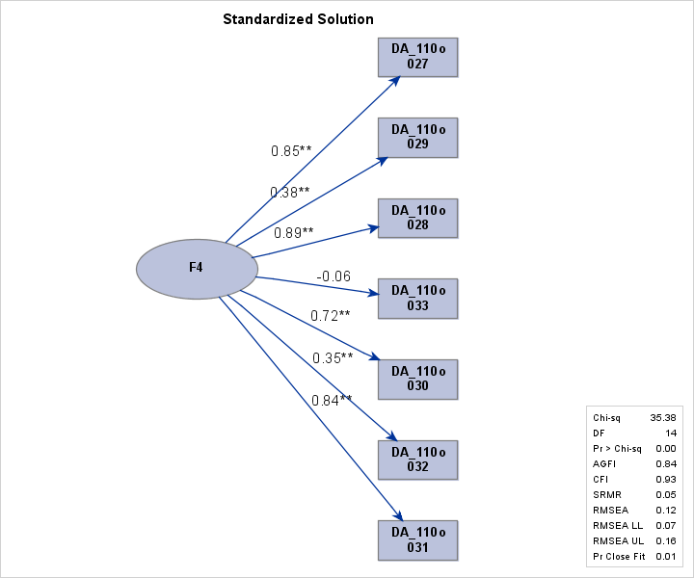  i7  i1  i2  i3  i4  i5  i6  Adult Hostility
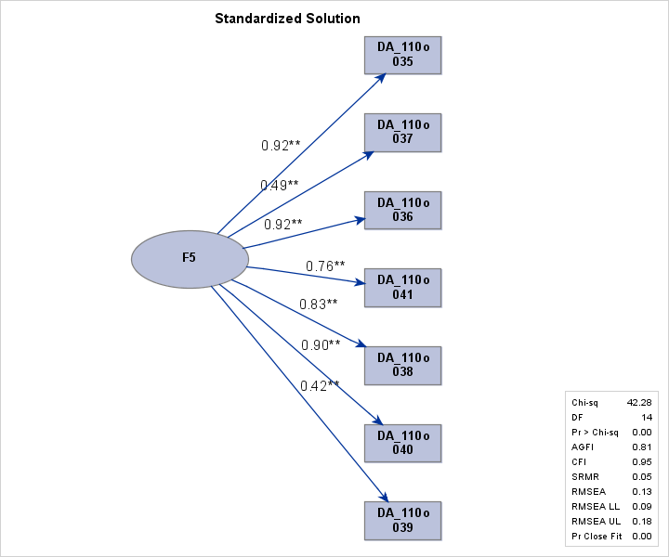  i7  i1  i2  i3  i4  i5  i6  Child Responsiveness | 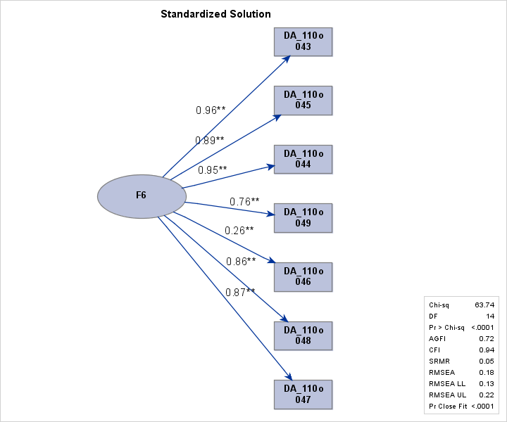  i7  i1  i2  i3  i4  i5  i6  Child Involvement

