Supplementary Information

Journal: Veterinary Research Communications

Evaluation of oral supplementation of free and nanoencapsulated Minthostachys verticillata essential oil on immunological, biochemical and antioxidants parameters and gut microbiota in weaned piglets

Ivana D. Montironi^{1,2,#}, Sofía Arsaute^{1,2,#}, Dardo A. Roma^{3,4}, María E. Cecchini^{1,2}, Agustina Pinotti⁵, Fernando Mañas^{3,4}, Fernando A. Bessone⁵, Alejandra de Moreno de LeBlanc⁶, Fabrisio E. Alustiza⁵, Romina V. Bellingeri^{7,8}, Laura N. Cariddi^{1,2,*}
# These authors contributed equally to this work.

*Corresponding author:
Prof. Dr. Laura Noelia Cariddi, Universidad Nacional de Río Cuarto, Departamento de Microbiología e Inmunología. Consejo Nacional de Investigaciones Científicas y Técnicas (CONICET), Instituto de Biotecnología Ambiental y Salud (INBIAS). Ruta 36 Km 601 CP: 5800, Río Cuarto, Córdoba, Argentina. E-mail: lcariddi@exa.unrc.edu.ar https://orcid.org/0000-0002-3047-6419. Phone: +54 0358-4676435 Fax: +54 0358-4676231.

Table S1: Chemical composition of free (EO) and nanoencapsulated (NEO) Minthostachys verticillata essential oil.
Identified compounds | Formula | Retention time (min) | Relative percentage (%) in M. verticillata essential oil (EO) | Relative percentage (%) in Nanoencapsulated EO (NEO)
Limonene | C₁₀H₁₆ | 10.035 | 2.29 | 1.98
Menthone | C₁₀H₁₈O | 14.162 | 27.99 | 27.53
Isomenthone | C₁₀H₁₈O | 14.437 | 1.53 | 1.45
Isopulegone | C₁₀H₁₆O | 14.772 | 2.43 | 2.00
Pulegone | C₁₀H₁₆O | 16.653 | 41.34 | 40.08
Piperitone | C₁₀H₁₆O | 17.123 | 1.71 | 1.55
Berbenone | C₁₀H₁₄O | 19.484 | 5.89 | 4.78
β-Cubebene | C₁₅H₂₄ | 23.201 | 1.46 | 1.13
γ-Elemene | C₁₅H₂₄ | 23.566 | 6.88 | 5.56
(-)-Spathulenol | C₁₅H₂₄O | 25.521 | 1.39 | 1.13
Total |  | ------ | 92.91 | 87.19
Note that the total relative percentage of compounds identified is not 100%, due to some sample components were not identified by gas chromatography-mass spectrometry (GC-MS), because they were in a percentage lower than 1%.

Table S2: Mass spectra and chemical structure of compounds identified in free (EO) and nanoencapsulated (NEO) Minthostachys verticillata essential oil
Mass spectra / Chemical structure

Name: Limonene
Formula: C₁₀H₁₆
MW: 136 CAS#: 138-86-3

Name: Menthone
Formula: C₁₀H₁₈O
MW: 154 CAS#: 10458-14-7
Name: Isomenthone
Formula: C₁₀H₁₈O
MW: 154 CAS#: 491-07-6
Name: Isopulegone
Formula: C₁₀H₁₆O
MW: 152 CAS#: 29606-79
Name: Pulegone
Formula: C₁₀H₁₆O
MW: 152 CAS#: 89-82-7
Name: Piperitone
Formula: C₁₀H₁₆O
MW: 152 CAS#: 89-81-6
Name: Berbenone
Formula: C₁₀H₁₄O
MW: 150 CAS#: 80-57-9
Name: β-Cubebene
Formula: C₁₅H₂₄
MW: 204 CAS#: 13744-15-5
Name: γ-Elemene
Formula: C₁₅H₂₄
MW: 204 CAS#: 339154-91-5
Name: (-)-Spathulenol
Formula: C₁₅H₂₄O
MW: 220 CAS#: 77171-55-2

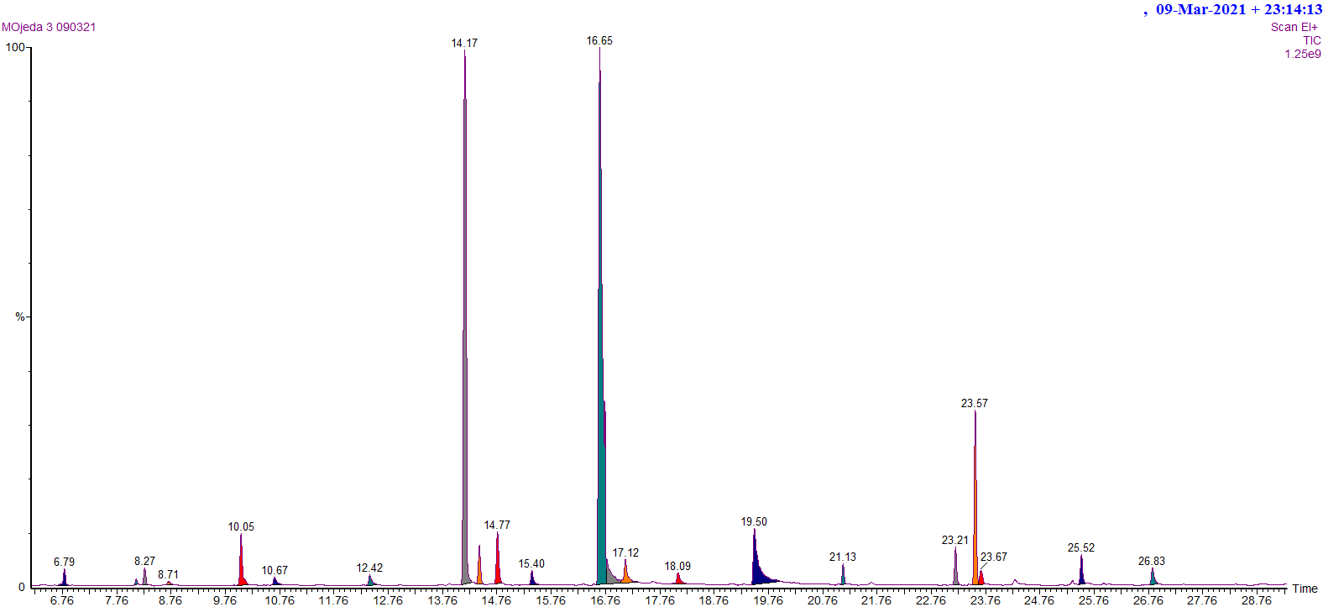
a

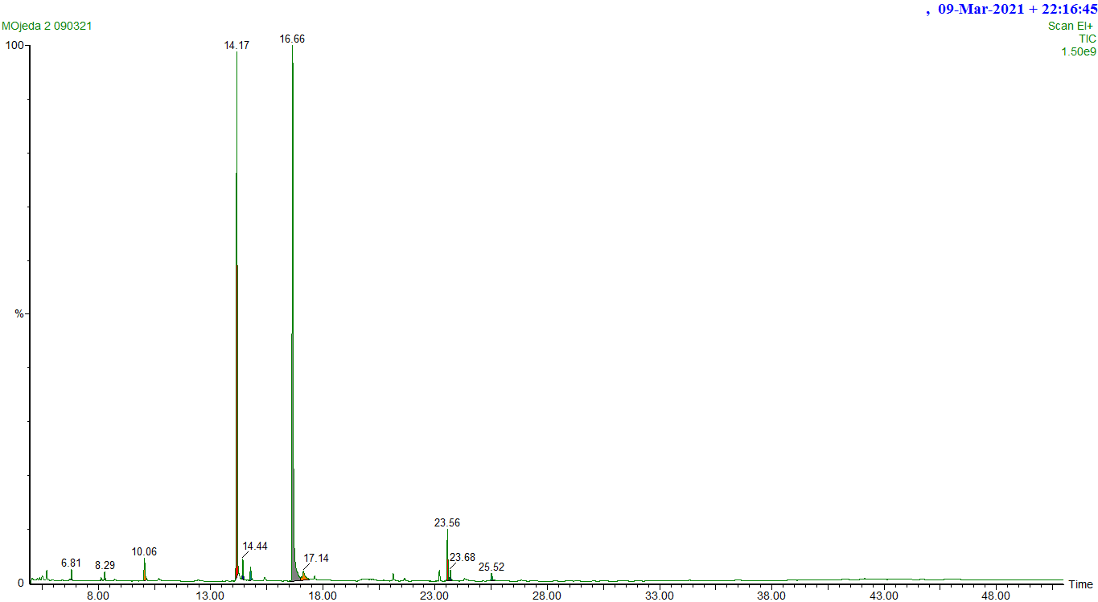
b

Fig S1 Chromatographic profile obtained by gas chromatography-mass spectrometry (GC-MS). Free Minthostachys verticillata essential oil (EO) (a). Nanoencapsulated M. verticillata essential oil (NEO) (b). The area represented by the peaks corresponds to the proportions in which each component is in the mixture. Retention times of each peak are observed.

