Table 3 Summary of model results for focal independent variables
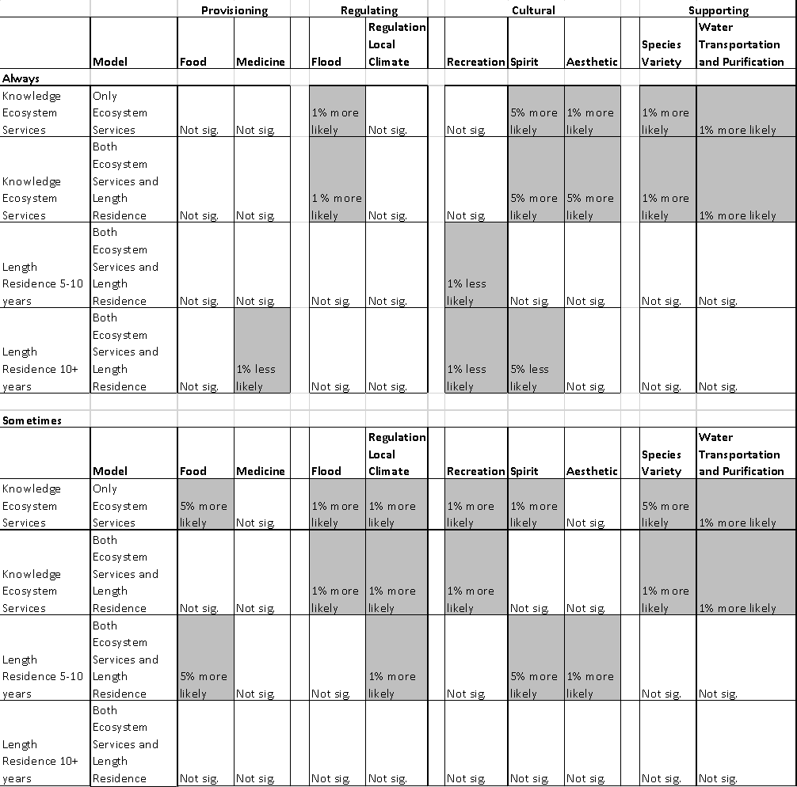

Table 4 Summary of results for model control variables
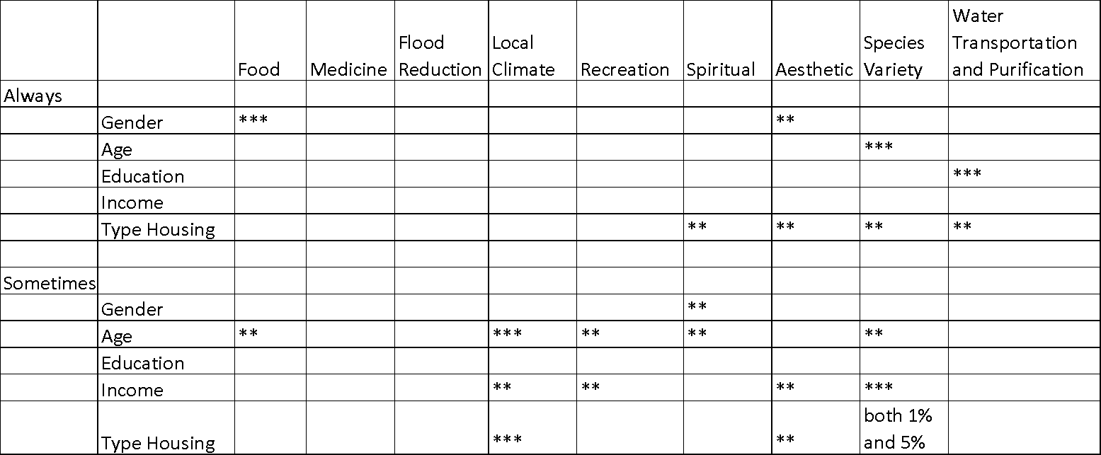
Note: ***Denotes 1% significance, **Denotes 5% significance

