(a) (b)
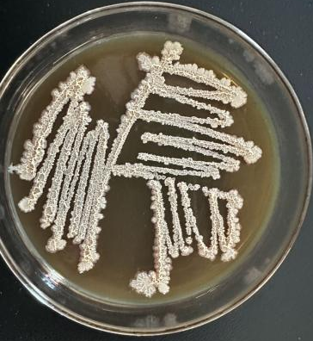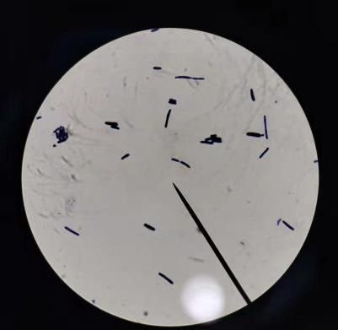
Fig.S1 Morphological features of strain ZR72-1,Colony morphology (a), Gram staining (b):magnification 10*100

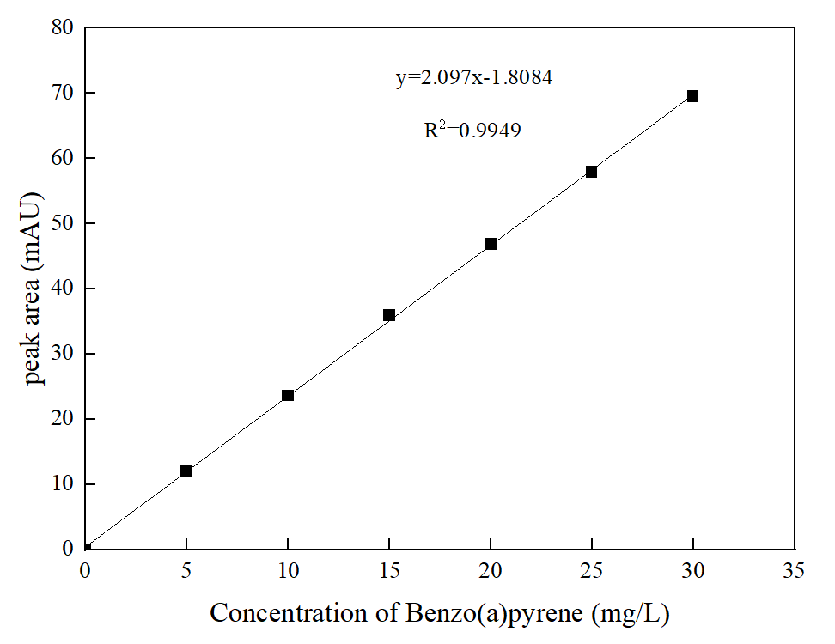
Fig.S2 Benzo (a) pyrene solution standard curve

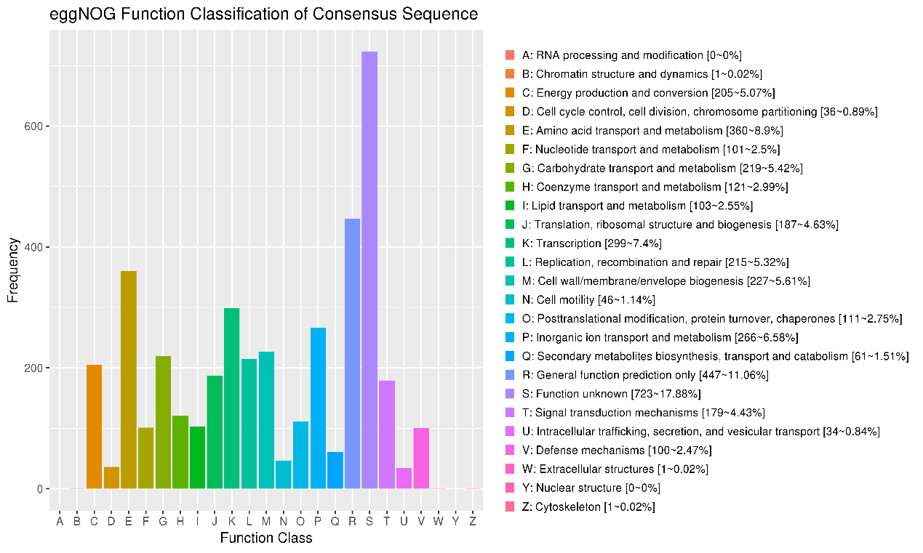
Fig.S3 Functional annotation classification of eggNOG of Bacillus cereus ZR72-1

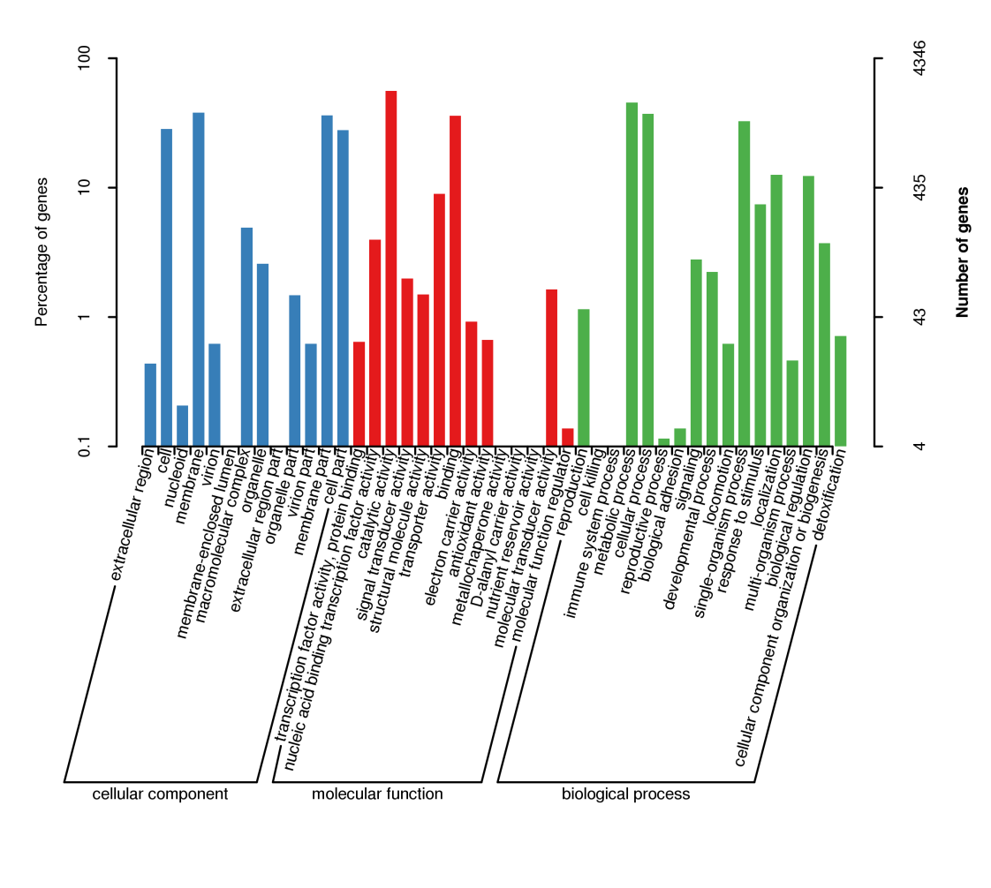
Fig.S4 Classification of GO function notes of Bacillus cereus ZR72-1

Table S1 Specific information on the Xenobiotics biodegradation and metabolism of
Bacillus cereus ZR72-1
Pathways | Identified KOs | Gene number
Chlorocyclohexane and chlorobenzene degradation | K01560、K07104、K07104、K01560 | 4
Benzoate degradation | K07104、K00626、K00626、K07104、K13767、K00632、K07516、K00074、K00626、K01821 | 10
Xylene degradation | K07104、K01821、K07104 | 3
Chloroalkane and chloroalkene degradation | K00128、K13953、K00001、K00128、K00121、K01560、K00001、K00128、K04072、K01560、K00121、K00121、K00121、K00121 | 14
Naphthalene degradation | K13953、K00001、K00121、K00001、K04072、K00121、K00121、K00121、K00121 | 9
Nitrotoluene degradation | K10680 | 1
Styrene degradation | K00451、K01426、K01426、K01426、K07104、K07104 | 6
Aminobenzoate degradation | K01426、K01426、K01034、K01426、K01077、K14338、K01077、K01101 | 8
Degradation of aromatic compounds | K13953、K00001、K00121、K00001、K07104、K07104、K04072、K01821、K00121、K00121、K00121、K00121 | 12

