Supplementary Information

Experimental evidence of the molecular and macroscopic origins of circular dichroism in chiral metal-halide networks
Alexandre Abhervé
MOLTECH-Anjou, UMR 6200, CNRS, UNIV Angers, 2 bd Lavoisier, 49045 ANGERS Cedex, France
E-mail: alexandre.abherve@univ-angers.fr

General procedures.
Materials and methods. The precursors PbBr₂, PbI₂, S-1-amino-2-propanol, R-1-amino-2-propanol, HBr and HI solutions, ethyl acetate (EtOAc) and anhydrous dimethylformamide (DMF) were commercially available and used without further purification. Elemental analyses were recorded using Flash 2000 Fisher Scientific Thermo Electron analyser. UV-Vis absorption and circular dichroism spectra were recorded in transmission mode on a JASCO J-1500 spectrometer at 22°C.
Synthesis of the hybrid compounds. Single crystals of (S/R-HP1A)PbBr₃ and (S/R-HP1A)PbI₃ were prepared using the liquid-vapor diffusion technique. PbBr₂ (110 mg, 0.3 mmol) or PbI₂ (138 mg, 0.3 mmol) were dissolved in HBr or HI (1 mL) and S-1-amino-2-propanol or R-1-amino-2-propanol (39 µL, 0.3 mmol) was added and the mixture was stirred for 5 minutes at room temperature. The compounds (S/R-HP1A)PbBr₃ and (S/R-HP1A)PbI₃ were crystallized by slow vapor diffusion of EtOAc in the solution. The needle-like crystals were filtered, rinsed with EtOAc and dried under vacuum. Elemental analysis, calculated for C₃H₁₀NOBr₃Pb (%): C, 6.89, H, 1.93, N, 2.68; found: C, 6.66, H, 1.93, N, 2.74. Calculated for C₃H₁₀NOI₃Pb (%): C, 5.43, H, 1.52, N, 2.11; found: C, 5.30, H, 1.52, N, 2.23.
Single-crystal X-ray diffraction. Single crystals of the compounds were mounted on glass fiber loops using a viscous hydrocarbon oil to coat the crystal and then transferred directly to the cold nitrogen stream for data collection. Data collections were performed on an Agilent Supernova with CuKα (λ = 1.54184 Å). Intensities were corrected for Lorentz-polarization effects, as well as for absorption effect (multi-scan method using CrysAlisPro program -CrysAlisPro, Agilent Technologies, V1.171.38.46, 2015). The structures were solved by direct methods with the SIR97 program and refined against all F² values with the SHELXT programs. All non-hydrogen atoms were refined anisotropically. Hydrogen atoms were placed in calculated positions and refined isotropically with a riding model. CCDC 2321101 ((S-HP1A)PbBr₃), CCDC 2321102 ((R-HP1A)PbBr₃), CCDC 2321103 ((S-HP1A)PbI₃) and CCDC 2321104 ((R-HP1A)PbI₃) contain the supplementary crystallographic data for this paper. This data can be obtained free of charge from The Cambridge Crystallographic Data Centre via www.ccdc.cam.ac.uk/data_request/cif.
Thin films preparation. 15*15 mm FTO substrates were first washed by ultrasonication in soap at room temperature, followed by ultrasonication in ethanol and further dried under N₂ flow. The precursor solutions were prepared by dissolving crystals of the hybrid compounds in anhydrous DMF. 50 µL of the solution was deposited on the substrate and spin coating was performed at 1000 rpm (10 sec) and 6000 rpm (20 sec). The spin-coating rotation was configured clockwise or counter-clockwise. The films were placed on a 95°C hot plate during 10 min for annealing.
Structural characterization of the thin films. Powder X-Ray diffraction (PXRD) measurements were measured on a D8 Bruker diffractometer (CuKα, λ = 1.5418 Å) equipped with a linear Vantec super speed detector.
Supplementary Table 1 Crystallographic data for (S-HP1A)PbBr₃, (R-HP1A)PbBr₃, (S-HP1A)PbI₃ and (R-HP1A)PbI₃.
 | (S-HP1A)PbBr₃ | (R-HP1A)PbBr₃ | (S-HP1A)PbI₃ | (R-HP1A)PbI₃
Empirical formula | C₃H₁₀NOBr₃Pb | C₃H₁₀NOBr₃Pb | C₃H₁₀NOI₃Pb | C₃H₁₀NOI₃Pb
Fw | 523.04 | 523.04 | 664.01 | 664.01
Crystal color | Colorless | Colorless | Yellow | Yellow
Crystal size (mm³) | 0.27*0.08*0.05 | 0.22*0.05*0.04 | 0.28*0.04*0.03 | 0.38*0.06*0.03
Temperature (K) | 230 | 230 | 230 | 200
Wavelength (Å) | 1.54184 | 1.54154 | 1.54184 | 1.54184
Crystal system, Z | Monoclinic, 4 | Monoclinic, 4 | Monoclinic, 4 | Monoclinic, 4
Space group | P2₁ | P2₁ | P2₁ | P2₁
a (Å) | 4.38330 (10) | 4.38590 (10) | 4.53690 (10) | 4.52440 (10)
b (Å) | 21.3037 (7) | 21.3105 (4) | 22.3809 (4) | 22.3120 (6)
c (Å) | 11.0862 (3) | 11.0879 (2) | 11.7529 (3) | 11.7526 (3)
α (°) | 90 | 90 | 90 | 90
β (°) | 96.195 (2) | 96.196 (2) | 96.969 (2) | 96.574 (3)
γ (°) | 90 | 90 | 90 | 90
V (Å³) | 1029.19 (5) | 1030.28 (4) | 1184.57 (5) | 1178.61 (5)
ρ_{calc} (g.cm⁻³) | 3.376 | 3.372 | 3.723 | 3.742
μ(CuKα) (mm⁻¹) | 45.066 | 45.018 | 88.691 | 89.140
θ range (°) | 4.011–74.116 | 4.010–74.016 | 3.789–76.246 | 3.786–76.245
Data collected | 8514 | 8717 | 13690 | 10640
Data unique | 3857 | 4043 | 4760 | 4685
Data observed | 3782 | 3973 | 4609 | 4395
R(int) | 0.0525 | 0.0425 | 0.0418 | 0.0732
Nb of parameters / restraints | 163/1 | 163/1 | 163/1 | 163/1
Flack parameter | 0.006 (15) | -0.017 (8) | 0.022 (18) | -0.01 (3)
R1(F),ª I > 2σ(I) | 0.0649 | 0.0407 | 0.0393 | 0.0842
wR2(F²),^{b} all data | 0.1688 | 0.0989 | 0.1058 | 0.2136
S(F²),^{c} all data | 1.036 | 1.057 | 1.030 | 1.045
ªR1(F) = ΣǁF₀|-|F_{C}ǁ/Σ|F₀|; ^{b}wR2(F²) = [Σw(F₀²-F_{C}²)²/ΣwF₀⁴]^{1/2}; ^{c}S(F²) = [Σw(F₀²-F_{C}²)²/(n+r-p)]^{1/2}.

Supplementary Table S2 Pb – X bond distances values in (S/R-HP1A)PbBr₃ and (S/R-HP1A)PbI₃.
(S-HP1A)PbBr₃ | (R-HP1A)PbBr₃ | (S-HP1A)PbI₃ | (R-HP1A)PbI₃
Short apical bonds
2.823 (3) | 2.8253 (15) | 3.0591 (12) | 3.0593 (16)
2.836 (3) | 2.8369 (16) | 3.0720 (11) | 3.0685 (16)
Long apical bonds
3.239 (3) | 3.242 (2) | 3.3827 (11) | 3.3794 (16)
3.316 (3) | 3.318 (2) | 3.4209 (11) | 3.4207 (16)
Equatorial bonds
3.018 (2) | 3.0196 (17) | 3.1484 (11) | 3.1451 (16)
3.019 (3) | 3.0216 (16) | 3.1999 (12) | 3.1997 (17)
3.083 (2) | 3.0876 (16) | 3.2825 (12) | 3.2805 (16)
3.100 (3) | 3.0988 (17) | 3.2849 (11) | 3.2818 (16)
3.021 (3) | 3.0225 (17) | 3.2355 (12) | 3.2382 (16)
3.101 (3) | 3.1017 (17) | 3.2942 (11) | 3.2947 (16)
2.960 (3) | 2.9629 (17) | 3.1942 (12) | 3.1938 (16)
3.033 (3) | 3.0318 (18) | 3.2010 (12) | 3.2018 (16)

Supplementary Fig. 1 Asymmetric unit in a (S-HP1A)PbBr₃, b (R-HP1A)PbBr₃, c (S-HP1A)PbI₃ and d (R-HP1A)PbI₃.
Supplementary Fig. 2 Intermolecular hydrogen bonding (dashed cyan lines) in (S-HP1A)PbBr₃ (top) and (S-HP1A)PbI₃ (bottom).
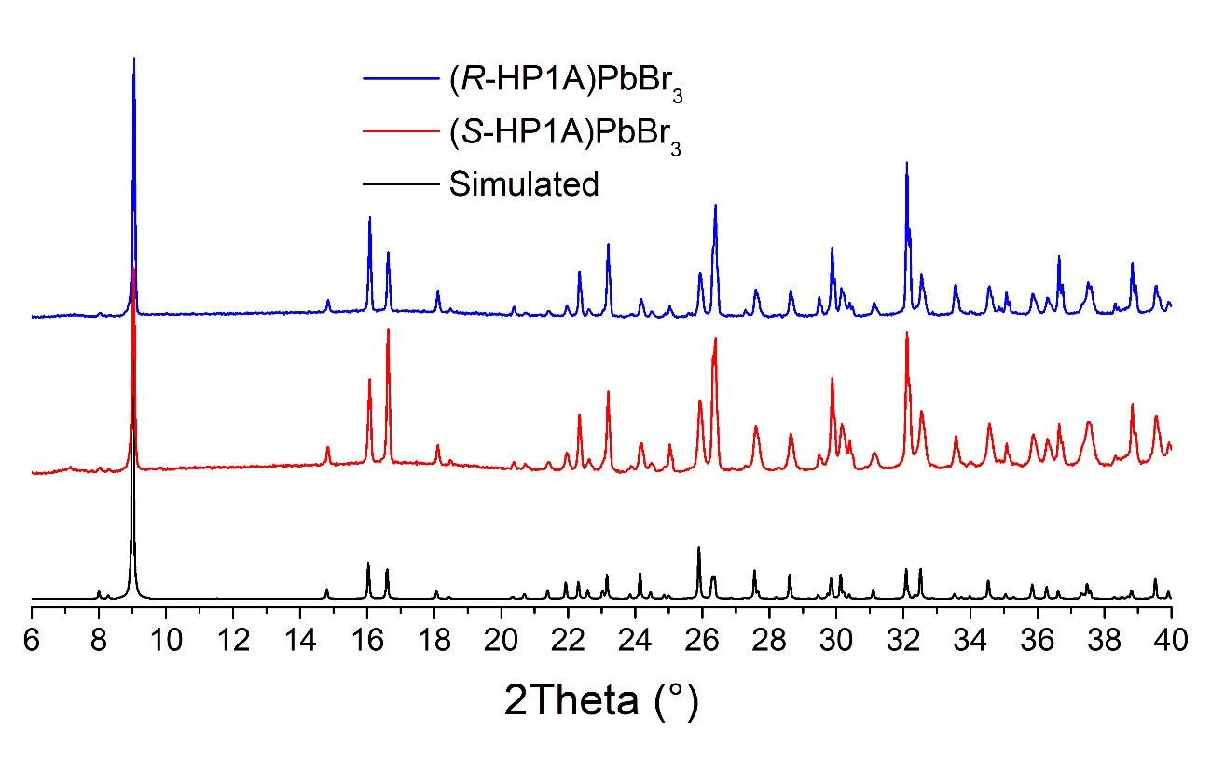
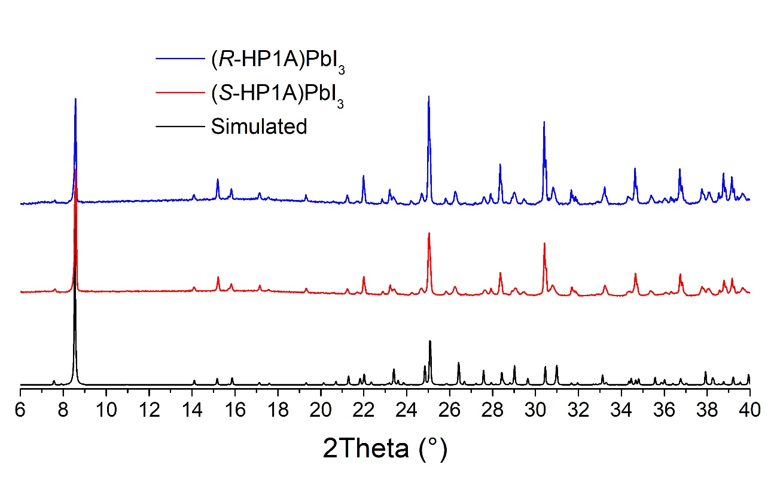
Supplementary Fig. 3 Simulated and experimental XPRD patterns for crystalline powders of (S/R-HP1A)PbBr₃ (top) and (S/R-HP1A)PbI₃ (bottom).

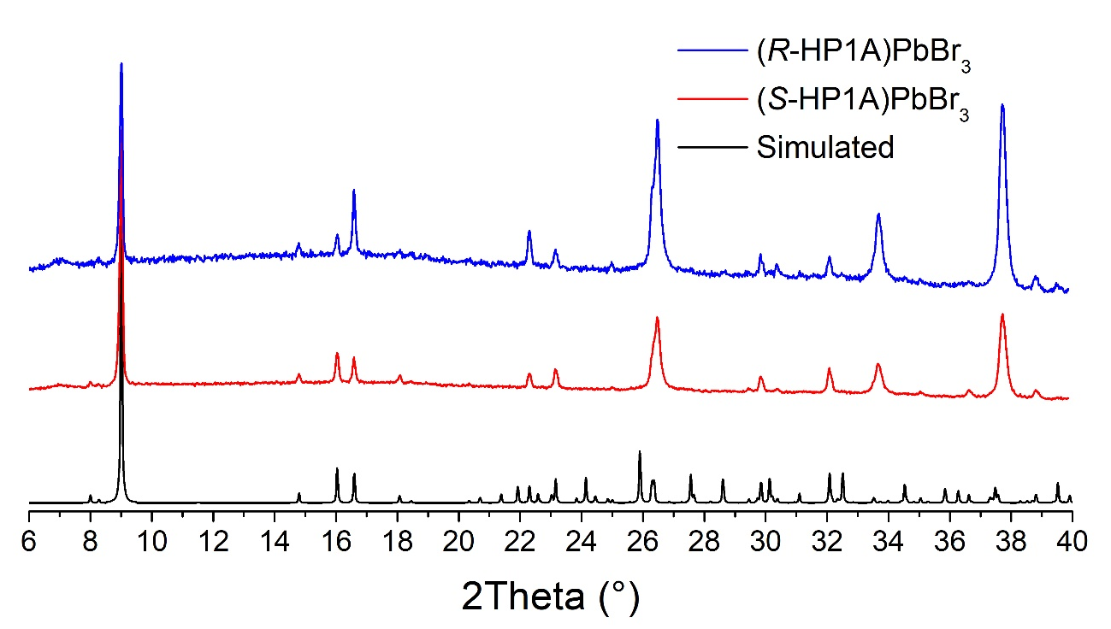
Supplementary Fig. 4 Simulated and experimental XPRD patterns for thin films of (S/R-HP1A)PbBr₃. The three peaks at 2Theta = 26.6, 33.8 and 37.8° correspond to the FTO substrate.
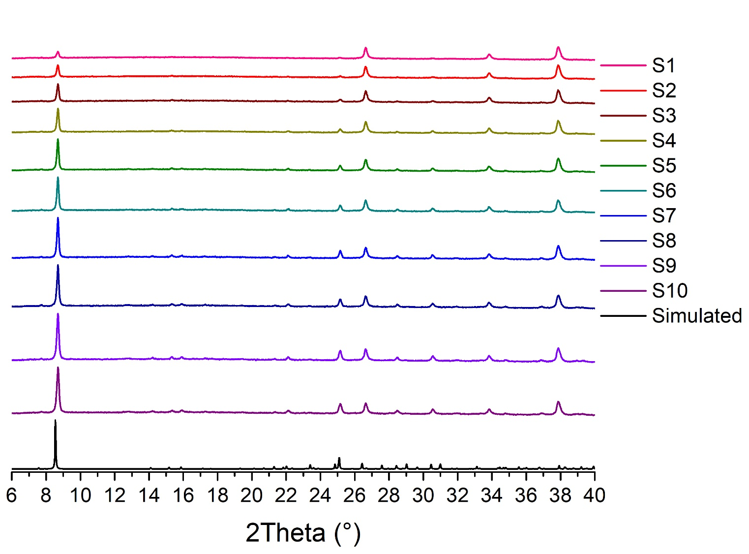
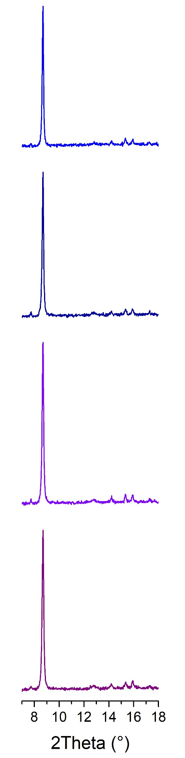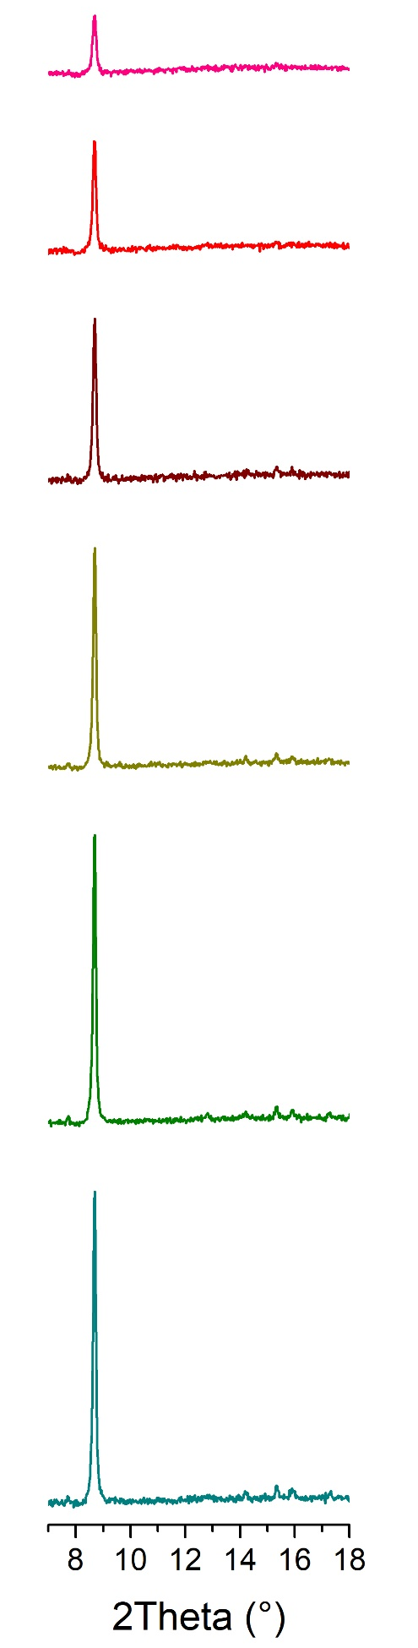
Supplementary Fig. 5 Simulated and experimental XPRD patterns for thin films of (S-HP1A)PbI₃. Top: full spectra. Bottom: zoom at the lowest 2Theta values. All patterns have been normalized based on the first peak of the FTO substrate (at 2Theta = 26.6°).
a | b
 | 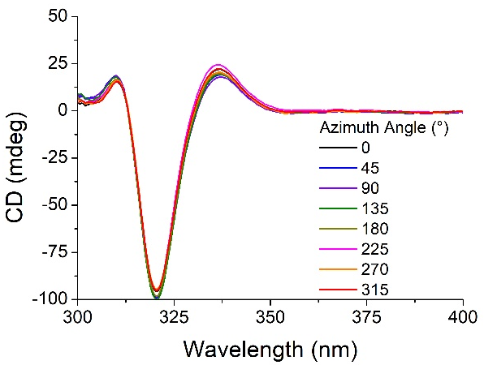
c | d
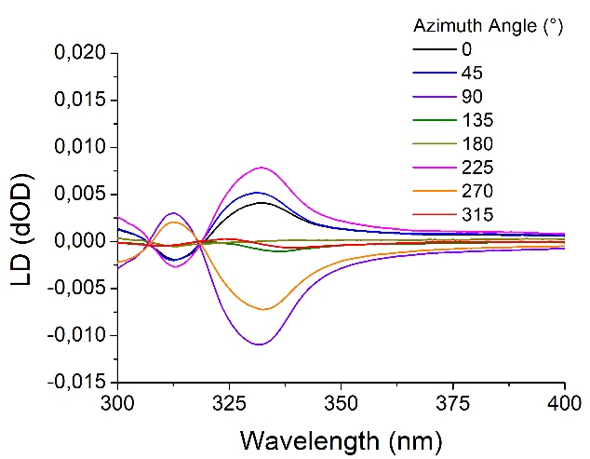 | 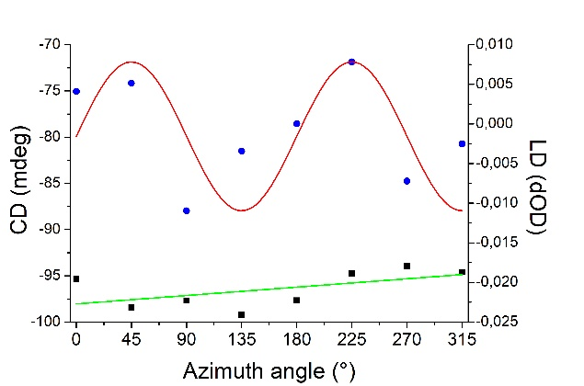
Supplementary Fig. 6 CD measurements on (S-HP1A)PbBr₃ thin film. a Representation of light propagation axis (arrow) and azimuth angles (θ). b CD measurements at various θ angles. c LD measurements at various θ angles. d Azimuth angle dependence of the CD at 320 nm (black squares) and of the LD values at 332 nm (blue circles). The green and red curves represent the linear fit of CD values and the waveform fit (sine square model) of LD values, respectively.
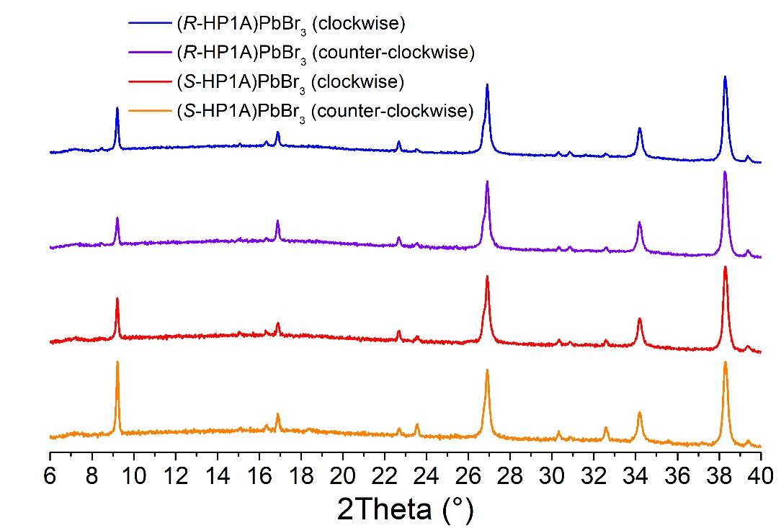
Supplementary Fig. 7 XRPD patterns for (S/R-HP1A)PbBr₃ thin films prepared under clockwise and counter-clockwise spin-coating rotation.

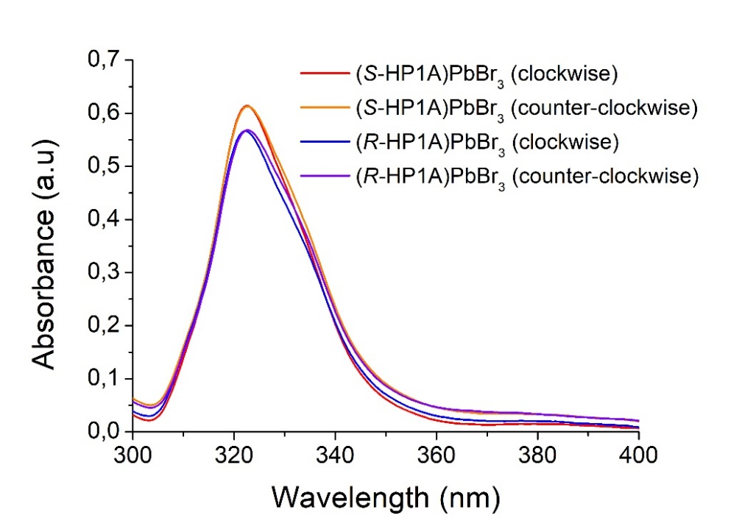
Supplementary Fig. 8 UV-Vis absorbance measurements of (S/R-HP1A)PbBr₃ thin films prepared under clockwise and counter-clockwise spin-coating rotation.
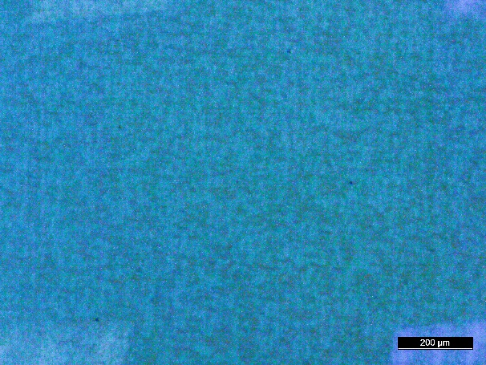 |  | 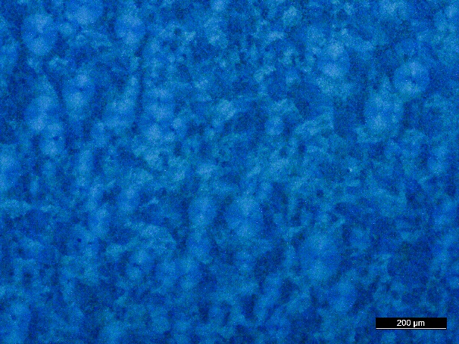
(S-HP1A)PbBr₃ (clockwise rotation) |  | (R-HP1A)PbBr₃ (clockwise rotation)
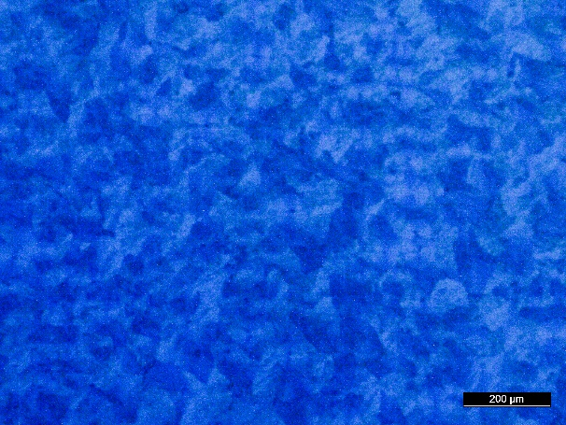 |  | 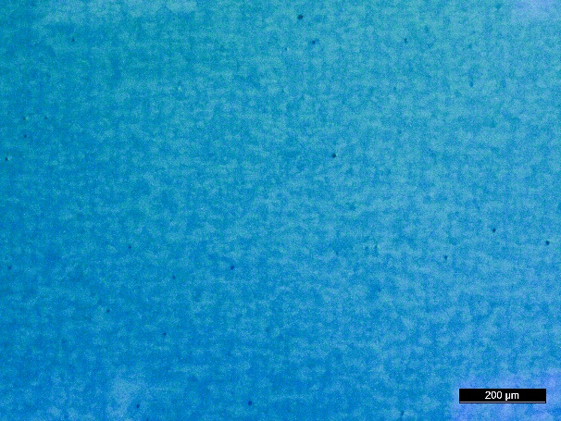
(S-HP1A)PbBr₃ (counter-clockwise rotation) |  | (R-HP1A)PbBr₃ (counter-clockwise rotation)
Supplementary Fig. 9 1.0*1.3 mm optical microscopy images under polarized light of (S/R-HP1A)PbBr₃ thin films prepared under clockwise and counter-clockwise spin-coating rotation.

Supplementary Fig. 10 CD of (S-HP1A)PbBr₃ (red lines) and (R-HP1A)PbBr₃ (blue lines) thin films prepared by deposition of the precursor solution during the spin-coating rotation. a CD measurements front and back configurations on thin films prepared under clockwise rotation. b CD_{iso} and LDLB calculated from experimental measurements in a. c, d Same for the thin films prepared under counter-clockwise rotation.
Supplementary Fig. 11 CD of (S/R-HP1A)PbBr₃ thin films at various concentrations. a CD_{iso} and b aLDLB calculated for a precursor solution at 1.0 M. c CD_{iso} and d aLDLB calculated for a precursor solution at 0.5 M. e CD_{iso} and f aLDLB calculated for a precursor solution at 0.2 M.
Supplementary Fig. 12 Absorbance and CD spectra of a (S/R-HP1A)PbBr₃ and b (S/R-HP1A)PbI₃.
Supplementary Fig. 13 CD study of (S-HP1A)PbI₃ thin film prepared from a precursor solution at 0.3 M. a CD measurements at various azimuth angles. b Azimuth angle dependence of the CD (black squares) and of the LD values (blue circles) at 416 nm. The green and red curves represent the linear fit of CD values and the waveform fit (sine square model) of LD values, respectively. c CD of (S-HP1A)PbI₃ front and back positions. The inset shows a zoom at the maximum signal.
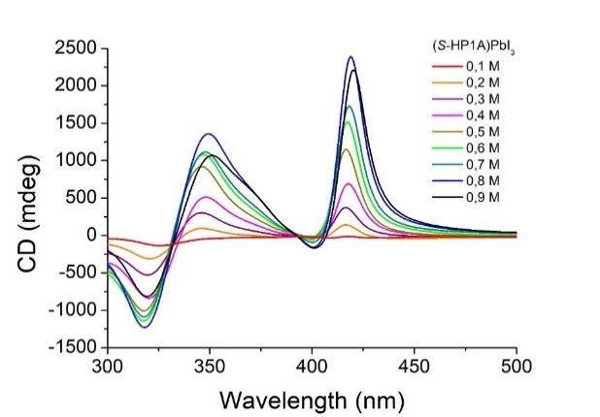
Supplementary Fig. 14 CD spectra of (S-HP1A)PbI₃ thin films at various concentrations of the precursor solution and deposited on glass substrates.
 | Unpolarized Light | Polarized Light
0.1M | 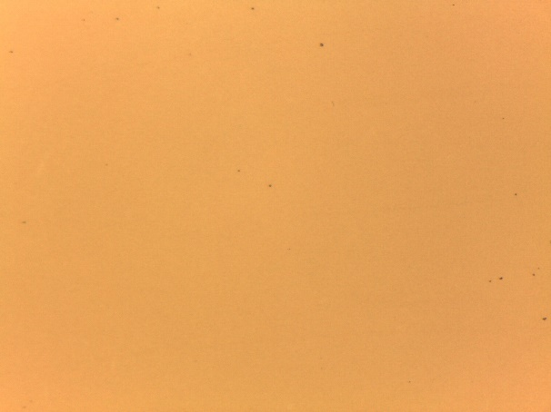 | 
0.2M | 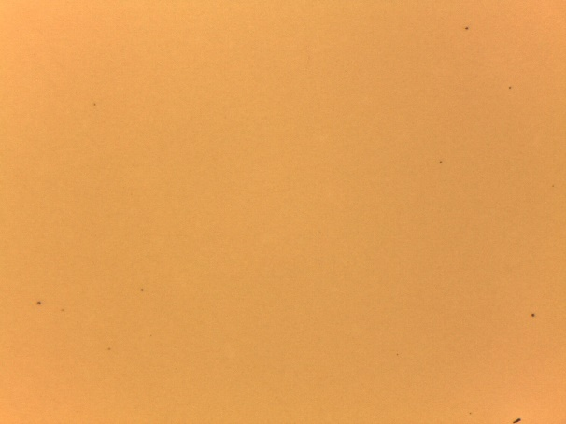 | 
0.3M | 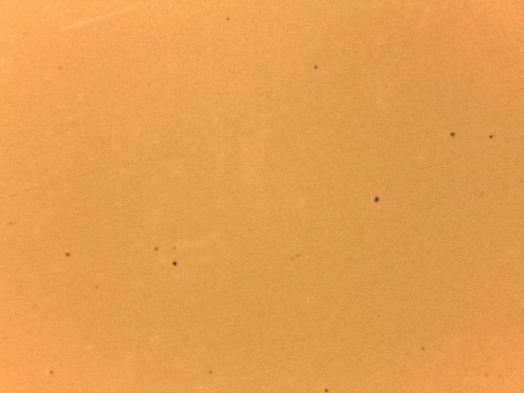 | 
0.4M | 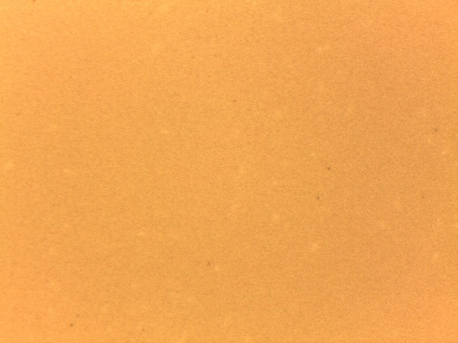 | 
0.5M | 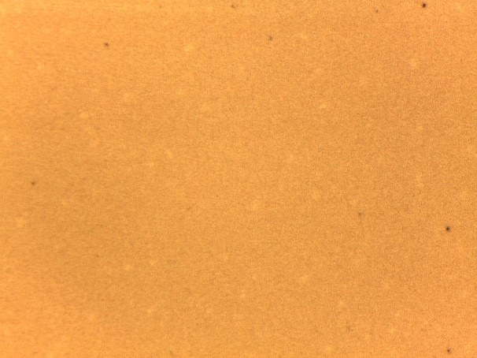 | 
0.6M | 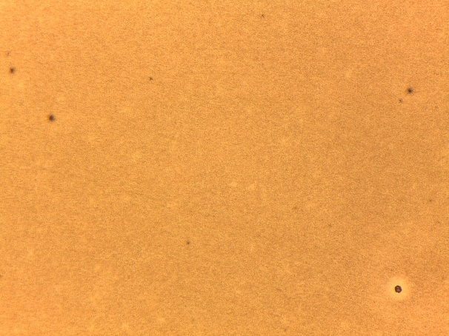 | 
0.7M | 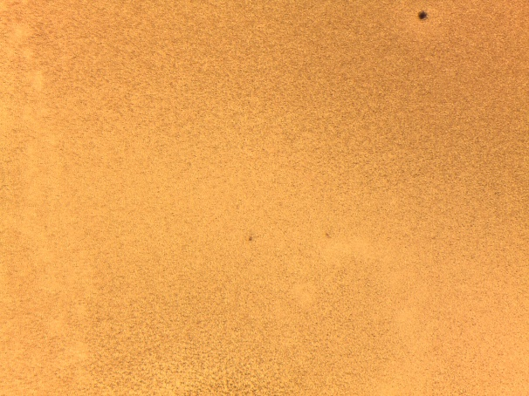 | 
0.8M | 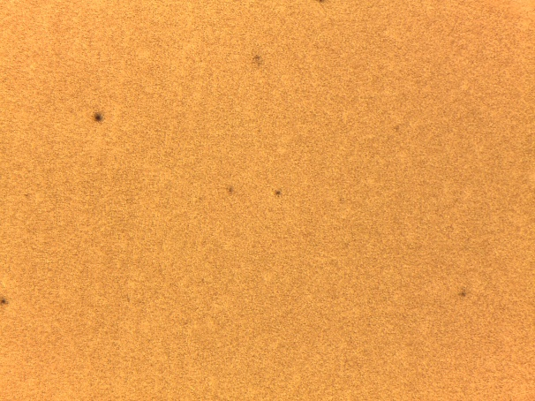 | 
0.9M | 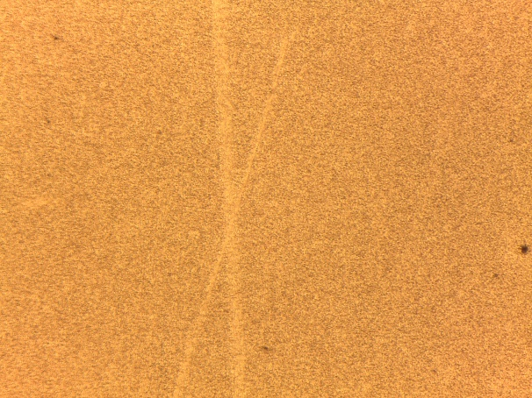 | 
1.0M | 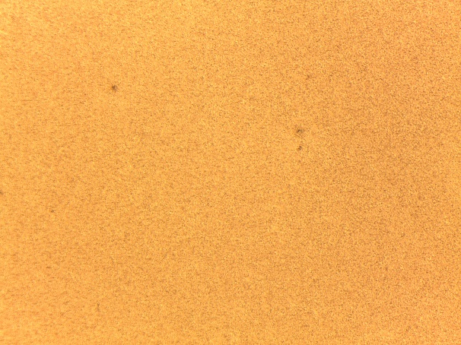 | 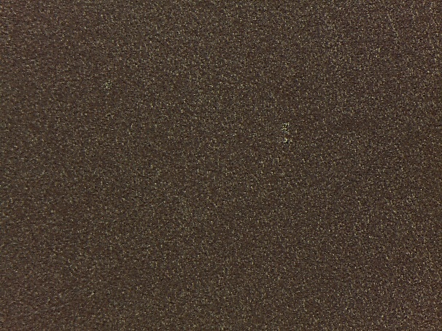
Supplementary Fig. 15 1.0*1.3 mm optical microscopy images of (S-HP1A)PbI₃ thin films prepared a each concentration of the precursor solution under unpolarized (left) and polarized light (right).

(S/R-α-PEA)PbI₃ | (R-EBA)PbI₃
a
b
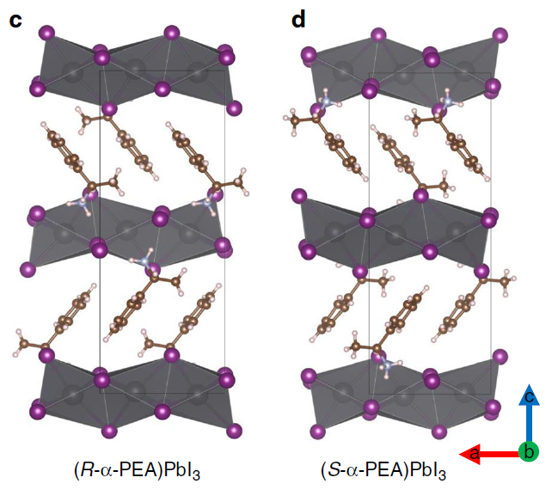 | 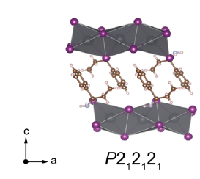
c
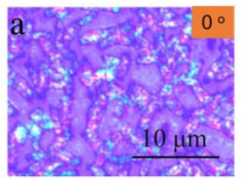 | 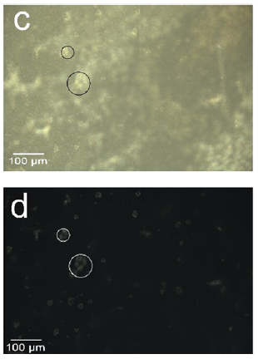
d
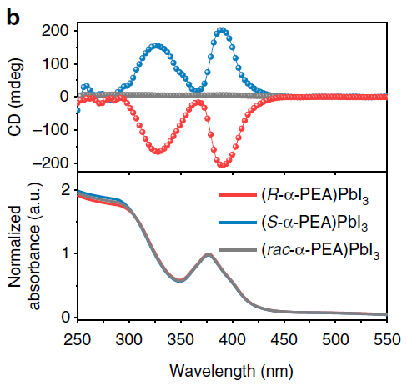 | 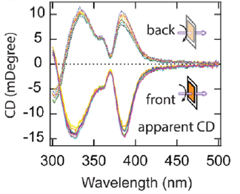
Supplementary Fig. 16 Structural and chiroptical characterization of (S/R-α-PEA)PbI₃ (left) and (R-EBA)PbI₃ (right). a Structure of the cation. b Single-crystal X-ray structure of the hybrid compound. c Optical microscopy images. d CD measurements on thin films.

Chen, C.; Gao, L.; Gao, W.; Ge, C.; Du, X.; Li, Z.; Yang, Y.; Niu, G. & Tang J. Circularly polarized light detection using chiral hybrid perovskite. Nat. Commun. 10, 1927 (2019).
Zhang, Z.; Wang, Z.; Sung, H. H.-Y.; Williams, I. D.; Yu, Z.-G. & Lu, H. Revealing the Intrinsic Chiroptical Activity in Chiral Metal-Halide Semiconductors. J. Am. Chem. Soc. 144, 22242-22250 (2022).

