Supplementary Material 1
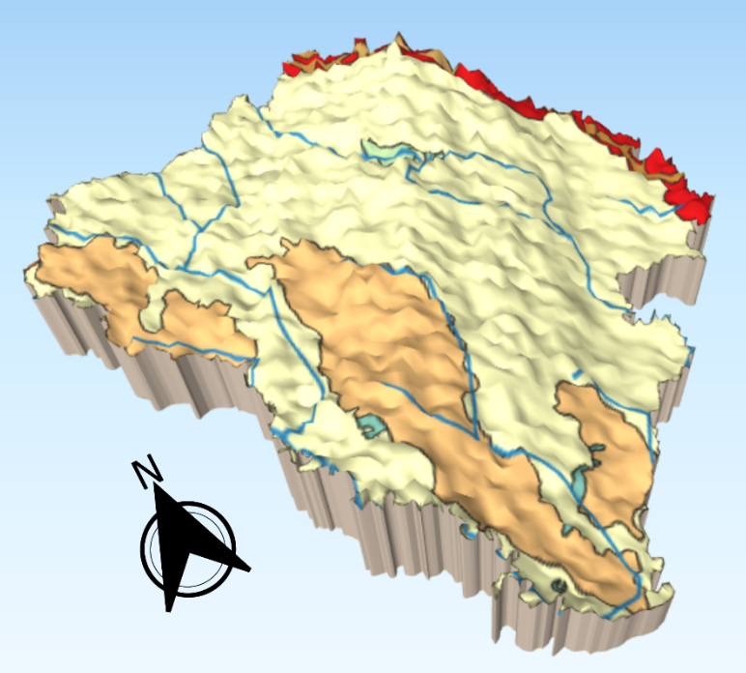
Figure 1. Elevation map of Rangpur

