Supplementary Information
Multi-modal biosensing enabled by on-chip nano-corrugated graphene
Nik Humaidi Nik Zulkarnine ¹, Vahid Faramarzi¹, Siyuan Huang^{2,3}, Narendhar Chandrasekar¹, Ramaswamy Sandeep Perala¹, Park Ju Seong⁴, Katherine Koprowski^{2,5}, Sihan Chen^{2,3}, Yue Zhang³, Sriya Darsi^{2,5}, Maher Adoni^{2,5}, Alicia Y. Kim^{2,5}, Jun Baek^{2,6}, Enrique, Valera^{2,5,7}, Jaechul Ryu⁸, Arend M. van der Zande^{2,3,6,9}, Myung Jong Kim⁴, Insu Park^{10*}, Rashid Bashir^{2,3,5,6,7,11,12*}, Michael Taeyoung Hwang^{1*}
¹Department of BioNano Technology, Gachon University, 1342 Seongnam-Daero, Sujeong-Gu, Seongnam-si 13120, Republic of Korea.
²Holonyak Micro and Nanotechnology Laboratory, University of Illinois, Urbana, IL, USA.
³Department of Mechanical Science and Engineering, University of Illinois at Urbana-Champaign, Urbana, IL, 61801, USA
⁴Department of Chemistry, Gachon University, 1342 Seongnam-Daero, Sujeong-Gu, Seongnam-si 13120, Republic of Korea.
⁵Department of Bioengineering, University of Illinois at Urbana-Champaign, Urbana, IL, 61801, USA
⁶Department of Materials Science and Engineering, University of Illinois at Urbana-Champaign, Urbana, IL, 61801, USA
⁷Carl R. Woese Institute for Genomic Biology, University of Illinois at Urbana-Champaign, Urbana, Illinois, USA.
⁸Institute of Bio & Nano Convergence, Biogo Co., LTD, Seoul, 08826, Republic of Korea
⁹Materials Research Laboratory, University of Illinois at Urbana-Champaign, Urbana, IL 61801 USA
¹⁰Department of Biomedical Engineering, Konyang University, Daejeon 35365, Republic of Korea
¹¹Department of Biomedical and Translation Science, Carle Illinois College of Medicine, University of Illinois at Urbana-Champaign, Urbana, IL, 61801, USA
¹² Department of Electrical and Computer Engineering, University of Illinois at Urbana-Champaign, Urbana, IL, 61801, USA
* Corresponding authors

Contents
Section I: Fabrication of NCGr Device 5
Supplementary Information 1.1: Plasma system configuration 5
Supplementary Information 1.2: Etching procedure 6
Supplementary Information 1.3: NCSiO₂ wafer 7
Supplementary Information 1.4: Wet transfer: graphene atop NCSiO₂ 8
Section II: Surface Analysis of NCGr 10
Supplementary Information 2.1: Full Raman spectrum to analyse the quality of monolayer graphene 10
Supplementary Information 2.2: Raman mode peak position correlation analysis 14
Supplementary Information 2.2.1: Setup 14
Supplementary Information 2.2.2: Raman peak position correlation analysis 15
Supplementary Information 2.2.3: Raman spectra of strain by substrate correlation analysis 16
Supplementary Information 2.3: AFM images of NCSiO₂ species and their respective surface roughness analyses 17
Supplementary Information 2.4: AFM images of NCGr species and their respective surface roughness analyses 19
Supplementary Information 2.5: SEM images for NCGr15, NCGr30, and NCGr45. 20
Supplementary Information 2.6: Suspension behaviour of graphene membrane 21
Supplementary Information 2.7: Height profiles of NCGr30–NCGr90 for higher etching times, with 15 min intervals 22
Supplementary Information 2.8: Wetting contact angle (WCA) measurement 23
Supplementary Notes 2.9: Wetting contact angle (WCA) measurement explanation 25
Supplementary Information 2.10: Dual pulse measurement for δn residual measurement 26
Supplementary Notes 2.9.1: Transition between capacitive effect and charge trapping 27
Section III: Device Architecture and Stabilization 29
Nano-corrugated field-effect transistor (NCGrFET) 29
Supplementary Information 3.1.1: NCGrFET setup and general experimental details. 29
Supplementary Information 3.1.2: Drain current, I_{D} vs drain voltage, V_{D}, graph (3 terminals) with V_{g} bias steps 30
Nano-corrugated microfluidic chamber electrochemical (NCGr-µL-EC) device 31
Supplementary Information 3.2.1: NCGr-µL-EC setup and general experimental details. 31
Supplementary Information 3.2.2: Capacitance measurement 32
Supplementary Information 3.2.3: CV for capacitance measurement of NCGr0, NCGr15, NCGr30, and NCGr45. 32
Supplementary Information 3.2.4: Electrochemical impedance spectroscopy 33
Supplementary Information 3.2.6: Randles equivalent circuit 35
Supplementary Information 3.2.7: Description of Randles equivalent circuit 35
Supplementary Information 3.2.8: Full spectra of CV for capacitance measurement of NCGr0, NCGr15, NCGr30, and NCGr45. 36
Supplementary Information 3.2.9: NCGr sensing chip passivation pathway via EIS technique. 37
Nano-corrugated SERS-bed–like Raman spectroscopy (NCGr-SERS) 38
Supplementary Information 3.3.1: NCGr-SERS setup and general experimental details. 38
Section IV: Extended Detection Works 39
Supplementary table 4.1: DNA sequences in DNA hybridisation detection 39
Supplementary Information 4.2: DNA hybridization protocol 39
Supplementary Information 4.3: DNA hybridization in human serum 40
Supplementary Information 4.4.1: FET device: Detection performance for types of devices 40
Supplementary Information 4.4.2: Carrier density approximation from Dirac point in I–V curve 41
Supplementary Mechanism 4.4.3: Carrier density approximation from Dirac point in I–V curve 42
Supplementary Information 4.4.4: Transfer curves of dopamine detection 45
Supplementary Information 4.4.5: Transfer curves of dopamine detection 46
Supplementary Table 4.4.6: Sequences used in dopamine detection 47
Supplementary Information 4.5: Heterogeneous isotherm models 48
Supplementary Mechanism 4.6: Electrocyclic reaction of Methylene Blue 49
Supplementary Information 4.7.1: Raman Spectroscopy: Baseline experiment using dATP protocol. 49
Supplementary Information 4.7.2: Raman Spectroscopy: dATP behaviour of SERS-like graphene bed 50
Supplementary Information 4.8: Raman Spectroscopy: Correlation coefficients between spectra 51
Supplementary Information 4.9: Raman Spectroscopy: Assignment of peaks in Raman spectra (1100–1500 cm⁻¹) 53
Section V: Refractive index (RI) based NCGr device: Simulation 54
Supplementary information 5.1: Computational details 54
Supplementary Mechanism 5.2: Preferential of CM over EM 56
References: 57

Section I: Fabrication of NCGr Device

Supplementary Information 1.1: Plasma system configuration
The illustration below shows the reactive ion etching (RIE) setup for fabricating NCSiO₂ Wafer.
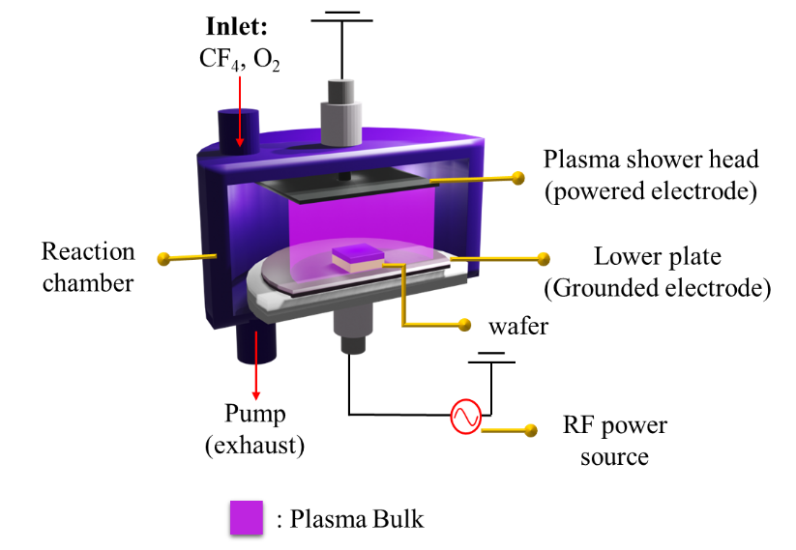
The configuration of the device is as follows.
Power (W) | 100
Frequency (kHz) | 50
O₂ (sccm) | 4
CF₄ (sccm) | 26
Pressure (torr) | ~2.71e²
Etching time (min) | 15

Supplementary Information 1.2: Etching procedure
The substrates were cleaned using a sonicator in isopropyl alcohol (IPA) for 30 min before blow-drying with a nitrogen gun, to remove any debris from the surface. The cleaning was performed prior to etching. The SiO₂/Si wafer was etched using the RIE technique under the conditions mentioned previously.
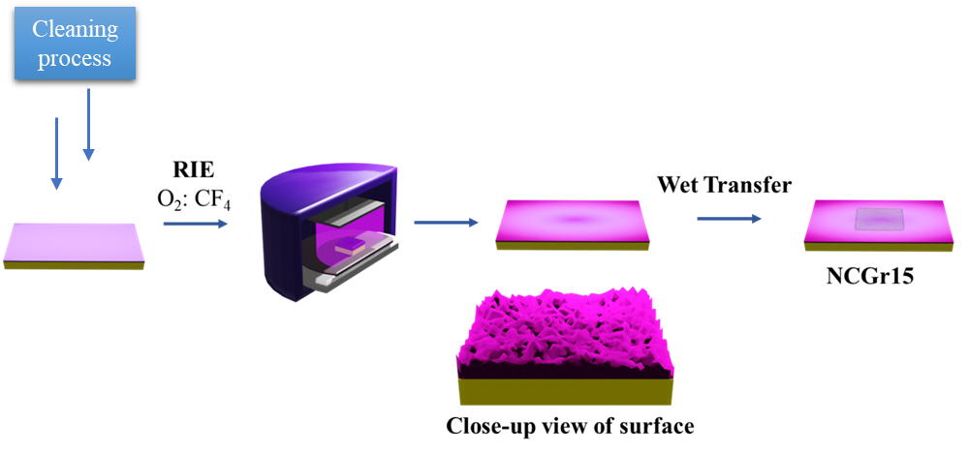

Supplementary Information 1.3: NCSiO₂ wafer
The figure below shows the colour gradient of the NCSiO₂15 substrate. We observed different gradient colours upon increasing the etching time from 0 to 45 min in 15 min intervals.
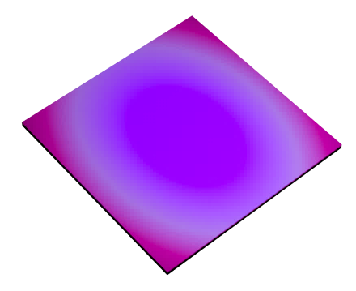
Strain induction across the surface.
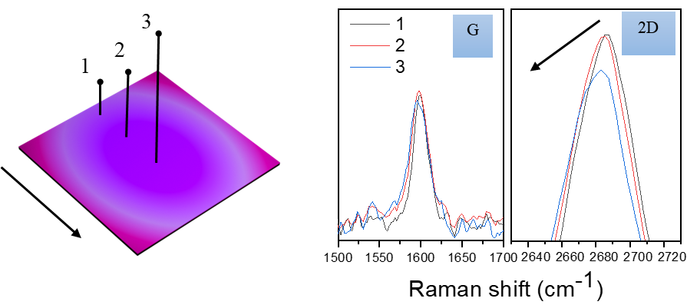

Supplementary Information 1.4: Wet transfer: graphene atop NCSiO₂
Graphene with dimensions of 20 mm × 20 mm was spin coated on a Cu film with poly (methyl methacrylate) (PMMA) at 1500 rpm for 45 s. It was further spun at 4500 rpm before being soft baked at 120 °C for 90 s. The PMMA-coated graphene-Cu was cut into 2 mm × 15 mm strips and allowed to float on top of the etchant solution for 24 h. The strips were left floating in the deionized (DI) water chamber, before being subjected to DI water jumping, as described in SI 1.6. The strips were transferred to the final DI water chamber that contained a 1% v/v IPA: DI H₂O bath. After immersion in the chamber for 10 min, the PMMA-ed strips were transferred onto the surface of the plasma-treated SiO₂ substrate. The transferred strips were blown using a nitrogen air gun to ensure adhesion between graphene and SiO₂. After transferring the PMMA-ed graphene on the etched SiO₂ chips, they were left to dry for at least 5 h, and then baked in an oven for 75 min at 200 °C. The PMMA layer was removed by soaking the chips in a 60 °C acetone bath for 20 min and rinsing with copious amounts of DI water, following which they were dried for 3 h. The graphene monolayer chips were dried using a nitrogen air gun, which also removed any debris on the top of the surface [1].
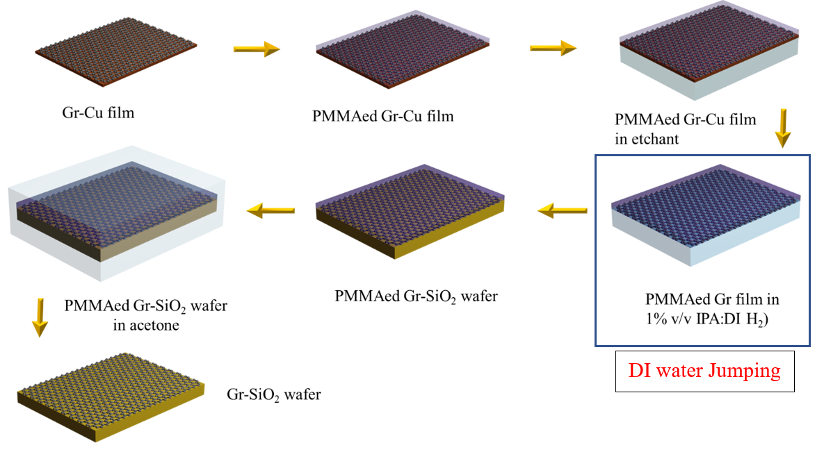

Supplementary Information 1.5: DI water jumping protocol
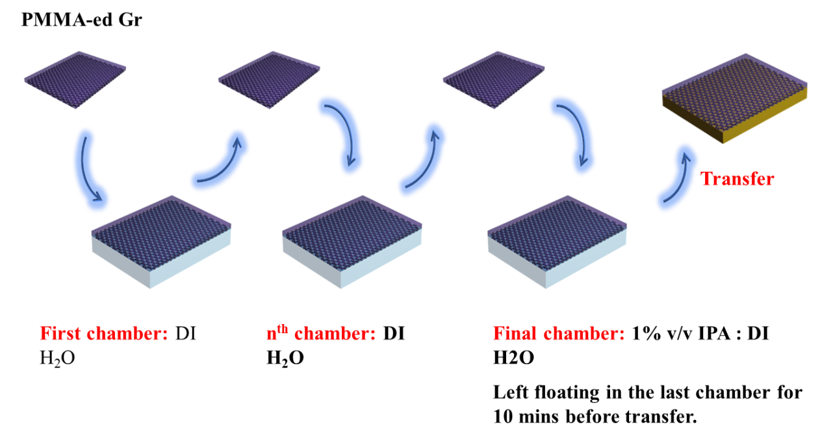
: DI H₂O

In DI water jumping, the PMMA-ed graphene strips were transferred into the first DI H₂O chamber. Subsequently, the PMMA-ed graphene strips were transferred to the subsequent n^{th} DI H₂O chamber, where n is the number of DI water chambers in the following transfer. In our case, we used five water chambers, making up seven water chambers in total, considering the first and final DI H₂O chambers. In the final water chamber, DI H₂O was mixed in 1% v/v ratio of DI H₂O to IPA solution. This allowed the surface tension of DI H₂O to reduce, consequently decreasing the graphene discontinuity in the graphene monolayer. The graphene strips in the final water chamber were left to float for approximately 10 min, before being transferred onto the NCSiO₂ wafer. The NCSiO₂ wafer in this stage was O₂-plasma treated to reduce its hydrophobicity.

Section II: Surface Analysis of NCGr

Supplementary Information 2.1: Full Raman spectrum to analyse the quality of monolayer graphene
Figure a shows red shift that occurs for both the G and 2D peaks. The shift could have been contributed by the strain induced by the underlying corrugated substrate. The strain modifies the phonon dispersion relation, which can contribute to this change. Red Raman shift depends on the corrugation degree and is programmed by the etching time. Minimal strain is experienced by graphene on a relatively flat surface, resulting in peaks at approximately 2700 (2D peak) and 1580 cm⁻¹ (G peak). The formation of apexes and trenches (by nano-corrugation surface SiO₂) modifies the phonon dispersion relation. The 2D peak position (red) reduces owing to the increase in the effective phonon mass. The G peak symbolizes disorder in graphene owing to changes in the C–C bond. Thus, the red shift occurs because of this elongation.
b illustrates the monolater in the graphene lattice by the I_{G}/I_{2D} ratio respectively.
The D peak can be observed in the following individual spectrum of NCGr0 to NCGr45. The graph consists of standard errors. Some measurements have been taken at several points. The reduction of the 2D/G peak ratio proves that PMMA residues may be present on the surface.

Left. G peak position of NCGr0 species, right position of G peak for NCGr15. Reduction in Raman intensity occurred owing to PMMA-ed surface. Spectra were measured at the device’s center.

Supplementary Information 2.2: Raman mode peak position correlation analysis

Supplementary Information 2.2.1: Setup
We performed point Raman measurements using Nanophoton Raman 11 with 532 excitation wavelength, 2400 l/mm grating and 0.50 mW laser power. The acquisition time for a single spectrum is 180s. All spectra were calibrated using reference neon lamp emission lines.
Substrate information. We fabricated a substrate with several mm-long regions of different roughness by using a 50 nm thick electron-beam deposited gold film as a hard etching mask, then performing sequential 1min to 4min plasma etching on the same substrate while using a potassium iodide gold etchant to sequentially remove regions of the hard mask. We then transferred a CVD grown graphene strip that covered all four regions. This minimizes the sample-to-sample differences induced by different batches of fabrication and graphene transfers to allow direct comparison between the different regions.

Supplementary Information 2.2.2: Raman peak position correlation analysis
We extracted strain and doping using the shift of G mode and 2D mode positions. Previous studies have shown that it is possible to correlate the strain and doping to Raman mode shift through a linear matrix operation. Here following from the analysis in reference xx, we assume the Gruneisen parameters to correlate the strain (ε, in %) and doping (n, in 1012 cm⁻²) in graphene to the Raman mode positions as:
$$ε=0.02 \left(ω_{G}- ω_{G}^{0}\right)-0.028 \left(ω_{2D}- ω_{2D}^{0}\right)$$
$$n=1.03 \left(ω_{G}- ω_{G}^{0}\right)-0.47 \left(ω_{2D}- ω_{2D}^{0}\right)$$
Here we assume ($ω_{G}^{0},ω_{2D}^{0}$) = (1590.0, 2684.8) as the starting point using the average values of the flat graphene on silicon oxide. We did this because the exact values of zero strain and doping are not well defined, depending on the sample environment. However, the variations the values defined as zero from different studies are small compared with the shifts observed in our data with increased roughness. Note that here, we assumed a uniaxial strain. The real strain will be a combination of uniaxial and biaxial strain, but deconvolving the relative contributions in samples which have both has not yet been done.

Supplementary Information 2.2.3: Raman spectra of strain by substrate correlation analysis
Raman spectra of graphene on a SiO₂/Si substrate of different roughness, R_{q} of 0.2 nm (black), 1.5 nm (red), 3.7 nm (green), and 4.7 nm (blue).
We gain a statistical view of the mode positions by performing hyperspectral Raman Mapping to measure 30 spectra within a 20 x 6 μm2 rectangle. The results are shown as the individual data points of each colour. We then apply vector decomposition to quantify the local strain and doping in the graphene, shown as the tilted orange and brown axes respectively. The orange arrow in strain axis corresponds to tensile strain and the brown arrow in doping axis corresponds to n-type doping. Here, we assume the average G mode and 2D mode peak positions of flat graphene as the reference origin. The decomposed positions of every point to the doping and strain axes show the doping and strain levels in graphene.
The data shows that increased roughness induces increased red shifts of both G mode and 2D mode in crumpled graphene, and higher variability at higher roughness. Moreover, as substrate roughness increases, the graphene Raman modes shift along the strain axis, and do not significantly change along the doping axis. Effectively, increasing the substrate roughness to Rq = 4.7 nm increases the tensile strain in the graphene by 0.28 ± 0.11 %, and the doping by -0.21 ± 3.02×10¹² cm⁻². Note that with the roughness increase, the crumpled Gr exhibits larger Raman peak positions variations. We hypothesize that the increase in variability is a result of increased to non-uniformity and variations in graphene conformation after transfer in substrates with higher roughness.

Supplementary Information 2.3: AFM images of NCSiO₂ species and their respective surface roughness analyses
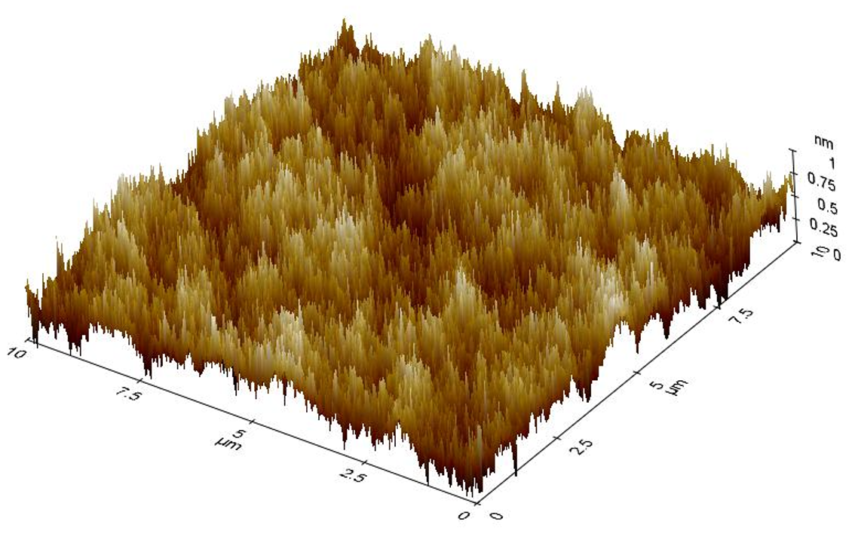 | 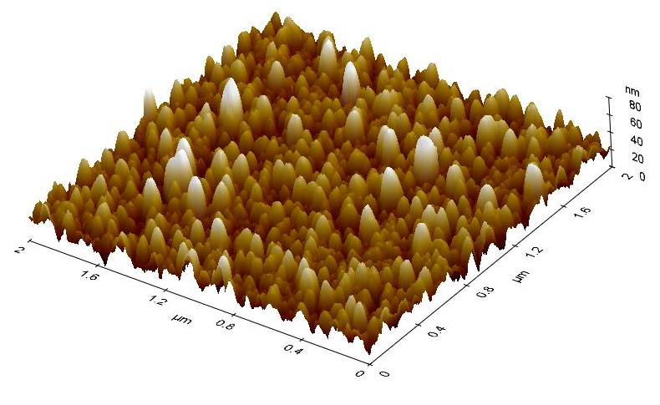
NCGr0 | NCGr15
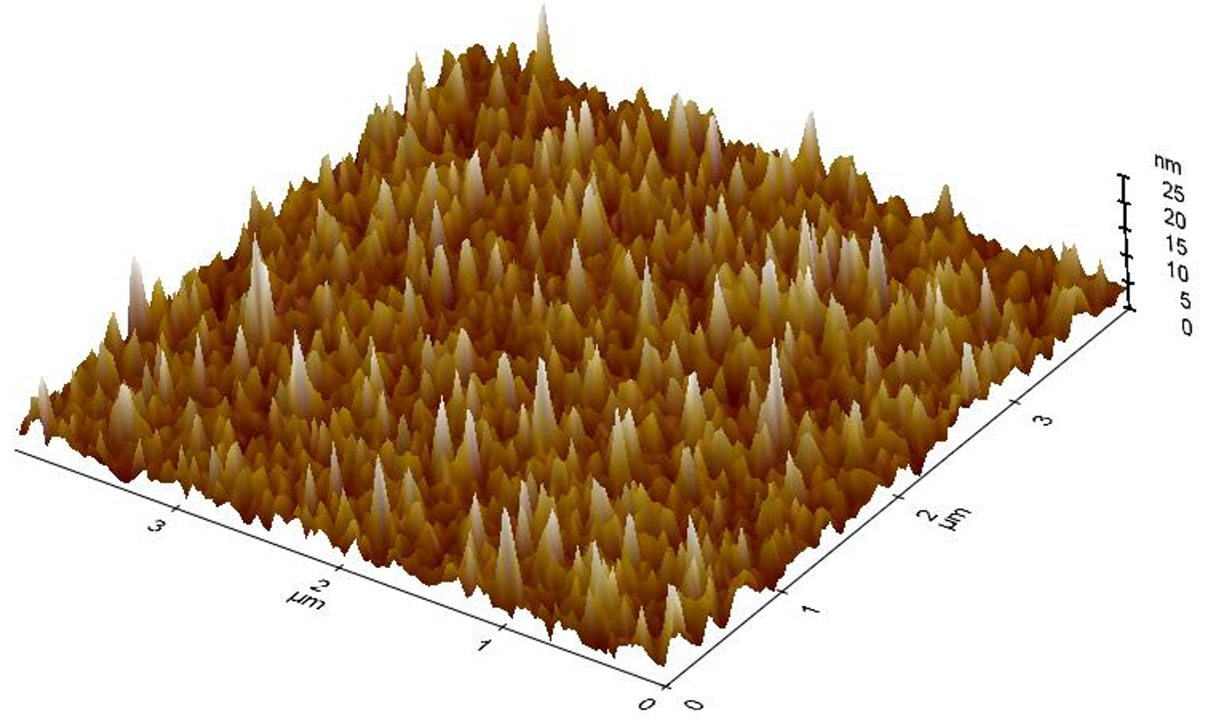 | 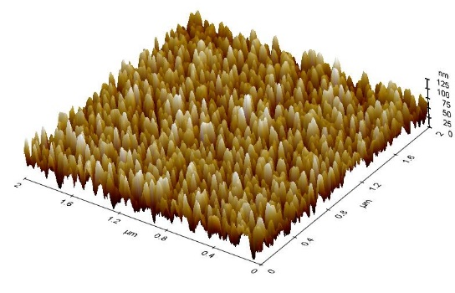
NCGr30 | NCGr45

Supplementary table 2.3.1:
We evaluated the surface roughness through three essential parameters: i) root mean square roughness (Rq), average surface roughness (Ra), and ten-point height (Rz (iso)). The changes in these three parameters are as follows.
Sample | Mean (nm) | RPV (nm) | Rq (nm)
NCGr0 | 0.466 | 0.815 | 0.152
NCGr15 | 6.517 | 25.804 | 3.819
NCGr30 | 27.312 | 46.527 | 8.932
NCGr45 | 54.520 | 85.488 | 18.339

Supplementary Information 2.4: AFM images of NCGr species and their respective surface roughness analyses
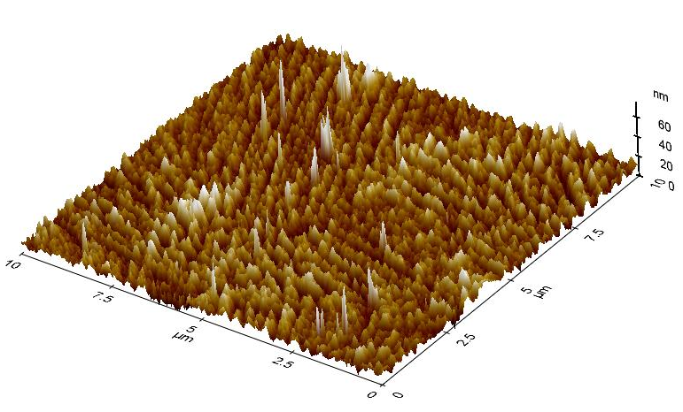
NCGr15
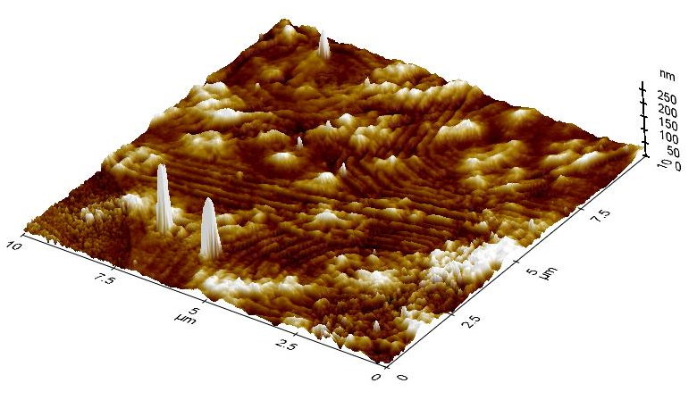 | 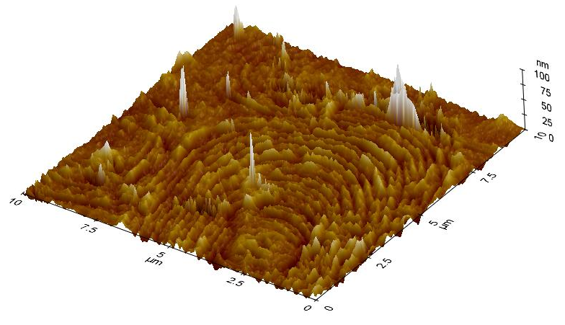
NCGr30 | NCGr45

Supplementary Table 2.4.1:
The NCGr surface roughness data are tabulated as follows:
Sample | Mean (nm) | Rq (nm)
NCGr15 | 10.482 | 4.4200
NCGr30 | 18.683 | 11.465
NCGr45 | 19.624 | 9.259

Supplementary Information 2.5: SEM images for NCGr15, NCGr30, and NCGr45.
a. | b. | c.
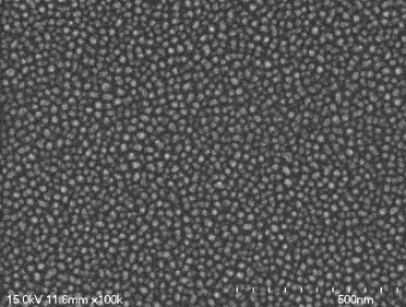 | 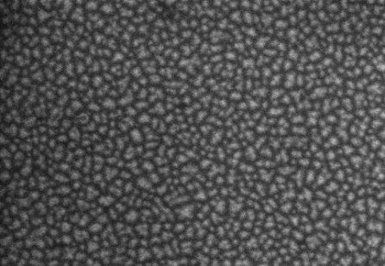 | 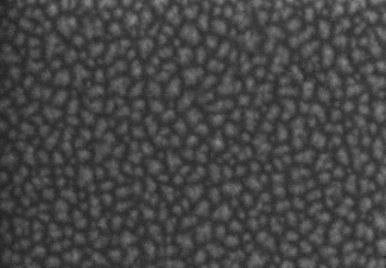
d. | e. | f.
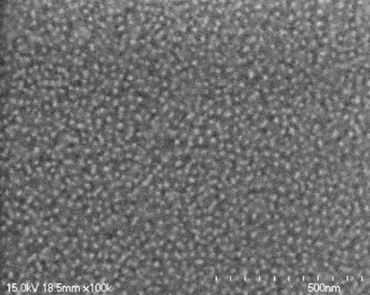 | 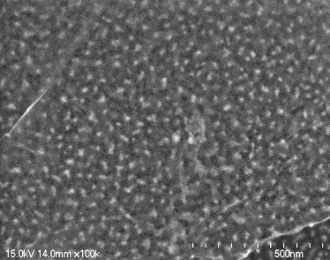 | 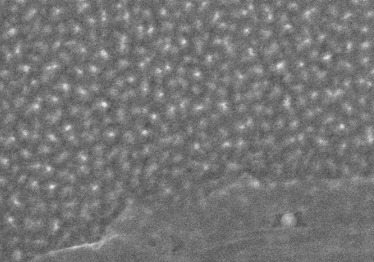
g. | h. | i.
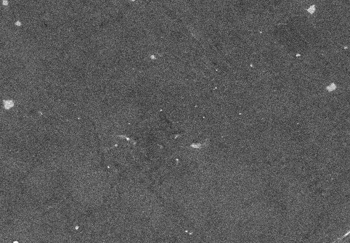 | 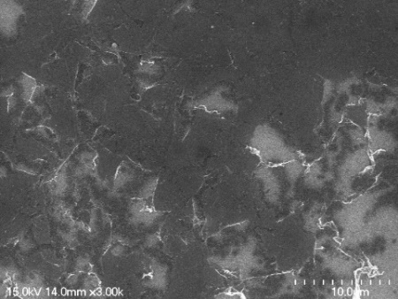 | 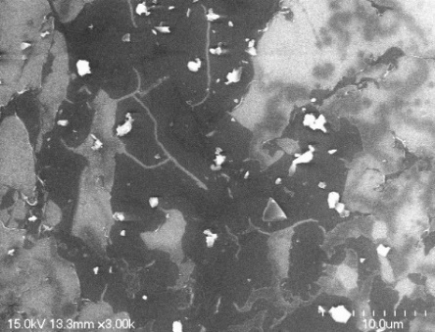
SEM images of NCGr15, NCGr30, and NCGr45 (left to right). The scale of SEM is 500 nm for (a–f) and 10 µm for (g–i). g–h shows the continuity of the graphene surface for NCGr15. In the case of NCGr30 and NCGr45, the graphene membrane failed to retain its shape.

Supplementary Note 2.5.1: SEM images for NCGr15, NCGr30, and NCGr45.
The mean surface roughness parameter was assessed for NCSiO2 under various etching durations, tetch, spanning from 0 to 45 min; we compared graphene suspensions on NCSiO₂ for different t_{etch}. For NCSiO₂ (t_{etch} = 0) and NCSiO₂ (t_{etch} = 15), a marked elevation in the height profiles of the images were observed, indicating that graphene [2] was deposited on NCSiO₂. For, graphene on NCSiO₂ (t_{etch} = 30) and NCSiO₂ (t_{etch} = 45), an abrupt reduction in surface roughness was prominent. We believe that the presence of graphene atop NCSiO₂ cannot be discounted; this is substantially supported by the comprehensive analysis of the SEM images presented in the supplementary information 2.5. Consequently, we attributed this phenomenon to the potential fracture of peaks within NCSiO₂ during the wet transfer of graphene; this aligned with our empirical evidence via the examination of the AFM height image at the spatial domain of graphene and NCSiO₂, provided in the supplementary information 2.3 and supplementary information 2.4. As higher t_{etch} was implied to SiO₂ substrate, we observed flattening in area at which graphene was deposited. Therefore, we believe higher degree of corrugation lead to fragility of peaks and from that we conclude graphene on higher t_{etch} suffer severe quality of transferred graphene.

Supplementary Information 2.6: Suspension behaviour of graphene membrane
Graphene was unable to conform into the void between the peaks of NCSiO₂ for the higher t_{etch}, owing to insufficient bending energy. Figures (a) and (b) show the mean surface roughness, Z, and average surface roughness, Ra, for t_{etch} = 30 min and t_{etch} = 45 min. They show that, either the peak is broken owing to the wet transfer or that graphene is unable to conform to its substrate mold (NCSiO₂).

Supplementary Information 2.7: Height profiles of NCGr30–NCGr90 for higher etching times, with 15 min intervals
a. | b.
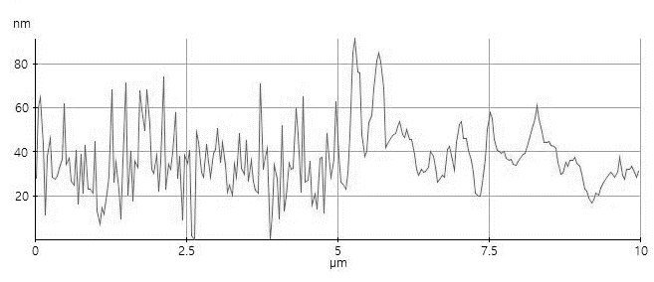 | 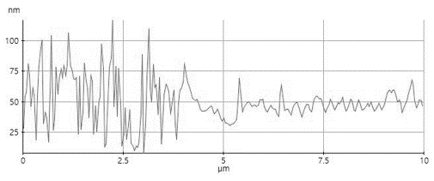
c. | d.
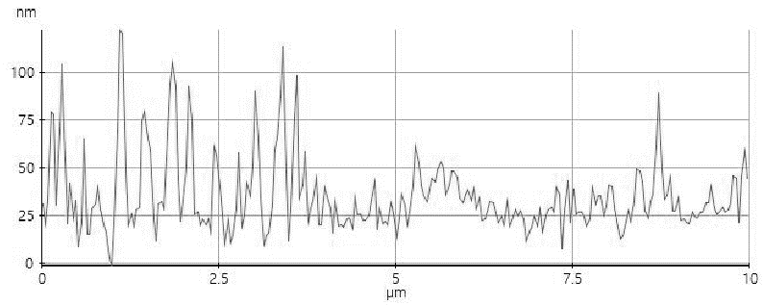 | 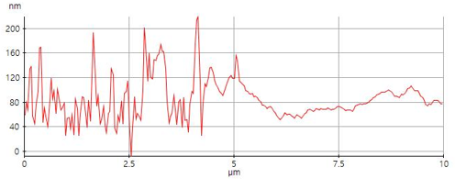
e.
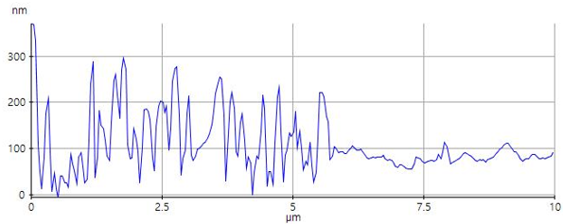
a–e, height profiles of NCGr30 to NCGr90 with 15 min intervals between different etching times. Left-hand-side region (LHSr) represents NCSiO₂ while the right-hand-side region (RHSr) represents NCGr. For a higher corrugation degree of NCSiO₂, the deposition of graphene atop NCSiO₂ causes the etched SiO₂ peak (observed in LHSr) to collapse. A smoother region (observed in RHSr) indicates suspension of graphene.

Supplementary Information 2.8: Wetting contact angle (WCA) measurement
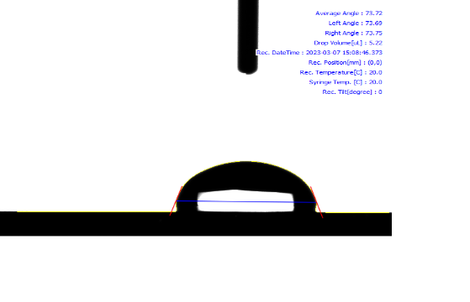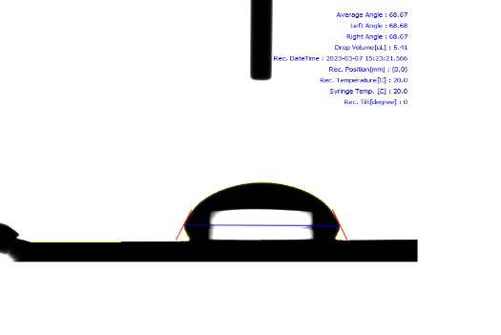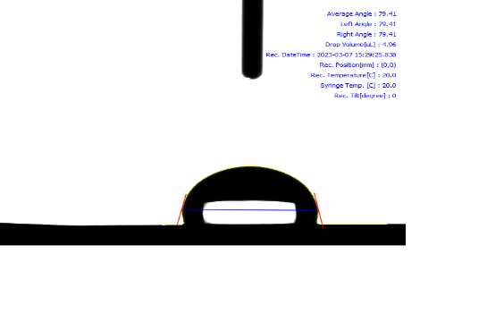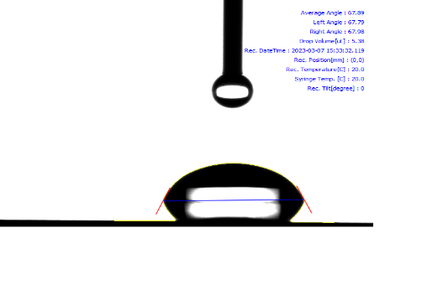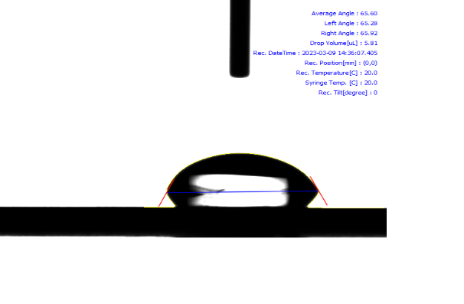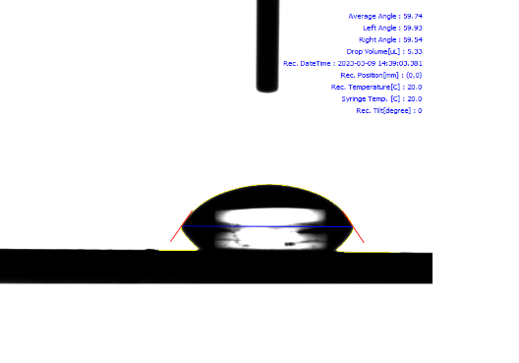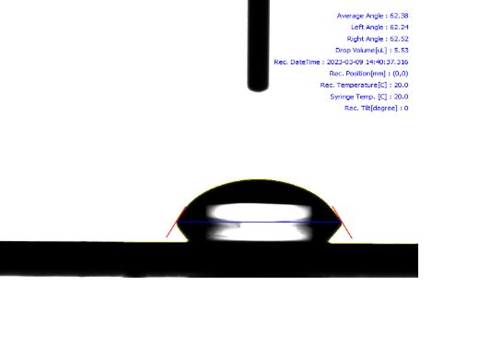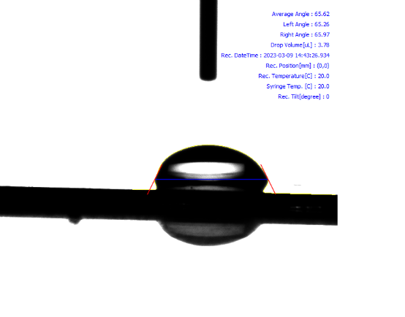
NCSiO₂0
NCSiO₂15
NCSiO₂30
NCSiO₂45
NCGr0
NCGr15
NCGr30
NCGr45
a.
b.

Measurement of contact angle for etched SiO₂ surface (a) for 0–45 min and (b) contact angle of NCGr(0–45), which were probed exactly on top of graphene, excluding the interaction with the substrate. Measurements were taken several times and the distribution of the measured contact angles were obtained and plotted (c). d is the average contact angle, CA_{ave}, for both surfaces (SiO₂ and graphene).
a. | b.
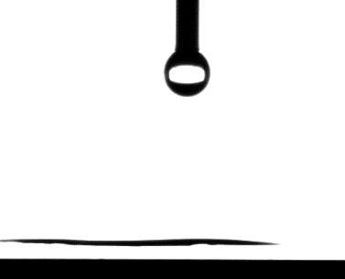 | 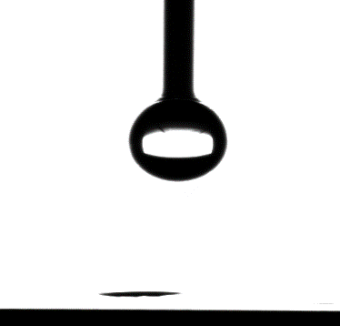
c. | d.
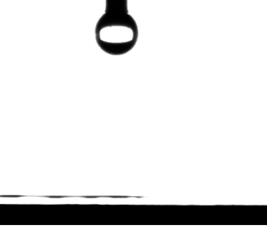 | 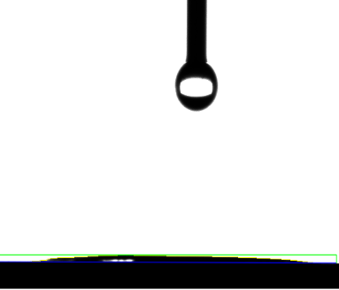

Elimination of graphene’s contact angle due to oxygen plasma surface treatment. (a–d) represent NCGr0,15, 30, and 45, respectively [3].

Supplementary Notes 2.9: Wetting contact angle (WCA) measurement explanation
We conducted measurements of the wetting contact angle (WCA) to elucidate the impact of water interactions on NCGr; this is shown in the supplementary information 2.8. Our findings align with those reported in, [4] revealing that there is no discernible significant trend for the WCA for the pretreated hydrophilic substrate. This outcome fails to corroborate our expectation, which posits that the hydrophobicity of NCSiO₂ and NCGr should increase with surface roughness. Our interpretation of these results is that the observed behaviour may be attributed to a stabilizing effect on surface hydrophilicity, as depicted in the supplementary information. This shift in behaviour can potentially be traced back to the utilization of IPA during the cleaning and transfer of graphene, as outlined in [4, 5] Consequently, we emphasize the imperative need for the surface to exhibit a sufficient degree of hydrophilicity to prevent delamination during the subsequent fabrication processes. We calculated the surface energies for NCGr0 and NCGr15, employing Girifalco–Goo–Fowkes–Young equation,
$$γ_{G}= \frac{[γ_{w}+(1+cosθ)]}{γ_{2}^{d}}$$ | (1)
We found that the values for the surface energies of both NCGr0 and NCGr15 is 121.63 and 137.46 mJm⁻², respectively.

Supplementary Information 2.10: Dual pulse measurement for δn residual measurement
Scan rate | 0.5 Vs⁻¹ | 0.05 Vs⁻¹ | 0.005 Vs⁻¹
0
15
30
45
Transition | Capacitive effect |  | Charge trapping

Supplementary Notes 2.9.1: Transition between capacitive effect and charge trapping
To analyse the change in behaviour, we measured the current loop (comprising forward and reverse currents) under ambient conditions to understand the hysteresis in the NCGr platform, which could impact device accuracy. The I–V curve of the source–drain current, I_{DS} as a function of the top gate voltage (V_{T}) for NCGr, without molecular designation atop graphene, shows an increase in hysteresis. Hysteresis, defined as a shift in the V_{CNP} forward curve from the V_{CNP} reverse curve, is explained by two co-existing mechanisms.
Primarily, negative hysteresis is attributed to the memory effect of the electrical double layer (EDL) caused by ionic movement in the graphene/electrolyte interface. As the scan rate increases (0.005 to 0.5 Vs-1), the hysteresis shifts from negative to positive, associated with the transition from capacitive gating to charge trapping. For NCGr0, the difference is minimal, prompting an investigation into whether charge trapping is dominant for higher corrugation degrees of NCGr. We propose that this charge trapping originates from beneath the graphene membrane. The broadening of positive hysteresis distance between forward and reverse curves indicates the presence of SiO2 broken peaks or underlying contamination, aligning with the increase in device resistivity (Fig 2b). Breakage of peaks in AFM images suggests the need for further investigation. Hence, we conclude that overall device resistivity is influenced by this phenomenon. The progression of the n shift of V_{CNP} is not from PMMA residual[6]; however, the n-shift from NCGr0 to NCGr15 can be attributed to the elimination of p-doped behaviour from the etching process itself. The hysteresis of the forward–reverse curve was calculated and tabulated. Here, hysteresis is defined as the cause of charge trapping due to impurities and defects. The degree of corrugation directly correlates with the obtained hysteresis; higher corrugation impedes charge carriers' free movement through the graphene surface [3, 7]. The presence of oxide traps induced by defects contributes to hysteresis.
When a voltage is applied, electrons flow across the graphene channel from source to drain. Some electrons may become stranded in oxide traps at the interface between the oxide layer and graphene channel, altering the device's electrical properties and causing hysteresis in the I–V curve. Hysteresis signifies the difference in residual charges in the graphene channel generated by sweeping the voltage gate to measure the drain–source current with a biasing drain voltage. The asymmetrical graph is likely due to the unbalanced charging of electrons and holes, mitigated by the use of fast pulse I–V sweeping to minimize charge contribution in the high-k dielectric. [2, 8]

Section III: Device Architecture and Stabilization

Nano-corrugated field-effect transistor (NCGrFET)

Supplementary Information 3.1.1: NCGrFET setup and general experimental details.
All electrical measurement experiments were conducted by sweeping the voltage gate, Vg, from 0.00 to 0.5 V, using a semiconductor parameter analyser (Keithley 4200A-SCS Parameter Analyzer) on a probe station comprising three source measurement units (SMUs). These SMUs were assigned to the source, drain, and Ag/AgCl electrode (acting as the gate to the 1X PBS buffer solution). To overcome the wettability issue of hydrophobic graphene, the graphene channels in the FET devices were incubated in 1X PBS approximately 5 h prior to the measurement. Here, 50 µL of 0.1 M HCl was introduced to the surface for 30 s to remove the possible oxide formed on the surface. Then 50 µL of 0.1 mM NaOH was used to neutralize the acidic surface of graphene, and it was allowed to sit on the graphene channel for 30 s before being rinsed with copious amounts of DI water.
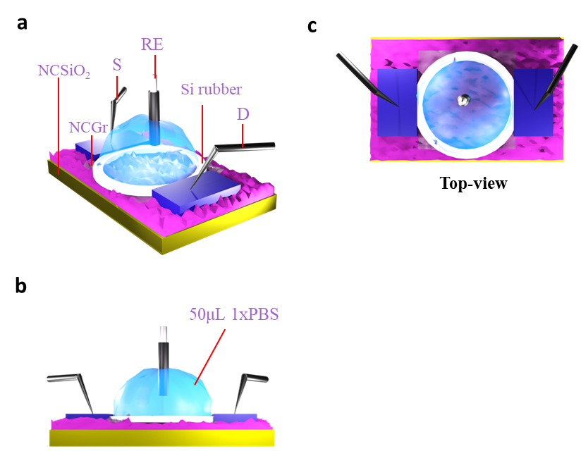

Supplementary Information 3.1.2: Drain current, I_{D} vs drain voltage, V_{D}, graph (3 terminals) with V_{g} bias steps

Nano-corrugated microfluidic chamber electrochemical (NCGr-µL-EC) device

Supplementary Information 3.2.1: NCGr-µL-EC setup and general experimental details.
a show the configuration of NCGr- NCGr-µL-EC setup. The electrochemical system setup emphasized the three-electrode configuration, that is, it was equipped with pure platinum wire, Pt, as the counter electrode (CE), Ag/AgCl electrode as the reference electrode (RE), and the NCGr platform as the working electrode (WE). All electrochemical experiments were performed using an SP-240 Biologic potentiostat. Layers in the µL-EC device was characterized by electrochemical impedance spectroscopy (EIS). The electrochemical experiments were conducted in a microfluidic chamber of 1X PBS (pH = 7.4) solution consisting of 4 mM of Fe(CN)₆⁴⁻ /Fe(CN)₆³⁻ redox couple illustrated in inset b and d. The solution containing electrochemical active species (Fe(CN)₆⁴⁻ /Fe(CN)₆³⁻ and Methylene Blue, MB) was prepared beforehand and continuously stirred in dark chamber and will be used throughout the experiment.
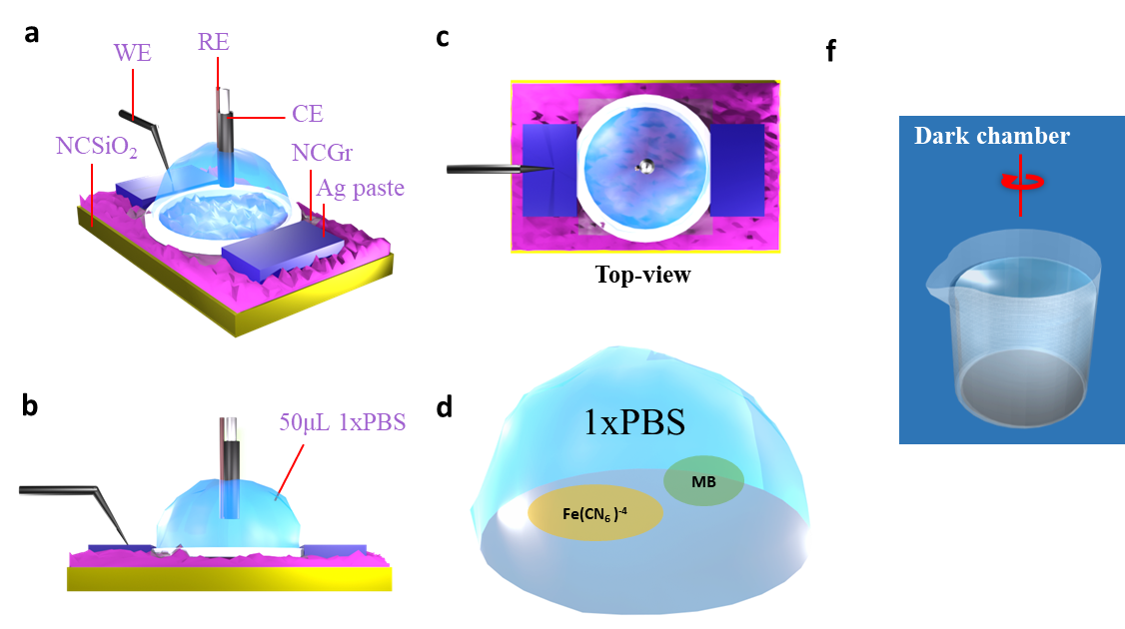

Supplementary Information 3.2.2: Capacitance measurement
The capacitance was measured using the setup mentioned in Section 3.2.1. NCGr species from t_{etch} = 0 min to t_{etch} = 90 min were investigated. Cyclic voltammetry (CV) was performed to measure the capacitance values of the NCGr platform. The CV curves were obtained by sweeping from -0.2 to 0.0 V at scan rates of 20–1000 mVs⁻¹.

Supplementary Information 3.2.3: CV for capacitance measurement of NCGr0, NCGr15, NCGr30, and NCGr45.

(a–d) show the individual capacitance behaviours with their respective capacitances EDL for NCGr0, NCGr15, NCGr30, and NCGr45, respectively. C_{EDL}-NCGr0 = 2.943 ± 0.083 µFcm⁻², C_{EDL}-NCGr15 = 2.428 ± 0.016 µFcm⁻², C_{EDL}-NCGr30 = 1.429 ± 0.035 µFcm⁻², and C_{EDL}-NCGr45 = 1.190 ± 0.214 µFcm⁻².

Supplementary Information 3.2.4: Electrochemical impedance spectroscopy
To visualize the processes occurring on top of the NCGr surface, we performed EIS experiments. A Nyquist plot was obtained and plotted as -Im (z) vs real impedance, Re (z), collected over the frequency range of 100 kHz to 0.1 Hz with 10 mV AC voltage and -0.31 V DC voltage [9, 10].
a. | b.
c | d.
Supplementary table 3.2.5: Randles circuit component values

NCGr0
R1 (Ω) | R2 (Ω) | R3 (Ω) | CPE1 | CPE2
0.01 | 3038.450162 | 490322.030404 | 81.925374 nsº/Ohm | 281.093219 nsº/Ohm
 |  |  | 0.633548 (alpha) | 0.967015
NCGr15
R1 (Ω) | R2 (Ω) | R3 (MΩ) | CPE1 | CPE2
0.01 | 5252.57 | 1.52976 | 790.673 nsº/Ohm | 330.502 nsº/Ohm
 |  |  | 0.505747 (alpha) | 0.846328

Supplementary Information 3.2.6: Randles equivalent circuit
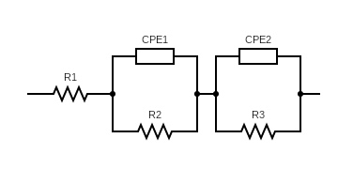
Randles circuit obtained from Nyquist plot fitting.

Supplementary Information 3.2.7: Description of Randles equivalent circuit
Explaining the detailed of the EIS procedure and data. First, the Randles circuit was used to describe the processes occurring on the NCGr electrochemical system’s interface by elucidating the impedance responses of the passivation components in µLEC-NCGr. First, we studied the interactions of the bare surface (for both surfaces) with the redox molecules. There are a few components in the Randles circuit model, such as the solution resistance, R_{S}, charge-transfer resistance, R_{CT}, and double-layer capacitance, C_{EDL}, where the electrodes store charges. The first curvature for each of NCGr0 and NCGr15 illustrates the double layer capacitance, C_{EDL}. It is worth noting that this capacitance behaviour is related to its modification through nano-structuring. From the capacitance data, we can see that the Faradic current is depleted with increase in t_{etch}, showing a reduction in the capacitance value. Therefore, the distortion of the first curvature forbids it to be well defined, essentially indicating that C_{EDL} is higher.
Additionally, in the first semicircle, the lack of proper definition indicates that the system is kinetically facile in which interface processes can occur quickly and easily owing to the low energy barrier. The formation of two curvatures indicates that finite diffusion has occurred. This diffusion can be illustrated by the transmission line along with the interfacial resistance, R_{int}. The second curvature depicted is formed whenever diffuse particles enter the passivation molecule film atop NCGr, and it stops diffusing at the point at which the curvature ends. NCGr15 curvatures end somewhat later (at a lower frequency) than that of NCGr0, indicating the formation of a thicker film [10, 11].

Supplementary Information 3.2.8: Full spectra of CV for capacitance measurement of NCGr0, NCGr15, NCGr30, and NCGr45.
a.
c.
d.
b.
(a-d) CV spectra that show electrochemical behaviour of NCGr0, NCGr15, NCGr30, and NCGr45.

Supplementary Information 3.2.9: NCGr sensing chip passivation pathway via EIS technique.
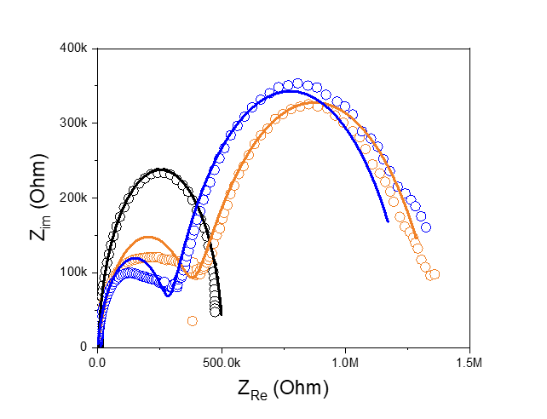
i.
ii.

Supplementary Information 3.2.10: further explanation through interfacial behaviour
In the Nyquist plot Fig 2d-f, the fitting circuit fits well with the proposed Randles circuit. The value of each circuit component is tabulated in the supplementary table 3.2.5. An increase in the overall semicircular diameter of NCGr15, from that of NCGr0, indicates an increase in the charge-transfer resistance. NCGr15’s semicircular EDL is distorted, and deviates from the ideal semicircle that is observed in the case of NCGr0. Owing to complexity of the Nyquist plot, the interfacial processes (Bode plots in Fig 2e and Fig 2f) are explained further. The capacitive and resistive properties of EDL are distributed in a complex manner. Each EDL partition is explained (i.e., Helmholtz region and diffuse layer) independently, and portrayed in terms of an impedance equation. The structure of Helmholtz layer gravitates toward sluggish charge transfer. This effect is dominant throughout the intermediate frequency, from a very low frequency. First, in the φ vs f graph. both electrodes behave, resistively in the constant phase element, CPE region when the φ (f < f_{H}) value < 0, at which f_{H} is Helmholtz frequency. Yet, NCGr15’s impedance curtail is lifted. The ECS spectrum shows that sluggish transfer agrees with the behaviour in the Bode plot. When the surface is rough, the ions navigate around the protrusions and travel through deep curvatures, reaching the electrode surface. In the Helmholtz region, softening of the first phasor peak indicates an increase in charge transfer resistance, R_{CT}, followed by peak suppression meanwhile a slight increase in |Z| is observed, and the mentioned capacitive behaviour of NCGr15 is somewhat depleted [12]. The ionic mobility (an effect of electrolyte concentration, C_{e}) factor is governed by the diffusion layer; its effect is dominant after the crossover frequency, at which the uplifted bump, φ minima in the pseudo-Gerischer region is likely a result of a relatively slow diffusion process (smaller diffusion coefficient (D) value) in the diffused partition, as C_{e} is constant throughout experiment; the interface also reacts in pseudo-Gerischer response. We noticed that a perturbed pseudo-Warburg response (φ < 45°) emerged at high frequencies.
Fig. 2g-i shows the complex capacitance (ECS) spectrum consisting of C_{re} and C_{im}. In C_{Re} vs. ω, the accessibility activity at which low ω and high ω explain the penetration into airgap; emergence of curtailed at low ω was briefly tell possible pathway of electrolyte into trenches. However scattering of points were observed in low ω, was a result of travel barrier of ion penetration[13]. The emergence of another tail at higher ω, provides insight into the impenetrable electrolyte into trenches, thus mass transport occurred touching outer curvatures of NCGr15[14]. The dielectric relaxation time, τ_{D}, is extracted from C_{im} vs ω, that is C_{im}(ω) is maxima. The τ_{D} value related to the interfacial relaxation of EDL is 708.08 µs and 1003.172 µs for NCGr0 and NCGr15, respectively. We further study interfacial processes atop the NCGr species, and the changes in the capacitive behaviour are significant for each surface. The impedance response of the NCGr species contains anomalies, complexity of impedance response inclusive fractality morphological factors dependent was employed.

Nano-corrugated SERS-bed–like Raman spectroscopy (NCGr-SERS)

Supplementary Information 3.3.1: NCGr-SERS setup and general experimental details.
Graphene characterization. The spectra were measured using a HEDA 250 3D confocal Raman Spectroscopy. For the characterization, all spectral components were centered at 1500 cm⁻¹ whereby the G and 2D peaks were probed in the wavenumber range of 1450–2500 cm⁻¹. A 1200 gr mm⁻¹ grating was used along with the 532 nm Neon LASER and 100% ND filter was used. Graphene sites were exposed for 10 s prior to the measurement and a single acquisition mode was set to obtain the spectra. Several sites were characterized to ensure the uniformity of NCGr across the surface. The experiment was repeated several times. The ratio of G/2D peak was calculated. The SERS-based device configuration is presented below.
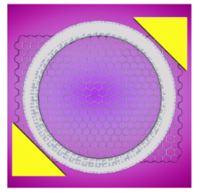
DNA Hybridization detection. All spectra were obtained by using the same Raman spectrum. The spectra were centralized at 1500 cm⁻¹ with a 1200 gr mm⁻¹ grating. We used a 532 nm Ne LASER with 11.1 mW power and 15 s exposure time. The objective lens used was 20x; thus, we increased the power to suit the measurement needs. Samples were dried 2 h prior to every measurement.

Section IV: Extended Detection Works

Supplementary table 4.1: DNA sequences in DNA hybridisation detection
Nomenclature | 5’ termini | DNA sequence
pDNA (22-mer) | NH₂- | 5’- TGA GGT AGT AGG TTG TGT GGT T -3’
tDNA (Let-7b) | - | 5’ AAC CAC ACA ACC TAC TAC CTC A-3’

Supplementary Information 4.2: DNA hybridization in human serum
In this experimental setup, the device is stabilized exclusively by the use of undiluted human serum, without any involvement of 1X PBS.

Supplementary Information 4.3.1: FET device: Detection performance for types of devices
The detection curves for NCGr0, NCGr15, NCGr30, and NCGr45 are presented. Depletion and saturation occur at high concentrations of tDNA (Let7b), which perturb the performance of NCGr30 and NCGr45.

Supplementary Information 4.3.2: Carrier density approximation from Dirac point in I–V curve
d.
b.
a.
c.
Carrier density approximation from Dirac point in I–V curve | (a–d) show the transfer curves for NCGr0, NCGr15, NCGr30, and NCGr45, respectively. The devices were introduced to 100 µM of tDNA, and the shift to the p region was achieved. As there were no biorecognition molecules at this point, the graphene directly interacted with the graphene surface, utilizing its π–π interactions. A greater shift from left to right was observed after tDNA passivation of the NCGr15 device. The pDNA was allowed to sit on each NCGr surface for 3 h before measurement.
The Dirac point shift for 1 fM < M(tDNA) possesses a quantum origin as proposed in ${ΔV}_{D} = \frac{eN_{DNA}^{unscreened}+e{∆n}_{bandgap}}{C_{T}}$. The bandgap was predicted to be higher because of the nanoscale elongation strain, which disturbs the atomic arrangement quite efficiently. Nanosized features allow more access for the DNA molecule to bind to the surface, owing to the increased additional conformational molecular adhesion on the corrugated surface of NCGr, with the increase in the density of states (DOS)[15]. Hwang et al. calculated the partial DOS for 2.45 nm narrow trenches of deformed graphene. With the DFT simulation result, the lowest binding energy was obtained as -532.187 Kcal mol⁻¹ between DNA and the graphene sheet. Furthermore, Zhang proposed, based on DFT studies[16], that a low protrusion amplitude increased the band gap value (~0.8 eV) and DOS. The increasing DOS was dominant between the edges (in our case, the peak) and bottom of curvature; the middle portions exhibited equivalent p-x and p-z states, which meant that higher states were available. In the partial DOS in Hwang et al.’s model of uniaxial graphene with 2.45 nm trenches, the contributions of the p-x and p-z orbitals are dominant, unlike the case of flat graphene where p-x is the sole contributor. We could see the migration of the conduction band that is geometrically dependent, away from its fermi level. If we use the charge density cross section of Zhang et al.’s solution, the binding mechanism can be understood to be because the preferable space is neither in the trenches nor peak; rather, it is in between these two positions, owing to the availability of p-x and p-z states. If the biaxial strain is considered, p-y too must be dominant.

Supplementary Mechanism 4.3.3: Carrier density approximation from Dirac point in I–V curve
To investigate the lowering of the detection limit of our NCGrFET chip, we studied the carrier mobility of our device and found that NCGr15 had higher carrier mobility, compared to NCGr0. The nanoconfinement in NCGr15’s surface topology perturbed the portability of ions from the electrolyte into its valley, reducing the electrostatic ionic screening and ensuring that the charges on the surface were not neutralized by the charged particles in the vicinity [15]. Our experiment was inspired by the work of Dontschuk et al. [17], wherein the carrier charge density of 100 µM Let-7b on NCGr15 was 42.49e µCcm⁻², which was higher than that of NCGr0 (0.22e µCcm⁻²), producing a larger Dirac point shift of 0.18 and 0.075 V for NCGr15 and NCGr0, respectively. We probed the shifts in the transfer curves for NCGr30 and NCGr45; however, they were not as significant for a large concentration of Let-7b. Charge-density experiments were performed by measuring the transfer curve. The 100µM of Let-7b thrown directly on surface similarly in [18], the relative Dirac shift obtained was considered and carrier density was calculated using equation (5). We utilized the π–π stacking interactions between the nucleobases in ssDNA (5’- TGA GGT AGT AGG TTG TGT GGT T -3’) and graphene [19].
 | $$∆V= \frac{∆n}{eC_{T}}$$ | (2)
$∆n,∆V,$and $C_{T}$ are the charge-carrier density, relative shift of Dirac points of V_{CNP} (Charge neutralisation point) from the Dirac point due to the Let-7b presence, and gate capacitance, respectively [4]. The carrier mobility affects the sensitivity of our NCGrFET chips by introducing nano-corrugations, as it shows the facile flow of charge carriers (electron and holes) moving across the graphene fluidic channel, relative to the applied electric field. Random nanofeatures on graphene suppressed the possibility of scattering corresponding to the movement of charge carriers through the graphene-lattice interface. The deposition of Let-7b on graphene in NCGr15 led to the accumulation of negatively charged Let-7b, mainly, in the valley of NGr15, while the uncharged molecules remained on the crest [20]. The adsorption of DNA was favoured in the concave region, evidenced by its highest adsorption energy when compared to that of the other regions [15]. These negatively charged valleys served as electrical hotspots induced by the trapped DNA, improving the depleted electrical conductivity of NCGr15. It is worth noting that ssDNA can induce large electrical potential gradients whenever it is proximal to the conductive surface of graphene, as the charges coming from the backbone and nitrogenous bases ssDNA. Upon correlating the surface potential distributions on the graphene interface, it becomes clear that NCGr15 possesses nano-corrugations, which in turn distribute the surface potential uniformly across the graphene lattice. Here, charge carriers experience lesser scattering from the local potential variations that arise from defects or impurities present in NCGr0 [21]. The planar graphene channel in FET often suffers severe ionic charge screening, which is affected by the high ionic strength of the 1X PBS solution, which perturbs its performance at a lower analyte concentration. The architecture of nano-corrugations on the graphene monolayer surface forbids this hurdle by extending the Debye length, enabling more DNA molecules to be captured by simply increasing the surface area for interaction. The AgCl electrode used as the top gate is attached to the fluidic chamber in which the EDL layer allows coupling between graphene and the gate [22]. The approximate thickness of the EDL was studied by estimating the Debye length, L, by measuring its capacitance. We found that the value of capacitance decreased with the formation of nanofeatures. The correlation of the total capacitance and Debye length is presented in the following equation:
 | $C_{T}= \frac{ε_{r} ε_{0} A}{L}$, | (3)
where $L$is the Debye length and $ε_{r,} ε_{0}, and A$ are the permittivity of material, permittivity of free space, and electrode area, respectively. The extended $l$ reduces the counter ions’ screening near the surface and facilitates the adherence of analytes of interest on the surface of NCGr15, compared to screening effect coming from flatness of NCGr0. The Debye length characterizes sensitivity of NCGrFET, as interactions of the biomolecules and graphene sensor are determined by the thickness and strength of the electric field in the EDL.

Supplementary Information 4.3.4: Transfer curves of dopamine detection
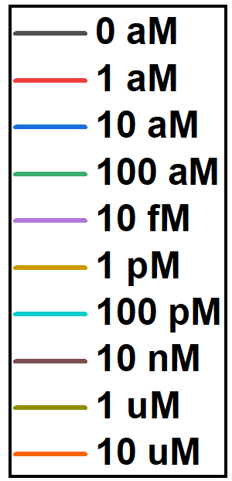
a
b
Example transfer curves after incubation in increasing dopamine concentrations for (a) NCGr0 and (b) crumpled NCGr with roughness Rq = 3.9 nm. Dirac point shift ΔV_{D} is defined as the Dirac point position after 1hr incubation in a given concentration - the Dirac point position at fresh 0.1x PBS (0 aM dopamine). We observe that dopamine binding induces the downshift of the Dirac point for NCGr(3.9 nm): around 330 mV to 315 mV for the NCGr0 and around 225mV to 197mV for the crumpled NCGr(3.9 nm).

Supplementary Information 4.3.5: Transfer curves of dopamine detection
Shift of the graphene Dirac point as a function of dopamine concentration for both crumpled graphene (in orange, data from 3 samples) and flat graphene (in black, data from 3 samples). Dopamine is diluted in 0.1x PBS.
Detection Environment:
- Electrolyte – 0.1xPBS
- Roughness of NCGr – 3.9 nm

Supplementary Table 4.3.6: Sequences used in dopamine detection
Nomenclature | 5’ termini | DNA sequence
pDNA (22-mer) | 5AmMC6 | CG ACG CCA GTT TGA AGG TTC GTT CGC AGG TGT GGA GTG ACG TCG
tDNA (Let-7b) | - | Dopamine Hydrochloride  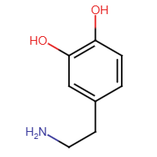 ∙HCl

Supplementary Information 4.4: Heterogeneous isotherm models
Based on the work of Hwang et al., we used the sips model, in which the second-order Langmuir isotherm model is used to describe the heterogeneity binding and saturation of DNA adsorption on the NCGr surface, to obtain a better understanding of the manner in which DNA hybridization occurs at an interface. In our experiment, NCGr15 comprised higher saturation current, with a relatively similar area of graphene exposed to the analyte, as in Hwang et al.’s works. However, we noticed changes in the association constant, a value that indicates the distribution of the adsorption energy of the DNA isotherm [23].
 | NCGr15 | NCGr0
Current saturation, A | 0.145 V | 0.075 V
Heterogeneity index, a | 0.154 | 0.436
Dissociation constant, K_{d} | 1.12e-11 M | 9.71 M

Supplementary note 1.x: Assessing the heterogeneity in Let-7b-pDNA binding.
We calculated the sips fitting curves by using the following sips isotherm expression,
$${∆V}_{CNP}\left(V\right)=A (\frac{{\left(\frac{c}{K_{a}}\right)}^{a}}{1+{\left(\frac{c}{K_{a}}\right)}^{a}} )$$
The parameters used in this study to fit the sips curve are tabulated in supplementary information 4.5. We realized that a value is much smaller than NCGr0, indicating the heterogeneity of the binding of Let-7b- pDNA. Whenever a =1, the binding affinity of the interacting molecules shall be homogenous. A higher heterogeneity index predominantly allows better understanding of the diversity in binding between Let-7b-pDNA. Thus, we believe that it is related to unperturbed number of conformations atop the corrugated surface rather than a normal surface [24].

Supplementary Mechanism 4.5: Electrocyclic reaction of Methylene Blue

$$MB (k_{1}) ⇌{MB}_{1} (k_{-1})$$ | EC.1
$${MB }_{1}+{2e }^{-}+H^{+}⇌{LB}_{1}$$ | EC.2
$${LB}_{1}(k_{2}) ⇌LB (k_{-2})$$ | EC.3
$$LB+2{Fe\left(CN\right)}_{6}^{3-}\left(k_{3}\right)⇌MB+ 2{Fe\left(CN\right)}_{6}^{4-}+H^{+}$$ | EC.4

Supplementary Information 4.6.1: Raman Spectroscopy: Baseline experiment using dATP protocol.
A droplet containing approximately 5 mM of dATP was deposited on both PBASE and non-PBASE passivated surfaces. While SERS was absent on NCGr0, it was clearly observed on NCGr15. In this context, dATP served as a baseline for the adenine peak, which is of primary interest for DNA detection.

Supplementary Information 4.6.2: Raman Spectroscopy: dATP behaviour of SERS-like graphene bed
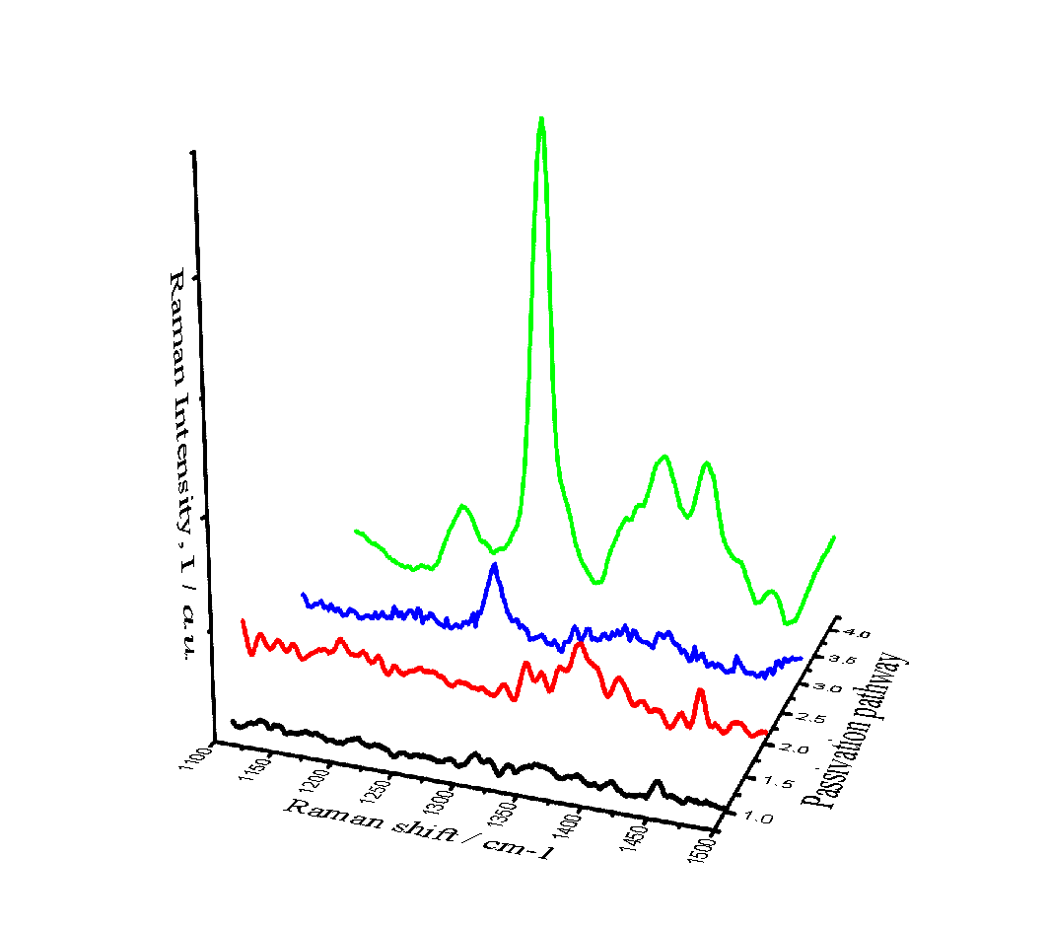
Raman spectra of adenine deposition for baseline investigation | Aromatic adenine breathing vibration lies at ~1300, 1350, and 1375 cm⁻¹. The vibrations of adenine resonate with cytosine and thymine vibrations. We used NH2- 5’- TGA GGT AGT AGG TTG TGT GGT T -3’, which is almost adenine-free. Thus, through the introduction of target DNA (5’- AAC CAC ACA ACC TAC TAC CTC A -3’) that is rich in adenine, we suspect that the assigned peak intensity will increase. In our experiment too, these three regions vibrate sufficiently to create a baseline for DNA detection. Black, red, blue, and green lines (front to back) represent NCGr0-Adenine, NCGr15-Adenine, NCGr0-PBASE-Adenine, and NCGr15-PBASE-Adenine, respectively [25].
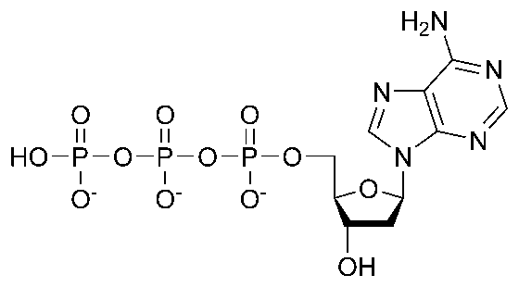

Supplementary Information 4.7: Raman Spectroscopy: Correlation coefficients between spectra
We are quantitatively analysed the consistency of spectral sets for the detection of Let-7b molecule. By emphasize the following equation to reduce the possibility of false correction, all spectra were treated following the Savitzky–Golay 2nd derivative method with the 2nd order polynomial, beforehand. Twenty-five points were taken per device at a randomly selected point. Note that the Raman mapping technique at this stage is not suitable as the working area (in which DNA is introduced) is large. The selection of the spectrum is without bias indicating that every point with the probability of finding DNA adherence (P_{FP} indicating presence (P_{FP}=1) and absence (P_{FP}=0)) was considered. In this calculation, the range of 1100–1450 cm⁻¹ was considered, prior to the peak of interest. The calculations were run using python-based code.
$$P_{i,j}^{α,β}=\frac{\sum_{k=1}^{W}{(I_{i}^{α}\left(k\right)- \overline{I_{i}^{α}})(I_{j}^{β}\left(k\right)- \overline{I_{j}^{β}})}}{α_{i}^{α}σ_{j}^{β}}$$
$$Γ^{α,β}=\frac{\sum_{i=1}^{M}{\sum_{j=1}^{N}{P_{i,j}^{α,β}}}}{MN}$$
Here, α and β signify the pDNA sample and pDNA-Let-b pair (at n concentration where n = 1 aM, 1 fM … 1 nM). i and j indexes represent the spectra measured based on the α and β substrates, respectively, and M and N are the total numbers of spectra. The cross-correlation coefficient, $Γ^{α,β},$ is illustrated as follows, for a concentration pair.
The pDNA spectra’s $Γ$ value was calculated using individual off-diagonal correlation coefficients, equated as follows.
$$Γ=\frac{\sum_{i=1}^{M}{\sum_{j=i+1}^{N}{P_{i,j}}}}{N(N-1)}$$
Here, $Γ^{α,β}$ justified that the distinguishable spectral variation is much higher at lower concentrations of aM, fM, pM, and nM pairs, indicating that detection can be performed. There are no significant changes in the pDNA spectrum; thus, this proves sufficient homogenous pDNA saturation ($Γ^{pDNA}$= 0.8915). Thus, P_{FP} shall be 1 throughout the surface [26].

Supplementary Information 4.8: Raman Spectroscopy: Assignment of peaks in Raman spectra (1100–1500 cm⁻¹)
SERS support | Range | Raman shift (cm⁻¹) | Assignment | Ref.
graphene | ~1300 cm⁻¹ | 1375 | A, C, T | Insu park et al[25]
graphene | ~1300 cm⁻¹ | 1325 | A | Insu park et al[25]
graphene | ~1300 cm⁻¹ | 1310 | A | Insu park et al[25]
graphene | ~1200 cm⁻¹ | 1225 | T | Insu park et al[25]
AuNPs |  | 1336 | A | Aoune Barhoumi et al [26]
 |  | 1485 | A, T, C

Section V: Refractive index (RI) based NCGr device: Simulation

Supplementary information 5.1: Computational details
First, we used various biaxial NCGr structures with (i) different dimension ratios, W/H, (ii) different H with constant W, H (W = 10 nm), and (iii) different H with constant W, H (W = 30 nm) with a periodic boundary condition. The determination of optical absorption (far-field response) spectrum signalling toward plasmonic response is illustrated in Fig. 4f,i and Fig. 4f,ii as well Fig. 4h,i and Fig. 4h,ii. In our numerical simulations, the graphene layer is modelled as a thin film with a thickness (t) of 0.34 nm and 2D surface conductivity (σ_{Gr}) with an anisotropic dielectric function described by a diagonal tensor. The intraband conductivity of graphene at midinfrared frequencies can be characterized with a semiclassical Drude model [27]:
$$σ_{Gr}\left(ω\right)=(2e^{2})/(πℏ^{2})k_{B}T_{k}×ln[2×cosh(E_{f}/(2k_{B}T_{k}))]i/(ω+i{τ_{Gr}}^{-1})$$ | (4)
where $T_{k}$ is the temperature, $k_{B}$ is the Boltzmann constant, $ℏ$ is the reduced Planck constant, $τ_{Gr}$ is the carrier relaxation time that determines the carrier mobility μ in graphene as $τ_{Gr}=μE_{f}/ev_{f}^{2}$, and $E_{f}=ℏv_{f}{(πn) }^{1/2}$ is the Fermi energy level, where $v_{f}={10}^{6} m/s$ is the Fermi velocity and n is the carrier density in graphene. The in-plane permittivity tensor components are $ε_{r_{11}}=ε_{r_{22}}=2.5+iσ_{Gr}/(ε_{0}ωt)$, and the normal component to the surface is defined as $ε_{r_{33}}=2.5$, based on the graphite permittivity. A periodic port is chosen in the normal direction (z-direction) to illuminate the structure and periodic boundary conditions are applied to the unit cell in the respective crumpling directions ($x$ and $y$) to simulate the real structure with an array of infinite unit cells. A transverse electric field propagating along the crumpling direction is radiated in the direction normal to the structure. During simulation, nonuniform mesh sizes are used to decrease the simulation time and memory. The accuracy of the mesh for graphene boundaries along the $x$ and $y$ axes is set to 0.5 nm, and the mesh sizes increase gradually outside the graphene layer with a mesh growth rate of 1.2. To ensure the accuracy of the calculations in the mesh generation process, simulations are performed until convergence is achieved. A minimum mesh size of 0.5 nm is assigned to the graphene boundaries and the refined mesh size is used in other regions. In the simulations, the maximum mesh element size is 25 nm, and a mid-infrared light source illuminates the structure from the top port. The scattering (S) parameters of the proposed device in this work are calculated using the FEM. The S parameters are employed to determine the optical responses (i.e., transmission, reflection, or absorption spectra), and resonance wavelengths of the graphene structures. The transmission and reflection coefficient spectra can be obtained by solving the Maxwell equations and are defined as Ti = |S21|2 and Ri = |S11|2, respectively. Therefore, the absorption spectrum can be obtained as Ai = 1-Ti-Ri. The refractive indexes of the SiO₂ substrates in the mid-infrared region were taken from Kischkat [28]. To model the sensor used for biosensing, the sensing medium to be detected was placed on top of the structure surface. For undulated structures, the wrinkles were filled using the substrate material. The refractive-index range of the sensing medium was selected to cover commonly used biomolecules such as human serum albumin, single-strand DNA, and double-strand DNA, depicted in S.9f. As in a previous work [29], the damping effect on plasmonic vibrations was eliminated for NCSiO₂.

Supplementary Mechanism 5.3: Preferential of CM over EM
Considering the increases in the angular momenta orbitals, changes in the configuration of the frontier molecular orbital were observed. We postulated that the rearrangement of these p-x, p-y, and p-z orbitals changed the HOMO–LUMO electron cloud of the adsorbed DNA configuration, facilitating charge transfer. Hwang et al. provided ab-initio calculation of the interactions of different nucleobase conformations with the deformed graphene surface; we obtained a stable confirmation of the unperturbed DNA using their solution, allowing DNA closer to the surface, reaching the lowest Hartree contribution, and total electrostatic forces. The deep minima in parallel DNA were a result of strong local potentials and reflected the stability of DNA at a certain distance [30]. The molecular interactions were improved when DNA and graphene were brought closer, enhancing the charge transfer; thus, CM was considered dominant.

Supplementary information 5.3: Plasmonic shift
Case I: Addition of molecule

Case II: Changes in Refractive index
 | 15 nm (W = H) RI-NCGr |  | 30 nm (W = H) RI-NCGr
 | 1st mode, nm | 2nd mode, nm | 1st mode, nm | 2nd mode, nm
PBS | 2513.73 (0.3175 a.u.) | 2004.87 (0.3309 a.u.), | 3484.91 (0.3692 a.u.) | 2754.24 (0.2676 a.u.)
ssDNA | 2513.73 (0.3175 a.u.) | 2093.09 (0.2894 a.u.), | 3671.86 (0.45281 a.u.) | 2889.00 (0.3659 a.u.)
dsDNA | 2722.88 (0.3695 a.u.) | 2145.08 (0.3411 a.u.) | 3784.81 (0.4510 a.u.) | 2963.00 nm (0.1992 a.u.)
RI, n | 15 nm (W = H) RI-NCGr |  | 30 nm (W = H) RI-NCGr
RI, n | 1st mode, nm | 2nd mode, nm | 1st mode, nm | 2nd mode, nm
n = 1 | 2487.95 (0.4525 a.u.), | 1956.29 (0.1747 a.u.), | 3437.73 (0.2975 a.u.) | 2735.09 (0.3844 a.u.),
n =2 | 2496.67 (0.4471 a.u.), | 1994.88 (0.1980 a.u.), | 3454.63 (0.3599 a.u.), | 2745.84 (0.3641 a.u.),
n =3 | 2509.07 (0.4510 a.u.) | 2001.69 (0.2252 a.u.). | 3454.63 (0.3599 a.u.), | 2756.36 nm (0.3352 a.u.).

References:
1. Lukose, R., et al., Influence of plasma treatment on SiO2/Si and Si3N4/Si substrates for large-scale transfer of graphene. Scientific reports, 2021. 11(1): p. 13111.
2. Wu, G., et al. The effect of ionic strength on the sensing performance of liquid-gated biosensors. in 2017 IEEE 17th International Conference on Nanotechnology (IEEE-NANO). 2017. IEEE.
3. Goniszewski, S., et al., Correlation of p-doping in CVD Graphene with Substrate Surface Charges. Scientific reports, 2016. 6(1): p. 22858.
4. Ondarçuhu, T., et al., Wettability of partially suspended graphene. Scientific reports, 2016. 6(1): p. 24237.
5. Li, Z., et al., Effect of airborne contaminants on the wettability of supported graphene and graphite. Nature materials, 2013. 12(10): p. 925-931.
6. Son, B., et al., Electron beam induced removal of PMMA layer used for graphene transfer. Scientific reports, 2017. 7(1): p. 1-7.
7. Papamatthaiou, S., P. Estrela, and D. Moschou, Printable graphene BioFETs for DNA quantification in Lab-on-PCB microsystems. Scientific Reports, 2021. 11(1): p. 9815.
8. Yan, Z., et al., Controlled Modulation of Electronic Properties of Graphene by Self-Assembled Monolayers on SiO2 Substrates. ACS Nano, 2011. 5(2): p. 1535-1540.
9. Dauphin-Ducharme, P., et al., Chain dynamics limit electron transfer from electrode-bound, single-stranded oligonucleotides. The Journal of Physical Chemistry C, 2018. 122(37): p. 21441-21448.
10. Espinosa, J.R., et al., DNA biosensor based on double-layer discharge for the detection of HPV type 16. Sensors, 2019. 19(18): p. 3956.
11. Lazanas, A.C. and M.I. Prodromidis, Electrochemical Impedance Spectroscopy─ A Tutorial. ACS Measurement Science Au, 2023.
12. Singh, M.B. and R. Kant, Debye–Falkenhagen dynamics of electric double layer in presence of electrode heterogeneities. Journal of Electroanalytical Chemistry, 2013. 704: p. 197-207.
13. Taberna, P., P. Simon, and J.-F. Fauvarque, Electrochemical characteristics and impedance spectroscopy studies of carbon-carbon supercapacitors. Journal of the Electrochemical Society, 2003. 150(3): p. A292.
14. Arunkumar, M. and A. Paul, Importance of electrode preparation methodologies in supercapacitor applications. ACS omega, 2017. 2(11): p. 8039.
15. Hwang, M.T., et al., Ultrasensitive detection of nucleic acids using deformed graphene channel field effect biosensors. Nature Communications, 2020. 11(1): p. 1543.
16. Zhang, J., K.P. Ong, and P. Wu, The Influence of Out-of-Plane Deformation on the Band Gap of Graphene Nanoribbons. The Journal of Physical Chemistry C, 2010. 114(29): p. 12749-12753.
17. Dontschuk, N., et al., A graphene field-effect transistor as a molecule-specific probe of DNA nucleobases. Nature Communications, 2015. 6(1): p. 6563.
18. Chen, T.-Y., et al., Label-free detection of DNA hybridization using transistors based on CVD grown graphene. Biosensors and Bioelectronics, 2013. 41: p. 103-109.
19. Luan, B. and R. Zhou, Spontaneous ssDNA stretching on graphene and hexagonal boron nitride in plane heterostructures. Nature Communications, 2019. 10(1): p. 4610.
20. Maccariello, D., et al., Spatially Resolved, Site-Dependent Charge Transfer and Induced Magnetic Moment in TCNQ Adsorbed on Graphene. Chemistry of Materials, 2014. 26(9): p. 2883-2890.
21. Lin, L., et al., Towards super-clean graphene. Nature Communications, 2019. 10(1): p. 1912.
22. Béraud, A., et al., Graphene field-effect transistors as bioanalytical sensors: design, operation and performance. Analyst, 2021. 146(2): p. 403-428.
23. Peterson, A.W., L.K. Wolf, and R.M. Georgiadis, Hybridization of mismatched or partially matched DNA at surfaces. Journal of the American Chemical Society, 2002. 124(49): p. 14601-14607.
24. Vijayendran, R.A. and D.E. Leckband, A quantitative assessment of heterogeneity for surface-immobilized proteins. Analytical Chemistry, 2001. 73(3): p. 471-480.
25. Park, I., et al., Detection of SARS-CoV-2 virus amplification using a crumpled graphene field-effect transistor biosensor. ACS sensors, 2021. 6(12): p. 4461-4470.
26. Barhoumi, A., et al., Surface-enhanced Raman spectroscopy of DNA. Journal of the American Chemical Society, 2008. 130(16): p. 5523-5529.
27. Gao, W., et al., Excitation of plasmonic waves in graphene by guided-mode resonances. ACS nano, 2012. 6(9): p. 7806-7813.
28. Kischkat, J., et al., Mid-infrared optical properties of thin films of aluminum oxide, titanium dioxide, silicon dioxide, aluminum nitride, and silicon nitride. Applied optics, 2012. 51(28): p. 6789-6798.
29. Faramarzi, V., et al., Plasmonic biosensors based on deformed graphene. Biophysica, 2022. 2(4): p. 538-547.
30. Bobadilla, A.D. and J.M. Seminario, Assembly of a Noncovalent DNA Junction on Graphene Sheets and Electron Transport Characteristics. The Journal of Physical Chemistry C, 2013. 117(50): p. 26441-26453.

