Supplementary Materials for
Defect-driven Selective Metal Oxidation at Atomic Scale
Qi Zhu^{1,#}, Zhiliang Pan^{2,#}, Zhiyu Zhao^{1,#}, Langli Luo³, Chaolun Ni¹, Hua Wei⁴, Ze Zhang^{1,*}, Frederic Sansoz^{5,*}, Jiangwei Wang^{1,*}
¹Center of Electron Microscopy and State Key Laboratory of Silicon Materials, School of Materials Science and Engineering, Zhejiang University, Hangzhou 310027, China
²School of Mechanical and Electrical Engineering, Guilin University of Electronic Technology, Guilin, Guangxi Province 541004, China
³Institute of Molecular Plus, Tianjin University, Tianjin 300072, China
⁴Center for Hypergravity Experimental and Interdisciplinary Research, Zhejiang University, Hangzhou 310027, China
⁵Department of Mechanical Engineering and Materials Science Program, The University of Vermont, Burlington, Vermont 05405, USA

Content:
Supplementary Figures 1-13

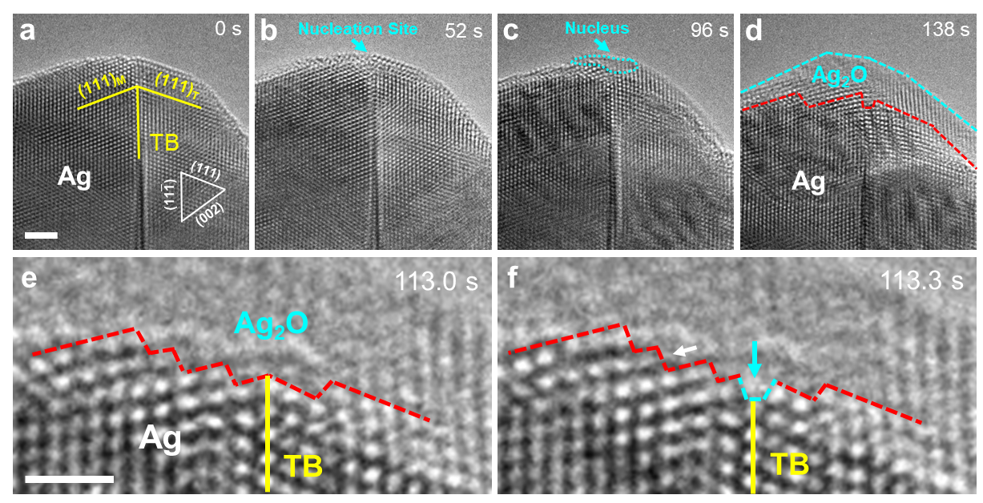
Supplementary Figure 1. Additional example showing the site-selective oxidation in a nanotwinned Ag nanocrystal. (a-d) Preferential oxide nucleation and growth at the TB-surface junction. The light blue arrows point to the preferential nucleation site of the Ag₂O embryo. (e-f) Zoomed-in images showing the preferential dissolution of atoms at TB-interface junction into Ag₂O and the migration of interface step during the oxide growth, as indicated by the light blue and white arrows, respectively. Scale bars: (a) 2 nm; (e) 1 nm.

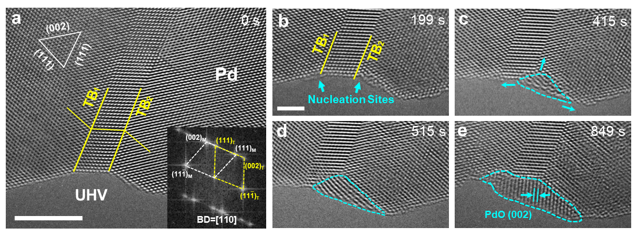
Supplementary Figure 2. Preferential oxidation at TBs in a Pd nanocrystal. (a) Pristine structure of the nanotwinned Pd. Inset is the FFT pattern of the nanotwinned Pd. (b-c) Preferential oxide nucleation at the TB-surface intersections (indicated by the light blue arrows). (d-e) Inward growth of the oxide (PdO) along the TB accompanied with lateral expansion along the surface. Scale bars: (a) 5 nm; (b) 2 nm.

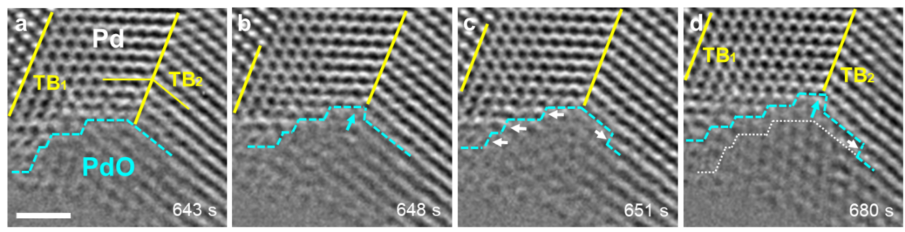
Supplementary Figure 3. TB-assisted layer-by-layer inward oxidation in a nanotwinned Pd nanocrystal. (a) Atomic structure of the Pd/PdO interface, which consists of multiple steps. (b) Preferential oxidation of the atom column at TB-intreface junction that generates two new steps (pointed out by the light blue arrows). (c-d) Layer-by-layer oxidation via the nucleation and migration of interface steps. The light bue dashed line and the white dotted line in (d) indicate the real-time and initial positions of the interface, respectively. Scale bar: 1 nm.

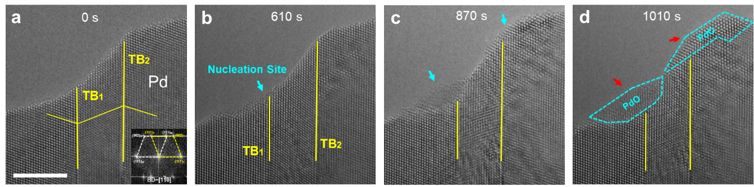
Supplementary Figure 4. Additional example showing the preferential oxidation at neighbouring TBs in a Pd nanocrystal. (a) A pristine Pd nanocrystal with two parallel TBs that intersect with the surface. Inset is the FFT pattern of the nanotwinned Pd. (b-d) Preferential oxidation at both TB-surface junctions. Scale bar: 5 nm.

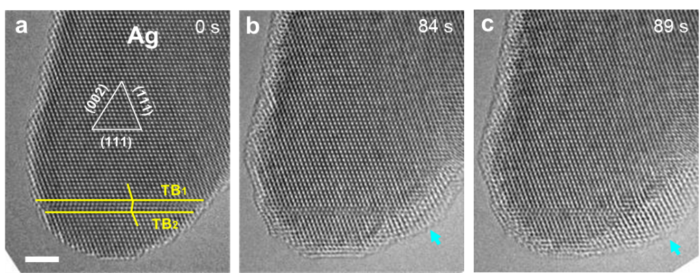
Supplementary Figure 5. Additional example showing the preferential oxidation at a transverse nanotwin away from the crystal tip. (a) Pristine Ag nanocrystal with an isolated transverse nanotwin. (b-c) Preferential oxide nucleation and growth at the TB-surface intersection site (indicated by the light blue arrow). Scale bar: 2 nm.

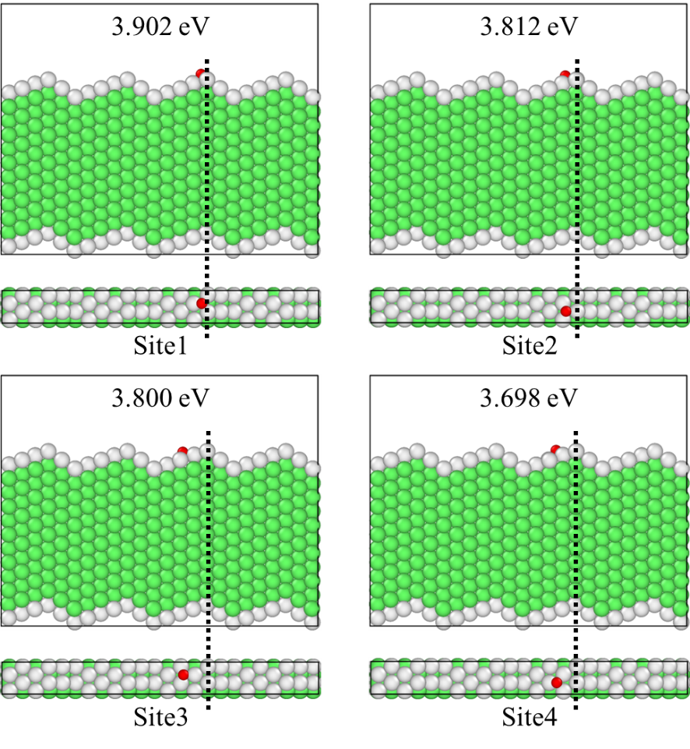
Supplementary Figure 6. Density-functional-theory (DFT) calculation of O binding energy (E_{b}) at different adsorption sites in the Ag single crystal. The dotted lines delineate the junctions of the surface facets and the red dot indicate different adsorption sites on the surface.

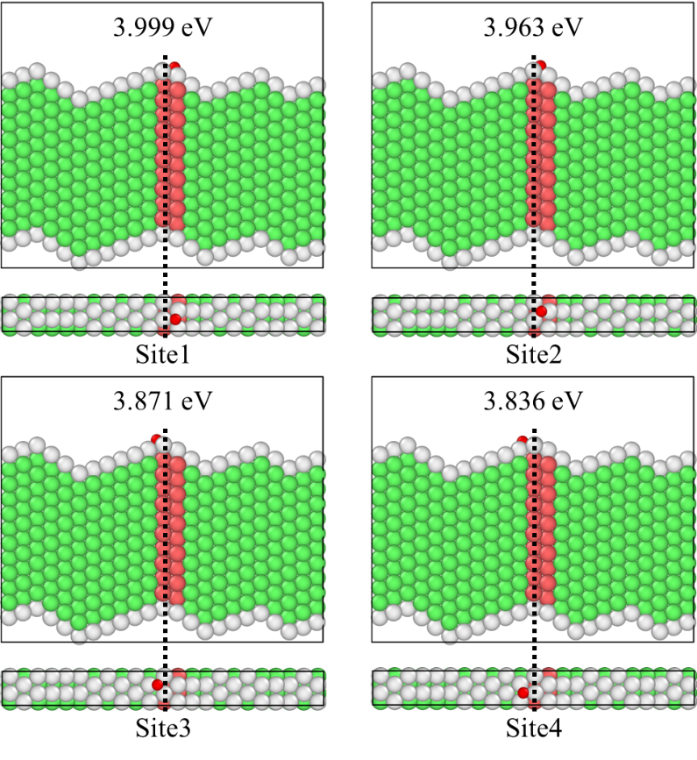
Supplementary Figure 7. Site-specific E_{b} at different surface adsorption sites near an isolated stacking fault (SF) calculated by ab initio simulation.

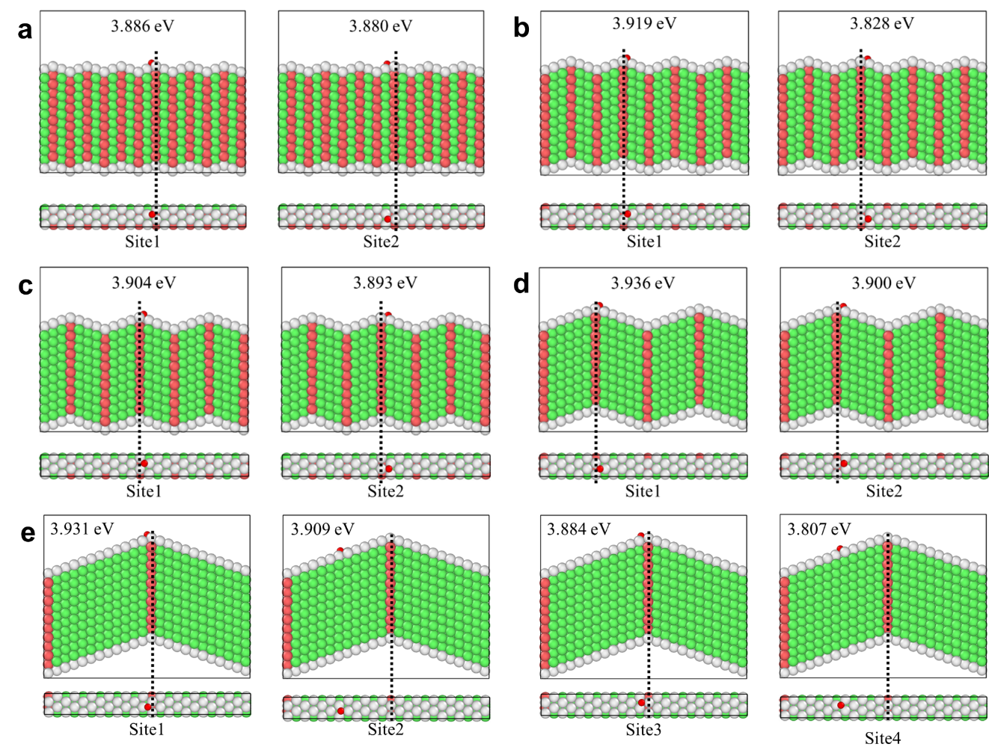
Supplementary Figure 8. Site-specific E_{b} of nanotwinned Ag nanocrystals with different TB spacings. (a) Two (111) atomic layers (i.e., extrinsic stacking fault configuration). (b) Three (111) atomic layers. (c) Four (111) atomic layers. (d) Six (111) atomic layers. (e) Twelve (111) atomic layers.

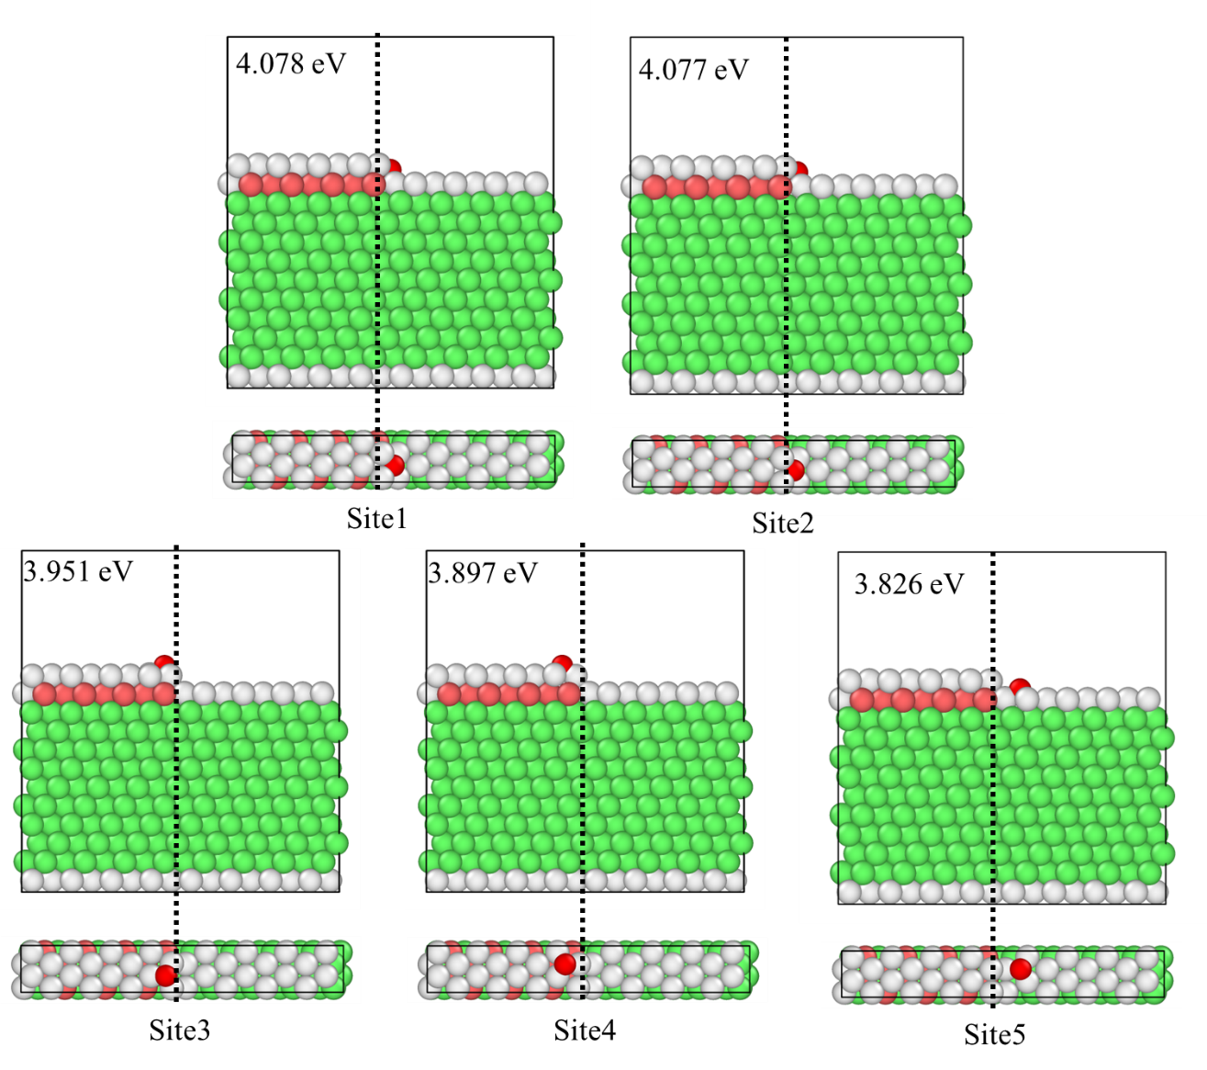
Supplementary Figure 9. Site-specific E_{b} around an atomic kink step on the (111) surface in the vicinity of a SF in Ag single crystal.

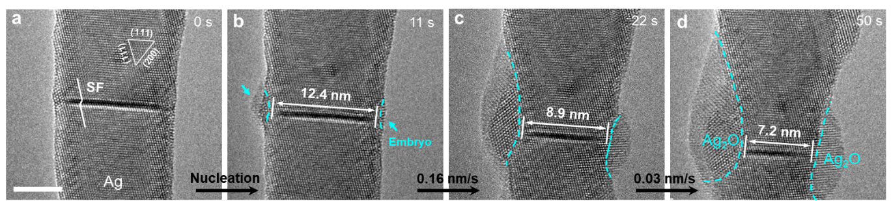
Supplementary Figure 10. Calculation of oxidation rate along the SF plane in Ag nanocrystal. (a) Pristine Ag nanocrystal with an isolcated transverse SF intesecting with both surfaces. (b) Simultaneous oxide nucleation at both SF-surface junctions. (c-d) Continuous inward oxide growth along the SF, where the distance between two oxide fronts (L) decreases from 12.4 nm to 7.2 nm. The average oxidation rate is determined by -$\text{∆}$L/$\text{2}\text{∆}$t, which gives 0.16 nm/s and 0.03 nm s⁻¹ (with an average rate of 0.07 nm s⁻¹) for steady growth (b-c) and self-limiting (c-d) oxidation stages, respectively. Scale bar: 5 nm.

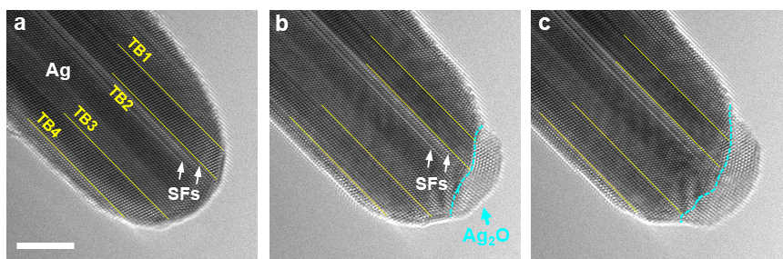
Supplementary Figure 11. Preferential oxidation in an Ag nanocrystal with multiple twins and SFs. (a) Morphology of the pristine Ag nanocrystal with multiple TBs and SFs (indicated by the white arrows). (b) Preferential oxide nucleation at the defect-surface intersection sites. (c) Subsequent inward and lateral growth of the oxide. Scale bar: 5 nm.

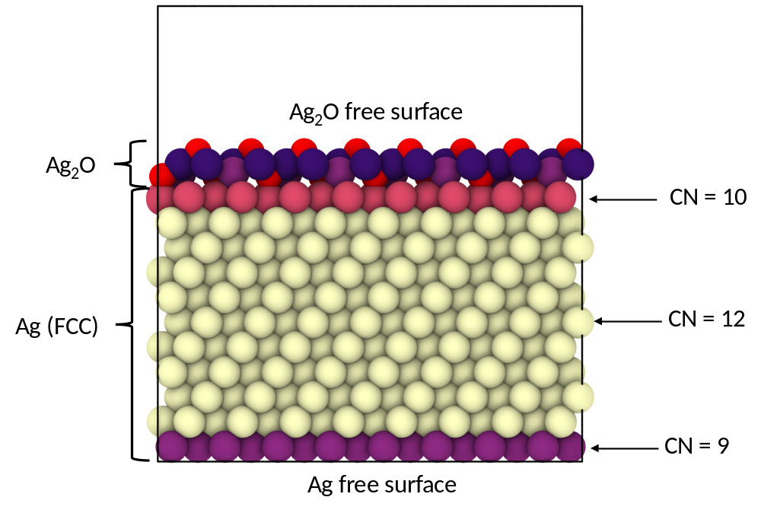
Supplementary Figure 12. Coordination numbers (CN) of atoms in a relaxed Ag-Ag₂O flat interface at equilibrium obtained by DFT calculation.

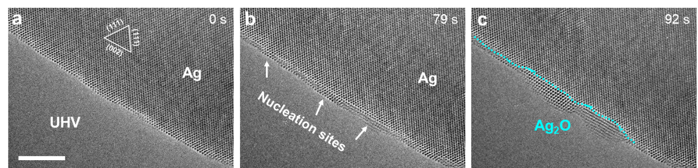
Supplementary Figure 13. Oxidation of a defect-free Ag single crystal. (a) Flat surface of the pristine Ag nanocrystal. (b) Homogeneous oxide nucleation at multiple sites on the surface. (c) Slow inward and lateral growth of the oxides. Scale bar: 5 nm.

