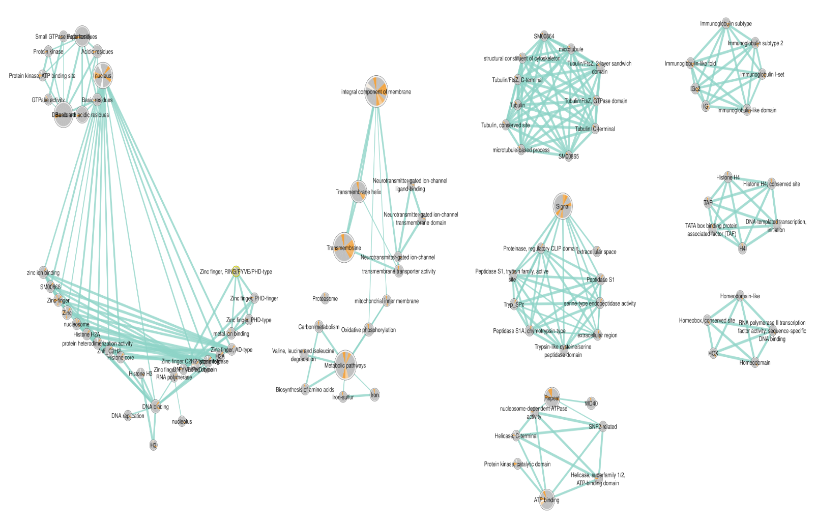
Supplementary 1
Illustration of an Enrichment Map for Anopheles gambiae Coexpression Network. A visual representation of the Anopheles gambiae coexpression network's enriched terms, encompassing pathways, Gene Ontology (GO), and Kyoto Encyclopedia of Genes and Genomes (KEGG) terms.

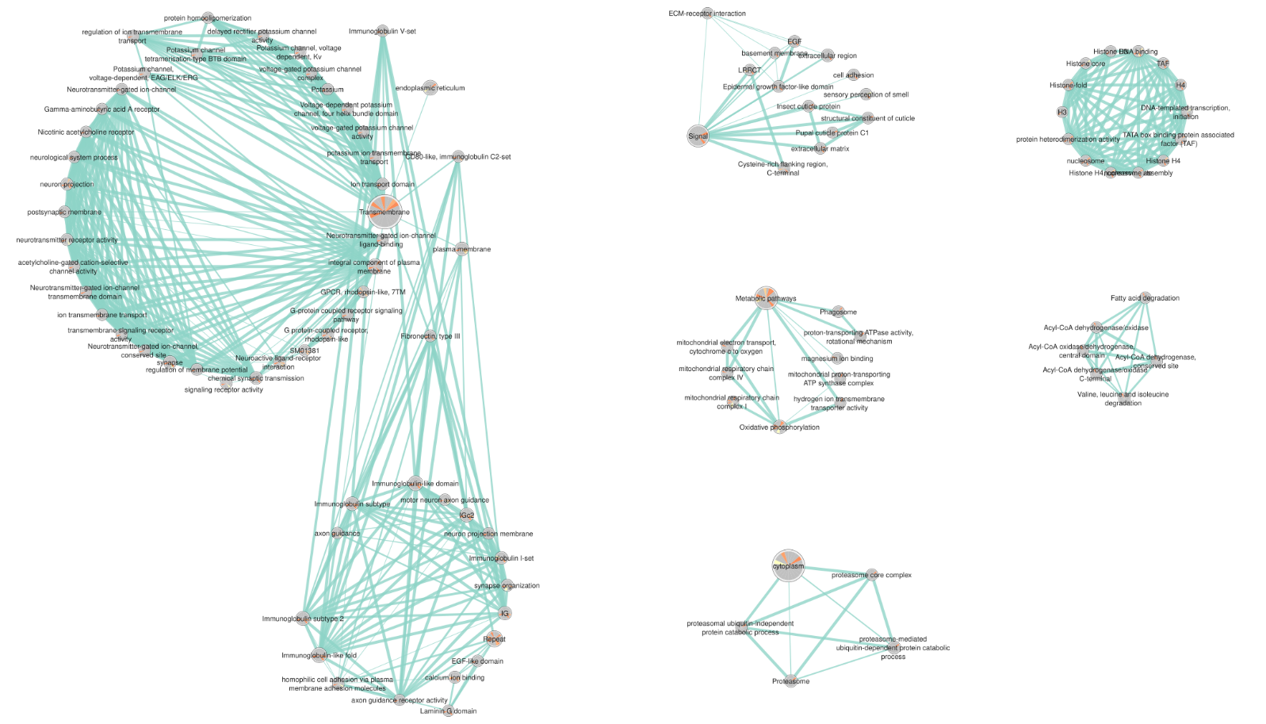

Supplementary 2
Illustration of an Enrichment Map for Anopheles arabiensis Coexpression Network. A visual representation of the Anopheles arabiensis coexpression network's enriched terms, encompassing pathways, Gene Ontology (GO), and Kyoto Encyclopedia of Genes and Genomes (KEGG) terms.

