Supplementary Material:
A numerical study on the energy barrier for cutting magnetic stripe domains in thin films

Kyoung-Woong Moon, Seungmo Yang, Changsoo Kim, Tae-Seong Ju, and Chanyong Hwang*

*e-mail: cyhwang@kriss.re.kr

This supplemental material contains the following sections:
- Initial states and stabilized states
- How to select material properties and stripe width
- GNEB Method
- Dipole field stripe
- Bubbles in thin stripes
- Effect of DMI

A. Initial states and stabilized states
Supplementary Figure 1 shows the initial guesses and energy minimized states for Fig. 1. States to which the perpendicular magnetic field is applied can also obtain stable states. The state in which the in-plane magnetization has a certain rotation direction can also be stabilized in the same way.
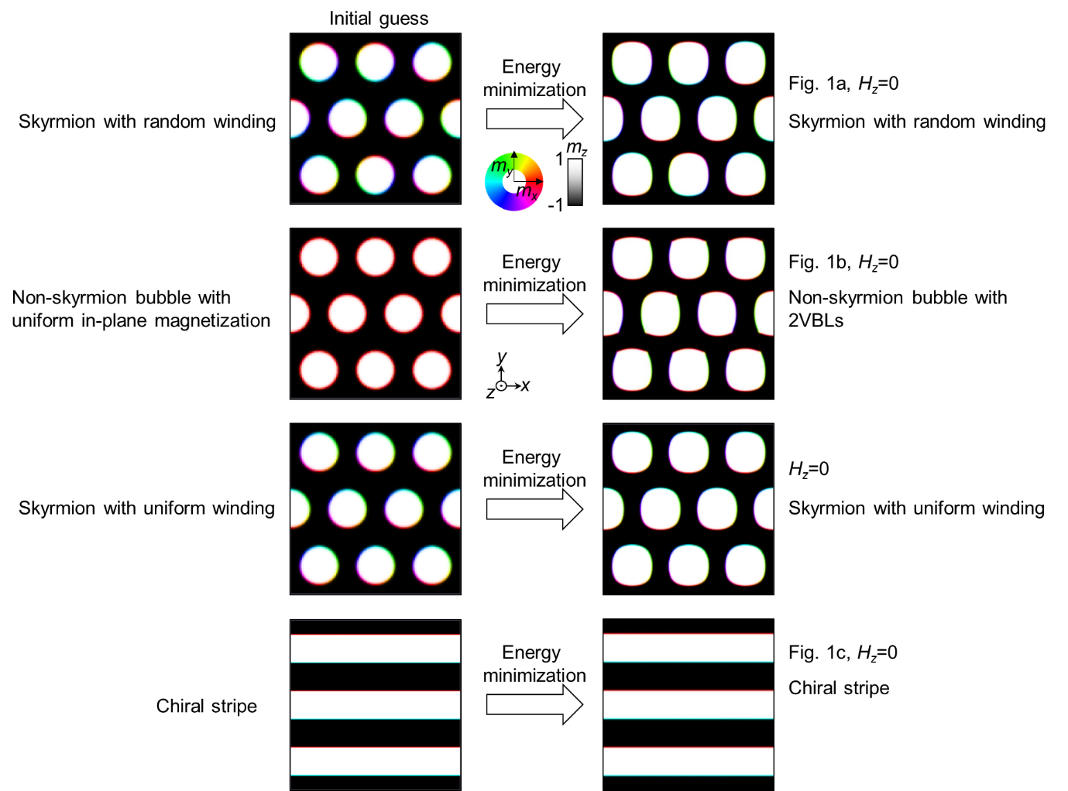
Supplementary Fig. 1 Initial guesses for Fig. 1 and energy minimization.

B. How to select material properties and stripe width
The width of the stripe ($λ$) was chosen to form the most stable stripe state in the zero magnetic field. Here is an example procedure of how the anisotropy values in Set 1 were selected.
- Select material values.
- Assuming a wide square plate (4000×4000×1 nm³), apply the periodic boundary condition in the x-axis and y-axis directions to make it similar to an infinite plate.
- Vary the number of repetitions of the stripe and obtain a minimum energy state after energy minimization.
- Plot the energy according to the number of repetitions of the stripe and obtain the optimal stripe repetition number (indicated by an arrow in Supplementary Fig. 2). Here, repetition number 0 means the uniform up(+z) state.
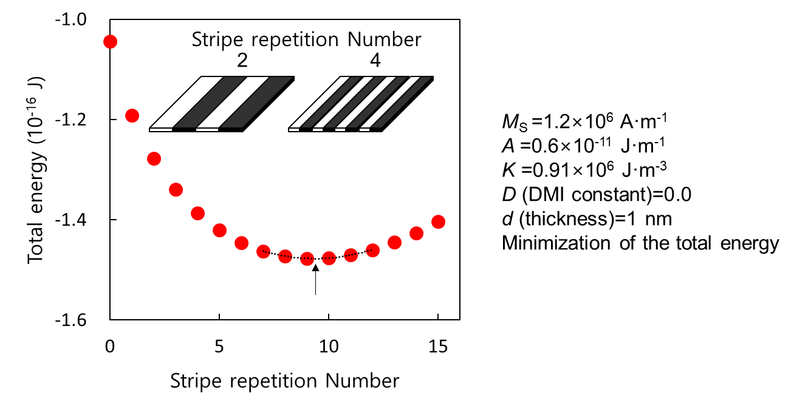
Supplementary Fig. 2 Stabilized energy with respect to the number of stripes.
- Repeat ①-③ with several PMA values and plot them together (Supplementary Fig. 3).
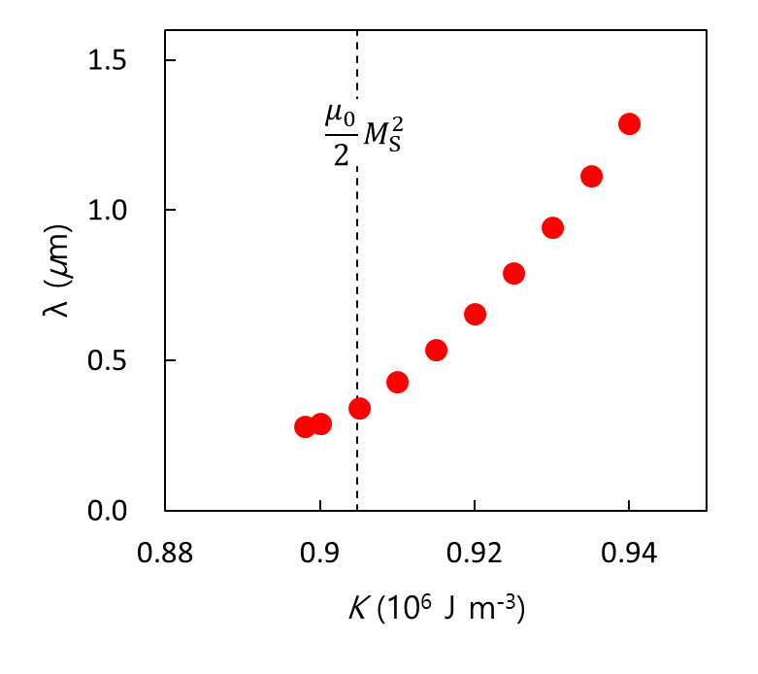
Supplementary Fig. 3 Optimal stripe widths as a function of the PMA strength.

- Select some values of K and λ for Set 1 from the above trend using an interpolation method.

C. GNEB Method
To explain the GNEB (geodesic nudged elastic band) method, I will first describe the concept of the NEB (nudged elastic band) method. The NEB method was mainly used to study the rearrangement of atoms^{1,2}. This allows us to determine at least what energy barriers atoms must cross in order to rearrange themselves, and this barrier is a criterion for determining whether a reaction can occur due to thermal fluctuations.
The simplest problem is to assume that one atom lies in a xy-plane with the following energy distribution (E(x,y)). Supplementary Figure 4 shows two locations having local minimum energy. Our interest is the smallest energy barrier(indicated by the red cross) between these two locations. This can be determined by finding the minimum energy path (MEP) that passes the saddle point state (SPS).
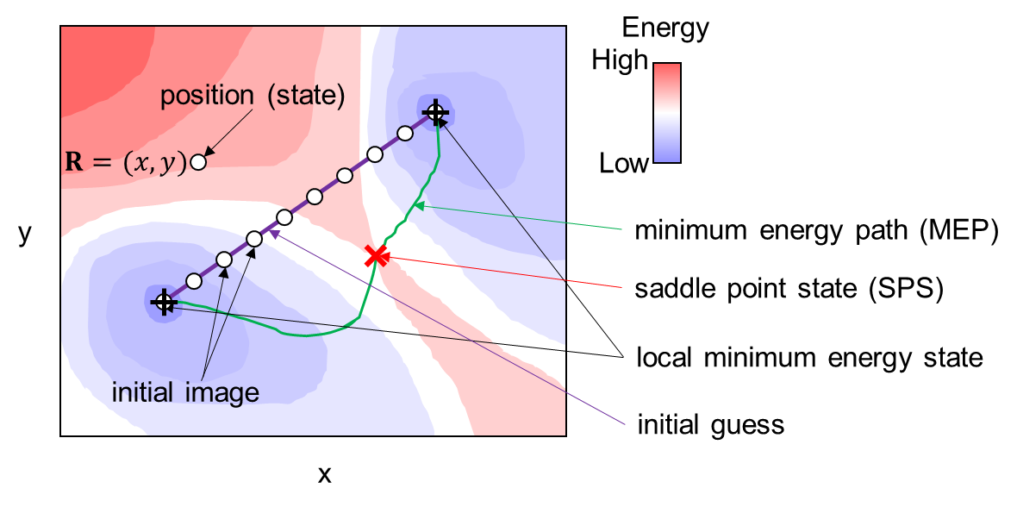
Supplementary Fig. 4 Energy distribution and SPS by location of two-dimensional space

At first, the shortest path connecting the two minimum energy points can be assumed and intermediate states are set at regular intervals on this path (a purple line and dots). These intermediate states are also called “images”. Each image changes its status slightly every step to find the SPS. At this stage, we use a different method than the usual energy minimization method. A typical energy minimization method is to obtain an energy gradient at a position and change the previous state slightly in the direction that the energy gradient is maximized to a negative value. Following this conventional approach, all the initially images will eventually converge to a nearby energy minimum. In other words, we cannot obtain information about the SPS.
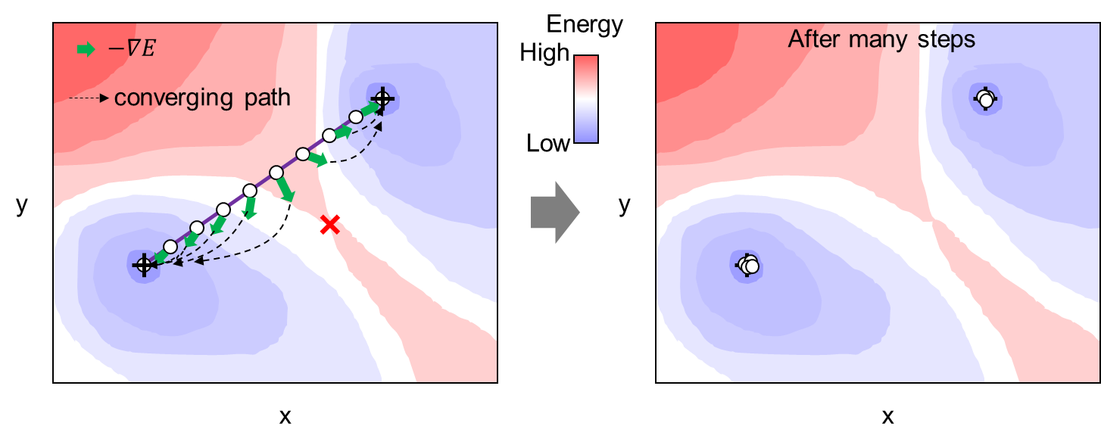
Supplementary Fig. 5 Results of typical energy minimization methods

The core principle of NEB to prevent this phenomenon is to update images after removing certain components from the energy gradient. One image has a spatially linked before and after images. Thus, we can define a vector indicating such direction and this vector is called the tangent to the path ($τ^{ν}$). Here, $ν$ is an index of a image. If we project the energy gradient to $τ^{ν}$ and subtract the result from the energy gradient, we can get the vector that is perpendicular to $τ^{ν}$. Using this vector ($-∇E_{⊥}$) to update the location of images at every step, all images finally placed on the MEP.
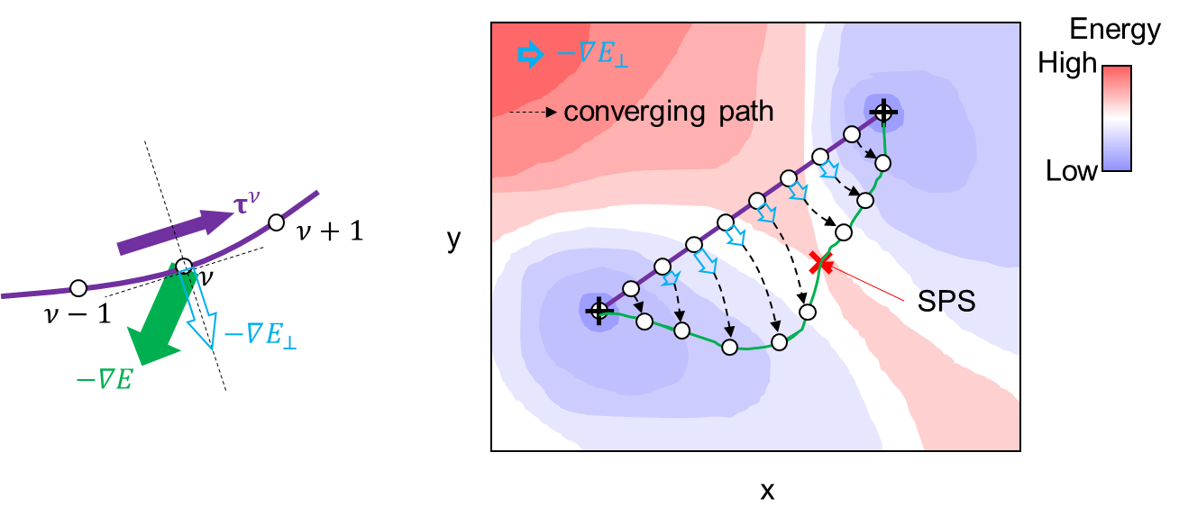
Supplementary Fig. 6 Definition of $-∇E_{⊥}$ and converging images.

There are two main ways to continuously represent the obtained images. One is to represent the energies of the images sequentially at equal intervals and the other is to arrange them in proportion to the distance on the xy-plane between the images. The latter is said to be arranged according to the reaction coordinate. The position of the start state may be normalized to 0 and the position of the last state may be normalized to 1.
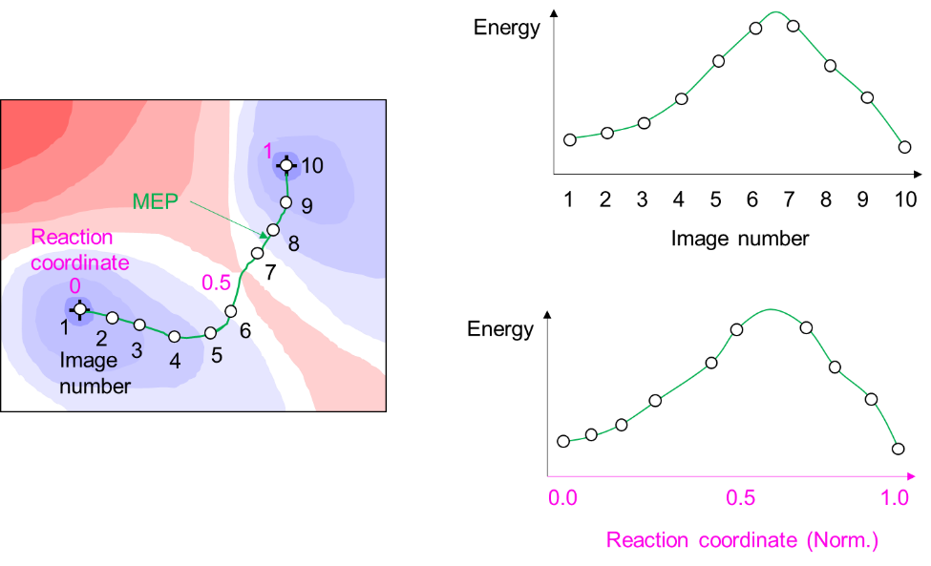
Supplementary Fig. 7 Two ways to display images and the MEP

Through this process, the approximate value of the SPS can be known. However, information about the SPS is still not provided accurately. This may be due to the gap between the obtained images being too wide near the SPS. To solve this problem, assume that a virtual spring exists between images. It is important to note that the direction in which the spring exerts force is only in the $τ^{ν}$ direction. Therefore, the spring does not affect energy minimization at all, but only the spacing between images. Considering this spring action, the image interval may be adjusted. As the simplest situation, if all springs have the same spring constant ($κ$), the image spacing in the final MEP will be equal. In order to obtain the SPS more efficiently, the spring constant may be set to be proportional to energy. By doing so, many images are located near the SPS at tight intervals, so that a more accurate guess of the SPS can be made. Note that, another method knows as “climbing image” could also be used for finding the SPS accurately³.
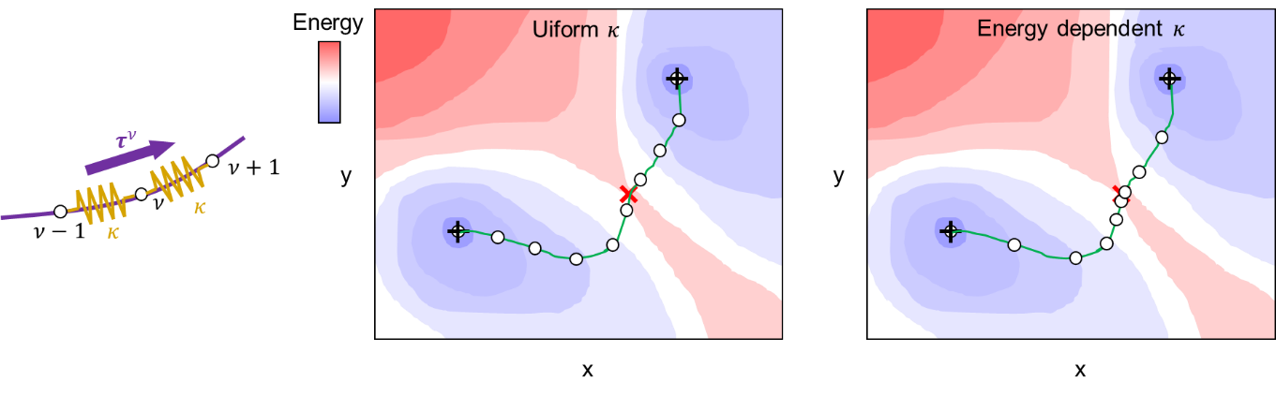
Supplementary Fig. 8 Spring effects.

In the above model, only one atom on the xy-plane was covered. In this case, two values, x and y, were required to represent the position, and the position could be defined as a vector $R=(x,y)$. If two atoms are located in a three-dimensional space, a total of six positional coordinates will be required and the position vector can be defined as $R=(x_{1},y_{1},z_{1},x_{2},y_{2},z_{2})$. In the same way, it can be extended to the case where there are N atoms. Regardless of N, we can always obtain $R$ as well as E(R). In addition, energy gradient and $τ^{ν}$ are also available, so the NEB method can be applied to N atoms.
Now I will briefly explain the difference between the NEB method and the GNEB method³. Let's think about a system of N magnetization vectors. Each vector requires m_{x}, m_{y}, and m_{z} components, thus 3N coordinates are sufficient to describe this system. We can write R, which is a kind of position in 3N-dimensional space, as follows.
$$R=\left(m_{1},m_{2},…,m_{i},…m_{N}\right)=\left(m_{1x},m_{1y},m_{1z},m_{2x},m_{2y},m_{2z}…,m_{ix},m_{iy},m_{iz},…,m_{Nx},m_{Ny},m_{Nz}\right).$$
Here, i is an index for the normalized magnetization vector $m_{i}$. Therefore, a system consisting of N magnetization vectors could be treated by the NEB method dealing with N atomic positions. However, magnetization vectors have strong restrictions. That is,
$$m_{ix}^{2}+m_{iy}^{2}+m_{iz}^{2}=1.$$
Therefore, all valid vectors must be readjusted to maintain the condition of $|m_{i}|=1$. To this end, a plane perpendicular to the magnetization vector is defined as a tangent space, and some vectors are projected into this tangent space. Supplementary Figure 9 shows how $τ^{ν}$ is projected into the tangent space in a system with one magnetization vector. Note that this projection should be applied not only to $τ^{ν}$ but also to the spring action and energy minimization process.
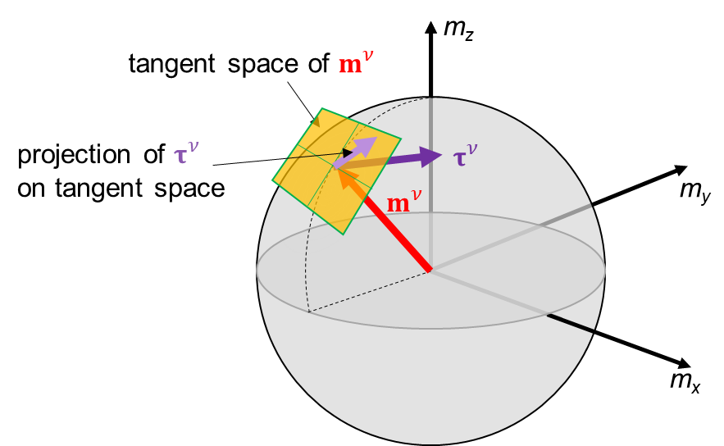
Supplementary Fig. 9 Tangent space and the vector projection

There is also a difference in how to define the distance that causes the spring action. For positions of atoms, a form of $\sqrt{{(∆x)}^{2}+{(∆y)}^{2}{+(∆z)}^{2}}$ is obvious to represent the distance. However, all changes in the system of magnetization vectors are caused by vector rotation. So, the strength of the spring action is determined by the length of the geodesic line (Supplementary Fig. 10). These reasons explain why the word geodesic was attached to NEB.
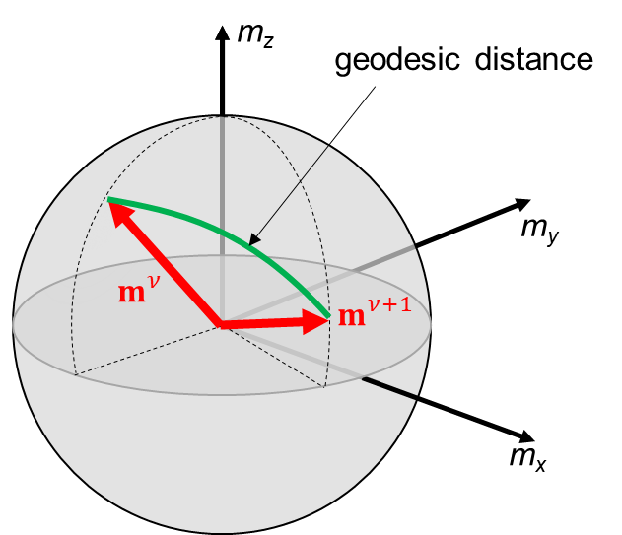
Supplementary Fig. 10 Magnetization rotation and the geodetic line

D. Dipole field stripe
In PMA films, the stripe has a structure in which up (+z) and down (-z) domains repeated. There is a domain wall (DW) between the up and down domains. In the DW, the magnetization vector needs to rotate 180 degrees in space, so a lot of exchange energy is required. The PMA energy is also required in DWs due to the in-plane magnetization component that the PMA does not prefer. In addition, demagnetization energy and DMI energy according to the wall type are required. By these energies, the DW has a constant energy density⁴. It is written as $σ_{w}$, which refers to the energy density per unit area. The energy that the DWs occupies in the entire system can be obtained by multiplying this energy density by the total length of the DW and the thickness (d) of the magnetic material.
The energy generated in the remaining areas except for the DW is mainly induced by magnetic dipoles from domains. The magnitude of dipole energy is obtained from the magnetization array repeated up and down. As a method of approximately estimating this, it can be said that the area with a width of $∆_{w}$ is empty at the location of the DW^{5,6}. In other words, it is to think of a structure in which the perpendicular magnetized ribbon-shaped magnetic material is repeated at a regular interval.
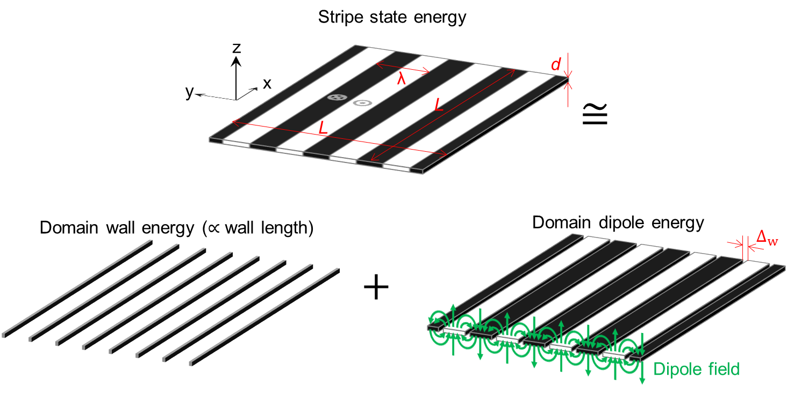
Supplementary Fig. 11 Stripe state and two energies that make up the total energy
The total energy density, $ε_{tot}$, per unit volume was obtained through this approach. $ε_{tot}$ is written as the sum of the DW energy ($ε_{wall}$) and the domain dipole energy ($ε_{domain}$) as follows^{5–7}.
$$ε_{tot}=ε_{wall}+ε_{domain}=σ_{w}∙L∙\frac{2L}{λ}∙d-\frac{{2μ}_{0}M_{S}^{2}d}{πλ}\ln\left(\frac{λ}{πΔ_{w}}\right)L^{2}d.$$
${∂ε_{tot}}/{∂λ}=0$ results in Eq. (2) of the main text. Note that, this result shows the overall tendency of the stripe structure formed by the dipole field. The effect of DMI could be included in $σ_{w}$.

E. Bubbles in thin stripes
According to the results of the paper, the broken state is hard to be stabilized in a thin stripe structure ($λ<{πe^{2}∆}_{w}$). This is because $E_{cross}$ is lower than $E_{broken}$, so $E_{cross}$ alone cannot be an energy barrier between $E_{broken}$ and $E_{stripe}$. However, this situation can be changed by the perpendicular magnetic field ($H_{z}$). When $H_{z}$ is applied, $E_{broken}$ and $E_{cross}$ begin to decrease to zero. The reduction rate of $E_{broken}$ is twice as large as that of $E_{cross}$. Therefore, a situation in which $E_{cross}$>$E_{broken}$ occurs in a certain magnetic field, and $E_{cross}$ acts as an energy barrier.
Supplementary Figure 12 shows an example. We obtained a magnetization state that can be stabilized and calculated the energy difference ($E_{bubble}-E_{stripe}$) between stripe state and bubble state. The used values were: $M_{S}$ (saturation magnetization) = 1.2 × 10⁶ A/m, $A$ (exchange constant) = 0.6 × 10^{–11} J/m, $K$ (PMA constant) = 9.036 × 10⁵ J/m³, $d$ (thickness) = 1 nm. These values stabilized $λ$=296 nm and $∆_{w}$=16.4 nm. There was no DMI. The two initial states were set to determine whether the bubble state and the stripe state could be stabilized. The magnetization direction of all of the DWs is set to x direction. When $H_{z}$=0, the initial bubble state is not stable and becomes stripe state as we expected. This continues until $μ_{0}H_{z}$= -3.8 mT (Region I). Increasing $|H_{z}|$ will allow $E_{cross}$ to act as an energy barrier and stabilize the bubbles. This occurs from $μ_{0}H_{z}$= -3.9 mT to $μ_{0}H_{z}$= -5 mT (Region II). As $|H_{z}|$ increases further, $E_{broken}$ is lower than $E_{stripe}$. But the stripes don't transform into bubbles because $E_{cross}$ still acts as a barrier. This occurs from $μ_{0}H_{z}$=-5 mT to $μ_{0}H_{z}$=-5.7 mT (Region III). When a larger $|H_{z}|$ is applied, the bubble becomes too small and disappears and only the stripe state can exist at this time (Region IV).
Here, we dealt with bubbles rather than skyrmion phases. If we assume skyrmion-structured bubbles, they can exist stably up to $|H_{z}|$=12 mT.

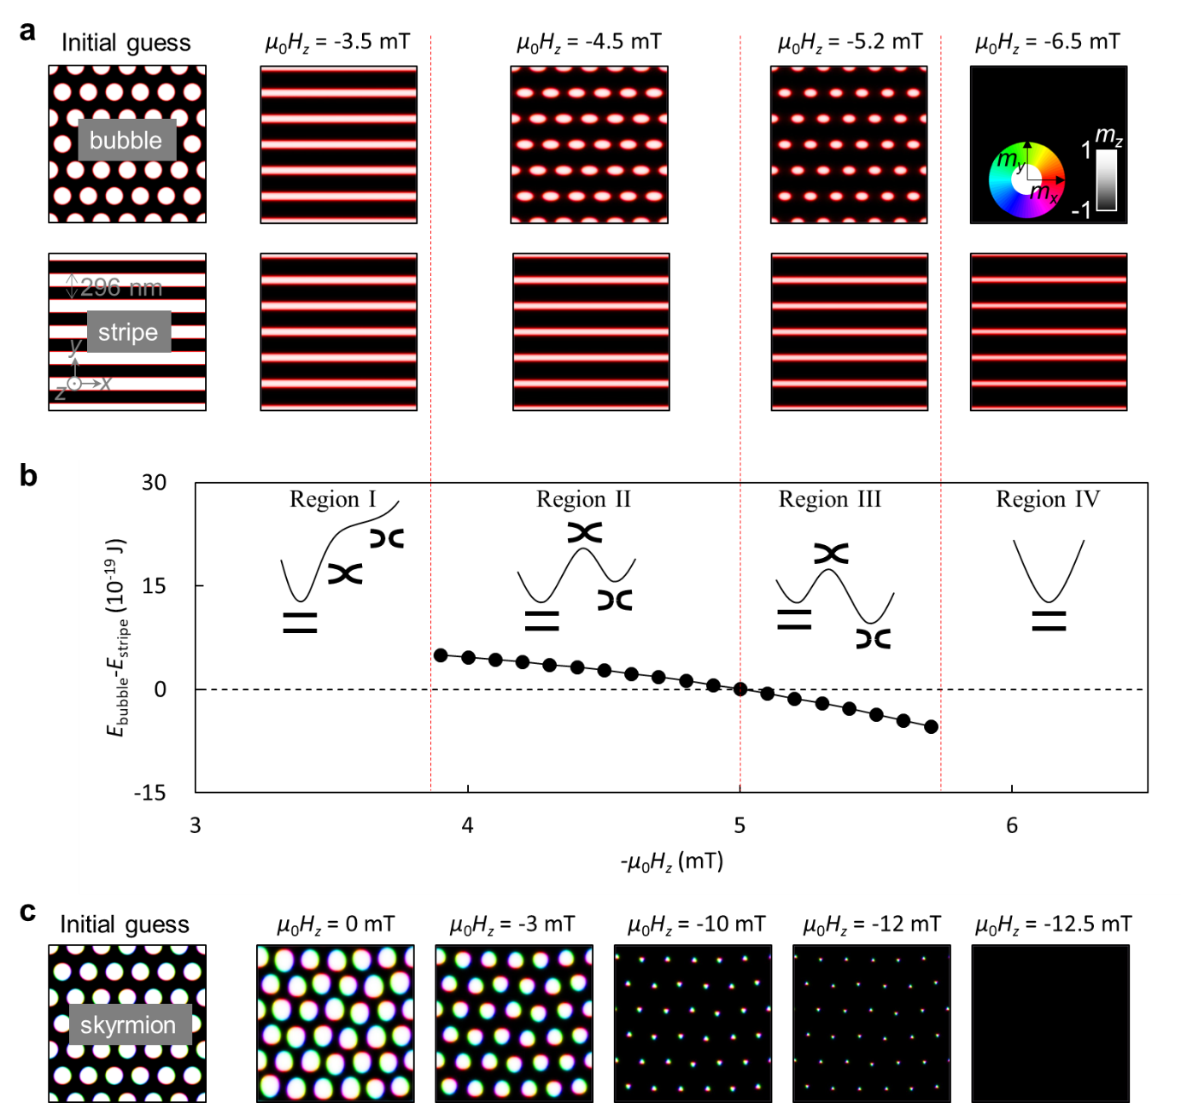
Supplementary Fig. 12 The dependence of the thin stripe state on $H_{z}$. a Two initial states set before the energy minimization process and the stable states after energy minimization. b Energy differences of magnetization states shown in a and expected energy profiles. c Stabilized states assuming the skyrmion bubble state.

F. Effect of DMI
In this section, we will test the situation where there is a finite DMI. To do this, an interface-type DMI ($D_{ind}$= -0.5×10⁻³ J/m²) was assumed with $A$ (=0.909×10⁻¹¹ J/m) and $K$ (= 9.515×10⁵ J/m³). These values stabilize a stripe with $λ$=776 nm and $Δ_{w}$=10.1 nm, which is the same as the stripe structure of $D_{ind}$=0 shown in Fig. 2. $M_{S}$(=1.2×10⁶ A/m) and $d$(= 1 nm) are also identical to the values in Fig. 2. Supplementary Figure 13 shows the results of applying the GNEB method.
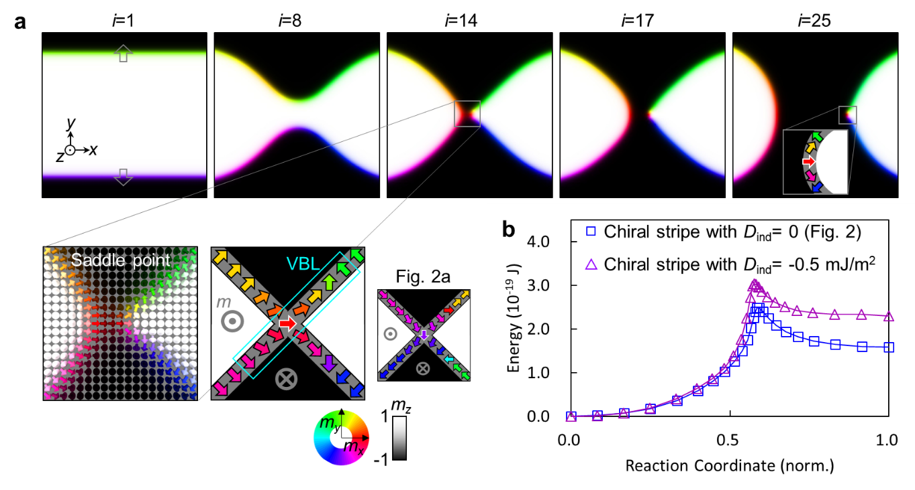
Supplementary Fig. 13 The stripe breaking with a nonzero DMI. a Images of the minimum energy path. b Comparison of energy.

The chiral Néel walls are shown when i=1 due to the nonzero DMI. The SPS is obtained from i=14, where the overall shape of the magnetization state is similar to the SPS of chiral stripe obtained in Fig. 2a. To create the same state as in Fig 2a, we can think of a rotational transformation in which all magnetization vectors rotate 90 degrees with the z-axis as the rotational axis. We know that any uniform rotational transformation preserves the skyrmion charge and the exchange energy. In addition, since the axis of rotation of the magnetization vector is the z-axis, PMA energy is also conserved. The only energy that the difference occurs is the Néel wall energy, but it does not directly affect the energy barrier, but affects the width of the stripes. So, it is possible to analyze the stripe with DMI using the chiral stripe state without DMI. Therefore, our approach addresses a much more comprehensive situation including chiral stripes, achiral stripes, and chiral-DMI stripes.
However, there is a difference in the energy value of SPS (Supplementary Fig. 13b), which is because the energy of the VBL is different. Since a VBL^{8–10} is a structure in which the magnetization direction is rapidly twisted in space, the exchange energy accounts for most of the energy of VBL. Here, we used 50% larger $A$ than that of Fig. 2 to keep the same $λ$ and $Δ_{w}$. Therefore, when VBLs are formed, we can see that it has a constant energy greater than the result of Fig. 2. This energy difference is maintained because the VBL continues to exist afterwards.
There is another difference that the generated two VBLs have a more compressed form. Looking at the final i=25 state in Fig. 2, the two VBLs formed are far apart from each other. However, when there is non-zero DMI, the two VBLs are closely attached to each other (i=25 in Supplementary Fig. 13a). This is because the DMI preferred a certain form of DW. If two VBLs are adjacent to each other, the area of the DW that the DMI dislikes is minimized. Note that this state can be called a domain wall skyrmion⁹.
Despite this difference in the spacing of the VBLs, the energy of the VBL depends mainly on the number of VBLs rather than the location of the VBLs. Therefore, it is considered useful to interpret a stripe with DMI based on a chiral stripe without DMI.

References
1. Mills, G., Jónsson, H. & Schenter, G. K. Reversible work transition state theory: application to dissociative adsorption of hydrogen. Surf. Sci. 324, 305–337 (1995).
2. Henkelman, G. & Jónsson, H. Improved tangent estimate in the nudged elastic band method for finding minimum energy paths and saddle points. J. Chem. Phys. 113, 9978–9985 (2000).
3. Bessarab, P. F., Uzdin, V. M. & Jónsson, H. Method for finding mechanism and activation energy of magnetic transitions, applied to skyrmion and antivortex annihilation. Comput. Phys. Commun. 196, 335–347 (2015).
4. Je, S. G. et al. Asymmetric magnetic domain-wall motion by the Dzyaloshinskii-Moriya interaction. Phys. Rev. B - Condens. Matter Mater. Phys. 88, 214401 (2013).
5. Kashuba, A. & Pokrovsky, V. L. Stripe domain structures in a thin ferromagnetic film. Phys. Rev. Lett. 70, 3155–3158 (1993).
6. Meier, T. N. G., Kronseder, M. & Back, C. H. Domain-width model for perpendicularly magnetized systems with Dzyaloshinskii-Moriya interaction. Phys. Rev. B 96, 144408 (2017).
7. Saratz, N., Ramsperger, U., Vindigni, A. & Pescia, D. Irreversibility, reversibility, and thermal equilibrium in domain patterns of Fe films with perpendicular magnetization. Phys. Rev. B - Condens. Matter Mater. Phys. 82, 184416 (2010).
8. Yoshimura, Y. et al. Soliton-like magnetic domain wall motion induced by the interfacial Dzyaloshinskii–Moriya interaction. Nat. Phys. 12, 157–161 (2015).
9. Cheng, R. et al. Magnetic domain wall skyrmions. Phys. Rev. B 99, 184412 (2019).
10. Yang, J. et al. Racetrack memory based on current-induced motion of topological Bloch lines. Appl. Phys. Express 14, 103002 (2021).

