Using modified descriptive analysis and instrumental measurements to assess the impact of grape smoke exposure on the wine matrix of different red wine varietals in California.

Authors: Lik Xian Lim¹, Cristina Medina-Plaza¹, Ignacio Arías-Perez¹, Y. Wen¹, Bishnu Neupane¹, Larry Lerno¹, Jean-Xavier Guinard² and Anita Oberholster^{1*}

¹Department of Viticulture and Enology, University of California Davis, Davis, 95616, CA, USA
²Department of Food Science and Technology, University of California Davis, Davis, 95616, CA, USA
*Corresponding author

Supplementary Files

Supplemental Materials

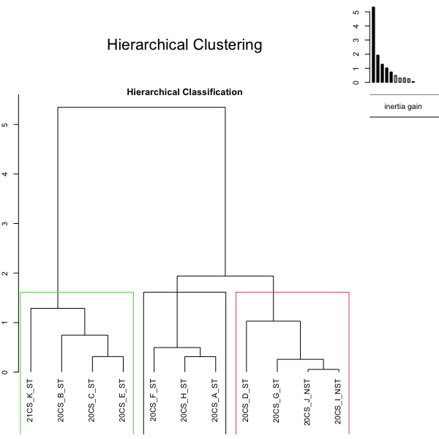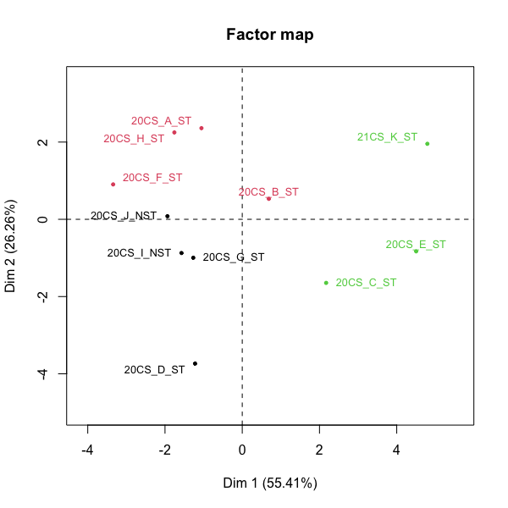
Supplemental Figure S1: Hierarchical clustering of principal components for PCA of DA 1 in Figure 2.

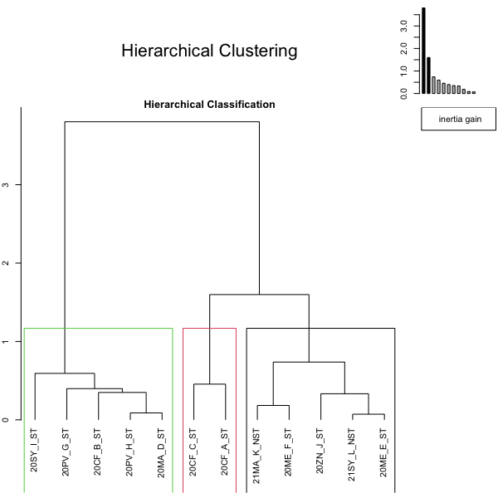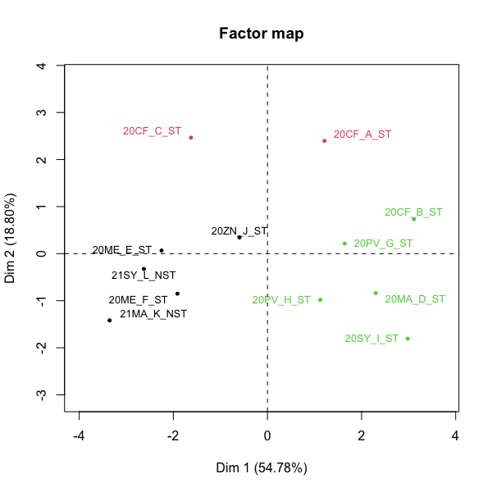
Supplemental Figure S2: Hierarchical clustering of principal components for PCA of DA 2 in Figure 4.

Supplementary Table S1: MRM calibration table from commercial standards for VP analysis.

Compound Name | Precursor ion | MS1 res | Product ion | MS2 res | RT | Left  Delta  RT | Right  Delta  RT | Dwell (ms) | CE  (V)
d-guaiacol | 127.1 | Wide | 109 | Wide | 8.84 | 0.20 | 0.14 | 82.6 | 10
d-guaiacol | 127.1 | Wide | 81 | Wide | 8.84 | 0.20 | 0.14 | 82.6 | 20
guaiacol | 123.9 | Wide | 109 | Wide | 8.86 | 0.12 | 0.14 | 82.6 | 10
guaiacol | 123.9 | Wide | 81 | Wide | 8.86 | 0.12 | 0.14 | 82.6 | 20
creosol | 138.1 | Wide | 123 | Wide | 9.61 | 0.12 | 0.14 | 54.7 | 10
creosol | 138.1 | Wide | 95 | Wide | 9.61 | 0.12 | 0.14 | 54.7 | 20
d-creosol | 141.1 | Wide | 126 | Wide | 9.61 | 0.12 | 0.14 | 54.7 | 10
d-creosol | 141.1 | Wide | 98 | Wide | 9.61 | 0.12 | 0.14 | 54.7 | 20
d-o-cresol | 115 | Wide | 113 | Wide | 9.87 | 0.12 | 0.14 | 67.1 | 20
d-o-cresol | 115 | Wide | 81 | Wide | 9.87 | 0.12 | 0.14 | 67.1 | 30
o-cresol | 108 | Wide | 107 | Wide | 9.91 | 0.12 | 0.14 | 45.5 | 15
o-cresol | 107 | Wide | 77 | Wide | 9.91 | 0.12 | 0.14 | 45.5 | 15
phenol | 94 | Wide | 66 | Wide | 9.94 | 0.12 | 0.14 | 43.6 | 10
phenol | 94 | Wide | 65 | Wide | 9.94 | 0.12 | 0.14 | 43.6 | 20
d-4-ethylguaiacol | 157 | Wide | 139 | Wide | 10.15 | 0.12 | 0.14 | 42.4 | 10
d-4-ethylguaiacol | 157 | Wide | 96 | Wide | 10.15 | 0.12 | 0.14 | 42.4 | 30
4-ethylguaiacol | 151.8 | Wide | 137 | Wide | 10.19 | 0.12 | 0.14 | 73.3 | 10
4-ethylguaiacol | 151.8 | Wide | 94 | Wide | 10.19 | 0.12 | 0.14 | 73.3 | 30
d-pm-cresol | 115 | Wide | 113 | Wide | 10.54 | 0.12 | 0.14 | 67.1 | 20
d-pm-cresol | 115 | Wide | 85 | Wide | 10.54 | 0.12 | 0.14 | 67.1 | 20
pm-cresol | 108 | Wide | 107 | Wide | 10.58 | 0.12 | 0.14 | 48.5 | 15
pm-cresol | 107 | Wide | 77 | Wide | 10.58 | 0.12 | 0.14 | 48.5 | 15
2,3-dimethoxyphenol | 154 | Wide | 139 | Wide | 10.67 | 0.12 | 0.14 | 67.1 | 5
2,3-dimethoxyphenol | 154 | Wide | 65 | Wide | 10.67 | 0.12 | 0.14 | 67.1 | 20
d-4-ethylphenol | 126.1 | Wide | 111 | Wide | 11.29 | 0.12 | 0.14 | 54.7 | 10
d-4-ethylphenol | 126.1 | Wide | 80 | Wide | 11.29 | 0.12 | 0.14 | 54.7 | 30
4-ethylphenol | 121.9 | Wide | 107 | Wide | 11.30 | 0.12 | 0.14 | 82.6 | 10
4-ethylphenol | 121.9 | Wide | 77 | Wide | 11.30 | 0.12 | 0.14 | 82.6 | 30
d-syringol | 160 | Wide | 142 | Wide | 11.99 | 0.12 | 0.14 | 82.5 | 10
d-syringol | 160 | Wide | 114 | Wide | 11.99 | 0.12 | 0.14 | 82.5 | 20
syringol | 153.9 | Wide | 139 | Wide | 12.02 | 0.12 | 0.14 | 82.5 | 5
syringol | 153.9 | Wide | 65 | Wide | 12.02 | 0.12 | 0.14 | 82.5 | 20
4-methylsyringol | 168 | Wide | 153 | Wide | 12.71 | 0.12 | 0.14 | 110.4 | 5
4-methylsyringol | 168 | Wide | 125 | Wide | 12.71 | 0.12 | 0.14 | 110.4 | 10

Supplementary Table S2: MRM calibration table from commercial standards for individual bound glycoside analysis.
Compound Name | Precursor Ion | Product Ion | Fragmentor (V) | Collision Energy (V) | Retention Time (min) | Retention Window | Polarity
Salicin | 304 | 269 | 70 | 5 | 2.41 | 0.8 | Positive
Salicin | 304 | 107 | 70 | 10 | 2.41 | 0.8 | Positive
Guaiacol gentiobioside | 466 | 325 | 90 | 5 | 3.05 | 0.8 | Positive
Guaiacol gentiobioside | 466 | 163 | 90 | 10 | 3.05 | 0.8 | Positive
Guaiacol gentiobioside | 466 | 145 | 90 | 20 | 3.05 | 0.8 | Positive
d3-Guaiacol gentiobioside | 469 | 325 | 90 | 5 | 3.05 | 0.8 | Positive
d3-Guaiacol gentiobioside | 469 | 163 | 90 | 10 | 3.05 | 0.8 | Positive
Phenol penthex | 406 | 295 | 70 | 5 | 3.24 | 1 | Positive
Phenol penthex | 406 | 163 | 70 | 10 | 3.24 | 1 | Positive
Phenol penthex | 406 | 133 | 70 | 15 | 3.24 | 1 | Positive
d3-Syringol gentiobioside | 501 | 163 | 90 | 15 | 3.45 | 0.8 | Positive
d3-Syringol gentiobioside | 501 | 145 | 90 | 20 | 3.45 | 0.8 | Positive
Syringol gentiobioside | 496 | 325 | 90 | 5 | 3.5 | 0.8 | Positive
Syringol gentiobioside | 496 | 163 | 90 | 15 | 3.5 | 0.8 | Positive
Syringol gentiobioside | 496 | 145 | 90 | 20 | 3.5 | 0.8 | Positive
Guaiacol glucoside | 304 | 163 | 70 | 5 | 3.66 | 0.8 | Positive
Guaiacol glucoside | 304 | 145 | 70 | 5 | 3.66 | 0.8 | Positive
Guaiacol glucoside | 304 | 125 | 70 | 5 | 3.66 | 0.8 | Positive
d5-Phenol rutinoside | 425 | 309 | 90 | 5 | 3.69 | 0.8 | Positive
d5-Phenol rutinoside | 425 | 147 | 90 | 10 | 3.69 | 0.8 | Positive
Phenol rutinoside | 420 | 309 | 90 | 5 | 3.76 | 0.8 | Positive
Phenol rutinoside | 420 | 164 | 90 | 5 | 3.76 | 0.8 | Positive
Phenol rutinoside | 420 | 147 | 90 | 10 | 3.76 | 0.8 | Positive
Amygdalin | 475 | 325 | 80 | 5 | 3.89 | 0.8 | Positive
Amygdalin | 475 | 163 | 80 | 15 | 3.89 | 0.8 | Positive
Guaiacol penthex | 436 | 295 | 70 | 5 | 4.05 | 1 | Positive
Guaiacol penthex | 436 | 163 | 70 | 10 | 4.05 | 1 | Positive
Guaiacol penthex | 436 | 133 | 70 | 15 | 4.05 | 1 | Positive
Syringol penthex | 471 | 295 | 90 | 5 | 4.4 | 1 | Positive
Syringol penthex | 471 | 163 | 90 | 15 | 4.4 | 1 | Positive
Syringol penthex | 471 | 155 | 90 | 15 | 4.4 | 1 | Positive
Cresol penthex | 420.2 | 295 | 70 | 5 | 4.44 | 1 | Positive
Cresol penthex | 420.2 | 163 | 70 | 15 | 4.44 | 1 | Positive
Cresol penthex | 420.2 | 133 | 70 | 15 | 4.44 | 1 | Positive
d3-Guaiacol rutinoside | 453 | 309 | 90 | 5 | 4.54 | 0.8 | Positive
d3-Guaiacol rutinoside | 453 | 147 | 90 | 10 | 4.54 | 0.8 | Positive
Guaiacol rutinoside | 450 | 309 | 90 | 5 | 4.58 | 0.8 | Positive
Guaiacol rutinoside | 450 | 164 | 90 | 10 | 4.58 | 0.8 | Positive
Guaiacol rutinoside | 450 | 147 | 90 | 10 | 4.58 | 0.8 | Positive
4-Methylsyringol gentiobioside | 510 | 325 | 90 | 10 | 5.08 | 0.8 | Positive
4-Methylsyringol gentiobioside | 510 | 163 | 90 | 15 | 5.08 | 0.8 | Positive
4-Methylsyringol gentiobioside | 510 | 145 | 90 | 20 | 5.08 | 0.8 | Positive
d5-Cresol rutinoside | 439 | 309 | 90 | 5 | 5.56 | 0.8 | Positive
d5-Cresol rutinoside | 439 | 147 | 90 | 10 | 5.56 | 0.8 | Positive
Cresol rutinoside | 434 | 309 | 90 | 5 | 5.67 | 0.8 | Positive
Cresol rutinoside | 434 | 164 | 90 | 5 | 5.67 | 0.8 | Positive
Cresol rutinoside | 434 | 147 | 90 | 10 | 5.67 | 0.8 | Positive
4-MS penthex | 480 | 295 | 90 | 10 | 5.9 | 1 | Positive
4-MS penthex | 480 | 169 | 90 | 15 | 5.9 | 1 | Positive
d3-4-Methylguaiacol rutinoside | 467 | 309 | 90 | 5 | 6.28 | 0.8 | Positive
d3-4-Methylguaiacol rutinoside | 467 | 147 | 90 | 10 | 6.28 | 0.8 | Positive
4-Methylguaiacol rutinoside | 464 | 309 | 90 | 5 | 6.31 | 0.8 | Positive
4-Methylguaiacol rutinoside | 464 | 309 | 90 | 5 | 6.31 | 0.8 | Positive
4-Methylguaiacol rutinoside | 464 | 164 | 90 | 10 | 6.31 | 0.8 | Positive
4-Methylguaiacol rutinoside | 464 | 147 | 90 | 10 | 6.31 | 0.8 | Positive

Supplemental Table S3: Descriptive analysis descriptors and preparation.
s/n | Category | Descriptor | Recipe | Brand
1 | Aroma | Cigarette smoke | Pinch of ash of Camel Brand Loose Leaf Tobacco + 20mL Base wine | No. 91 Danish Export Virginia Blend Cigarete Tobacco.
2 | Aroma | Musty | 2cm square Wet Cardboard + 5mL water to wet evenly
3 | Aroma | Medicinal / Brett | 1 drop 40% Phenol Solution + 40mL Base Wine
4 | Aroma | Liquid Smoke | 1mL Wrights Liquid smoke hickory with 40mL base wine. | Wright's Liquid Smoke Concentrated Seasoning, Hickory
5 | Aroma | Sweet BBQ | 1mL Stubbs Mesquite Liquid Smoke with 40mL base wine. | Stubbs Mesquite Liquid Smoke
6 | Aroma | Menthol | 1 ml solution (3 drops Eucalyptus oil in 100 ml water) + 40 ml base wine | Nature's Truth Eucalyptus 100% pure essential oil
7 | Aroma | Tar | 1 slice bicycle inner tube touch with asphalt cement | Bell 12.5" Bicycle inner tube, Black Jack All weather Roof cement
8 | Aroma | Solvent | 0.125ml acetone, 1 drop ethyl acetate, 50ml base wine | Acetone- Day logic brand 100% Acetone
9 | Aroma | Red Fruit | 2 Frozen Dark Cherry, 2 frozen Raspberry, 1 Frozen Strawbery cut into cubes and smashed | Strawberry: Cascadian Farm (Sedro-Woolley, WA)  Dark Cherry & Raspberry: Woodstock Organic
10 | Aroma | Dark fruit | 4 Frozen Blackberry, 2 Dark Frozen cherries, 5 Frozen Blueberry, all cut and smashed. + 1 drop Everclear | Blueberry: Cascadian Farm (Sedro-Woolley, WA). Dark Cherry: Woodstock Organic. Blackberries: Sthalbush Island Farms. Everclear: 120 proof
11 | Aroma | Cooked fruit | 1 tsp of each blueberry jam, blackberry jam, 1/2 tsp Strawberry and 1/2 raspberry Jam in 20 mL red wine base | Wild Blueberry Jam- St Dalfour brand. Strawberry, Blackberry, Raspberry Preserve- Smuckers
12 | Aroma | Dried fruit | 1/8 Pcs prune + 4 Raisins + 1/4 Dried Figs +10mL wine | Prunes: Sunsweet D’Noir Prunes preservative free. Raisins: Sunmaid raisins. Figs: Sun maid mission figs
13 | Aroma | Bell pepper | 0.5 cm square piece of green bell pepper + wine 40ml, 10 mins, (3 pcs of 2cmX2cm square in 600ml Wine, soak 10 mins, the pour out)
14 | Aroma | Spice | 1 chip Nutmeg + 1 chip Cinnamon + 4 pcs all spice + 4pcs cloves, in 40mL Base Wine Soak 45 mins and filter | Nutmeg: Morton and Barret,  Cinnamon, All spice, Cloves: Mc Cormick
15 | Aroma | Alcohol Hotness | 16% Alcohol final content, 270mL/L 60% v/v Everclear | Everclear, 120 proof
16 | Mouthfeel | Sweet | Low 5g/L Fructose, High 12.5g/L Fructose | Now Real Food
17 | Mouthfeel | Sour | Low 0.5g/L Tartaric Acid, High 2g/L Tartaric Acid
18 | Mouthfeel | Bitter | Low- 500mg/L Caffeine, High 1000mg/L | Caffeine Anhydrous, VWR Life science
19 | Mouthfeel | Dry | Low- 200mg/L Alum, High 620mg/L Alum | Mc Cormick
20 | Mouthfeel | Hot | Low- 85mL/L 60% v/v Everclear, High- 170mL/L 60% v/v Everclear | Everclear, 120 proof
21 | Mouthfeel | Viscosity | Low- plain Water, High 2g/L CMC in water | Sugarman candy.
22 | Ashy | Ashy Aftertaste | Burnt Leeks ash in water, 100g leeks to 1000g water to make concentrate,  Concentrate : Water, 1 :5 for 100% solution. ,
#Base wine- where applicable , all aroma, taste, and mouthfeel standards made with Franzia Pinot Noir / Carmenere blend

