Supplementary Information

Dorian Hüne*, Arne Dittrich, Thomas Gimpel,

Influencing the corrosion rates of titanium and titanium nitride surfaces by incorporation of iridium or ruthenium during femtosecond laser treatment

Scientific Reports

D. Hüne, T. Gimpel
Clausthal University of Technology – Research Center Energy Storage Technologies, Am Stollen 19A, 38640 Goslar, Germany

A. Dittrich
Institute for Solar Energy Research, Am Ohrberg 1, 31860 Emmerthal, Germany

*Corresponding author email: dorian.huene@tu-clausthal.de

Sample | Step height at edge [μm]
TiRuN | 3.8 ± 1
TiNIr | 4.5 ± 0.8
Ti-Ru | 4.5 ± 0.9
Ti-Ir | 4.4 ± 0.8
Step Height of treated Area

Table S1. Step-height at edge of treated area, obtained by LSM.

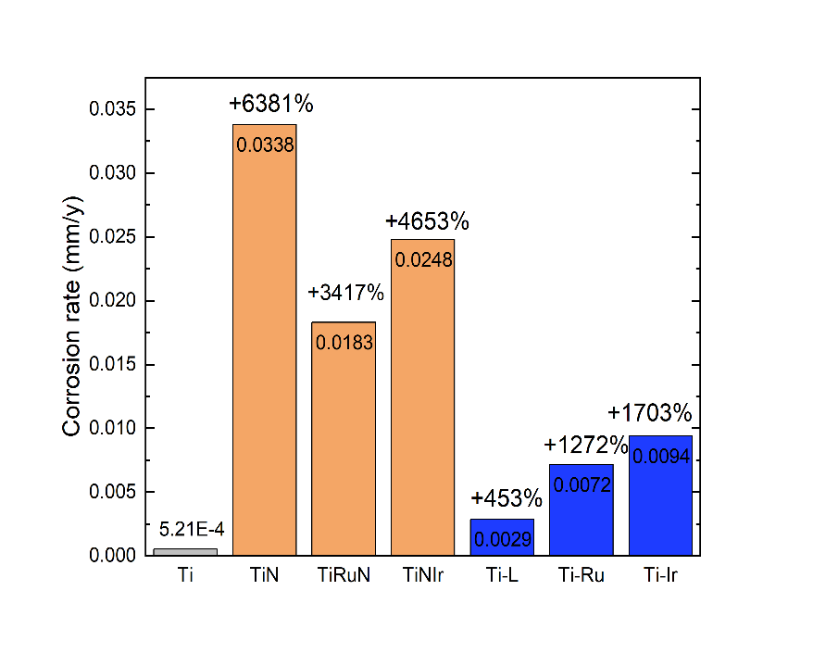
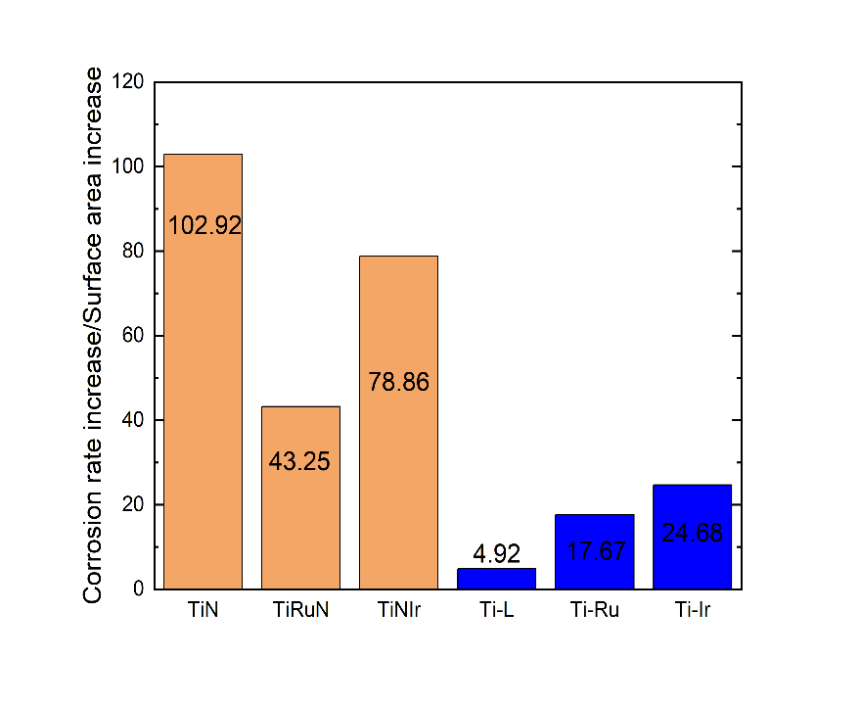
Corrosion rate by surface area increase
Fig. S1 a) Corrosion rate and increase compared to reference. b) Corrosion rate increase divided by surface area increase
a)
b)

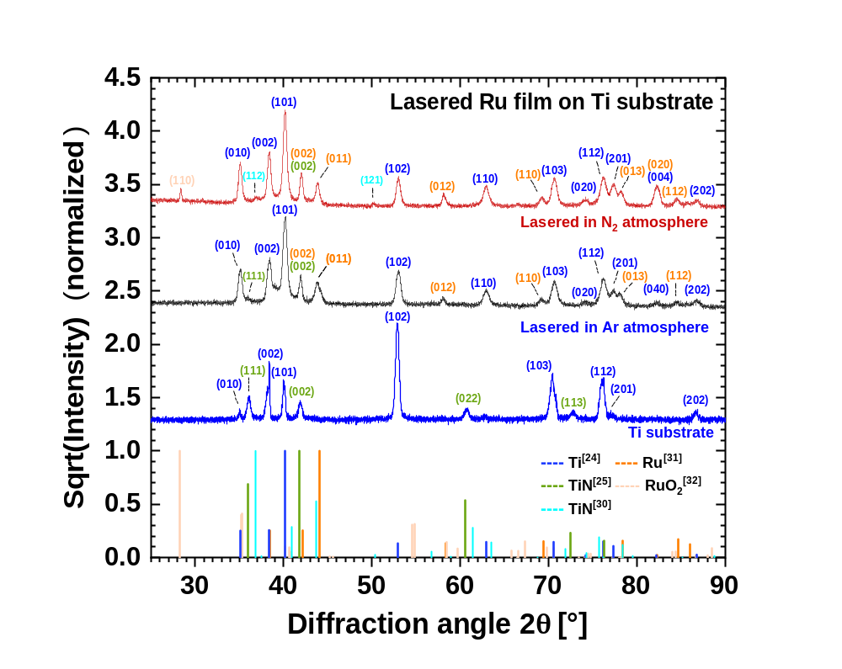
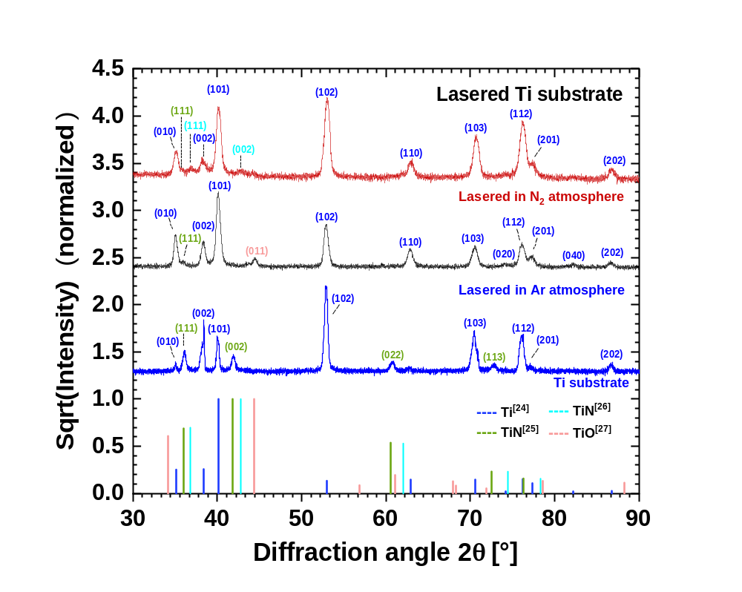
GIXRD-Spectra
RuO^{[38]}
Ru^{[37]}
TiN^{[36]}
TiN^{[31]}
Ti^{[30]}
TiN^{[31]}
TiO^{[33]}
TiN^{[32]}
Ti^{[30]}
b)
a)

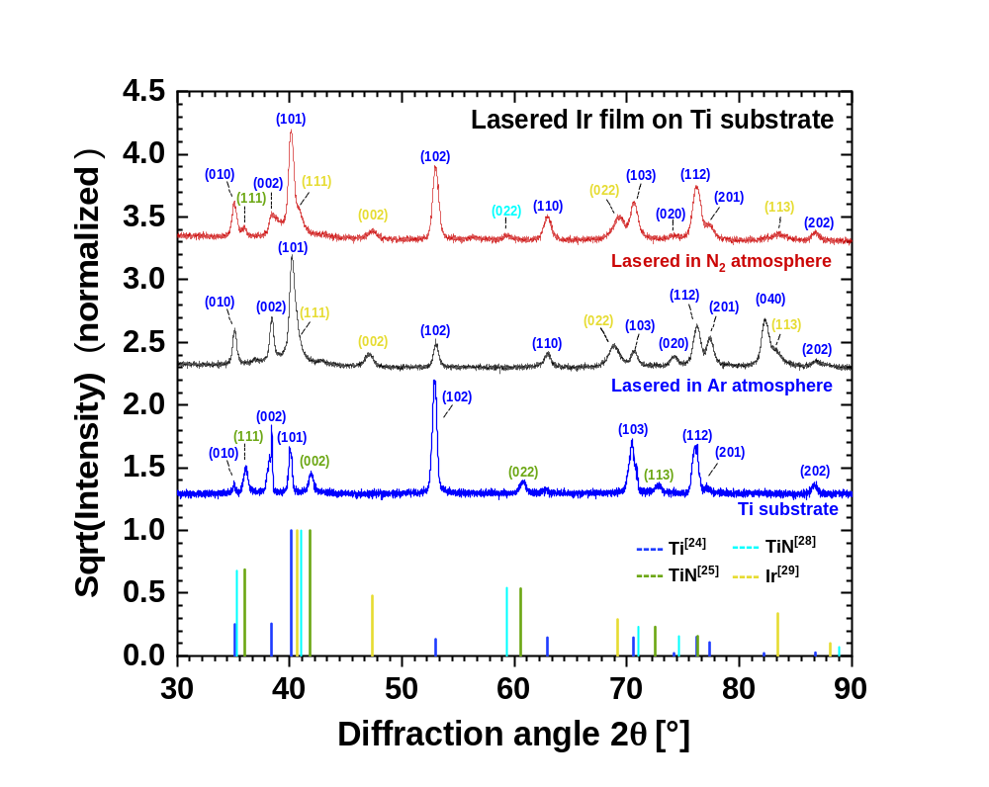
Ir^{[35]}
TiN^{[34]}
TiN^{[31]}
Ti^{[30]}
c)
Fig. S2 GIXRD-Spectra of a) uncoated, b) Ru-coated and c) Ir-coated samples after exposition to H₂SO₄. Top curve shows samples lasered in N₂-atmosphere, middle curve in Ar-atmosphere and the lowest curve always shows untreated Ti-sample. The lower bars show the relevant peak positions known from the literature. [30-38]

