Supplement Material
To ensure the validity of the experimental procedure, we additionally performed frequency spectrum analysis on the resting-state EEG data between sleep deprivation (SD) and sleep control (SC). The EEG preprocessing pipeline closely followed the procedures described for microstate analysis in the main text, with the exception that the filtering range was adjusted to 0.2-45Hz. The frequency spectrum was calculated using the Welch method.The absolute power for each electrode was logarithmically transformed to calculate the power spectrum (1 dB = 10 × log(μV²)). The power spectrum data for the Cz electrode were averaged, and the mean and standard deviation for each participant were calculated under the conditions of sleep control (SC) and sleep deprivation (SD) .Based on Figure 1, it can be observed that following sleep deprivation, there was an increase in theta (4-8 Hz) energy across all frequency bands. Our findings are in agreement with previous results(Del et al.,2019; Tramonti et al.,2022; Lian et al.,2023).

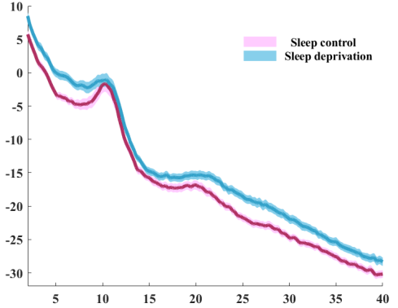
Absolute Power(dB)
Frequency (Hz)
Fig 1 EEG power spectrum during sleep control (pink) and sleep deprivation (blue).

The topographical maps of theta (4-8 Hz) for Sleep Deprivation (SD) and Normal Sleep (NS) are shown in the fig.2. After sleep deprivation, there is an increase in the energy of theta (t = -26.23, p < 0.000).

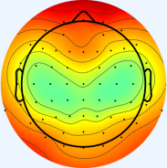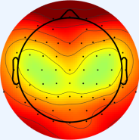
Sleep control-theta
Sleep deprivation-theta
10
-20
(dB)

Fig 2 Topography of resting-state EEG in theta for sleep control and sleep deprivation conditions.

