Multifunctional ENR-g-PNIPAM/PPy/cotton fabrics composites for hexavalent chromium removal

Hongda Ding¹, Xiaoran Yang¹, Yanqiu Wang¹, and Xiande Shen*^{,1,2}

¹Research Center for Polymer Materials, Engineering Research Center of Optoelectronic Functional Materials，Ministry of Education, School of Materials Science and Engineering, Changchun University of Science and Technology, Weixing Road 7089, Jilin 130022, China
²Chongqing Research Institute, Changchun University of Science and Technology, No. 618 Liangjiang Avenue, Longxing Town, Yubei District, Chongqing City 401135, China

* Corresponding author
E-mail address: shenxiande@cust.edu.cn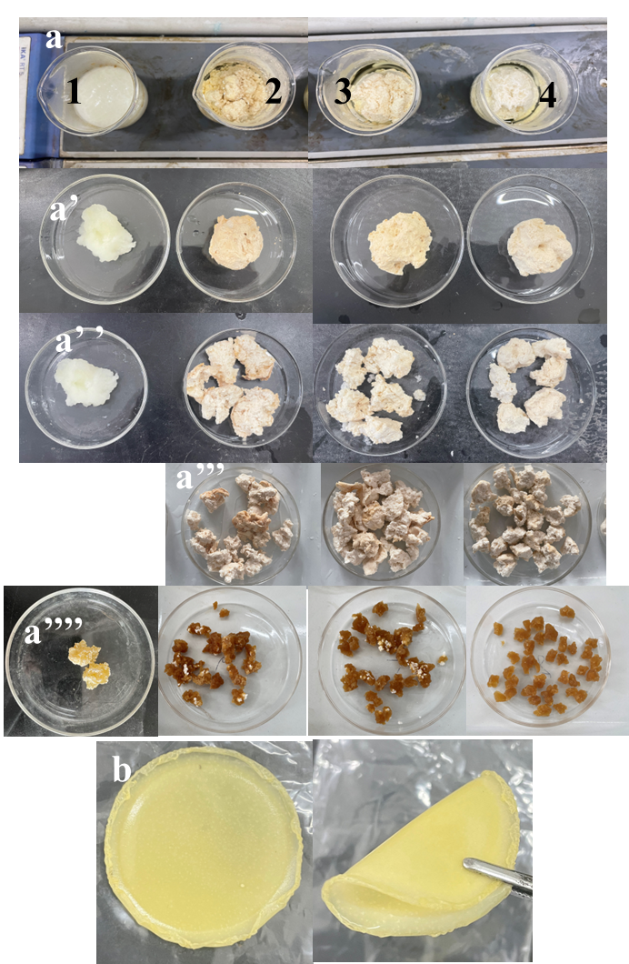
Figure S1. Photographs of ENR-g-PNIPAM hydrogels at various ENR contents (a) 0ENR, 50ENR, 60ENR, and 70ENR (1, 2, 3, and 4), a’, a’’ and a’’’ are corresponding to resultant ENR-g-PAM hydrogels before and after splitting, and a’’’’ is corresponding to resultant ENR-g-PAM dried hydrogel and (b) films of 70ENR. (Diameter of the culture dish is 10 cm.)

Materials: N-isopropylacrylamide (NIPAM), N, N-methylenebisacrylamide (MBA), ceric ammonium nitrate (CAN), Pyrrole (Py) monomer, and Methylene blue (MB) were obtained from Energy Chemical (Anhui, China). Diphenylcarbazide (DPCI), potassium dichromate (K₂Cr₂O₇), and anhydrous ferric chloride (FeCl₃) were purchased from Macklin (Shanghai, China). hydrochloric acid (HCl, 37%) was purchased from Sinopharm Chemical Reagent Co., Ltd. Woven cotton fabrics was kindly provided by Jilin city Jinma Shiye Co., Ltd. Epoxidized natural rubber Latex (ENRL, 30% dry rubber content (DRC)) with 50% epoxidization level was provided by Agricultural Product Processing Research Institute, Chinese Academy of Tropical Agricultural Sciences. The MBA and CAN act as cross-linker and initiator for polymerization of NIPAM, respectively. Water used is deionized water in throughout experiment. All materials were analytical purity and used as received, unless stated otherwise.
Instruments of characterization of the ENR-g-PNIPAM hydrogels and EPPC：

The morphologies of the 70ENR hydrogel and EPPC were observed by scanning electron microscope (SEM) (JSM-6701F, JEOL). Element analysis was performed with a Hitachi S4800 SEM equipped with an energy-dispersive X-ray spectroscopy (EDS) detector. The Fourier transform infrared (FT-IR) spectroscopy measurement was carried out on an infrared microspectrometer (Nicolet in10, Thermo Scientific, USA).

The related equations:

Adsorption capacity (q_{e}) (mg/g) was calculated using Eq. (1), while Eq. (2) represents the removal (%) ratio of the hydrogel adsorbent.
$$q_{e}=\frac{\left(c_{0}-c_{e}\right)×V}{W_{0}} \left(1\right)$$
Removal (%) $=\frac{\left(c_{0}-c_{e}\right)}{c_{0}}×100 (2)$
where C_{o} and C_{e} (mg/L) are the initial concentration of the Cr (VI) solution and the concentration at equilibrium, respectively, V (L) is the volume of dye solution and W_{o} (g) is the initial mass of the dry sample.
To elucidate the adsorption mechanism, two kinetic models were employed: the pseudo-first-order (PFO) and pseudo-second-order (PSO) models, expressed according to Eqs. (3) and (4), respectively:
$$\log\left(q_{e}-q_{t}\right)=logq_{e}-K_{1}t (3)$$
$$\frac{t}{q_{t}}=\frac{1}{K_{L}q_{e}^{2}}+\frac{1}{q_{e}} t (4)$$
where q_{t} (mg/g) is the adsorption capacity at time t (min), and K₁ (1/min) and K_{L} (g/(mg·min)) are the rate constants of the PFO and PSO models, respectively.
To identify adsorption behavior, the experimental data at equilibrium from various initial concentrations of MB solutions (10–5000 ppm) were interpreted using Langmuir and Freundlich isotherms, which are expressed in Eqs. (5) and (6), respectively.
$$\log\left(q_{e}-q_{t}\right)=logq_{e}-K_{1}t (5)$$
$$lnq_{e}=\frac{1}{n}lnC_{e}+lnK_{F} (6)$$
Where q_{e} (mg/g) is the adsorption capacity at equilibrium, q_{m} (mg/g) is the maximum adsorption capacity, K_{L} (L/min) and K_{F} [(mg/g)/(L/mg)^{1/n}] are the Langmuir and Freundlich coefficients, respectively, and 1/n expresses the intensity of adsorption, which is favorable when 1 < n < 10. The Langmuir isotherm explains a monolayer adsorption on homogeneous surfaces, whereas the Freundlich isotherm explains multilayer adsorption on heterogeneous surfaces.

