Table 1 Structure of melamine formaldehyde polymers under different conditions

Molar Ratio | pH | Polymer Structures | Ref.
3.0 | 8-9 | 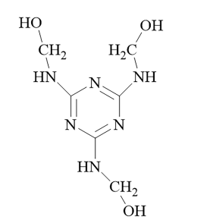 | [51]
10.0 | 7.8 | 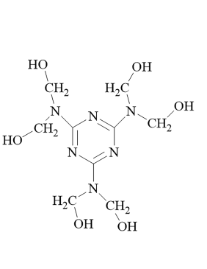 | [52]
1.0 | 9.3-9.8 | 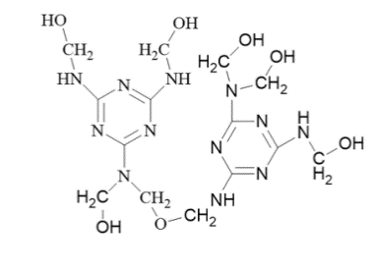 | [18]

