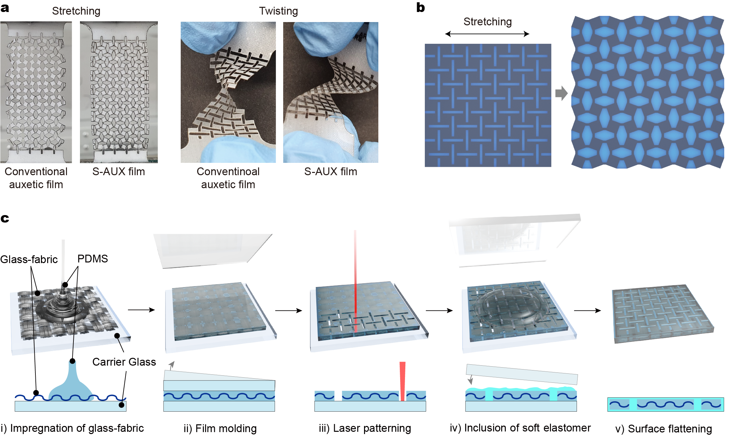
Extended Data Figure 1︱Seamless auxetic omnidirectionally stretchable substrate (S-AUX) film. a, Deformation behavior of a conventional auxetic film (left) and the S-AUX film (right) under uniaxial tension and twisting, respectively. b, Schematic image of the S-AUX film before (left) and after (right) stretching. c, Schematic illustrations of the S-AUX film fabrication process: impregnation of glass-fabric into a PDMS premixture resin (i); fabrication of GFRPDMS film using vacuum bag molding process (ii); laser patterning of GFRPDMS film to form an auxetic structure (iii); inclusion of soft elastomers in the perforations (iv); resulting S-AUX film with flat surface after curing (v).
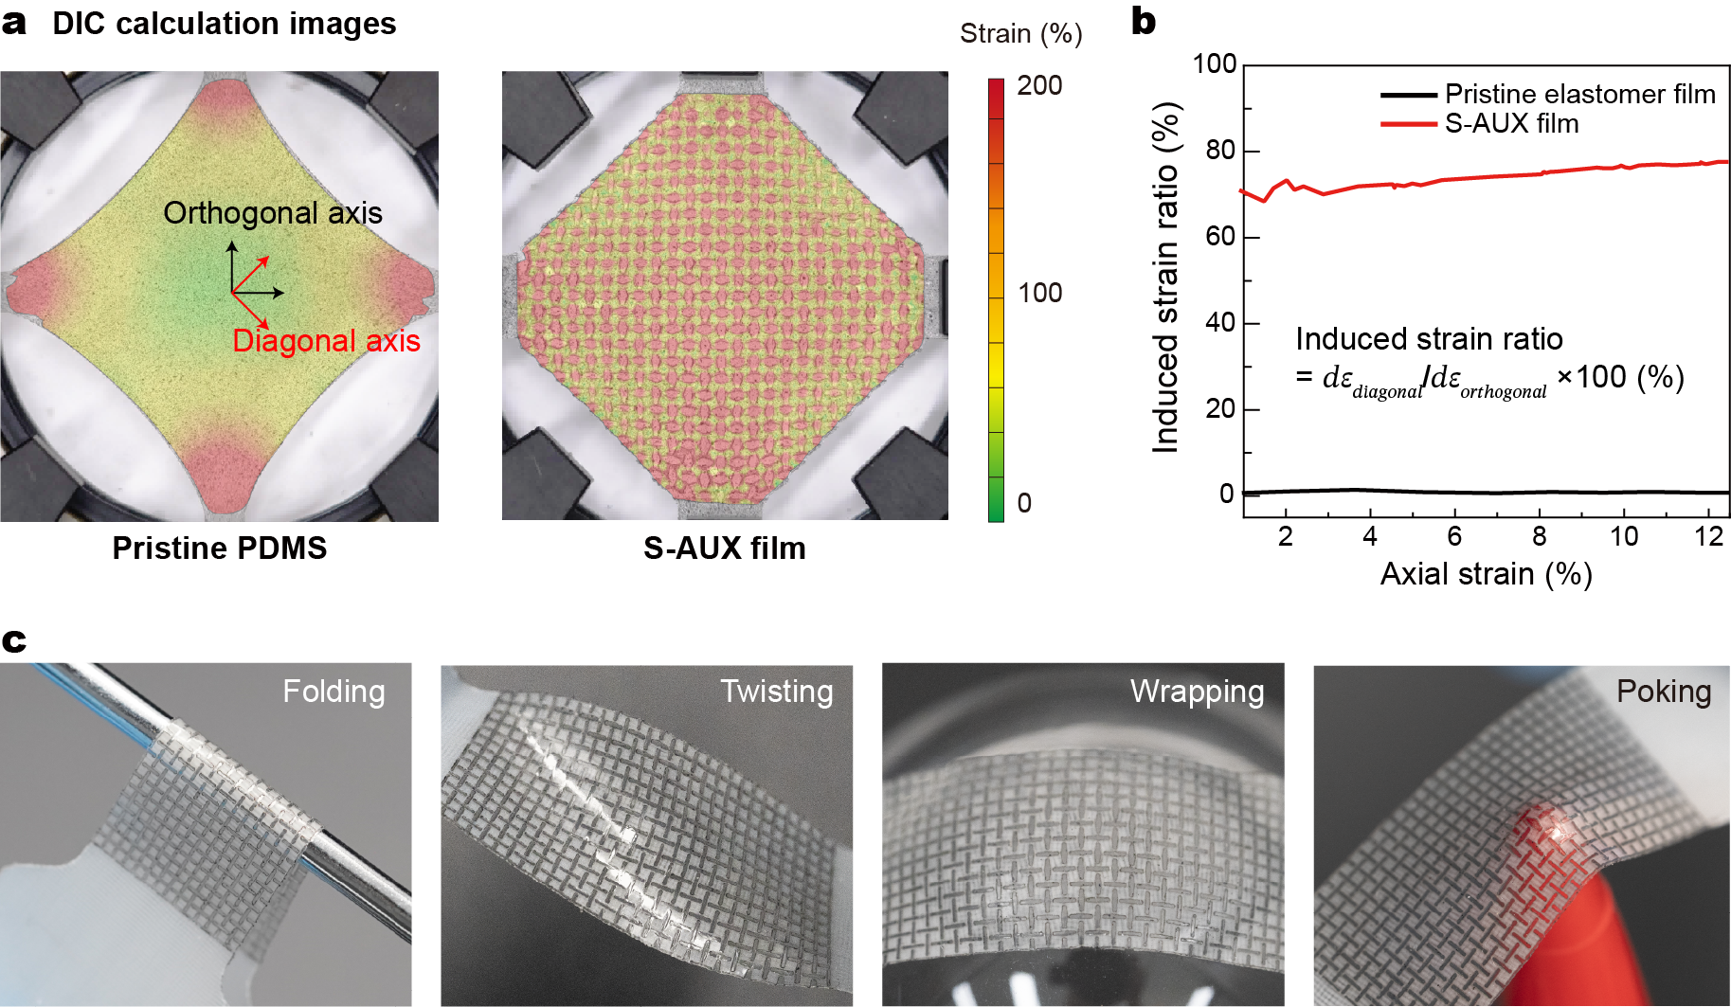
Extended Data Figure 2︱Distortion reduction ability and deformation behaviors of the S-AUX films. a, Visualized strain map of pristine elastomer (left) and an S-AUX film (right) under biaxial stretching. (black arrows: load applied axes, and red arrows: induced deformation axes) b, Calculated induced strain ratio (Δε_{diagonal}/Δε_{orthogonal} ×100 (%)) of pristine elastomer film and S-AUX film. c, Photographic image of the S-AUX film in various deformed states: folding over a screwdriver (left end); twisting (left center); wrapping a 5 cm diameter hemisphere (right center); and poking with a sharp-ended felt pen (right end).
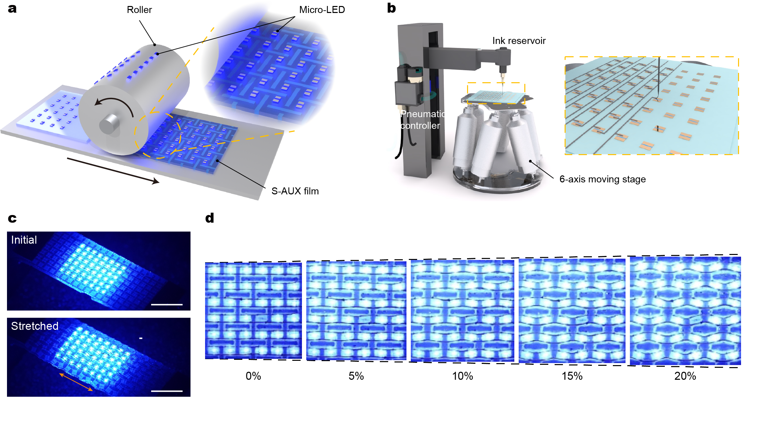
Extended Data Figure 3︱Fabrication and characterization of the distortion-free display. a, Roll-stamping transfer process of micro-LED arrays. b, 3D printing of liquid metal electrodes for interconnection of the micro LEDs. c, Photographic images of S-AUX film-based display under uniaxial stretching (scale bars, 5 mm). d, Photographic images of an S-AUX film-based distortion-free display driving under uniaxial stretching of 0 ~ 20%.

